**Vanier College**

**Computer Science Department**

**420-320-VA Database I**

**Fall 2018**

**Lab/Assignment Number and Title:**

Lab 5: Function, Substitution Variables, DEFINE and CASE Structure

**Submitted by:**

**Student Name:** Marissa Gonçalves

**Student ID:** 1775227

**1.**



**2.a)**

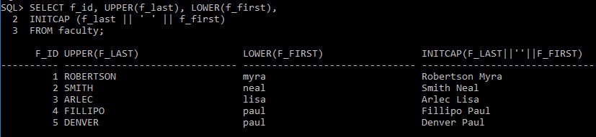

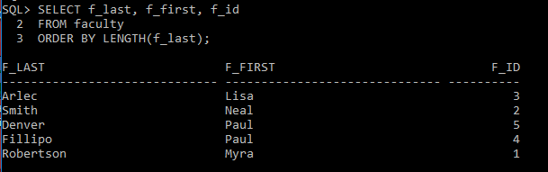

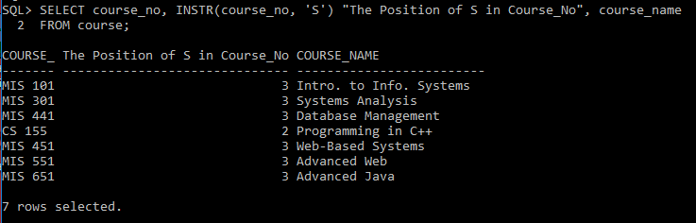

**b)**

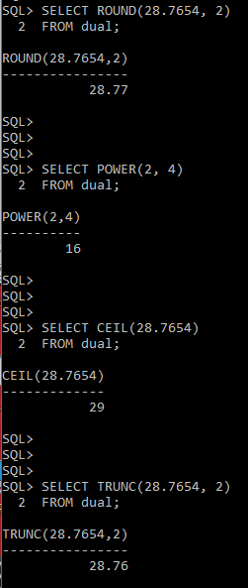

**c)**

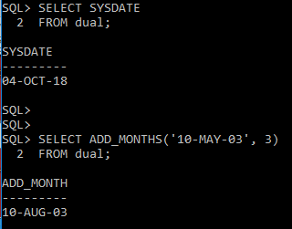

**d)**

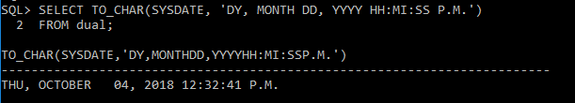

**e)**

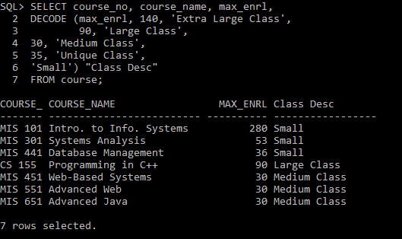

**f)**

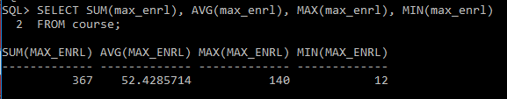

**3.a)**

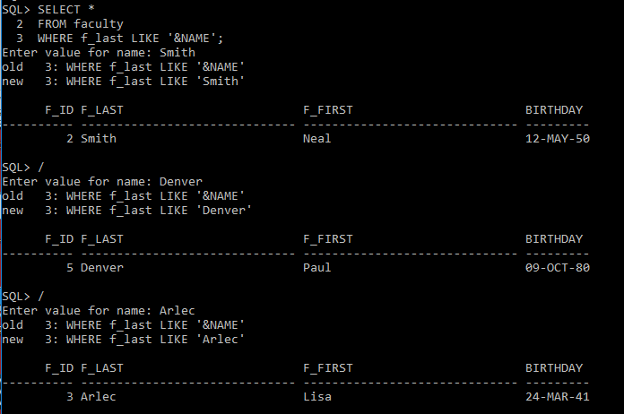

**b)**

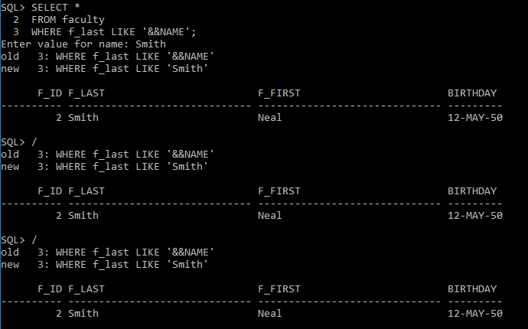

**c)**

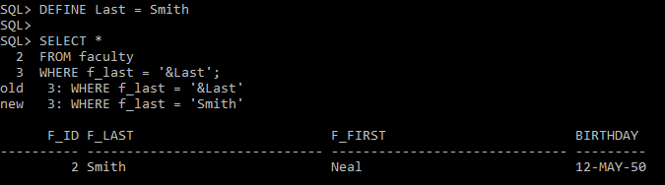

**d)**

