Off Brand Discover Weekly
Marissa Montano | Final project | Design plan

Summary:

Every Monday Spotify releases a customized playlist to each user called ‘Discover weekly’. The playlist comes with 30 new songs, all with a very high probability that you will like them. The music recommendation system that they use, is actually based on three types of models to get an accurate set of songs. Collaborative filtering, natural language processing, and raw audio are all the models they use for the recommendations. The basic gist is that they use data from similar users (users who usually like the same music as you), data scraped from music blog post on the web (specific language used to talk about artists, related artists, etc...), and raw audio clips (to get the tempo, time signature, beats per minute, etc…) to get a probability of you liking that specific song. To make this concept easier to understand, and keep this paper on topic, lets just say lots of matrix math and neural nets are at work here.

Because I've only taken Intro to Data Science and Intro to Artificial Intelligence, there is no way I can match the kind of accuracy that Spotify reaches in my recommendation system, but I do have access to there song analysis data. I can get the duration, key, mode, time signature, acousticness, danceability, energy, instrumentalness, liveness, loudness, speechiness, valence, and tempo for each song. This means I can make a fairly accurate recommendation system based on user feedback and the song analysis. There are three types of classifiers I want use for the recommendation system: K-nearest neighbors, Radial basis function SVM, and Gradient boosting. These classifiers can give me the most accurate recommendations with the small amount of data I have access to (more in depth reasoning for each classifier is on page 3).

TL;DR

My final project is going to be a music recommendation website from Spotify API. This sounds an awful lot like Discover Weekly, huh? That's why this website will be called Off-Brand/Knock Off Discover Weekly. The main difference being that my recommender will be far less accurate because I will only implement a single classifier with less data then Spotify has access to. The user will have a unique profile and based on what songs they say they like and don’t like new song recommendations will appear. They can also update the cache of the songs in the database to pull in new songs and change the algorithm that gives them their recommendations. The only caveat of getting accurate song recommendations is how much data you put in; the better recommendations the more songs you rate.

GUI – PyQt5:

The GUI side is going to be used for modifying the recommendation system. You will have the option to update the cache (ie. do a pull from the Spotify API and update the database with new songs) and update the algorithm used to give you new songs. Another feature will be the menu bar that explains more about the configuration methods provided, so you have control over how you get your recommendations. If time allows I would like to pull in new songs from other databases, namely the Echo Nest database, and add more features to modify the algorithm. Figures 1-3 below are a rough sketch of how I wanted the GUI to look.

Add in mood: studying, to change tempo etc….

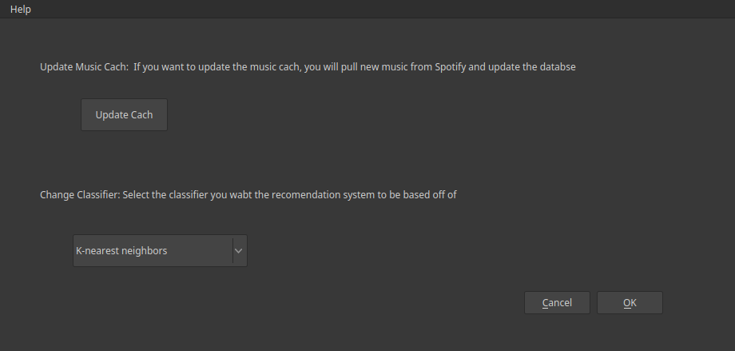
Figure 1
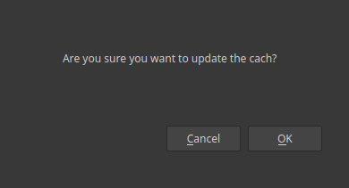
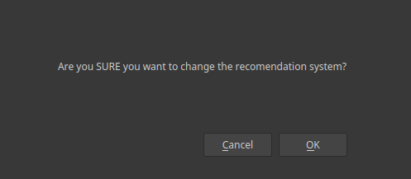

Figure 2 Figure 3

Non-GUI – Sklearn (main component):
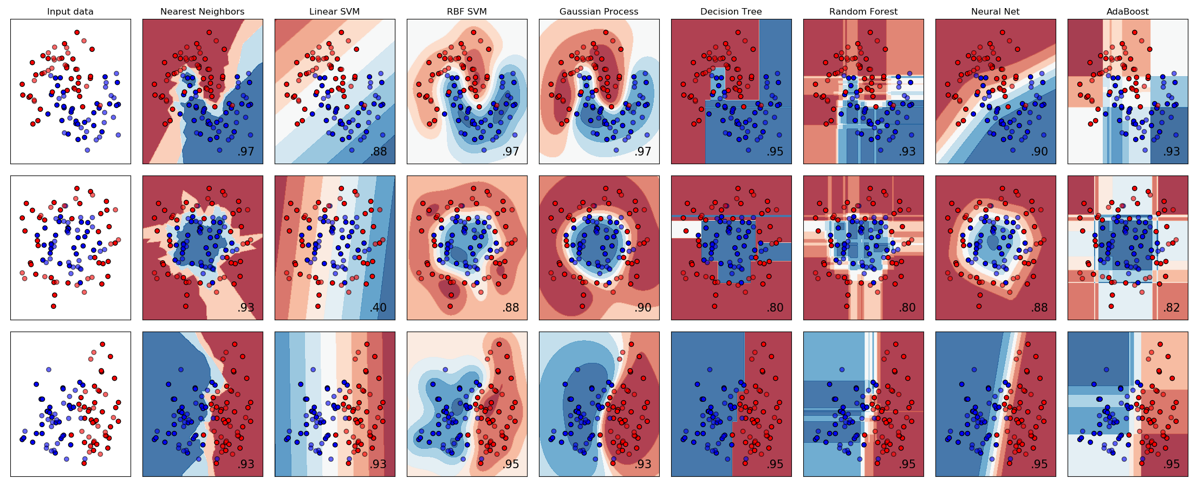
Figure 4
Class methods for recommendation algorithm:
- Fetch data for specific user logged in
- if no data is present for a user load in 10 random songs
- Train classifier with user specific data
- Select random songs (filtered by the ‘mood’ selected in the GUI)to feed in classifier until you get 10 songs the user should like/dislike
- Update song list on website with new songs
- Update graphs on website maybe..
- Reload recommendations

First implementation using classifiers with multiple features:
(Use Multiple Linear Regression to filter out non-helpful features)
K-nearest neighbors – voting from close by neighbors:
The idea around k-nearest neighbors is it groups itself based on its k-nearest neighbors. For example, if its k-nearest neighbors are a majority of songs the user likes, its going to get grouped in with a list of good songs.

Linear non-separable Support Vector Machine, RBF – separating with a:
SVM are used to maximize the decision boundary between two categories. Because the data were using can be non-separable (no clear line can be drawn) we have to use the kernel trick with RBF. This creates new features based on the distance between a center and other points (higher the gamma closer the reach, so we have a non-linear line used as the decision boundary).

Gradient boosting - minimizing a loss function by converting weak learners to strong learners:
Like SLR we want to fit a model to the data that will minimize loss, but with gradient boosting we will do so sequentially by using early learners to fit the data and later learners to fix the ‘errors’ or compute and predict the residuals made by the earlier learners. You stop just before over fitting the data.
Database – Sqlite3:
Add popularity, artists as an array, rating a 5 point scale? And add genre (of album only)too!
I’m going to use a Sqlite database to hold all my data (in figure 5 you can see the data model in third normal form). One table will be used to hold all the song information such as name, artists, tempo, time signature, acousticness, etc., the other will hold the users identity (ie. username and password), and the last table will be a list of user songs, this will keep track if the user liked or disliked a specific song.
There are two ways the database can be updated, one is if the user updates the cache from the GUI and the other is if the user creates/deletes a profile or likes/dislikes a song from the website, but in both cases the non-GUI will take over and be the main driver to update the database. In the first case the non-GUI will make a new call to the Spotify API and grab all the new songs not already stored in the database and will update the Song table. In the other case it will add/remove users from the User table when prompted and will get the user info about the songs, (ie. if the user liked them or not) and will update the User_Song table.

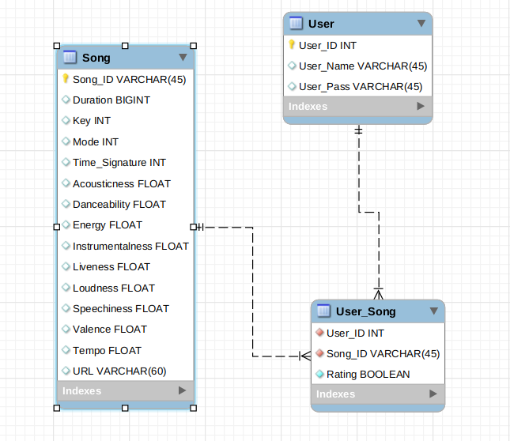
Figure 5

Web - Flask:
Make top 10 and bottom 10 songs, embed a web player? Maybe Spotify? Maybe not? No soundcloud.
The web page will consist of three main parts: a login page, a home page, and a music page. The login will create/ log in users to their unique profile. The home page will let them delete accounts, logout, access the music page, and lets them learn more about the website as a whole. Lastly the music page will allow them to look at there recommendations, rate songs from the recommendations, and access the GUI. Figures 6-7 show the design scheme I wanted the website to have.

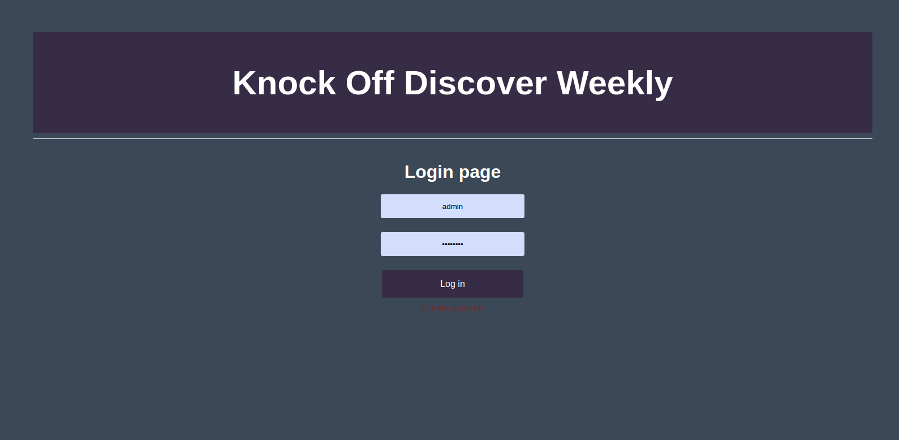
Figure 6

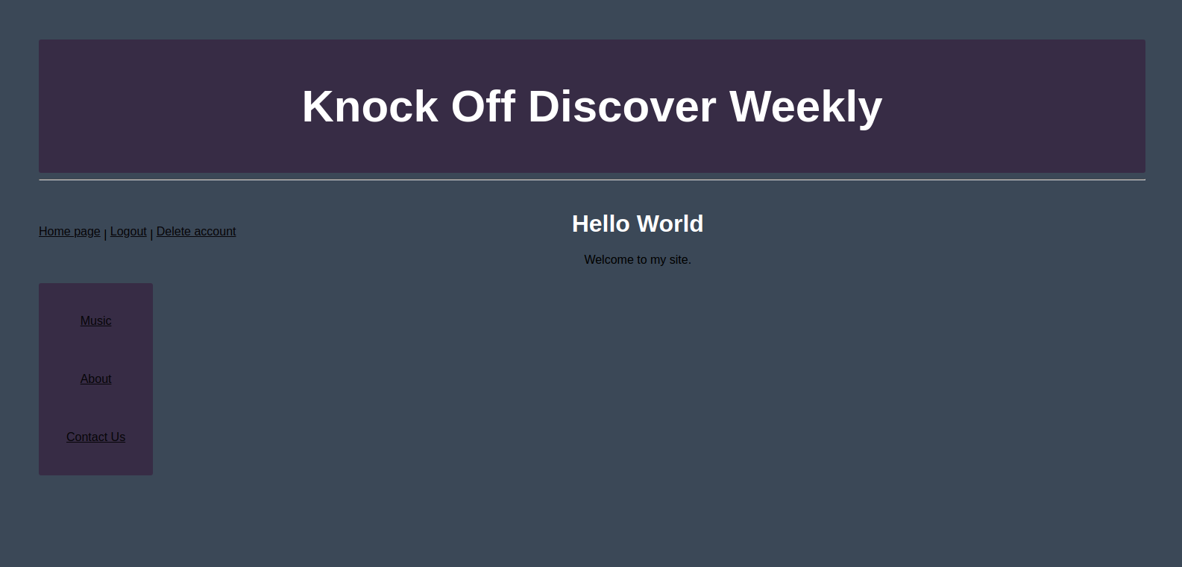
Figure 7
Big picture:

The app works as whole, but it’s mainly driven through an ‘engine’. To make this music recommendation system we need multiple parts: a way to store the data, a way to show the recommendations, a way to update the data, and an algorithm to compute recommendations based on probability. In figure 2 you can see the way each part interacts with the other components. The most important part of the diagram is that non-GUI is the ‘engine’ that controls everything else.

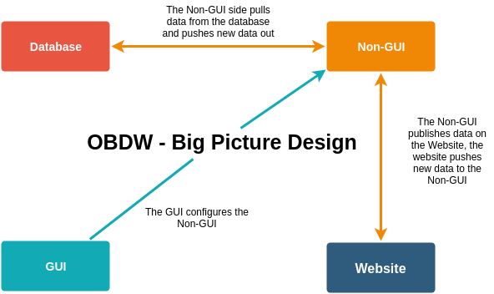
Figure 8

Resources:

https://medium.com/s/story/spotifys-discover-weekly-how-machine-learning-finds-your-new-music-19a41ab76efe

https://scikit-learn.org/stable/auto_examples/classification/plot_classifier_comparison.html

Next time:
- Make login more safe….
- Make flask work with mobile
-
-
-
-
-
-
-
-
-

