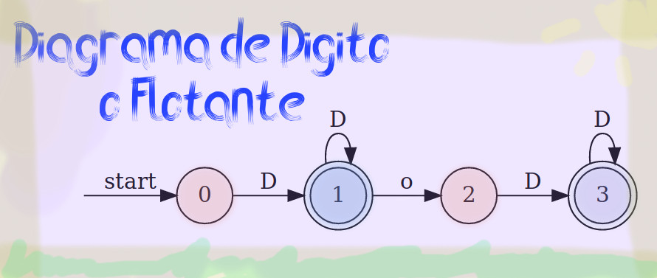

1. **Q= {0,1,2,3}**
2. **0**
$\sum{}=\{D, .\}$

3. **F={1, 3}**
4. **Diagrama de= D+|(D+ . D+)\***

|  |  |  |
| --- | --- | --- |
| **Estados** | **Dígito** | **punto** |
| ***A*** | $δ(A,Dígito)$ ={B} |  |
| **B** | $δ(A,Dígito)$ ={B} | $δ(A,punto)$ ={C} |
| **C** | $δ(A,Dígito)$ ={D} |  |
| **D** | $δ(A,Dígito)$ ={B} |  |

1. **Lenguaje Formal = D(L | D)\***

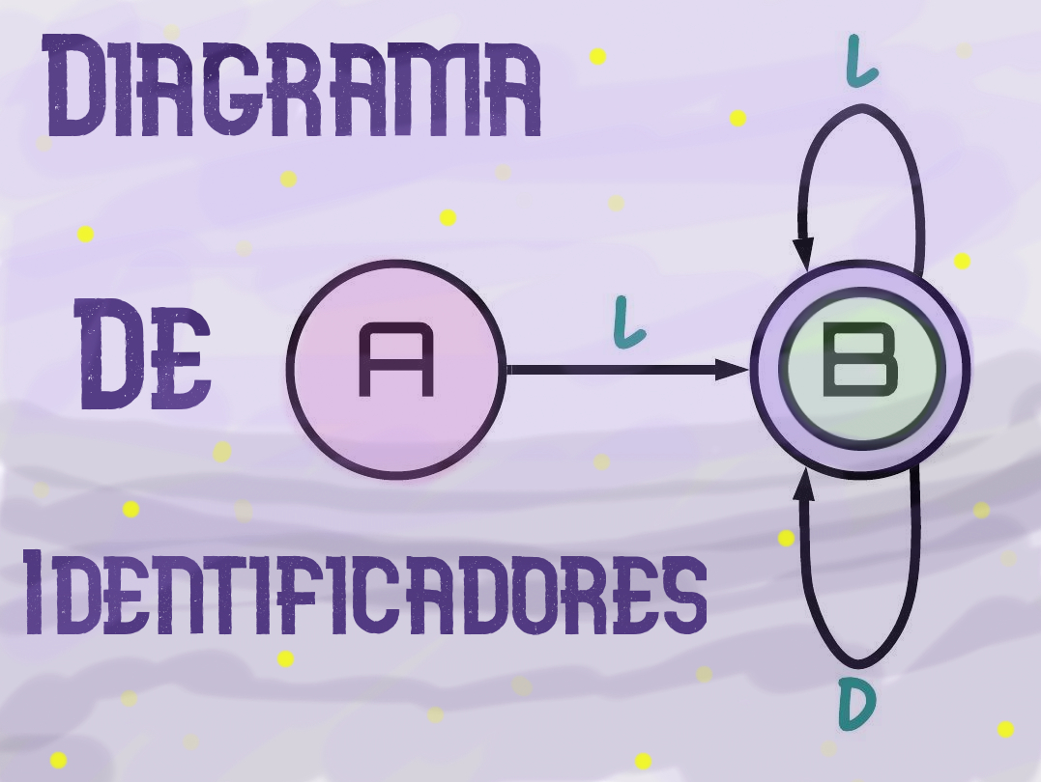

1. **Q={A, B}**
2. **A**
$\sum{}=\{Letra, Dígito\}$

3. **F = {B}**
4. **Diagrama de= L(L |D)\***

|  |  |  |
| --- | --- | --- |
| **Estados** | **Letra** | **Dígito** |
| ***A*** | $δ(A,letra)$ ={B} |  |
| **B** | $δ(A,letra)$ ={B} | $δ(A,letra)$ ={B} |

1. **Lenguaje Formal = L(L | D)\***