ADVANCED PROGRAMMING

ASSIGNMENT #1

Marium Aslam

217197

BSCS 7B

OpenCart is an effective and customizable platform for an ecommerce store. Opencart is an easy to-use, powerful, open-source online store management program that can manage multiple online stores from a single back-end. All it requires is to simply install, choose a template, and add products. The store is then ready to be employed online.

I installed opencart using bitnami add-ins on my xampp server. It was a fast and easy installation and did not need me to install a separate SQL server since xampp already offers that feature. ON its website it also provides a demo of the website that will be seen to the customers, called the 'store-front' as well as that of an administration side which gives access to admins to look over their site activities. This is what the store-front website looks like when you first install the platform, the template I am using is a gadgets ecommerce website :

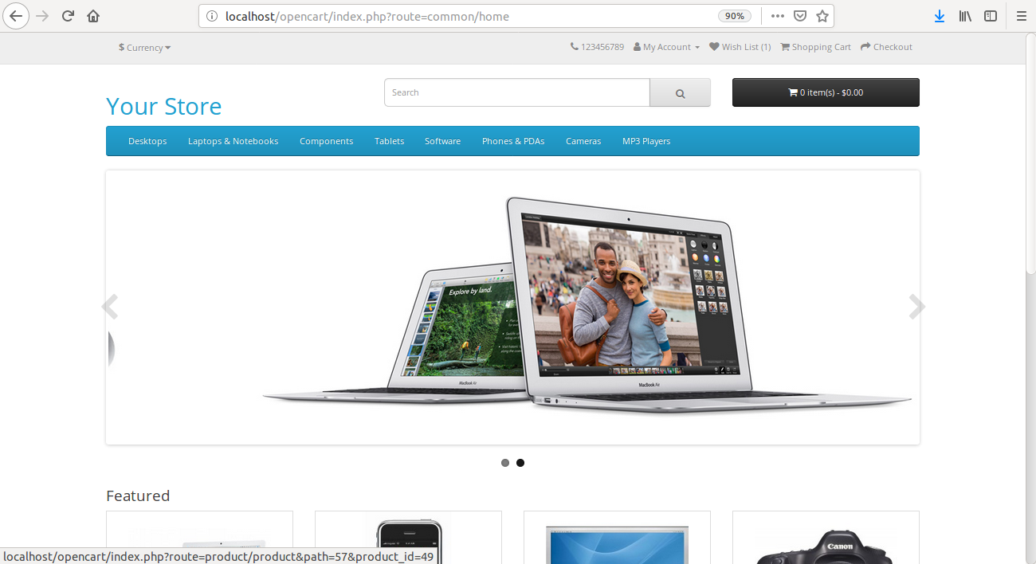

**EXPLORING THE SOFTWARE WITH A USER PERSPECTIVE**

The installation process required me to set-up a user admin login and password which I used to login to the dashboard. This is what the dashboard looked like:

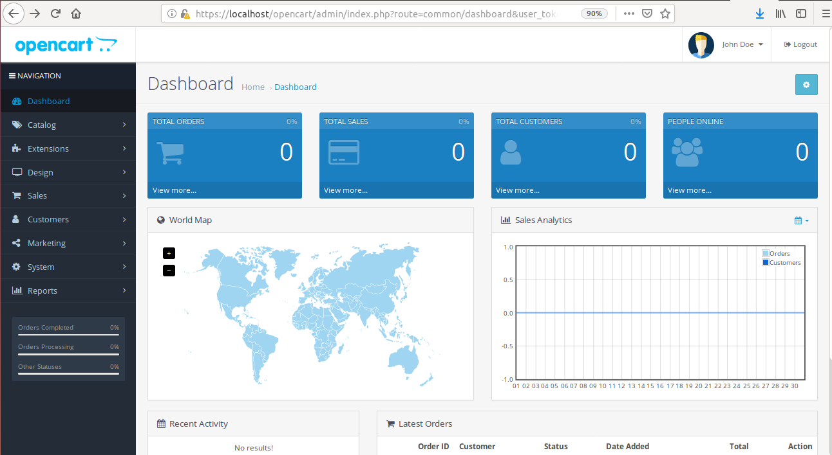

With a first glance, we can observe that the dashboard provides a summarized and graphical view of the current activities on the site. It provides a sum of total orders placed, total sales made in USD, number of customers that have used the site and currently online people browsing the site.

The dashboard also gives insight on the sales analytics with a graph to show the progression of customers and orders on a daily, weekly, monthly, or yearly basis. A world map highlighting the areas of customer activity is also showcased.

There is a small box to display the recent activity and another table to show details of a the latest orders placed consequently alerting the administrator of orders placed as soon as possible to ensure maximum efficiency.

The admin front also features a menu to the side which the user may navigate to administer the website and cater to all the requirements of keeping a website live. The admin can view, add and remove data that is stored in the website servers visible on this menu using this interface. The menu contains the following categories of items:

The catalog displays all the useful website data that is visible to a customer on the store front. It lists: the categories of products, the list of products, the frequent customers, the possible filters a customer may apply to his/her product list, the attributes- or keyword tags, that are used to describe a product, the options in a user form, the manufacturers whose products are show-cased, list of downloads, reviews, and lastly information about the shipping and delivery details.

The extensions drawer is where a user may alter the website to his/her taste. It provides the interface to browse as well as install the extensions and/or plug-ins for changes in theme, functionality, usability, etc. It also lets to modify and add events to override the default functionality of your store.

The design tab displays options and allows the users to change the look and feel of the website. It allows changes in themes, layouts, languages, banners and details of the SEO URL.

The sales drawer records the sales summary, recurrent profiles, returns and gift vouchers available.

The customers drawer records the data on the customers on the website. It also recognizes customer groups and their approvals and custom fields.

The marketing menu is an interesting one. It lists the marketing campaigns deployed and their success in the form or a table. It also features a the coupons available to customers and provides an interface to email all subscribers at once. The last option in the menu is that of google store. It is a feature which allows you to post your website advertisements in Google.

The system tab provided a fast and effective way to have a watch over all your websites (that deploy opencart) and their activities. It provides a list of store settings, a list of users divided into administrators and demonstrators. A localization drop-down features the different locations, languages, zones, currencies, stock and order statuses, taxes etc that are applicable and eployed at your websites. The maintenance option lets you track the backups, upload and error logs of your stores. The reports tab gives a display of transaction reports, currently online customers as well as their recent activity and website statistics.

All in all, I believe it is a very thorough and complete front and has nothing lacking for the day-to-day monitoring and management of your ecommerce websites while also providing and easy interface for the non-technical administrators to modify the websites to their will.

**UNDERSTANDING THE DATABASE AND CODING STRUCTURE**

All the data that is displayed and saved on the opencart website is stored in an sql database on the back-end. When we open the opencart sql database on xampp's phpmyadmin on localhost this is what we get to see:

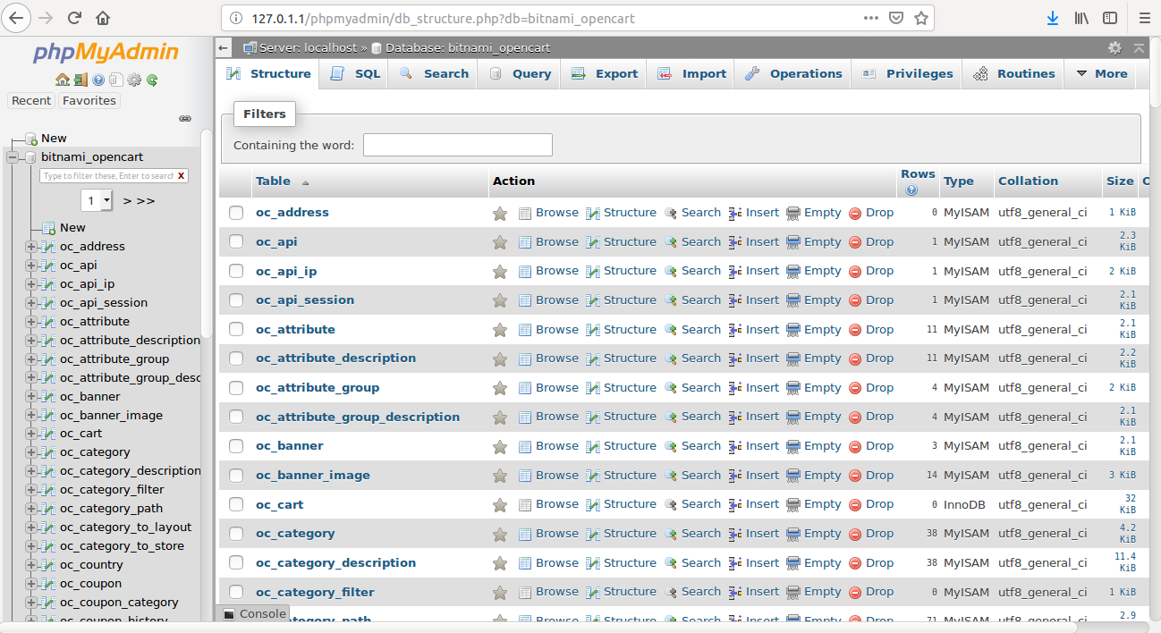

The database contains a total of 136 tables keeping records of all the data of the website. Each relation name has a prefix oc_. Some of these are: oc_customer, oc_currency, oc_category, oc_product, oc_cart, oc_manufacturer etc. We can look up the data inside these relations by either clicking on them or write queries in sql for more specific dataview requests. Will demonstrate some of the relations that I have mentioned above.

**QUERY: select * from oc_currency**

Displays all rows of oc_currency.

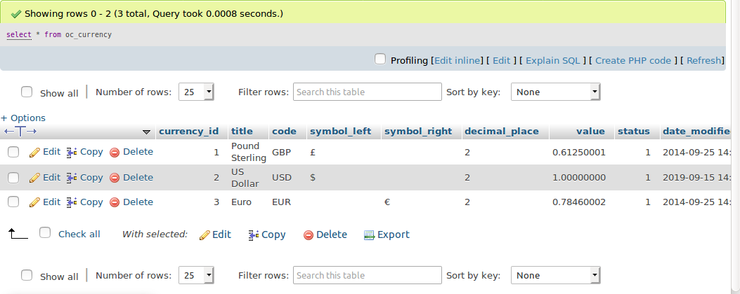

**QUERY: select * from oc_manufacturer**

Displays all rows of oc_manufacturer.

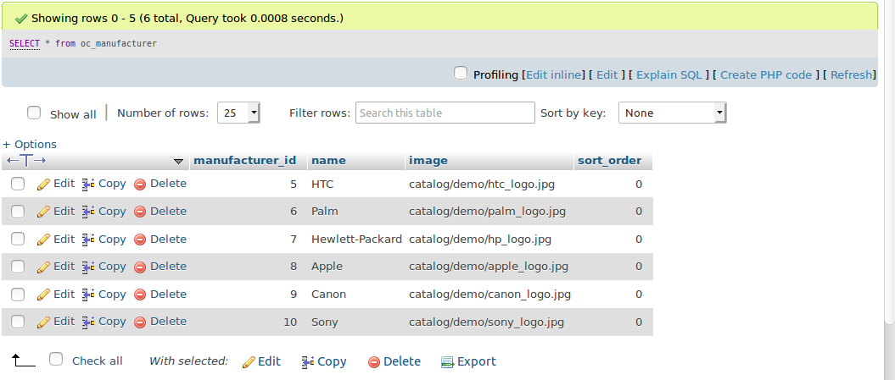

**QUERY: select * from oc_product where oc_product.manufacturer_id=8**

Displays all rows of oc_product which are made by Apple which has id 8 in oc_manufacturer.

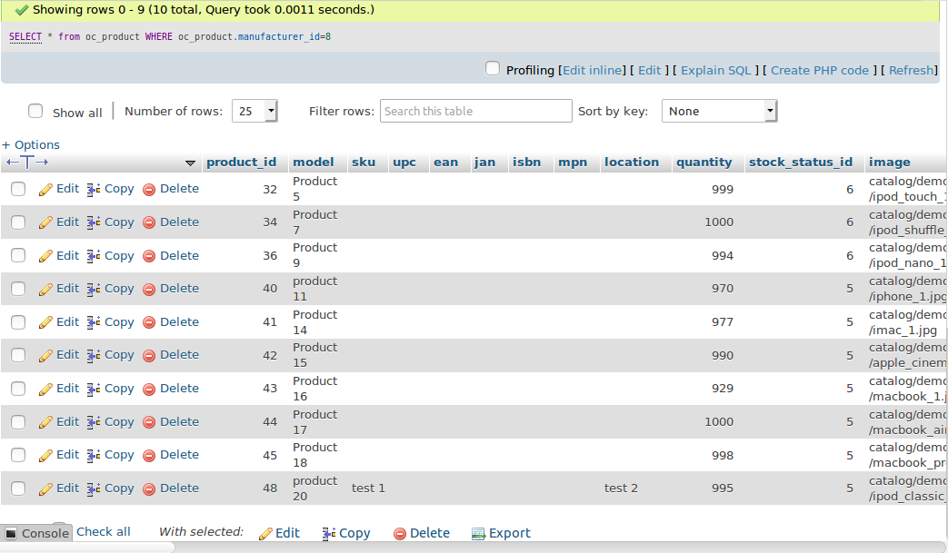

In addition to retrieving data, a database designer may add, remove, and edit data that is stored in the database. This is different from the administrator because a db designer can directly make changes into the databases and has more freedom in what kind of data is present in the servers.

Using the store-front I registered a customer to see what changes I will see in the currently empty oc_customer relation.

As we can see, my customer has been added. It is also noted that the password stored in this relation is encrypted so that the database designer cannot view it, committing to the privacy of the user.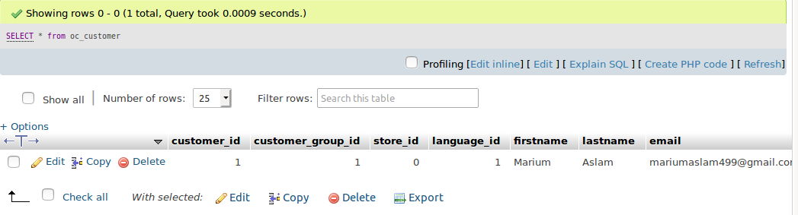

When I added items to the cart, we note those item added in the oc_cart relation:

we can also observe that customer_id is 1, which is the id of the customer that I just added.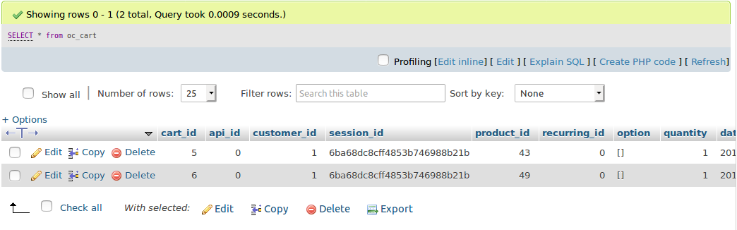

Now that we have a good idea about how the sql database functions and helps in the maintenance of the website data, lets take a look at the code side of the platform.

The basic opencart file structure is divided into two sections, the admin and the catalog. All opencart modules, like opencart follow the MVC-L framework. As a coder, you can have full access to all code including php, css and javascript files. We can access the code files however, it is highly recommended in the opencart documentation not to change the core css files directly, instead add new stylesheet for your designs and leave the core files, as is. This is so that your code is not lost when you update the opencart software.

Following is a view of the top of the main stylesheet of the website.

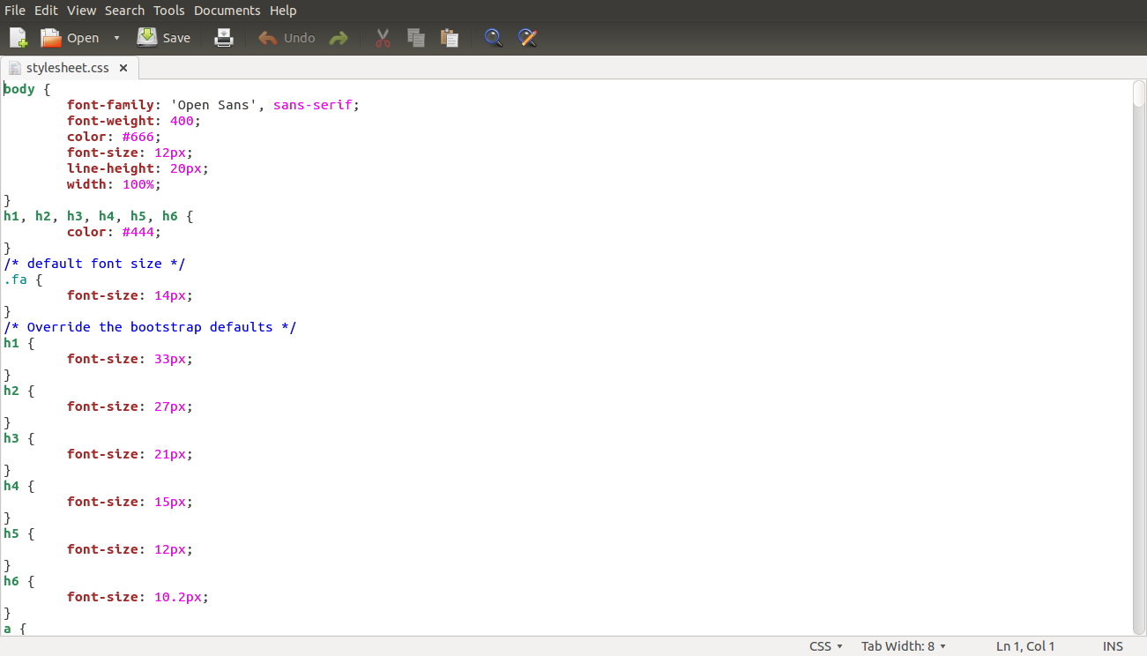

As we can see a cider can easily edit the styling of the sheet although it is not recommended.

I edited it just to see the possible changes. I changed the color of the headings to teal:



resultantly my headings changed color on the website:

(the Tablets heading is in teal now).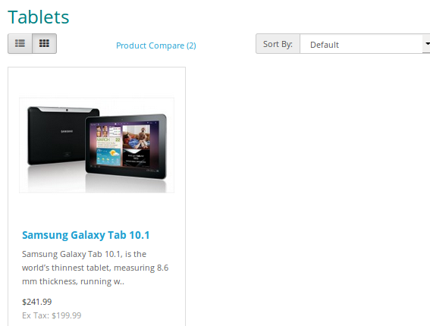

**USING ONLINE AVAILABLE PLUGINS OR MODULES OF OPENCART**

In the world of global social networking, it is almost necessary for all services websites to have a way where customers can contact you using an easy, live chat. I added on my website a google hangouts live chat because of its easy availability and widespread use. I downloaded the module from the opencart available extensions and added it to my website layout.