Project-Marium-Afzal

02

**Images of paper charts and paper stories**

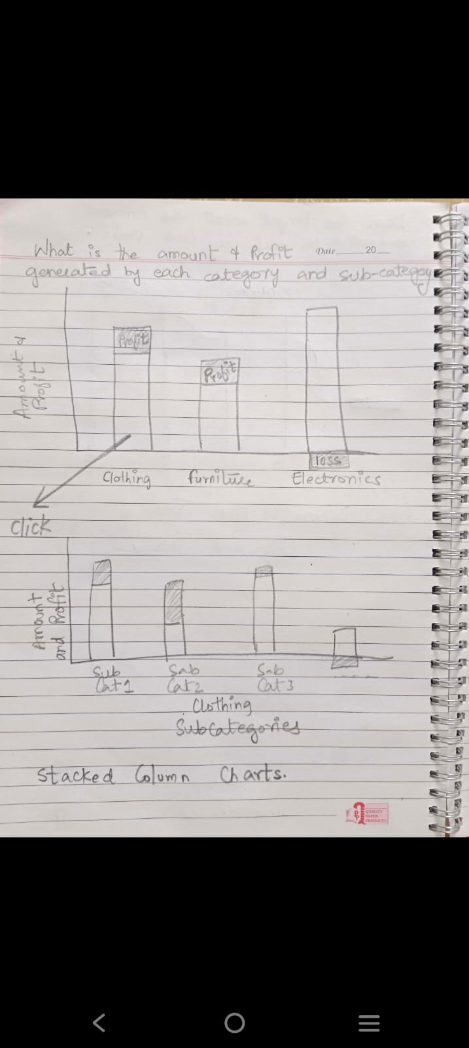



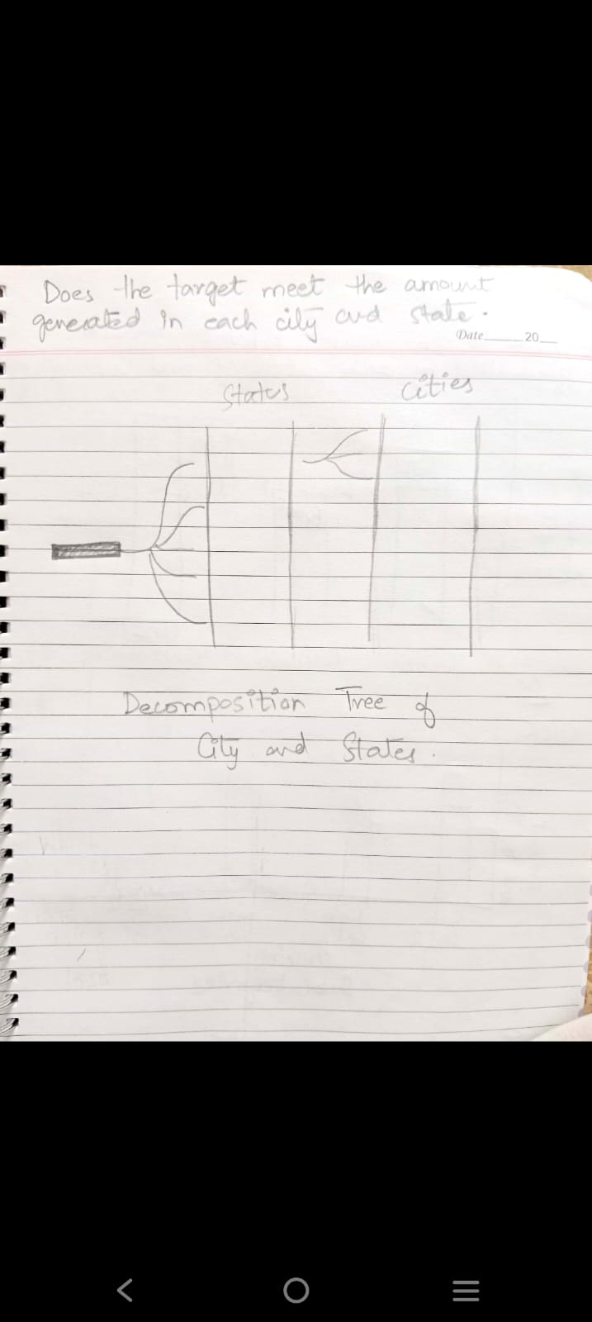

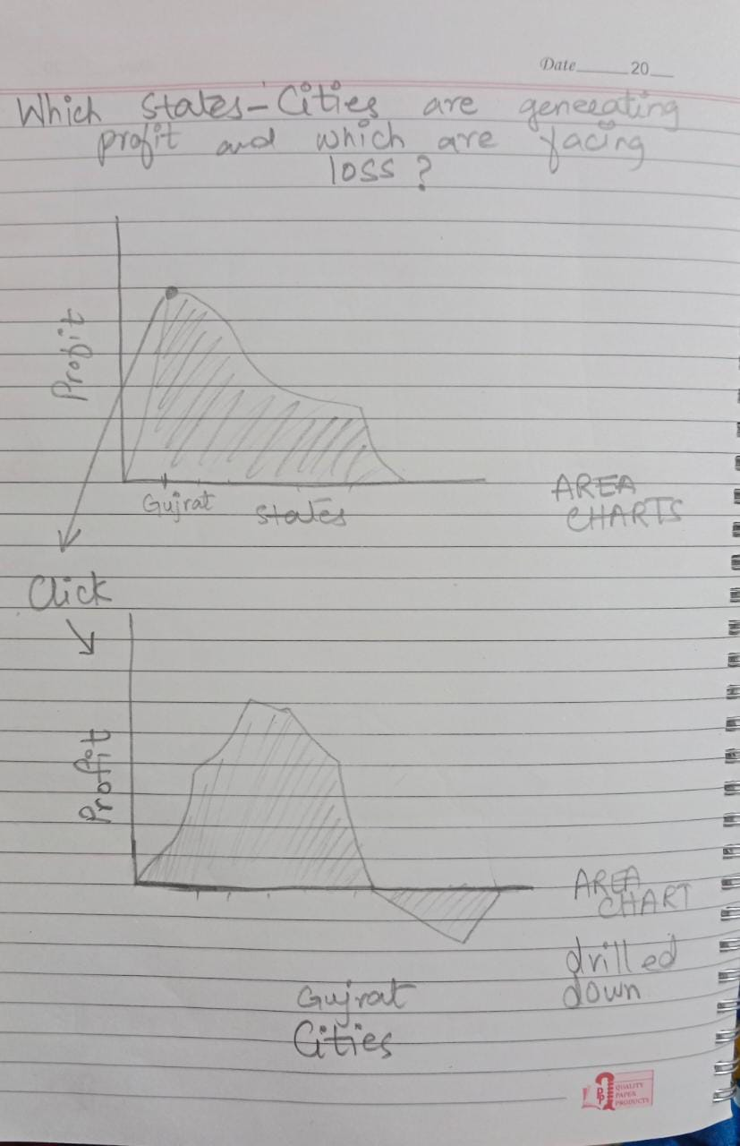

03

Stacked Column Chart

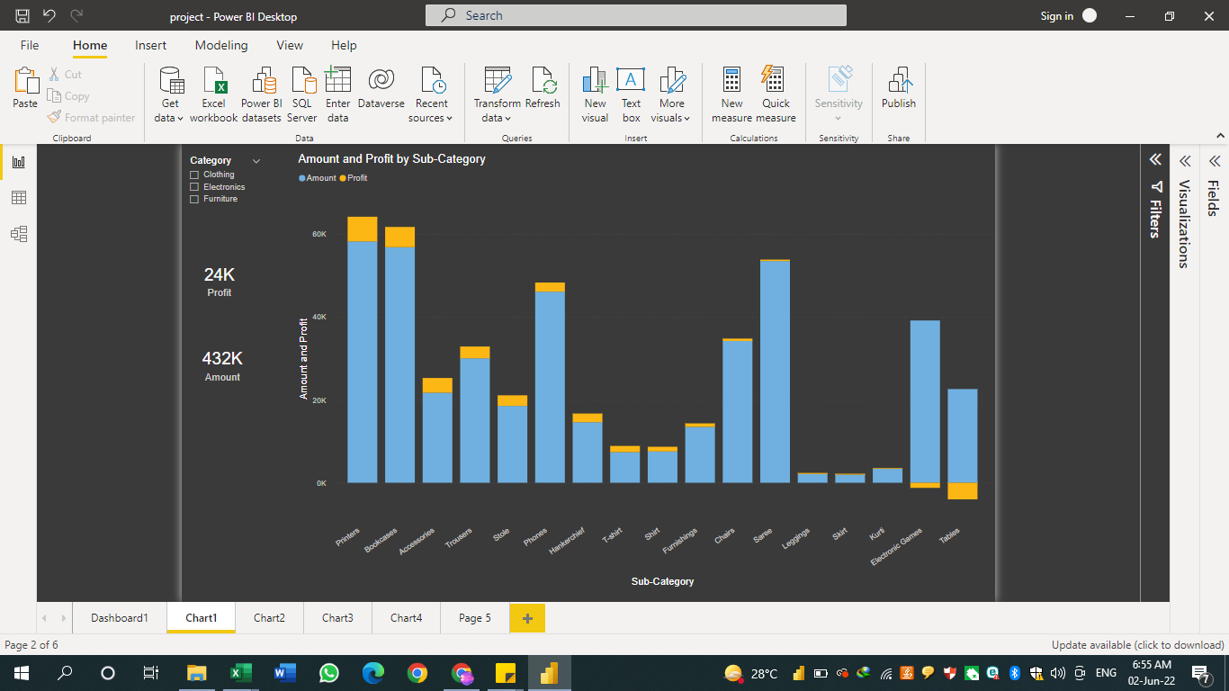

This chart gives a detailed view of each sub-category, their total profits and total amount generated from these products. The loss due to some categories is clearly visible. I have used cards on the side for easy reading. You can easily calculate profit percentage and find out whether those products that are not generating any profit are worth keeping, or they should be removed from the inventory eg Electronic games and Tables. Some of the calculations I have done from this chart are:

* Removing Electronic Games from Electronics category will increase the profit percentage from 6% to 10%.
* Removing Tables from Furniture category will increase the profit percentage from 1.8% to 6%.
* Removing both these items will cause an overall percentage profit increase from 5.5% to 7.9%.

I have used the formula (total profit/total amount) *100

Area Chart

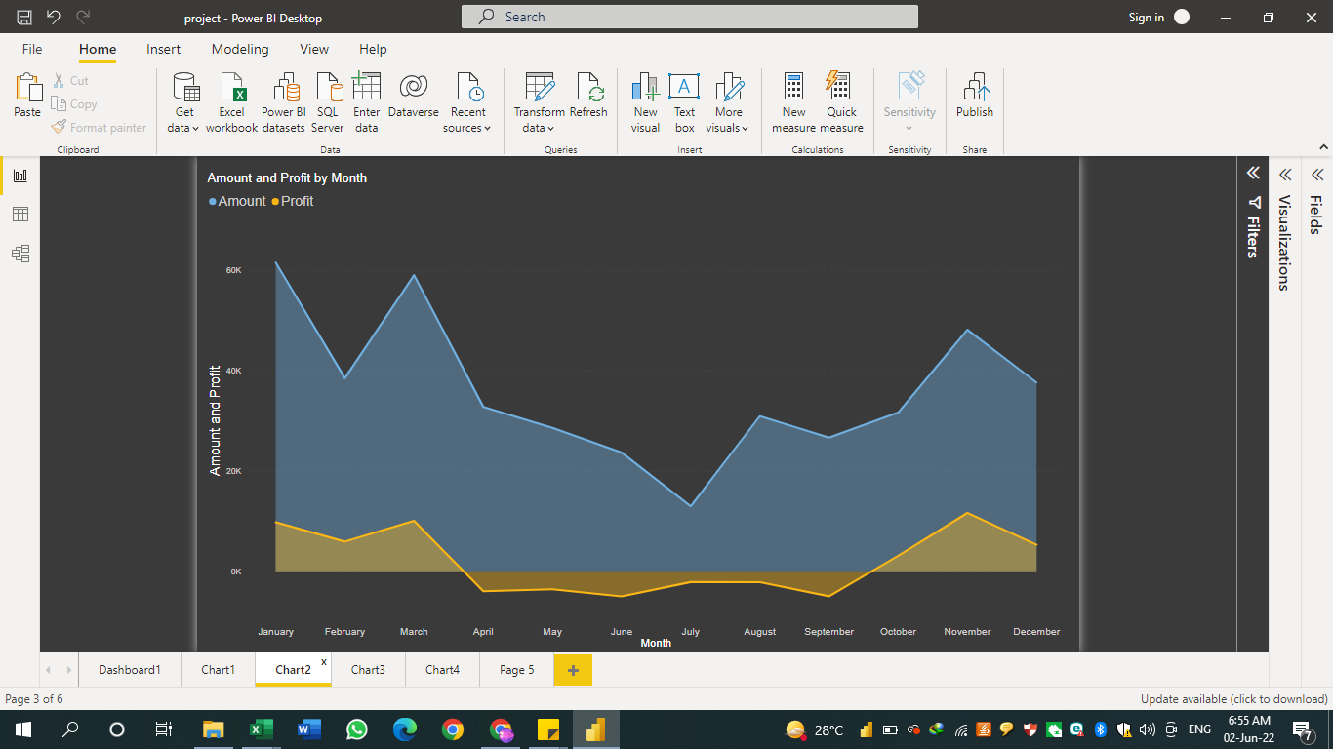

This Area Chart gives me Amount and Profit of each Category/sub-Category by month. You can click on any point in graph to drill down the category heirarchy or months. It clearly shows that we are not making any profits in the months of April till September.

Decomposition Tree and Map

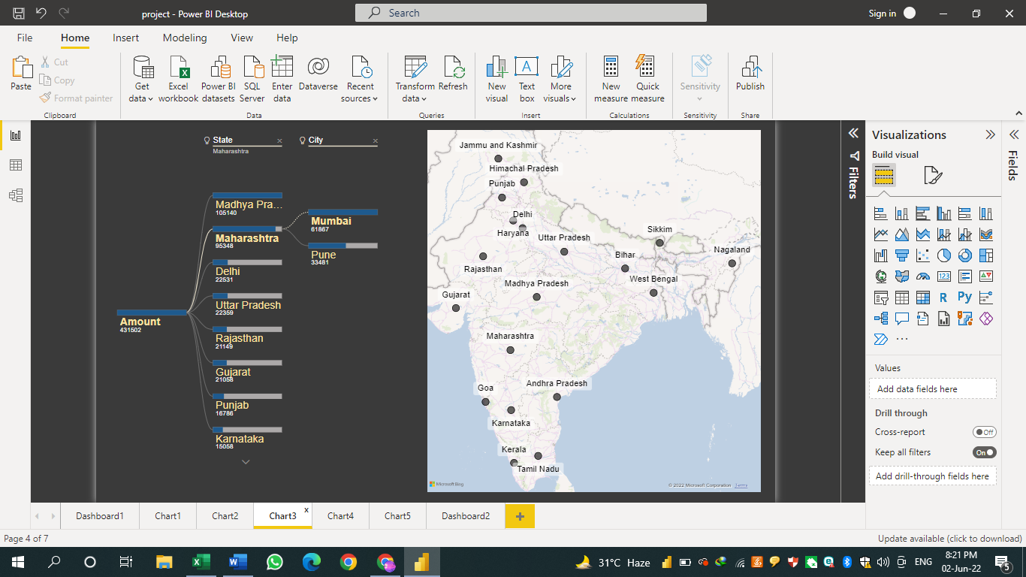

This chart gives a clear illustration of which cities are in which states and how much amount and profit they generate.

Funnel Chart

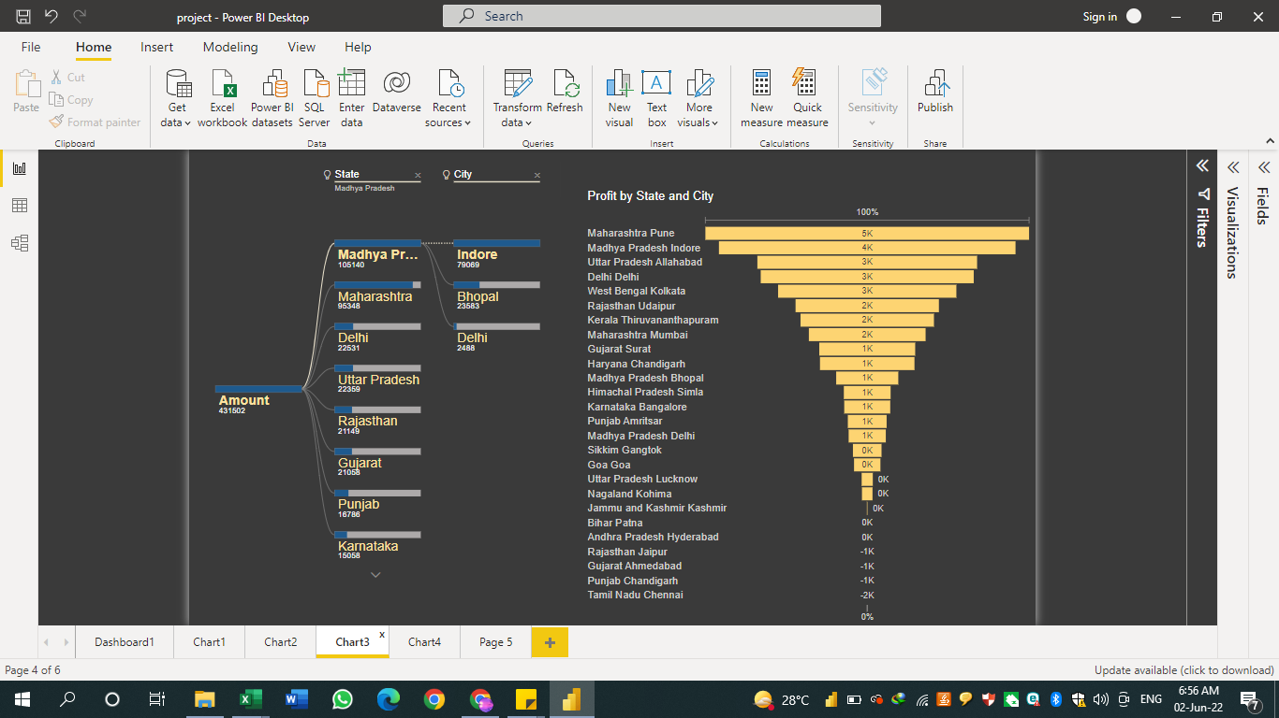

This graph helps us identify the prominent cities which are making the most profit.

Cities which show loss are not visible in this chart.

Line Chart stacked with Column chart

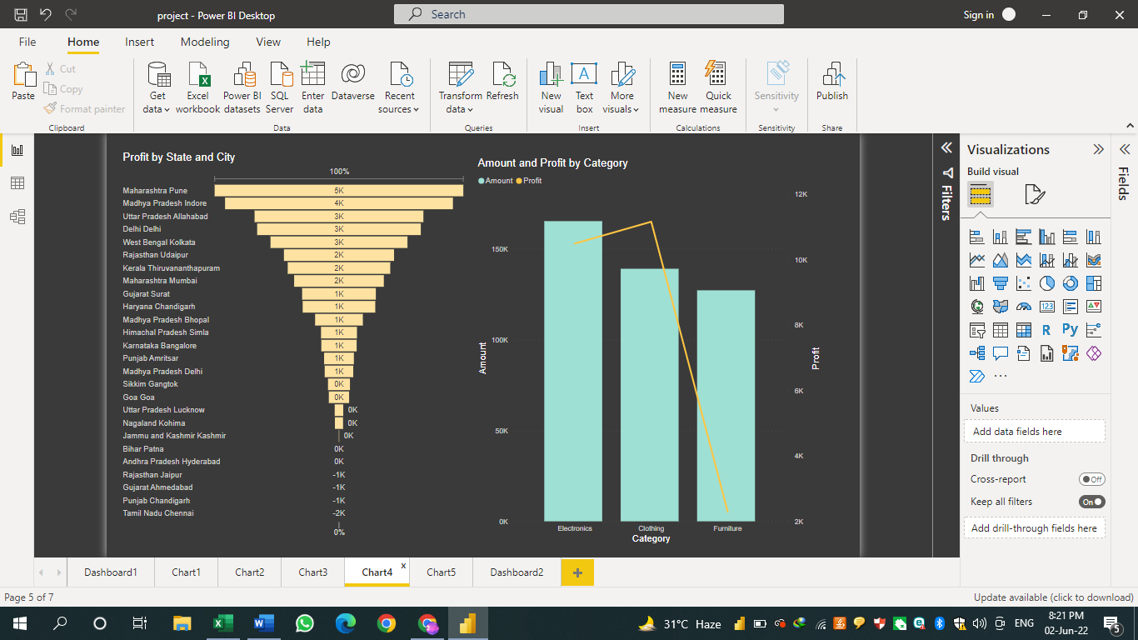

This chart is used in combination with Funnel chart or Map chart to better understand the category amounts and profits with respect to each city/state.

Area Chart

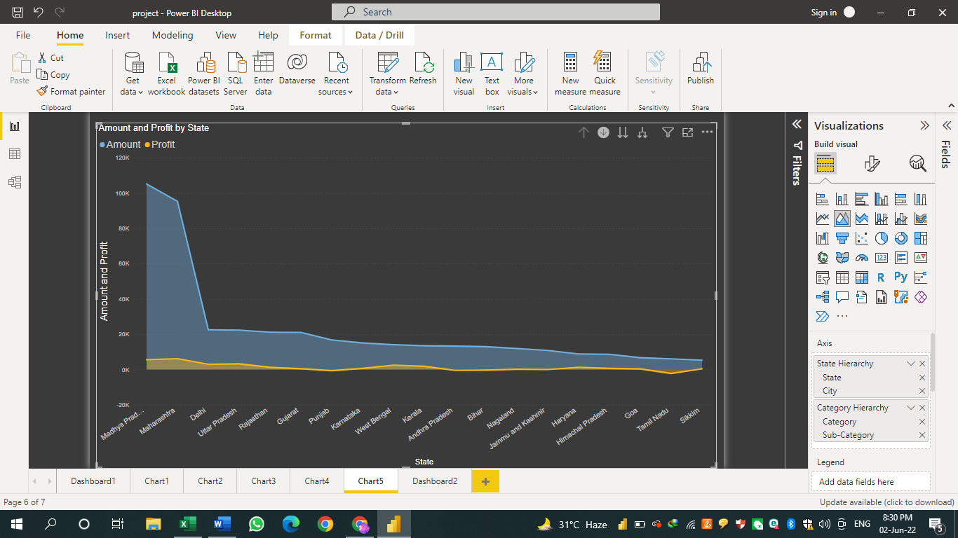

This chart in my opinion is the most comprehensive chart if you target each locality and try to find which category and sub-category is making profits and which is making a loss. We can analyze the amounts generated, profit and loss, and the targets to be achieved by comparing them with each city. There might be geographical reasons as to why certain product fail to do good, and this chart will make it easy to identify them. If a sub-category is a luxury item, and is sold in a poor state, chances of it decreasing our percentage profit are more. Keep some of the items which are making a loss, because they might be generating a better cash-flow overall.

Clicking on a state, takes us to all the cities in that state, clicking a city further takes us to all the categories amounts and profits, clicking each category further takes us to each sub-category where you can do a detailed analysis of which products to keep and which products to exclude from your inventory.

Story- Starts from Dashboard1—moves to Dashboard2

Interactive Dashboards

Dashboard1- for problem statement1

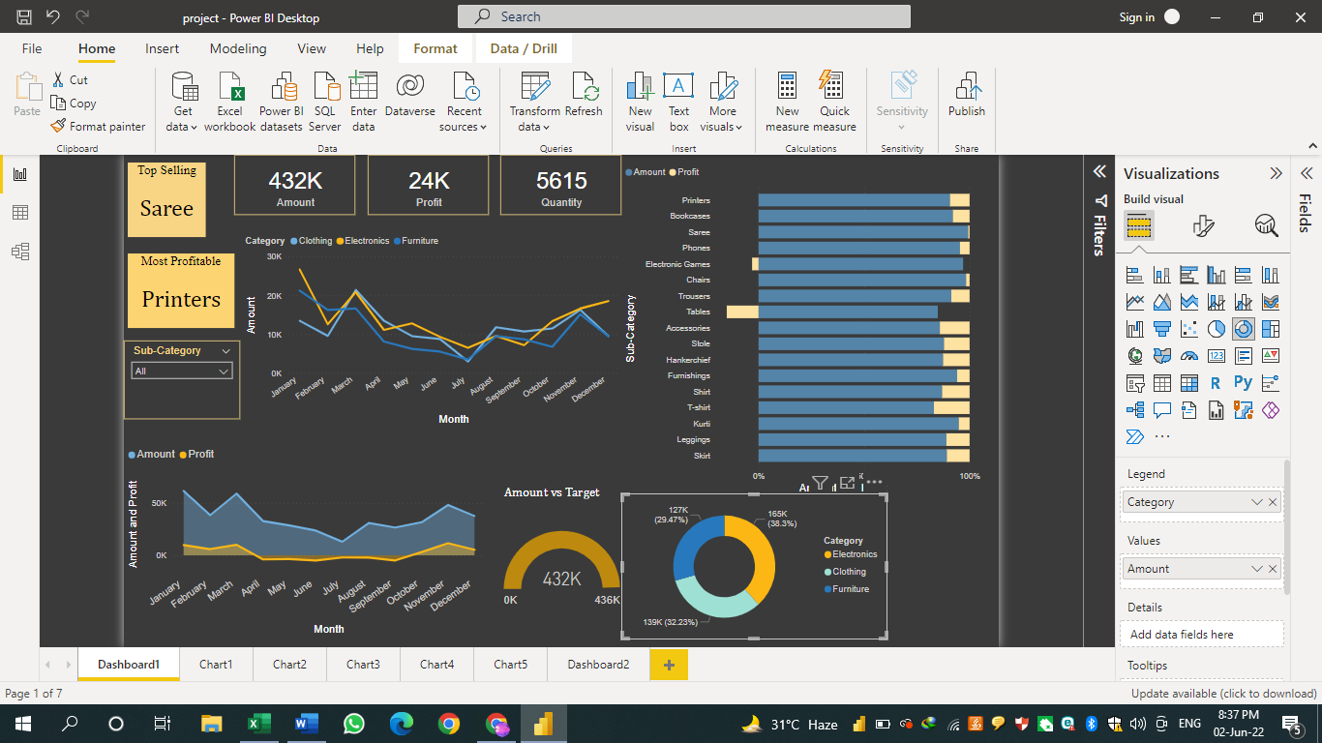

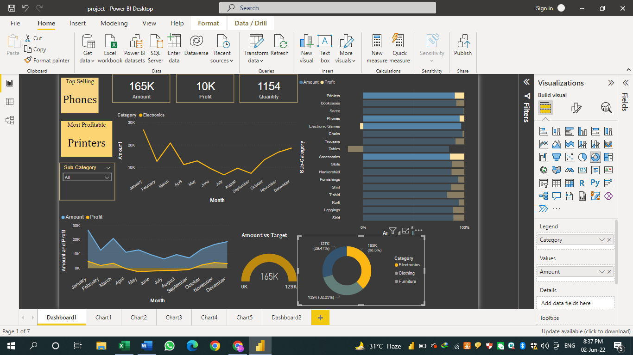

Once you have explored Dashboard 1 move onto a more detailed analysis with states and cities and how they effect sales.

Dashboard2

