GhostShell Project Report
Purpose: This document is a structured report template for the GhostShell project. It is designed to include screenshots and images illustrating features, workflows, and test results.

Table of Contents
- Overview
- Objectives
- Architecture
- Environment & Test Lab
- Features Demonstration
- Security & Ethical Use
- Limitations
- Future Work
- Appendix

Overview
GhostShell is a lightweight post-exploitation framework focused on educational Red Team workflows. It is split into a Controller (main.py) and a Zero-Dependency Agent (agent.py).
The project aims to simulate a realistic C2 (Command & Control) scenario where an operator interacts with a compromised target. It prioritizes stealth (via process masquerading and timestomping) and ease of deployment (using standard libraries only). The framework demonstrates core concepts like reverse/bind shells, persistence mechanisms, and basic forensic evasion.

Objectives
- Provide a modular post-exploitation workflow for training and research.
- Demonstrate safe, controlled testing in an isolated environment.
- Offer a minimal dependency footprint for the agent.

Architecture
Components:
- Controller (main.py): Operator interface and orchestration.
- Agent (agent.py): Payload executed on the target.
Diagram / Screenshot:

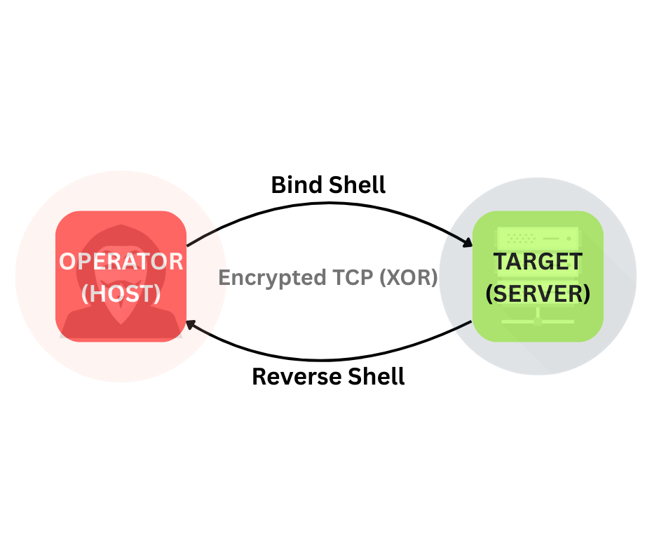

Environment & Test Lab
Host OS: e.g., Windows 11 / Ubuntu 22.04
Python Version: e.g., 3.11
Docker: e.g., Docker Desktop 4.x
Lab Setup Screenshot:

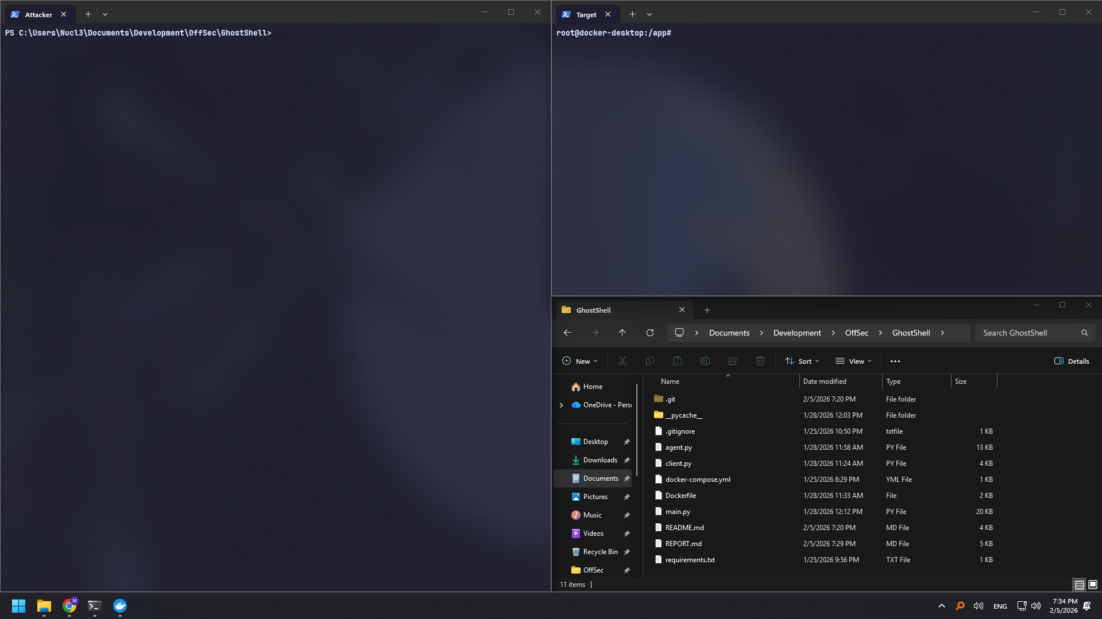

Features Demonstration
Below are example sections for documenting features. Replace placeholders with your own screenshots and short notes.

1) Reverse Shell
Description: Target initiates a connection to the operator.

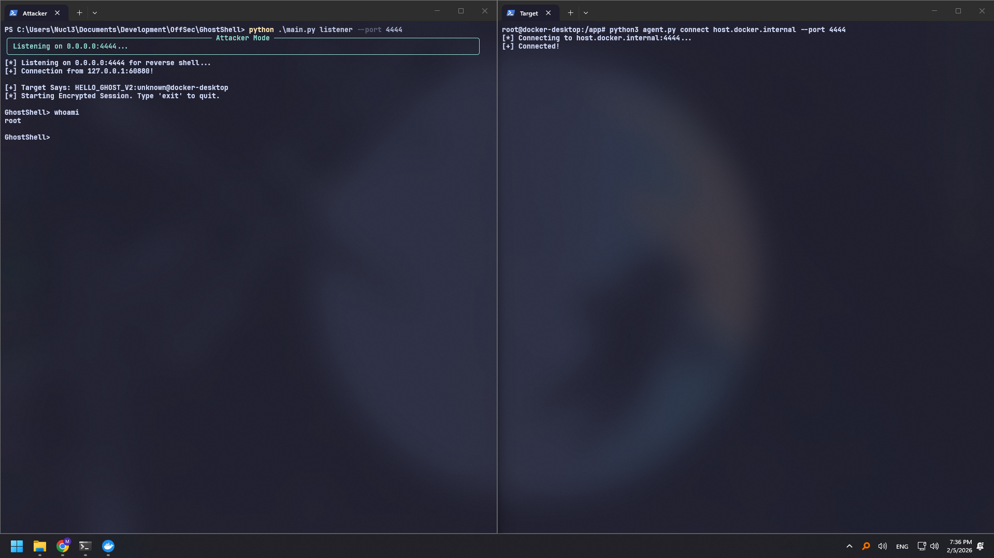
Notes:- The agent successfully connected back to the listener. - Useful for bypassing inbound firewall restrictions. - Connection remained stable during command execution.

2) Bind Shell
Description: Target listens; operator connects.

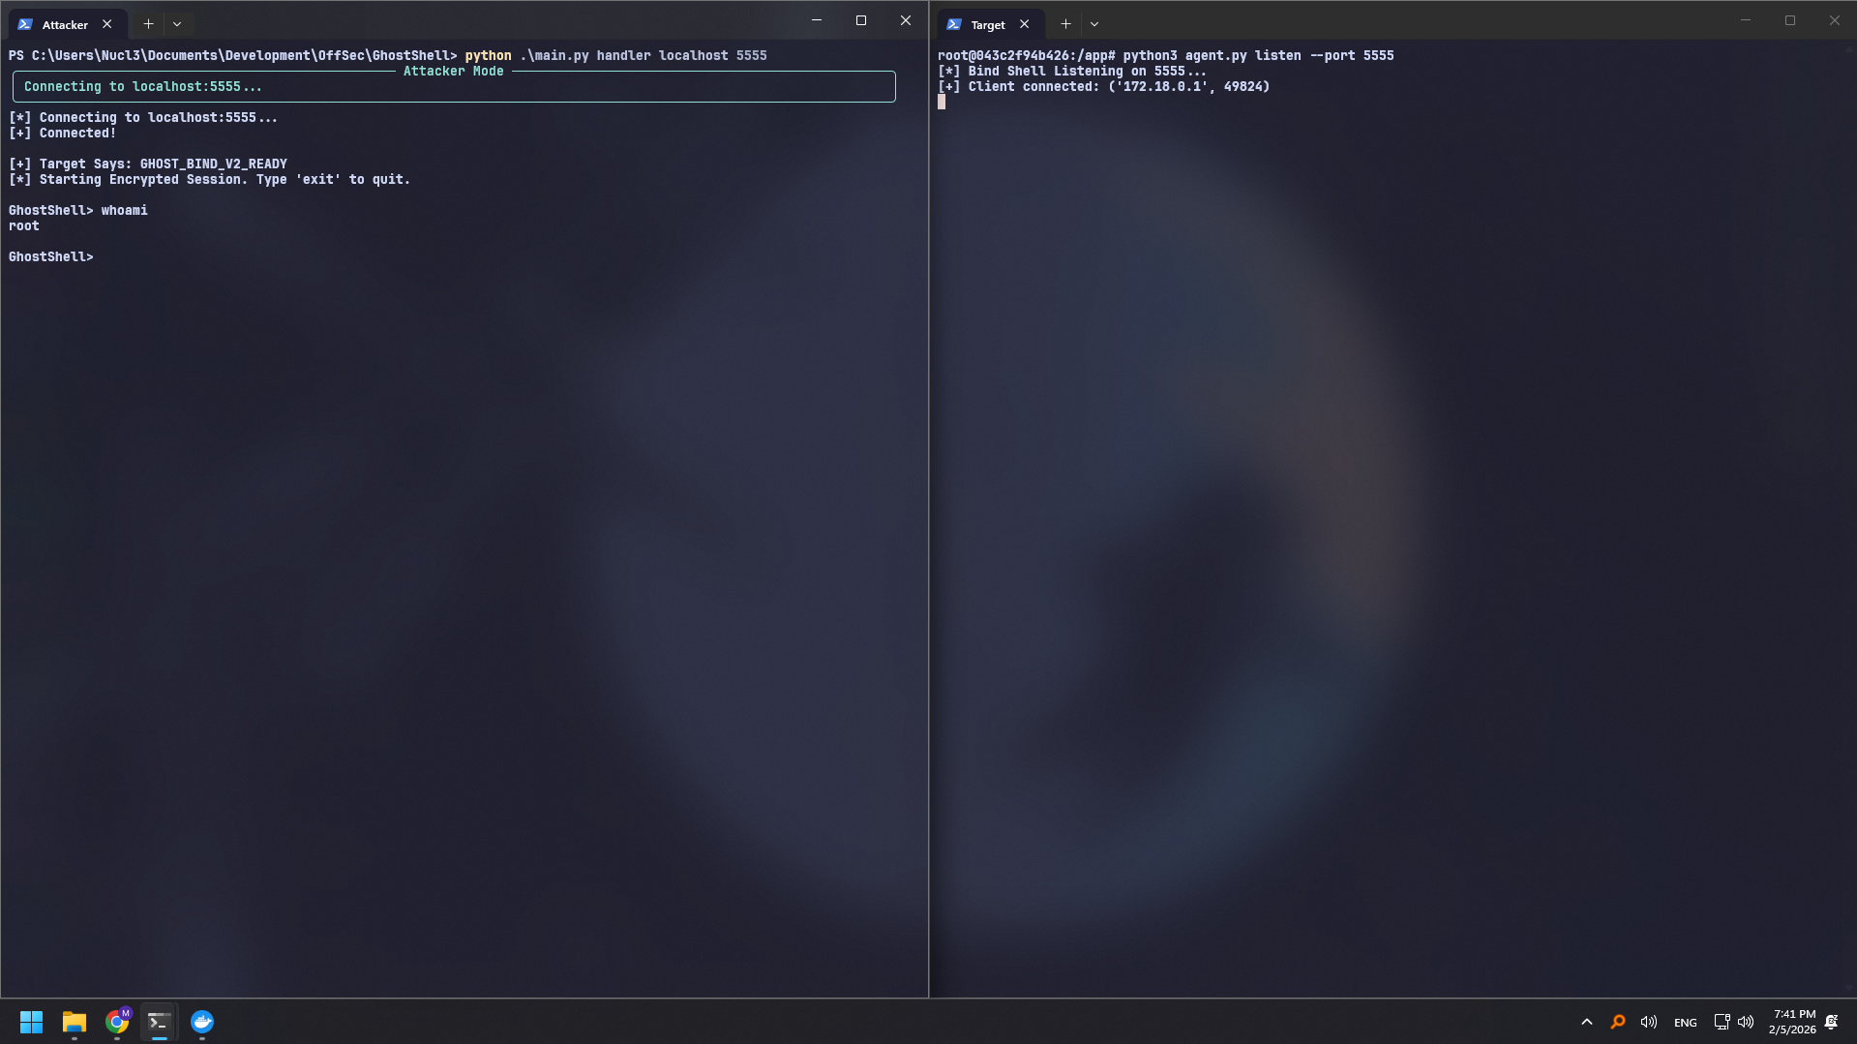
Notes:
- The agent opened the specified port on the target.
- Requires the target to have the port accessible (no firewall blocking).
- Good fallback if reverse connections are blocked.

3) Process Masquerading
Description: Agent process name is customized to blend in.
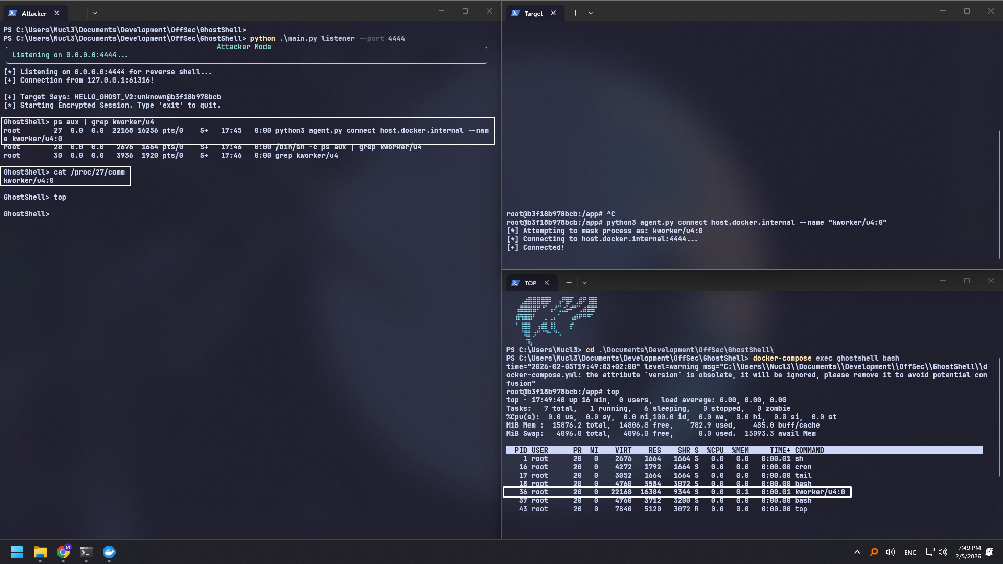
Notes:
- Process name changed to kworker/u4:0 (or custom name).
- Verified using ps aux or top.
- Hides the malicious nature of the python script in process listings.

4) Local Audit
Description: Quick checks for kernel vulnerabilities and risky SUID binaries.

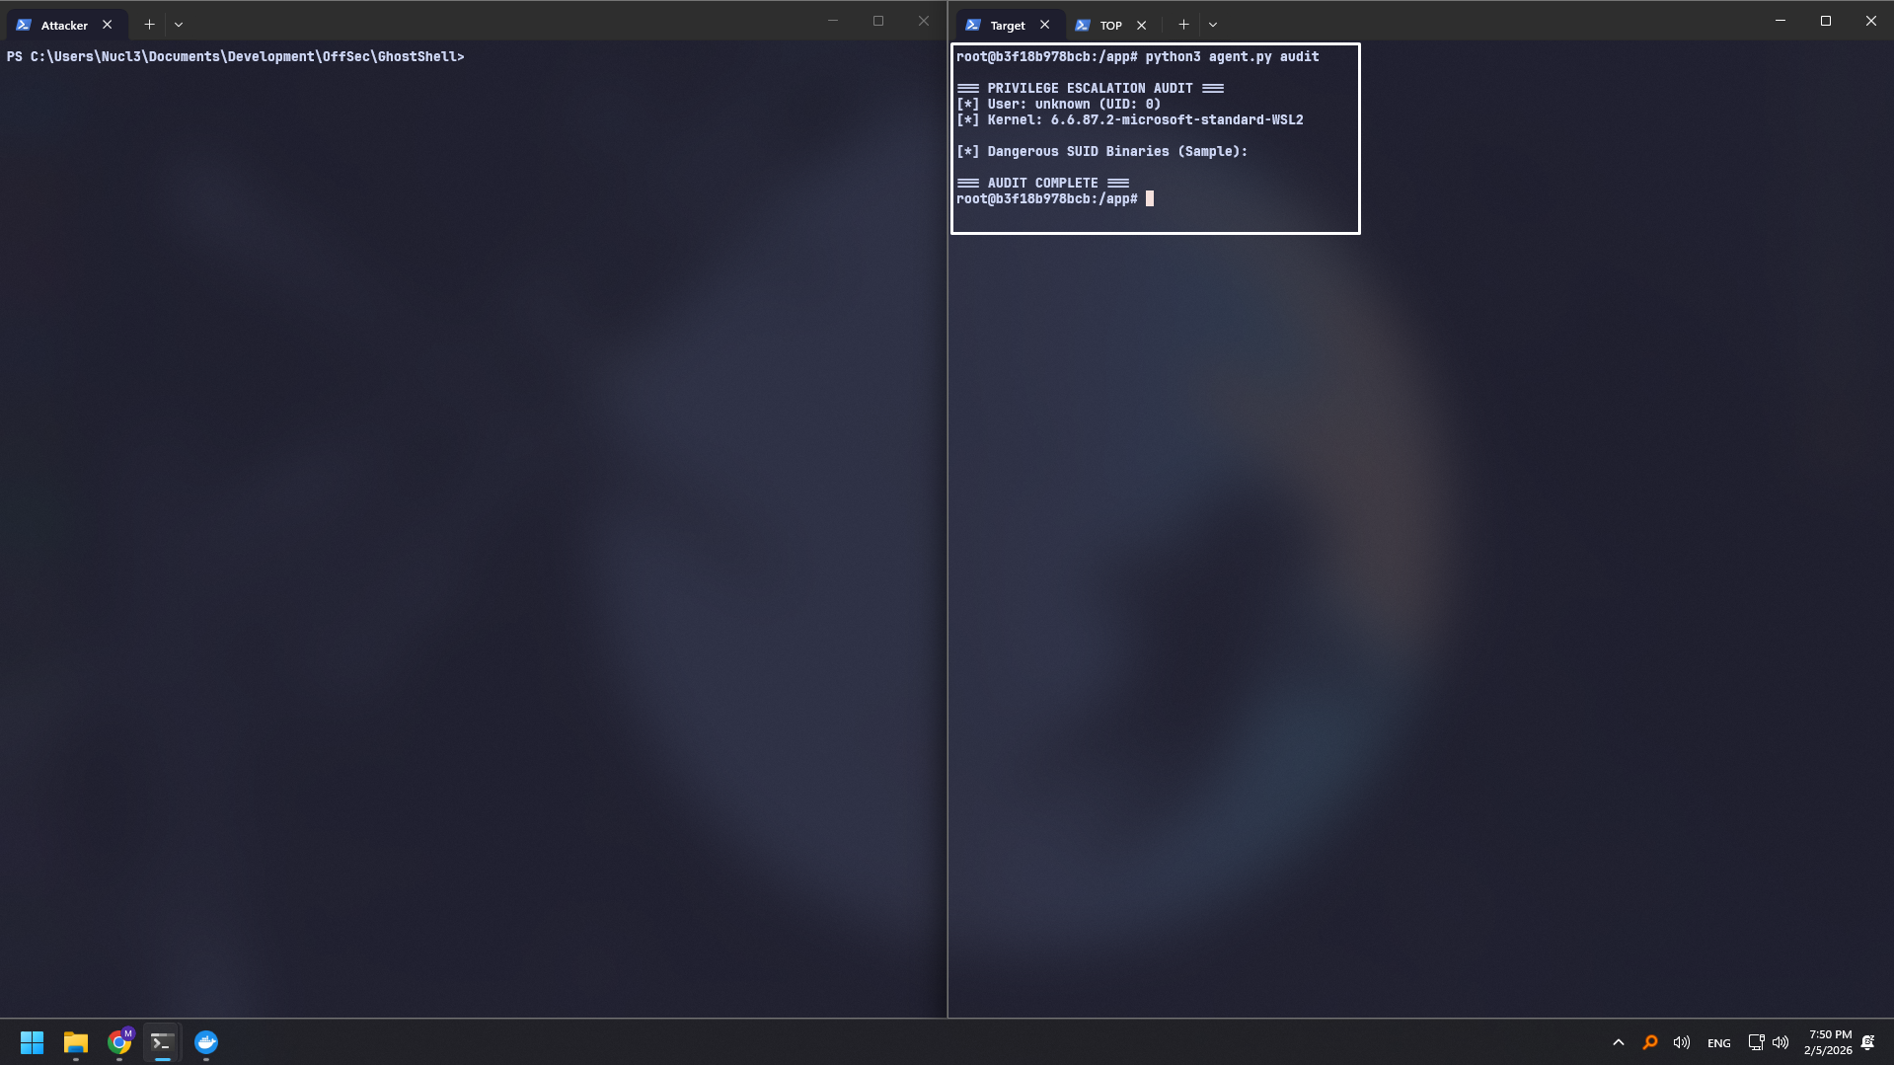
Notes:
- Identified Kernel version and potential exploits (e.g., Dirty Pipe).
- Listed binaries with SUID bit set, highlighting potential GTFOBins vectors.
- Fast and automated reconnaissance.

5) Network Sniffer
Description: Captures cleartext traffic (root required).
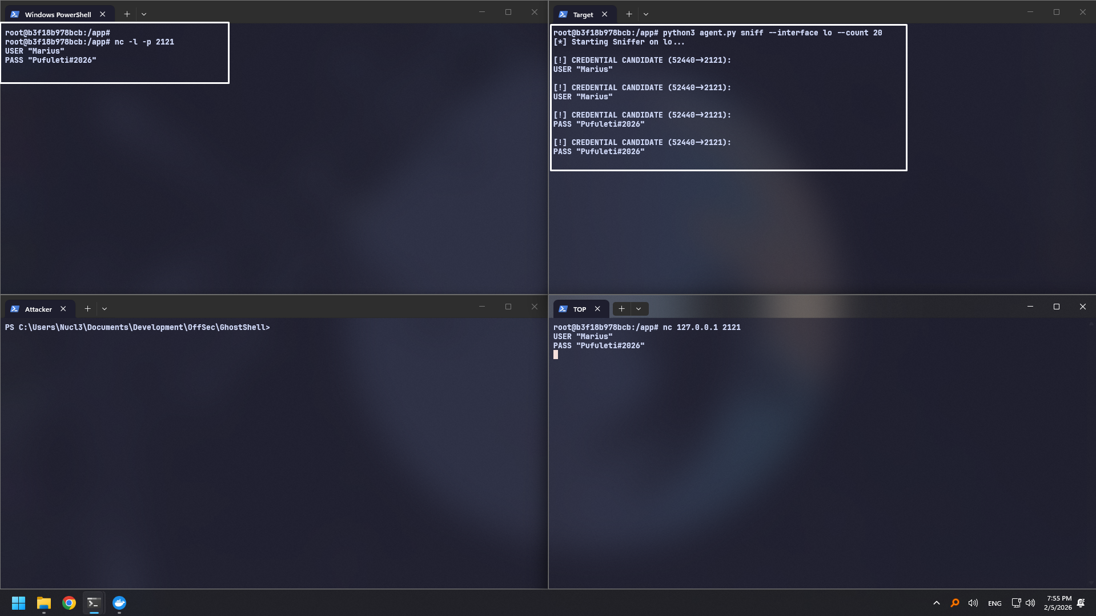
Notes:
- Captured raw packets on the specified interface.
- Successfully extracted potential credentials (simulated/real traffic).
- Requires root privileges to open raw sockets.

6) Timestomping
Description: Modifies file timestamps to match a reference.
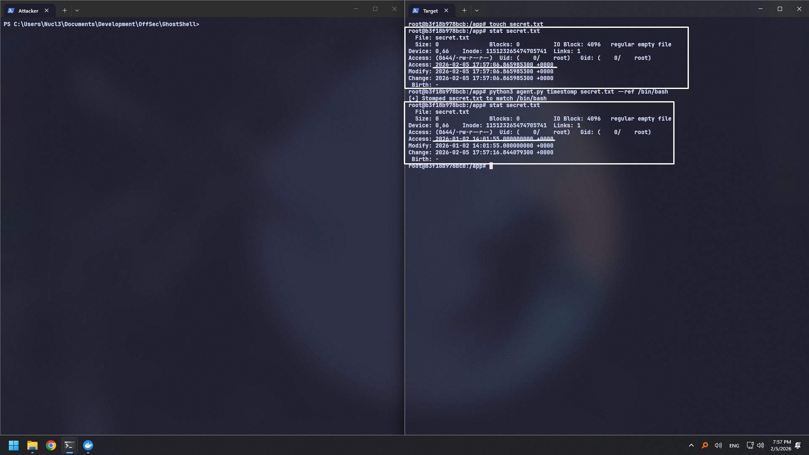
Notes:
- Modified Access and Modify times of the target file.
- Matched timestamps with /bin/bash (or reference file).
- Verified changes using stat or ls -l.

7) Persistence
Description: Agent is configured to run on system reboot.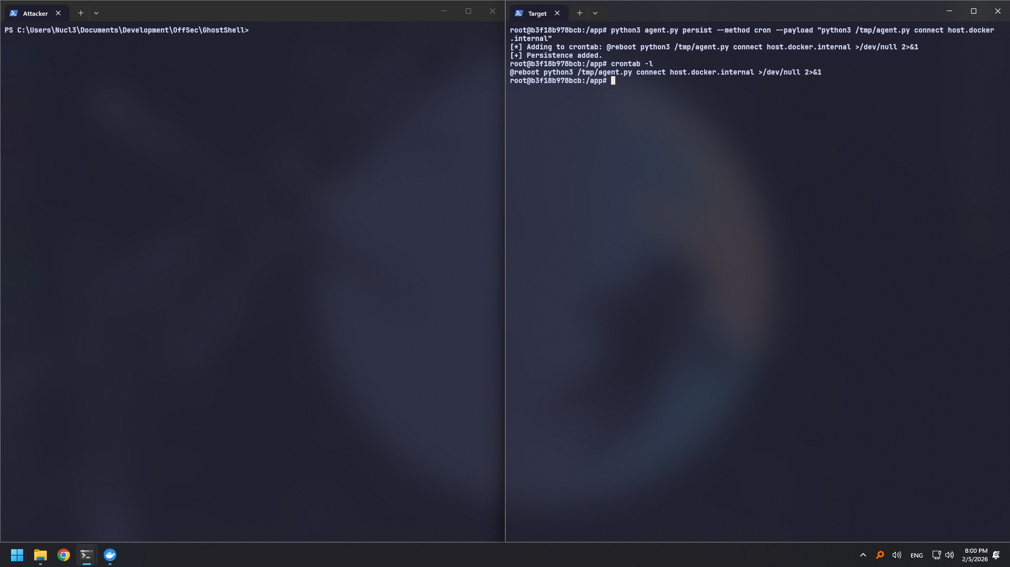
Notes:
- Created a systemd service or cron job for auto-start.
- Verified service status or crontab entry.
- Ensures the agent reconnects after a system reboot.

Security & Ethical Use
GhostShell is intended strictly for educational and authorized testing. Use only in environments where explicit permission has been granted.

Limitations
- Process Masquerading: The prctl method changes the process name visible in tools like top or /proc/pid/comm, but ps aux may still reveal the full command line arguments (e.g., python3 agent.py ...).
- Platform Dependency: The Agent is optimized for Linux (specifically for Sniffer, Masquerading, and Persistence). Windows support for these specific features is limited or non-existent in the current agent.py.
- Encryption: Communication uses a static XOR key (GHOST), which is sufficient for obfuscation but not secure against determined cryptanalysis.
- Docker Networking: On non-Linux hosts (Windows/macOS), the host network driver is restricted. Explicit port mapping (Bridge mode) is required for Bind Shells to be reachable from the host.

Future Work
- Enhanced Cryptography: Replace static XOR with Diffie-Hellman key exchange and AES encryption for secure communications.
- Windows Agent: Develop a dedicated PowerShell or Python-based agent fully compatible with Windows APIs (Service Manager, Registry Persistence).
- File Transfer: Implement commands to upload/download files between Controller and Agent.
- Dynamic Module Loading: Allow the Agent to fetch and execute Python scripts from memory without touching the disk (Reflective Loading).

