# Semester Project 1

Mariusz Rozycki

Word count

## INTRODUCTION TO REPORT OF SEMESTER PROJECT 1

As an introduction to the raport I wish to write that whole project was planned, designed and coded by myself. I started to plan whole process of how to make that assignment already in november. Of course life has werified termins, and I had to move a little bit my deadlines, but because of long time allocated on the project I could make everything as assumed.

I started with putting together a work plan. On the pictures below it’s possible to see how did I plan all upcoming work regarding semestral project 1.

Figure . Gantt_1-2_week_semestral-project_Community-Science-Museum_Mariusz-Rozycki_mar21.

According to figure 1. during two first weeks I went from familiarization with project through sketching low-fidelity wireframes and preparing typography, to creating in Adobe XD mid-fidelity wireframes. At the end of first two weeks, I tested my assumptions on people from target audience.

Figure . Gantt_3-4_week_semestral-project_Community-Science-Museum_Mariusz-Rozycki_mar21.

Figure 2 shows that during week 3 and 4 I prepared style tile, high-fidelity wireframes, prototypes and again tested my project to find fails. After correcting those fails, I gave my project to two kids in age 14 to test it again.

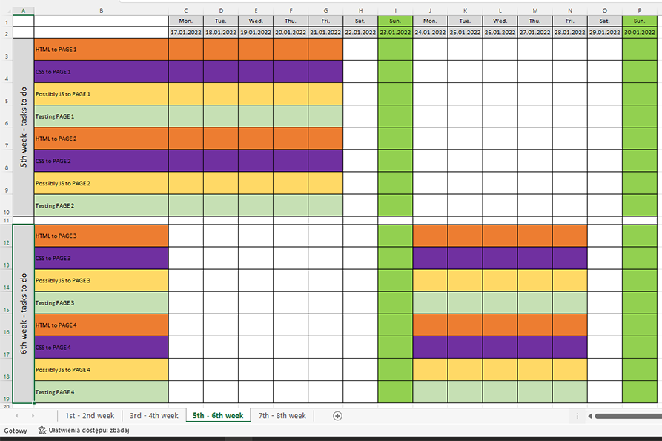

Figure . Gantt_5-6_week_semestral-project_Community-Science-Museum_Mariusz-Rozycki_mar21.

Figure 3 shows that at week 5 I started to write code of semestral project. I wrote code until week 8th. It will be possible to look at the figure 4. From week 3 – 8 I was writing HTML of each side and styling side by using CSS. If it was necessary, I add some Java Script code and was testing sides again. I will describe more about whole process in next chapters.

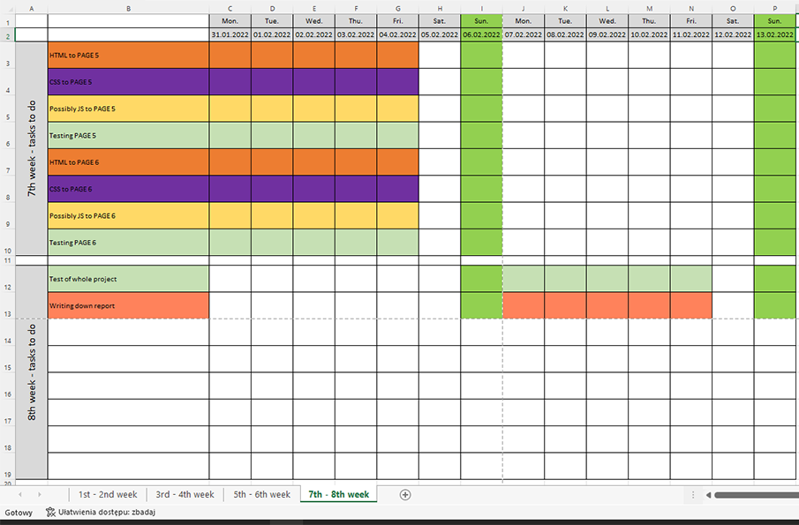

Figure . Gantt_7-8_week_semestral-project_Community-Science-Museum_Mariusz-Rozycki_mar21.

As it’s possible to notice on my Gantt Chart, week 8 at the end I started to write report.

## Design

### **What went well on the project**

About design and what went well on the project, I can write - that everything went well. I had quite much time to think about design, to look at another websides of technical and science museums.

To design my website I was supporting myself by such websites as: Centrum Nauki Kopernik in Warszawa – Poland (references 1), Teknisk Museum in Oslo (references 2), Museum of Science in Boston (references 3). After looking at those websites I could image more or less how I would like to design my semestral project. Such review helped me to choose pallete of colour and to check how, such kind of website can be designed.

Because of skils I have acquired during first semester, I could by using tools like Adobe XD and Photoshop create project as I wished.

### **What was difficult/didn’t go well on the project**

The most dificcult think for me was it to get people to test website. The target audience was quite young and kids wasn’t so willing to help me with testing of website. It was difficult to test product when it wasn’t existed. Much easier was to send coded web to different people and then ask them about opinion.

Even If designer is asking family about help with testing it difficult. As long as project “doesn’t look” it’s really wery diffiult to ask someone another about help.

### **What would you do differently next time**

## Technical

### **What went well on the project**

### **What was difficult/didn’t go well on the project**

### **What would you do differently next time**

## WCAG guidelines, content management and SEO

### **What went well on the project**

### **What was difficult/didn’t go well on the project**

### **What would you do differently next time**

## References

(place references to websites, books, forums etc. that helped you in the project)

References 1: <https://www.kopernik.org.pl/en>

References 2: <https://tekniskmuseum.no/>

References 3: <https://www.mos.org/>