

Mariusz Wieczorek

mariusz.wieczorek@kabat.pl

Streszczenie

Implementacja okna modalnego

asp.net Core

Okno modalne w Bootstrap

What is Code-First?

Entity Framework introduced the Code-First approach with Entity Framework 4.1. Code-First is mainly useful in Domain Driven Design. In the Code-First approach, you focus on the domain of your application and start creating classes for your domain entity rather than design your database first and then create the classes which match your database design. The following figure illustrates the code-first approach.

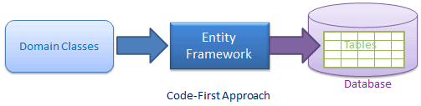

As you can see in the above figure, EF API will create the database based on your domain classes and configuration. This means you need to start coding first in C# or VB.NET and then EF will create the database from your code.

**Code-First Workflow**

The following figure illustrates the code-first development workflow.

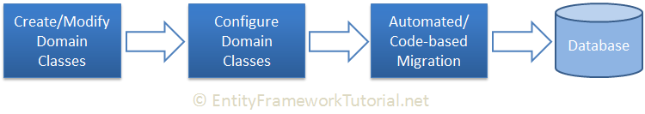

The development workflow in the code-first approach would be:  
-> Create or modify domain classes  
-> Configure these domain classes using Fluent-API or data annotation attributes  
-> Create or update the database schema using automated migration or code-based migration.

**Configure Many-to-Many Relationships in Code-First**

Here, we will learn how to configure a Many-to-Many relationship between the Student   
and Course entity classes. Student can join multiple courses and multiple students  
can join one Course .

Many-to-Many Relationship by Following Conventions

EF 6 includes default conventions for many-to-many relationships. You need to include a collection navigation property at both ends. For example, the Student class should have a collection navigation property of Course type, and the Course class should have a collection navigation property of Student type to create a many-to-many relationship between them without any configuration, as shown below:

|  |
| --- |
| public class Student  {  public Student()  {  this.Courses = new HashSet<Course>();  }  public int StudentId { get; set; }  [Required]  public string StudentName { get; set; }  public virtual ICollection<Course> Courses { get; set; }  }  public class Course  {  public Course()  {  this.Students = new HashSet<Student>();  }  public int CourseId { get; set; }  public string CourseName { get; set; }  public virtual ICollection<Student> Students { get; set; }  } |

The following is the context class that includes the Student and Course entities.

|  |
| --- |
| public class SchoolDBContext : DBContext  {  public SchoolDBContext() : base("SchoolDB-DataAnnotations")  {  }  public DbSet<Student> Students { get; set; }  public DbSet<Course> Courses { get; set; }  protected override void OnModelCreating(DbModelBuilder modelBuilder)  {  base.OnModelCreating(modelBuilder);  }  } |

EF API will create Students, Courses and also the joining table StudentCourses in the database for the above example. The StudentCourses table will include the PK (Primary Key) of both tables - Student_StudentId & Course_CourseId, as shown below.

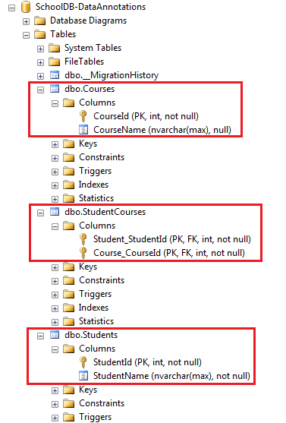

**Note:** EF automatically creates a joining table with the name of the both entities and the suffix 's'.

**Configure a Many-to-Many Relationship using Fluent API**

As you have seen above, the default conventions for many-to-many relationships creates a joining table with the default naming conventions. Use Fluent API to customize a joining table name and column names, as shown below:

|  |
| --- |
| protected override void OnModelCreating(DbModelBuilder modelBuilder)  {  modelBuilder.Entity<Student>()  .HasMany<Course>(s => s.Courses)  .WithMany(c => c.Students)  .Map(cs =>  {  cs.MapLeftKey("StudentRefId");  cs.MapRightKey("CourseRefId");  cs.ToTable("StudentCourse");  });  } |

In the above example, the HasMany() and WithMany() methods are used to configure a many-to-many relationship between the Student and Course entities. The Map() method takes Action type delegate, hence, we can pass the lambda expression to customize column names in a joining table. We can specify the PK property name of Student in MapLeftKey() (we started with the Student entity, so it will be the left table) and the PK of the Course table in MapRightKey() method. The ToTable() method specifies the name of a joining table (StudentCourse in this case).

The above code will create a joining table StudentCourse with two Primary Keys StudentRefId and CourseRefId which will also be Foreign Keys, as shown below:

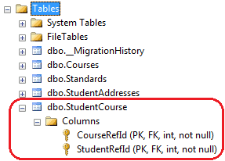

In this way, you can override the default conventions for many-to-many relationship and customize a joining table name and its columns.

|  |
| --- |
| using Microsoft.EntityFrameworkCore;  namespace EF6CodeFirstDemo  {      public class SchoolContext : DbContext      {          public SchoolContext() : base("SchoolDB-EF6CodeFirst")          {              Database.SetInitializer<SchoolContext>(new SchoolDBInitializer());          }          protected override void OnModelCreating(DbModelBuilder modelBuilder)          {              //Adds configurations for Student from separate class              modelBuilder.Configurations.Add(new StudentConfigurations());              modelBuilder.Entity<Teacher>()                  .ToTable("TeacherInfo");              modelBuilder.Entity<Teacher>()                  .MapToStoredProcedures();          }          public DbSet<Student> Students { get; set; }          public DbSet<Grade> Grades { get; set; }          public DbSet<Course> Courses { get; set; }          public DbSet<StudentAddress> StudentAddresses { get; set; }      }  } |