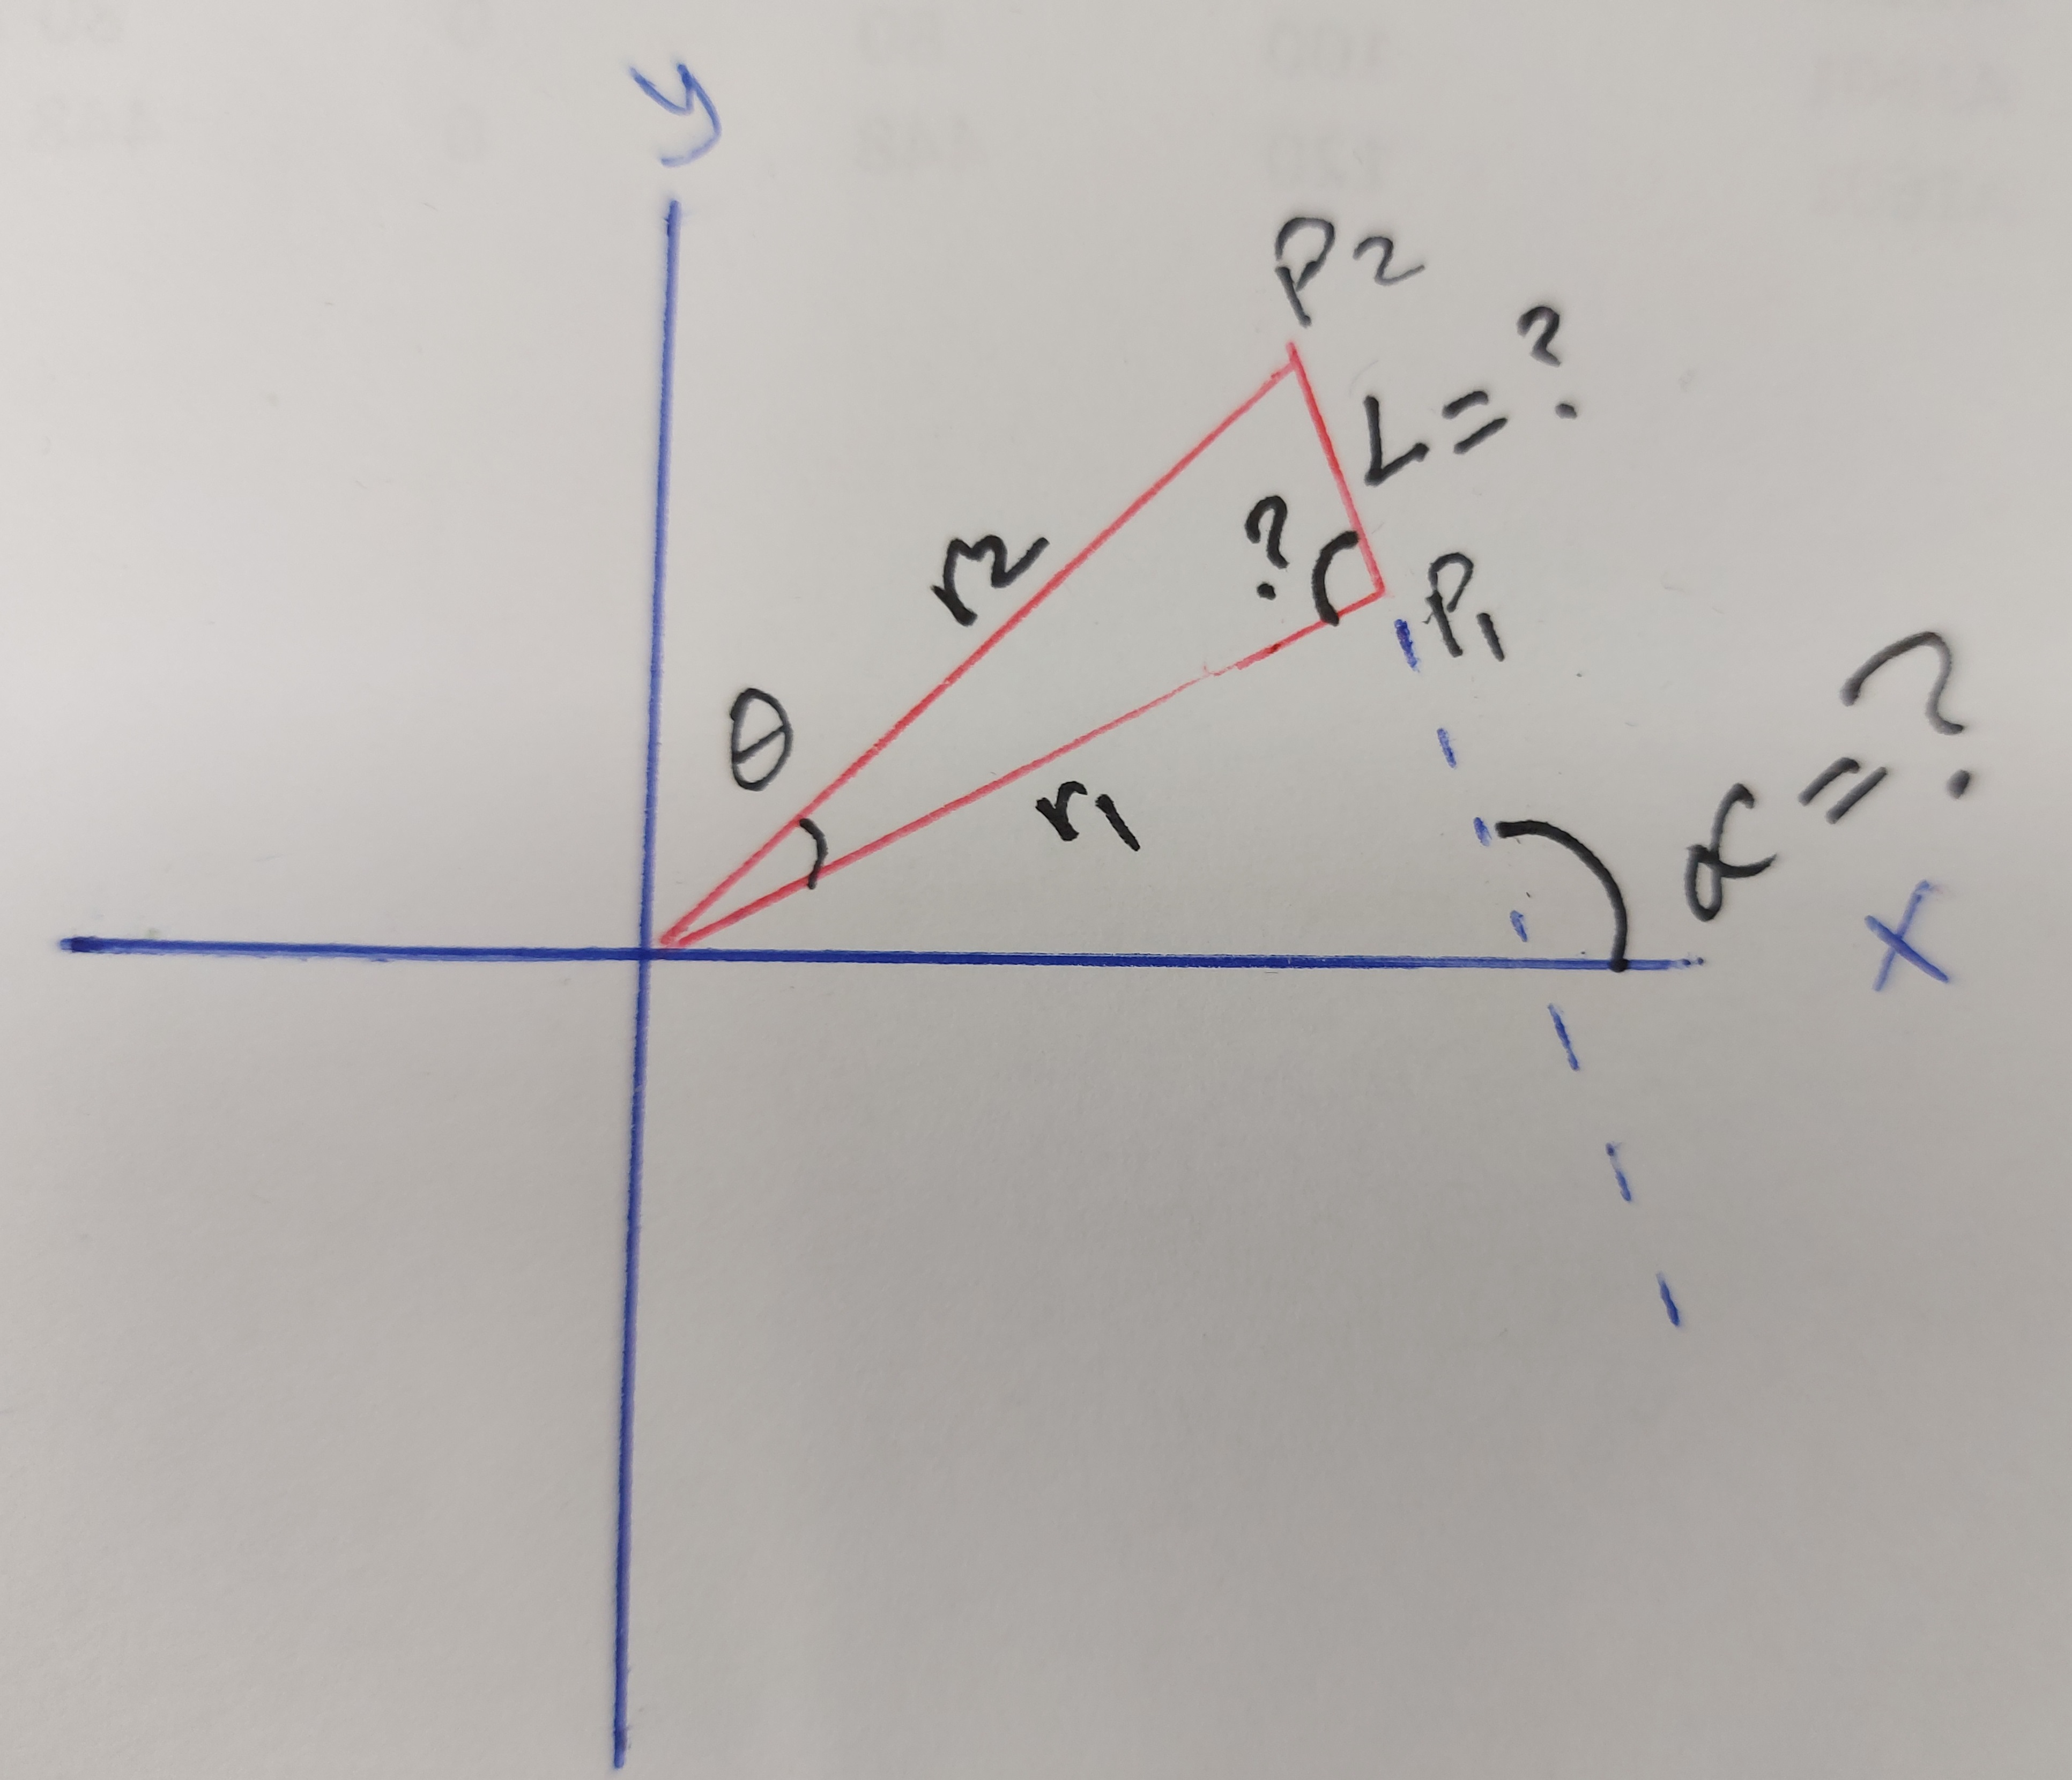

   r1=math.sqrt(math.pow(px1,2)+math.pow(py1,2)+math.pow(pz1,2))  #Enough to take p1 as a coordinate

   r2=math.sqrt(math.pow(px2,2)+math.pow(py2,2)+math.pow(pz2,2))  #Enough to take p1 as a coordinate

 if p1.x>=0 :

        thi=(math.atan(p1.y/p1.x))

    elif p1.x<0 :

        thi=(math.atan(p1.y/p1.x))+math.radians(180)

    elif p1.x==0:

        thi=0

    thiResult.append(thi)

sin (vinkel)= r2/r1 🡪 vinkel = sin-1 (r2/r1)

vinkel1 + thi + vinkel2=180

vinkel2= 180-thi – vinkel2

alpha = vinkel2

cos (thi)=L/r1 🡪 L= r1.cos(thi)