**RESUME**

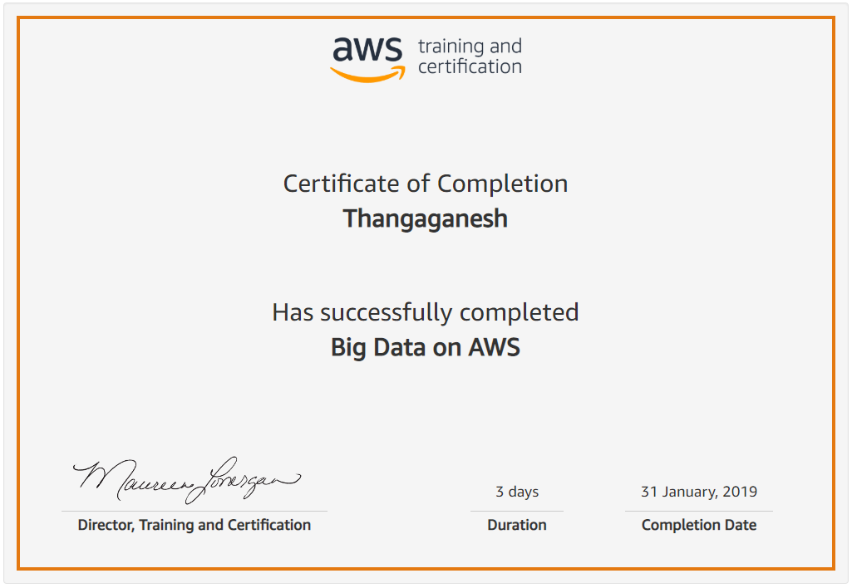

**Thangaganesh Soundarapandian**

**E-mail**: [thrustheart202020@gmail.com](mailto:thrustheart202020@gmail.com) **Mobile**: +91-9566262480.

**Objective**

Building a positive career where my skills and knowledge are utilized towards the continuous growth of individuals, company and society.

Primary tools worked on:

1. Talend Cloud Data Platform (7.2/ 7.3) – Enterprise Cloud Solution
2. Talend Data Service Platform (6.2.1) mounted in AWS cloud
3. Talend Enterprise Edition (DI, DQ, MDM) (Version 5.2)
4. Talend Open Studio (DI, DQ) (Version 5.4.1 / 5.4.2)

Experience Summary

Creation of MDM from legacy system into Snowflake. Applying DI, DQ, Data Preparation and

Stewardship using Talend and load clean data. Enabling real time integration using Talend ESB

Migration of legacy data into Strategic system. Integrating data into Data Lake, Data Warehouse

and Data Marts using Talend DI and DQ in AWS platform

Responsible in requirement gathering, breaking down into tasks and work with onsite team to

develop, test and deploy Talend jobs for a banking client. Achieved Talend Certification

Migrating data from old legacy Cobol systems into SAP. Maintaining the DWH of manufacturing

products of client. Responsible in data migration with Data quality along with ESB capability

using Talend

Lead & manage a team of 2 members, Responsible in requirement gathering, breaking-down

into tasks, work with onsite team to develop, test, deploy Talend jobs for a banking client.

Responsible in creating 360-degree view for client's customer data using Talend. Creation of

MDM with DI, DQ capabilities of Talend including Fuzzy matching, real-time integration with ESB.

Experience at Hexaware

**Data Governance – Data migration project** – As an Architect and Senior ETL Lead

Environment:

Talend Data Service Platform Talend Cloud Data Management Platform 7.3.1 (Talend cloud Cloud), Data preparation, Data Governance, Data Stewardship, Snowflake, MySQL, API

Project Role:

* To lead and manage a team of 10 members (ETL developers)
* Responsible in creation of Talend job design
* Work with Snowflake DB objects design
* To discuss with analysts and understand the scope and requirement for each target
* To create HLD and LLD from the requirement
* To estimate and assign work to ETL resources
* To manage the ETL part of project till completion
* Create and manage Talend ETL jobs which loads data into Snowflake MSSQL server
* Continuously monitor the efforts burnt
* Analyze and fix bugs arises in SIT testing
* Setting up environments for SIT, PRE-PROD and PROD
* Build and deploy the release candidates into environments
* Prepare and Maintain release notes for each release

Experience at AstraZeneca

**Finance Transformed – Data migration project** – As a Senior ETL Lead

Environment:

Talend Data Service Platform 6.2.1 - Licensed, Aurora 5.6, S3 Bucket (All in AWS cloud), Big Data, Hdfs, Hive, PIG, Spark jobs

Project Role:

* To lead and manage a team of 6 members (ETL developers)
* Responsible in creation of Talend job design
* Work with AWS Redshift DB
* To discuss with analysts and understand the scope and requirement for each target
* To create HLD and LLD from the requirement
* To estimate and assign work to ETL resources
* To manage the ETL part of project till completion
* Create and manage Talend ETL jobs which loads data into AWS Aurora and AWS Redshift
* Continuously monitor the efforts burnt
* Analyze and fix bugs arises in SIT testing
* Setting up environments for SIT, PRE-PROD and PROD
* Build and deploy the release candidates into environments
* Prepare and Maintain release notes for each release

Experience at L&T Infotech

**Citi Mutual Funds – Data migration project** – As a Technical Lead

Environment:

Talend DI 5.4.1 - Licensed, Oracle 11g, Windows 7, Big Data, Hdfs, Hive, PIG, Spark jobs

Project Role:

* To lead and manage a team of 2 members (ETL developers)
* Responsible in creation of Target architecture
* To discuss with client and understand the scope and requirement for each commission
* To create BRD and FRD
* To create HLD and LLD from the BRD and FRD created by myself
* To estimate and assign work to ETL resources
* To manage the ETL part of project till completion

Experience at Robert BOSCH

**Product MDM - migration project** – As a Technical Lead

Project Role:

* To lead and manage a team of 7 members (ETL developers)
* Responsible in creation of MDM architecture
* To review and understand the requirement specification from client.
* To review the specification from architect and create LLD for HLDs
* To segregate the LLD based on modules and assign the task to developers.
* To track the team status both technical and management vise and report the same to architect and Project management on daily basis.
* To create the process flow for project execution and ensure the adherence of team on the execution process (Both Technical and Functional).
* To work on R&D subjects on project execution like SAP interface creation, decoding the mainframe files as per requirement (including Kanji characters, double byte characters, Japanese characters, COMP-3 data types in mainframe, binary characters conversion).
* Creation of a generic plug-in to capture the log from all jobs executed and provide run control and resuming jobs from break points (Similar to AMC in Talend Enterprise edition).

Experience at Syntel

**Reconciliation migration project** – As a ETL Developer

Project Role:

* To lead and manage a team of 6 members (ETL developers)
* To review and understand the requirement specification from client for the reconciliation release.
* To create Talend ETL jobs to enrich and transform the input files as per the specification.
* To deploy the jobs into UNIX box.
* To write complex UNIX scripts which need to be executed as generic components based on the input arguments being passed to execute the Talend jobs deployed.
* To schedule the jobs in Autosys (deploying the JILs) as per the expected schedule timings.

Experience at Virtusa

**Customer Data Management –** As a ETL Developer

Project Role:

* To review and understand the data we receive from other components as flat file or positional file or delimited file and profile the same using **Talend DQ** perspective.
* To understand the Design document from CDM Designer (as per MDM architecture).
* To design and develop the ELT Jobs in **Talend DI** perspective as per the Design.
* To write the Developer test cases for job developed.
* To carry out Unit test cases and preserve the result.
* To deliver the Job to QA for testing.
* To analyze and fix issues encountered if any in the Job developed.
* To create Data Model in Talend to store Master (customer) data using **Talend MDM** perspective (Talend in-built **eXists** database).
* To maintain Talend TAC (**Talend Administration Console**) for Talend configurations and privileges.
* To maintain SVN configurations in Talend for creation of Sandbox projects.
* To maintain Talend Command line execution process for code promotion and code deployment.

Education

ACADEMIC QUALIFICATION:

* B.E Anna University Sri Ram Engineering College (2004-08) **76.00%**
* H.S.C TN State Board of Education K. C. S Hr. Sec. School (2003-04) **88%**
* S.S.L.C TN State Board of Education K. C. S Hr. Sec. School (2001-02) **90%**