**DATA SCIENCE WITH PYTHON**

**Student Name:N.HARI KISHORE REDDY**

**ID Number: N191092**

**Class:CSE-3**

**DEPARTMENT OF COMPUTER SCIENCE AND**

**ENGINEERING RGUKT-NUZ-AP**

**E2-SEMESTER-II, AY-2022-23**

**TABLE OF CONTENTS:**

|  |  |  |
| --- | --- | --- |
| **Assignment No** | **Assignment Name** | **Page Number** |
| **1** | **Python Basics** | **2-4** |
| **2** | **Python Data Structures** | **5-10** |
| **3** | **Python programming fundamentals** | **11-15** |
|  |  |  |
| **4** | **Working with data in python** | **16-20** |
| **5** | **Working Numpy Arrays** | **21-24** |
| **6** | **Importing datasets and Cleaning and preparing the** | **26-31** |
|  | **Data** |  |
| **7** | **Model Development** | **32-36** |
| **8** | **Model Evalution** | **37-39** |
| **9** | **Introduction to visualizationtools** | **40-41** |
|  |  |  |
| **10** | **Basic visualization tools** | **42-44** |
| **11** | **Specialized visualization tolls** | **45-46** |
| **12** | **Advanced Visualization tools** | **47-49** |



**LAB-01**

**AIM :** a) Python Basics: Your first program, Types Expressions and Variables String Operations

**Code:**

print("hello world")

color="green"

print(type(color))

a=3

print(a,type(a))

b=-3.5

print(b,type(b))

c=2+3j

print(type(c))

d,e,f=2,3,-4

print(f)

print(e)

print(d)

h=j=k="RAM"

print(h,j,k)

id1='How are you?'

print(id1[1:7])

x=0b11

print(type(x))

val=None

print(val)

**#python string**

id1="HARI"

print(id1[1])

#negative indexing

print(id1[-3])

#id1[3]=q

#multiline strings

string="""THIS IS THE FIRST LAB"""

print(string)

#python string operation

id2=" is the roommate of Jana"

print(id1+id2)

id3="Hari"

id4="Hari"

print(id3==id4)

id3="Hari"

id4="Hari1"

print(id3==id4)

#iterton

gr='welcome'

for letter in gr:

print(letter)

gr='welcome' for

letter in gr:

print(gr)

print(len(gr))

#membership

print("a" in gr)

print("a" not in gr)

print(gr.upper())

print(gr.lower())

print(gr.startswith("h"))

id='name' name='HARI'

print(f'my {id} is {name}')

**output:**

hello world

<class 'str'>

3 <class 'int'>

-3.5 <class 'float'>

<class 'complex'>

-4

3

2

RAM RAM RAM

ow are

<class 'int'>

None

A

A

THIS IS THE FIRST LAB

HARIis the roommate of Jana

True

False

W

E

L

C

O

M

E

welcome

welcome

welcome

welcome

welcome

welcome

welcome

7

False

True

WELCOME

Welcome

False

my name is HARI

**LAB-02**

**AIM :** Python Data Structures: Lists and Tuples Sets,and Dictionaries

**CODE:**

a=[2,'a','aba','aaa']

print(a)

num=(1,5,3)

print(num)

b={'a':3,'ba':456,'a':4}

print(b)

c={1,4,3,2,5,}

print(c)

d={2,'a','aba','aaa'}

print(d)

lan=["telugu","tamil","kannada"]

print(lan[2])

print(type(lan))

e={2,2,2,3}

print(e)

a=True

print(a)

b=False

print(b)

#list

a=[4,6,7]

print(a)

print(a[0])

print(a[-3])

print(a[0:2])

#append

a.append(2)

print(a)

#extend

b=[8,9,7]

a.extend(b)

print(a)

a[0]=0

print(a)

#del

del b[1]

print(b)

a.remove(0)

1. sort()

print(a)

a.reverse()

print(a)

1. pop(2)

print(a)

#checking print(1 in a) print(len(a))

#list comprehensionc=[]

for x in range(1,6):

c.append(x*x)

print(c)

**#tuple**

print("tuples")

a=(3,4,5)

print(a)

b="hello",

print(type(b))

c=("hello")

print(type(c))

#tuple accessing

print(a[-1])

print(a[1])

print(a[0:2])

#tuple methods

d=(6,5,7,7,7,8,4,9,0)

print(d.count(7))

print(d.index(6))

#iteration

for x in d:

print(x)

print(7 in d)

**#sets**

a={3,5,6,7,8,9,4,5,6}

b={10,20,30,40}

print("set")

print(a)

print(type(a))

a.add(10) print(a)

#min print(min(a))

#max

print(max(a))

#len

print(len(a))

#all print(all(a))

#any

print(any(a))

#enumerate

print(enumerate(a))

#sum

print(sum(a))

#sorted

print(sorted(a))

#union

print(a|b)

print(a.union(b))

#intersection

print(a&b)

print(a.intersection(b))

#symmetric difference

print(a^b)

#equal

print(a==b)

**#dictonary**

dic={1:"a",2:"b",3:"c",4:"d",5:"e"}

print(dic)

print(type(dic))

#adding

dic[6]="f"

print(dic)

#changing

dic[3]="C"

print(dic)

#accessing

print(dic[3])

#remove

del dic[6]

print(dic)

* sorted sorted(c) print(dic)

#membership

print(1 in dic) print(4

not in dic)

**output:**

[2, 'a', 'aba', 'aaa']

(1, 5, 3)

{'a': 4, 'ba': 456}

{1, 2, 3, 4, 5}

{2, 'aba', 'a', 'aaa'}

kannada

<class 'list'>

{2, 3}

True

False

[4, 6, 7]

4

4

[4, 6]

[4, 6, 7, 2]

[4, 6, 7, 2, 8, 9, 7]

[0, 6, 7, 2, 8, 9, 7]

[8, 7]

[2, 6, 7, 7, 8, 9]

[9, 8, 7, 7, 6, 2]

[9, 8, 7, 6, 2]

False

5

[1, 4, 9, 16, 25]

Tuples

(3, 4, 5)

<class 'tuple'>

<class 'str'>

5

4

(3, 4)

3

0

6

5

7

7

7

8

4

9

0

True

set

{3, 4, 5, 6, 7, 8, 9}

<class 'set'>

{3, 4, 5, 6, 7, 8, 9, 10}

3

10

8

True

True

<enumerate object at 0x000001803DC96E80>

52

[3, 4, 5, 6, 7, 8, 9, 10]

{3, 4, 5, 6, 7, 8, 9, 10, 40, 20, 30}

{3, 4, 5, 6, 7, 8, 9, 10, 40, 20, 30}

{10}

{10}

{3, 4, 5, 6, 7, 40, 8, 9, 20, 30}

False

{1: 'a', 2: 'b', 3: 'c', 4: 'd', 5: 'e'}

<class 'dict'>

{1: 'a', 2: 'b', 3: 'c', 4: 'd', 5: 'e', 6: 'f'}

{1: 'a', 2: 'b', 3: 'C', 4: 'd', 5: 'e', 6: 'f'}

C

{1: 'a', 2: 'b', 3: 'C', 4: 'd', 5: 'e'}

{1: 'a', 2: 'b', 3: 'C', 4: 'd', 5: 'e'}

True

False

**LAB- 03**

**Python Programming Fundamentals:** Conditions and BranchingLoops, Functions,Objects and Classes

**Code:**

**if-else:**

number=int(input("Enter a Number:"))

if number>10:

print('Number is greater than 10')

else:

print('Number is less than 10')

**Output:**

Enter a number:11

Number is greater than 10

**If-elif-else:**

num=int(input('Enter a Number:'))

if num>0:

print('Positive Number')

elif num<0:

print('Negative Number')

else:

print('Positive Number')

print('This statement is always executed')

**Output:**

Enter a number:10

Positive Number

**nested-if:**

num=int(input('Enter a Number:'))

if(num>=0):

if num==0:

print('Number is 0')

else:

print('Number is positive')

else:

print('Number is Negative')

**output:**

Enter a Number:15

Number is positive

**short-hand-if:**

a=10;

b=20;

if a<b: print('This is if')

**Output:**

This is if

**shorthand-if-else:**

a=30;

b=20;

print('This is if') if a<b else print('this is else')'''

**Output:**

This is else

**for-loop:**

lang=['swift','c','python','c++']

for x in lang:

print(x)

**range function:**

a=range(6)

for x in a:

print(x)

a=range(1,6)

for x in a:

print(x)

a=range(2,22,2)

for x in a:

print(x)

for i in range(1,1001):

for j in range (1,11):

print(i*j,end=" ")

print()

**for loops with else:**

digits=[0,1,2]

for i in digits:

print(i)

else:

print("No items left.")

**while loop:**

i=1

n=5

while i<=n:

print(i)

i=i+1

**Python oops Concept**

**python inheritence:**

class Animal:

def speak(self):

print("Animal Speaking")

class Dog(Animal):

def bark(self):

print("dog barking")

class DogChild(Dog):

def eat(self):

print("Eating bread...")

d=DogChild()

d.speak()

d.bark()

d.eat()

**Output:**

Dog Barking

Animal Speaking

Eating Bread

**Method overriding:**

'class Animal:

def speak(self):

print("Speaking")

class Dog(Animal):

def speak(self):

print("Not Speaking")

class Cat(Dog):

def speak(self):

print("Is this a cat")

d=Cat()

d.speak()

**Output:**

Speaking Not

SpeakingIs this

a cat

**Data Abstraction:**

|  |  |  |  |  |  |  |  |  |  |  |
| --- | --- | --- | --- | --- | --- | --- | --- | --- | --- | --- |
| class Employee: | | | | | | |  |  |  |  |
|  |  |  | count=0; | | | |  |  |  |  |
|  | def |  |  | init | | |  | (self): |  |  |
|  | Employee. | | | |  | | count=Employee. | |  | count+1 |

def display(self):

print("The number of Employees",Employee. count)



emp=Employee()

try:

print(emp. count)



finally:

emp.display()

**Output:**

Number of Employees:3

**Abstract Method:**

from abc import ABC, abstractmethod

class Car(ABC):

def mileage(self):

pass

class Tesla(Car):

def mileage(self):

print("The mileage is 30kmph")

class Suzuki(Car):

def mileage(self):

print("The mileage is 25kmph ")class

Duster(Car):

def mileage(self):

print("The mileage is 24kmph ")

class Renault(Car): def

mileage(self):

print("The mileage is 27kmph ")

* Driver codet= Tesla () t.mileage()

r = Renault()

r.mileage()

s = Suzuki()

s.mileage()

d = Duster()

d.mileage()

**Output**

The mileage is 30kmph

The mileage is 25kmph

The mileage is 24kmph

The mileage is 27kmph

**LAB-04**

**AIM:** Working with Data in Python: Reading files with open, Writing files with open,Loading data with Pandas, Working with and Saving data with Pandas

**CODE:**

import pandas as pd import

numpy as np

print(pd. version )



b=[1,2,3,4]

c=pd.Series(b)

print©

b=['s','d']

c=pd.Series(b[-1])

print(c)

d=np.array(['a','b','c','d'])

s=pd.Series(d)

r=pd.DataFrame(d)

print(s)

print(r)

print(len(s))

s=pd.Series(d,index=[101,103,103,104])

j=pd.Series(d,index=["x","y","z","w"])

print(s)

print(j)

dataset={'icecreams':['vanila','strawberry','badam','pista'], 'rating':[4.5,3.8,4.2,4.6]

}

ds=pd.DataFrame(dataset)print(ds)

ds=pd.Series(dataset)print(ds)

**Output:**

2.0.1

1. 1
2. 2
3. 3
4. 4

dtype: int64

1. d

dtype: object

1. a
2. b
3. c
4. d

dtype: object0

1. a
2. b
3. c
4. d

101 a

103 b

1. c
2. d

dtype: object

* 1. a
  2. b
  3. c

|  |  |  |
| --- | --- | --- |
| w | d |  |
| dtype: object | |  |
| icecreams rating | | |
| 0 | vanila | 4.5 |
| 1 | strawberry | 3.8 |
| 2 | badam | 4.2 |
| 3 | pista | 4.6 |

icecreams [vanila, strawberry, badam, pista]

rating [4.5, 3.8, 4.2, 4.6]

dtype: object

**Attribute of series**

import pandas as pdimport

numpy as np

ds=np.array(['a','b','c','d'])

d=pd.Series(ds)

print(d)

d=pd.Series(ds ,index=[101,102,103,"e"])

print(d)

print(d[103])

ds1={'d1':100,'d2':200,'d3':300}

d=pd.Series(ds1)

print(d)

j=pd.Series(ds1,index=['d1','d2'])

print(j)

print(j.name)

print(j.values)

print(j.size)

print(d.shape)

print(d.ndim)

print(d.nbytes)

print(d.memory_usage)

print(j.empty)

j.name='raj'

print(j.name)

**output:**

1. a
2. b
3. c
4. d dtype: object
5. a
6. b
7. c

e d dtype: objectc

d1100

d2200

d3 300 dtype: int64

d1100

d2 200 dtype: int64 None

[100 200]

2

(3,)

1

24

<bound method Series.memory_usage of

d1100

d2200

d3 300

dtype: int64>

False

raj

**Multiplication of series :**

import pandas as pd

import numpy as np

ds1=np.array([1,1,2,3,4])

d1=pd.Series(ds1)

ds2=np.array([2,2,3,4,5])

d2=pd.Series(ds2)

a=d1.add(d2)

print(a)

b=d1.sub(d2)

print(b)

c=d1.mul(d2)

print(c)

d=d1.multiply(4)

print(d)

e=d1.div(d2)

print(e)

f=d2.mod(d1)

print(f)

g=d2.pow(3)

print(g)

h=d2.le(d1)

print(h)

i=d2.gt(d1)

print(i)

j=d2.equals(d1)

print(j)

**output:**

1. 3
2. 3
3. 5
4. 7
5. 9

dtype: int32

1. -1
2. -1
3. -1
4. -1
5. -1 dtype: int32
6. 2
7. 2
8. 6
9. 12
10. 20

dtype: int32

1. 4
2. 4
3. 8
4. 12
5. 16

dtype: int32

1. 0.500000
2. 0.500000
3. 0.666667
4. 0.750000
5. 0.800000 dtype: float64
6. 0
7. 0
8. 1
9. 1
10. 1

dtype: int32

1. 8
2. 8
3. 27
4. 64
5. 125

dtype: int32 0 False 1 False 2 False 3 False 4 False

dtype: bool

0 True

1. True
2. True
3. True

4True dtype: bool False

**LAB-05**

**Aim:** Working with Numpy Arrays: Numpy 1d Arrays, Numpy 2d Arrays **Code:**

import numpy as np

from numpy import random

a=np.array([1,2,3,4])

print(a)

b=np.array([[1,2,3,4,5],[6,7,8,9,0]])

print(b)

c=np.array([[[1,2,3],[4,5,6],[7,0,9]]])

print(c)

d=np.array(32)

print(d)

print(a.ndim)

print(b.ndim)

print(c.ndim)

print(d.ndim)

e=np.array([1,2,3,4] ,ndmin=5)

print(e)

f=np.array([5,6],ndmin=3)

print(f)

print(f.ndim)

print(b[1,2])

#slicing

print(a[0:2])

print(a[2:])

print(a[:3])

print(a[-4:-2])

print(a[1:4:2])

print(a[1:4:3])

print(a[::1])

print(b[1,0:3:2])

g=np.array([1,2,3,4],dtype='S')

print(g)

print(b[1,0::3])

print(type(g))

print(g.dtype)

i=np.array([1.1,2.2,3.3,4.4])

print(i) j=i.astype('i')

print(j) print(i)

a=([1,3,4],[5,6,7])

b=np.asarray(a,order='f')

print(b)

for i in np.nditer(b):

print(i)

a=np.zeros((5,2 ),dtype=int)

print(a)

b=np.full([2,3],56 ,dtype=float)

print(b)

c=np.ones(([4,2]),dtype=int)

print(c)

x=random.randint(10000)

print(x)

for i in range(1,5):

x=random.randint(10)

print(x)

d=np.eye(5,3 ,dtype=int, k=-1)

print(d)

a=np.eye(3,3, dtype=int)

print(a)

b=np.asarray(a,order='f')

for i in np.nditer(b):

print(i)

#captcha

x=random.randint(10000)

print(x)

c=int(input('enter the capctha'))

while(c!=x):

print("invalid captcha")

c=int(input('enter'))

print("valid")

c=random.rand(3,2)

print(c)

d=random.ranf([3,2])

print(d)

**output:**

[1234]

[[12345]

[67890]]

[[[1 2 3]

[456]

[7 0 9]]]

32

1

2

3

0

[[[[[1 2 3 4]]]]]

[[[5 6]]]

3

8

[1 2]

[3 4]

[123]

[1 2]

[2 4]

[2]

[1234]

[6 8]

[b'1' b'2' b'3' b'4']

[6 9]

<class 'numpy.ndarray'>

|S1

[1.1 2.2 3.3 4.4]

[1234]

[1.1 2.2 3.3 4.4]

[[1 3 4]

[5 6 7]]

1

5

3

6

4

7

[[0 0]

[0 0]

[0 0]

[0 0]

[0 0]]

[[56. 56. 56.]

[56. 56. 56.]]

[[1 1]

[1 1]

[1 1]

[1 1]]

5425

7

2

4

3

[[0 0 0]

[100]

[010]

[001]

[0 0 0]]

[[1 0 0]

[010]

[0 0 1]]

1

0

0

0

1

0

0

0

1

7479

enter the capctha7479

valid

[[0.14702871 0.94097438]

[0.80805663 0.52615084]

[0.45495018 0.4452953 ]]

[[0.99567496 0.61726301]

[0.44050543 0.35901677]

[0.69665999 0.3356309 ]]

**LAB-06**

**Aim:** Importing Datasets: Learning Objectives, Understanding the Domain, Understandingthe Dataset, Python package for data science, Importing and Exporting Data in Python, BasicInsights from DatasetsCleaning and Preparing the Data: Identify and Handle Missing Values, DataFormatting, Data Normalization Sets, Binning, Indicator variables

**Code:**

import pandas as pd

import numpy as np

technologies =

{ 'Courses':["Spark","PySpark","Hadoop","Python"], 'Fee' :[20000,25000,26000,22000], 'Duration':['30day','40days',np.nan, None], 'Discount':[1000,2300,1500,1200]

}

indexes=['r1','r2','r3','r4']

df = pd.DataFrame(technologies,index=indexes)print(df)

# Drop rows by Index Label

df = pd.DataFrame(technologies,index=indexes)df1 = df.drop(['r1','r2'])

print('\n\n',df1)

# Delete Rows by Index numbers

df = pd.DataFrame(technologies,index=indexes)

df1=df.drop(df.index[[1,3]])

df.drop(df.index[-1],inplace=True)

for col in df.columns:if

'Fee' in col:

del df[col]

print('\n\n',df)

import pandas as pd

import numpy as np

technologies = {

'Courses':["Spark","PySpark","Hadoop","Python","pandas",np.nan], 'Fee' :[20000,25000,26000,23093,24000,np.nan], 'Duration':['30day','40days','35days','45days',np.nan,np.nan], 'Discount':[1000,np.nan,1200,2500,pd.NaT,np.nan], 'one':[np.nan,np.nan,np.nan,np.nan,np.nan,np.nan]

}

index_labels=['r1','r2','r3','r4','r5','re']

df = pd.DataFrame(technologies,index=index_labels)print(df)

df.columns.values[-1]='one'

print(df) print(df.dropna(),'\n\n')

print(df.dropna(axis=1),'\n\n')

print(df.dropna(how='all'),'\n\n') print(df.dropna(how='all',axis=1),'\n\n')

print(df.dropna(thresh=1))

print(df.dropna(thresh=2,axis=1))

* Drop rows that has NaN values on selected columns df2=df.dropna(subset=['Courses','Duration']) print('\n\n',df2)

|  |  |  |  |  |
| --- | --- | --- | --- | --- |
| **output:** | |  |  |  |
|  | Courses | Fee Duration Discount | | |
| r1 | Spark 20000 | | 30day | 1000 |
| r2 | PySpark | 25000 | 40days | 2300 |
| r3 | Hadoop 26000 | | NaN | 1500 |
| r4 | Python 22000 | | None | 1200 |
|  | Courses | Fee Duration Discountr3 | | |
| Hadoop 26000 | | | NaN | 1500 |
| r4 Python 22000 | | | None | 1200 |



|  |  |  |  |
| --- | --- | --- | --- |
|  | Courses Duration | | Discount |
| r1 | Spark | 30day | 1000 |
| r2 | PySpark | 40days | 2300 |
| r3 | Hadoop | NaN | 1500 |

Empty DataFrame

Columns: [] Index:

[r1, r2, r3]

Empty DataFrame

Columns: [] Index:

[r1, r2, r3]

|  |  |  |  |  |  |  |
| --- | --- | --- | --- | --- | --- | --- |
|  | Courses | Fee Duration | | | Discount one r1 | |
|  | Spark 20000.0 | |  | 30day | | 1000 NaN r2 |
| PySpark 25000.0 | | |  | 40days | | NaN NaNr3 |
|  | Hadoop 26000.0 | | | 35days | | 1200 NaN |
| r4 | Python | 23093.0 |  | 45days | | 2500 NaN r5 |
| pandas 24000.0 | | | NaN | | NaT | NaN re NaN |
| NaN NaN NaN NaN | | | |  |  |  |
|  | Courses | Fee Duration Discount oner1 | | | | |
|  | Spark 20000.0 | |  | 30day | | 1000 NaN |
| r2 | PySpark 25000.0 | | | 40days | | NaN NaN |
| r3 | Hadoop 26000.0 | | | 35days | | 1200 NaN |
| r4 | Python 23093.0 | |  | 45days | | 2500 NaN |
| r5 | pandas 24000.0 | |  | NaN | | NaT NaN |
|  | Courses | Fee Duration Discount one r1 | | | | |
|  | Spark 20000.0 | |  | 30day | | 1000 NaN r2 |
| PySpark 25000.0 | | |  | 40days | | NaN NaNr3 |
|  | Hadoop 26000.0 | | | 35days | | 1200 NaN |
| r4 | Python 23093.0 | |  | 45days | | 2500 NaN |

**LAB-07**

**AIM: Model Development (Simple and Multiple Linear Regression, Model evaluation esing Visualization, Polynomial Regression and Pipelines, R-squared and MSE for In-Sample Evaluation, Prediction and Decision Making)**

**Code: Linear Regression**

import pandas as pd

df=pd.read_csv("data.csv")

df.head()

data_=df.loc[:,['Weight','CO2']]

print(data_.head(10))

#showing the data in matplotlib

#to use we need to first install matplotlib

import matplotlib.pyplot as plt

df.plot(x='Weight',y='CO2',style='o')

plt.xlabel('Weight')

plt.ylabel('CO2')

plt.show()

#dividing the variables into dependent and independent

X=pd.DataFrame(df['Weight'])

y=pd.DataFrame(df['CO2'])

#Split the data into train and test sets

from sklearn.model_selection import train_test_split

X_train,X_test,y_train,y_test=train_test_split(X,y,test_size=0.2,random_state=1)

#knowing the shapes of the test and train

print(X_train.shape)

print(X_test.shape)

print(y_train.shape)

print(y_test.shape)

#train the algorithm

from sklearn.linear_model import LinearRegression

regressor=LinearRegression()

regressor.fit(X_train,y_train)

#retriving the intercept

print(regressor.intercept_)

#retriving the slope

print(regressor.coef_)

#predecting the test results

y_pred = regressor.predict(X_test)

y_test

print(y_pred)

print(y_test)

#evaluting the algorithm

from sklearn import metrics

import numpy as np

print('Mean Absolute Error:',metrics.mean_absolute_error(y_test,y_pred))

print('Mean Squared Error:',metrics.mean_squared_error(y_test,y_pred))

print('Root Mean Squared Error:',np.sqrt(metrics.mean_squared_error(y_test,y_pred)))

#plot for the train set

plt.scatter(X_train, y_train, color='red') # plotting the observation line

plt.plot(X_train, regressor.predict(X_train), color='blue') # plotting the regression line

plt.title("Weight vs CO2 (Training set)") # stating the title of the graph

plt.xlabel("Weight") # adding the name of x-axis

plt.ylabel("CO2") # adding the name of y-axis

plt.show() # specifies end of graph

#plot for the test set

plt.scatter(X_test, y_test, color='red')

plt.plot(X_train, regressor.predict(X_train), color='blue') # plotting the regression line plt.title("Weight vs CO2 (Testing set)")

plt.xlabel("Weight")

plt.ylabel("CO2")

plt.show()

#importing pandas

import pandas as pd

#importing data set

df=pd.read_csv("data.csv")

#making list of independent variales as x and dependent variable as y

X = df[['Weight', 'Volume']]

y = df['CO2']

#to import this sklearn pip install -U scikit-learn

from sklearn import linear_model

regr = linear_model.LinearRegression()

regr.fit(X, y)

predictedCO2 = regr.predict([[2300, 1300]])

print(predictedCO2)

print(regr.coef_)

predictedCO2 = regr.predict([[3300, 1300]])

print(predictedCO2)

import numpy as np

import matplotlib.pyplot as plt

import pandas as pd

df=pd.read_csv('data.csv')

x=df['Weight']

y=df['CO2']

mymodel=np.poly1d(np.polyfit(x, y, 3))

myline=np.linspace(1,30,100)

plt.scatter(x,y)

plt.plot(myline,mymodel(myline))

plt.show()

import numpy as np

import matplotlib.pyplot as plt

from sklearn.datasets import load_diabetes

from sklearn.linear_model import Ridge

from sklearn.model_selection import train_test_split

from sklearn.metrics import mean_squared_error

* Load the dataset diabetes = load_diabetes()
* Separate the features and target variable X = diabetes.data

y = diabetes.target

* Split the dataset into training and testing sets

X_train, X_test, y_train, y_test = train_test_split(X, y, test_size=0.2, random_state=42)

# Initialize and fit the Ridge regression model

ridge = Ridge(alpha=1.0) # You can adjust the regularization strength with the 'alpha' parameter ridge.fit(X_train, y_train)

# Predict on the test set

y_pred = ridge.predict(X_test)

* Calculate coefficients and intercept coefficients = ridge.coef_ intercept = ridge.intercept_
* Print the coefficients and intercept print("Coefficients:", coefficients) print("Intercept:", intercept)

# Calculate mean squared error

mse = mean_squared_error(y_test, y_pred)

print("Mean Squared Error:", mse)

* Plot the predicted values against the true values plt.scatter(y_test, y_pred)

plt.plot([y.min(), y.max()], [y.min(), y.max()], 'k--', lw=2) plt.xlabel('True Values')

plt.ylabel('Predicted Values')

plt.title('Ridge Regression - True vs Predicted') plt.show()

**Output:**

Weight CO2

1. 790 99
2. 1160 95
3. 929 95
4. 865 90
5. 1140 105
6. 929 105
7. 1109 90
8. 1365 92
9. 1112 98
10. 1150 99

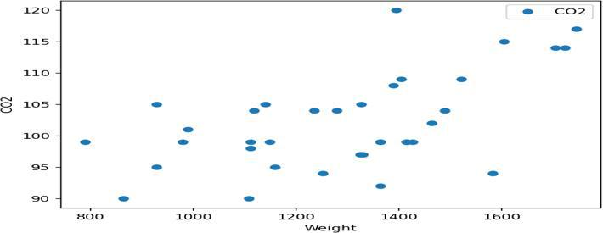

(28, 1)

(8, 1)

(28, 1)

(8, 1)

[83.33027919]

[[0.01428958]]

[[106.26505488]

[103.40713891]

[105.09330933]

[ 95.69076578]

[102.30684126]

[101.62094142]

[103.73579924]

[103.5500347 ]]

CO2

1. 115
2. 109
3. 109
4. 90
5. 105
6. 104
7. 99
8. 99

Mean Absolute Error: 4.785414241420883

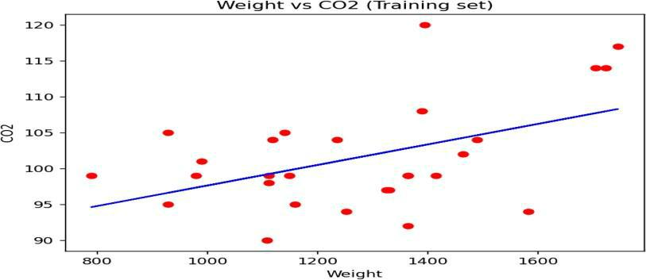

Mean Squared Error: 26.40875532851579

Root Mean Squared Error: 5.138944962588702

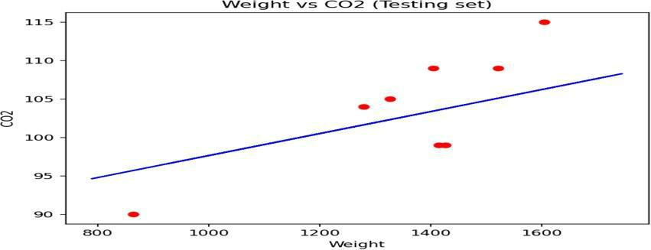

[107.2087328]

[0.00755095 0.00780526]

[114.75968007]

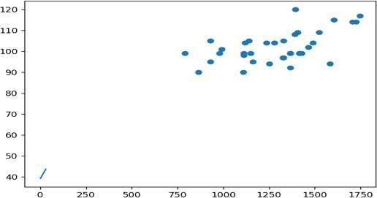

Coefficients: [ 45.36737726 -76.66608563 291.33883165 198.99581745 -0.53030959

-28.57704987 -144.51190505 119.26006559 230.22160832 112.14983004]

Intercept: 152.241675211113

Mean Squared Error: 3077.41593882723

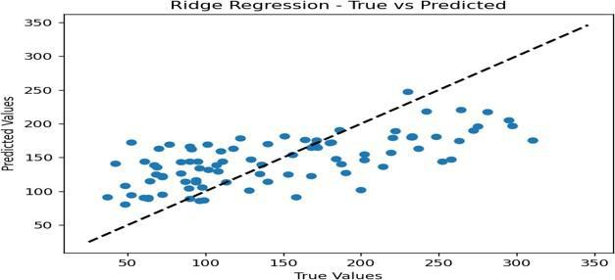

**LAB-08**

**AIM: Model Evaluation**

**(Over-fitting, Under-fitting and Model Selection, Ridge Regression, Grid Search, Model Refinement)**

**Code:**

import numpy as np

import matplotlib.pyplot as plt

from sklearn.model_selection import train_test_split

from sklearn.linear_model import LinearRegression

from sklearn.metrics import mean_squared_error

* Generate some sample data np.random.seed(42)

X = np.random.rand(100, 1) * 10

y = 2 * X + np.random.randn(100, 1)

* Split the data into training and validation sets

X_train, X_val, y_train, y_val = train_test_split(X, y, test_size=0.2, random_state=42)

* Fit a linear regression model on the training data model = LinearRegression() model.fit(X_train, y_train)
* Make predictions on training and validation data y_train_pred = model.predict(X_train) y_val_pred = model.predict(X_val)
* Calculate mean squared errors

train_error = mean_squared_error(y_train, y_train_pred)

val_error = mean_squared_error(y_val, y_val_pred)

# Plot the learning curves

plt.plot(X_train, y_train, 'bo', label='Training data')

plt.plot(X_val, y_val, 'ro', label='Validation data')

plt.plot(X_train, y_train_pred, 'g-', label='Training predictions')

plt.plot(X_val, y_val_pred, 'm-', label='Validation predictions')

plt.legend()

plt.xlabel('X')

plt.ylabel('y')

plt.title('Linear Regression')

plt.show()

print('Training MSE:', train_error)

print('Validation MSE:', val_error)

import numpy as np

import matplotlib.pyplot as plt

from sklearn.model_selection import train_test_split

from sklearn.linear_model import LinearRegression

from sklearn.metrics import mean_squared_error

* Generate some sample data np.random.seed(42)

X = np.random.rand(100, 1) * 10

y = 2 * X + np.random.randn(100, 1)

* Split the data into training and validation sets

X_train, X_val, y_train, y_val = train_test_split(X, y, test_size=0.2, random_state=42)

* Fit a linear regression model on a subset of the training data model = LinearRegression()

model.fit(X_train[:10], y_train[:10])

* Make predictions on training and validation data

y_train_pred = model.predict(X_train)

y_val_pred = model.predict(X_val)

# Calculate mean squared errors

train_error = mean_squared_error(y_train, y_train_pred)

val_error = mean_squared_error(y_val, y_val_pred)

# Plot the learning curves

plt.plot(X_train, y_train, 'bo', label='Training data')

plt.plot(X_val, y_val, 'ro', label='Validation data')

plt.plot(X_train, y_train_pred, 'g-', label='Training predictions')

plt.plot(X_val, y_val_pred, 'm-', label='Validation predictions')

plt.legend()

plt.xlabel('X')

plt.ylabel('y')

plt.title('Linear Regression')

plt.show()

print('Training MSE:', train_error)

print('Validation MSE:', val_error)

import numpy as np

from sklearn.model_selection import cross_val_score

from sklearn.linear_model import LinearRegression

from sklearn.tree import DecisionTreeRegressor

from sklearn.ensemble import RandomForestRegressor

from sklearn.metrics import mean_squared_error

* Generate some sample data np.random.seed(42)

X = np.random.rand(100, 1) * 10

y = 2 * X + np.random.randn(100, 1)

* Define the models

models = [

('Linear Regression', LinearRegression()),

('Decision Tree', DecisionTreeRegressor()),

('Random Forest', RandomForestRegressor())

]

* Evaluate each model using cross-validation for model_name, model in models:

scores = cross_val_score(model, X, y, scoring='neg_mean_squared_error', cv=5) rmse_scores = np.sqrt(-scores)

avg_rmse = np.mean(rmse_scores) print(model_name) print('RMSE scores:', rmse_scores) print('Average RMSE:', avg_rmse) print('---')

import numpy as np

from sklearn.datasets import load_iris

from sklearn.model_selection import train_test_split, GridSearchCV from sklearn.svm import SVC

iris = load_iris() # Load the iris dataset

X, y = iris.data, iris.target

# Split the data into training and test sets

X_train, X_test, y_train, y_test = train_test_split(X, y, test_size=0.2, random_state=42)

* Define the parameter grid for grid search param_grid = {

'C': [0.1, 1, 10, 100], # Regularization parameter

'kernel': ['linear', 'rbf', 'poly'] # Kernel function

}

svm = SVC()# Create a SVM classifier

# Create the GridSearchCV object

grid_search = GridSearchCV(estimator=svm, param_grid=param_grid, cv=5, scoring='accuracy')

* Perform grid search on the training data grid_search.fit(X_train, y_train)
* Print the best hyperparameters and the corresponding accuracy print("Best hyperparameters:", grid_search.best_params_) print("Best accuracy:", grid_search.best_score_)
* Evaluate the model on the test data using the best hyperparameters best_model = grid_search.best_estimator_

test_accuracy = best_model.score(X_test, y_test)

print("Test accuracy with best hyperparameters:", test_accuracy)

**Output:**

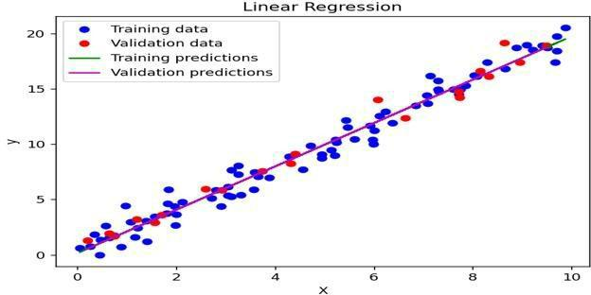

Training MSE: 0.8476788564209707

Validation MSE: 0.653699513717003

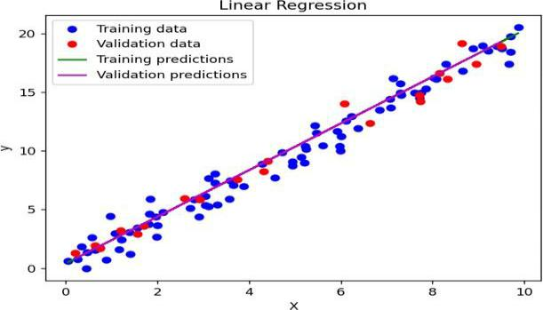

Training MSE: 1.009101708602413

Validation MSE: 0.6575637436381261

Linear Regression

RMSE scores: [0.77953381 0.89086877 1.0326569 0.90782046 0.98769618]

Average RMSE: 0.919715223669806

---

Decision Tree

RMSE scores: [1.08188241 1.45774641 1.36210368 0.91080956 1.36022072]

Average RMSE: 1.2345525556529042

---

Random Forest

RMSE scores: [0.95060216 1.19257089 1.16866416 0.9016125 1.19856087]

Average RMSE: 1.0824021156248491

---

Best hyperparameters: {'C': 1, 'kernel': 'linear'}

Best accuracy: 0.9583333333333334

Test accuracy with best hyperparameters: 1.0

**LAB-09**

**AIM: Introduction to Visualization Tools (Introduction to Data Visualization, Introductionto Matplotlib, Basic Plotting with Matplotlib, Dataset on Immigration to Canada, Line Plots)**

**Code:**

#scatterplot d1=df.head(50) x_scatter=d1['yearsExperience']

y_scatter=d1['salary'] plt.xlabel('yearsExperience')

plt.ylabel('Salary')

plt.scatter(x_scatter,y_scatter,label="Scatter plot")

plt.legend() plt.show()

**Output:**

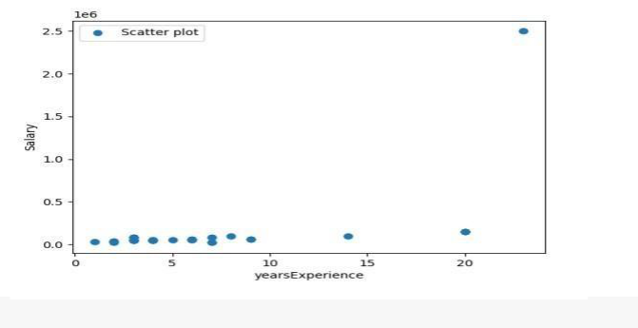

import matplotlib.pyplot as plt

import numpy as np

x=np.linspace(0,1*np.pi,10000)

y=np.sin(x) fig, ax=plt.subplots()

ax.plot(x,y) plt.show() **Output:**

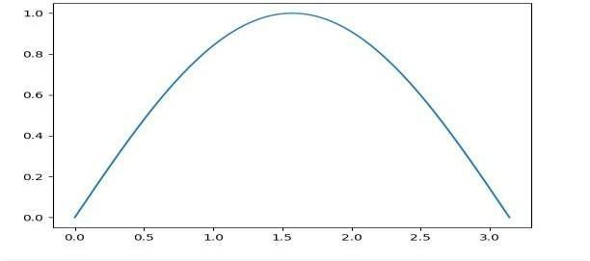

**LAB-10**

**AIM: Visualization Tools** (**Area Plots, Histograms, Bar Charts**)

**Code**: import pandas as pd

import matplotlib.pyplot as plt

import numpy as np

df=pd.read_csv("abss.csv") df

import pandas as pd import

matplotlib import matplotlib.pyplot

as plt import numpy as np

df=pd.read_csv("abss.csv")

plt.plot(df.age,df.price,) plt.show()

plt.plot(df.age,df.price,marker="*") plt.show()

plt.plot(df.age,df.price,marker="*",ms="30")

plt.show()

plt.plot(df.age,df.price,marker="*",ms="20",mec="red") plt.show()

plt.plot(df.age,df.price,marker="*",ms="20",mfc="green") plt.show()

**Output:**

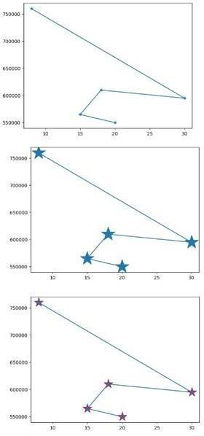

**#Area plots**

d2=df.head()

print(d2['yearsExperience'])

x_area=d2['yearsExperience']

y_area=d2['salary']

plt.xlabel('yearsExperience')

plt.ylabel('Salary')

plt.fill_between(x_area,y_area,label="Area

Plot",color="crimson") plt.legend() plt.show()

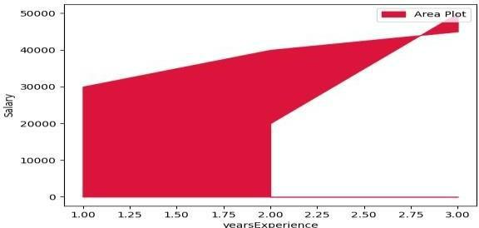

**#Bars Plots**

import matplotlib.pyplot



as pltimport numpy as np

x = np.array(["M", "S", "V",

"k"])y = np.array([7, 3, 1,

8]) plt.bar(x,y)

plt.show()

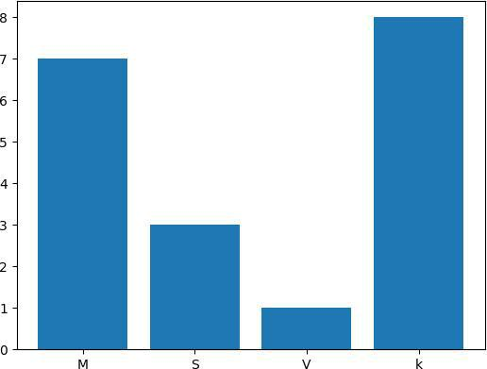

**#Histogram:**

import matplotlib.pyplot



as pltimport numpy as np

x = np.random.normal(170,

10, 250)plt.hist(x)

plt.show()

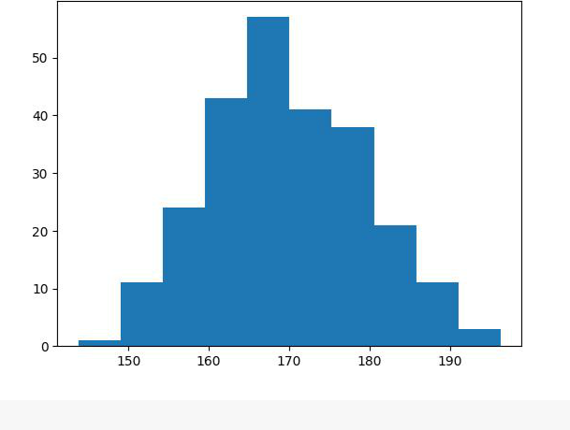

**LAB-11**

**AIM: Specialized Visualization Tools (Pie Charts, Box Plots, Scatter Plots, Bubble Plots)**

**#PIE Charts:**

import matplotlib.pyplot



as pltimport numpy as np

y = np.array([35, 25, 25, 5,5,5]) mylabels = ["VK", "MS", "Sachin","Hardgik","Bhuvi","Nattu"]myexplode = [0.2, 0, 0, 0,0,0]

plt.pie(y, labels = mylabels, explode = myexplode,

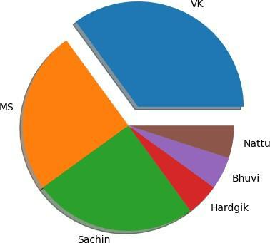

**#Box plot :**

import pandas as pd import

matplotlib.pyplot as plt

import numpy as np data=

pd.read_csv("data.csv")

data.head() x = data.Volume

plt.boxplot(x)

plt.show()

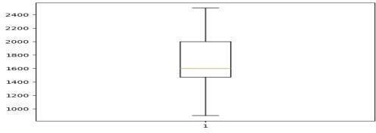

**LAB-12**

**AIM: Advanced Visualization Tools**

**(Waffle Charts, Word Clouds, Seaborn)**

**Code:**

**#Waffle charts**

* python program to generate Waffle Chart
* importing all necessary requirements import pandas as pd import matplotlib.pyplot as plt from pywaffle import Waffle # creation of a dataframe data ={'grossary': ['wheat', 'rice','ragi','jowar', 'dal'],

'stock': [12, 40, 18, 5, 10]} df = pd.DataFrame(data) # To plot the waffle Chart

fig = plt.figure(FigureClass =Waffle, rows = 5,values = df.stock,

labels = list(df.grossary))

**Output:**

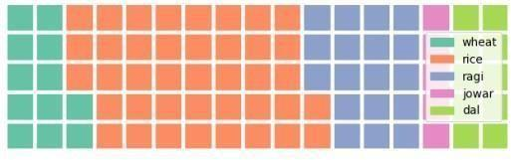

**#world cloud:**

from wordcloud import WordCloud

import matplotlib.pyplot as plt

text="Hello"

wc=WordCloud().generate(text)

plt.imshow(wc)

plt.axis("off")

plt.show()

**Output:**



**#SEABORN**

import numpy as np

import seaborn as sns

sns.set(style="white")

* Generate a random univariate dataset rs = np.random.RandomState(10) d = rs.normal(size=200)
* Plot a simple histogram and kde sns.histplot(d,

kde=True, color="green")

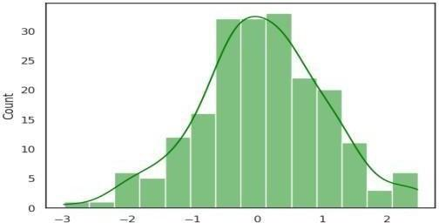

**#maps**

* import the library import folium
* Make an empty map m = folium.Map(location=[20,0], tiles="OpenStreetMap", zoom_start=2)
* Import the pandas library import

pandas as pd

* Make a data frame with dots to show on the map data = pd.DataFrame({

'lon':[-58, 20.5937, 145, 30.32, -4.03, -73.57, 36.82, -38.5],

'lat':[-34, 78.9629, -38, 59.93, 5.33, 45.52, -1.29, -12.97],

'name':['Buenos Aires', 'norway', 'melbourne', 'St Petersbourg', 'Abidjan',

'Montreal', 'Nairobi', 'Salvador'],

'value':[10, 12, 40, 70, 23, 43, 100, 43]

}, dtype=str)

* add marker one by one on the map for i in range(0,len(data)):

folium.Marker( location=[data.iloc[i]['lat'], data.iloc[i]['lon']], popup=data.iloc[i]['name'], ).add_to(m)

* Show the map again

