**DATA SCIENCE WITH PYTHON**

**STUDENT NAME : N.Mariya Babu**

**ID NUMBER : N190750**

**ClASS : CSE-03**

DEPARTMENT OF COMPUTER SCIENCE

AND ENGINEERING RGUKT-NUZ-AP

E2-SEMESTER-II, AY-2022-23

**TABLE OF CONTENTS**

|  |  |  |
| --- | --- | --- |
| **Assignment number** | **Assignment Name** | **Page Number** |
| 1 | **Python Basics** | **3-6** |
| **2** | **Python Data Structures** | **7-13** |
| **3** | **Python Programming Fundamentals** | **14-17** |
| **4** | **Working with data in python** | **18-24** |
| **5** | **Working Numpy Arrays** | **25-29** |
| **6** | **Importing and datasets and cleaning and preparing the data** | **30-34** |
| **7** | **Model Development** | **35-39** |
| **8** | **Model Evaluation** | **40-43** |
| **9** | **Introduction to Visualization tools** | **44-45** |
| **10** | **Basic Visualization** | **46-49** |
| **11** | **Specialized visualization tools** | **50-51** |
| **12** | **Advanced Visualization Tools** | **52-54** |

**LAB-01**

AIM : a) Python Basics: Your first program, Types Expressions and Variables

String Operations

Code:

print("hello world")

color="green"

print(type(color))

a=3

print(a,type(a))

b=-3.5

print(b,type(b))

c=2+3j

print(type(c))

d,e,f=2,3,-4

print(f)

print(e)

print(d)

h=j=k="RAJA"

print(h,j,k)

id1='How are you?'

print(id1[1:7])

x=0b11

print(type(x))

val=None

print(val)

**#python string**

id1="Mariya babu"

print(id1[1])

#negative indexing

print(id1[-3])

#id1[3]=q

#multiline strings

string="""mariya babu is the roommate of durgaprasad”

Hari is friend of mariya"""

print(string)

#python string operation

id2=" is the roommate of Durgaprasad"

print(id1+id2)

id3="babu"

id4="babu"

print(id3==id4)

id3="babu"

id4="babu1"

print(id3==id4)

#iterton

gr='welcome'

for letter in gr:

print(letter)

gr='welcome'

for letter in gr:

print(gr)

print(len(gr))

#membership

print("a" in gr)

print("a" not in gr)

print(gr.upper())

print(gr.lower())

print(gr.startswith("h"))

id='name'

name='DURGA PRASAD'

print(f'my {id} is {name}')

#escape sequence

ex="he said,\"what's is there?\""

print(ex)

**output:**

hello world

<class 'str'>

3 <class 'int'>

-3.5 <class 'float'>

<class 'complex'>

-4

3

2

RAJA RAJA RAJA

ow are

<class 'int'>

None

a

a

mariya babu is the roommate of durgaprasa

Hari is friend of mariya

Mariya babu is the roommate of Durgaprasad

True

False

w

e

l

c

o

m

e

welcome

welcome

welcome

welcome

welcome

welcome

welcome

7

False

True

WELCOME

welcome

False

my name is DURGA PRASAD

he said,"what's is there?"

**LAB-02**

AIM : Python Data Structures: Lists and Tuples Sets,and Dictionaries

CODE

**""" list,tuple,dic,set"""**

a=[2,'a','aba','aaa']

print(a)

num=(1,5,3)

print(num)

b={'a':3,'ba':456,'a':4}

print(b)

c={1,4,3,2,5,}

print(c)

d={2,'a','aba','aaa'}

print(d)

lan=["telugu","tamil","kannada"]

print(lan[2])

print(type(lan))

e={2,2,2,3}

print(e)

a=True

print(a)

b=False

print(b)

#list

a=[4,6,7]

print(a)

print(a[0])

print(a[-3])

print(a[0:2])

#append

a.append(2)

print(a)

#extend

b=[8,9,7]

a.extend(b)

print(a)

a[0]=0

print(a)

#del

del b[1]

print(b)

a.remove(0)

a.sort()

print(a)

a.reverse()

print(a)

a.pop(2)

print(a)

#checking

print(1 in a)

print(len(a))

#list comprehension

c=[]

for x in range(1,6):

c.append(x*x)

print(c)

#tuple

print("tuples")

a=(3,4,5)

print(a)

b="hello",

print(type(b))

c=("hello")

print(type(c))

#tuple accessing

print(a[-1])

print(a[1])

print(a[0:2])

#tuple methods

d=(6,5,7,7,7,8,4,9,0)

print(d.count(7))

print(d.index(6))

#iteration

for x in d:

print(x)

print(7 in d)

#sets

a={3,5,6,7,8,9,4,5,6}

b={10,20,30,40}

print("set")

print(a)

print(type(a))

a.add(10)

print(a)

#min

print(min(a))

#max

print(max(a))

#len

print(len(a))

#all

print(all(a))

#any

print(any(a))

#enumerate

print(enumerate(a))

#sum

print(sum(a))

#sorted

print(sorted(a))

#union

print(a|b)

print(a.union(b))

#intersection

print(a&b)

print(a.intersection(b))

#symmetric difference

print(a^b)

#equal

print(a==b)

#dictonary

dic={1:"a",2:"b",3:"c",4:"d",5:"e"}

print(dic)

print(type(dic))

#adding

dic[6]="f"

print(dic)

#changing

dic[3]="C"

print(dic)

#accessing

print(dic[3])

#remove

del dic[6]

print(dic)

# sorted

sorted(c)

print(dic)

#membership

print(1 in dic)

print(4 not in dic)

**OUTPUT:**

output:

[2, 'a', 'aba', 'aaa']

(1, 5, 3)

{'a': 4, 'ba': 456}

{1, 2, 3, 4, 5}

{2, 'aba', 'a', 'aaa'}

Kannada

<class 'list'>

{2, 3}

True

False

[4, 6, 7]

4

4

[4, 6]

[4, 6, 7, 2]

[4, 6, 7, 2, 8, 9, 7]

[0, 6, 7, 2, 8, 9, 7]

[8, 7]

[2, 6, 7, 7, 8, 9]

[9, 8, 7, 7, 6, 2]

[9, 8, 7, 6, 2]

False

5

[1, 4, 9, 16, 25]

tuples

(3, 4, 5)

<class 'tuple'>

<class 'str'>

5

4

(3, 4)

6

5

7

7

7

8

4

9

0

True

set

{3, 4, 5, 6, 7, 8, 9}

<class 'set'>

{3, 4, 5, 6, 7, 8, 9, 10}

3

10

8

True

True

<enumerate object at 0x000001803DC96E80>

52

[3, 4, 5, 6, 7, 8, 9, 10]

{3, 4, 5, 6, 7, 8, 9, 10, 40, 20, 30}

{3, 4, 5, 6, 7, 8, 9, 10, 40, 20, 30}

{10}

{10}

{3, 4, 5, 6, 7, 40, 8, 9, 20, 30}

False

{1: 'a', 2: 'b', 3: 'c', 4: 'd', 5: 'e'}

<class 'dict'>

{1: 'a', 2: 'b', 3: 'c', 4: 'd', 5: 'e', 6: 'f'}

{1: 'a', 2: 'b', 3: 'C', 4: 'd', 5: 'e', 6: 'f'}

C

{1: 'a', 2: 'b', 3: 'C', 4: 'd', 5: 'e'}

{1: 'a', 2: 'b', 3: 'C', 4: 'd', 5: 'e'}

True

False

**LAB-03**

**AIM:Python Programming Fundamentals: Conditions and Branching**

**Loops, Functions,Objects and Classes**

CODE:

**if-else**

number=int(input("Enter a Number:"))

if number>10:

print('Number is greater than 10')

else:

print('Number is less than 10')

**Output:**

Enter a number:11

Number is greater than 10

**If-elif-else**

num=int(input('Enter a Number:'))

if num>0:

print('Positive Number')

elif num<0:

print('Negative Number')

else:

print('Positive Number')

print('This statement is always executed')

**Output:**

Enter a number:10

Positive Number

**nested-if**

num=int(input('Enter a Number:'))

if(num>=0):

if num==0:

print('Number is 0')

else:

print('Number is positive')

else:

print('Number is Negative')

**output:**

Enter a Number:15

Number is positive

**short-hand-if**

a=10;

b=20;

if a<b: print('This is if')

**Output:**

This is if

**shorthand-if-else**

a=30;

b=20;

print('This is if') if a<b else print('this is else')'''

**Output**:

This is else

**for-loop**

lang=['swift','c','python','c++']

for x in lang:

print(x)

range function

a=range(6)

for x in a:

print(x)

a=range(1,6)

for x in a:

print(x)

a=range(2,22,2)

for x in a:

print(x)

for i in range(1,1001):

for j in range (1,11):

print(i*j,end=" ")

print()

**for loops with else**

digits=[0,1,2]

for i in digits:

print(i)

else:

print("No items left.")

**while loop**

i=1

n=5

while i<=n:

print(i)

i=i+1

**Python oops Concept**

**python inheritence**

class Animal:

def speak(self):

print("Animal Speaking")

class Dog(Animal):

def bark(self):

print("dog barking")

class DogChild(Dog):

def eat(self):

print("Eating bread...")

d=DogChild()

d.speak()

d.bark()

d.eat()

**Output:**

Dog Barking

Animal Speaking

Eating Bread

**Method overriding**

'class Animal:

def speak(self):

print("Speaking")

class Dog(Animal):

def speak(self):

print("Not Speaking")

class Cat(Dog):

def speak(self):

print("Is this a cat")

d=Cat()

d.speak()

**Output:**

Speaking

Not Speaking

Is this a cat

**Data Abstraction**

class Employee:

__count=0;

def __init__(self):

Employee.__count=Employee.__count+1

def display(self):

print("The number of Employees",Employee.__count)

emp=Employee()

try:

print(emp.__count)

finally:

emp.display()

**Output:**

Number of Employees:3

**Abstract Method**

from abc import ABC, abstractmethod

class Car(ABC):

def mileage(self):

pass

class Tesla(Car):

def mileage(self):

print("The mileage is 30kmph")

class Suzuki(Car):

def mileage(self):

print("The mileage is 25kmph ")

class Duster(Car):

def mileage(self):

print("The mileage is 24kmph ")

class Renault(Car):

def mileage(self):

print("The mileage is 27kmph ")

# Driver code

t= Tesla ()

t.mileage()

r = Renault()

r.mileage()

s = Suzuki()

s.mileage()

d = Duster()

d.mileage()

**Output**

The mileage is 30kmph

The mileage is 25kmph

The mileage is 24kmph

The mileage is 27kmp**h**

**LAB-04**

**AIM: Working with Data in Python: Reading files with open, Writing files with**

**open,Loading data with Pandas, Working with and Saving data with Pandas**

CODE:

import pandas as pd

import numpy as np

print(pd.__version__)

b=[1,2,3,4]

c=pd.Series(b)

print(c)

b=['s','d']

c=pd.Series(b[-1])

print(c)

d=np.array(['a','b','c','d'])

s=pd.Series(d)

r=pd.DataFrame(d)

print(s)

print(r)

print(len(s))

s=pd.Series(d,index=[101,103,103,104])

j=pd.Series(d,index=["x","y","z","w"])

print(s)

print(j)

dataset={'icecreams':['vanila','strawberry','badam','pista'],

'rating':[4.5,3.8,4.2,4.6]

}

ds=pd.DataFrame(dataset)

print(ds)

ds=pd.Series(dataset)

print(ds)

**Output:**

2.0.1

0 1

1 2

2 3

3 4

dtype: int64

0 d

dtype: object

0 a

1 b

2 c

3 d

dtype: object

0

0 a

1 b

2 c

3 d

4

101 a

103 b

103 c

104 d

dtype: object

x a

y b

z c

w d

dtype: object

icecreams rating

0 vanila 4.5

1 strawberry 3.8

2 badam 4.2

3 pista 4.6

icecreams [vanila, strawberry, badam, pista]

rating [4.5, 3.8, 4.2, 4.6]

dtype: object

**Attribute of series**

import pandas as pd

import numpy as np

ds=np.array(['a','b','c','d'])

d=pd.Series(ds)

print(d)

N190302 19

DASARI GANGADHAR Data Science with Python Lab

d=pd.Series(ds ,index=[101,102,103,"e"])

print(d)

print(d[103])

ds1={'d1':100,'d2':200,'d3':300}

d=pd.Series(ds1)

print(d)

j=pd.Series(ds1,index=['d1','d2'])

print(j)

print(j.name)

print(j.values)

print(j.size)

print(d.shape)

print(d.ndim)

print(d.nbytes)

print(d.memory_usage)

print(j.empty)

j.name='raj'

print(j.name)

**output:**

0 a

1 b

2 c

3 d

dtype: object

101 a

102 b

103 c

e d

dtype: object

c

d1 100

d2 200

d3 300

dtype: int64

d1 100

d2 200

dtype: int64

None

[100 200]

2

(3,)

1

24

<bound method Series.memory_usage of d1 100

d2 200

d3 300

dtype: int64>

False

Raj

**Multiplication of series :**

import pandas as pd

import numpy as np

ds1=np.array([1,1,2,3,4])

d1=pd.Series(ds1)

ds2=np.array([2,2,3,4,5])

d2=pd.Series(ds2)

a=d1.add(d2)

print(a)

b=d1.sub(d2)

print(b)

c=d1.mul(d2)

print(c)

d=d1.multiply(4)

print(d)

e=d1.div(d2)

print(e)

f=d2.mod(d1)

print(f)

g=d2.pow(3)

print(g)

h=d2.le(d1)

print(h)

i=d2.gt(d1)

print(i)

j=d2.equals(d1)

print(j)

**output:**

0 3

1 3

2 5

3 7

4 9

dtype: int32

0 -1

1 -1

2 -1

3 -1

4 -1

dtype: int32

0 2

1 2

2 6

3 12

4 20

dtype: int32

0 4

1 4

2 8

3 12

4 16

dtype: int32

0 0.500000

1 0.500000

2 0.666667

3 0.750000

4 0.800000

dtype: float64

0 0

1 0

2 1

3 1

4 1

dtype: int32

0 8

1 8

2 27

3 64

4 125

dtype: int32

0 False

1 False

2 False

3 False

4 False

dtype: bool

0 True

1 True

2 True

3 True

4 True

dtype: bool

False

**LAB - 05**

**Working with Numpy Arrays:Numpy 1d Arrays,Numpy 2D**

**Arrays**

Code:

import numpy as np

#arrange

arr=np.arange(20)

print(arr)

#shape

arr.shape

print("Shape of array:",arr)

print(arr[4])

#asisgning a value

arr[7]=777

print(arr)

#reshape the existing array

arr=np.arange(20).reshape(4,5)

print("Rearranging the array:",arr)

print(arr.shape)

print(arr[1][2])

array=np.arange(27).reshape(3,3,3)

print(array)

#zero function

print(np.zeros((2,4)))

#ones function

print(np.ones((2,4)))

#empty function

print(np.empty((2,2)))

#full function

print(np.full((4,3),7))

#eye function

print(np.eye(3,3))

#linespace

print(np.linspace(0, 100, num=5))

#conversion from list to array

list=[4,5,6]

print(list)

array=np.array(list)

print(array)

print(type(array))

#random funcion

print(np.random.random((2,2)))

print(np.shape(array))

print(np.size(array))

print(np.dtype(float))

array1=np.array([1,2,3,4,5])

print(array1[1:5])

print(array1[:])

print(array1[3:])#copying the array

myarray=np.copy(array1)

print(myarray)

myarray[2]=8

print(myarray,array1)

#view function

arrayv=array1.view()

print(arrayv)

arrayv[2]=9

print(arrayv,array1)

yammu=np.array(['A','B'])

ary=np.array([11,22,33,44])

print(ary)

print(np.delete(ary,2))

#atack function

a=np.array([1,2,3,4])

b=np.array([5,6,7,8])

c=np.stack((a,b),axis=1)

print(c)

#concatenate

x=np.array([[1,2],[3,4]])

y=np.array([[12,30]])

r=np.array([[33,44]])

z=np.concatenate((x,y),axis=0)

print(z)

print(np.vstack((x,y)))

print(np.hstack((y,r)))

print(np.dstack((y,r)))

split=np.array([11,22,33,44,55,66])

newarr=np.array_split(split,3)

print(newarr)

#where function

t=np.arange(12)

s=np.where(a<6,a,5*a)

print(s)

fun=np.array([1,11,2,22,3,33])

print(np.max(fun))

print(np.min(fun))

print(np.mean(fun))

print(np.median(fun))

print(np.var(fun))

print(np.std(fun))

**Output:**

[ 0 1 2 3 4 5 6 7 8 9 10 11 12 13 14 15 16 17 18 19] Shape of array: [ 0 1

2 3 4 5 6 7 8 9 10 11 12 13 14 15 16 17 18 19] 4

[ 0 1 2 3 4 5 6 777 8 9 10 11 12 13 14 15 16 17 18 19]

Rearranging the array: [[ 0 1 2 3 4]

[ 5 6 7 8 9]

[10 11 12 13 14]

[15 16 17 18 19]]

(4, 5)

7

[[[ 0 1 2]

[ 3 4 5]

[ 6 7 8]]

[[ 9 10 11]

[12 13 14]

[15 16 17]]

[[18 19 20]

[21 22 23]

[24 25 26]]]

[[0. 0. 0. 0.]

[0. 0. 0. 0.]]

[[1. 1. 1. 1.]

[1. 1. 1. 1.]]

[[2.12199579e-314 4.67296746e-307]

[1.11658836e-320 1.04614393e-311]]

[[7 7 7]

[7 7 7]

[7 7 7]

[7 7 7]]

[[1. 0. 0.]

[0. 1. 0.]

[0. 0. 1.]]

[ 0. 25. 50. 75. 100.]

[4, 5, 6]

[4 5 6]

<class 'numpy.ndarray'>

[[0.04181302 0.70924674]

[0.96165792 0.17146781]]

(3,)

3

float64

[2 3 4 5]

[1 2 3 4 5]

[4 5]

[1 2 3 4 5]

[1 2 8 4 5] [1 2 3 4 5]

[1 2 3 4 5]

[1 2 9 4 5] [1 2 9 4 5]

[11 22 33 44]

[11 22 44]

[[1 5]

[2 6]

[3 7]

[4 8]]

[[ 1 2]

[ 3 4]

[12 30]]

[[ 1 2]

[ 3 4]

[12 30]]

[[12 30 33 44]]

[[[12 33]

[30 44]]]

[array([11, 22]), array([33, 44]), array([55, 66])]

[1 2 3 4]

33

1

12.0

7.0

140.66666666666666

11.86029791643813

**LAB-06**

**Aim: Importing Datasets: Learning Objectives, Understanding the Domain,**

**Understandingthe Dataset, Python package for data science, Importing and**

**Exporting Data in Python, BasicInsights from Datasets**

**Cleaning and Preparing the Data: Identify and Handle Missing Values, Data**

**Formatting, Data Normalization Sets, Binning, Indicator variables**

Code:

Importing datasets and preparing the data

import pandas as pd

df=pd.read_csv(r'C:\Users\DURGAPRASAD\Desktop\DSP\data1.csv')

d=pd.DataFrame(df)

print(d)

d=df.loc[4]

print(d)

d=df.loc[2:3]

print(d)

print(df.loc[1,"Name"])

print(df.loc[0:4,["Name","marks"]])

print(df.loc[4:8,"Name":"marks"])

"""ILOC"""

print(df.iloc[3])

print(df.iloc[3:8])

print(df.iloc[3:8,1])

print(df.iloc[5:9,1:3])

print(df.iloc[[2,4,6,7]]

**OUTPUT**

Unnamed: 0 Name id marks

0 1 Dasari R1254 14

1 2 Gangadhar R1255 14

2 3 Sree R1256 13

3 4 Raj R1257 12

4 5 Ram R1258 15

5 6 Roja R1259 13

6 7 Rahul R1260 14

7 8 Ramya R1261 11

8 9 Siri NaN 12

9 10 Lava R1263 10

Unnamed: 0 5

Name Ram

id R1258

marks 15

Name: 4, dtype: object

Unnamed: 0 Name id marks

2 3 Sree R1256 13

3 4 Raj R1257 12

Gangadhar

Name marks

0 Dasari 14

1 Gangadhar 14

2 Sree 13

3 Raj 12

4 Ram 15

Name id marks

4 Ram R1258 15

5 Roja R1259 13

6 Rahul R1260 14

7 Ramya R1261 11

8 Siri NaN 12

Unnamed: 0 4

Name Raj

id R1257

marks 12

Name: 3, dtype: object

Unnamed: 0 Name id marks

3 4 Raj R1257 12

4 5 Ram R1258 15

5 6 Roja R1259 13

6 7 Rahul R1260 14

7 8 Ramya R1261 11

3 Raj

4 Ram

5 Roja

6 Rahul

7 Ramya

Name: Name, dtype: object

Name id

5 Roja R1259

6 Rahul R1260

7 Ramya R1261

8 Siri NaN

Unnamed: 0 Name id marks

2 3 Sree R1256 1

**Data cleaning**

dropna()

import pandas as pd

import numpy as np

df=pd.read_csv(r'C:\Users\DASARI GANGADHAR\Desktop\DSP\data1.csv')

print(df)

d=df.dropna()

print(d)

print(df)

print(df.loc[:,["marks","Name"]].dropna())

d=df.dropna(inplace=True)

print(d)

print(df)

**output:**

Unnamed: 0 Name id marks

0 1 Dasari R1254 14

1 2 Gangadhar R1255 14

2 3 Sree R1256 13

3 4 Raj R1257 12

4 5 Ram R1258 15

5 6 Roja R1259 13

6 7 Rahul R1260 14

7 8 Ramya R1261 11

8 9 Siri NaN 12

9 10 Lava R1263 10

Unnamed: 0 Name id marks

0 1 Dasari R1254 14

1 2 Gangadhar R1255 14

2 3 Sree R1256 13

3 4 Raj R1257 12

4 5 Ram R1258 15

5 6 Roja R1259 13

6 7 Rahul R1260 14

7 8 Ramya R1261 11

9 10 Lava R1263 10

Unnamed: 0 Name id marks

0 1 Dasari R1254 14

1 2 Gangadhar R1255 14

2 3 Sree R1256 13

3 4 Raj R1257 12

4 5 Ram R1258 15

5 6 Roja R1259 13

6 7 Rahul R1260 14

7 8 Ramya R1261 11

8 9 Siri NaN 12

9 10 Lava R1263 10

marks Name

0 14 Dasari

1 14 Gangadhar

2 13 Sree

3 12 Raj

4 15 Ram

5 13 Roja

6 14 Rahul

7 11 Ramya

8 12 Siri

9 10 Lava

None

Unnamed: 0 Name id marks

0 1 Dasari R1254 14

1 2 Gangadhar R1255 14

2 3 Sree R1256 13

3 4 Raj R1257 12

4 5 Ram R1258 15

5 6 Roja R1259 13

6 7 Rahul R1260 14

7 8 Ramya R1261 11

9 10 Lava R1263 10

**fillna()**

import pandas as pd

df=pd.read_excel(r"C:\Users\DURGA PRASAD\Desktop\DSP\data2.xlsx")

print(df)

d=df.fillna("missing")

print(d)

df.fillna("missing",inplace=True)

print(df)

**output:**

name gender age weight

0 John M 48.0 128.6

1 Peter NaN 58.0 158.3

2 Liz F NaN 115.5

3 Joe M 28.0 170.1

name gender age weight

0 John M 48.0 128.6

1 Peter missing 58.0 158.3

2 Liz F missing 115.5

3 Joe M 28.0 170.1

name gender age weight

0 John M 48.0 128.6

1 Peter missing 58.0 158.3

2 Liz F missing 115.5

3 Joe M 28.0 170.1

**LAB-07**

**Aim: Model Development: Simple and Multiple Linear Regression, Model EvaluationUsingVisualization, Polynomial Regression and Pipelines, R-squared and MSE for In-Sample Evaluation, Prediction and Decision Making**

**SIMPLE LINEAR REGRESSION:**

import matplotlib.pyplot as plt

from scipy import stats

x = [5,7,8,7,2,17,2,9,4,11,12,9,6]

y = [99,86,87,88,111,86,103,87,94,78,77,85,86]

slope, intercept, r, p, std_err = stats.linregress(x, y)

def myfunc(x):

return slope * x + intercept

mymodel = list(map(myfunc, x))

plt.scatter(x, y)

plt.plot(x, mymodel)

plt.show()

**OUTPUT**

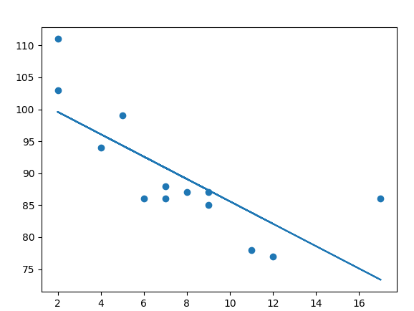

**Multiple Regression**

import numpy as np

import pandas as pd

import matplotlib.pyplot as plt

from mpl_toolkits.mplot3d import Axes3D

#from sklearn.linear_model import LinearRegression as lr

# Load the dataset

data = pd.read_csv('pra.csv')

# Extract the independent variables (features)

X = data[['$cost','rating']].values

# Extract the dependent variable

y = data['discount'].values

# Create and fit the multiple regression model

from sklearn.linear_model import LinearRegression

model = LinearRegression()

model.fit(X, y)

# Generate predicted values

predicted_y = model.predict(X)

print("Coefficients: ", model.coef_)

print("Intercept: ", model.intercept_)

print("Predicted values: ", predicted_y)

# Plot the original data points and the predicted values

plt.scatter( X[:, 1], y, c='blue', label='Original data') plt.plot(

X[:, 1], predicted_y, c='red', label='Multipleregression')

plt.xlabel('matchpoints')

plt.ylabel('rank')

plt.title('Multiple Regression')

plt.legend()

plt.show()

fig = plt.figure()

ax = fig.add_subplot(111, projection='3d')

ax.scatter(X[:, 0], X[:, 1], y, c='blue', label='Original data')

ax.plot(X[:, 0], X[:, 1], predicted_y, c='red', label='Multipleregression')

ax.set_xlabel('$cost')

ax.set_ylabel('rating')

ax.set_zlabel('discount')

ax.set_title('Multiple Regression')

ax.legend()

plt.show()

**Output:**

Coefficients: [-0.02574741 -0.28450588]

Intercept: 38.95936897090988

Predicted values: [33.67472874 34.73165679 35.01616266 35.73452119 36.32414269

35.34188804

35.96496343 35.99199525 34.10858139 34.9350672 35.5246887 35.62639391

35.88386797 36.14134203]

**GRAPHS**

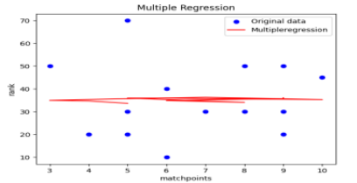

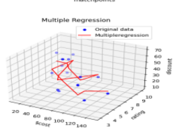

**Polynomial regression**

# Import Pandas Library, used for data manipulation

# Import matplotlib, used to plot our data

# Import numpy for linear algebra operations

import pandas as pd

import matplotlib.pyplot as plt

import numpy as np

# Import our WeatherDataP.csv and store it in the variable rweather_data_p

weather_data_p = pd.read_csv("WeatherDataP.csv")

# Display the data in the notebook

weather_data_p

# Set our input x to Pressure, use [[]] to convert to 2D array suitable for model input

X = weather_data_p[["Pressure (millibars)"]]

y = weather_data_p.Humidity

# Produce a scatter graph of Humidity against Pressure

plt.scatter(X, y, c = "black")

plt.plot(X,y)

plt.xlabel("Pressure (millibars)")

plt.ylabel("Humidity")

plt.show()

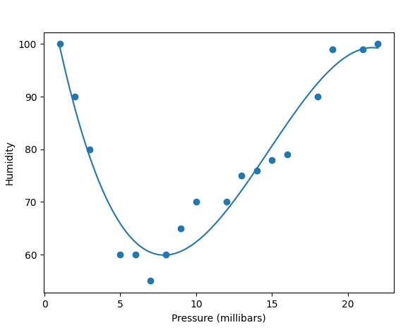

**LAB-08**

**Aim: Model Evaluation: Model Evaluation, Over-fitting, Under-fitting and Model**

**Selection,Ridge Regression, Grid Search, Model Refinement**

Code: Ridge regression

import pandas as pd

import matplotlib.pyplot as plt

from sklearn.model_selection import train_test_split

from sklearn.linear_model import Ridge

from sklearn import metrics

import numpy as np

df=pd.read_csv("PewDiePie.csv")

#dividing the variables into dependent and independent

X=pd.DataFrame(df['Date'])

y=pd.DataFrame(df['Subscribers'])

#Split the data into train and test sets

X_train,X_test,y_train,y_test=train_test_split(X,y,test_size=0.2,random_state=1)

#train the algorithm

ridge=Ridge(alpha=1.0)

ridge.fit(X_train,y_train)

#retriving the intercept

print(ridge.intercept_)

#retriving the slope

print(ridge.coef_)

#predecting the test results

y_pred = ridge.predict(X_test)

#evaluting the algorithm

print('Mean Absolute Error:',metrics.mean_absolute_error(y_test,y_pred))

print('Mean Squared Error:',metrics.mean_squared_error(y_test,y_pred))

print('Root Mean Squared Error:',np.sqrt(metrics.mean_squared_error(y_test,y_pred)))

plt.scatter(X_train, y_train, color='red') # plotting the observation line

plt.plot(X_train, ridge.predict(X_train), color='blue') # plotting the regression line

plt.title("Date vs Subscribers (Training set)") # stating the title of the graph

plt.xlabel("Date") # adding the name of x-axis

plt.ylabel("Subscribers") # adding the name of y-axis

plt.show() # specifies end of graph

#plot for the test set

plt.scatter(X_test, y_test, color='red')

plt.plot(X_train, ridge.predict(X_train), color='blue') # plotting the regression line

plt.title("Date vs Subscribers (Testing set)")

plt.xlabel("Date")

plt.ylabel("Subscribers")

plt.show()

**output:**

[47611.65464541]

[[-605.65189665]]

Mean Absolute Error: 7670.798653106103

Mean Squared Error: 74374253.37775256

Root Mean Squared Error: 8624.0508682261

**GRAPH**

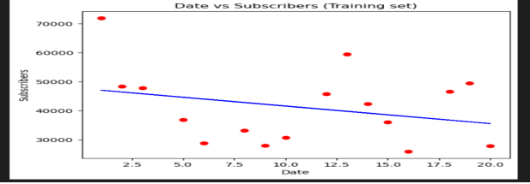

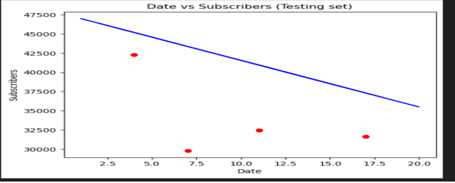

**Overfitting and underfitting Problem:**

Import numpy as np

Import matplotlib.pypplot as plt

from sklearn.pipeline import Pipeline from sklearn.preprocessing import PolynomialFeatures

from sklearn.linear_model import LinearRegression #this allows us to create a random dataset

X = np.sort(np.random.rand(100)) #Lets create a true function

true_f = lambda X: np.cos(3.5 * np.pi * X)

y = true_f(X) + np.random.randn(100) * 0.1

degrees = [1,15]

plt.figure(figsize=(15, 10))

for i in range(len(degrees)):

ax = plt.subplot(1, len(degrees), i+1)

plt.setp(ax, xticks=(), yticks=()) polynomial_features = PolynomialFeatures(degree=degrees[i],

include_bias=False) linear_regression = LinearRegression()

pipeline=Pipeline([("polynomial_features",polynomial_features),("linear_regression",

linear_regression)])

pipeline.fit(X[:, np.newaxis], y) #Testing

X_test = np.linspace(0, 1, 100)

hat = pipeline.predict(X_test[:, np.newaxis])

plt.plot(X_test, hat,label="Model")

plt.plot(X_test, true_f(X_test), label="True function") plt.scatter(X, y, label="Samples")

plt.xlabel("x") plt.ylabel("y")

plt.xlim((0, 1))

plt.ylim((-2, 2))

plt.legend(loc="best")

plt.title("Degree %d" % degrees[i])

plt.show()

**OUTPUT:**

**­**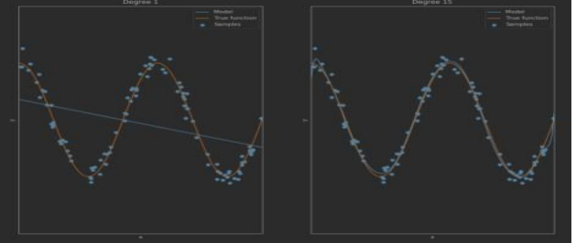

**LAB-09**

**Aim:Introduction to Visualization Tools: Introduction to Data Visualization,Introduction to Matplotlib**

**CODE:**

#scatterplot

d1=df.head(50)

x_scatter=d1['yearsExperience']

y_scatter=d1['salary']

plt.xlabel('yearsExperience')

plt.ylabel('Salary')

plt.scatter(x_scatter,y_scatter,label="Scatter plot")

plt.legend()

plt.show()

**output:**

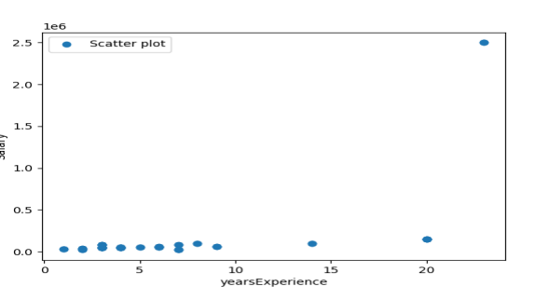

import matplotlib.pyplot as plt

import numpy as np

x=np.linspace(0,1*np.pi,10000)

y=np.sin(x)

fig, ax=plt.subplots()

ax.plot(x,y)

plt.show()

**GRAPH**

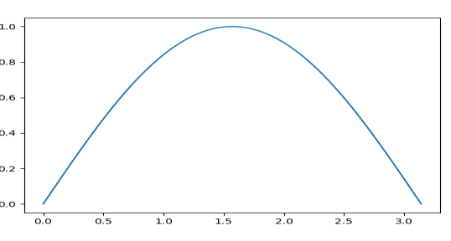

**LAB-10**

**AIM:Basic Visualization Tools: Area Plots,Histograms,Bar Charts**

**BAR PLOT:-**

import matplotlib.pyplot as plt

# Sample data

year= ['2018', '2019', '2020', '2021']

literacy = [25, 50, 75, 100]

# Create a bar chart

plt.bar(year, literacy)

# Add labels and title

plt.xlabel('year')

plt.ylabel('literacy')

plt.title('Bar Chart')

# Display the chart

plt.show()

**Output:-**

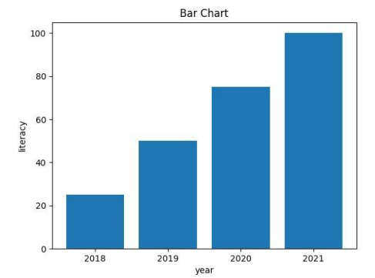

**LINE PLOT:-**

#lineplot

x = [1, 2, 3, 4, 5]

y = [5, 10, 15, 20, 25]

# Create a figure and axis

fig, ax = plt.subplots()

# Plot the data

ax.plot(x, y, marker='o', linestyle='-', color='r')

# Customize the plot

ax.set_xlabel('X-axis')

ax.set_ylabel('Y-axis')

ax.set_title('Line Plot')

# Display the plot

plt.show()

**OUTPUT:-**

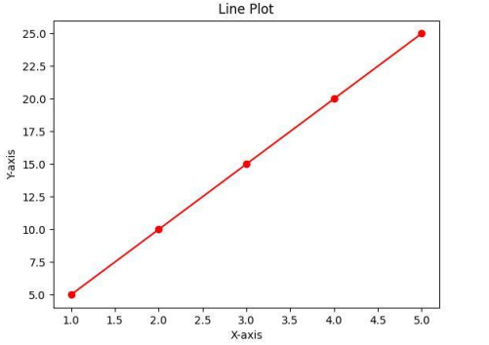

**AREA PLOT:-**

#area plot

# Sample data

years = [2010, 2011, 2012, 2013, 2014, 2015]

level1 = [2, 5, 8, 6, 9, 3]

level2 = [1, 3, 2, 7, 5, 4]

level3 = [6, 8, 7, 3, 2, 5]

# Plotting

plt.stackplot(years, level1, level2, level3, labels=['level 1', 'level 2', 'level 3'])

plt.legend(loc='upper left')

plt.xlabel('Year')

plt.ylabel('Value')

plt.title('Area Plot')

plt.show()

**OUTPUT:-**

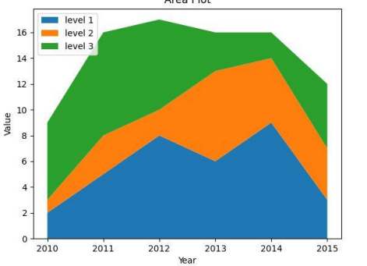

**#histogram**

import numpy as np

data = np.random.randn(1000)

plt.hist(data, bins=30, alpha=0.5, color='steelblue')

plt.xlabel('year')

plt.ylabel('literacy')

plt.title('Histogram')

plt.show()

#pie chart

x=[2010,2012,2013,2014,2015]

y=[20,30,40,50,60]

plt.pie(y,labels=x,autopct='%1.1f%%')

plt.axis("equal")

plt.show()

**OUTPUT:-**

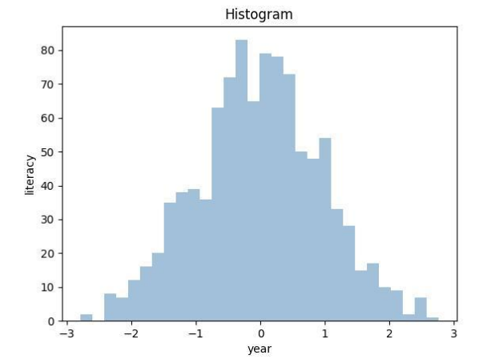

**LAB-11**

**Aim: Specialized visualization tools pie charts ,boxplot**

**CODE:**

**#pie chart**

x=[2010,2012,2013,2014,2015]

y=[20,30,40,50,60]

plt.pie(y,labels=x,autopct='%1.1f%%')

plt.axis("equal")

plt.show()

**Output:**

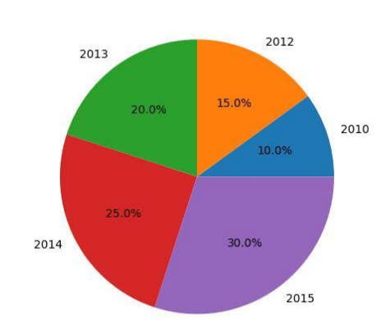

**#box plot**

import pandas as pd

import matplotlib.pyplot as plt

import numpy as np

data = pd.read_csv("data.csv")

data.head()

x = data.Volume

plt.boxplot(x)

plt.show()

**OUTPUT:**

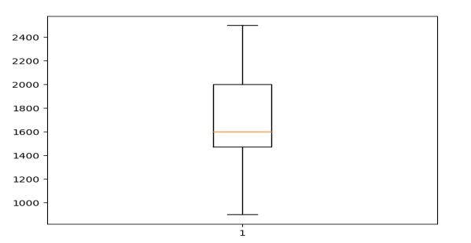

**LAB-12**

**Aim: Advanced Visualization Tools: Waffle Charts, Word Clouds,Seaborn and Regression Plots**

**Waffle charts:**

import pandas as pd

import matplotlib.pyplot as plt

from pywaffle import Waffle

data={'vehicles':['car', 'lorry','bus','bike','bicycle'],

'stock':[25,20,15,10,5]}

df=pd.DataFrame(data)

fig=plt.figure(FigureClass=Waffle,rows=5,values=df.stock,

labels=list(df.vehicles))

plt.show()

**OUTPUT**

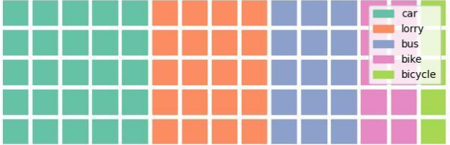

**Word clouds**

#word cloud

from wordcloud import WordCloud

import matplotlib.pyplot as plt

text="hi hello welcome to word cloud it is very easy to understand"

wc=WordCloud().generate(text)

plt.imshow(wc)

plt.axis("off")

plt.show()

**Output:**



**#SEABORN**

import numpy as np

import seaborn as sns

sns.set(style="white")

# Generate a random univariate dataset

rs = np.random.RandomState(10)

d = rs.normal(size=200)

# Plot a simple histogram and kde

sns.histplot(d, kde=True, color="green"

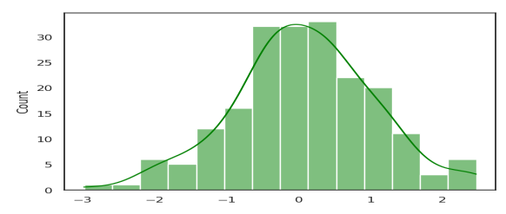

import folium

# Make an empty map

m = folium.Map(location=[20,0], tiles="OpenStreetMap", zoom_start=2)

# Import the pandas library

import pandas as pd

# Make a data frame with dots to show on the map

data = pd.DataFrame({

'lon':[-58, 20.5937, 145, 30.32, -4.03, -73.57, 36.82, -38.5],

'name':['Buenos Aires', 'norway', 'melbourne', 'St Petersbourg', 'Abidjan',

'Montreal', 'Nairobi', 'Salvador'],

'value':[10, 12, 40, 70, 23, 43, 100, 43]

}, dtype=str)

# add marker one by one on the map

for i in range(0,len(data)):

folium.Marker(

location=[data.iloc[i]['lat'], data.iloc[i]['lon']],

popup=data.iloc[i]['name'],

).add_to(m)

