**DATA STRUCTURES THROUGH C**

**LABORATORY**

**N.MARIYA BABU**

**(N190750)**

**CSE-03**

**DEPARTMENT OF COMPUTER SCIENCE AND**

**ENGINEERING, RGUKT-NUZ-AP**

**E-1 SEMESTER-II, AY-2021-2022**

**Table of Contents**

| **Assignment No.** | **Assignment Name** | **Date** | **Page No** |
| --- | --- | --- | --- |
| **1** | **Recursion** | **21-06-2022** | **2-5** |
| **2** | **Linked List** | **28-06-2022** | **5-28** |
| **3** | **Stacks** | **12-07-2022** | **28-42** |
| **4** | **Queue** | **18-07-2022** | **42-50** |
| **5** | **Searching** | **26-07-2022** | **51-54** |
| **6** | **Sorting** | **02-08-2022** | **54-59** |
| **7** | **Binary Search Tree** | **23-08-2022** | **59-70** |
| **8** | **Heap Sort** | **13-09-2022** | **71-74** |

**LAB-1**

**/* Author Name : N.Mariya Babu**

**Id No : N190750**

**Assignment Number : 1**

**programme Number : 1**

**programme Description : C Programme to find the gcd of two numbers**

**Date : 6/21/2022 (MM/DD/YYYY)**

**certification : I hereby certify that this work is my own and none of it is the work of any other person */**

//Header Files

#include<stdio.h>

//Function Definition

int gcd(int,int);

//Main Function

int main(){

int a,b,result;

printf("Enter the a value :");

scanf("%d",&a);

printf("Enter the b value :");

scanf("%d",&b);

if(a>b){

result = gcd(a,b);

}else{

result = gcd(b,a);

}

printf("The gcd of the %d and %d is %d",a,b,result);

}

//Function to find GCD

int gcd(int a ,int b){

int rem;

rem = a%b;

if(rem==0){

return b;

}

else{

return gcd(b,rem);

}

}

**Output:**

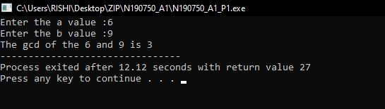

**/* Author Name : N.Mariya Babu**

**Id No : N190750**

**Assignment Number : 1**

**programme Number : 2**

**programme Description : C Programme for multiplication without using the division operator**

**Date : 6/21/2022 (MM/DD/YYYY)**

**certification : I hereby certify that this work is my own and none of it is the work of any other person */**

//Header Files

#include<stdio.h>

#include<math.h>

int mult(int,int);

//Main Function

int main(){

int a,b,i,result;

printf("Enter the a value: ");

scanf("%d",&a);

printf("Enter the b value :");

scanf("%d",&b);

result = mult(a,b);

printf("The multiplication of the %d and %d is %d",a,b,result);

}

//Function to multiply without out * operator

int mult(int a,int b){

if(b>0){

a = a + mult(a,b-1);

return a;

}

else{

return 0;

}

}

**Output:**

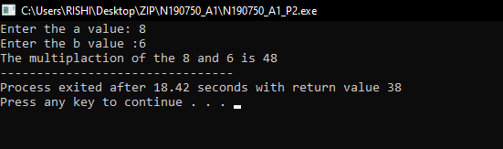

**/* Author Name : N.Mariya Babu**

**Id No. : N190750**

**Assignment Number : 1**

**programme Number : 3**

**programme Description : C Programme for division without using the division operator**

**Date : 6/28/2022 (MM/DD/YYYY)**

**certification : I hereby certify that this work is my own and none of it is the work of any other person */**

//Header Files

#include<stdio.h>

#include<math.h>

//Function Declaration

int div(int,int);

//Main Function

int main(){

int a,b,i,result;

printf("Enter the a value: ");

scanf("%d",&a);

printf("Enter the b value :");

scanf("%d",&b);

result = div(a,b);

printf("The division of the %d and %d is %d",a,b,result);

}

//Function to find the division of two numbers

int div(int a,int b){

int ;

if(a>=b){

return 1 + div(a-b,b);

}

else{

return 0;

}

}

**Output:**

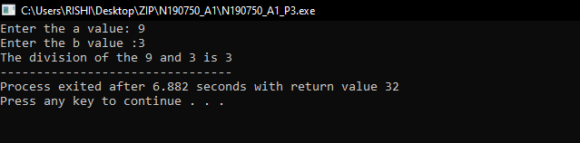

**/* Author Name : N.Mariya Babu**

**Id No. : N190750**

**Assignment Number : 1**

**programme Number : 4**

**programme Description : C Programme to find the power of two numbers without using the power function**

**Date : 6/21/2022 (MM/DD/YYYY)**

**certification : I hereby certify that this work is my own and none of it is the work of any other person */**

//Header Files

#include<stdio.h>

//Function Declaration

int power(int,int);

//Main Function

int main(){

int a,b,i,result;

printf("Enter the a value: ");

scanf("%d",&a);

printf("Enter the b value :");

scanf("%d",&b);

result = power(a,b);

printf("The %d power %d is %d",a,b,result);

}

//Power Function

int power(int a ,int b){

if(b>0){

a = a * power(a,b-1);

return a;

}

else{

return 1;

}

}

**Output:**

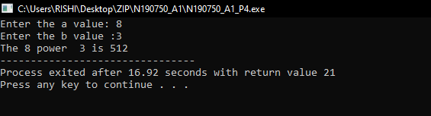

**/* Author Name : N.Mariya Babu**

**Id No : N190750**

**Assignment Number : 1**

**programme Number : 5**

**programme Description : C programme to find the given number is palindrome or not**

**Date : 6/21/2022 (MM/DD/YYYY)**

**certification : I hereby certify that this work is my own and none of it is the work of any other person */**

//Header Files

#include<stdio.h>

//Function Declaration

int rev(int);

//Main Function

int main(){

int n,revers;

printf("Enter the n value ");

printf("to check the number is palindrome or not :");

scanf("%d",&n);

revers = rev(n);

if(revers==n){

printf("The given number is palindrome!");

}

else{

printf("the given number is not palindrome");

}

}

//Function to reverse the given number

int rev(int n){

static int rem = 0 ;

if(n>0){

rem = rem * 10 + n%10;

return rev(n/10);

}

else{

return rem;

}

}

**Output:**

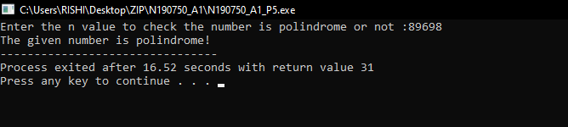

**LAB-2**

**/* Author Name : N.Mariya Babu**

**Id No. : N190750**

**Assignment Number : 2**

**programme Number : 1**

**programme Description : C Programme to create a SLL and perform all insertion and deletion cases**

**Date : 6/28/2022 (MM/DD/YYYY)**

**certification : I hereby certify that this work is my own and none of it is the work of any other person */**

//Header Files

#include<stdio.h>

#include<stdlib.h>

// function declaration

int read(void);

int display(void);

int insertion(void);

int deletion(void);

int searching(void);

//structure creation

struct node{

int data;

struct node *next;

}*head= NULL,*p,*qtr,*r,*nn,*ptr;

// main function

int main(){

while(1){

int n;

printf("\n1 create list 2 insertion ");

printf(" 3 deletion 4 searching 5 exit \n");

printf("\nChoose your option :");

scanf("%d",&n);

switch(n){

case 1:

read();

break;

case 2:

insertion();

break;

case 3:

deletion();

break;

case 4:

searching();

break;

case 5:

exit(1);

break;

default:

printf("Invalid Syntax");

}

display();

}

}

// funcion to read the node element's

int read(){

int i =1;

while(i != 0){

nn = (struct node *)malloc(sizeof(struct node));

printf("Enter the node data :");

scanf("%d",&nn->data);

if(head == NULL){

head = nn;

nn->next = NULL;

}

else{

ptr = head;

while(ptr->next !=NULL){

ptr = ptr->next;

}

ptr->next = nn;

nn->next = NULL;

}

printf("Enter the 0 to exit :");

scanf("%d",&i);

}

return 0;

}

// function to display the node element's

int display(){

ptr = head;

int i = 0;

while(ptr!=NULL){

printf("\nThe data at node %d is %d ",i,ptr->data);

ptr = ptr->next;

i++;

}

return 0 ;

}

//function for inserting the element at required position

int insertion(){

int x=0,y = 0,k = 1;

ptr = head;

nn = (struct node *)malloc(sizeof(struct node));

printf("Enter the node data :");

scanf("%d",&nn->data);

nn->next = NULL;

while(ptr!=NULL){

ptr= ptr->next;

y++;

}

int n;

while(x==0){

printf("\nEnter the position where you want");

printf(" to insert the data :");

scanf("%d",&n);

if(n<=y+1 && n>0){

x++;

}

else{

printf("Invalid position");

}

}

if(n==1){

nn->next = head;

head = nn;

}else if(n==y+1){

ptr = head;

while(ptr->next != NULL){

ptr = ptr->next;

}

ptr->next = nn;

}else{

ptr = head;

for(k=1;k<n;k++){

ptr = ptr->next;

}

nn->next = ptr->next;

ptr->next = nn;

}

return 0;

}

// function to delete the element from the list

int deletion(){

int x=0,y = 0,k = 1;

ptr = head;

while(ptr!=NULL){

ptr= ptr->next;

y++;

}

int n;

while(x==0){

printf("\nEnter the position of the element ");

printf("Where you want the delete : ");

scanf("%d",&n);

if(n<=y && n>0){

x++;

}

else{

printf("Invalid position");

}

}

if(n==1){

ptr = head;

head = ptr->next;

free(ptr);

}else if(n==y){

ptr = head;

while(ptr->next != NULL){

qtr = ptr;

ptr = ptr->next;

}

qtr->next = NULL;

free(ptr);

}else{

ptr = head;

for(k=1;k<n;k++){

qtr = ptr;

ptr = ptr->next;

}

qtr->next = ptr->next;

free(ptr);

}

return 0;

}

//Searching

int searching(){

int n,i;

printf("Enter the position of the element :");

scanf("%d",&n);

ptr = head;

for(i=1;i<n;i++){

ptr=ptr->next;

}

printf("The element at position %d is %d",n,ptr->data);

ptr = head;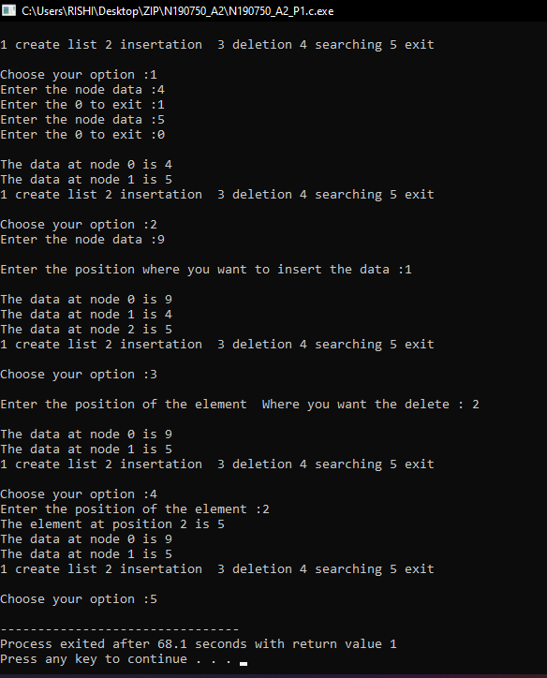

return 0;

}

**Output:**

**/* Author Name : N.Mariya Babu**

**Id No. : N190750**

**Assignment Number : 2**

**programme Number : 2**

**programme Description : C Programme to create a CLL and perform insertion and deletion at beginning and end**

**Date : 6/28/2022 (MM/DD/YYYY)**

**certification : I hereby certify that this work is my own and none of it is the work of any other person */**

//Header Files

#include<stdio.h>

#include<stdlib.h>

// function declaration

int read(void);

int display(void);

int insertion(void);

int deletion(void);

int searching(void);

//structure creation

struct node{

int data;

struct node *next;

}*head= NULL,*p,*qtr,*r,*nn,*ptr;

// main function

int main(){

while(1){

int n;

printf("\n1 create list 2 insertion ");

printf("3 deletion 4 searching 5 exit \n");

printf("\nChoose your option :");

scanf("%d",&n);

switch(n){

case 1:

read();

break;

case 2:

insertion();

break;

case 3:

deletion();

break;

case 4:

searching();

break;

case 5:

printf("Programme terminated...");

exit(1);

break;

default:

printf("Invalid Syntax");

}

display();

}

}

// funcion to read the node element's

int read(){

int i =1;

while(i != 0){

nn = (struct node *)malloc(sizeof(struct node));

printf("Enter the node data :");

scanf("%d",&nn->data);

if(head == NULL){

head = nn;

nn->next = head;

}

else{

ptr = head;

while(ptr->next !=head){

ptr = ptr->next;

}

ptr->next = nn;

nn->next = head;

}

printf("Enter 0 to exit : ");

scanf("%d",&i);

}

return 0;

}

// function to display the node element's

int display(){

ptr = head;

int i = 0;

while(ptr->next!=head){

printf("\nThe data at node %d is %d ",i,ptr->data);

ptr = ptr->next;

i++;

}

printf("\nThe data at node %d is %d ",i,ptr->data);

return 0 ;

}

//function for inserting the element at required position

int insertion(){

int x=0,y = 1,k = 1;

ptr = head;

nn = (struct node *)malloc(sizeof(struct node));

printf("Enter the node data :");

scanf("%d",&nn->data);

nn->next = NULL;

while(ptr->next!=head){

ptr= ptr->next;

y++;

}

int n;

while(x==0){

printf("\nEnter the position where ");

printf("you want to insert the data :");

scanf("%d",&n);

if(n<=y+1 && n>0){

x++;

}

else{

printf("Invalid position");

}

}

if(n==1){

ptr = head->next;

while(ptr->next!=head){

ptr = ptr->next;

}

nn->next = head;

head = nn;

ptr->next = head;

}else if(n==y+1){

ptr = head->next;

while(ptr->next != head){

ptr = ptr->next;

}

ptr->next = nn;

nn->next = head;

}else{

ptr = head;

for(k=1;k<n;k++){

ptr = ptr->next;

}

nn->next = ptr->next;

ptr->next = nn;

}

return 0;

}

// function to delete the element from the list

int deletion(){

int x=0,y = 1,k = 1;

ptr = head->next;

while(ptr!=head){

ptr= ptr->next;

y++;

}

int n;

while(x==0){

printf("\nEnter the position where ");

printf("you want to delete the data :");

scanf("%d",&n);

if(n<=y && n>0){

x++;

}

else{

printf("Invalid position");

}

}

if(n==1){

ptr = head->next;

while(ptr->next!=head){

ptr = ptr->next;

}

ptr->next = head->next;

ptr= head;

head = head->next;

free(ptr);

}else if(n==y){

ptr = head->next;

while(ptr->next != head){

qtr = ptr;

ptr = ptr->next;

}

qtr->next = head;

free(ptr);

}else{

ptr = head;

for(k=1;k<n;k++){

qtr = ptr;

ptr = ptr->next;

}

qtr->next = ptr->next;

free(ptr);

}

return 0;

}

//function to get the element at required position

int searching(){

int n,i;

printf("Enter the position of the element :");

scanf("%d",&n);

ptr = head;

for(i=1;i<n;i++){

ptr=ptr->next;

}

printf("The element at position %d is %d",n,ptr->data);

ptr = head;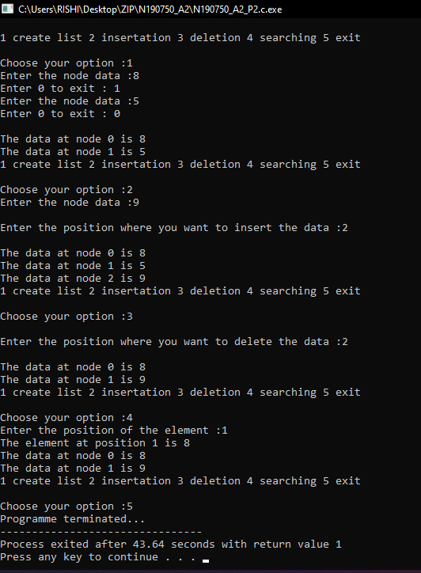

return 0;

}

**Output:**

**/* Author Name : N.Mariya Babu**

**Id No : N190750**

**Assignment Number : 2**

**programme Number : 3**

**programme Description : C Programme to creat a DLL and perform all insertion and deletion cases**

**Date : 6/28/2022 (MM/DD/YYYY)**

**certification : I hereby certify that this work is my own and none of it is the work of any other person */**

//Header Files

#include<stdio.h>

#include<stdlib.h>

// function declaration

int read(void);

int display(void);

int insertion(void);

int deletion(void);

int searching(void);

//structure creation

struct node{

struct node *previous;

int data;

struct node *next;

}*head= NULL,*p,*qtr,*r,*nn,*ptr;

// main function

int main(){

while(1){

int n;

printf("\n1 create list 2 insertion ");

printf(" 3 deletion 4 searching 5 exit \n");

printf("\nChoose your option :");

scanf("%d",&n);

switch(n){

case 1:

read();

break;

case 2:

insertion();

break;

case 3:

deletion();

break;

case 4:

searching();

break;

case 5:

exit(1);

break;

default:

printf("Invalid Syntax");

}

display();

}

}

// funcion to read the node element's

int read(){

int i =1;

while(i != 0){

nn = (struct node *)malloc(sizeof(struct node));

printf("Enter the node data :");

scanf("%d",&nn->data);

if(head == NULL){

head = nn;

nn->previous = NULL;

nn->next = NULL;

}

else{

ptr = head;

while(ptr->next !=NULL){

ptr = ptr->next;

}

nn->previous = ptr;

ptr->next = nn;

nn->next = NULL;

}

printf("Enter 0 to exit :");

scanf("%d",&i);

}

return 0;

}

// function to display the node element's

int display(){

ptr = head;

int i = 0;

while(ptr!=NULL){

printf("\nThe data at node %d is %d ",i,ptr->data);

ptr = ptr->next;

i++;

}

return 0 ;

}

//function for inserting the element at required position

int insertion(){

int x=0,y = 0,k = 1;

ptr = head;

nn = (struct node *)malloc(sizeof(struct node));

printf("Enter the node data :");

scanf("%d",&nn->data);

nn->next = NULL;

nn->previous = NULL;

while(ptr!=NULL){

ptr= ptr->next;

y++;

}

int n;

while(x==0){

printf("\nEnter the position where ");

printf("you want to insert the data :");

scanf("%d",&n);

if(n<=y+1 && n>0){

x++;

}

else{

x =0;

printf("Invalid position");

}

}

if(n==1){

nn->next = head;

head->previous = nn;

head = nn;

}else if(n==y+1){

ptr = head;

while(ptr->next != NULL){

ptr = ptr->next;

}

ptr->next = nn;

nn->previous = ptr;

}else{

ptr = head;

for(k=1;k<n;k++){

qtr = ptr;

ptr = ptr->next;

}

nn->next = ptr;

nn->previous = qtr;

ptr->previous = nn;

qtr->next = nn;

}

return 0;

}

// function to delete the element from the list

int deletion(){

int x=0,y = 0,k = 1;

ptr = head;

while(ptr!=NULL){

ptr= ptr->next;

y++;

}

int n;

while(x==0){

printf("\nEnter the position where ");

printf(" you want to delete the data :");

scanf("%d",&n);

if(n<=y && n>0){

x++;

}

else{

printf("Invalid position");

}

}

if(n==1){

ptr = head;

head = ptr->next;

head->previous = NULL;

free(ptr);

}else if(n==y){

ptr = head;

while(ptr->next != NULL){

qtr = ptr;

ptr = ptr->next;

}

qtr->next = NULL;

free(ptr);

}else{

ptr = head;

for(k=1;k<n;k++){

ptr = ptr->next;

}

ptr->previous->next = ptr->next;

ptr->next->previous = ptr->previous;

free(ptr);

}

return 0;

}

//function to get the element at required position

int searching(){

int n,i;

printf("Enter the position of the element :");

scanf("%d",&n);

ptr = head;

for(i=1;i<n;i++){

ptr=ptr->next;

}

printf("The element at position %d is %d",n,ptr->data);

ptr = head;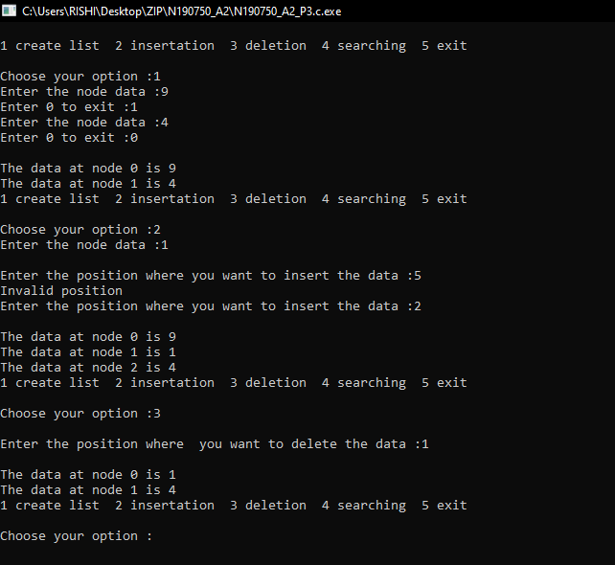

return 0;

}

**Output:**

**/* Author Name : N.Mariya Babu**

**Id No. : N190750**

**Assignment Number : 2**

**programme Number : 4**

**programme Description : C Programme to create a DLL and perform insertion and deletion at beginning and end**

**Date : 6/28/2022 (MM/DD/YYYY)**

**certification : I hereby certify that this work is my own and none of it is the work of any other person */**

//Header Files

#include<stdio.h>

#include<stdlib.h>

// function declaration

int read(void);

int display(void);

int insertion(void);

int deletion(void);

int searching(void);

//structure creation

struct node{

struct node *previous;

int data;

struct node *next;

}*head= NULL,*p,*qtr,*r,*nn,*ptr;

// main function

int main(){

while(1){

int n;

printf("\n1 create list 2 insertion ");

printf("3 deletion 4 searching 5 exit\n");

printf("\nChoose your option :");

scanf("%d",&n);

switch(n){

case 1:

read();

break;

case 2:

insertion();

break;

case 3:

deletion();

break;

case 4:

searching();

break;

case 5:

exit(1);

break;

default:

printf("Invalid Syntax");

}

display();

}

}

// funcion to read the node element's

int read(){

int i =1;

while(i != 0){

nn = (struct node *)malloc(sizeof(struct node));

printf("Enter the node data :");

scanf("%d",&nn->data);

if(head == NULL){

head = nn;

nn->previous = NULL;

nn->next = head;

}

else{

ptr = head;

while(ptr->next !=head){

ptr = ptr->next;

}

nn->previous = ptr;

ptr->next = nn;

nn->next = head;

head->previous = nn;

}

printf("Enter 0 to exit :");

scanf("%d",&i);

}

return 0;

}

// function to display the node element's

int display(){

ptr = head;

int i = 0;

while(ptr->next!=head){

printf("\nThe data at node %d is %d ",i,ptr->data);

ptr = ptr->next;

i++;

}

printf("\nThe data at node %d is %d ",i,ptr->data);

return 0 ;

}

//function for inserting the element at required position

int insertion(){

int x=0,y = 0,k = 1;

ptr = head;

nn = (struct node *)malloc(sizeof(struct node));

printf("Enter the node data :");

scanf("%d",&nn->data);

while(ptr->next!=head){

ptr= ptr->next;

y++;

}

y++;

int n;

while(x==0){

printf("\nEnter the position where ");

printf(" you want to insert the data :");

scanf("%d",&n);

if(n<=y+1 && n>0){

x++;

}

else{

x =0;

printf("Invalid position");

}

}

if(n==1){

nn->next = head;

nn->previous = head->previous;

head->previous = nn;

ptr = head;

while(ptr->next != head){

ptr = ptr->next;

}

head = nn;

ptr->next=head;

}else if(n==y+1){

ptr = head;

while(ptr->next != head){

ptr = ptr->next;

}

nn->next = head;

nn->previous = ptr;

ptr->next = nn;

head->previous = nn;

}else{

ptr = head;

for(k=1;k<n;k++){

qtr = ptr;

ptr = ptr->next;

}

nn->next = ptr;

nn->previous = qtr;

ptr->previous = nn;

qtr->next = nn;

}

return 0;

}

// function to delete the element from the list

int deletion(){

int x=0,y = 0,k = 1;

ptr = head;

while(ptr->next!=head){

ptr= ptr->next;

y++;

}

y++;

int n;

while(x==0){

printf("\nEnter the position where ");

printf("you want to delete the data :");

scanf("%d",&n);

if(n<=y && n>0){

x++;

}

else{

printf("Invalid position");

}

}

if(n==1){

ptr = head; **Output:**

while(ptr->next!=head){

ptr=ptr->next;

}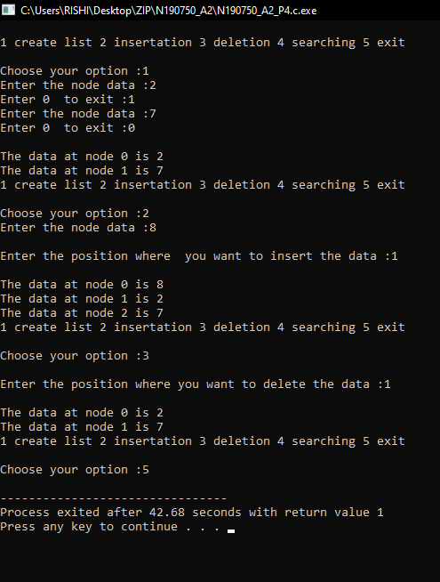

ptr->next = head->next;

head->next->previous = ptr;

ptr = head;

head = head->next;

free(ptr);

}else if(n==y){

ptr = head;

while(ptr->next != head){

qtr = ptr;

ptr = ptr->next;

}

qtr->next = head;

head->previous = qtr;

free(ptr);

}else{

ptr = head;

for(k=1;k<n;k++){

ptr = ptr->next;

}

ptr->previous->next = ptr->next;

ptr->next->previous = ptr->previous;

free(ptr);

}

return 0;

}

//function to get the element at required position

int searching(){

int n,i;

printf("Enter the position of the element :");

scanf("%d",&n);

ptr = head;

for(i=1;i<n;i++){

ptr=ptr->next;

}

printf("The element at position %d is %d",n,ptr->data);

ptr = head;

return 0;

}

**/* Author Name : N.Mariya Babu**

**Id No. : N190750**

**Assignment Number : 2**

**programme Number : 5**

**programme Description : C Programme to store polynomial in a linked list and apply add and subtract operations on 2 polynomials**

**Date : 6/28/2022 (MM/DD/YYYY)**

**certification : I hereby certify that this work is my own and none of it is the work of any other person */**

//Header Files

#include<stdio.h>

#include<stdlib.h>

//Function declaration

int read(void);

int display(void);

int add(void);

int sub(void);

//Structure definition in the global declaration

struct poly{

int coff1;

int coff2;

struct poly *next;

}*head=NULL,*ptr,*qtr,*nn;

//Main function

int main(){

int n,i = 1;

while(i!=0){

printf("\n1 read polynomial 2 add two polynomials ");

printf("3 subtract two polynomials 4 exit");

printf("\nChoose your option :");

scanf("%d",&n);

switch(n){

case 1:

read();

display();

break;

case 2:

add();

break;

case 3:

sub();

break;

case 4:

exit(1);

default:

printf("Invalid syntax!...");

}

}

}

//Function to read the coefficient of the polynomials

int read(){

int i=1,j=0;

while(i!=0){

nn = (struct poly *)malloc(sizeof(struct poly));

printf("Enter the fun1 x power %d coefficient :",j);

scanf("%d",&nn->coffs1);

printf("Enter the fun2 x power %d coefficient :",j);

scanf("%d",&nn->coff2);

j++;

if(head==NULL){

head = nn;

nn->next = NULL;

}else{

ptr = head;

while(ptr->next!=NULL){

ptr = ptr->next;

}

ptr->next = nn;

nn->next = NULL;

}

printf("0 to exit press any number for new coffercient");

scanf("%d",&i);

}

}

//Function to display the polynomial

int display(){

ptr= head;

int i = 0;

printf("\nFirst polynomial :\n");

while(ptr!=NULL){

printf("+(%d)x^ %d ",ptr->coff1,i);

ptr = ptr->next;

i++;

}

i= 0 ;

ptr = head;

printf("\nSecond polynomial :\n");

while(ptr!=NULL){

printf("+(%d)x^ %d ",ptr->coff2,i);

ptr = ptr->next;

i++;

}

}

//Function to add the polynomials

int add(){

ptr = head;

int i = 0 ;

printf("\n The addition of the two polynomials is :\n'");

while(ptr!=NULL){

printf("+(%d)x^ %d ",ptr->coff1+ptr->coff2,i);

ptr = ptr->next;

i++;

}

return 0;

}

//Function to subtract the polynomials

int sub(){

ptr = head;

int i = 0 ;

printf("\n The addition of the two polynomials is :\n'");

while(ptr!=NULL){

printf("+(%d)x^ %d ",ptr->coff1-ptr->coff2,i);

ptr = ptr->next;

i++;

}

return 0;

}

**Output:**

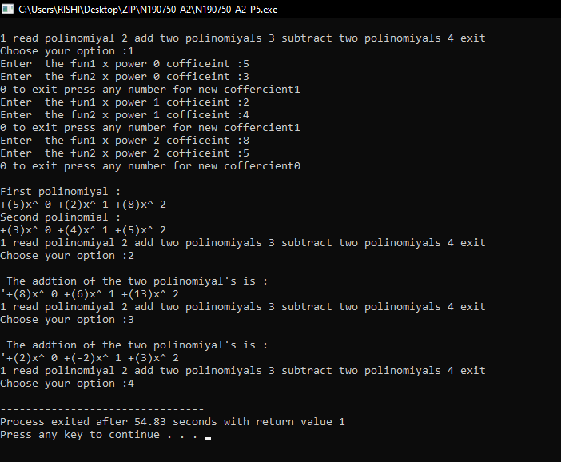

/*

Author Name : N.Mariya Babu

Id No. : N190750

Assignment Number : 2

programme Number : 6

programme Description : C Programme to sort the numbers given in a LL

Date : 6/28/2022 (MM/DD/YYYY)

certification : I hereby certify that this work is my own and none of it is the work of any other person

*/

//Header Files

#include<stdio.h>

#include<stdlib.h>

// function declaration

int read(void);

int display(void);

int sorting(void);

//structure creation

struct node{

int data;

struct node *next;

}*head= NULL,*p,*qtr,*r,*nn,*ptr;

// main function

int main(){

while(1){

int n;

printf("\n1 create list 2 exit");

printf("\nChoose your option :");

scanf("%d",&n);

if(n==1){

read();

printf("Data before sorting !\n");

display();

printf("Data after sorting !\n");

sorting();

display();

}

else if(n==2){

exit(1);

}

else{

printf("invalid..");

}

}

}

// funcion to read the node element's

int read(){

int i =1;

while(i != 0){

nn = (struct node *)malloc(sizeof(struct node));

printf("Enter the node data :");

scanf("%d",&nn->data);

if(head == NULL){

head = nn;

nn->next = NULL;

}

else{

ptr = head;

while(ptr->next !=NULL){

ptr = ptr->next;

}

ptr->next = nn;

nn->next = NULL;

}

printf("Enter 0 to exit :");

scanf("%d",&i);

}

return 0;

}

// function to display the node element's

int display(){

ptr = head;

int i = 0;

while(ptr!=NULL){

printf("\nThe data at node %d is %d ",i,ptr->data);

ptr = ptr->next;

i++;

}

return 0 ;

}

//Function to sort the element's

int sorting(){

int temp = 0;

ptr =head;

while(ptr!=NULL){

qtr = ptr->next;

while(qtr!=NULL){

if(ptr->data > qtr->data){

temp = ptr->data;

ptr->data = qtr->data;

qtr->data = temp;

}

qtr = qtr->next;

}

ptr= ptr->next;

}

return 0;

}

**Output:**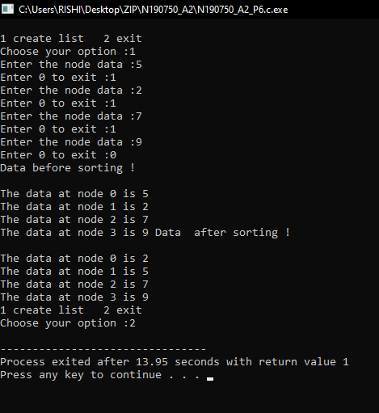

**/* Author Name : N.Mariya Babu**

**Id No. : N190750**

**Assignment Number : 2**

**programme Number : 7**

**programme Description : C Programme to create LL which stores details of students**

**and print the names of the students who got first class**

**Date : 6/28/2022 (MM/DD/YYYY)**

**certification : I hereby certify that this work is my own and none of it is the work of any other person**

**\***/

//Header Files

#include<stdio.h>

#include<stdlib.h>

//Function declaration

int read(void);

int display(void);

int rank(void);

//structure declaration

struct student{

char name[50];

int marks;

struct student *next;

}*head=NULL,*nn,*ptr,*qtr;

//main function

int main(){

printf("Hello World!\n");

read();

display();

rank();

}

//Function to read the student details

int read(){

int i=1;

printf("Enter the student details :\n");

while(i==1){

nn = (struct student *)malloc(sizeof(struct student));

printf("Enter the student name :");

scanf("%s",nn->name);

printf("Enter the student marks :");

scanf("%d",&nn->marks);

if(head==NULL){

head = nn;

nn->next = NULL;

}else{

ptr = head;

while(ptr->next!=NULL){

ptr = ptr->next;

}

ptr->next = nn;

nn->next = NULL;

}

printf("Press 0 to exit :");

scanf("%d",&i);

}

return 0;

}

// Function to display the student details

int display(){

int i = 0;

ptr = head;

while(ptr!=NULL){

printf("The student %d name is %s ",i,ptr->name);

printf("and marks are %d \n",ptr->marks);

ptr = ptr->next;

i++;

}

return 0;

}

//Function to display the rank

int rank(){

int fc;

printf("Enter the required mark to get first class :");

scanf("%d",&fc);

ptr = head;

while(ptr!=NULL){

if(ptr->marks>=fc){

printf("%s got the first class \n",ptr->name);

}

ptr = ptr->next;

}

return 0;

}

**Output:**

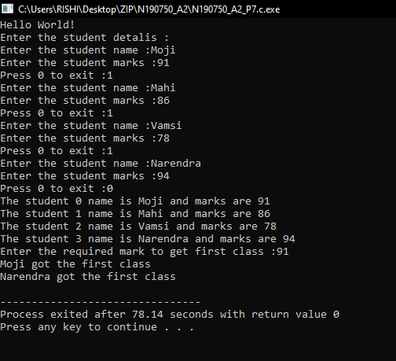

**LAB-3**

**LAB-3**

**/* Author Name : N.Mariya Babu**

**Id No. : N190750**

**Assignment Number : 3**

**programme Number : 1**

**programme Description : C Programme to perform push,pop and peek operations on a stack using arrays**

**Date : 7/12/2022 (MM/DD/YYYY)**

**certification : I hereby certify that this work is my own and none of it is the work of any other person */**

//Header file's section

#include<stdio.h>

#include<stdlib.h>

//Global declaration

#define N 20

int Stack[N];

int top = -1;

//Function declaration section

int push(void);

int pop(void);

int peek(void);

int display(void);

//Main function

int main(){

while(1){

int n;

printf("\n1 push 2 pop 3peek element 4 exit\n");

printf("Enter your option :");

scanf("%d",&n);

switch(n){

case 1:

push();

break;

case 2:

pop();

break;

case 3:

peek();

break;

case 4:

exit(1);

break;

default:

printf("Invalid Syntax");

}

display();

}

}

//Function to read the element's

int push(){

int i=1;

while(i !=0){

if(top==N-1){

printf("Over Flow");

}else{

int n;

top++;

printf("Enter the element :");

scanf("%d",&n);

Stack[top] = n;

}

printf("Press any key to continue 0 to exit");

scanf("%d",&i);

}

return 0;

}

//Function to pop the top element

int pop(){

if(top==-1){

printf("Under Flow");

}else{

int item;

item = Stack[top];

printf("The popped item is %d\n",item);

top--;

}

return 0;

}

//Function to display the peek element

int peek(){

printf("The peek element is %d\n",Stack[top]);

}

//Function to display the element's

int display(){

int i;

if(top== -1){

printf("Under Flow\n");

}else{

for(i=0;i<=top;i++){

printf("%d ",Stack[i]);

}

printf("\n");

}

return 0;

}

**Output:**

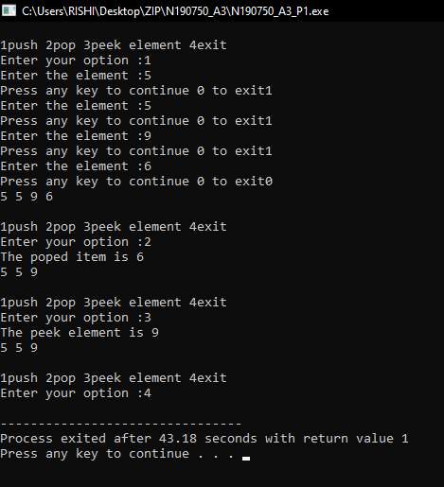

**/* Author Name : N.Mariya Babu**

**Id No. : N190750**

**Assignment Number : 3**

**programme Number : 2**

**programme Description : C Programme to implement stack using linked list**

**Date : 7/12/2022 (MM/DD/YYYY)**

**certification : I hereby certify that this work is my own and none of it is the work of any other person */**

//Header file's section

#include<stdio.h>

#include<stdlib.h>

//Structure Definition section

struct stack{

int data;

struct stack *next;

}*head=NULL,*ptr,*qtr,*nn,*top,*temp=NULL;

//Function declaration section

int push(void);

int pop(void);

int peek(void);

int display(void);

//Main function

int main(){

while(1){

int n;

printf("\n1.push 2.pop 3.peek element 4.exit\n");

printf("Enter your option :");

scanf("%d",&n);

switch(n){

case 1:

push();

break;

case 2:

pop();

break;

case 3:

peek();

break;

case 4:

exit(1);

break;

default:

printf("Invalid Syntax");

}

display();

}

return 0;

}

//Function to read the element's

int push(){

int i=1;

while(i){

nn = (struct stack *)malloc(sizeof(struct stack));

printf("Enter the data :");

scanf("%d",&nn->data);

nn->next = NULL;

//top = nn;

if(head==NULL){

head = nn;

top = nn;

}else{

ptr = top;

top = nn;

top->next = ptr;

}

printf("Press 0 to exit : ");

scanf("%d",&i);

}

return 0;

}

//Function to pop the top element

int pop(){

int item;

item = top->data;

temp = top;

top = top->next;

free(temp);

printf("The popped item is %d\n",item);

return item;

}

//Function to display the peek element

int peek(){

printf("The peek element is %d\n ",top->data);

return top->data;

}

//Function to display the elements in the stack

int display(){

temp = top;

while(temp!=NULL){

printf("%d\t",temp->data);

temp = temp->next;

}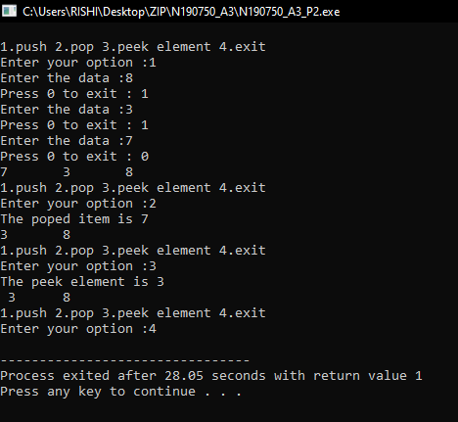

return 0;

}

**Output:**

**/* Author Name : N.Mariya Babu**

**Id No. : N190750**

**Assignment Number : 3**

**programme Number : 3**

**programme Description : C Programme to reverse the contents of stack**

**Date : 7/12/2022 (MM/DD/YYYY)**

**certification : I hereby certify that this work is my own and none of it is the work of any other person */**

//Header Files

#include<stdio.h>

#include<stdlib.h>

#define N 20

//Stack definition

int stack[N];

int top = -1;

//Function to push the element's into the stack

int push(int x){

if(top==N-1){

return 0;

}

stack[++top] = x;

}

//Function to pop the element from the stack

int pop(){

if(top==-1){

return 0;

}

return stack[top--];

}

//Function to display the stack content

int display(){

int i;

for(i=top;i>=0;i--){

printf("%d ",stack[i]);

}

return 0;

}

//Function to display the peek element

int peek(){

printf("\n The peek element : %d\n",stack[top]);

}

//Queue definition

int queue[N];

int front=-1,rare=-1;

//Function to insert the data into the queue

int enqueue(int x){

if(front==-1 && rare==-1){

front=rare=0;

queue[rare] = x;

}

else if((rare+1)%N==front){

return 0;

}

else{

rare = (rare+1)%N;

queue[rare] = x;

}

}

//Function to delete the element from the stack

int dequeue(){

int item;

if(front==-1 && rare==-1){

return -1;

}

else if(front==rare){

item = queue[front];

front=rare=-1;

return item;

}

else{

item = queue[front];

front = (front+1)%N;

return item;

}

}

//Function to reverse the stack

int stack_reversing(){

while(top>=0){

int x = pop();

enqueue(x);

}

while(rare!=-1){

push(dequeue());

}

}

//Main Function

int main(){

int data;

int opt;

while(1){

printf("\n1.push 2.pop 3.reverse stack");

printf(" 4.peek 5.exit\n");

printf("Choose your option :");

scanf("%d",&opt);

if(opt==1){

printf("Enter the data :");

scanf("%d",&data);

push(data);

}else if(opt==2){

pop();

}else if(opt==3){

stack_reversing();

}else if(opt==4){

peek();

}else if(opt==5){

exit(1);

}

display();

}

}

**Output:**

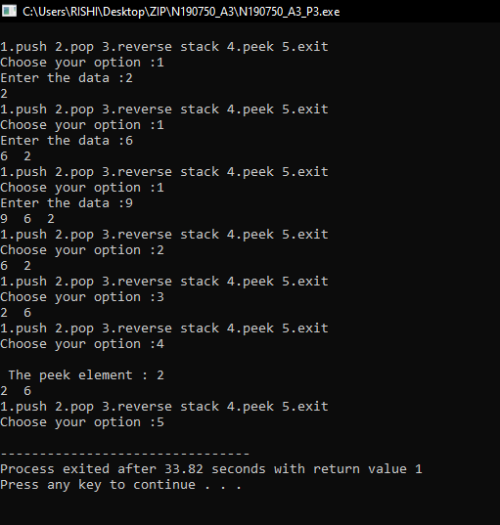

**/* Author Name : N.Mariya Babu**

**Id No. : N190750**

**Assignment Number : 3**

**programme Number : 4**

**programme Description : C Programme to check the nesting of parentheses**

**Date : 7/12/2022 (MM/DD/YYYY)**

**certification : I hereby certify that this work is my own and none of it is the work of any other person */**

//Header Files

#include<stdio.h>

#include<string.h>

#include<stdlib.h>

//Macros

#define MAX 30

//Stack Definition

int stack[MAX];

int top=-1;

//Function definition

void push(char);

char pop();

int match(char a,char b);

int check(char []);

int main()

{

char exp[MAX];

int valid;

printf("Enter an algebraic expression : ");

gets(exp);

valid=check(exp);

if(valid==1)

printf("Valid expression\n");

else

printf("Invalid expression\n");

return 0;

}

int check(char exp[] ){

int i;

char temp;

for(i=0;i<strlen(exp);i++){

if(exp[i]=='(' || exp[i]=='{' || exp[i]=='[')

push(exp[i]);

if(exp[i]==')' || exp[i]=='}' || exp[i]==']')

if(top==-1){ /*stack empty*/

printf("Right parentheses are more \n");

return 0;

}

else{

temp=pop();

if(!match(temp, exp[i])){

printf("Mismatched parentheses are : ");

printf("%c and %c\n",temp,exp[i]);

return 0;

}

}

}

if(top==-1){

/*stack empty*/

printf("Balanced Parentheses\n");

return 1;

}

else{

printf("Left parentheses are more \n");

return 0;

}

}/*End of main()*/

int match(char a,char b){

if(a=='[' && b==']')

return 1;

if(a=='{' && b=='}')

return 1;

if(a=='(' && b==')')

return 1;

return 0;

}/*End of match()*/

void push(char item){

if(top==(MAX-1)){

printf("Stack Overflow\n");

return;

}

top=top+1;

stack[top]=item;

}/*End of push()*/

char pop(){

if(top==-1){

printf("Stack Underflow\n");

exit(1);

}

return(stack[top--]);

}/*End of pop()*/

**Output:**

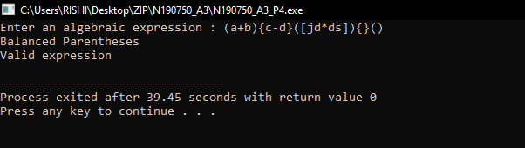

**/* Author Name : N.Mariya Babu**

**Id No. : N190750**

**Assignment Number : 3**

**programme Number : 5_1**

**programme Description : C Programme to convert infix to postfix**

**Date : 7/12/2022 (MM/DD/YYYY)**

**certification : I hereby certify that this work is my own and none of it is the work of any other person */**

//Header Files section

#include<stdio.h>

#include<ctype.h>

//Definition section

# define N 20

//stack declaration

char stack[N];

int top = -1;

//Function to push the element

int push(char op){

stack[++top] = op;

}

//Function to pop the element

char pop(){

if(top==-1){

return -1;

}

return stack[top--];

}

//Functio for presidence

int prec(char op){

if(op=='('){

return 0;

}

if(op=='+'||op=='-'){

return 1;

}

if(op=='*'||op=='/'){

return 2;

}

if(op=='^'){

return 3;

}

return 0;

}

//Function to to perform infix to postfix

char* Infix_To_Postfix(char *exp){

int k=0;

static char postfix[50];

char *e;

e = exp;

while(*e!=NULL){

if(isalnum(*e)){

postfix[k++] = *e;

}

else if(*e=='('){

push(*e);

}

else if(*e==')'){

while(stack[top]!='('){

postfix[k++] = pop();

}

pop();

}

else{

while(prec(stack[top]) >= prec(*e))

postfix[k++] = pop();

push(*e);

}

e++;

}

while(top!=-1){

postfix[k++] = pop();

}

printf("The postfix exp is %s ",postfix);

return postfix;

}

//Mani function

int main(){ char exp[50],*postfix;

printf("Enter the infix expression :");

scanf("%s",exp);

postfix = Infix_To_Postfix(exp);

}

**Output:**

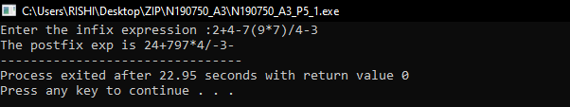

**/* Author Name : N.Mariya Babu**

**Id No. : N190750**

**Assignment Number : 3**

**programme Number : 5_2**

**programme Description : C Programme to convert infix to prefix**

**Date : 7/12/2022 (MM/DD/YYYY)**

**certification : I hereby certify that this work is my own and none of it is the work of any other person**

**\*/**

//Header Files section

#include<stdio.h>

#include<ctype.h>

#include<string.h>

//Definition section

# define N 20

//stack declaration

char stack[N];

int top = -1;

//Function to push the element

int push(char op){

stack[++top] = op;

}

//Function to pop the element

char pop(){

if(top==-1){

return -1;

}

return stack[top--];

}

//Functio for presidence

int prec(char op){

if(op==')'){

return 0;

}

if(op=='+'||op=='-'){

return 1;

}

if(op=='*'||op=='/'){

return 2;

}

if(op=='^'){

return 3;

}

return 0;

}

//Function to to perform infix to postfix

char* Infix_To_Prefix(char *exp){

int k=0;

static char postfix[50];

char *e;

e = exp;

while(*e!=NULL){

if(isalnum(*e)){

postfix[k++] = *e;

}

else if(*e==')'){

push(*e);

}

else if(*e=='('){

while(stack[top]!=')'){

postfix[k++] = pop();

}

pop();

}

else{

while(prec(stack[top]) > prec(*e))

postfix[k++] = pop();

push(*e);

}

e++;

}

while(top!=-1){

postfix[k++] = pop();

}

//printf("\nThe postfix exp is %s ",postfix);

return postfix;

}

//Mani function

int main(){

char exp[50],*prefix;

printf("Enter the infix expression :");

gets(exp);

prefix = Infix_To_Prefix(strrev(exp));

prefix = strrev(prefix);

printf("\nThe prefix expression is : \n%s",prefix);

}

**Output:**

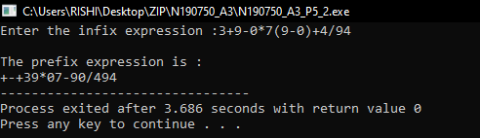

**/* Author Name : N.Mariya Babu**

**Id No. : N190750**

**Assignment Number : 3**

**programme Number : 6**

**programme Description : C Programme to evaluate a postfix and prefix expressions**

**Date : 7/12/2022 (MM/DD/YYYY)**

**certification : I hereby certify that this work is my own and none of it is the work of any other person**

**\*/**

//Header Files

#include<stdio.h>

#include<ctype.h>

#include<string.h>

#define n 50

//Stack definition

int stack[n];

int top = -1,b;

//Function to push the element's into the stack

int push(int x){

stack[++top] = x;

}

//Function to pop the element's from the stack

int pop(){

if(top==-1){

return -1;

}

return stack[top--];

}

//Function to evaluate the postfix expression

int Postfix_Evaluation(char *exp){

int num,n1,n2,n3;

char *e;

e = exp;

while(*e!=NULL){

if(isdigit(*e)){

num = *e-48;

// printf("%d",num);

push(num);

}

else{

if(b==2){

n2 = pop();

n1 = pop();

}

else{

n1 = pop();

n2 = pop();

}

switch(*e){

case '+':

n3 = n1+n2;

break;

case '-':

n3 = n2 - n1;

break;

case '*':

n3 = n2 * n1;

break;

case '/':

n3 = n2/n1;

break;

case '^':

n3 = n1^n2;

break;

}

push(n3);

}

e++;

}

int x = pop();

return x;

}

//Main Function

int main(){

char exp[50];

int result=1;

printf("Enter 1.postfix expression 2.prefix expression\n");

scanf("%d",&b);

if(b==1){

printf("Enter the postfix expression :");

scanf("%s",exp);

result = Postfix_Evaluation(exp);

}

else if(b==2){

printf("Enter the prefix expression :");

scanf("%s",exp);

result = Postfix_Evaluation(strrev(exp));

}

printf("The result of the expression is %d",result);

}

**Output:**

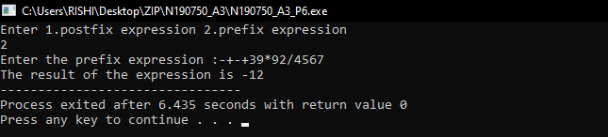

**LAB-4**

**/* Author Name : N.Mariya Babu**

**Id No. : N190750**

**Assignment Number : 4**

**programme Number : 1**

**programme Description : C Programme to implement queue using linked list**

**Date : 7/18/2022 (MM/DD/YYYY)**

**certification : I hereby certify that this work is my own and none of it is the work of any other person */**

#include<stdio.h>

#include<stdlib.h>

//Structure definition

struct queue{

int data;

struct queue *next;

}*head=NULL,*tail=NULL,*nn,*ptr;

//Enqueue Operation

int enqueue(){

nn = (struct queue*) malloc (sizeof(struct queue));

printf("Enter the node data :");

scanf("%d",&nn->data);

if(head==NULL && tail==NULL){

head=tail=nn;

nn->next = NULL;

}

else{

tail->next=nn;

tail=nn;

nn->next = NULL;

}

}

//Dequeue Function

int dequeue(){

int item = head->data;

if(head==tail){

head=tail=NULL;

return item;

}

else{

ptr = head;

head=head->next;

return item;

}

}

//Display Function

int display(){

ptr = head;

while(ptr!=NULL){

printf("%d\t",ptr->data);

ptr = ptr->next;

}

return 0;

}

//Main Function

int main(){

int opt;

printf("Queue implementation using linked list");

while(1){

printf("\n1.enqueue 2.dequeue 3.exit ");

printf("\nEnter your option :");

scanf("%d",&opt);

switch(opt){

case 1:

enqueue();

break;

case 2:

dequeue();

break;

case 3:

exit(1);

default:

printf("Invalid Option....");

}

display();

}

return 0;

}

**Output:**

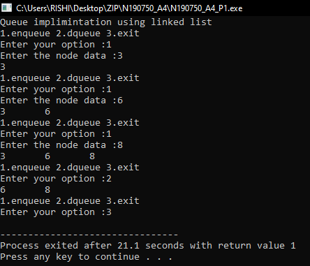

**/* Author Name : N.Mariya Babu**

**Id No. : N190750**

**Assignment Number : 4**

**programme Number : 2**

**programme Description : C Programme to implement queue using array**

**Date : 7/18/2022 (MM/DD/YYYY)**

**certification : I hereby certify that this work is my own and none of it is the work of any other person */**

#include<stdio.h>

#include<stdlib.h>

#define N 20

//Queue definition

int queue[N];

int rare=-1,front=-1;

//Enqueue Function

int enqueue(int x){

if(front==-1 && rare==-1){

front=rare=0;

queue[rare] = x;

}

else if(rare==N-1){

printf("Overflow..");

}

else{

queue[++rare] = x;

}

return 0;

}

//Dequeue Function

int dequeue(){

int item = queue[front];

if(front==-1 && rare==-1){

printf("UnderFlow..");

return -1;

}

else if(front==rare){

front=rare=-1;

return item;

}else{

front++;

return item;

}

}

//Display Function

int display(){

int i;

for(i=front;i<=rare;i++){

printf("%d\t",queue[i]);

}

return 0;

}

//Main Function

int main(){

int opt,data;

while(1){

printf("\n1.enqueue 2.dequeue 3.exit \n");

printf("Choose your option :");

scanf("%d",&opt);

if(opt==1){

printf("Enter the data into the queue :");

scanf("%d",&data);

enqueue(data);

}

else if(opt==2){

printf("The deleted element is %d \n",dequeue());

}

else if(opt==3){

exit(1);

}

else{

printf("Invalid...");

}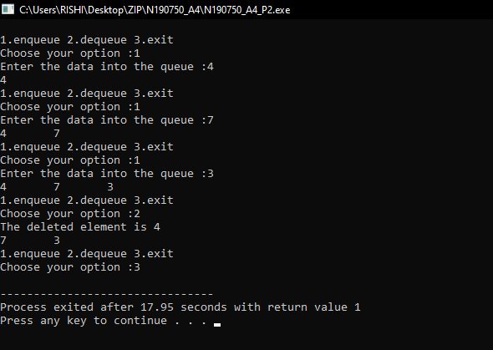

display();

}

}

**Output:**

**/* Author Name : N.Mariya Babu**

**Id No. : N190750**

**Assignment Number : 4**

**programme Number : 3**

**programme Description : C Programme to implement queue using circular array**

**Date : 7/18/2022 (MM/DD/YYYY)**

**certification : I hereby certify that this work is my own and none of it is the work of any other person */**

#include<stdio.h>

#include<stdlib.h>

#define N 20

//Queue definition

int queue[N];

int rare=-1,front=-1;

//Enqueue Function

int enqueue(int x){

if(front==-1 && rare==-1){

front=rare=0;

queue[rare] = x;

}

else if((rare+1)%N==front){

printf("Overflow..");

}

else{

rare = (rare+1)%N;

queue[rare] = x;

}

return 0;

}

//Dequeue Function

int dequeue(){

int item = queue[front];

if(front==-1 && rare==-1){

printf("UnderFlow..");

return -1;

}

else if(front==rare){

front=rare=-1;

return item;

}else{

front = (front+1)%N;

return item;

}

}

//Display Function

int display(){

int i=front;

while(i!=(rare+1)){

printf("%d\t",queue[i]);

i = (i+1)%N;

}

return 0;

}

//Main Function

int main(){

int opt,data;

while(1){

printf("\n1.enqueue 2.dequeue 3.exit\n");

printf("Choose your option :");

scanf("%d",&opt);

if(opt==1){

printf("Enter the data into the queue :");

scanf("%d",&data);

enqueue(data);

}

else if(opt==2){

printf("The deleted element is %d \n",dequeue());

}

else if(opt==3){

exit(1);

}

else{

printf("Invalid...");

}

display();

}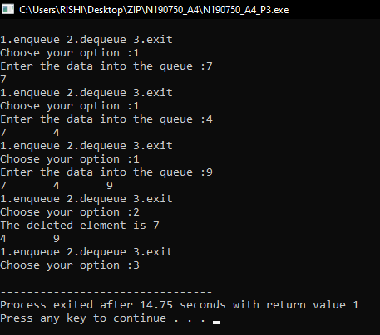

}

**Output:**

**/* Author Name : N.Mariya Babu**

**Id No. : N190750**

**Assignment Number : 4**

**programme Number : 4**

**programme Description : C Programme to implement queue which permits insertion and deletion at both the ends**

**Date : 7/18/2022 (MM/DD/YYYY)**

**certification : I hereby certify that this work is my own and none of it is the work of any other person */**

//Header Files

#include<stdio.h>

#include<stdlib.h>

#define N 5

//Queue definition

int queue[N];

int front=-1,rare=-1;

//Enqueue from the front of the queue

int EnqueueFront(int x = 10){

if(front==-1 && rare==-1){

front=rare=0;

queue[front] = x;

}

else if(front==0){

if(rare==N-1){

printf("OverFlow");

}

else{

front=N-1;

queue[front] = x;

}

}

else {

if(((front-1)%N)==rare){

printf("OverFlow");

}

else{

front = (front-1)%N;

queue[front] = x;

}

}

}

//Enqueue from the rare of the queue

int EnqueueRare(int x = 5){

if(front==-1 && rare==-1){

rare = front = 0;

queue[rare] = x;

}

else if((rare+1)%N==front){

printf("Overflow..");

}

else{

rare = (rare+1)%N;

queue[rare] = x;

}

return 0;

}

//Dequeue the element from the front

int DequeueFront(){

int item;

item = queue[front];

if(front==-1 && rare==-1){

printf("Under Flow...");

}

else if(front==rare){

printf("\nThe Dequeued item is : %d ",item);

front=rare=-1;

return item;

}

else{

front = (front+1)%N;

printf("\nThe Dequeued item is %d : \n",item);

return item;

}

}

//Dequeue the element from the rare of the queue

int DequeueRare(){

int item;

item = queue[rare];

if(front==-1 && rare==-1){

printf("UnderFlow...");

}

else if(front==rare){

front=rare=-1;

printf("\nThe Dequeued item is %d : \n",item);

return item;

}

else if(rare==0){

rare = N-1;

printf("\nThe Dequeued item is %d : \n",item);

return item;

}

else{

rare = (rare-1)%N;

printf("\nThe Dequeued item is %d : \n",item);

return item;

}

}

//Display the content of the queue

int display(){

int i;

i = front;

while(i!=rare){

printf("%d\t",queue[i]);

i = (i+1)%N;

}

printf("%d\t",queue[i]);

return 0;

}

//Main Function

int main(){

int opt,data;

printf("Double Ended queue data structure ");

while(1){

printf("\n1.EnqueueFront 2.EnqueueRare ");

printf(" 3.DequeueFront 4.DequeueRare 5.exit \n");

printf("Enter your option :");

scanf("%d",&opt);

if(opt==1){

printf("Enter data to insert from front of the queue :");

scanf("%d",&data);

EnqueueFront(data);

}

else if(opt==2){

printf("Enter data to insert from rare of the queue :");

scanf("%d",&data);

EnqueueRare(data);

}

else{

switch(opt){

case 3:

DequeueFront();

break;

case 4:

DequeueRare();

break;

case 5:

exit(1);

default:

printf("Invalid option...");

}

}

display();

}

}

**Output:**

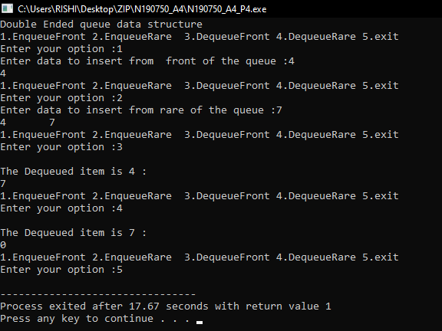

**LAB-5**

**/* Author Name : N.Mariya Babu**

**Id No. : N190750**

**Assignment Number : 5**

**programme Number : 1**

**programme Description : C Programme to find an Element using LinearSearch**

**Date : 7/19/2022 (MM/DD/YYYY)**

**certification : I hereby certify that this work is my own and none of it is the work of any other person */**

//Header Files

#include<stdio.h>

//Function definition section

int read(int*,int);

int LinearSearch(int*,int,int);

//Main function

int main(){

int n,key;

printf("LinearSearch implementation....\n");

printf("Enter the size of the array :");

scanf("%d",&n);

int arr[n];

read(arr,n);

printf("Enter the search element :");

scanf("%d",&key);

LinearSearch(arr,key,n);

}

//Read Function

int read(int arr[],int n){

for(int i=0;i<n;i++){

printf("a[%d] :",i);

scanf("%d",&arr[i]);

}

}

//LinearSearch Function

int LinearSearch(int arr[],int key,int n){

int i,flag=0;

for(i=0;i<n;i++){

if(arr[i]==key){

printf("Search key is found at the index : %d",i);

flag++;

return i;

}

}

if(flag==0){

printf("Element not present...");

return -1;

}

}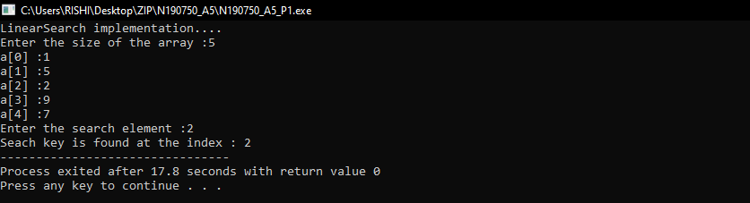

**Output:**

**/* Author Name : N.Mariya Babu**

**Id No. : N190750**

**Assignment Number : 5**

**programme Number : 2**

**programme Description : C Programme to find an Element using Binary Search without recursion**

**Date : 7/19/2022 (MM/DD/YYYY)**

**certification : I hereby certify that this work is my own and none of it is the work of any other person */**

//Header Files

#include<stdio.h>

//Function definition section

int read(int*,int);

int BinarySearch(int*,int,int);

//Main function

int main(){

int n,key;

printf("...BinarySearch without using the recursion \n");

printf("Enter the size of the array :");

scanf("%d",&n);

int arr[n];

read(arr,n);

printf("Enter the searching element :");

scanf("%d",&key);

BinarySearch(arr,key,n);

}

//Read Function

int read(int arr[],int n){

int i;

printf("..Enter Elements in sorted order..");

for(i=0;i<n;i++){

printf("arr[%d] :",i);

scanf("%d",&arr[i]);

}

}

//Binary Search

int BinarySearch(int arr[],int key,int n){

int start=0,end=n;

int flag = 0;

while(start<=end){

int mid = (start+end)/2;

if(arr[mid]==key){

printf("Search element is found at the index : %d",mid);

flag++;

return mid;

}

else if(arr[mid]<key){

start = mid+1;

}

else{

end = mid-1;

}

}

if(flag==0){

printf("Search element is not found....");

}

}

**Output:**

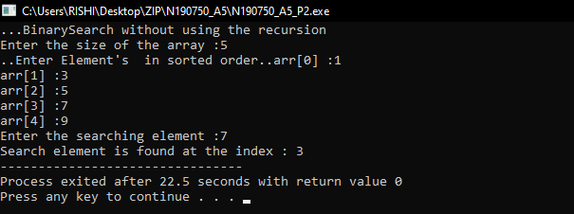

**/* Author Name : N.Mariya Babu**

**Id No. : N190750**

**Assignment Number : 5**

**programme Number : 3**

**programme Description : C Programme to implement the BinarySearch using the Recursion**

**Date : 7/19/2022 (MM/DD/YYYY)**

**certification : I hereby certify that this work is my own and none of it is the work of any other person */**

#include<stdio.h>

//Function definition section

int read(int*,int);

int BinarySearch(int*,int,int,int);

//Main function

int main(){

int n,key;

printf("...BinarySearch with using the recursion...\n");

printf("Enter the size of the array :");

scanf("%d",&n);

int arr[n];

read(arr,n);

printf("Enter the search element :");

scanf("%d",&key);

BinarySearch(arr,0,n,key);

}

//Function to read the element's from the array

int read(int arr[],int n){

int i;

printf("..Enter elements in sorted order..");

for(i=0;i<n;i++){

printf("arr[%d] :",i);

scanf("%d",&arr[i]);

}

}

//Function to search the given element

int BinarySearch(int arr[],int start,int end,int key){

int mid = (start+end)/2;

if(start<=end){

if(arr[mid]==key){

printf("The search key is found at the index : %d",mid);

return mid;

}

else if(arr[mid]<key){

BinarySearch(arr,mid+1,end,key);

}

else{

BinarySearch(arr,start,mid-1,key);

}

}

else{

printf("Element was not found...");

return 0;

}

}

**Output:**

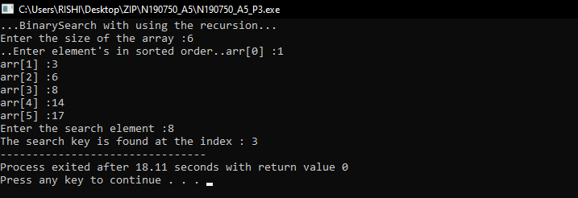

**LAB-6**

**/\***

**Author Name : N.Mariya Babu**

**Id No. : N190750**

**Assignment Number : 6**

**programme Description : 1**

**programme Description : C Programme to implement Selection Sort**

**Date : 8/2/2022 (MM/DD/YYYY)**

**certification : I hereby certify that this work is my own and none of it is the work of any other person**

**\*/**

//Header file section

#include<stdio.h>

//Function definition section

int read(int*,int);

int display(int*,int);

int SelectionSort(int*,int);

//Main function

int main(){

printf(".....Selection Sort.....\n");

int n;

printf("Enter the size of the array :");

scanf("%d",&n);

int arr[n];

read(arr,n);

printf("Array before sorting \n");

display(arr,n);

printf("Array after sorting \n");

SelectionSort(arr,n);

display(arr,n);

}

//Function to read the array element's

int read(int arr[],int n){

int i;

printf("Enter the array element's \n");

for(i=0;i<n;i++){

printf("arr[%d] :",i);

scanf("%d",&arr[i]);

}

return 0;

}

//Function to display the array element's

int display(int arr[],int n){

int i;

for(i=0;i<n;i++){

printf("%d\t",arr[i]);

}

printf("\n");

}

//Function to implement the selection sort

int SelectionSort(int arr[],int n){

int i,j,min_index,temp;

for(i=0;i<n;i++){

min_index = i;

for(j=i+1;j<n;j++){

if(arr[min_index]>arr[j]){

min_index = j;

}

}

temp = arr[i];

arr[i] = arr[min_index];

arr[min_index] = temp;

}

}

**Output:**



**/* Author Name : N.Mariya Babu**

**Id No. : N190750**

**Assignment Number : 6**

**programme Description : 2**

**programme Description : C Programme to implement Merge Sort**

**Date : 8/2/2022 (MM/DD/YYYY)**

**certification : I hereby certify that this work is my own and none of it is the work of any other person */**

//Headfiles section

#include<stdio.h>

//Function definition section

int read(int*,int);

int display(int*,int);

int MergeSort(int*,int,int);

int merge(int*,int,int,int);

//Main Function

int main(){

printf(" MergeSort Technique \n");

int n;

printf("Enter the array size :");

scanf("%d",&n);

int arr[n];

read(arr,n);

printf("\nArray before sorting \n");

display(arr,n);

printf("\nArray after sorting \n");

MergeSort(arr,0,n-1);

display(arr,n);

}

//Read function

int read(int arr[],int n){

int i;

printf("\nEnter array element's :\n");

for(i=0;i<n;i++){

printf("arr[%d] : ",i);

scanf("%d",&arr[i]);

}

return 0;

}

//Display function

int display(int arr[],int n){

int i;

for(i=0;i<n;i++){

printf("%d\t",arr[i]);

}

printf("\n");

return 0;

}

//MergeSort function

int MergeSort(int arr[],int s,int e){

int mid = (s+e)/2;

if(s<e){

MergeSort(arr,s,mid);

MergeSort(arr,mid+1,e);

merge(arr,s,mid,e);

}

return 1;

}

//Merging the element's of the array

int merge(int arr[],int s,int mid,int e){

int b[e];

int i=s,j=mid+1,k=s;

while(i<=mid && j<=e){

if(arr[i]<arr[j]){

b[k++] = arr[i++];

}

else{

b[k++] = arr[j++];

}

}

if(i>mid){

while(j<=e){

b[k++] = arr[j++];

}

}

else{

while(i<=mid){

b[k++] = arr[i++];

}

}

for(i=s;i<=e;i++){

arr[i] = b[i];

}

return 0;

}

**Output:**



**/* Author Name : N.Mariya Babu**

**Id No. : N190750**

**Assignment Number : 6**

**programme Description : 3**

**programme Description : C Programme to implement Quick Sort**

**Date : 8/2/2022 (MM/DD/YYYY)**

**certification : I hereby certify that this work is my own and none of it is the work of any other person */**

//Header Files section

#include<stdio.h>

//Function definition section

int read(int*,int);

int display(int*,int);

int swap(int*,int*);

int QuickSort(int*,int,int);

int partition(int*,int,int);

//Main Function

int main(){

printf(" QuickSort Technique \n");

int n;

printf("Enter the array size :");

scanf("%d",&n);

int arr[n];

read(arr,n);

printf("\nArray before sorting \n");

display(arr,n);

printf("\nArray after sorting \n");

QuickSort(arr,0,n-1);

display(arr,n);

}

//Read function

int read(int arr[],int n){

int i;

printf("\nEnter array element's :\n");

for(i=0;i<n;i++){

printf("arr[%d] : ",i);

scanf("%d",&arr[i]);

}

return 0;

}

//Display function

int display(int arr[],int n){

int i;

for(i=0;i<n;i++){

printf("%d\t",arr[i]);

}

return 0;

}

//Quick Sort function

int QuickSort(int arr[],int lb,int ub){

int loc;

if(lb<ub){

loc = partition(arr,lb,ub);

QuickSort(arr,lb,loc-1);

QuickSort(arr,loc+1,ub);

}

}

//Partition function

int partition(int arr[],int lb,int ub){

int pivot=arr[lb];

int s = lb;

int e = ub;

while(s<e){

while(pivot>=arr[s]){

s++;

}

while(pivot<arr[e]){

e--;

}

if(s<e){

swap(&arr[s],&arr[e]);

}

}

swap(&arr[lb],&arr[e]);

return e;

}

//Function to swap the given element's

int swap(int *ptr,int *qtr){

int temp;

temp = *ptr;

*ptr = *qtr;

*qtr = temp;

}

**Output:**



**LAB-7**

**/* Author Name : N.Mariya Babu**

**Id No. : N190750**

**Assignment Number : 7(BST)**

**programme Number : 1**

**programme Description : C Programme to create BST and Insertion,deletion,3 traversal**

**Date : 8/23/2022**

**certification : I hereby certify that this work is my own and none of it is the work of any other person */**

//Description:-BST Operations

//HeaderFiles section

#include<stdio.h>

#include<stdlib.h>

//Structure definition

struct node{

int data;

struct node *lst;

struct node *rst;

};

//Insert the data into the node

struct node * insert(struct node *root){

int val;

printf("enter value of node :");

scanf("%d",&val);

struct node *nn,*node,*parent;

nn=(struct node*)malloc(sizeof(struct node));

nn->data=val;

nn->lst=0;

nn->rst=0;

if(root==0){

root=nn;

root->lst=0;

root->rst=0;

}

else{

parent=0;

node=root;

while(node!=0){

parent=node;

if(val<node->data)

node=node->lst;

else

node=node->rst;

}

if(val<parent->data)

parent->lst=nn;

else

parent->rst=nn;

}

return root;

}

//Inorder traversal for the BST

void inorder(struct node *root){

if(root!= NULL){

inorder(root->lst);

printf("%d ",root->data);

inorder(root->rst);

}

}

//Preorder traversal of the BST

void printPreorder(struct node* node){

if (node == NULL)

return;

printf("%d ", node->data);

printPreorder(node->lst);

printPreorder(node->rst);

}

//Postorder traversal of the BST

void printPostorder(struct node* node){

if (node == NULL)

return;

printPostorder(node->lst);

printPostorder(node->rst);

printf("%d ", node->data);

}

//Searching in the BST

struct node* search(struct node* node,int key){

if(node==0 || node->data==key)

return node;

else if(key>node->data)

return search(node->rst,key);

else if(key<node->data)

return search(node->lst,key);

printf("element not found");

}

//Maximum element in the tree

struct node* max(struct node *node){

if(node==0 || node->rst==0)

return node;

else

return max(node->rst);

}

//Minimum element in the tree

struct node* min(struct node *node){

if(node==0 || node->lst==0)

return node;

else

return min(node->lst);

}

//Delete the data from the BST

struct node *delete(struct node *root,int x){

struct node *temp;

if(root==0){

printf("no data to delete");

return root;

}

if(x<root->data){

root->lst=delete(root->lst,x);

}

else if(x>root->data){

root->rst=delete(root->rst,x);

}

else{

if(root->lst==0){

temp=root->rst;

free(root);

return temp;

}

else if(root->rst==0){

temp=root->lst;

free(root);

return temp;

}

else if((root->lst==0 )&& (root->rst==0))

free(root);

temp=min(root->rst);

root->data=temp->data;

root->rst=delete(root->rst,temp->data);

}

return root;

}

//Main Function

int main(){

int val,n,i=0,key,x;

struct node *root=0,*mini,*maxi;

printf("enter no. of nodes : ");

scanf("%d",&n);

while(i<n){

root=insert(root);

i++;

}

printf("\nInorder Traversal \n");

inorder(root);

printf("\nPreorder traversal \n");

printPreorder(root);

printf("\Postorder traversal \n");

print Postorder(root);

mini=min(root);

printf("\nsmallest element is %d\n",mini->data);

maxi=max(root);

printf("largest element is %d\n",maxi->data);

printf("enter element to delete : ");

scanf("%d",&x);

delete(root,x);

printf("\nInorder traversal After deletion \n");

inorder(root);

return 0;

}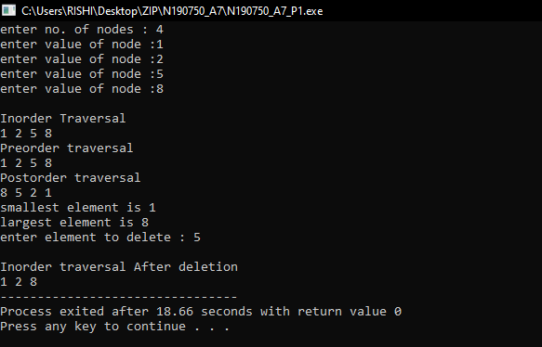

**Output:**

**/* Author Name : N.Mariya Babu**

**Id No. : N190750**

**Assignment Number : 7(BST)**

**programme Description : 2**

**programme Description :C Programme to count the number nodes of a BST**

**Date : 8/23/2022**

**certification : I hereby certify that this work is my own and none of it is the work of any other person */**

//

//HeaderFiles section

#include<stdio.h>

#include<stdlib.h>

//Structure Definition

struct node{

int data;

struct node *lst;

struct node *rst;

};

//Function to insert the data into the BST

struct node * insert(struct node *root){

int val;

printf("enter value of node :");

scanf("%d",&val);

struct node *newnode,*node,*parent;

newnode=(struct node*)malloc(sizeof(struct node));

newnode->data=val;

newnode->lst=0;

newnode->rst=0;

if(root==0){

root=newnode;

root->lst=0;

root->rst=0;

}

else{

parent=0;

node=root;

while(node!=0){

parent=node;

if(val<node->data)

node=node->lst;

else

node=node->rst;

}

if(val<parent->data)

parent->lst=newnode;

else

parent->rst=newnode;

}

return root;

}

//Function to find the total no.of nodes in the BST

int totalnodes(struct node *root){

if(root==0)

return 0;

else

return(totalnodes(root->lst)+totalnodes(root->rst)+1);

}

//Main Function

int main(){

int val,n,i=0,choice=1;

struct node *root=0;

while(choice){

root=insert(root);

i++;

printf("enter 0 to stop :");

scanf("%d",&choice);

}

printf("total no. of nodes %d",totalnodes(root));

return 0;

}

**Output:**

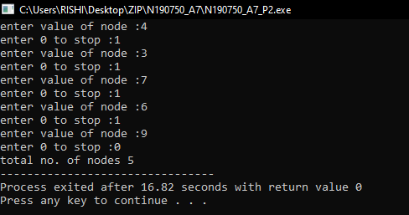

**/* Author Name : N.Mariya Babu**

**Id No. : N190750**

**Assignment Number : 7(BST)**

**programme Description : 3**

**programme Description : C Programme to find the nth node in the inOrder traversal of a BST**

**Date : 8/23/2022**

**certification : I hereby certify that this work is my own and none of it is the work of any other person */**

//HeaderFiles section

#include<stdio.h>

#include<stdlib.h>

//Structure Definition

struct node{

int data;

struct node *lst;

struct node *rst;

};

//Function to insert the data into the BST

struct node * insert(struct node *root){

int val;

printf("enter value of node :");

scanf("%d",&val);

struct node *newnode,*node,*parent;

newnode=(struct node*)malloc(sizeof(struct node));

newnode->data=val;

newnode->lst=0;

newnode->rst=0;

if(root==0){

root=newnode;

root->lst=0;

root->rst=0;

}

else{

parent=0;

node=root;

while(node!=0){

parent=node;

if(val<node->data)

node=node->lst;

else

node=node->rst;

}

if(val<parent->data)

parent->lst=newnode;

else

parent->rst=newnode;

}

return root;

}

//Function to print the inorder traversal of the BST

void inorder(struct node *root){

if(root!= NULL){

inorder(root->lst);

printf("%d ",root->data);

inorder(root->rst);

}

}

//Function to find the nth node in the inOrder

void nthinorder(struct node *root,int pos){

static int count=0;

if(root== NULL)

return;

if(count<=pos){

nthinorder(root->lst,pos);

count++;

if(count==pos)

printf("%d",root->data);

nthinorder(root->rst,pos);

}

}

//Main Function

int main(){

int val,n,i=0,pos;

struct node *root=0,*mini,*maxi;

printf("enter no. of nodes");

scanf("%d",&n);

while(i<n){

root=insert(root);

i++;

}

printf("\nInorder traversal of binary tree is \n");

inorder(root);

printf("\nenter position:");

scanf("%d",&pos);

printf("\n%d th node in Inorder traversal of binary tree is \n",pos);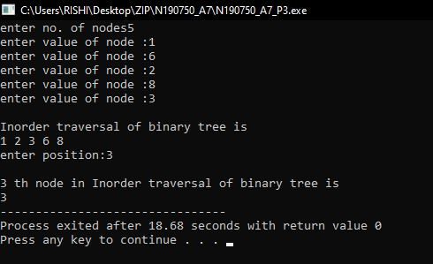

nthinorder(root,pos);

return 0;

}

**Output:**

**/* Author Name : N.Mariya Babu**

**Id No. : N190750**

**Assignment Number : 7(BST)**

**programme Description : 4**

**programme Description : C Programme to find the largest and smallest elements of a BST**

**Date : 8/23/2022**

**certification : I hereby certify that this work is my own and none of it is the work of any other person */**

//HeaderFiles section

#include<stdio.h>

#include<stdlib.h>

//Structure Definition

struct node{

int data;

struct node *lst;

struct node *rst;

};

//Function to insert the data into the BST

struct node * insert(struct node *root){

int val;

printf("enter value of node :");

scanf("%d",&val);

struct node *newnode,*node,*parent;

newnode=(struct node*)malloc(sizeof(struct node));

newnode->data=val;

newnode->lst=0;

newnode->rst=0;

if(root==0){

root=newnode;

root->lst=0;

root->rst=0;

}

else{

parent=0;

node=root;

while(node!=0)

{

parent=node;

if(val<node->data)

node=node->lst;

else

node=node->rst;

}

if(val<parent->data)

parent->lst=newnode;

else

parent->rst=newnode;

}

return root;

}

//Function to find the maximum element in the BST

struct node* max(struct node *node){

if(node==0 || node->rst==0)

return node;

else

return max(node->rst);

}

//Function to find the minimum element in the BST

struct node* min(struct node *node){

if(node==0 || node->lst==0)

return node;

else

return min(node->lst);

}

//Main Function

int main(){

int val,n,i=0,key,x;

struct node *root=0,*mini,*maxi;

printf("enter no. of nodes");

scanf("%d",&n);

while(i<n){

root=insert(root);

i++;

}

mini=min(root);

printf("smallest element is %d\n",mini->data);

maxi=max(root);

printf("largest element is %d",maxi->data);

}

**Output:**

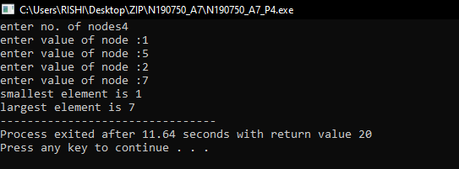

**/* Author Name : N.Mariya Babu**

**Id No. : N190750**

**Assignment Number : 7(BST)**

**programme Description : 5**

**programme Description : C Programme to find all the elements of Nth level**

**Date : 8/23/2022**

**certification : I hereby certify that this work is my own and none of it is the work of any other person */**

//HeaderFiles section

#include <stdio.h>

#include <stdlib.h>

//Structure Definition

struct btnode{

int value;

struct btnode *l;

struct btnode *r;

}*root = NULL, *temp = NULL, *t2, *t1;

//Function Declaration section

void insert();

void inorder(struct btnode *t);

void create();

void level(struct btnode *t,int plevel,int l);

void search(struct btnode *t);

//Main Function

void main(){

int i,x,l;

printf("Enter the level number:");

scanf("%d",&l);

printf("Enter the number of nodes:");

scanf("%d",&x);

for(i=0;i<x;i++)

{

insert();

}

level(root,0,l);

}

// Function to insert the data into the BST

void insert(){

create();

if (root == NULL)

root = temp;

else

search(root);

}

/* To create a node */

void create(){

int data;

printf("Enter data of node to be inserted : ");

scanf("%d", &data);

temp = (struct btnode *)malloc(1*sizeof(struct btnode));

temp->value = data;

temp->l = temp->r = NULL;

}

//Approative position to insert the node

void search(struct btnode *t){

if ((temp->value > t->value) && (t->r != NULL))

search(t->r);

else if ((temp->value > t->value) && (t->r == NULL))

t->r = temp;

else if ((temp->value < t->value) && (t->l != NULL))

search(t->l);

else if ((temp->value < t->value) && (t->l == NULL))

t->l = temp;

}

void level(struct btnode *t,int plevel,int l){

if(t==NULL){

return;

}

if(plevel==l){

printf("%d ",t->value);

return;

}

level(t->l,plevel+1, l);

level(t->r,plevel+1,l);

}

**Output:**

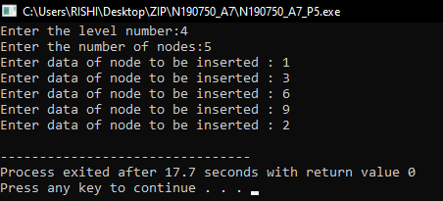

**/* Author Name : N.Mariya Babu**

**Id No. : N190750**

**Assignment Number : 7(BST)**

**programme Description : 6**

**programme Description : C Programme to find nodes which are At max distance from the root node in the BST**

**Date : 8/23/2022**

**certification : I hereby certify that this work is my own and none of it is the work of any other person */**

//HeaderFiles section

#include <stdio.h>

#include <stdlib.h>

//Structure definition

struct btnode{

int value;

struct btnode *l;

struct btnode *r;

}*root = NULL, *temp = NULL, *t2, *t1;

//Function definition section

void insert();

void create();

void search(struct btnode *t);

void max(struct btnode *t);

int c=0,m=0,v[50],j=0,a[50],ma;

//main Function

void main(){

int i,x;;

printf("Enter the number of nodes:");

scanf("%d",&x);

for(i=0;i<x;i++){

insert();

}

m=0;c=0;

max(root);

for(i=0;i<j;i++){

ma=a[0];

if(ma<a[i])

ma=a[i];

}

printf("Maximum distance node:");

for(i=0;i<j;i++){

if(ma==a[i])

printf("%d ,%d ",v[i],ma);

}

}

//Insertion

void insert(){

create();

if (root == NULL)

root = temp;

else

search(root);

}

//Node Creation

void create(){

int data;

printf("Enter data of node to be inserted : ");

scanf("%d", &data);

temp = (struct btnode *)malloc(1*sizeof(struct btnode));

temp->value = data;

temp->l = temp->r = NULL;

}

//The exact position to insert the node

void search(struct btnode *t){

if ((temp->value > t->value) && (t->r != NULL))

search(t->r);

else if ((temp->value > t->value) && (t->r == NULL))

t->r = temp;

else if ((temp->value < t->value) && (t->l != NULL))

search(t->l);

else if ((temp->value < t->value) && (t->l == NULL))

t->l = temp;

}

//Max Value in the BST

void max(struct btnode *t){

if(t->l!=NULL){

c++;

max(t->l);

}

if(m<c)

m=c;

if(m==c){

a[j]=m;

v[j]=t->value;

j++;

}

if(t->r!=NULL){

c++;

max(t->r);

}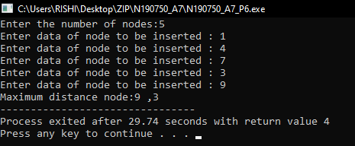

c--;

}

**Output:**

**LAB-8**

**/* Author Name : N.Mariya Babu**

**Id No. : N190750**

**Assignment Number : 8**

**programme Number : 1**

**programme Description : C Programme to implement Heap Sort Algorithm using Max Heap method**

**Date : 6/21/2022 (MM/DD/YYYY)**

**certification : I hereby certify that this work is my own and none of it is the work of any other person */**

//Header Files

#include <stdio.h>

int size = 0,i;

//Swap Function

void swap(int *a, int *b){

int temp = *b;

*b = *a;

*a = temp;

}

//Heapify Function

void heapify(int array[], int size, int i){

if (size == 1){

printf("Single element in the heap");

}

else{

int largest = i;

int l = 2 * i + 1;

int r = 2 * i + 2;

if (l < size && array[l] > array[largest])

largest = l;

if (r < size && array[r] > array[largest])

largest = r;

if (largest != i){

swap(&array[i], &array[largest]);

heapify(array, size, largest);

}

}

}

//Insertion Function

void insert(int array[], int newNum){

if (size == 0){

array[0] = newNum;

size += 1;

}

else{

array[size] = newNum;

size += 1;

for ( i = size / 2 - 1; i >= 0; i--){

heapify(array, size, i);

}

}

}

//Function to delete the RootData

void deleteRoot(int array[], int num){

int i;

for (i = 0; i < size; i++){

if (num == array[i])

break;

}

swap(&array[i], &array[size - 1]);

size -= 1;

for (i = size / 2 - 1; i >= 0; i--){

heapify(array, size, i);

}

}

//Function to print the array element's

void printArray(int array[], int size){

for ( i = 0; i < size; ++i)

printf("%d ", array[i]);

printf("\n");

}

//Main Function

int main(){

int array[10];

insert(array, 3);

insert(array, 4);

insert(array, 9);

insert(array, 5);

insert(array, 2);

printf("Max-Heap array: ");

printArray(array, size);

deleteRoot(array, 4);

printf("After deleting an element: ");

printArray(array, size);

}

**Output:**

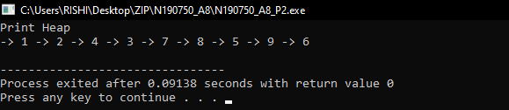

**/* Author Name : N.Mariya Babu**

**Id No. : N190750**

**Assignment Number : 8**

**programme Number : 2**

**programme Description : C Programme to implement Heap Sort Algorithm using Min Heap method**

**Date : 6/21/2022 (MM/DD/YYYY)**

**certification : I hereby certify that this work is my own and none of it is the work of any other person */**

//Header Files

#include<stdio.h>

#include<stdlib.h>

int HEAP_SIZE = 20;

//Structure Definition

struct Heap{

int *arr;

int count;

int capacity;

int heap_type; // for min heap , 1 for max heap

};

typedef struct Heap Heap;

//Function Declaration

Heap *CreateHeap(int capacity,int heap_type);

void insert(Heap *h, int key);

void print(Heap *h);

void heapify_bottom_top(Heap *h,int index);

void heapify_top_bottom(Heap *h, int parent_node);

//Main Function

int main(){

int i;

Heap *heap = CreateHeap(HEAP_SIZE, 0); //Min Heap

if( heap == NULL ){

printf("__Memory Issue____\n");

return -1;

}

for(i =9;i>0;i--)

insert(heap, i);

print(heap);

return 0;

}

//Function to create the heap

Heap *CreateHeap(int capacity,int heap_type){

Heap *h = (Heap * ) malloc(sizeof(Heap));

//check if memory allocation is fails

if(h == NULL){

printf("Memory Error!");

return 0;

}

h->heap_type = heap_type;

h->count=0;

h->capacity = capacity;

h->arr = (int *) malloc(capacity*sizeof(int)); //size in bytes

//check if allocation succeed

if ( h->arr == NULL){

printf("Memory Error!");

return 0;

}

return h;

}

//Insertion Function

void insert(Heap *h, int key){

if( h->count < h->capacity){

h->arr[h->count] = key;

heapify_bottom_top(h, h->count);

h->count++;

}

}

void heapify_bottom_top(Heap *h,int index){

int temp;

int parent_node = (index-1)/2;

if(h->arr[parent_node] > h->arr[index]){

//swap and recursive call

temp = h->arr[parent_node];

h->arr[parent_node] = h->arr[index];

h->arr[index] = temp;

heapify_bottom_top(h,parent_node);

}

}

void heapify_top_bottom(Heap *h, int parent_node){

int left = parent_node*2+1;

int right = parent_node*2+2;

int min;

int temp;

if(left >= h->count || left <0)

left = -1;

if(right >= h->count || right <0)

right = -1;

if(left != -1 && h->arr[left] < h->arr[parent_node])

min=left;

else

min =parent_node;

if(right != -1 && h->arr[right] < h->arr[min])

min = right;

if(min != parent_node){

temp = h->arr[min];

h->arr[min] = h->arr[parent_node];

h->arr[parent_node] = temp;

heapify_top_bottom(h, min);

}

}

//print Function

void print(Heap *h){

int i;

printf("Print Heap\n");

for(i=0;i< h->count;i++){

printf("-> %d ",h->arr[i]);

}

printf("\n");

}

**Output:**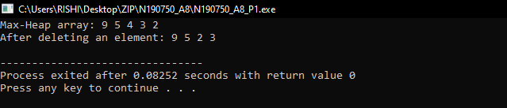

**Thank You**