|  |  |
| --- | --- |
| **EX.NO : 01** | **PROGRAMS ON SELECTION AND ITERATION OPERATIONS** |
| **DATE :** |

**AIM :**

To write a python program get an integer input from a user. If the number is odd, then find the factorial of a number and find the number of digits in the factorial of the number. If the number is even, then check whether the given number is palindrome or not.

**ALGORITHM :**

STEP 1 : Start the program.

STEP 2 : Define the factorial function:

Take a number n as input.

If n is 0 or 1, return 1 as the factorial.

Otherwise, return n multiplied by the factorial of n-1 (recursive call).

STEP 3 : Define the is_palindrome function:

Take a number num as input.

Convert num to a string.

Return True if the string representation of num is equal to its reverse, indicating it is a palindrome.

Return False otherwise.

STEP 4 : Define the is_palindrome function:

Take a number num as input.

Convert num to a string.

Return True if the string representation of num is equal to its reverse, indicating it is a palindrome.

Return False otherwise.

STEP 5 : Define the process_number function:

Prompt the user to enter an integer and store it in the variable number.

Check if number is odd:

If number is odd:

Calculate the factorial of number using the factorial function and store it in the variable fact.

Calculate the number of digits in fact using the count_digits function and store it in the variable digit_count.

Print the factorial of number and the number of digits in the factorial.

If number is even:

Check if number is a palindrome using the is_palindrome function:

If number is a palindrome, print that it is a palindrome.

If number is not a palindrome, print that it is not a palindrome.

STEP 6 : Call the process_number function to start the program execution.

Step 7: End the program.

**PROGRAM :**

# FUNCTION DEFINITION

def is_palindrome(num):

num = str(num)

return num == num[::-1]

def count_digits(num):

return len(str(num))

def process_number():

number = int(input("Enter an integer: "))

if number % 2 == 1: # odd number

fact = factorial(number)

digit_count = count_digits(fact)

print(f"The factorial of {number} is: {fact}")

print(f"The number of digits in the factorial is: {digit_count}")

else: # even number

if is_palindrome(number):

print(f"The number {number} is a palindrome.")

else:

print(f"The number {number} is not a palindrome.")

process_number()

**OUTPUT** :

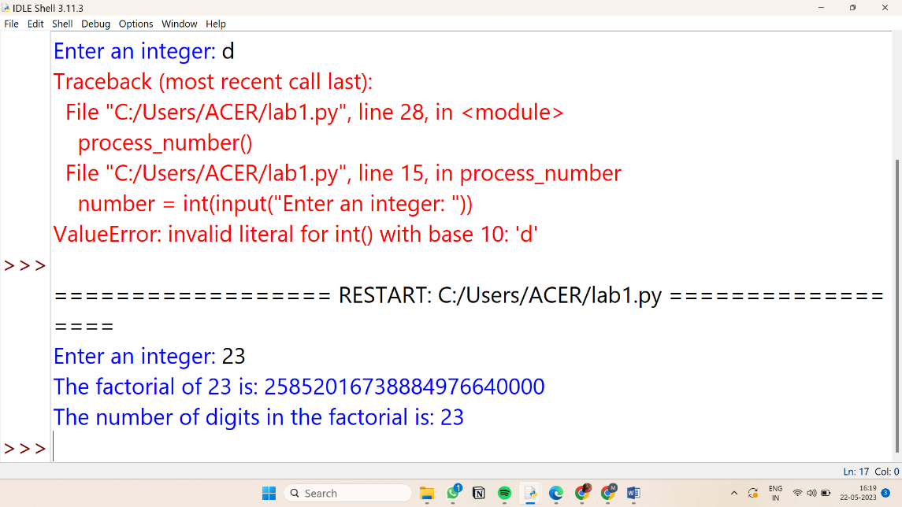

|  |  |  |
| --- | --- | --- |
| **DEPARTMENT OF EEE** | | |
| Preparation (Algorithm) | 4 |  |
| Observation (Program) | 4 |  |
| Results (Output) | 4 |  |
| Interpretation (Validation) | 4 |  |
| Viva – Voce | 4 |  |
| Total | 20 |  |

**RESULT :**

Thus the python program to get an integer input from a user and to find if the number is odd, then find the factorial of a number and find the number of digits in the factorial of the number and if the number is even, then check the given number is palindrome or not has been executed and the output is verified.