**Mongodb**

C:\data>"C:\Program Files\MongoDB\Server\4.2\bin\mongod.exe"

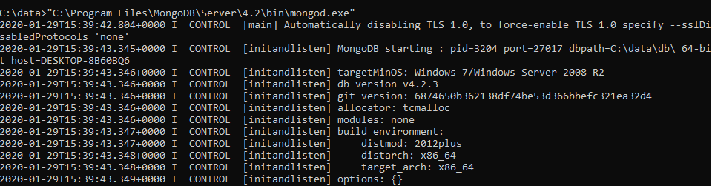

**Mongo**

Double click

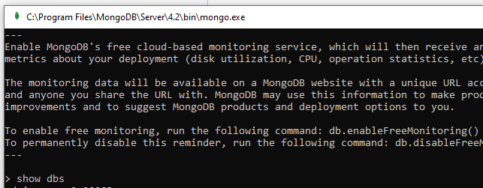

**Node**

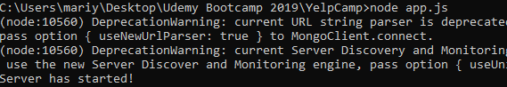

**+Mongoose**