1.Source files Read:


2.Remove Duplicates:
Before removing:
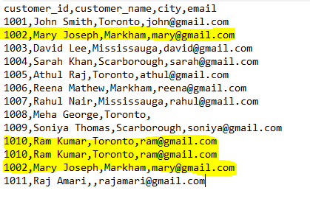
After removing:
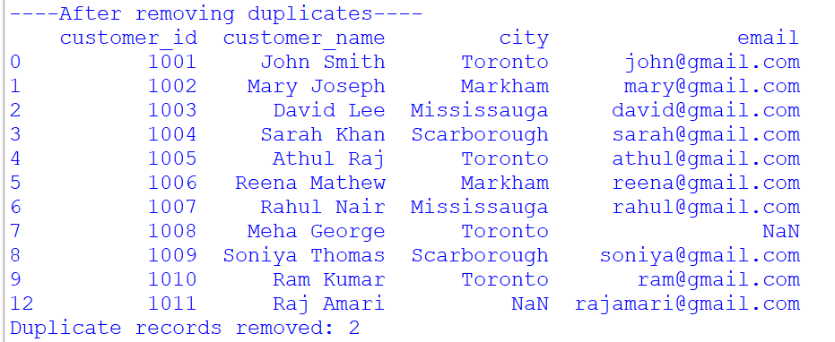

3.Before removing column with no email id, Replacing city value:
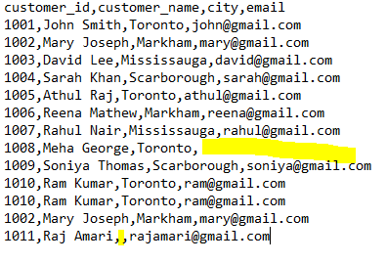
After correction:
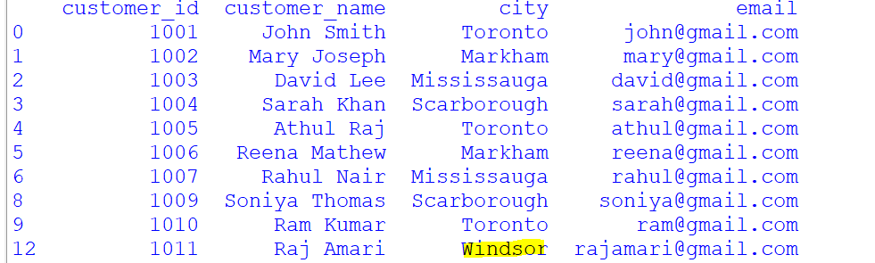

4.finding valid product_id and Invalid product_id:
Valid:
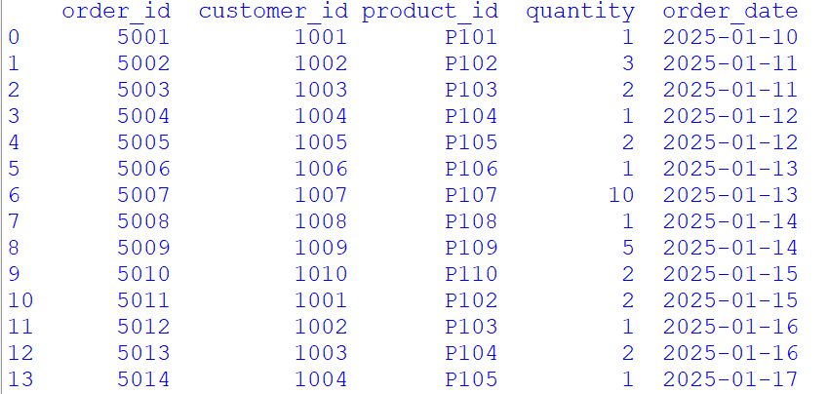

Invalid:
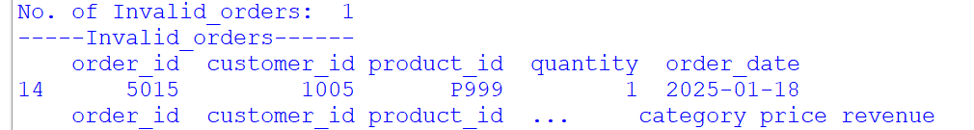
5.Total Revenue:

6.Revenue by product name:
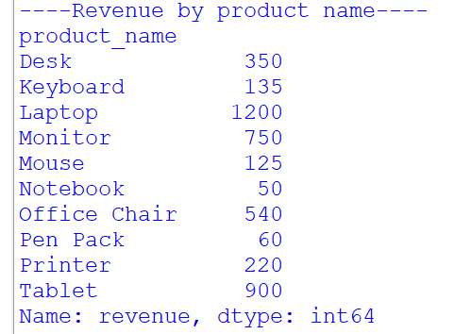
7.Revenue by customer name:
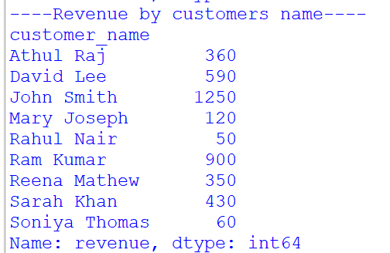

8.Top selling product:
9.Summary:
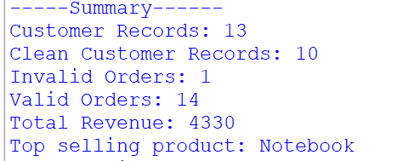

10. output files:
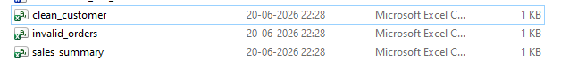

11.Data loaded in mysql:

