
Radioisotope Power Systems:
Quantum Tunneling in Alpha Decay

Objective this module is to study the phenomenon of radioactivity, focusing in more detail on one of the types — alpha decay. Students will be proposed to consider it in the context of quantum physics when alpha decay is interpreted as its tunneling through a potential barrier of the nucleus. Results of modeling this phenomenon based on the WKB (Wentzel–Kramers–Brillouin) approximation will then be applied to solve an applied problem at the end of the module.

Problem:
In the last section of the “Radioisotope Power Systems: Quantum Tunneling in Alpha Decay” module (https://qtechedu.centralesupelec.fr/EN/ex8.html) the basic principles of operation of the Radioisotope Thermoelectric Generator (RTG) were discussed (in the “Applications of Alpha Decay: Radioisotope Thermoelectric Generators” tab) .

A Radioisotope Thermoelectric Generator contains 1 kg of Plutonium-238 (²³⁸Pu). The energy released during the alpha decay of a single nucleus is 5.593 MeV. The generator’s thermocouples convert the thermal energy into electricity with an efficiency of 6%.

- Calculate the thermal power produced by 1 kg of ²³⁸Pu.
- Determine the electrical power output of the RTG.
- If the RTG is used to power electronics on a spacecraft, calculate how its power output will change after 10 years.

Parameters used for calculation:

- Mass of ²³⁸Pu: m= 1 kg
- Energy per alpha particle: Eα = 5.593 MeV
- Thermocouple efficiency is 6%.

To calculate the half-life t_{1/2} of ²³⁸Pu, use the “Quantum technology” platform .

Solution method:

To compute the current, the photoionization cross section σ is required. To obtain σ, use the “Quantum Technology” interface (https://qtechedu.centralesupelec.fr/EN/ex1.html) in the “Photoionization cross section” module.

Compare the efficiency of the RTG when the energy source is another radioactive material (Th-232, U-238, Po-210, etc.). What amount of uranium would be required to achieve similar generator performance?

Activity with the interface:
https://qtechedu.centralesupelec.fr/EN/ex1.html
Using the interface answer the following question and perform the suggested calculations.
1. The Introductory part:
- What is the physical interpretation of the photoionization cross section and what physical quantities determine its value?
- Compare the concept of cross section in classical and quantum mechanical approaches.
- Provide the formula used in this module to calculate the photoionization cross section of an atom?
- What physical assumptions and mathematical approximations are involved in the derivation?
- Why is the photoionization process often modeled by assuming that only one outer-shell electron participates? For which types of atoms is this one-electron approximation valid? Can you provide examples where this assumption is not valid?
- How are the initial and final states of an atom characterized in terms of energy and wave functions during the photoionization process?

2. In Tab “Coulomb functions for Negative Energies” explore the method for calculating the wave function of an electron in a bound state using Whittaker functions.
- What method is used to solve the radial Schrödinger equation for a bound electron in a Coulomb potential, and why is a variable transformation typically applied?
- What are the Whittaker functions?
- How are the Whittaker functions related to the solution of the Schrödinger equation for the Coulomb potential? What is the difference between the Whittaker functions and and which one is appropriate for describing bound electron states?
- How would you calculate these functions for a given energy E?
To visualize the wave function of an electron in bound state, use the interface. The necessary tools are located at the bottom of the tab “Coulomb functions for negative energies” (as shown in the image below).
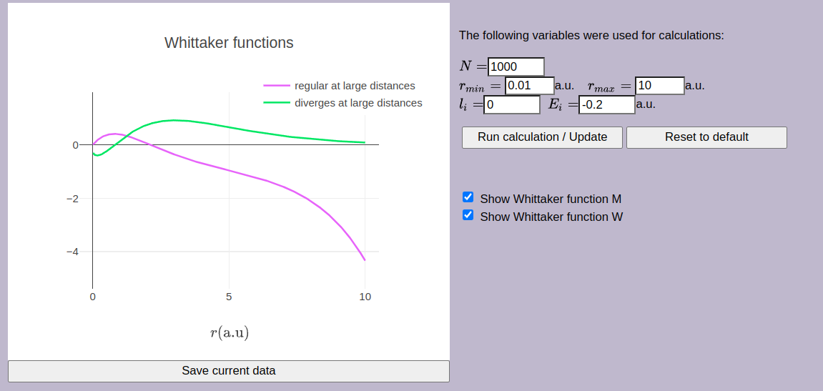 | 1. Use the following parameters:  r_{min} = 0.01 a.u. (bohr)  r_{max} = 10 a.u. (bohr)  l_{i} = 0  E_{i} = -0.2 a.u (hartree)  The mass is 1 a.u. (mass of electron, m_{e})  Click button “Run calculation”.
The “Reset to default” button allows you to restore the default values.
If you need to save the result, click button “Save current data”.
2. Perform calculations the Whittaker functions for different values of the initial energy, for example, -0.5 a.u., -0.25 a.u. Present the results of the calculation for the Whittakerfunctions and explain the obtained results.

3. In the tab “Coulomb functions for Positive Energies” a method for calculating the wave function of an electron in a free state after photoionization using Coulomb functions is presented.
- What are the regular (F_{l} (η,z)) and irregular (G_{l} (η,z)) Coulomb wave functions? How do they differ in their physical interpretations?
- How would you calculate the Coulomb wave functions F_{l} (η,z) and G_{l} (η,z) for a given positive energy E?
- What are the initial and final energy states of the atom during the ionization process? Describe the process of solving the radial Schrödinger equation for the case of a Coulomb potential for the bound and continuum states.
- Why the Schrödinger equation has to be transformed into a standard form?

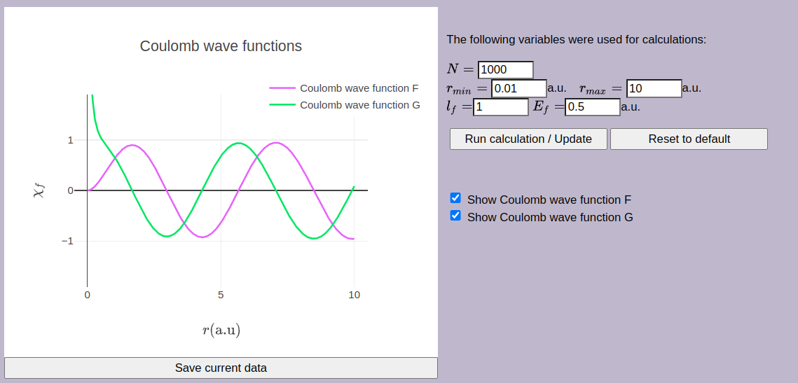 | 1. Use the parameters in the cases:  r_{min} = 0.01 a.u. (bohr)  r_{max} = 10 a.u. (bohr)  l_{i} = 0  E_{i} = 0.5 a.u (hartree)  The mass is 1 a.u. (mass of electron, m_{e})  Click button “Run calculation”.
2. Perform calculations for different values of the final energy: 0.8 a.u., 1.2 a.u. Present the results of the calculation and explain the obtained results.

4. In the “Photoionization Cross Section” tab, it is proposed to calculate the PI cross section for different atoms and transition types. When an atom is selected from the drop-down menu, its corresponding quantum numbers are automatically set, or you can manually enter the quantum numbers into the designated fields.

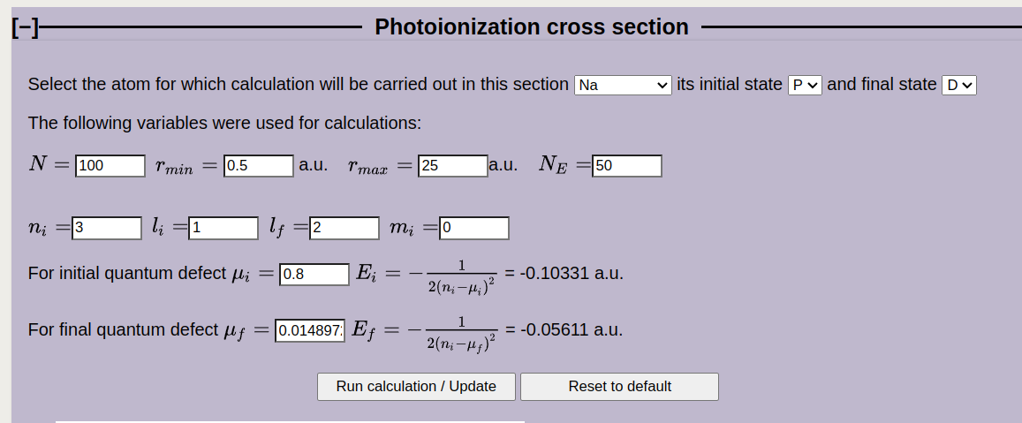 | 1. To find the PI cross section σ^{PI}:  - Select Na and the desired transition () or enter the required values into the fillable boxes.  - The corresponding values of the quantities will automatically appear in the boxes.
2. Using the interface, complete the blanks below with each quantity and its corresponding description.
N =
N_{E} =
r_{min} = a.u.*
r_{max} = a.u.
n_{i} =
l_{i} = , l_{f} =
m_{i} =
μ_{i} = , μ_{i} =
Click button “Run calculation”.
3. Look at the graphs, describe what they show and what you can learn from them.

The calculation results will be required to solve the problem described in the first paragraph, which involves determining the concentration of sodium vapor using a photoionization detector (PID). The basic principles of PID operation are discussed in the “Application” tab (https://qtechedu.centralesupelec.fr/EN/ex1.html). To solve this problem, answer the following questions:

- Using the resulting figures, determine the PI cross section for photons with energy 10,6 eV.
- Explain how the unit of concentration in [ppm] is converted to SI units [m⁻³].
- Write the final formula for current I using the material from “Solution method”. Use dimensional analysis to verify its correctness in SI units.
- Calculate the current that the PID shows, if the relative fraction of Na atoms is 3.6 ppm.

* Atomic units are used https://en.wikipedia.org/wiki/Hartree_atomic_units that are defined as following:
ħ=1 unit of angular momentum,
e=1 unit of charge,
mass of the electron m_{e}=1 unit of mass.
Units of all other quantities are derived from these three units. Atomic units are very convenient in quantum mechanics (atomic, molecular physics). If you see the symbols “a.u.”, it means that one uses atomic units for this quantity.

