**OBJECT :** Find the sum of 2 numbers .

**SOURCE CODE :**

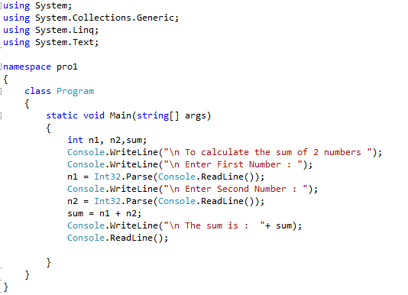

**OUTPUT :**

