**OBJECT :** Swap two integers without using third variable.

**SOURCE CODE :**

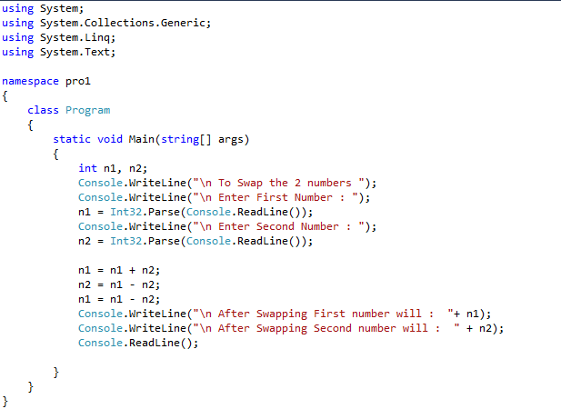

**OUTPUT :**

