**OBJECT:** To check the number is even or odd .

**SOURCE CODE :**

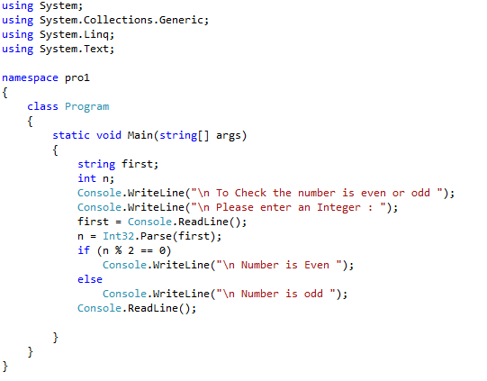

**OUTPUT :**

