**OBJECT :** Write an application that inputs from user the radius of circle and displays diameter, circumference and area of circle.

**SOURCE CODE :**

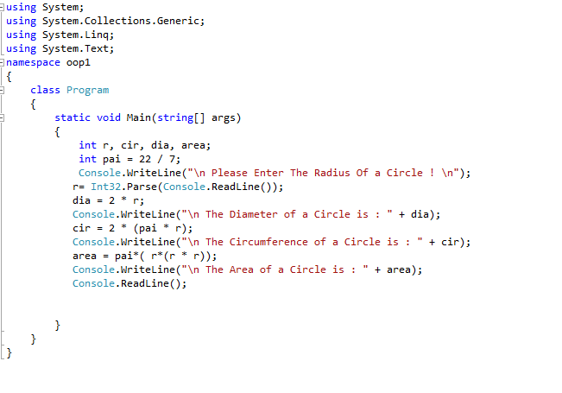

**OUTPUT :**

