Q1 . What is git?

Git is a version control system (vcs) that is commonly used by developers to track the different changes that are made during their development cycle. It is just simple, flexible and easily sharable by various project or team participants,developed by “linus torvalds” , creator of linux.

Q2. Difference between git and svn? next **commit**. However, git add doesn't really affect the repository in any significant way ,changes are not actually recorded until you run **git commit**

|  |  |
| --- | --- |
| GIT | SVN |
| 1. Git is a distributed version control system (vcs). | SVN is a non-distributed version control system (vcs). |
| 2. Git has a centralized server and repository. | SVN does not have a centralized server or repository. |
| Git branches are easier to work. | SVN branches are not much easier as git brances. |
| 4. Git was developed for linux kernel by linus torvalds. | SVN was developed by collabnet, inc. |
| 5. The content in git is stored as metadata | The co svn stores files of content. |

Q3. Write a command to commit your work in git?

The **git** add command adds a change in the working directory to the staging area. It tells git that you want to include updates to a particular file in the.

Q4. Create your own repository with your name and unique roll number in github. <done>

Q5. What is “staging area” and “index” in git? And what are the advantages of git?

Before completing the commits, it can be formatted and reviewed in ‘staging area’ or ‘index’.

ADVANTAGES OF GIT

**Github makes for easier contributions to your top open source projects.**

**github has everything turned into markdown.**

**Github has some of the best documentation around.**

One of the biggest advantages of git is its branching capabilities.

**Git** branches are cheap and easy to merge.

Q6. What is a git clone?

**The "clone" command downloads an existing git repository to your local computer.**

**Q7. What is the command to delete branch in git?**

git branch -d

Q8. Expalin the architecture of git in your own words .

Basically the git (vcs) works on 2 places :

Working copy(where you make changes)

Repository(where you do not make changes)

You cannot however change or get the files  in a repository directly, in able to retrieve a specific file from there, you have to checkout  or you can say clone.

Checking-out is the process of getting files from repository to your working copy. Committing is the process of putting back the files from working copy to repository.

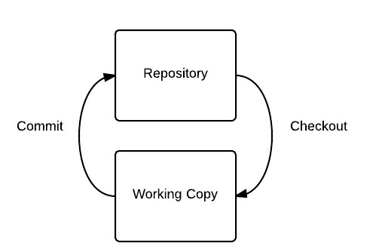

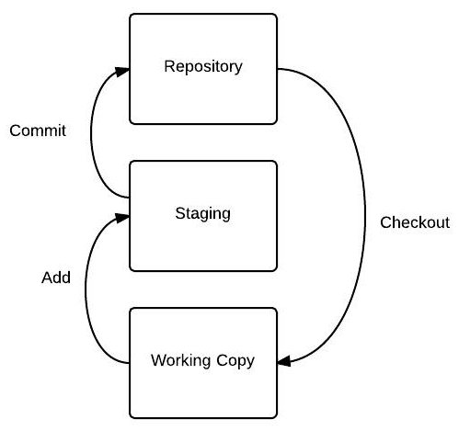

Staging area is a place where you prepare all the things that you are going to commit.

In git, you don't move things directly from your working copy to the repository, you have to stage them first

Q9. How to resolve a conflicts in git?

We can resolve [merge conflicts](https://help.github.com/articles/about-merge-conflicts) using the command line and a text editor. Merge conflicts may occur if competing changes are made to the same line of a file or when a file is deleted that another person is attempting to edit.

Q10. Name the different vendors that are working on vcs?

There’re so many vendors that are working on vcs .some of them are:

Google.

Facebook.

Microsoft

Linkedin

Netflix

Postgresql

Android

Qt

Gnome.

Eclipse.

Etc etc…