**Lab # 05**

**Business Card**

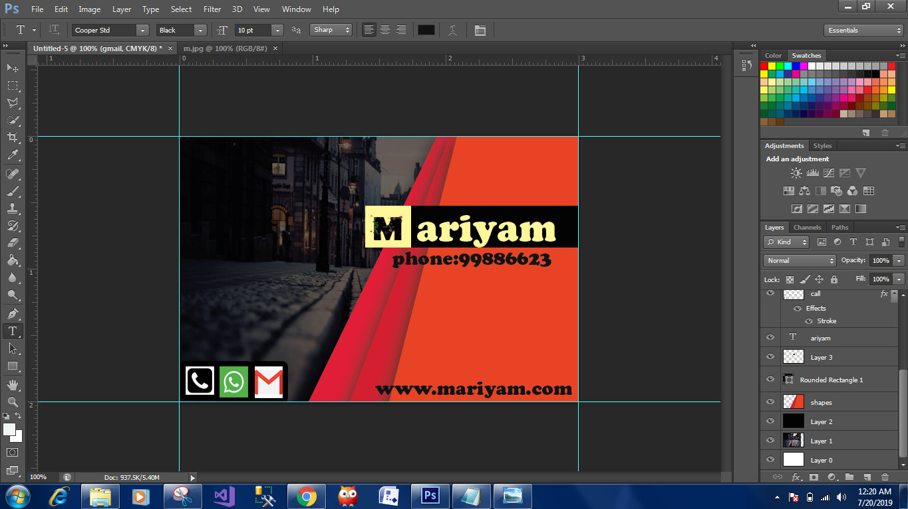

**Steps:**

set height and width 3 inches and 2 inches respectively.and 200 resolution

duble click to background and name layer 0

select rectangle tool and draw from center and coloured it to red.

select rectangle layer > edit > transform path > distort ,to trilled the shape of rectangle and press enter or clicked to the transform commit..

select rectangle layer and right clicked select blending option ,checked the drop shadow then blend mode :multiply,angle:90,checked to global light,distance:16%,spread:27%,size:32%.

go to rectangle layer and right click and select duplicate layer.

go to rectangle 1 layer and select new shade of red(d41b30),then go to edit >transform path >distort to trilled the shape of rectangle and enter or clicked to the transform commit checked icon on the top.

select rectangle 1 layer and right click and select duplicate layer.and then same process

select new shade of red(d41b30),then go to edit >transform path >distort to trilled the shape of rectangle

and enter or clicked to the transform commit checked icon on the top.

select all layers by click to first and shift+last layer > right click Rasterize layer style and then again right click and merge layer.

renamed it to shapes by double clicked.

copy image from internet and paste it

ctrl+T to free transform the image ,enter.

drag the layer 1 and shape .

add a new layer

select black color and choose a paint bucket tool and apply to image,apply capacity to 50%.

select shapes layer and select rectangle rounded tool to write Name.

ctrl+O for image .

copy icons and paste phone,gmail,whatsapp..