**OBJECT :** Find the factorial of number.

**SOURCE CODE:**

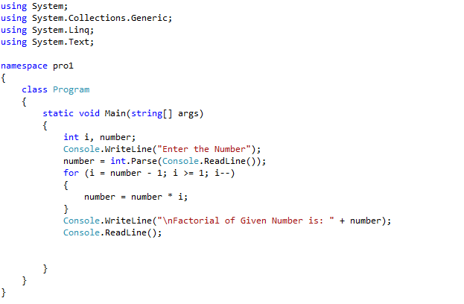

**OUTPUT :**

