**OBJECT :** Write an application that ask users to enter 2 numbers,then the program display its sum,product,difference and quotient.

**SOURCE CODE :**

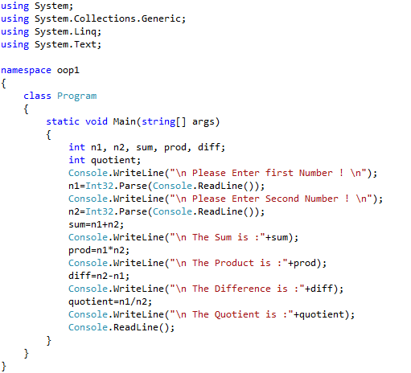

**OUTPUT :**

