Name: Maryam Bashir
Registration no: 04072313017
Course: MAD CS-442
Date: 5th October 2026
Lab 3: Campus Cafe Order System

Checkpoint 1: seed line, the Dish class and step1() code, the 2 printed lines.
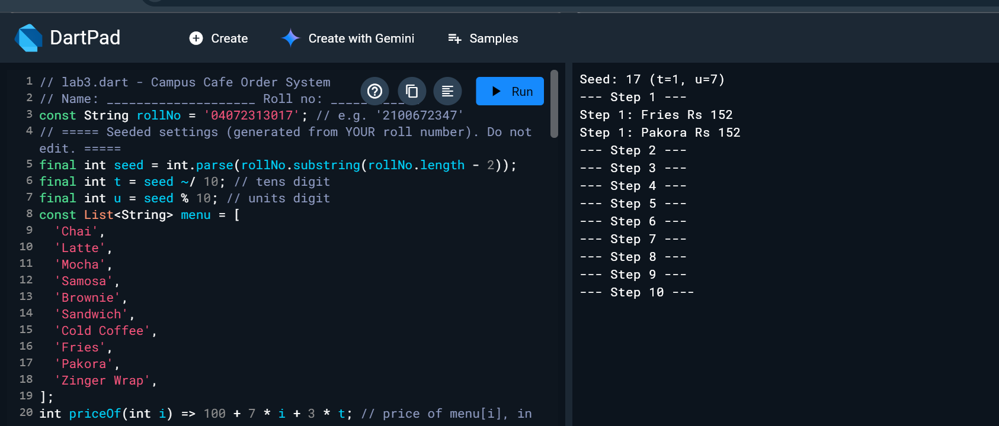
Checkpoint 2: seed line, the MenuItem class and step2() code, the 2 printed lines
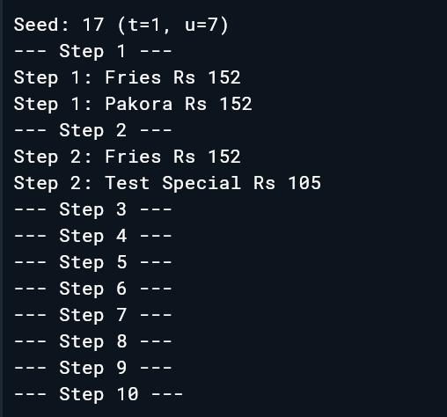

Checkpoint 3: seed line, the two new constructors and step3() code, the 3 printed lines.
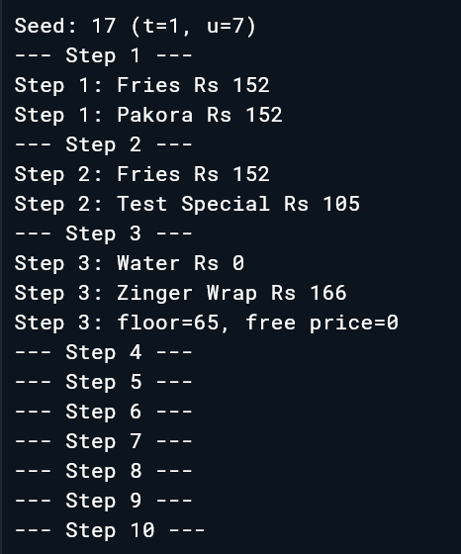
Checkpoint 4: seed line, the OrderLog class and step4() code, the 3 printed lines.
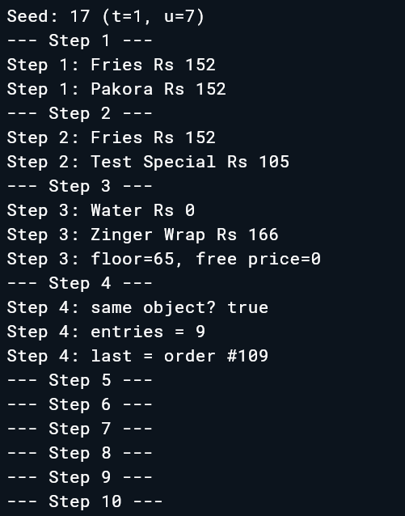
Checkpoint 5: seed line, the OrderLine class, mainOrder() and step5() code, the 3 printed lines.
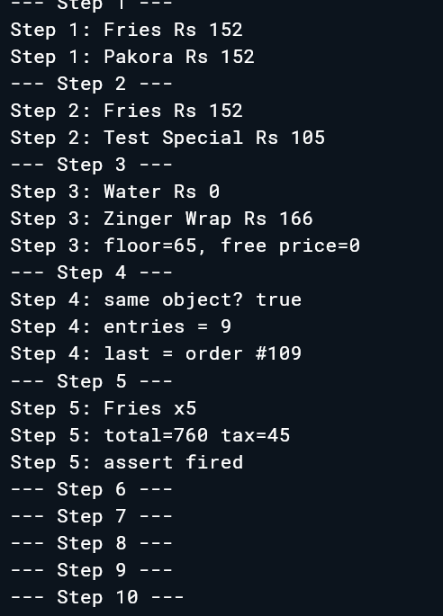
Checkpoint 6: seed line, the three getters and step6() code, the 3 printed lines.
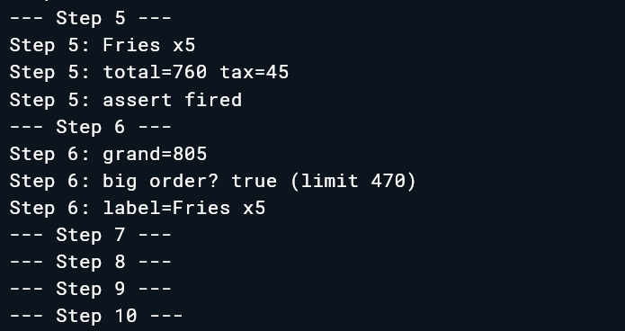
Checkpoint 7: seed line, the StudentCard class and step7() code, the 4 printed lines.
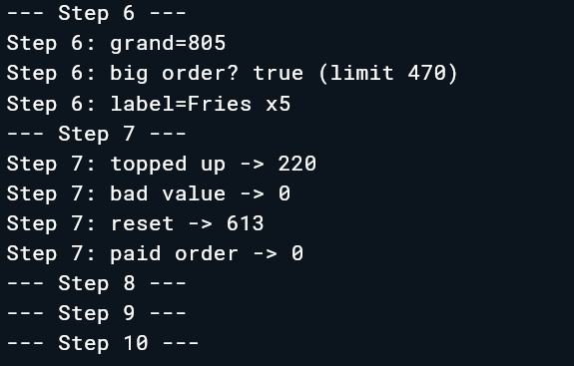
Checkpoint 8: seed line, toString(), buildMenu() and step8() code, the 3 printed lines
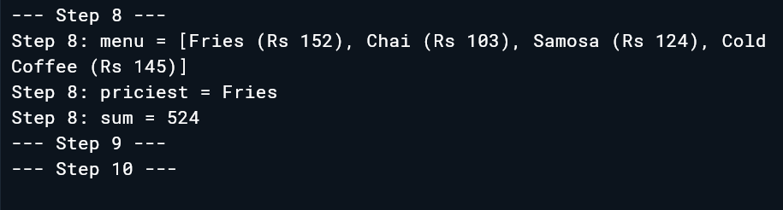
Checkpoint 9: seed line, buildReceipt() and step9() code, the 5 printed lines.
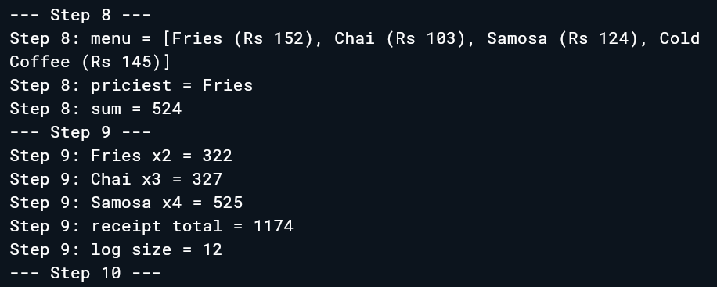
Checkpoint 10: seed line, the Coupon class and step10() code, the 3 printed lines.
