**STRING & PATTERN PROBLEMS - ASSIGNMENT -2**

1. Reverse a given string without using built-in reverse functions.

**Program:**

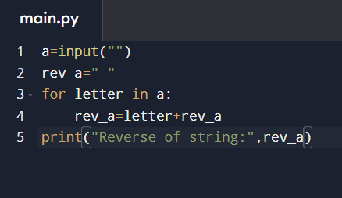

**Output:**

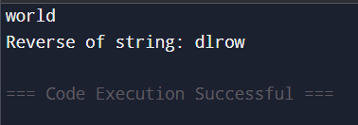

1. Check if a string is a palindrome.

**Program:**

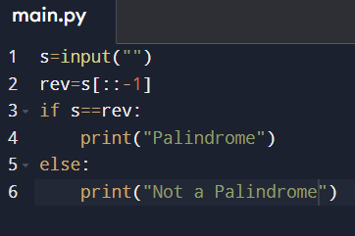

**Output:**

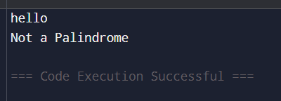

1. Remove all spaces from a given string.

**Program:**

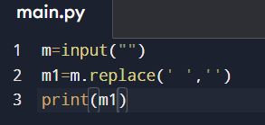

**Output:**

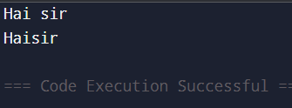

1. Count the number of vowels and consonants in a string.

**Program:**

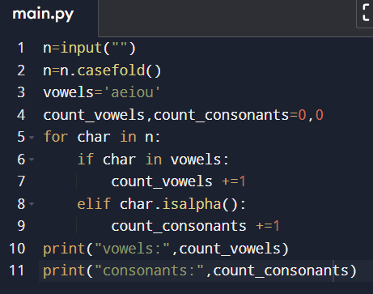

**Output:**

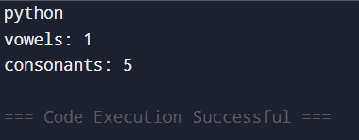

1. Count the frequency of each character in a string.

**Program:**

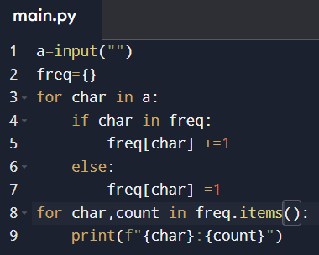

**Output:**

