SonarQube Code Quality and Security Analysis
The eatinity project was analyzed using SonarQube Community Build running locally in Docker. The analysis covered approximately 8,500 lines of React, Python, and Terraform code. The SonarQube Quality Gate passed.
The initial analysis reported:
- 11 security issues
- 23 reliability issues
- 88 maintainability issues
- 0 security hotspots
- 1.8% duplicated code
- 0% imported test coverage
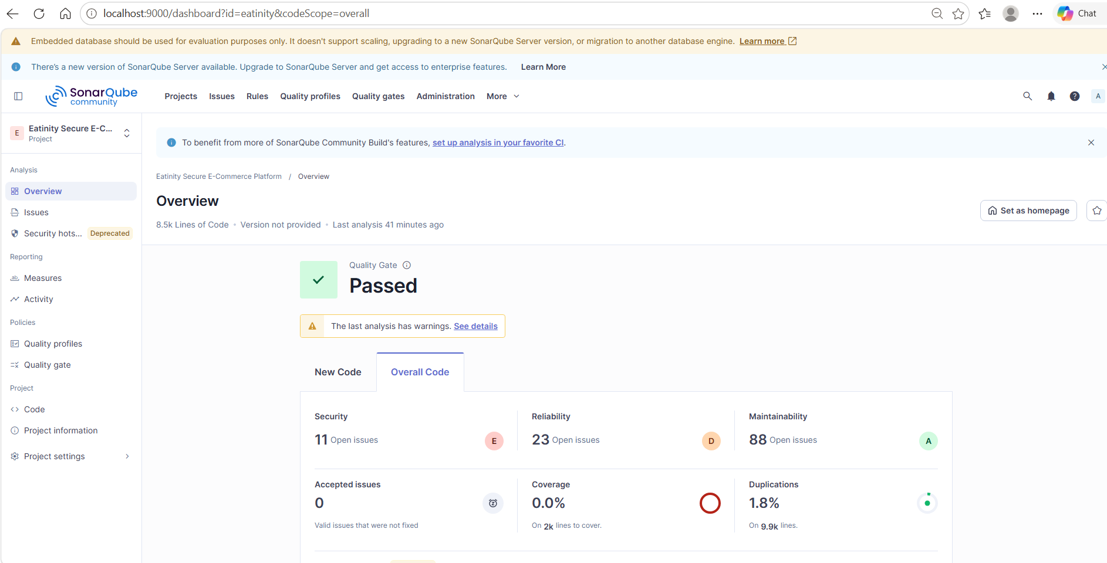
The 0% coverage result does not mean the application was untested. Eighteen Python backend unit tests passed successfully, but a coverage XML report was not supplied during this SonarQube analysis. Test execution and code-coverage import are separate processes.
SonarQube Community Build also displayed a notice that some advanced vulnerability detection, including additional injection analysis, is available only in commercial editions. This is a limitation of Community Build rather than an application or configuration failure.
The analysis results were reviewed alongside the Trivy security scan. Trivy’s high- and critical-severity security gate passed after vulnerable dependencies and infrastructure findings were remediated or documented with narrow, expiring exceptions. No credentials or SonarQube tokens were stored in the repository.
Evidence screenshots showing the passed Quality Gate and analysis summary are included in the project documentation.
The Quality Gate passed, with the reported issues recorded for review.

Area | Count | Preliminary action
Public API routes | 2 Blockers | Review and document intentional exposure
IAM | 2 Blockers | Likely requires code changes
CloudFront | 1 Major | Inspect exact rule
S3 storage | 6 vulnerabilities | Separate actual risks from intentional public-image design
Python backend | Multiple bugs | Fix after vulnerabilities
React/CSS | Mostly code smells | Lowest priority
Coverage | 0% | Generate and import coverage separately

SonarQube Community Build identified several high-severity findings related primarily to intentionally public AWS API Gateway routes and infrastructure security configuration. The public Stripe webhook must remain externally accessible so Stripe can deliver payment events; however, each request is cryptographically authenticated using the Stripe-Signature header and a webhook secret securely retrieved from AWS Secrets Manager. Invalid or unsigned requests are rejected. The public checkout route supports guest checkout, validates product availability and prices against DynamoDB, restricts quantities and cart size, and uses Stripe-hosted Checkout. Authenticated customers use a separate Cognito JWT-protected route.
The infrastructure findings were also reviewed carefully. Administrative and customer-account routes are protected using Amazon Cognito JWT authorization, CloudFront is connected to AWS WAF, SNS topics use AWS-managed KMS encryption, S3 access controls block ACL-based public access, and sensitive Stripe credentials are stored in AWS Secrets Manager. Public access to the product-image bucket is an intentional design decision because it contains only non-sensitive storefront assets; write access remains restricted through IAM. Accepted security decisions were documented with narrow, expiring exceptions rather than being silently ignored.
SonarQube’s Quality Gate passed after analyzing approximately 8,500 lines of React, Python, and Terraform code. The analysis reported zero security hotspots and 1.8% duplicated code. Remaining findings were recorded for continued review and were not represented as zero-risk results. The analysis was supplemented by a successful Trivy high- and critical-severity security gate and 18 passing backend unit tests.

We fixed all applicable issues. The remaining findings correspond to intentional design decisions (such as the public Stripe webhook and public product-image bucket) and were documented with appropriate security controls and justification.

