**Introduction:** In the enchanting world of gastronomy, few delights rival the sweet symphony of flavors encapsulated in jams, jellies, pickles, squashes, and ketchup. These delectable condiments, each with their unique taste profile, have become indispensable companions to our daily culinary adventures. Behind the luscious spreads, tangy relishes, and savory accompaniments lies a fascinating journey of manufacturing processes that transform raw ingredients into these beloved staples of our kitchen shelves.

**Manufacturing process of Jelly:**

1. **Raw Material Selection:** Choose ripe and fresh pineapples with a sweet and tangy flavor. Ensure that the pineapples are free from any spoilage or damage.
2. **Washing and Cleaning:** Wash the pineapples thoroughly to remove dirt, debris, and any pesticides. Peel and core the pineapples, removing the outer skin and tough inner core.
3. **Cutting and Crushing:** Cut the cleaned pineapples into small, uniform pieces or crush them to extract the juice. Crushing may involve using a mechanical crusher or a juicer.
4. **Juice Extraction:** Extract the pineapple juice from the crushed fruit using a juice extractor. Strain the juice to remove any remaining pulp or solids.
5. **Pectin Addition**: Pectin is a natural gelling agent found in fruits. Depending on the pineapple's natural pectin content, additional pectin may be added to achieve the desired jelly consistency.
6. **Acid Addition:** Adjust the acidity of the pineapple juice by adding citric acid or another acidifying agent. This helps in the gel formation during the cooking process.
7. **Sugar Addition:** Add a significant amount of sugar to the pineapple juice. The sugar acts as a preservative, enhances the flavor, and helps in the gelling process.
8. **Heating and Boiling:** Heat the mixture to a boiling point while stirring continuously. Boil the mixture until it reaches the gel point, where it thickens to the desired consistency. This step is crucial for jelly formation.
9. **Testing Gel Point:** Perform a gel test to determine if the mixture has reached the desired consistency. A small amount of the boiling mixture is placed on a cold surface to check if it forms a gel.

1. **Flavoring and Coloring:** Add any additional flavorings or colorings if desired. This step is optional, as pineapple jelly usually has a naturally vibrant color and flavor.
2. **Cooling and Filling:** Allow the hot pineapple jelly mixture to cool slightly. Fill the hot jelly into sterilized jars, leaving some headspace at the top.
3. **Sealing and Packaging:** Seal the jars tightly to prevent contamination. Label the jars with necessary information such as manufacturing date, ingredients, and storage instructions.

1. **Cooling and Storage:** Allow the jars to cool completely before storing them in a cool, dry place. Properly sealed and stored pineapple jelly has a shelf life of several months.

**Manufacturing process of Jam:**

1. **Raw Material Selection:** Choose ripe and fresh pineapples with a sweet and tangy flavor. Ensure that the pineapples are free from any spoilage or damage.
2. **Washing and Cleaning:** Wash the pineapples thoroughly to remove dirt, debris, and any pesticides. Peel and core the pineapples, removing the outer skin and tough inner core.
3. **Cutting and Crushing**: Cut the cleaned pineapples into small, uniform pieces or crush them to extract the juice. Reserve a portion of the crushed fruit to be used as pulp in the jam.
4. **Juice Extraction:** Extract the pineapple juice from the remaining crushed fruit using a juice extractor. Strain the juice to remove any remaining pulp or solids.
5. **Pectin Addition:** Pectin is a natural gelling agent found in fruits. Depending on the pineapple's natural pectin content, additional pectin may be added to achieve the desired jam consistency.
6. **Acid Addition:** Adjust the acidity of the pineapple juice by adding citric acid or another acidifying agent. This helps in the gel formation during the cooking process.
7. **Sugar Addition:** Add a significant amount of sugar to the pineapple juice. The sugar acts as a preservative, enhances the flavor, and helps in the gelling process. In the case of jam, a higher sugar content is typically used compared to jelly.
8. **Heating and Boiling:** Heat the mixture to a boiling point while stirring continuously. Boil the mixture until it reaches the gel point, where it thickens to the desired consistency. This step is crucial for jam formation.
9. **Testing Gel Point:** Perform a gel test to determine if the mixture has reached the desired consistency. A small amount of the boiling mixture is placed on a cold surface to check if it forms a gel.

1. **Pulp Addition:** Add the reserved crushed pineapple pulp to the boiling mixture. Stir well to ensure an even distribution of fruit pieces throughout the jam.
2. **Flavoring and Coloring:** Add any additional flavorings or colorings if desired. This step is optional, as pineapple jam usually has a naturally vibrant color and flavor.
3. **Cooling and Filling:** Allow the hot pineapple jam mixture to cool slightly. Fill the hot jam into sterilized jars, leaving some headspace at the top.
4. **Sealing and Packaging:** Seal the jars tightly to prevent contamination. Label the jars with necessary information such as manufacturing date, ingredients, and storage instructions.

1. **Cooling and Storage:** Allow the jars to cool completely before storing them in a cool, dry place. Properly sealed and stored pineapple jam has a shelf life of several months.

**Manufacturing process of Squash:**

The manufacturing process of pineapple squash involves extracting the juice from pineapples, concentrating it, and then mixing it with sugar and other ingredients to create a concentrated syrup. Here is a detailed overview of the process:

1. **Raw Material Selection**: Choose ripe and fresh pineapples with a sweet and tangy flavor. Ensure that the pineapples are free from any spoilage or damage.
2. **Washing and Cleaning:** Wash the pineapples thoroughly to remove dirt, debris, and any pesticides. Peel and core the pineapples, removing the outer skin and tough inner core.
3. **Cutting and Crushing:** Cut the cleaned pineapples into small, uniform pieces or crush them to facilitate juice extraction. Crushing may involve using a mechanical crusher or a juicer.
4. **Juice Extraction:** Extract the pineapple juice from the crushed fruit using a juice extractor. Strain the juice to remove any remaining pulp or solids.

1. **Clarification (Optional):** Depending on the desired clarity of the squash, the extracted juice may undergo a clarification process to remove any remaining impurities or cloudiness.
2. **Concentration:** Concentrate the pineapple juice by heating it to evaporate a portion of the water content. This can be done through a controlled heating process.
3. **Sugar Addition:** Add a significant amount of sugar to the concentrated pineapple juice. The sugar acts as a sweetener and preservative.
4. **Flavoring and Coloring:** Add any additional flavorings or colorings if desired. This step is optional and depends on the specific recipe or flavor profile desired for the pineapple squash.
5. **Acid Adjustment:** Adjust the acidity of the squash by adding citric acid or another acidifying agent. This helps enhance the flavor and acts as a preservative.
6. **Cooling:** Allow the pineapple squash mixture to cool to room temperature.
7. **Filtration (Optional):** The cooled mixture may undergo filtration to remove any remaining solids or impurities, resulting in a smoother texture.
8. **Pasteurization (Optional):** To enhance shelf life, the pineapple squash may undergo a pasteurization process, heating the mixture to a specific temperature to kill any remaining microorganisms.
9. **Bottling**: Fill the prepared pineapple squash into sterilized bottles, leaving some headspace at the top.

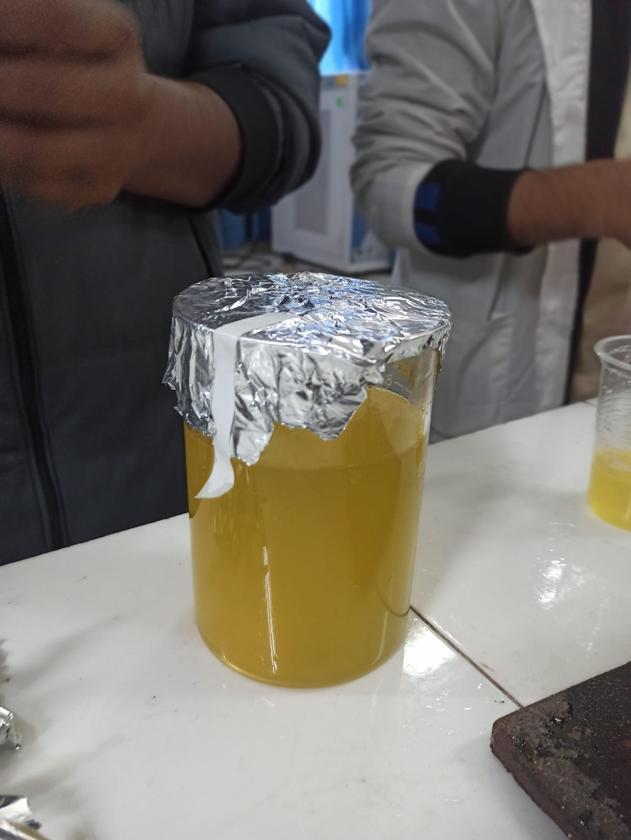

1. Sealing and Packaging: Seal the bottles tightly to prevent contamination. Label the bottles with necessary information such as manufacturing date, ingredients, and usage instructions.
2. **Cooling and Storage:** Allow the sealed bottles to cool completely before storing them in a cool, dry place. Properly sealed and stored pineapple squash has a longer shelf life.

**Manufacturing process of Pickle:**

1. **Selecting and Cleaning:** Choose fresh and firm jujube fruits. Wash them thoroughly to remove any dirt or debris.
2. **Cutting:** Cut the jujube fruits into halves or quarters, depending on your preference and the size of the fruits. Remove the seeds if desired.
3. **Preparing Brine**: In a pot, combine water and salt to create a brine solution. The concentration of salt depends on personal preference, but a common ratio is around 3-4 tablespoons of salt per liter of water. Bring the brine to a boil and then let it cool to room temperature.
4. **Blanching (Optional):** Some recipes may call for blanching the jujube fruits briefly in hot water to soften them slightly. This step is optional and depends on the desired texture.

1. **Vinegar Solution:** In a separate saucepan, combine vinegar and sugar to create a sweet and sour solution. The ratio of vinegar to sugar can vary based on personal taste. Bring the mixture to a boil and then let it cool.
2. **Preparing Spices:** Crush or chop spices like garlic, ginger, and chili peppers according to your taste preferences.
3. **Jars and Layering:** Sterilize the jars or containers by boiling them or using another suitable method. Begin layering the jujube pieces and spice mixture in the sterilized jars, alternating layers.
4. **Adding Brine and Vinegar Solution:** Pour the cooled brine into the jars, ensuring that the jujube pieces are fully submerged. Pour the cooled vinegar solution into the jars, covering the jujubes and spices.
5. **Sealing:** Seal the jars tightly to prevent air from entering. Use sterilized lids and make sure the rims are clean to ensure a proper seal.

1. **Fermentation (Optional**): Some pickle recipes involve allowing the jujube pickles to ferment for a few days to develop additional flavors. This step is optional.
2. **Storage**: Store the sealed jars in a cool, dark place for several weeks to allow the flavors to develop. Refrigerate after opening.

**Manufacturing process of Ketsup:**

1. **Raw Material Selection**: Choose ripe and high-quality tomatoes. The variety of tomatoes used can impact the flavor and color of the ketchup.
2. **Washing and Sorting:** Wash the tomatoes thoroughly to remove any dirt or contaminants. Sort the tomatoes to remove any damaged or unripe ones.
3. **Peeling and Deseeding:** Blanch the tomatoes in hot water to facilitate easy peeling. Peel the tomatoes and remove the seeds, as the seeds can affect the texture of the ketchup.

1. **Pulping:** Crush or pulp the peeled and deseeded tomatoes to obtain a smooth puree. This can be done using a pulping machine.
2. **Cooking:** Transfer the tomato puree to large kettles for cooking. Simmer the puree to reduce its water content, concentrating on the flavor. This step also helps to achieve the desired consistency.
3. **Straining:** Pass the cooked tomato mixture through a fine mesh or sieve to remove any remaining seeds or coarse particles.
4. **Seasoning and Flavoring:** Add sugar, salt, vinegar, and spices (such as onion powder, garlic powder, and various herbs) to enhance the flavor. Adjust the seasoning to achieve the desired taste profile.
5. **Cooking Again:** Cook the seasoned mixture again to incorporate the added ingredients and achieve the desired thickness.

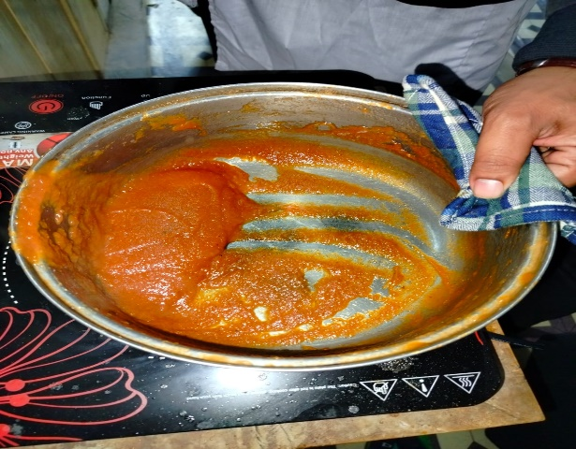

1. **Pasteurization:** Pasteurize the ketchup by heating it to a specific temperature to kill any harmful bacteria and extend its shelf life.
2. **Hot Filling**: - Fill the hot ketchup into sterilized bottles or containers. The heat helps create a vacuum seal and ensures product safety.

1. **Cooling:** - Allow the filled bottles to cool gradually to room temperature.
2. **Quality Checks**: - Conduct quality checks on the ketchup, including taste, color, texture, and pH levels.
3. **Packaging:** - Seal the bottles or containers with sterilized lids or caps. - Label the packages with necessary information, including ingredients, nutritional facts, and expiry date.
4. **Storage:** - Store the packaged ketchup in a cool, dry place before distribution.

**Conclusion:** In conclusion, our exploration into the manufacturing processes of jam, jelly, pickle, squash, and ketchup has unraveled the intricate tapestry of culinary craftsmanship. From the selection of raw ingredients to the final packaging, each step reflects a blend of tradition, innovation, and meticulous care. These condiments, beyond being simple spreads or accompaniments, carry the essence of culture and the artistry of those who craft them. As we close this assignment, we have not only gained insight into the technical aspects of production but also developed a deeper appreciation for the flavorsome alchemy that transforms everyday ingredients into the culinary delights that grace our tables.