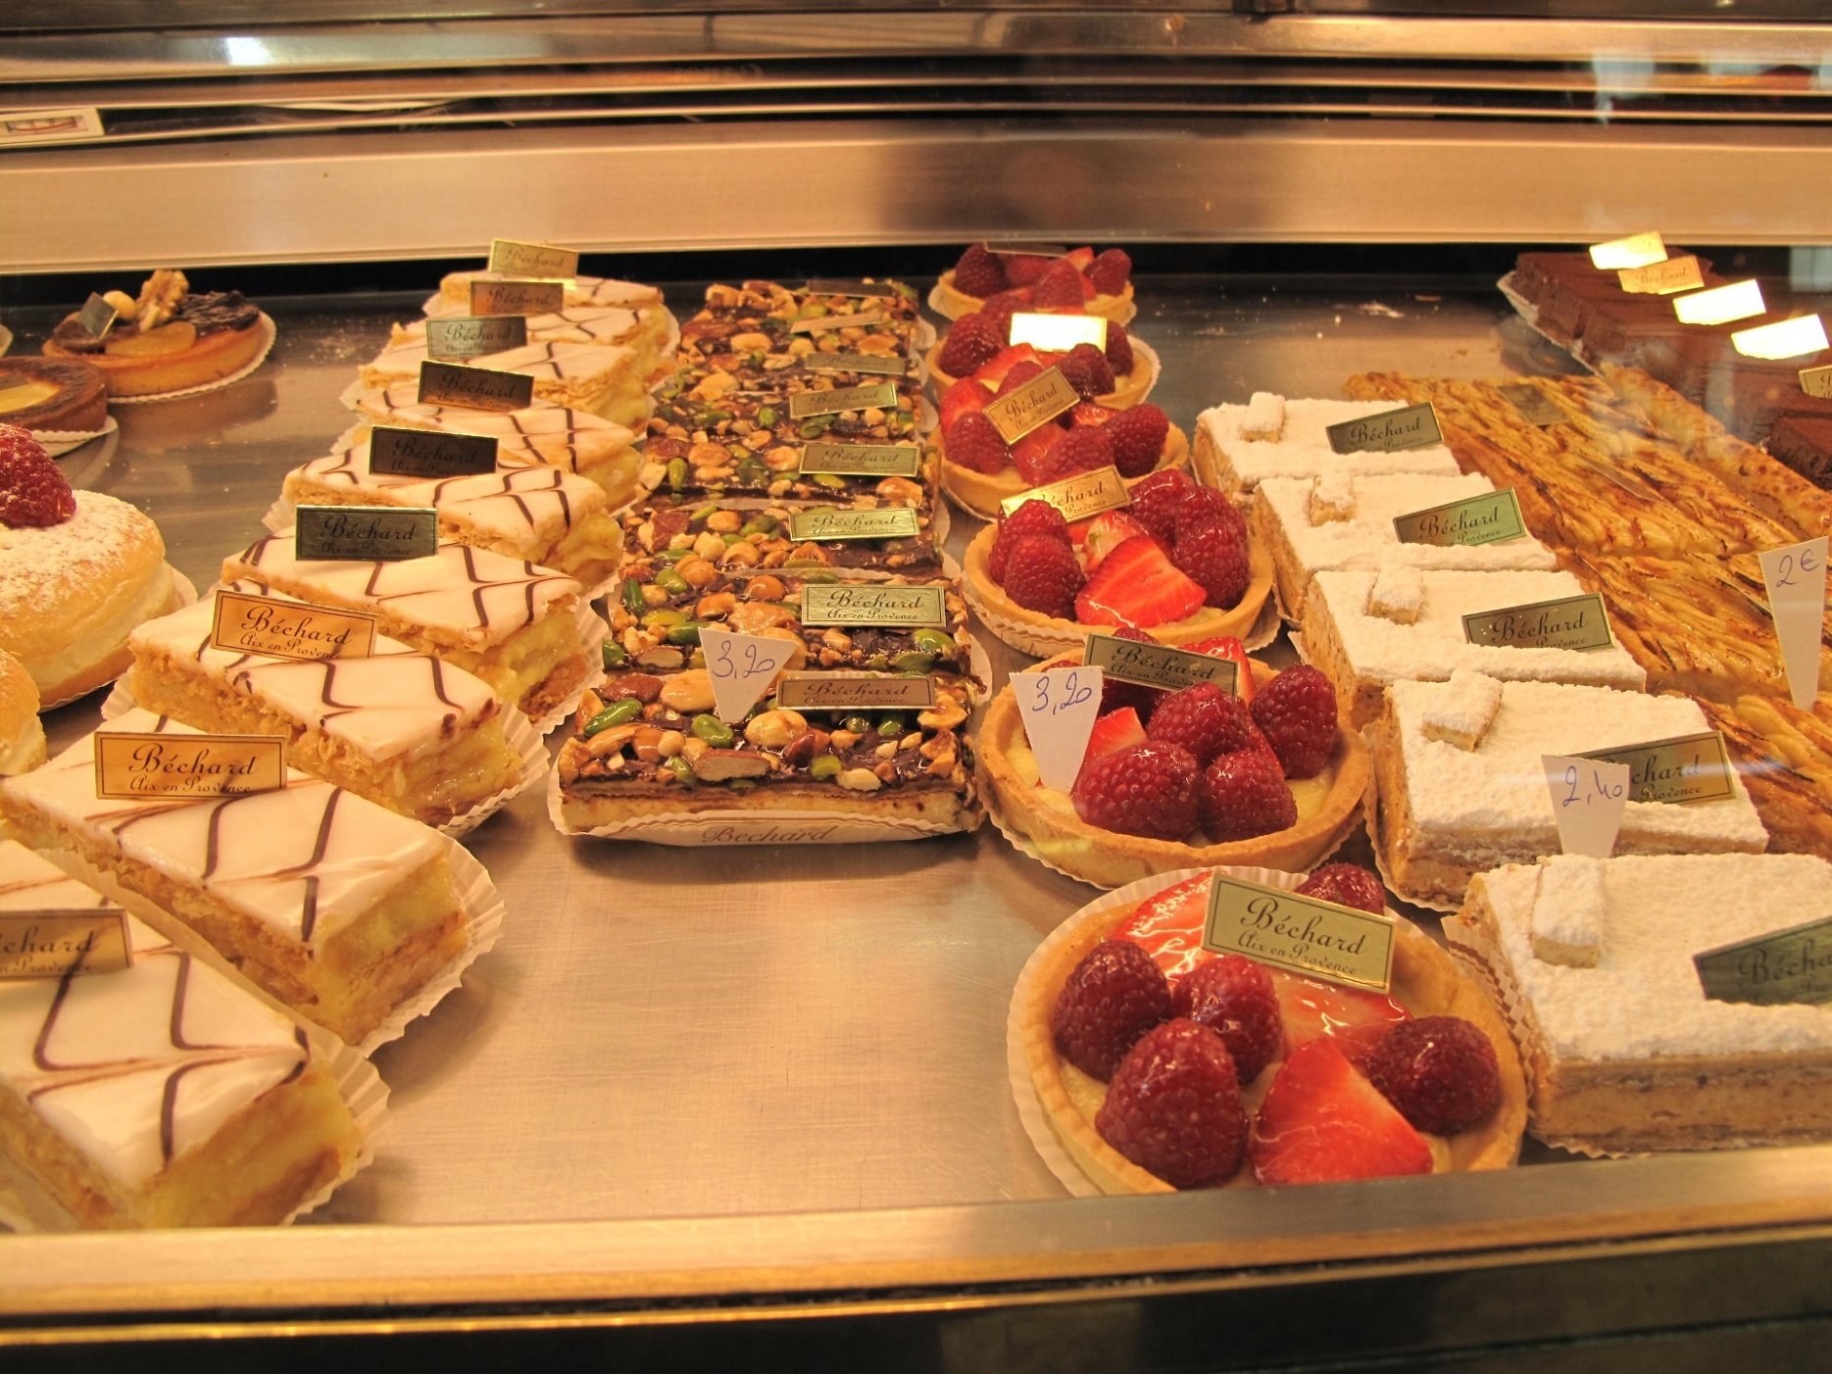

|  |
| --- |
| Data Driven Innovation Challenge |
| Guide document |
| 13-04-2025  Authored by: Marjolein van der Eerden |

# Introduction

Over the past few weeks, I have been working on an app that can identify ingredients from an image and suggest recipes you can make with them. To achieve this, I first looked for an image dataset containing labeled images of various ingredients. Then, I trained a model on this dataset so it could accurately detect the food items in a picture that a user uploads to the app. After the model was operational, I had to find a way to extract the ingredients list and feed it into a language model (LLM), which could then search the internet for recipes the user could make with the ingredients they have.

Table of Contents

Introduction 1

# Process

In the following section of this report I will talk about what I did for each phase of the project. The phases I will be talking about are:

* Data collection
* Data understanding
* Data preparation
* Preprocessing
* Modeling
* Evaluation
* Prototyping

## Data collection

At the start of this project, I was looking for a labelled image dataset specifically for fridges. However, I found it very difficult to locate one, so I eventually settled on a fridge detection dataset that I found on Roboflow (*FridgeDetection Object Detection Dataset (V2, Raw-images) by MyProject*, 2024). Despite its name, it doesn’t contain images of ingredients in a fridge. Instead, it includes images of food, mostly items that would typically be kept in a fridge, but they are staged on a table.

The dataset contains 1,739 images and 27 classes. The data is quite limited, as it mainly consists of the same types of food. Additionally, some of the classes in the dataset are not food items at all, which further restricts the available data.

Since the data challenge is time-bound and I had already spent quite a bit of time sourcing this dataset, I decided to proceed with it and see what I could accomplish.

## Data Understanding

The next step I took in my challenge was understanding the data I had and determining whether it was sufficient for what I wanted to achieve, as well as identifying its shortcomings. To do this, I examined a sample of the data.

In this overview, I noticed that the images contained a very limited variety of items. For example, it was always the same package of butter, the same types of noodles, and the same sausages. This means that if I were to use a different brand of butter, it’s likely that the model would not detect it.

However, there are also items like paprika, tomatoes, apples, potatoes, and lemons, which look the same overall since they are not packaged.

Another shortcoming I observed is that the dataset contains only 27 classes, some of which are irrelevant to the task at hand. For instance, there are classes like:

* basket
* scrubby
* sponge_opl
* cloth_opl
* tray
* help_me_carry_opl

These classes have nothing to do with food and aren’t ingredients for a recipe, so they don't add any value for my app. I Decided to deal with this later in the project if I had time remaining.

## Data Preparation

The first thing in the data prep step i did was

# References