**OUR CONCERNS ABOUT THE SYSTEM:**

1. Firstly, pag e click and open ang app, dapat ang mugawas sa first interface is the name of the app which is “UniReserve” with logo (kanang square sa taas is the logo dapat) then dapat maka choose ang taker/client kung unsa na service ilahang gusto e avail if ang “SUAST Slot Reservation” ba or “Frontline Service Transaction” pareha sa gipakita namo sa mock up. Una ni dapat na interface sunod tung pwede na maka register and login ang taker/client. This is the interface na amoa gi mean:

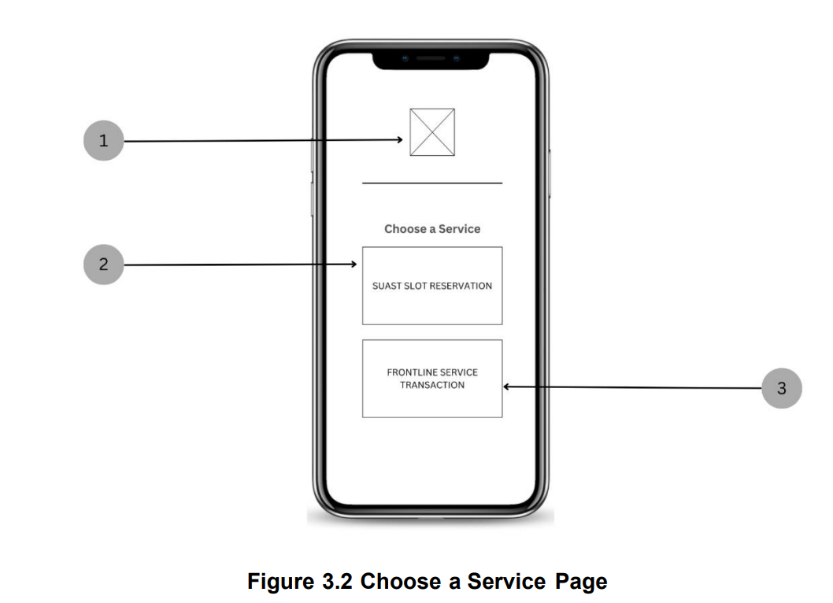

1. 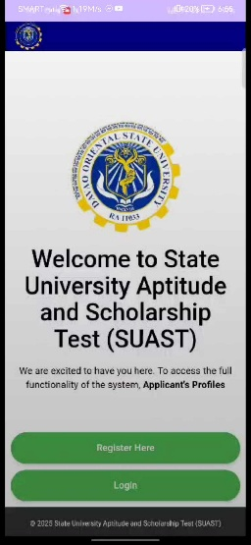After ato nga interface is ang sign up/login page na pareha atung naa sa video. Pero dapat kadto sya na interface na nasa vid is if ang pillion sa user is ang SUAST Slot Reservation. If Frontline Service Transaction ang gipili, same gihapon ang interface pero dapat about Frontline Service Transaction na ang nakabutang. Dri na interface if SUAST slot reservation ang gi pili, paki revise sa text na “Welcome to State University Aptitude and Scholarship Test (SUAST)” to “Welcome, SUAST Taker!” then if Frontline Service Transaction ang gipili, dapat “Welcome, Frontline Service Client!” ang nakabutang.
2. Sa Frontline Service Transaction na part, after pillion sa client ang Frontline Service Transaction sa 1st interface ug maka signin/login na sila, dapat ang 3rd interface niya is makapili ang client ug specific office sa Frontline. Currently, naay 3 offices sa frontline pero pending pa ang registrar so set aside lang muna sya (naay possibility na maapil sya or dili na, naghulat pa mi confirmation from our capstone adviser since wala pa sya nag reply). So ang offices na ilahang pilian is ang “Accounting Office” and Human Resource Management Office (HRMO)”. Then after makapili sa client ug office, dapat sa 4th interface makapili nasad sila ug specific service ato na office for transaction.

For **Accounting Office**, isa lang iya available service which is:

* Releasing of Examination Permit/Clearance Form

For **HRMO**, 4 ilaha available services which is:

* Issuance of Service Record
* Issuance of Certification
* Processing of Application for Leave
* Inquiries on Personnel-related matters

Pag Accounting office ilaha pillion, 1 lang ka service mulabas, pero if HRMO ilaha pillion 4 ka services mulabas. If nakapili na sila ug service mu diretso na dayun sa Interface ato na service to process their transactions.

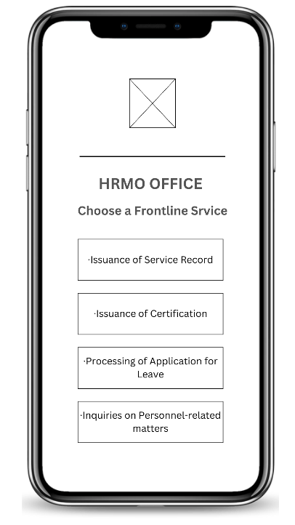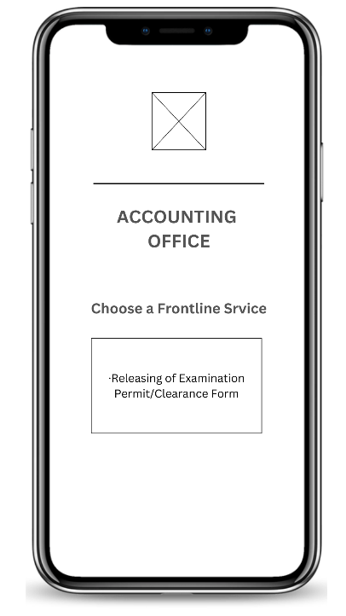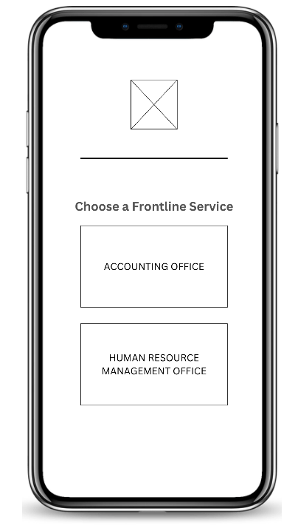

3rd Interface 4th Interfaces

1. Sa pag handle ug different roles, dapat lahi ang interface sa taker and client side and dapat lahi sad ang interface sa admin side. Then sa admin side, strictly dapat sila lang jud ang maka access for confidentiality. There are two roles sa user side
2. (taker for SUAST and client for Frontline). Sa admin side is admin lang jud.

Also, if gusto ka po og legit reference on how they actually process their services mao ni siya among maipakita.

**ACCOUNTING**

* 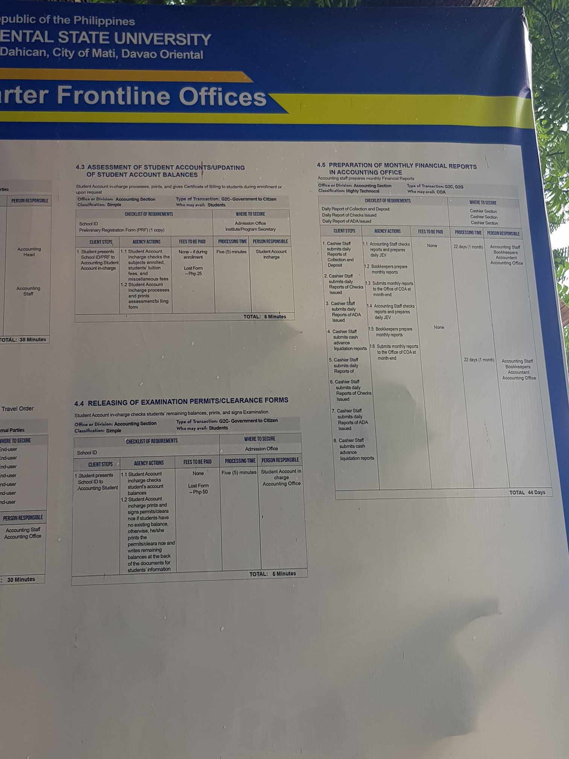Releasing of Examination Permits/ Clearance Forms

**HRMO**

* Issuance of Service Record
* Issuance of Certification
* Processing of Application for Leave
* Inquiries on Personnel-related matters

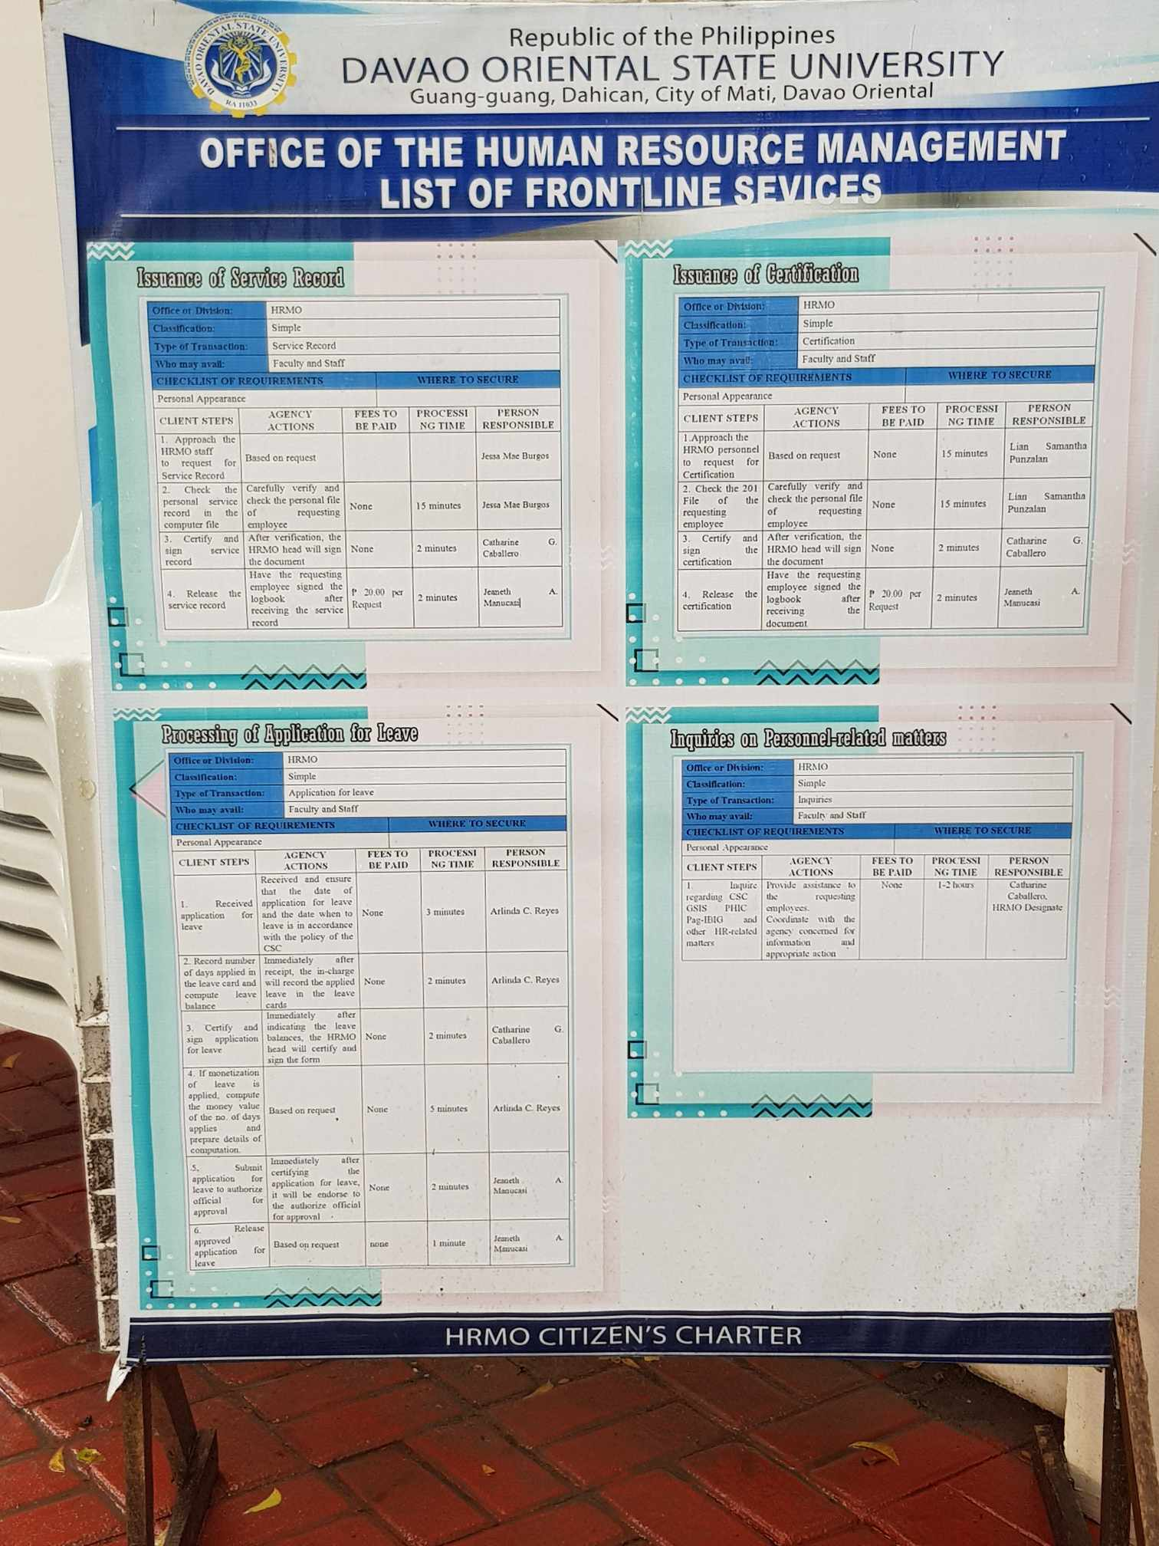

1. Note: kada office lahi lahi sila og registration and login page kay dili siya pwede isahon lang. Kay para daw dili maglibog ang kada offices.

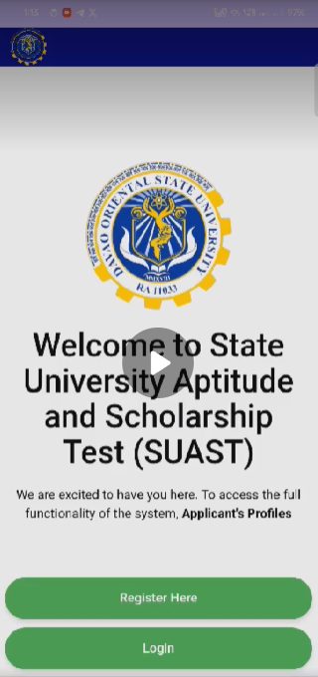

­

1. 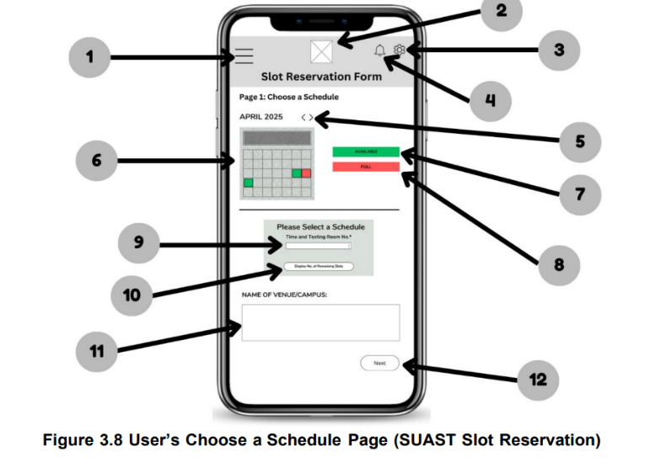Sa SUAST Slot Reservation Part, pwede lang mag base sa mock up na amoa gi provide. Then sa pag choose sa schedule for the exam, dri mi nag base sa fb post of OSCD page, pls access the link: <https://web.facebook.com/share/1EDD12vFKk/>



Mao ni sya ang mock-up for taker side, dapat makapili sila ug available date, time and testing room, then dapat makita nila ang remaining slots. Kada testing room, limited lang sya ug 30 slots. So if hurot na ang slot, di na sila kapili ato na sched so dapat lain sched nalang ilaha pillion.

Based sa naa sa post, there are 5 testing rooms and different scheduled times for each date. Pero consistent ang venue which is ang AB bldg. sa DORSU kay didto jud gina held ang exam. For example:

February 14, 2025 (AM sched)

* Testing Room 1: 8:00-10:00 am
* Testing Room 2: 8:00-10:00 am
* Testing Room 3: 8:00-10:00 am
* Testing Room 4: 8:00-10:00 am
* Testing Room 5: 8:00-10:00 am

After ani na sched, musunod na dayun ang naka pili ug sched na 10:00 am-12:00nn and afternoon sched na 1:00-3:00pm.

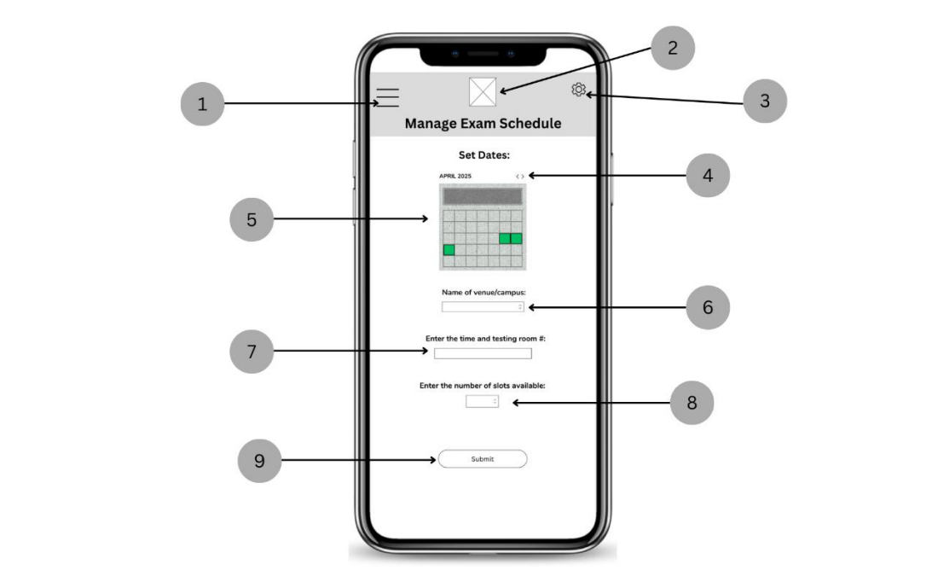

So sa admin side, dapat maka edit ang admin sa schedule and Testing room available sa exam if unsa nalang available like sa example. Then sa name of Venue/Campus, dapat maka edit sab ang admin ana sa admin side. Ang remaining slots, dapat e limit lang jud nila ug 30 kada testing room.

To be continued… (if ang kada offices na pud ang naay mga concern)