Ecplise CDT setup guide for darktable in Windows (and Linux)

I have been requested to post a guide about setting Eclipse CDT IDE for darktable, so here it is.
This guide assumes that you are already able to build darktable from sources (in Windows through MSYS2), by following the build guide on GitHub.
Basic knowledge of Eclipse CDT is also required.
If you want to contribute to darktable project, normally you need to create your own fork of the project in GitHub.
We assume that darktable sources are in C:\msys64\home\<username>\develop\darktable (/home/<username>/develop/darktable in Linux)

Step 1. Install Ecplise CDT from website
Step 2. From the Ecplise Marketplace, search and install the addon cmake4eclipse
Step 3. Import Darktable source code
In eclipse: File→ New → Project → C/C++ → C++ Project
In the dialog, choose “Linux GCC toolchain” and point to the source code folder. See below
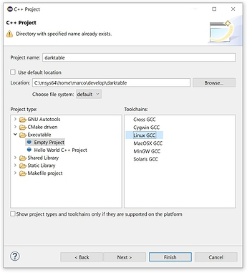
Hit “Finish”
Step 4. Set Project Properties
Go to the properties of the newly created Eclipse project. For example in Project explorer window, right click on the project → Properties
Setup as follows (hit “Apply” at every step)
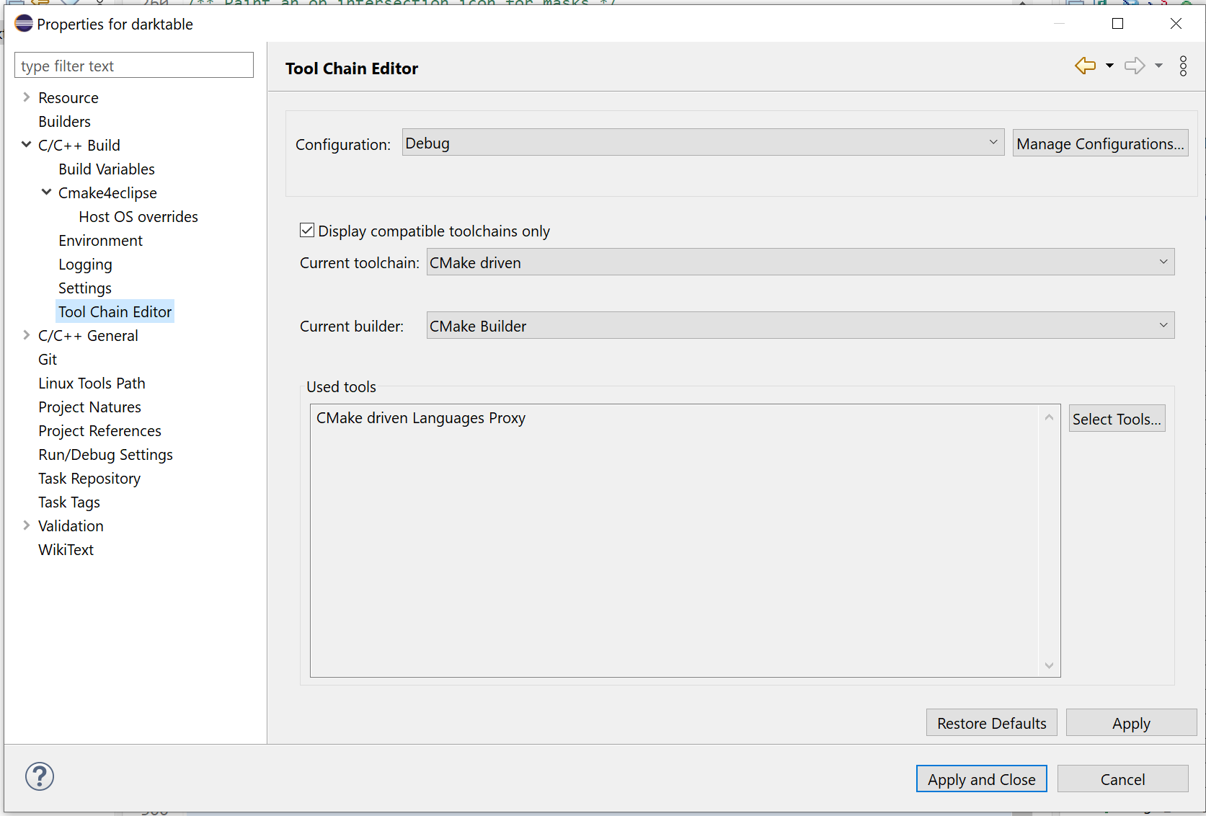
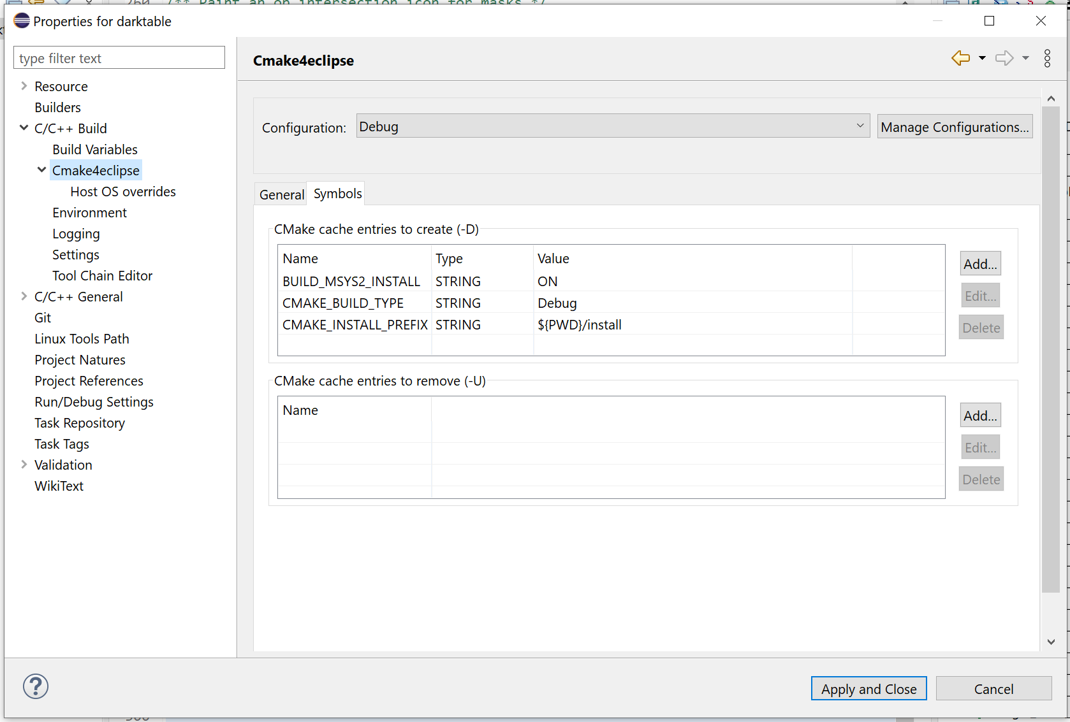
(in Linux, omit BUILD_MSYS2_INSTALL)
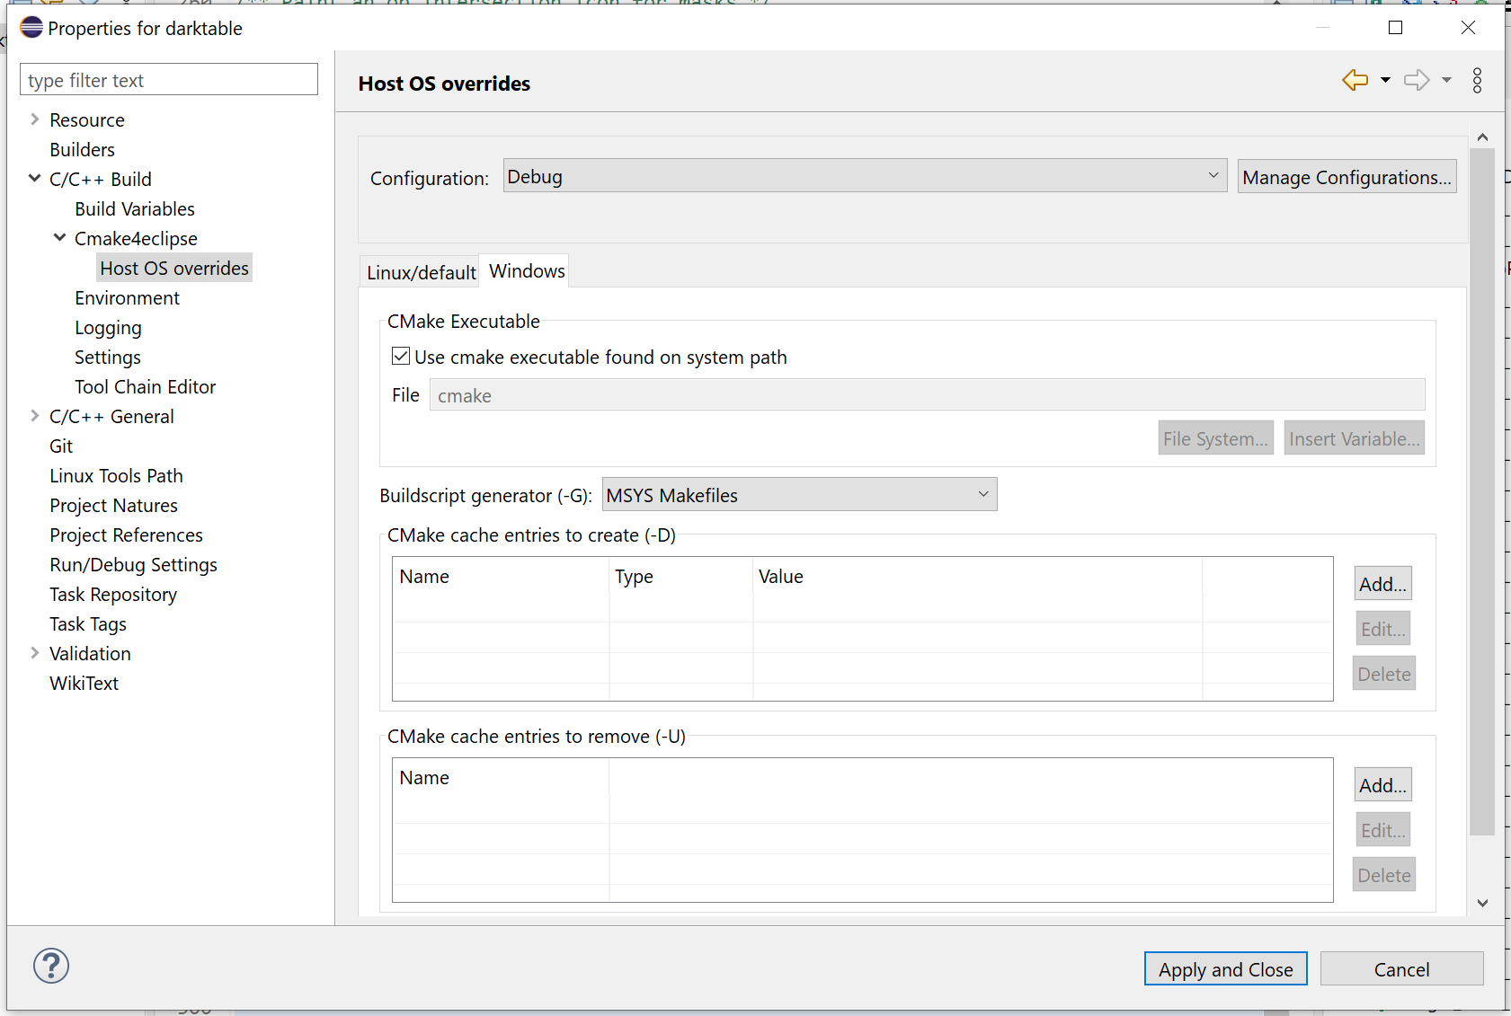
For newer releases of darktable you can also use Ninja as Buildscript generator, which is faster, provided you installed in MSYS2 the relative toolchain.
(for Linux, use the Linux/Default tab and put Unix Makefiles or Ninja as buildscript generator)

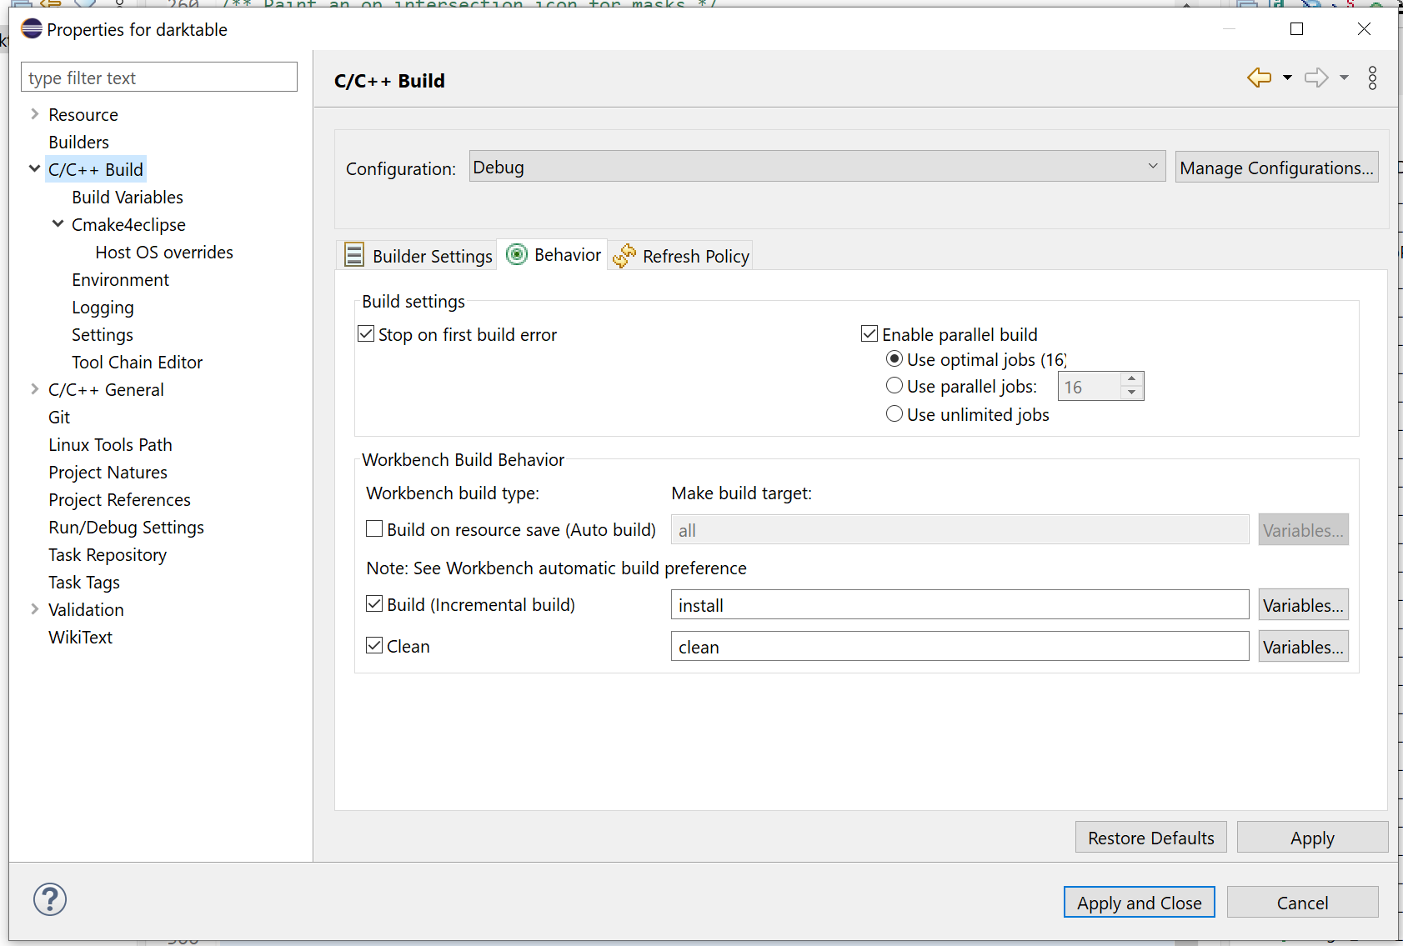
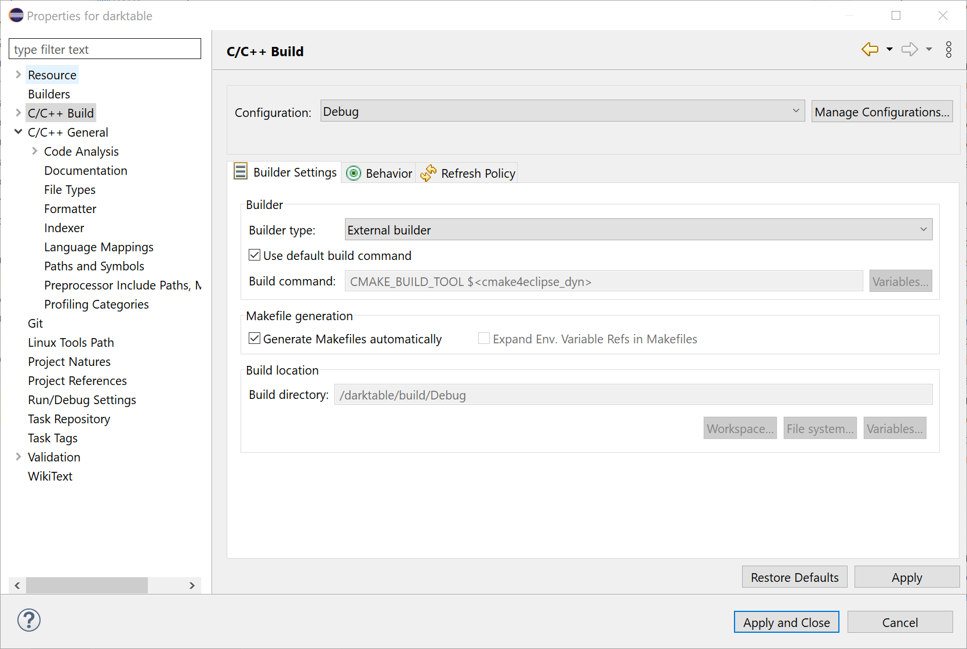

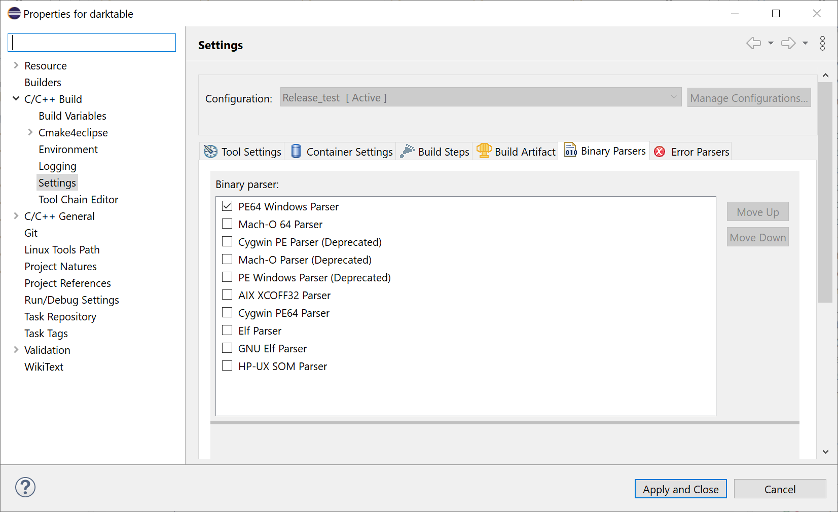
(for Linux, use GNU Elf Parser)

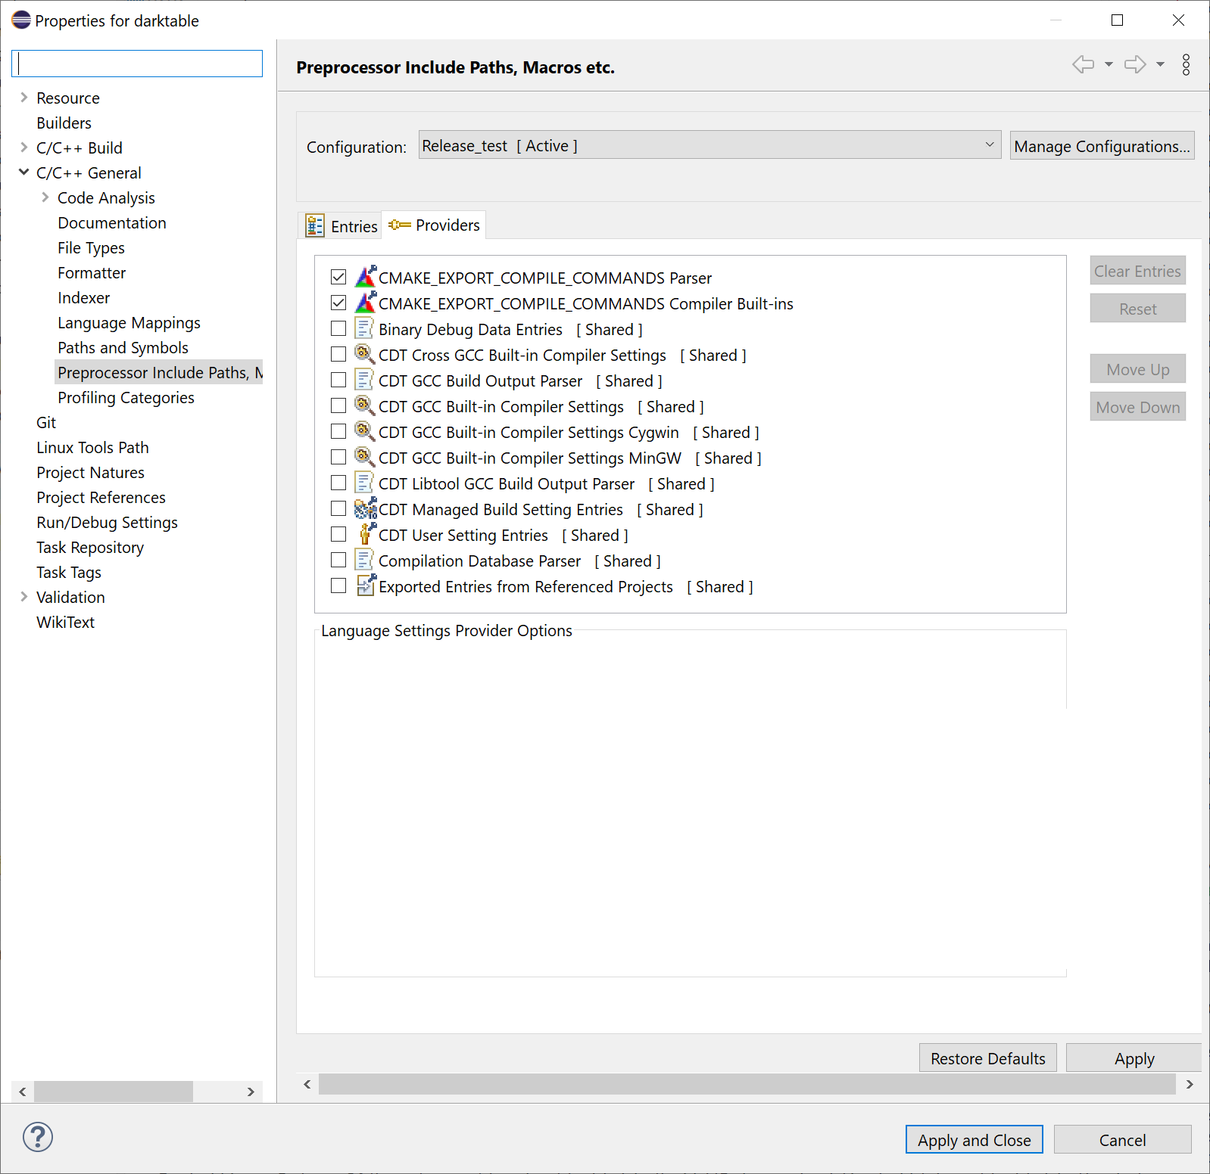

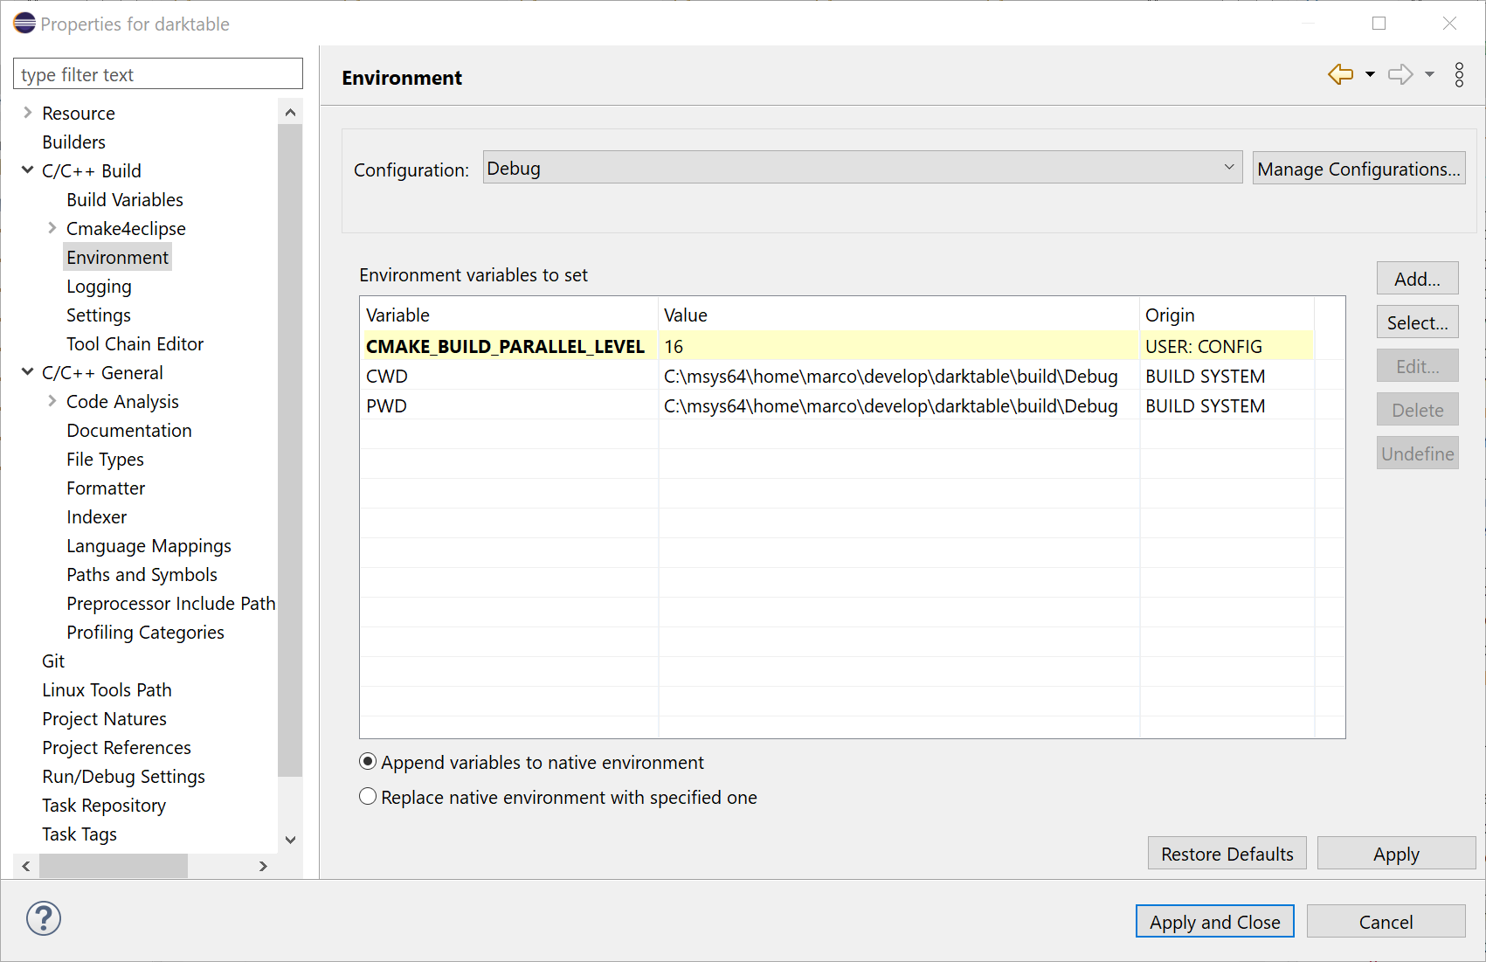
(fol Linux use the corresponding path /home/<username>/develop/darktable/build/Debug)
Hit “Apply and Close”

Step 5. Build the project
Eclipse should run CMake first and then make (or ninjia) and install, you can see the output in the Eclipse console.
The initial build could give some errors related to failing build of user manual and/or translations, that should not be a problem.
Incremental builds shall not give errors.

Step 6. Create a run configuration
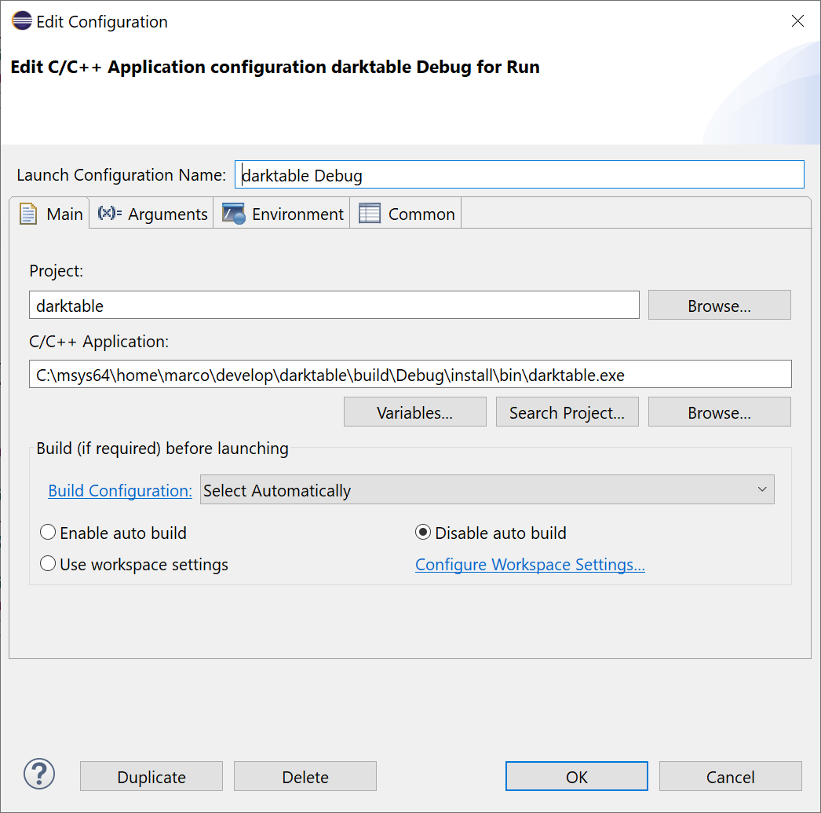

(for Linux use the path build/Debug/install/bin/darktable)
It is recommended you specify a configuration folder (you can have more than one)
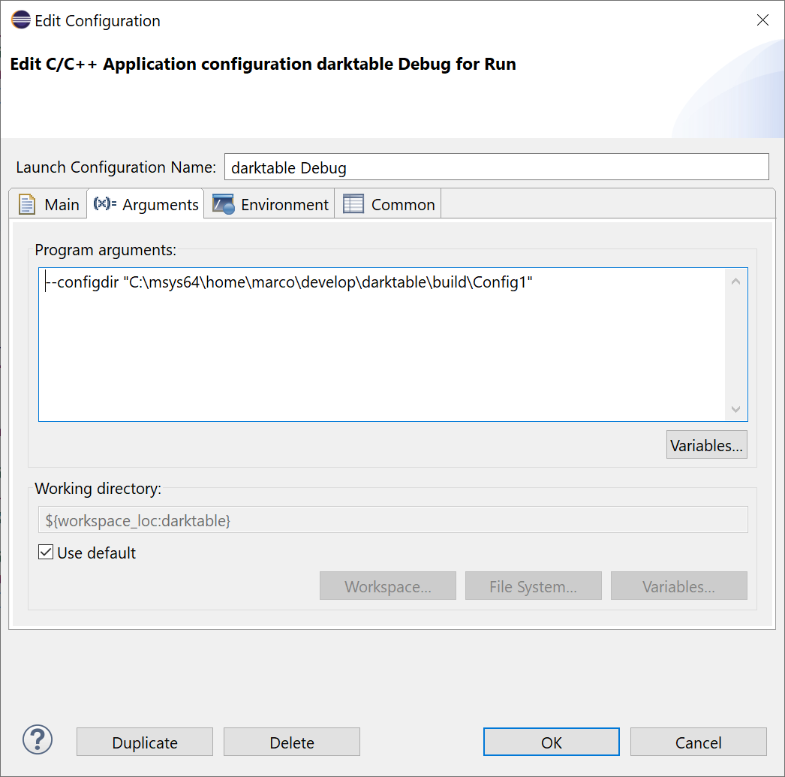
(for Linux, use the path /home/<username>/develop/darktable//build/Config1)
In this dialog you can also specify additional command line arguments for darktable, like debugging options (-d <debug option>).

Step 7. Create a debug configuration
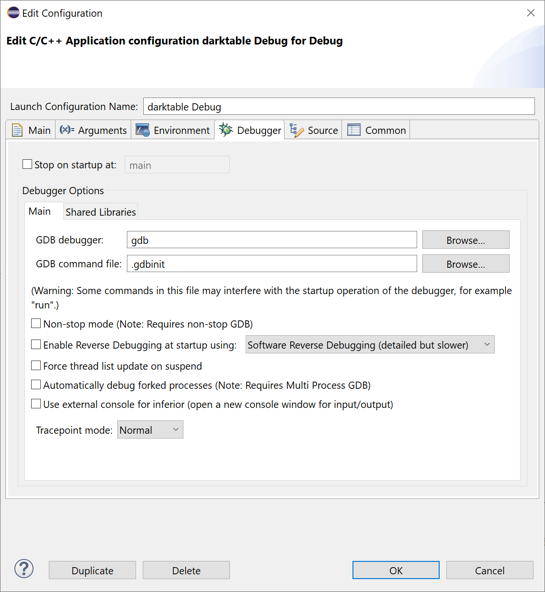
Now Eclipse should be able to run and debug darktable.

Final remarks
- You can define more configurations, like Release for example by changing CMAKE_BUILD_TYPE or other parameters.
- In general, building and debugging in Windows is slower than in Linux.

Feel free to comment / modify / improve.

