REPORT

|  |
| --- |
| DCS HW1 |
| Student: 111511076 陳彥宇 |

# Submodule Explanation

The homework’s module can be separated into 3 sections.

1. Fetch values with given address

* There are 6 input addresses in total, so 6 of the TA’s register module must be instantiated

1. Rearrange the sequence

* Some operations require the numbers sorted in non-decreasing or non-increasing order, so I used a modified version of Lab02’s module(It could take 5 inputs, I made it take 6 inputs by adding 5 more comparators) to achieve this
* The “Rearrange_Input_Sequence” module takes the values in their original order, the sorted values, and opcode[2:0] and sends the chosen sequence to the next stage.

1. Compute output

* The “Compute_out_n” module computes the final output based on the operation given by opcode[2:0]

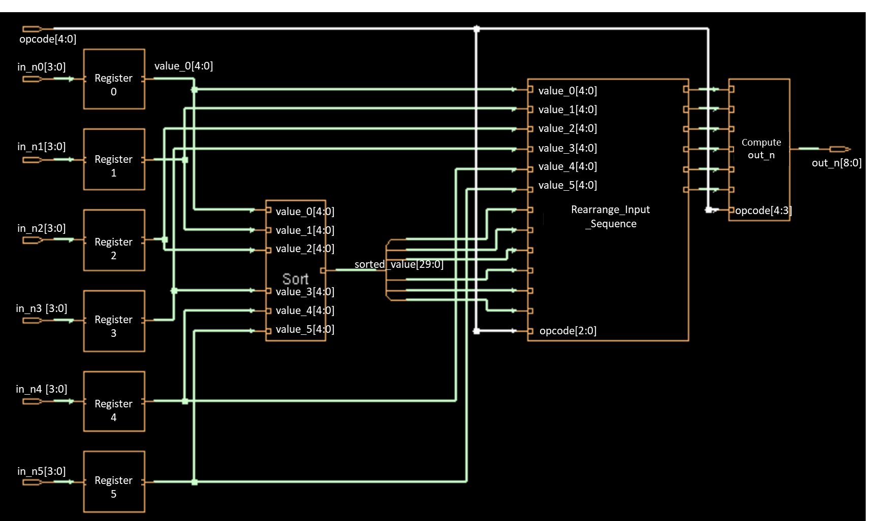

Fig. 1 Design Block Diagram

# Area & Timing Optimization:

According to p61 of Lecture 2-4, related logic should be put in the same always block so that resources can be shared. By combining the modules “Rearrange_Input_Sequence” and “Compute_out_n” into one. I reduced the area from 21383.099 to 20034.907. This may sacrifice a bit of readability, but it’s essentially just moving two case statements into the same always block. This highlights the importance of properly explaining the code using comments when working as a group. Circuit design is all about making compromises, so such sacrifices are inevitable. Properly explaining things will save everybody’s time and make the group project more efficient.

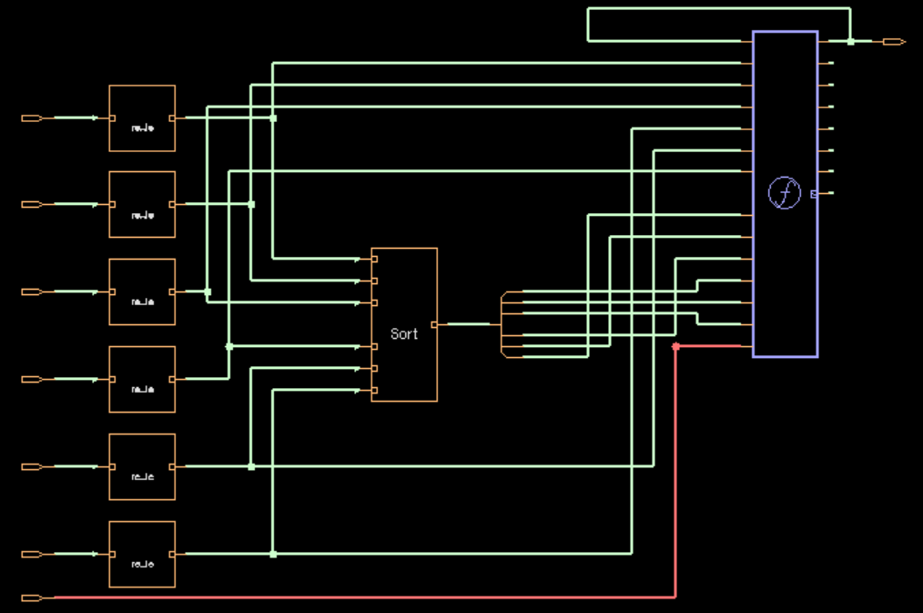

Fig. 2 Schematic of 2 Modules Combined

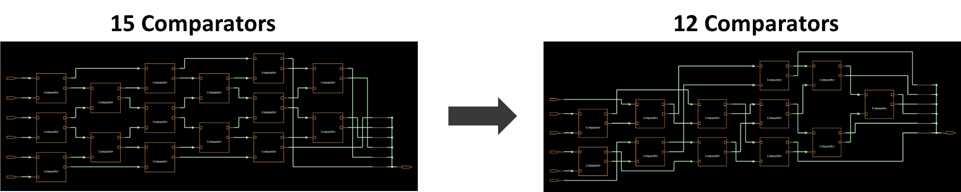

Fig. 3 Sorting Modification

Initially, I thought that sorting 6 elements required 15 comparisons minimum. However, that didn’t turn out to be the case. The correct minimum is actually 12 comparisons. Implementing this led to an area decrease of approximately 2000.

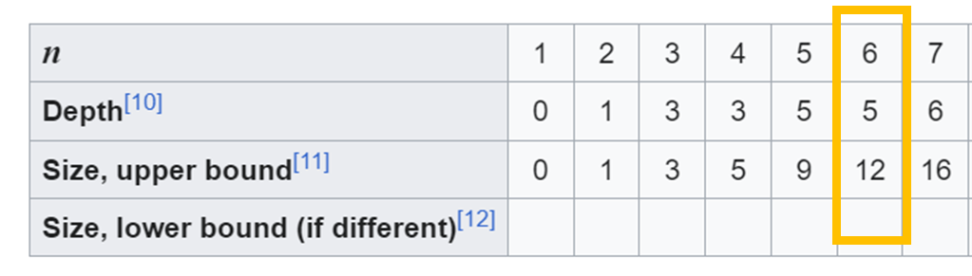

Fig. 4 n Element Minimum Comparisons Required

|  |  |  |  |  |  |  |
| --- | --- | --- | --- | --- | --- | --- |
| Code | V1(Best Readability) | V2(Module Combined) | V3 | V4 | V5 | V6(Sorting Improved) |
| Area | 21382.099435 | 20034.907432 | 19479.39648 | 17440.31544 | 16415.78425 | 15181.68989 |

Code: <https://github.com/Mark-Chen0220/DCS/tree/main>