REPORT

|  |
| --- |
| DCS HW2 |
| Student: 111511076 陳彥宇 |

# Block Diagram:

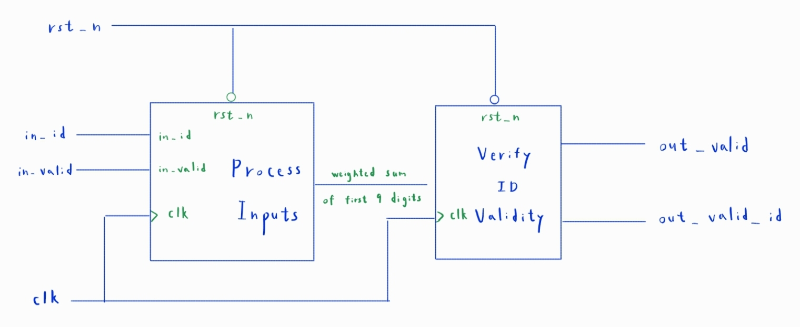

Fig. 1 Design Block Diagram

# Submodule Explanation:

The homework’s module can be separated into 2 sections:

1. Process inputs and sum them

* There are 10 inputs addresses in total, the first 9 need to be multiplied by fixed weights and summed together.

1. Check ID validity

* Take the modulo of the weighted sum divided by ten and compare it to the 10th digit.

# Area & Timing Optimization:

1. Originally, I had a 10 X 6-bit reg to hold all the digits of the ID. However, we actually only need to save the last (10th digit) for verifying the ID. Therefore, this reg was removed in latter versions of my code.
2. Dividing by 10 is a resource-intensive process, so I tried to implement a lookup table from 1 to 344 since the largest possible sum is given by Z999999999 (344). However, the area synthesized from this was even larger than dividing normally, so this idea was abandoned.

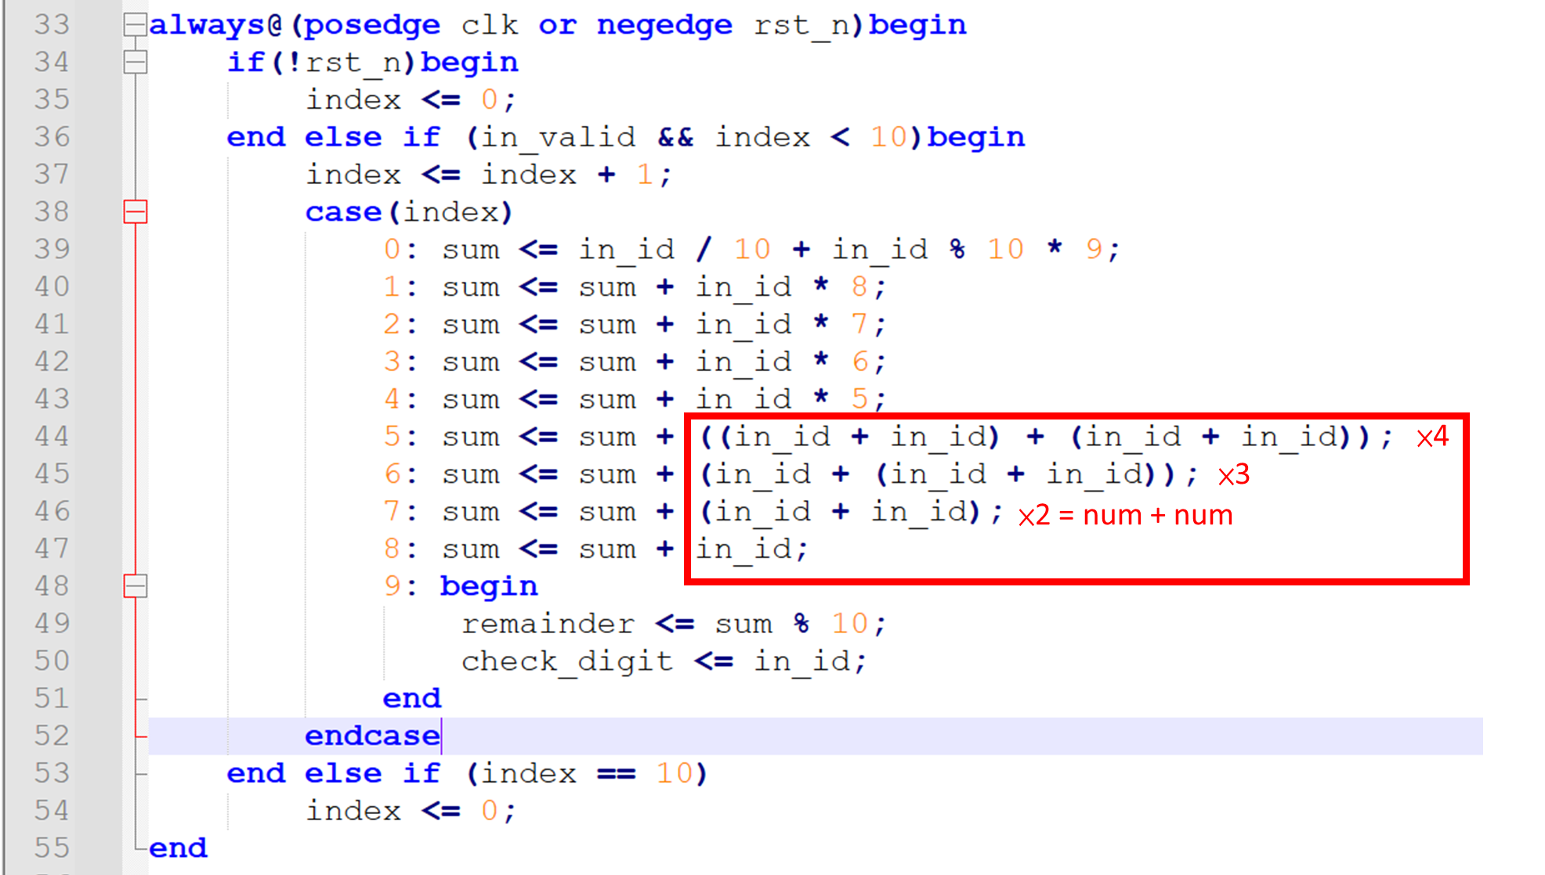

Fig. 2 Multiplication to Addition Trick

1. I reckoned that multipliers require more area than adders, so I tried replacing some multiplication operations with addition. After some testing, it would appear when having to multiply by 2 to 4, it’s better to achieve this using adders.
2. There are 10 inputs addresses in total, only the first 9 numbers need to be summed. There are no additional complex computations required after receiving the 10th digit. Therefore, it’s possible for us to output the result immediately upon receiving the 10th digit. Doing so will reduce the latency to 0.

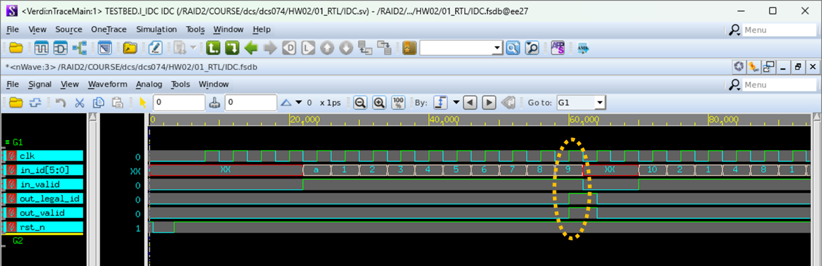

Fig. 3 Outputting at 10th clk edge

|  |  |  |  |  |  |  |
| --- | --- | --- | --- | --- | --- | --- |
| Code | V1 | V2 | V3 | V4 | V5(latency improved) | V6(area shrunk) |
| Area | 21382.099435 | 20034.907432 | 20806.63232 | 20600.39551 | 20836.56991 | 14130.54736 |
| Latency | 3000 | 3000 | 3000 | 3000 | 0 | 0 |

Code: <https://github.com/Mark-Chen0220/DCS/tree/main/HW02>