1. At 60ns, what’s the value of num_xor and num_add2 in decimal?

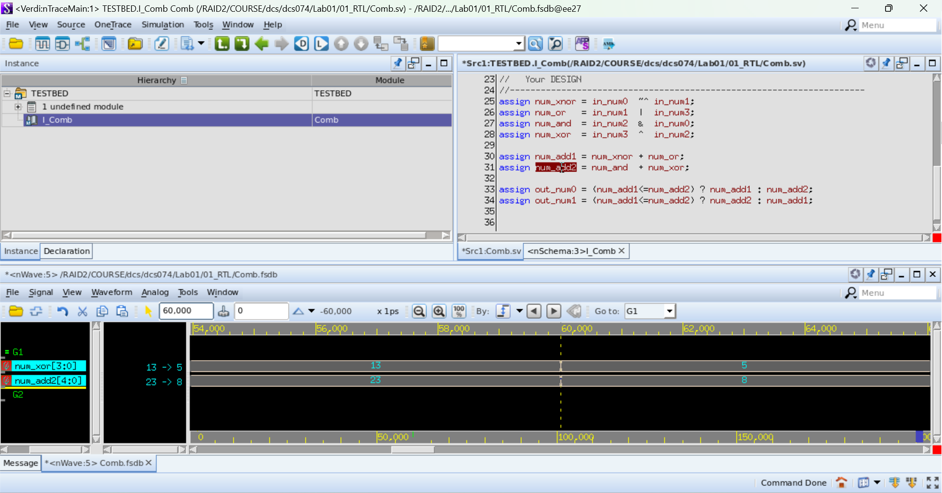

1. At 100ns, what’s the value of num_xnor and out_num0 in binary?

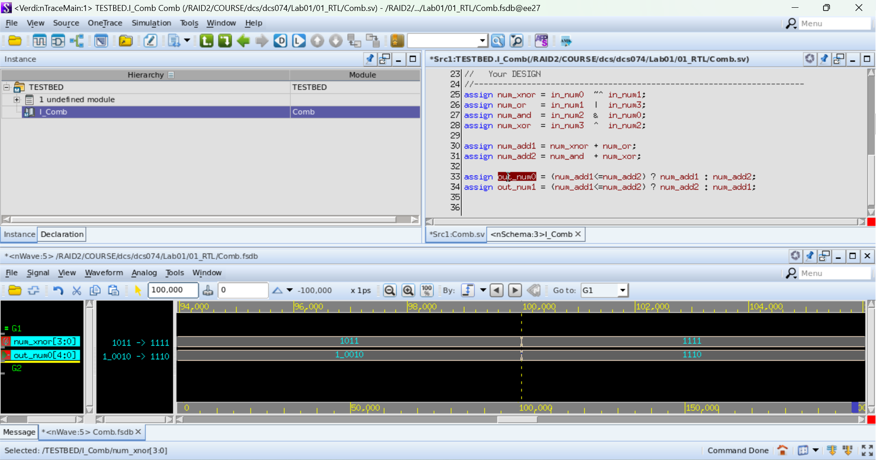

1. 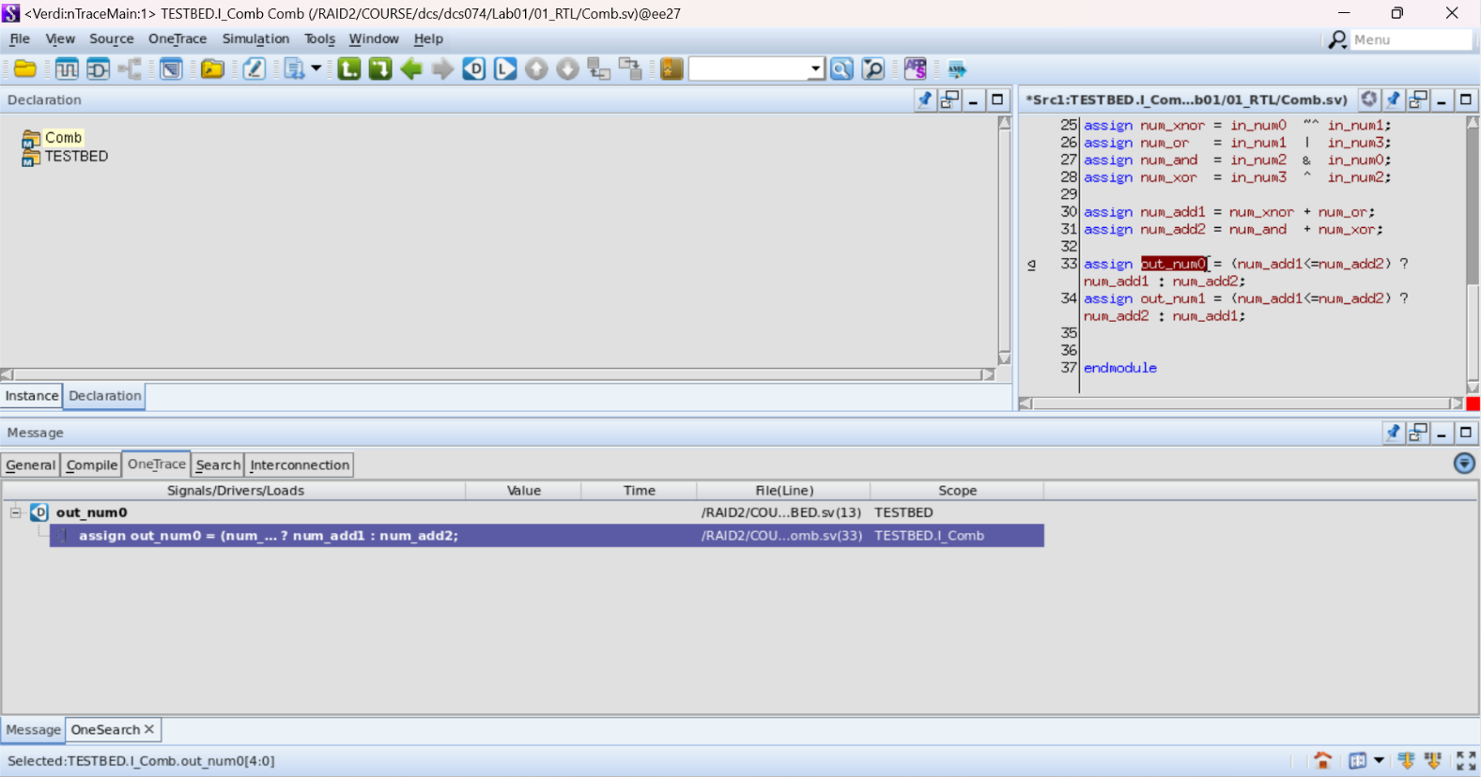Trace which signals drives out_num0 (use nTrace)
2. 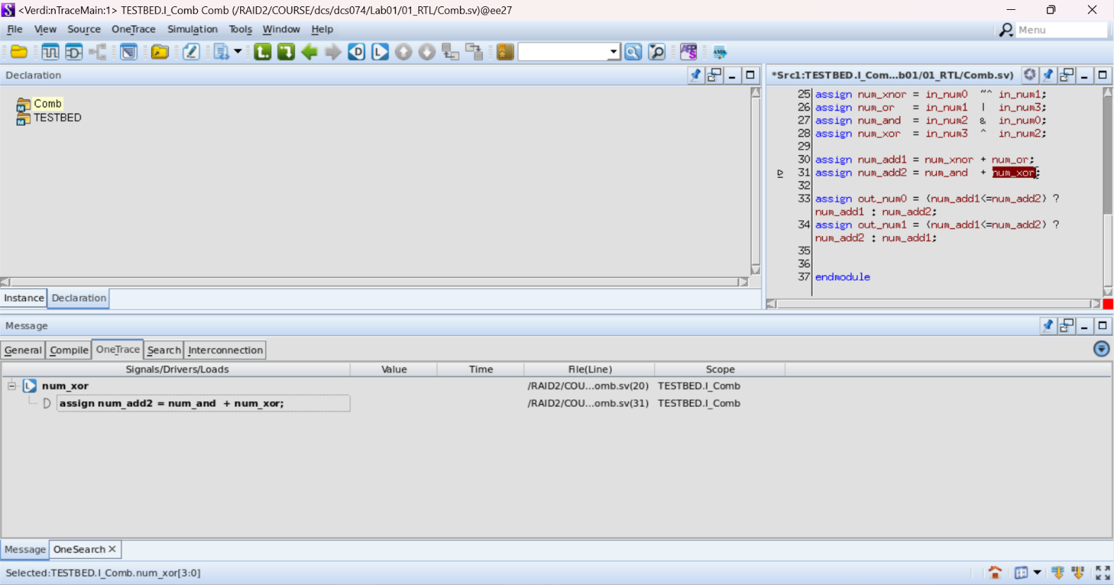Trace which signal is loading from num_xor (use nTrace)

