Digital Laboratory Lab01 Report

(Experiment Record Template)

Watch Lab video before the lab day. Playlist: <https://youtube.com/playlist?list=PLcGCikr5PJAgppG9guKmAlm_t7ZPcAz0z>

**Experiment-01**

Build this circuit on the breadboard. Apply the specified conditions to the circuit. Measure and record the results.

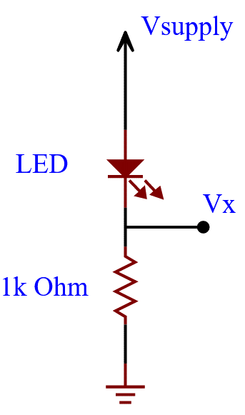

|  |  |  |  |  |  |  |  |  |  |  |
| --- | --- | --- | --- | --- | --- | --- | --- | --- | --- | --- |
| **Vsupply**  **(Volt)** | **500m** | **1** | **1.5** | **2** | **2.5** | **3** | **3.5** | **4** | **4.5** | **5** |
| **Vx**  **DC**  **(Volt)** | 2mV | 2mV | 2mV | 254mV | 708mV | 1.18V | 1.66V | 2.142V | 2.636V | 3.118V |
| **Brightness**  **change** | Brighter 🡨🡪 Darker  Or  Darker 🡨🡪 Brighter | | | | | | | | | |

Questions: **(Solve it at home. No live demo)**

**What is the LED?**

Ans: LED stands for Light Emitting Diode. It is a semiconductor device that produces light when powered. Unlike traditional incandescent light bulbs, it produces light not through heat, but through electroluminescence. In our experiment, it can be used to indicate logic 1 when it glows and logic 0 when it doesn’t.

**Does the variation of the voltage value at node x (i.e., Vx) make sense? How do you explain the phenomenon that influences the brightness of the LED?**

Ans: The brightness of an LED is decided by the amount of current that flows through it. The higher the current, the brighter the LED will be. By raising the voltage, we also increase the current. Doing so makes the LED brighter.

The measurements we got at 500mV, 1V, and 1.5V are extremely small because the voltage provided is lower than the threshold voltage of the LED, so no current is actually flowing through and the LED didn’t glow. It was only when we go above 2V did current start to go through and light up the LED.

DO NOT IMPLEMENT THE FOLLOWING CONDITION!

**If you change the resistance to 1 Ohm in the circuit, what will happen to the LED?**

Ans: The resistor used in our experiment has a resistance of 1000 Ohm. If we were to reduce that to 1 Ohm, the voltage will be too high for the LED. A typical LED can take around 4.5 to 5.5 volts. Should we go beyond that, it will get fried.

**(Ask your own questions and answer them by yourself)**

**Experiment-02**

Build the circuit on the breadboard. Apply the specified conditions to the circuit. Measure and record the results.

DEFINE: LED is bright = Logic(1), LED is dark = Logic(0)

**exp02-1: PULL-UP/PULL-HIGH circuit**

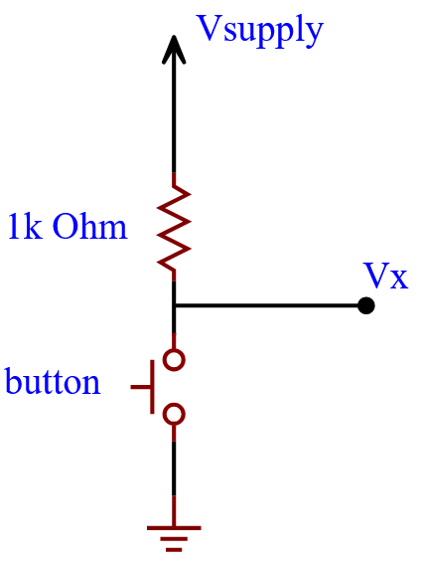

|  |  |  |  |  |
| --- | --- | --- | --- | --- |
| **Vsupply**  **(Volt)** | **5** | **5** | **3.3** | **3.3** |
| **Button status** | **RELEASED** | **PRESSED** | **RELEASED** | **PRESSED** |
| **Vx**  **(Volt)** | 5.004V | 10mV | 3.304V | 12mV |

**exp02-2**

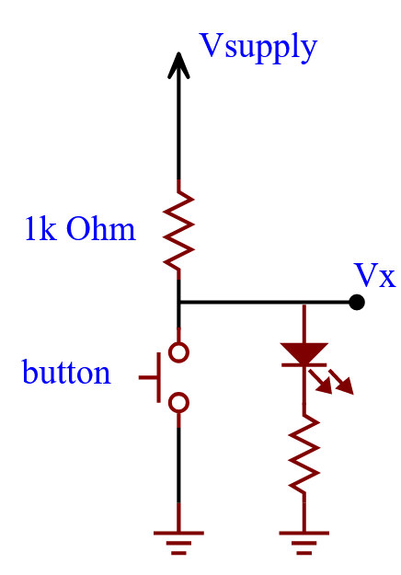

|  |  |  |  |  |
| --- | --- | --- | --- | --- |
| **Vsupply**  **(Volt)** | **5** | **5** | **3.3** | **3.3** |
| **Button status** | **RELEASED** | **PRESSED** | **RELEASED** | **PRESSED** |
| **LED status**  **(Logic value)** | 1 | 0 | 1 | 0 |

**exp02-3: PULL-DOWN/PULL-LOW circuit**

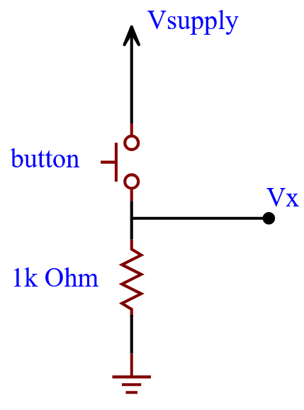

|  |  |  |  |  |
| --- | --- | --- | --- | --- |
| **Vsupply**  **(Volt)** | **5** | **5** | **3.3** | **3.3** |
| **Button status** | **RELEASED** | **PRESSED** | **RELEASED** | **PRESSED** |
| **Vx**  **(Volt)** | 10mV | 5.004V | 10mV | 3.306V |

**exp02-4**

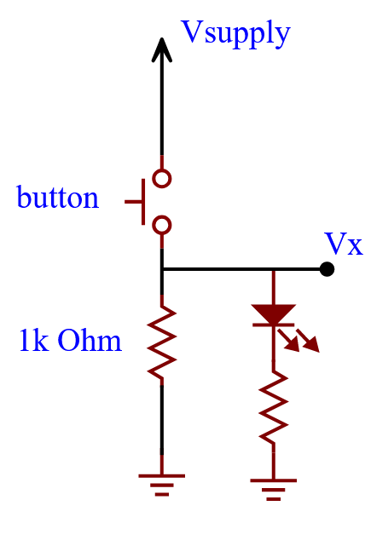

|  |  |  |  |  |
| --- | --- | --- | --- | --- |
| **Vsupply**  **(Volt)** | **5** | **5** | **3.3** | **3.3** |
| **Button status** | **RELEASED** | **PRESSED** | **RELEASED** | **PRESSED** |
| **LED status**  **(Logic value)** | 0 | 1 | 0 | 1 |

Questions: **(Solve it at home. No live demo)**

**What is the relationship between the logic potential and voltage supply?**

Ans: Combining the results of exp01 and exp02, once the voltage supply goes above the threshold voltage of the LED, it’s going to glow(display its corresponding logic value) regardless of how much voltage is being supplied.

**Why do we need these switch/button configurations? Is there any benefit to the digital system?**

Ans:

Buttons can momentarily open or close an electrical circuit. They are used in remotes, keyboards, etc. They are useful when you need to send a combination of logic 1s and 0s rapidly.

On the other hand, switches can open or close an electrical circuit after the user’s initial input and remain so until it’s changed again. They can be used to turn on lights, electronics, and other devices. One simply flips the switch and the device remains on or off until the user flips it back. Unlike a button, you don’t have to be there to hold it down. It’s useful when you need a logic signal to be constantly 1 or 0.

**(Ask your own questions and answer them by yourself)**

**Simply by swapping the button and the resistor, we can produce entirely opposite results. Why is that?**

Ans: We know that current likes to take the path with the least resistance.

In exp02-2, when the button’s released, there’s only one way for the current to go. Yet, when the button gets pressed, a new path with lower resistance is available. Most of the current is no longer going to the LED.

In exp02-4, when the button’s released, no current can flow through. Once it gets pressed, the current can get through and because all paths have around the same resistance, the LED glows.

**Experiment-03**

Build the circuit on the breadboard. Apply the specified conditions to the circuit. Measure and record the results.

DEFINE: LED is bright = Logic(1), LED is dark = Logic(0)

pinout of the micro switch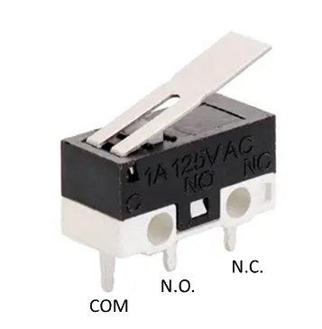

**exp03-1: Connect to N.O.**

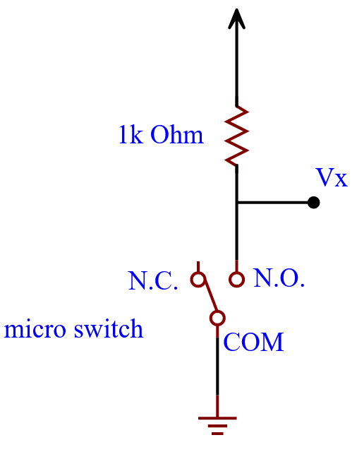

|  |  |  |
| --- | --- | --- |
| **Vsupply**  **(Volt)** | **3.3** | **3.3** |
| **Button status** | **RELEASED** | **PRESSED** |
| **Vx**  **(Volt)** | 3.306V | 10mV |

**exp03-2**

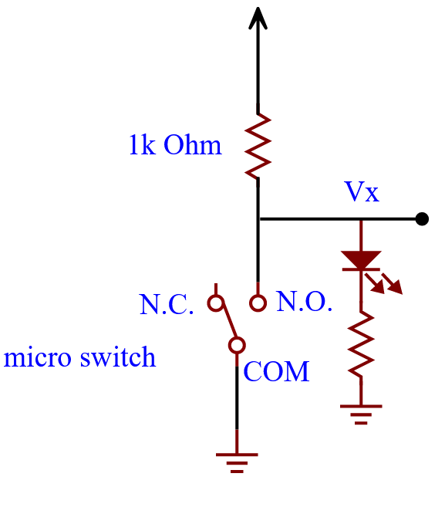

|  |  |  |
| --- | --- | --- |
| **Vsupply**  **(Volt)** | **3.3** | **3.3** |
| **Button status** | **RELEASED** | **PRESSED** |
| **LED status**  **(Logic value)** | 1 | 0 |

**exp03-3: Connect to N.C.**

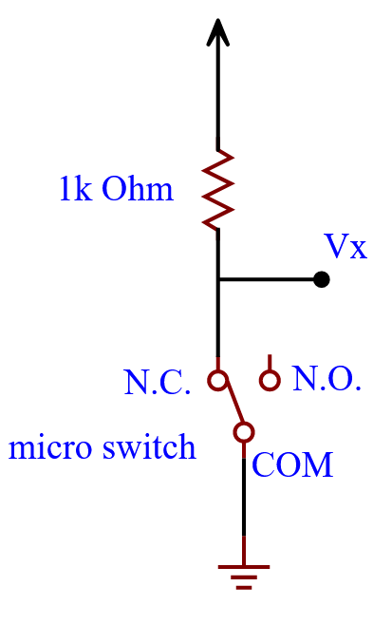

|  |  |  |
| --- | --- | --- |
| **Vsupply**  **(Volt)** | **3.3** | **3.3** |
| **Button status** | **RELEASED** | **PRESSED** |
| **Vx**  **(Volt)** | 10mV | 3.306V |

**exp03-4**

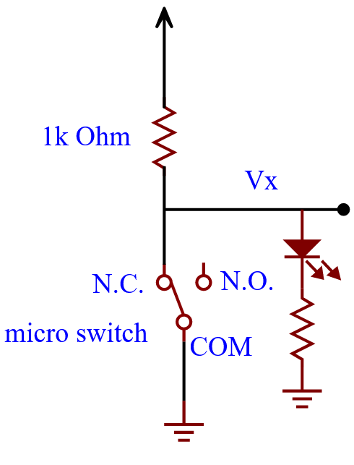

|  |  |  |
| --- | --- | --- |
| **Vsupply**  **(Volt)** | **3.3** | **3.3** |
| **Button status** | **RELEASED** | **PRESSED** |
| **LED status**  **(Logic value)** | 0 | 1 |

Questions: **(Solve it at home. No live demo)**

**(Ask your own questions and answer them by yourself)**

**What do N.O., N.C., and COM mean?**

Ans:

N.O. stands for normally open. If you connect your device(LED) to this pin, it’s going to work when the switch is released and stop temporarily when it’s pressed.

N.C. stands for normally closed. If you connect your device(LED) to this pin, it’s not going to work when the switch is released and start operating temporarily when it’s pressed.

COM stands for common. This pin is connected to the rest of the circuit.

**Experiment-04**

Build the circuit on the breadboard. Apply the specified conditions to the circuit. Measure and record the results.

DEFINE: LED is bright = Logic(1), LED is dark = Logic(0)

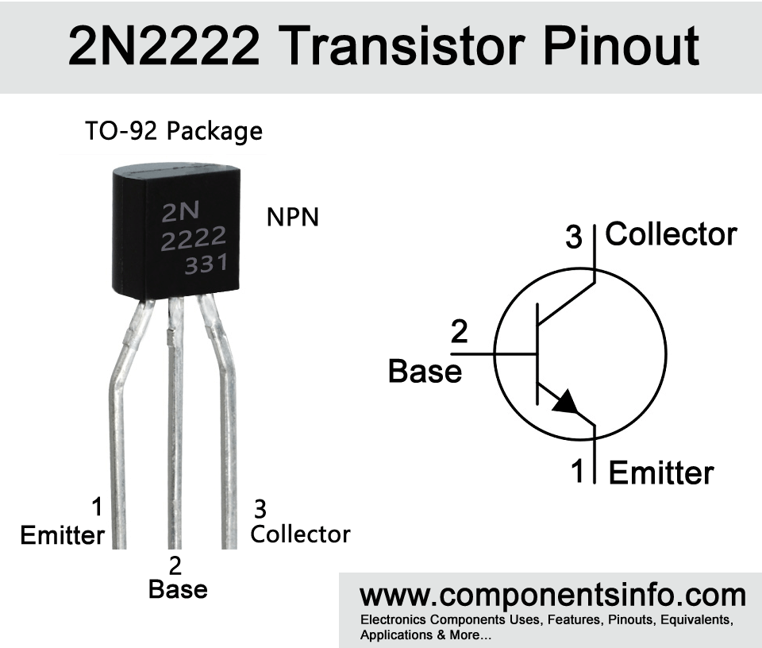

**exp04-1**

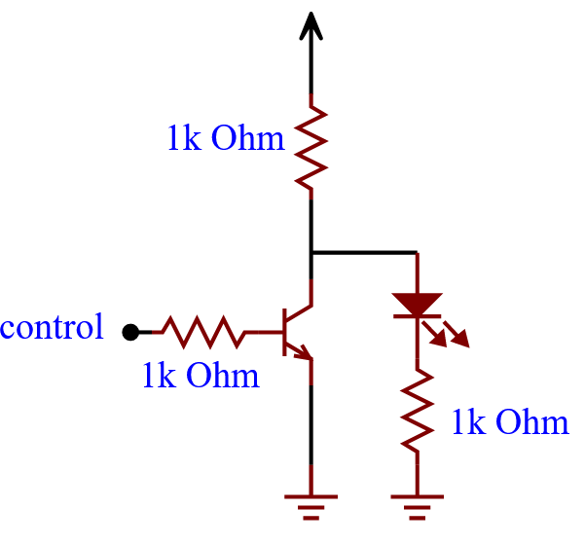

|  |  |  |
| --- | --- | --- |
| **Vsupply**  **(Volt)** | **3.3** | **3.3** |
| **Control**  **signal** | **Vsupply** | **GND** |
| **LED status**  **(Logic value)** | 0 | 1 |

**exp04-2**

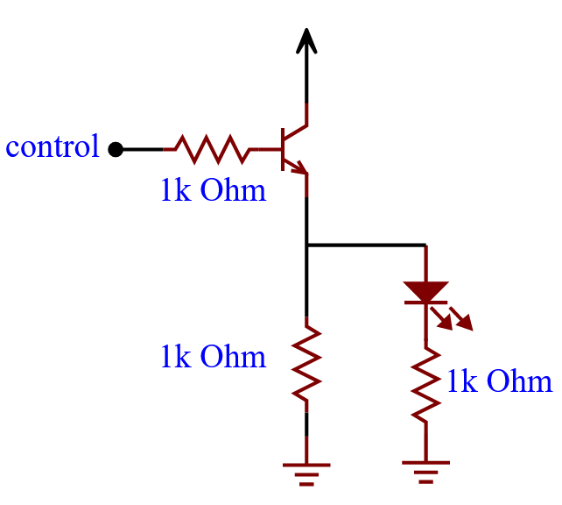

|  |  |  |
| --- | --- | --- |
| **Vsupply**  **(Volt)** | **3.3** | **3.3** |
| **Control**  **signal** | **Vsupply** | **GND** |
| **LED status**  **(Logic value)** | 1 | 0 |

Questions: **(Solve it at home. No live demo)**

**(Ask your own questions and answer them by yourself**

**What is a transistor?**

Ans: Invented in 1947 by John Bardeen, William Shockley, and Walter Brattain at Bell Labs, a transistor is a semiconductor device that is used to do two things:

1. Act as a switch

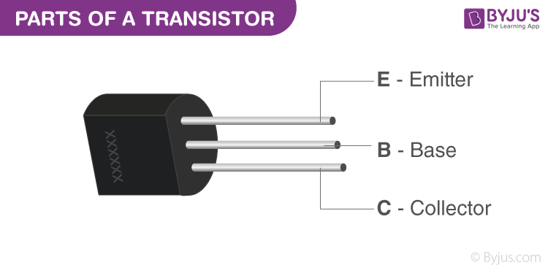2. Amplify electronic signals.

When the base pin is not powered, current flow from the collector to the emitter is blocked. Once the base pin is powered, the transistor is on and current can flow through. The transistor allows you to amplify a signal because a small change to the base pin’s supply voltage is going to cause a large change in the current flow from the collector to the emitter. In other words, one can control a large voltage/current with a small voltage/current.

**Why is the invention of the transistor important?**

Ans: Before the transistor was invented, people used vacuum tubes to control the flow of current. Those things were extremely bulky, power-consuming, and fragile(made of glass). The transistor had none of the these downsides and allowed humans to shrink down the size of electronic devices.

**Experiment-05**

Build the circuit on the breadboard. Apply the specified conditions to the circuit. Measure and record the results.

DEFINE: LED is bright = Logic(1), LED is dark = Logic(0)

**exp05-1: Use StaticIO as control signal. Channel-0: Select button(released=0, pressed=1)**

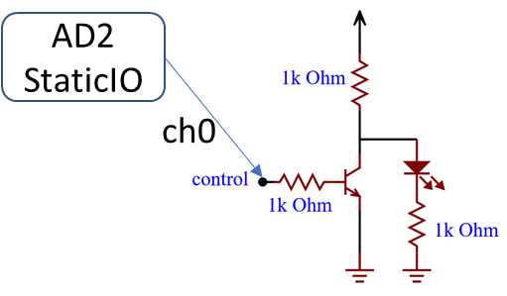

|  |  |  |
| --- | --- | --- |
| **Vsupply**  **(Volt)** | **3.3** | **3.3** |
| **Static IO**  **button** | **RELEASED** | **PRESSED** |
| **LED status**  **(Logic value)** | 1 | 0 |

**exp05-2**

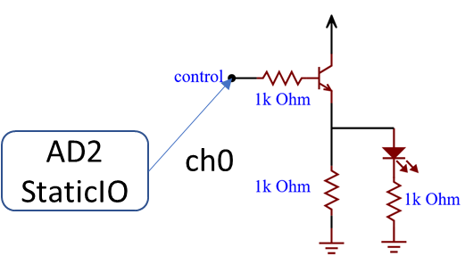

|  |  |  |
| --- | --- | --- |
| **Vsupply**  **(Volt)** | **3.3** | **3.3** |
| **Static IO**  **button** | **RELEASED** | **PRESSED** |
| **LED status**  **(Logic value)** | 0 | 1 |

**We used the Analog Discovery 2 to provide control input to the transistor. The AD2 is an FPGA. What’s an FPGA?**

Ans:

FPGA stands for Field Programmable Gate Array. It’s a type of integrated circuit that can be programmed or reprogrammed by the user after it has been manufactured. FPGAs are used to test out prototype ASIC (Application Specific Integrated Circuit) designs before actually manufacturing them. Since ASICs cannot be reprogrammed, it is much more efficient and economical to test them out before making them. The fact that FPGAs can be reprogrammed makes them very flexible and ideal for development.

**Experiment-06**

Build the circuit on the breadboard. Apply the specified conditions to the circuit. Measure and record the results.

DEFINE: LED is bright = Logic(1), LED is dark = Logic(0)

**exp06-1: Use StaticIO as control signal.**

**Channel-0: Select button(released=0, pressed=1)**

**Channel-1: Keep LED function.**

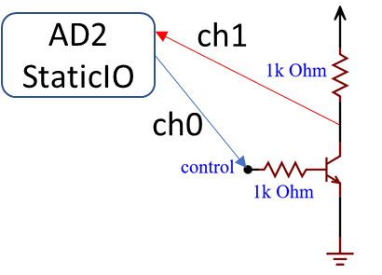

|  |  |  |
| --- | --- | --- |
| **Vsupply**  **(Volt)** | **3.3** | **3.3** |
| **Static IO**  **Button**  **Channel-0** | **RELEASED** | **PRESSED** |
| **LED status**  **(Logic value)** | 1 | 0 |

Screen Capture1

Channel-0 = released

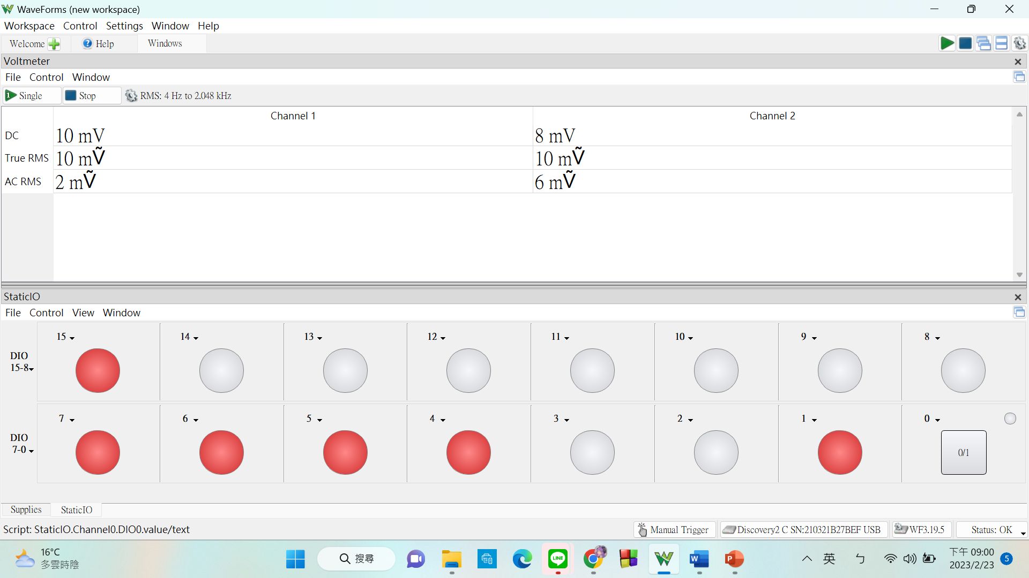

Screen Capture2

Channel-0 = pressed

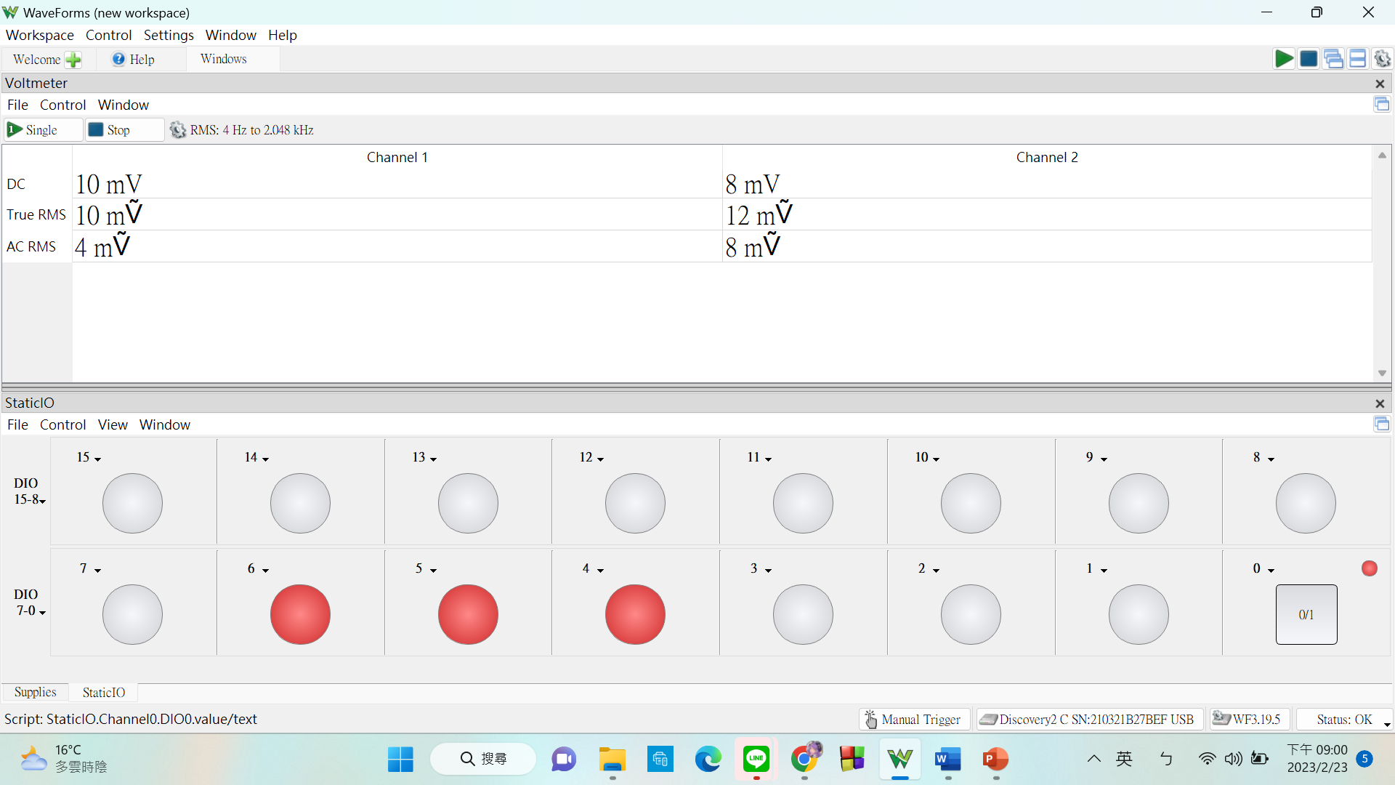

**exp06-2: Use StaticIO as control signal.**

**Channel-0: Select button(released=0, pressed=1)**

**Channel-1: Keep LED function.**

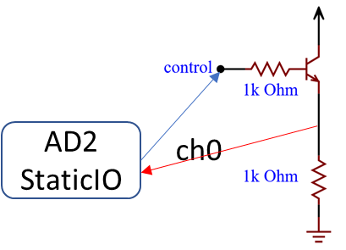

|  |  |  |
| --- | --- | --- |
| **Vsupply**  **(Volt)** | **3.3** | **3.3** |
| **Static IO**  **Button**  **Channel-0** | **RELEASED** | **PRESSED** |
| **LED status**  **(Logic value)** | 0 | 1 |

Screen Capture1

Channel-0 = released

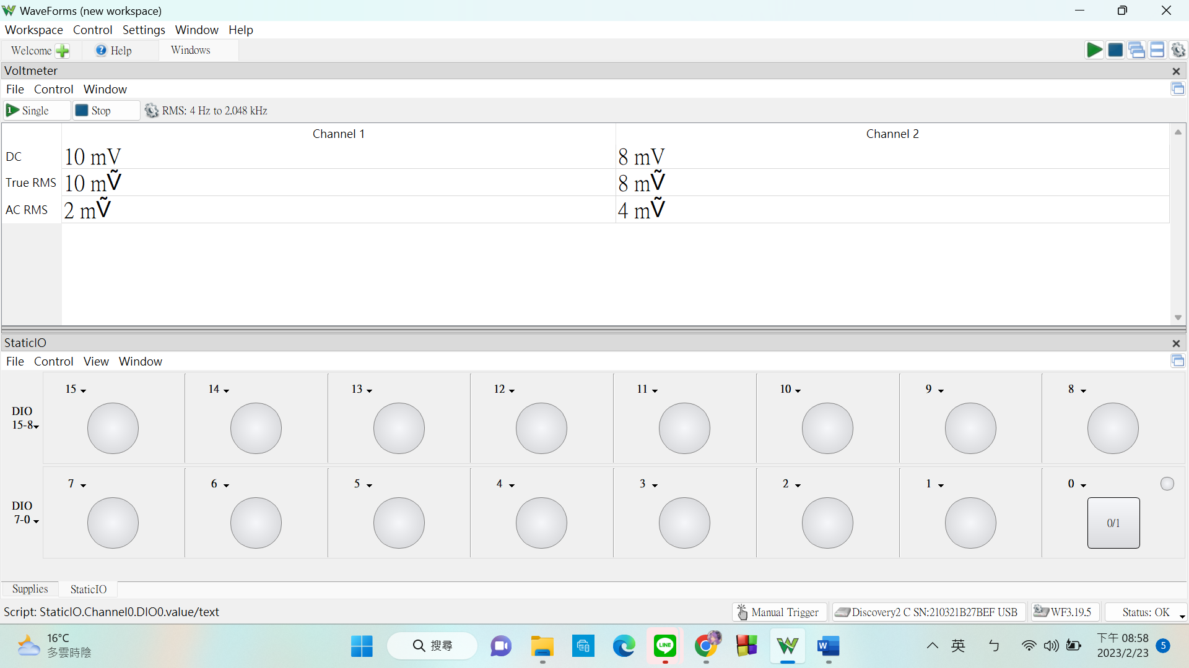

Screen Capture2

Channel-0 = pressed

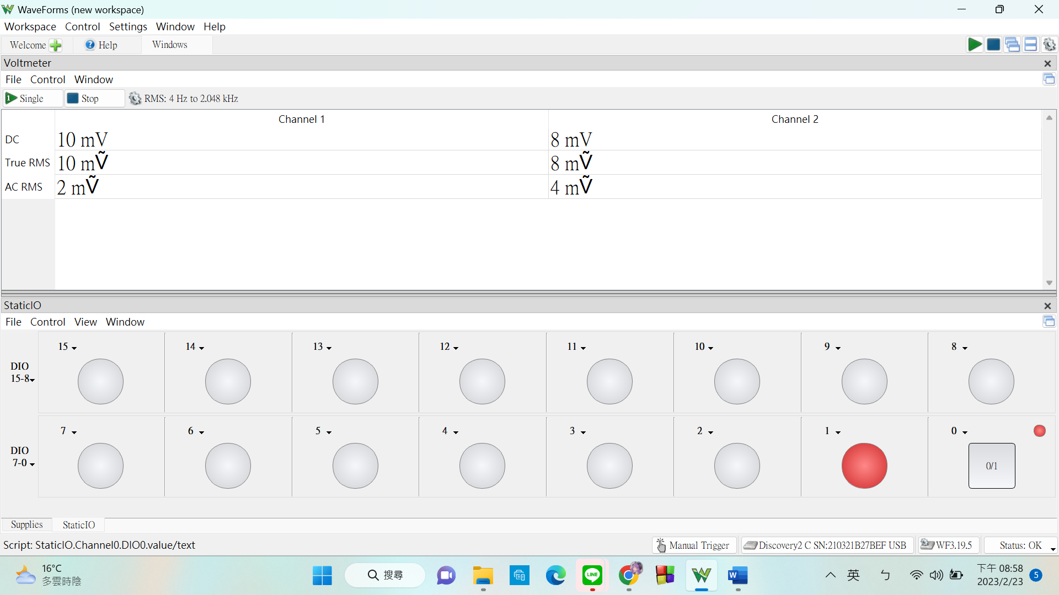

Questions: **(Solve it at home. No live demo)**

**(Ask your own questions and answer them by yourself)**

**In my screenshots for exp06-1, some of the unused channels were displaying logic 1. Why is that?**

Ans: When the TA came here for my demo, he mentioned that this was due to浮接(floating). A floating pin is a pin that is disconnected or has high impedance. It is not good to leave pins floating because their states become unstable. From what I observed, they may oscillate between 1 to 0 very rapidly. The solution for this would be to connect the pins to a pull high or pull low resistor. A pull high resistor sets the pin to 1 while a pull low resistor sets the pin to 0.