**REPORT**

|  |
| --- |
| **Experiment 1: Resistance Measurement** |

Deviation equation =

|  |  |  |  |  |  |
| --- | --- | --- | --- | --- | --- |
|  | Color bands | Nominal  resistance  Value  (Ω) | Tolerance  (%) | Measured  resistance  Value  (Ω) | Deviation  (%) |
| Example:  100 Ohm Resistor | Brown  Black  Brown  Gold | 100 | ±5 | 98 | 2 |
| 1Ω Resistor | Brown  Black  Gold  Gold | 1 | ±5 | 1.3 | 30 |
| 1 kΩ Resistor | Brown  Black  Red  Gold | 1000 | ±5 | 982 | 1.8 |
| 1 MΩ Resistor | Brown  Black  Green  Gold | 1000000 | ±5 | 0.98M | 2 |
| Human Body | N/A | N/A | N/A | 1.94M | N/A |
| 1Ω Resistor  & human body | Brown  Black  Gold  Gold | 1 | ±5 | 1.3 | 30 |
| 1 kΩResistor  & human body | Brown  Black  Red  Gold | 1000 | ±5 | 982 | 1.8 |
| 1 MΩ Resistor  & human body | Brown  Black  Green  Gold | 1M | ±5 | 0.7M | 30 |

**Question**:

**What do you find in these data?**

1. As we can see from the results of measuring a 1Ω resistor, **measuring low resistance with the multimeter produces inaccurate results.** (Solution is proposed on the lower half of this page)
2. Despite using the incorrect method, the measurements of the 1Ω and 1000Ω resistors remain largely unaffected.

**Does human body influence the resistance measurement? How do you explain it?**

When we hold both the probes and the resistor in our hands, we are essentially in parallel with the resistor. We know that current flowing through parallel circuits is given by the current divider formula:

Let R1 be the resistance of the resistor, and R2 be the resistance of human body(1.94MΩ). **We can see that 1Ω and 1000Ω are relatively low values compared to 1.94MΩ. The current divider formula shows that small values are almost unaffected by incorrect measuring methods. However, since 1M is close to 1.94M in terms of magnitude, the current divider formula shows that the measurement will be greatly affected when done incorrectly.**

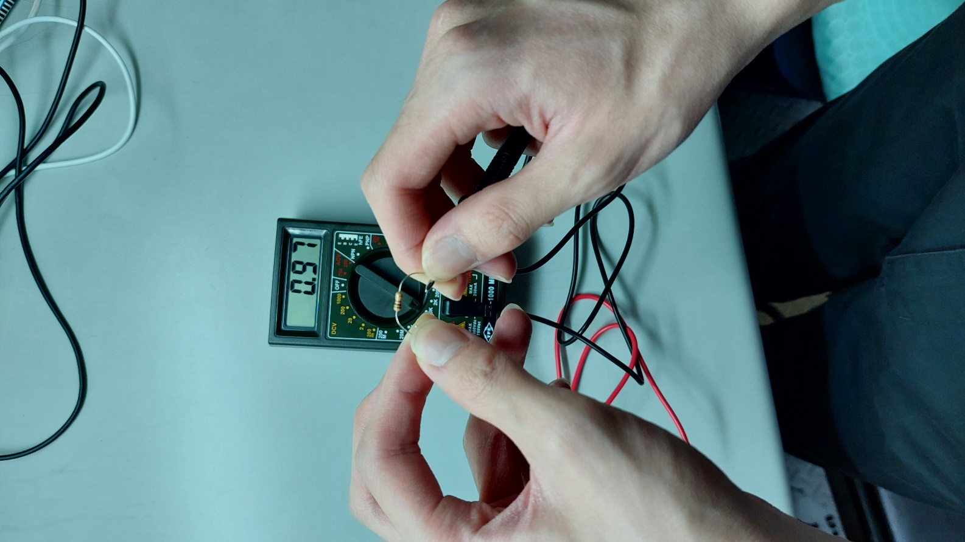

**How to measure low resistance?**

As we can see from the experiment result, it is **not possible to accurately measure low resistance ( ≤ 1 Ω) directly**. After doing some reading online, I came across the following method:

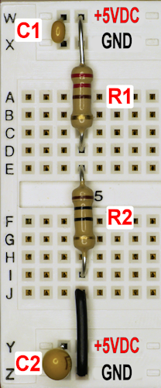Step 1. Connect the low-resistance resistor(R1) whose resistance we would like to acquire in series with a high-resistance resistor(R2) (whose resistance we can accurately measure, 220 Ω in this example).

*(R1 is actually 10 Ω, but let’s pretend we didn’t know that and try this method)

Step 2. Connect them to a voltage source (5V in this example)

Step 3. Measure the voltage across R1( V1 = 216.64mV ) and the voltage across R2( V2 = 4.7696 V ).

Step 4. Utilize the **voltage divider formula**: to acquire R1

Step 5. R1 = 9.963 Ω which is a good value with acceptable deviation.

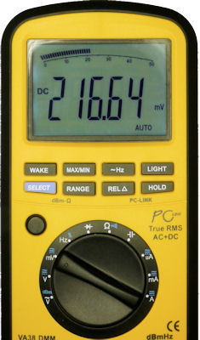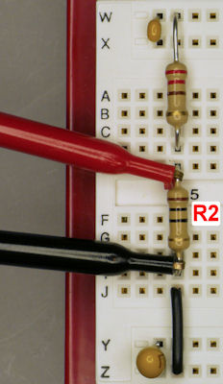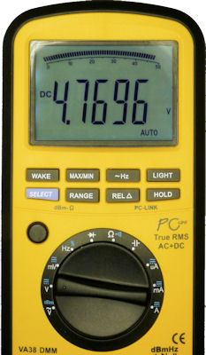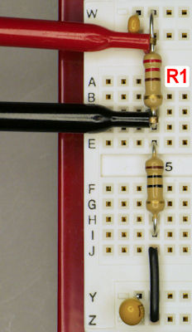

Image Source: <https://www.robotroom.com/Measuring-Low-Resistances.html>

|  |
| --- |
| **Experiment 2: Set the DC Power Supply** |

GW Power Supply

|  |  |  |  |  |  |
| --- | --- | --- | --- | --- | --- |
| Mode |  | Output 1 | | Output 2 | |
|  | Voltage(V) | Current(A) | Voltage(V) | Current(A) |
| Independent | 面板值 | **5.0** | **0.5** | **3.3** | **0.3** |
| 測量值 | 4.99 | 0.48 | 3.29 | 0.29 |
| Output +5V -5V and 0V | 面板值 | **5.0**  **(正電壓)** | **0.5** | **5.0**  **(負電壓)** | **0.5** |
| 測量值 | 4.9 | 0.49 | -4.9 | 0.49 |

Draw the following connection: (for positive and negative voltage output)

Ground, positive and negative terminal

Multi-meter probe position

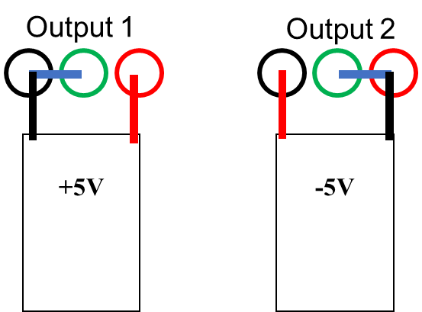

BK Power Supply

|  |  |  |  |  |  |
| --- | --- | --- | --- | --- | --- |
| Mode |  | Output 1 | | Output 2 | |
|  | Voltage(V) | Current(A) | Voltage(V) | Current(A) |
| Independent | 面板值 | **5.0** | **0.5** | **3.3** | **0.3** |
| 測量值 | 4.96 | 0.49 | 3.27 | 0.29 |
| Output +5V -5V and 0V | 面板值 | **5.0**  **(正電壓)** | **0.5** | **5.0**  **(負電壓)** | **0.5** |
| 測量值 | 4.99 | 0.49 | -4.99 | 0.49 |

Draw the following connection: (for positive and negative voltage output)

Ground, positive and negative terminal

Multi-meter probe position

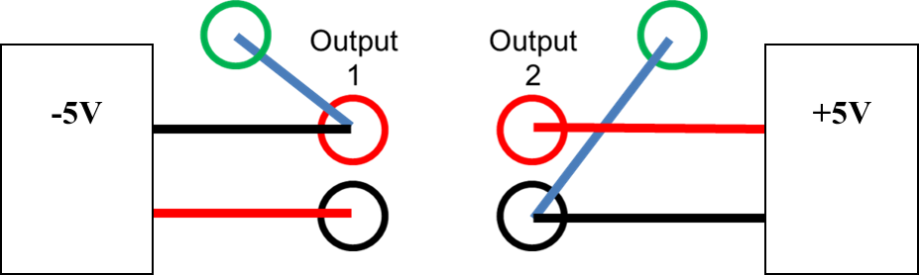

**Observation:**

Under normal circumstances, the **red(positive)** port is at a higher voltage level in reference to the **black(negative)** port. By grounding the **negative port**, we ensure that it is 0V with respect to the positive port and vice versa. When measuring the voltage with our multimeter, the correct method is to follow the convention of **“connecting the negative probe to the grounded pole”**.

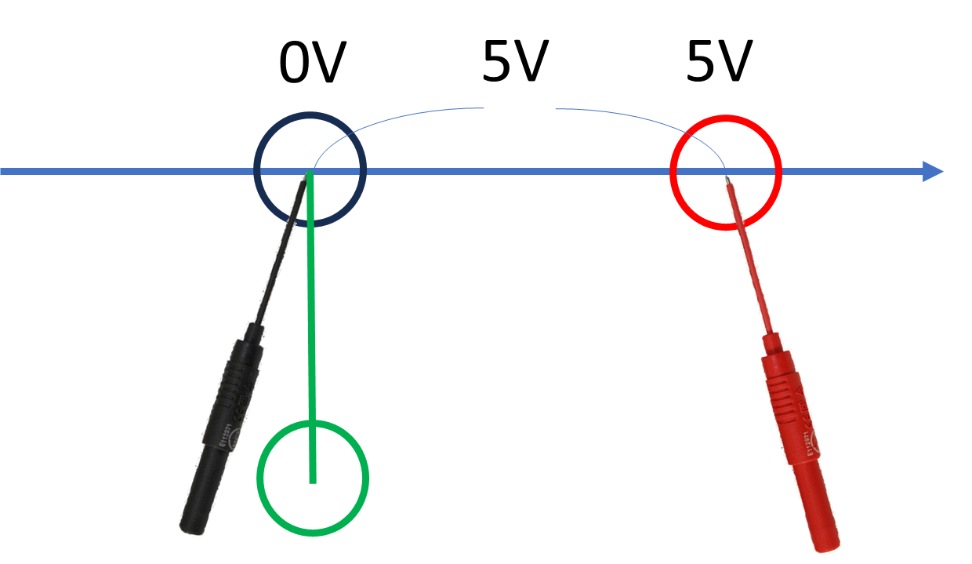 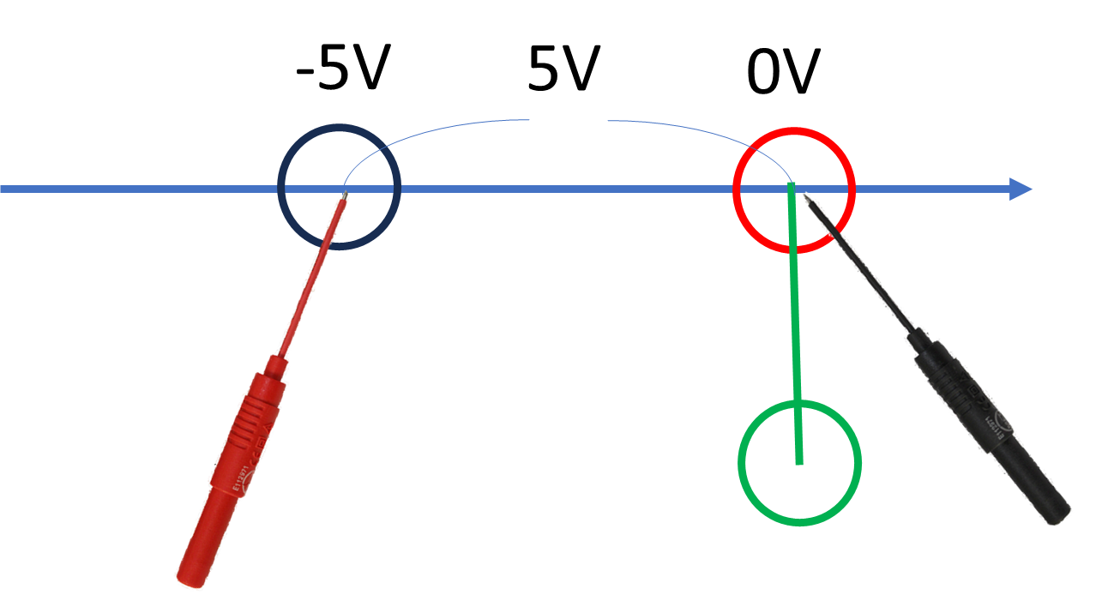

|  |
| --- |
| **Experiment 3: The Effect Caused by the Internal Resistance of Multimeter** |

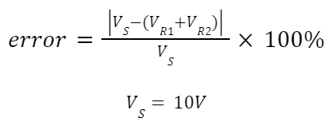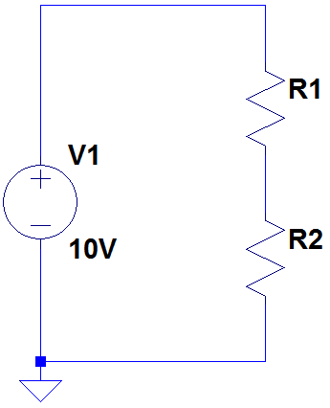

|  |  |  |  |  |  |
| --- | --- | --- | --- | --- | --- |
|  | voltage（VR1） |  | voltage（VR2） | VS | Error(%) |
| R1=100Ω | 4.99 | R2=100Ω | 4.99 | 9.99 | 0.1% |
| R1=1MΩ | 4.78 | R2=1MΩ | 4.74 | 9.99 | 4.7% |

**Question**:

**What do you find in these data?**

It seems that measuring the voltage across the high-resistance resistors(1M Ω) individually yielded less idealistic results. However, the total voltage across both the low-resistance resistors(100Ω) and high-resistance resistors(1M Ω) are relatively accurate.

**What are the influences of the internal resistance of multimeter?**

The multimeter I’m currently using is the TENMARS YF-1000. It has an internal resistance of

10MΩ. A multimeter having high internal resistance provides several benefits:

1. 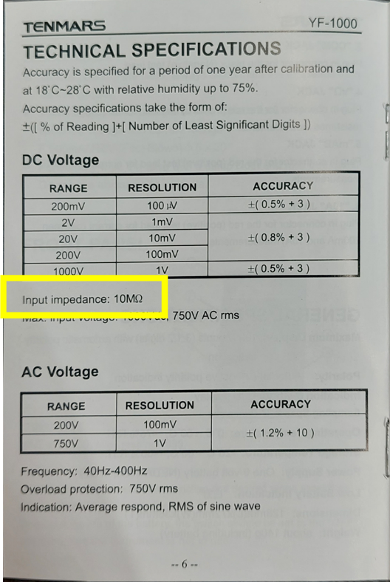**Compatibility with various circuits**: Multimeters are used to measure voltage in a wide range of electronic circuits, some of which may have high impedance. A multimeter with high internal resistance is less likely to disturb the circuit being measured, making it suitable for various applications.
2. **Prevent damage to the multimeter**: A high resistance means that little current flows into the multimeter, which prevents components from overheating.
3. **Maintain measurement accuracy:** Having high internal resistance, the multimeter will not load down the circuit, so it will produce accurate measurements.

|  |
| --- |
| **Experiment 4: Ground Concept Implement** |

|  |  |
| --- | --- |
|  | 1. The voltage between “+” and “GND”： 0 V. |
|  | 2. The voltage between “-” and “GND”： 0 V. |
|  | 3. The voltage between “+” and “-”： 9.99 V. |
|  | 4. The voltage between “+” and “GND”： 4.95 V,  and the voltage between “GND” and “-”： 5 V. |

**Observation:**

The multimeter measured 0V for questions **1.** and **2.** because **the ground does not form a circuit with the positive port (or the negative port)**. **A “loop” that allows current to travel through must exist in order for there to be measurable voltage.** There is no absolute voltage, voltage is a relative measurement of electric potential. When we talk about voltage, we are referring to the potential energy between two points in a “circuit”. In a similar sense, what if I connect one end of my probe to the positive end of one battery and the other end to the negative end of another battery? I would measure 0V. Why is that? Shouldn’t the positive end of a AAA battery be 1.5V higher than its negative end? The reason is because **absolute voltage doesn’t exist. The 1.5V of a battery is measured using its own two ends as reference, not one of its own end and one end from another battery.**

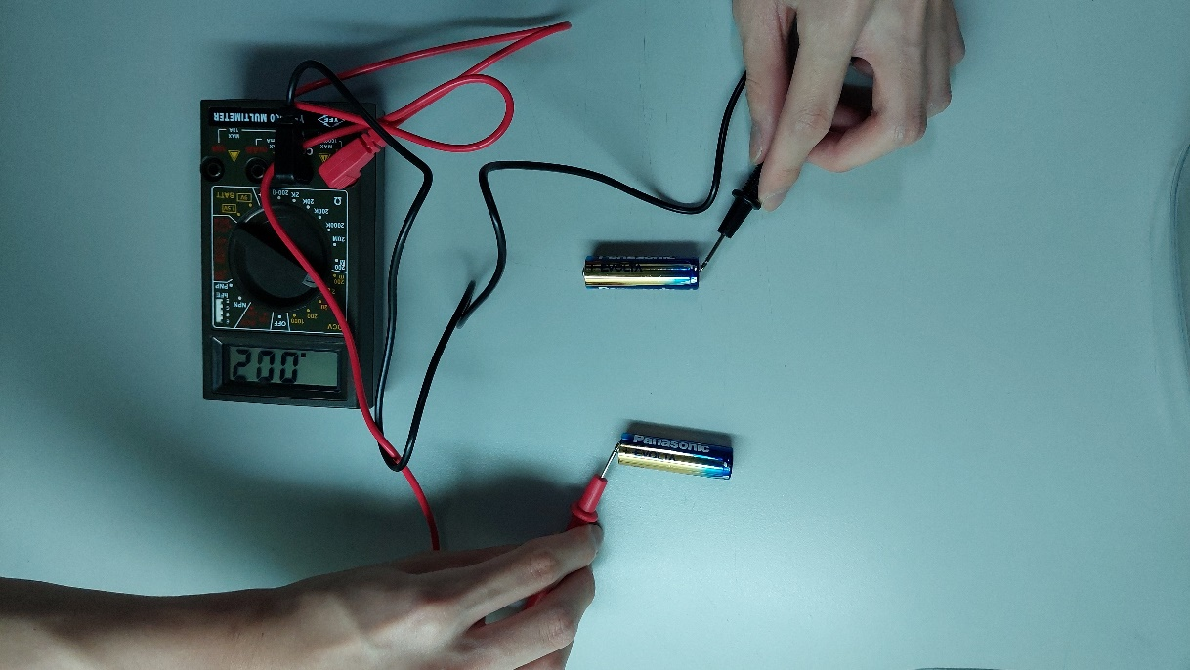

The result from question **4.** is quite interesting. It appears that when the 2 multimeters are connected in series, they behave like 2 resistors of the same resistance in series, dividing the voltage. This **shows that the multimeter my friend was using must also have an internal resistance of 10MΩ**.