**REPORT**

|  |
| --- |
| **Experiment 1: Basic practice for function generator and oscilloscope.** |

1.

DRAW waveform (sine, f=1M Hz, Vpp=5V, Voffset=2.5V, DC coupling)

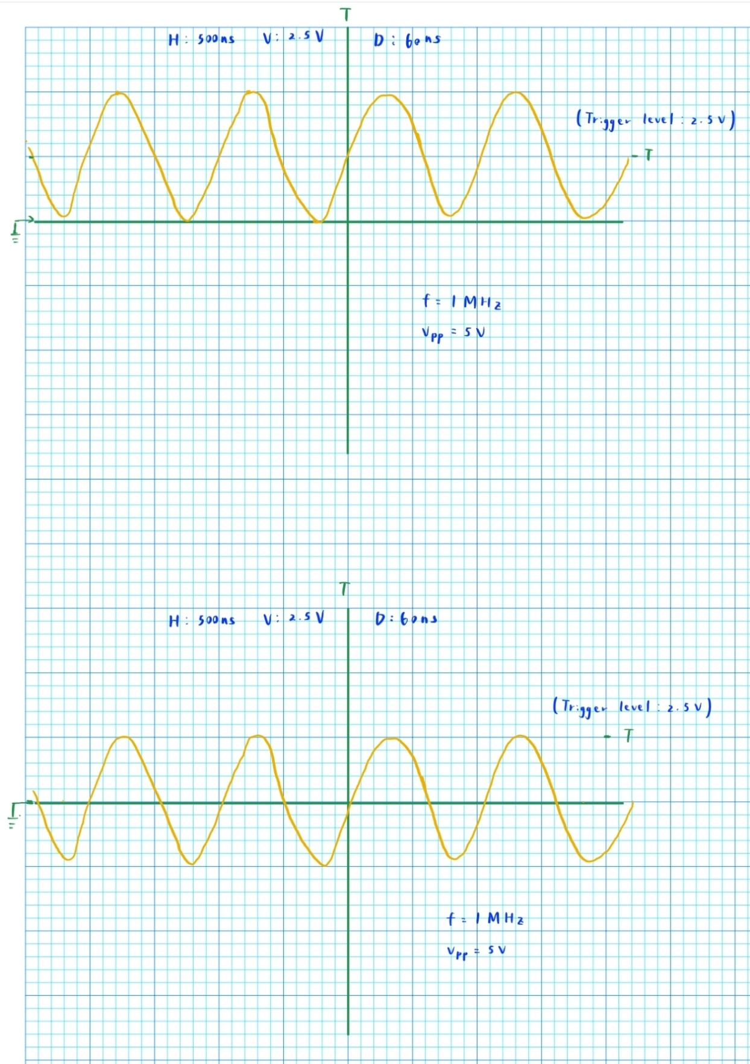

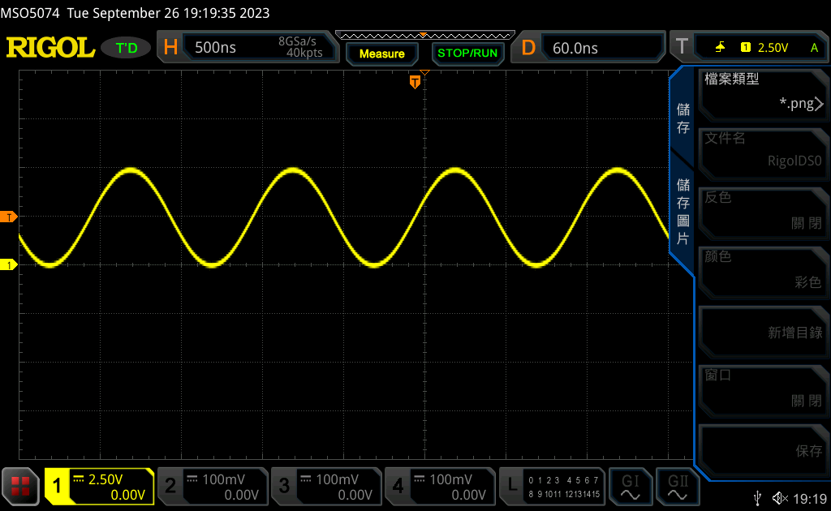

**REMEMBER TO SET YOUR “Trigger source” & “Trigger level”**

**DO NOT CHANGE “Trigger coupling”**

2.

DRAW waveform (sine, f=1M Hz, Vpp=5V, Voffset=2.5V, AC coupling)

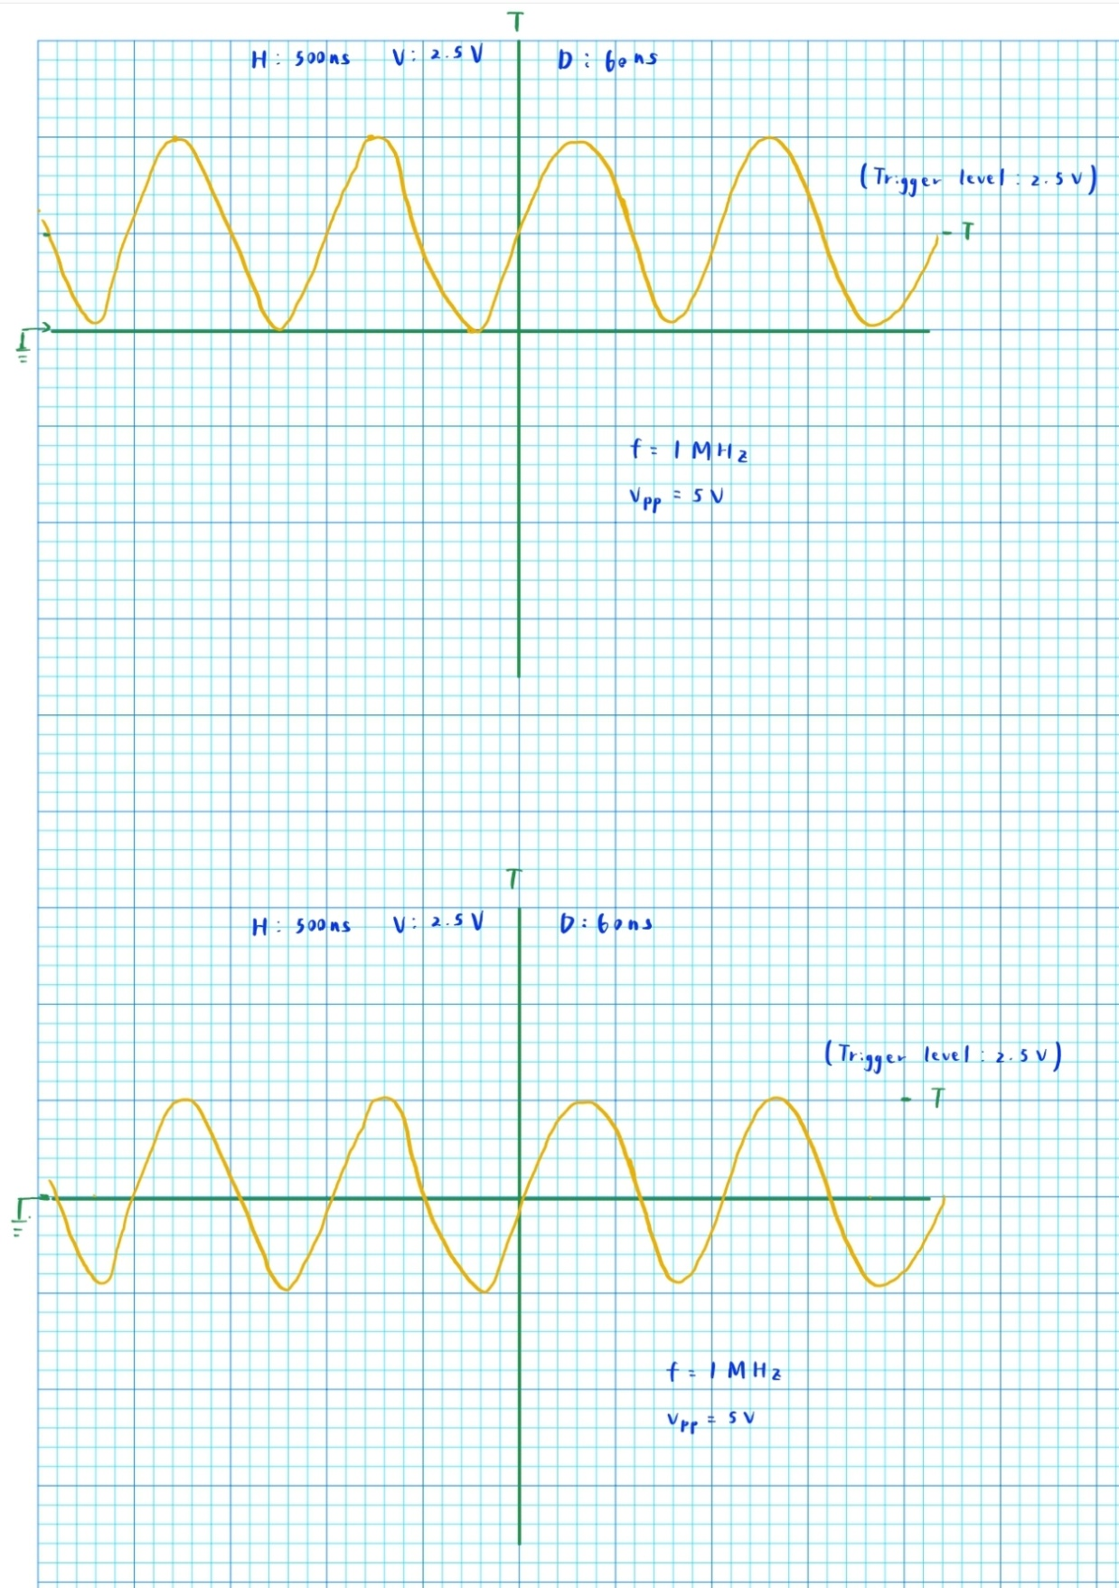

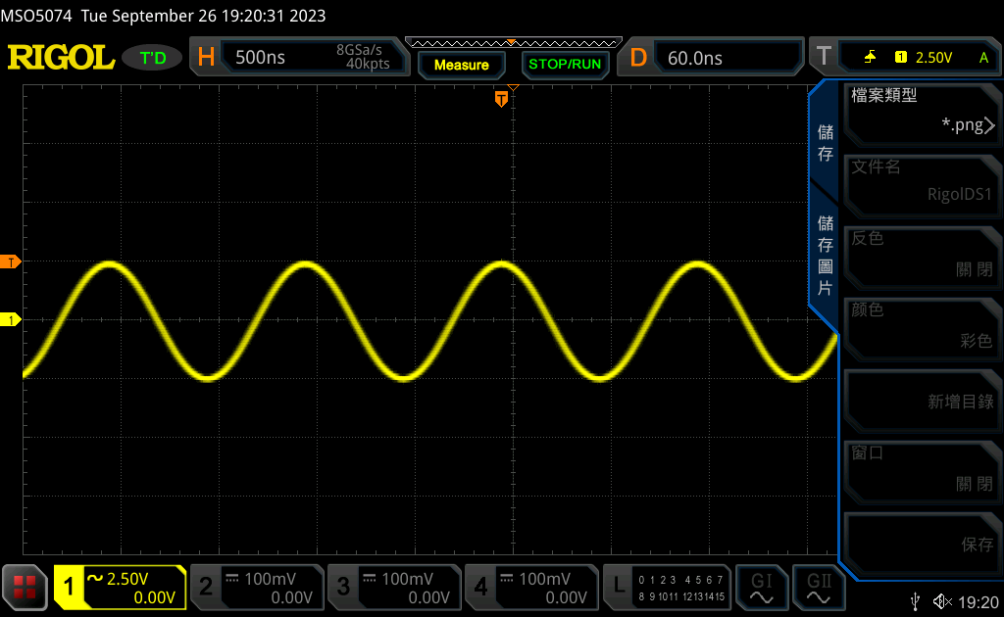

3.

**Question:**

**Is the waveform curve always continuous?**

No

**Is there any breaking point/part?**

Yes. This happens when passing a low-frequency signal into the scope, whose frequency is less than the update frequency of the scope.

**If yes, how does the point/part move?**

It follows **oscillates following the shape of the sine wave, and moves from left to right.** (Because new waves appear first on the left of the oscilloscope)

**Where does the point move from?**

It moves from the left to the right, starting from the **“time base position”.**

Breakpoint starting point

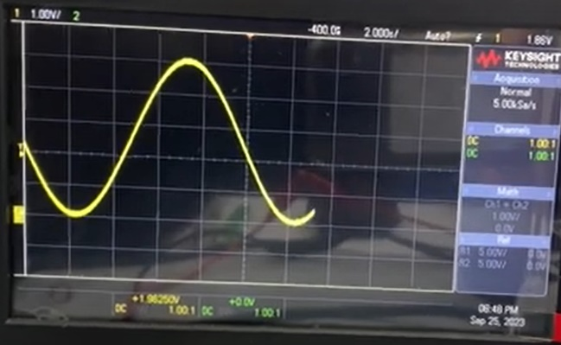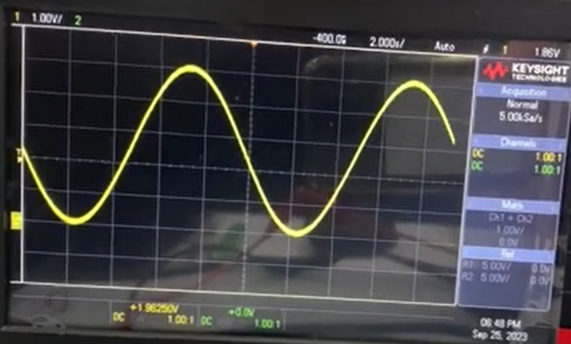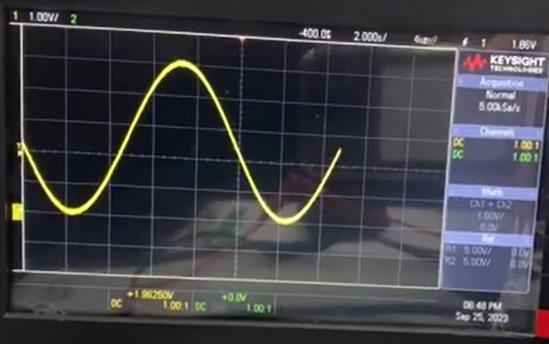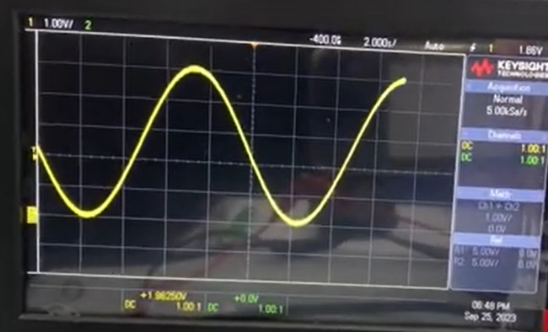

How the breakpoint moves

Additional video:

[EELAB - YouTube](https://www.youtube.com/watch?v=mJrG6I1Q2Ks)

4.

**Question:**

**The factor changing with increasing frequency is . (1) amplitude (2) shape (3) symmetry (4) duty cycle**

shape

**How does the factor change**

The wave is still singular, but **as frequency increases, the graph looks denser, and the peaks of the signal starts to look “pointier”**. The opposite takes place when **reducing the frequency, the peaks would look “smoother”**.

**Reflection:**

I may have made a slight mistake when during Experiment 1. After switching to AC coupling, the graph looks slightly **blurry**. This is because I **forgot to adjust the trigger level**. Notice that in my second waveform picture, the trigger level is right at the edge of the signal. I wasn’t aware of this during the experiment, but after reviewing my captured waveforms and researching online, I realized this problem. I **will definitely keep an eye out for this during future experiments.**

|  |
| --- |
| **Experiment 2: Observation on OUTPUT and SYNC port signals** |

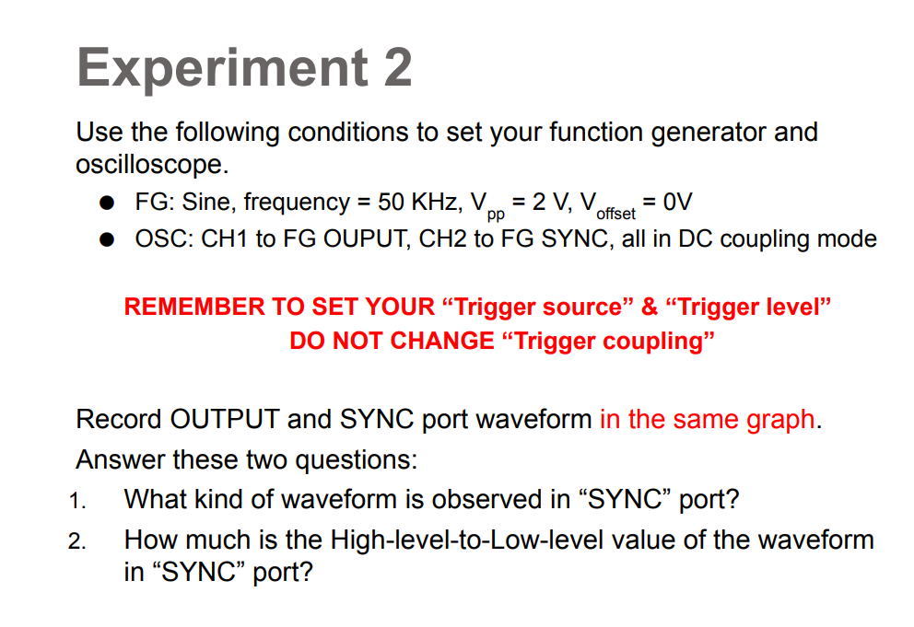

Record OUTPUT and SYNC port waveform in the same graph

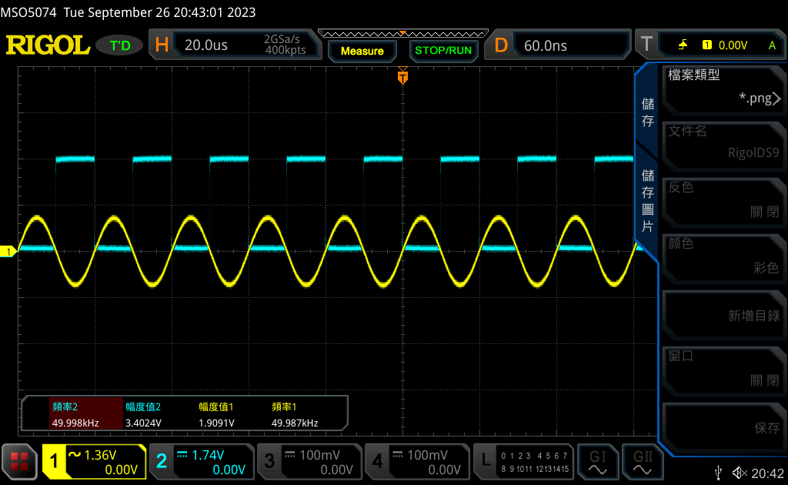

**What kind of waveform is observed in “SYNC” port?**

Square Waves

**How much is the High-level-to-Low-level value of the waveform in “SYNC” port?**

3.48V

**Question:**

**How do we know that OUTPUT and SYNC are synchronous?**

To check if OUTPUT and SYNC are in sync, we **verify their frequency and phase difference.** Looking at the graph, they appear to have the same frequency and are in phase. Therefore, **the two signals are synchronous.**

|  |
| --- |
| **Experiment 3: Advanced study of channel coupling with square wave** |

**REMEMBER TO SET YOUR “Trigger source” & “Trigger level”**

**DO NOT CHANGE “Trigger coupling”**

1.

Record waveform (DC coupling)

Function Generator: Square wave, Freq = 100 KHz, Vhigh = 5 V, Vlow = 0V, Duty cycle = 80%

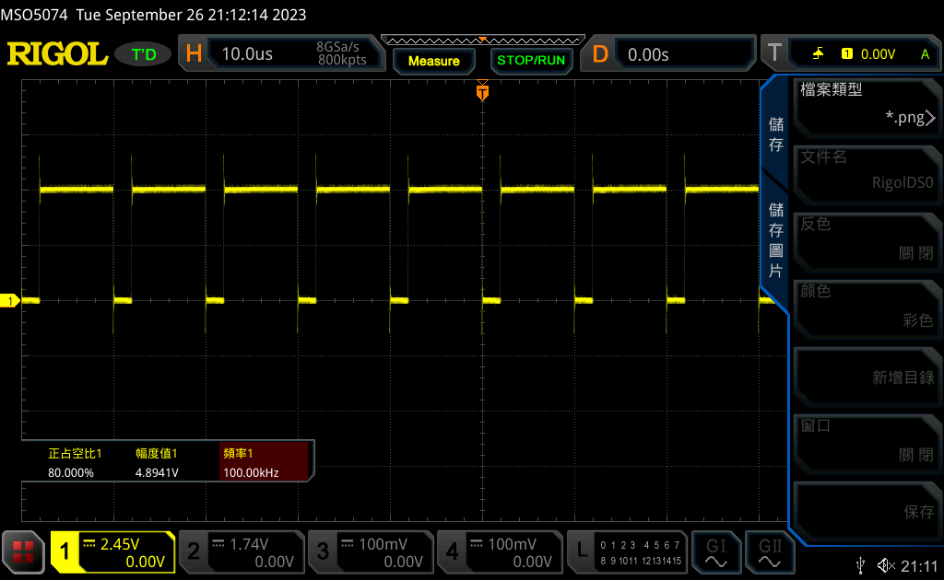

2.

Record waveform (AC coupling)

Function Generator: Square wave, Freq = 100 KHz, Vhigh = 5 V, Vlow = 0V, Duty cycle = 80%

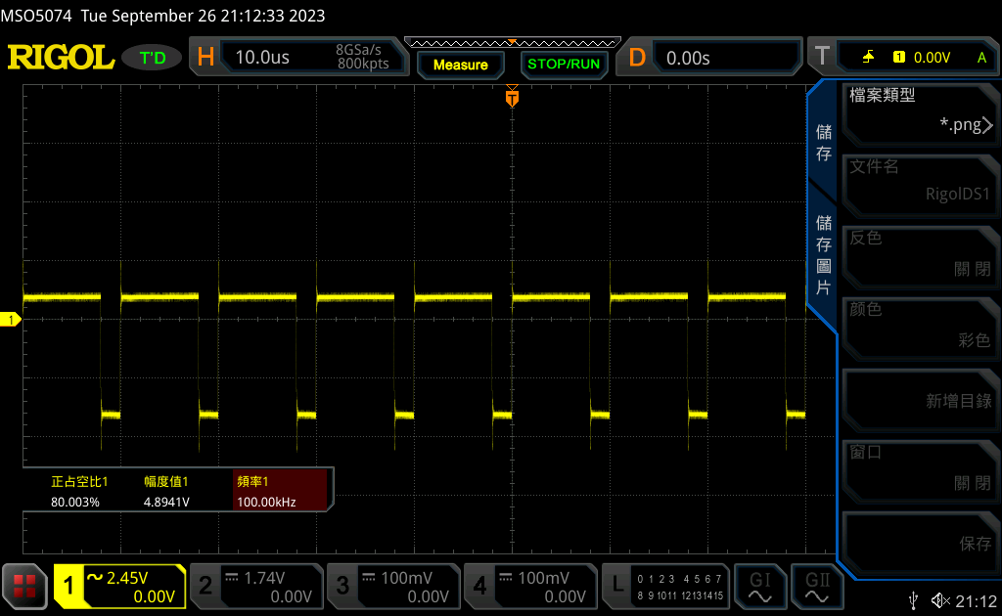

3.

Record waveform (DC coupling)

Function Generator: Square wave, Freq = 100 KHz, Vhigh = 5 V, Vlow = 0V, Duty cycle = 20%

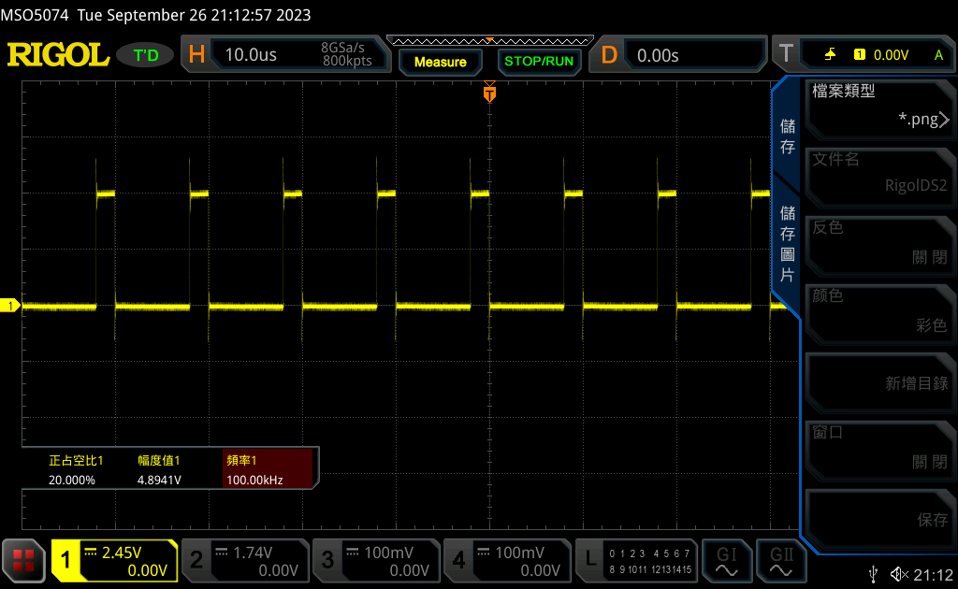

4.

Record waveform (AC coupling)

Function Generator: Square wave, Freq = 100 KHz, Vhigh = 5 V, Vlow = 0V, Duty cycle = 20%

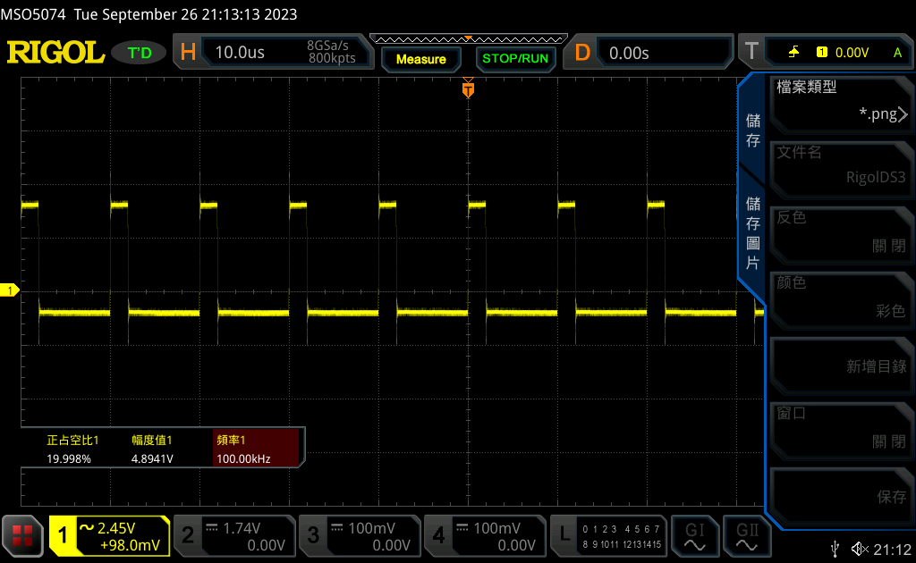

**Question:**

**What’s the difference between DC coupling and AC coupling?**

In **DC coupling**, the oscilloscope **passes both the DC and AC components** of an input signal to its output without any frequency-dependent filtering. This means that the device does not attenuate or filter out the DC component.

**AC coupling** **blocks the DC** component of an input signal, allowing **only the AC component** (frequencies above a certain cutoff frequency) to pass through the device. It is essentially a **high-pass filter.**

**When do we need to use AC coupling to observe waveforms?**

We **do not always have to use AC coupling when measuring AC signals.** Since AC coupling is achieved using a high-pass filter, it can attenuate(weaken) low-frequency signals. I found this **Keysight blogpost that shows what happens to a low-frequency signal when switching from DC to AC coupling.**

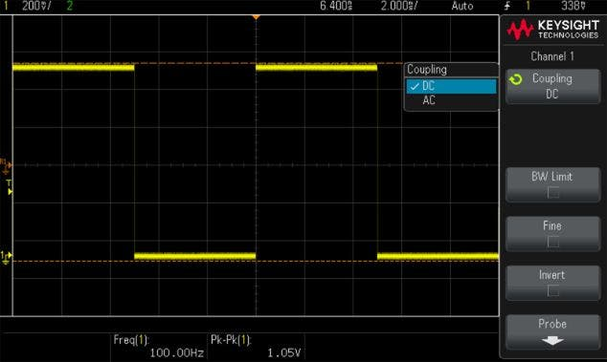

1. 100Hz square wave observed under DC coupling

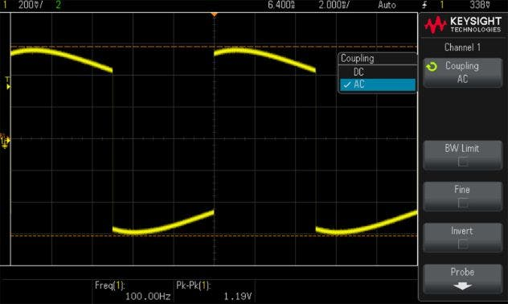

1. 100Hz square wave observed under AC coupling Image Source: Keysight Blog

**Notice the difference between (a) and (b). The signal deforms considerably when observed in AC coupling. This is what happens when the frequency of the wave is too close to the high-pass filter’s cutoff frequency. Therefore, we must be mindful of the oscilloscope’s cutoff frequency and the correct usage of AC coupling.**

AC coupling is **used when we want to observe AC signals with a large DC offset**. Some signals with large DC components are not observable on screen in DC coupling simply because we have to zoom in too far and the scope runs out of offset capability. In that case, we can **filter out the DC offset with AC coupling**, leaving us the AC component we’re interested in observing.

|  |
| --- |
| **Experiment 4: Observation on Trigger Source. Calculate phase difference.** |

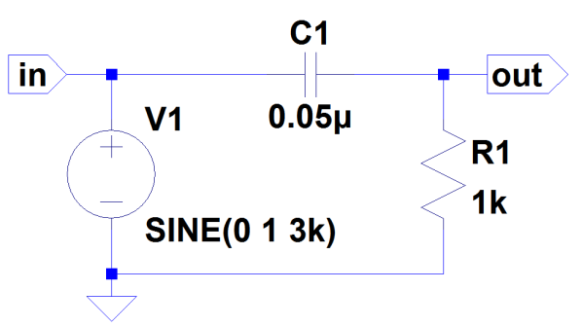

**DO NOT CHANGE “Trigger coupling”**

Record waveform on node “in” and node “out” in the same graph. (trigger source = CH1, trigger level = 0V)

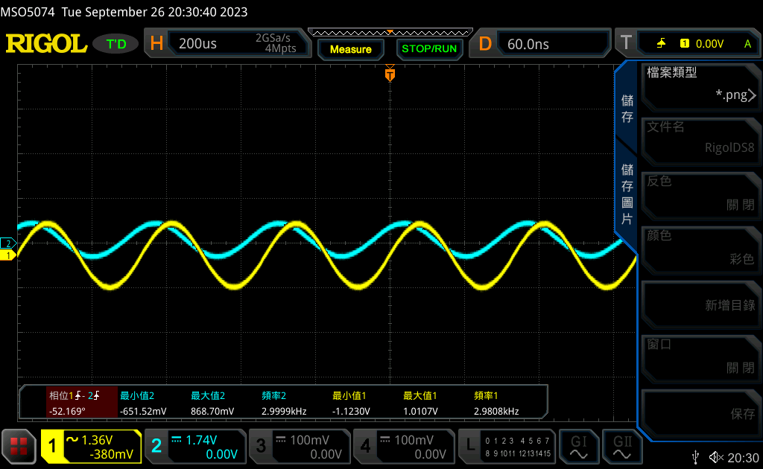

1.

CH1: VPP= 2.1337 V, CH2: VPP= 1.52 V

2.

CH 2 leads CH 1 by 52.169 degree.

Record waveform on node “in” and node “out” in the same graph. (trigger source = CH2, trigger level = 0V)

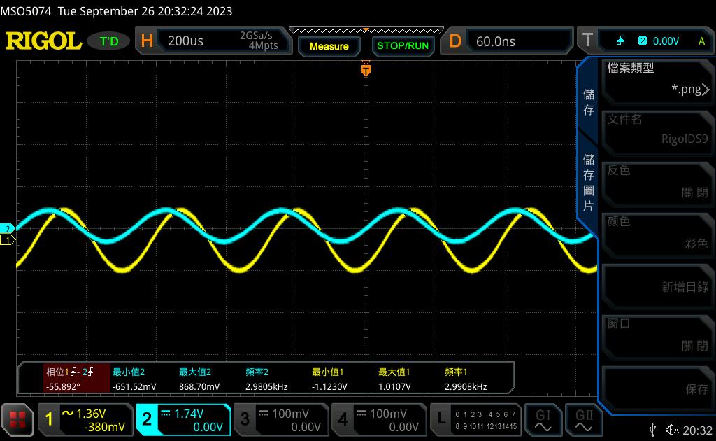

3.

CH1: VPP= 2.1337 V, CH2: VPP= 1.52 V

4.

**Describe the waveform movement when trigger level changed.**

The graph slightly **shifted to the left** when we adjusted the **trigger level upward**; it **shifted to the right** when we **moved the trigger level downward**.

**Question:**

**How does the trigger influence the waveform measurement?**

The trigger level is set by the user and represents a specific voltage level on the oscilloscope's vertical axis. The oscilloscope **triggers or initiates data acquisition and waveform display when the input signal crosses this threshold** in a specified direction, providing us with stable, repeatable waveforms. Therefore, **setting the trigger level appropriately is essential for preventing unwanted triggering due to noise or signal fluctuations.**

**How does the trigger influence the waveform curve shown on oscilloscope display?**

Waves move from right to left on an oscilloscope. The **newest data appears first on the left side.** The graph shift mentioned in Question 4 occurred because the voltage starts crossing the trigger level later/earlier as we adjust it upward/downward. **If we move the trigger level completely out of the wave’s amplitude range, the oscilloscope wouldn’t know when to update its display and the waves would not in sync, resulting in a blur on the screen.**

**Reflection:**

What we did in this week’s experiment was just **familiarizing ourselves with the equipment we’ll be using in the future.** Compared to what’s to come, it truly was the tiny tip of the iceberg. The main difficulty lied in the fact that this was our first time using function generators and oscilloscopes. Once I got the hang of it, (almost) everything went smoothly. **My TA was very nice and helpful, patiently answering my questions regarding certain device functionalities. Much appreciated!** Although making mistakes was frustrating, I know for a fact that **confronting them now is way better than not knowing what to do down the line.** I learned a lot this week and look forward to next week’s experiment after the Moon Festival.

**References:**

1. Circuit Gallery: AC vs DC Coupling Oscilloscope

<https://www.circuitsgallery.com/ac-vs-dc-coupling-oscilloscope/>

1. Keysight Blogs: When to use AC Coupling on Your Oscilloscope

<https://www.keysight.com/blogs/tech/bench/2018/10/18/when-to-use-ac-coupling-on-your-oscilloscope>