Sensitivity Tier Table — Client Review
Oct 25, 2026 · @Judy
22 categories, 4 tiers. Please confirm each category's tier or mark the ones to move. Policy version: policy-0.1.3-provisional.

How each tier is handled
The local model gives each item a score: the probability that it is private. The tier sets the cut-off.
Tier | Rule | Redacted when | Threshold adjustable per request?
High | Redact | Score ≥ 0.2 (redacted even when the model is fairly unsure) | No
Medium | Redact | Score ≥ 0.5 | Yes: the calling app may set its own threshold for one request
Low | Keep, unless combined | 3 or more different low-tier categories appear in the same field (e.g. city + employer + age) | No
Public | Keep if confidently public | Score ≥ 0.8 (redacted only when the model is fairly sure it is private) | No
- Always redacted, whatever the score: your term list, words a request marks as forbidden, items the model cannot classify
- All thresholds are initial values, tuned later on the golden dataset (flow below)
- Public starts above Medium (0.8 vs 0.5): public contacts are meant to be sent; the risk is a personal number mistaken for a public one

Categories
Three detectors run on every email; their results are merged.
- Local model: all 22 categories
- Pattern rules and Presidio (open-source PII toolkit): fixed-format items
- Model only: 8 categories, marked in the table
Category | Tier | Examples | Also found by
GOV_ID | High | SSN, passport, driver's licence, ITIN | Rules (SSN format), Presidio
CREDENTIAL | High | Passwords, API keys, access tokens | Model only
CARD_NUMBER | High | Payment card numbers | Rules (checksum-validated), Presidio
ACCOUNT_NUMBER | High | Bank, brokerage and client account numbers, IBAN, crypto wallets, other long numeric IDs | Presidio
HEALTH | High | Diagnoses, treatments, medical leave | Model only
BUSINESS_CONFIDENTIAL | High | Unreleased financials, deal terms, legal matters | Model only
CODENAME | High | Project and deal code names, counterparties | Rules (your term list)
DEMOGRAPHIC | High | Nationality, religion, political affiliation | Presidio
PERSON | Medium | Names of people | Rules (header names, sign-off names), Presidio
PHONE_PERSONAL | Medium | Personal phone numbers and extensions | Rules, Presidio
EMAIL_PERSONAL | Medium | Personal email addresses | Rules, Presidio
ADDRESS_HOME | Medium | Street addresses, PO boxes | Rules (US formats)
NETWORK_ID | Medium | IP and MAC addresses | Presidio
AMOUNT | Medium | Money amounts ($4.2M, USD 500k) | Rules
CITY | Low | Cities, countries | Presidio
DATE | Low | Dates and times | Presidio
ORG | Low | Company and organisation names | Model only
AGE | Low | "age 42", "42-year-old" | Rules, Presidio
GENDER | Low | Gender | Model only
PHONE_PUBLIC | Public | Company switchboard, support lines | Model only
EMAIL_PUBLIC | Public | info@, support@ mailboxes | Model only
ADDRESS_PUBLIC | Public | Publicly listed office and business addresses | Model only

How the table was built
- Personal data: tiers follow NIST SP 800-122 impact levels; health and demographic data are High per GDPR Art. 9
- Score vs threshold: the same decision approach as Minim (arXiv:2606.13949), with one threshold per tier
- Business categories and Public tier: our proposal; please check against your data classification
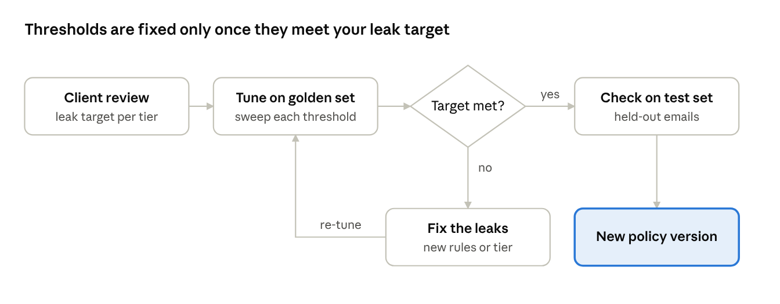
threshold tuning · 5 steps, 1 decision

Questions for Virtual Gold
- ☐ Are the tiers right? Flag any to move, especially AMOUNT (Medium), ORG (Low), DEMOGRAPHIC (High)
- ☐ Any categories to add? e.g. internal ticket IDs
- ☐ What leak rate is acceptable per tier? This sets the final thresholds

