Data & Architecture Proposal
Hybrid Local/Cloud AI Assistant — CMU MISM Capstone
Prepared for Virtual Gold Inc (Attn: Urte Jesina) | September 2026
This document proposes a concrete system architecture and a set of specific, public/synthetic datasets for the hybrid AI-assistant capstone, scoped to what a five-person student team can realistically design, build, and evaluate within a single semester alongside a full course load. Per Virtual Gold's guidance, items not explicitly specified in the original brief are resolved here as concrete proposals grounded in current (2026) industry practice — rather than left as open questions — so the team has a clear default to start from. Virtual Gold is welcome to redirect any of these choices before implementation begins in Week 3.

1. Recap of Project Scope
As described in the capstone brief, the project investigates a hybrid AI assistant architecture that uses a locally-run open-source LLM as the primary intelligence layer, escalates to a more capable cloud model only when needed, and evaluates the security, privacy, cost, and performance tradeoffs of that design. Virtual Gold has confirmed it will provide only public data (no PII); students work on their own laptops in a sandboxed environment with no corporate-system integration.
Given that constraint, the team's own dataset sourcing plan (Section 4) becomes the central open question — this proposal exists to answer it.

2. Scoping the Project to One Semester
Each of the five team members is a full-time graduate student carrying a complete course load in parallel with this project, which represents roughly a third of one semester's credits. We are therefore proposing a working prototype and a rigorous evaluation — not a production-grade platform. The design below is deliberately built from existing open-source components (Ollama, Presidio, established benchmarks) rather than novel infrastructure, so the team's effort goes into integration, evaluation, and the security/governance analysis Virtual Gold specifically asked for, rather than reinventing tooling that already exists.
We've split the plan into an MVP the team commits to delivering, and stretch goals pursued only if the core MVP lands ahead of schedule.

3. Proposed System Architecture
The diagram below shows the proposed MVP data flow: a query is first handled locally; a lightweight confidence score decides whether the local answer is returned directly or the query is escalated; anything leaving the local environment first passes through a PII redaction gate; and every request is logged for the benchmarking study.
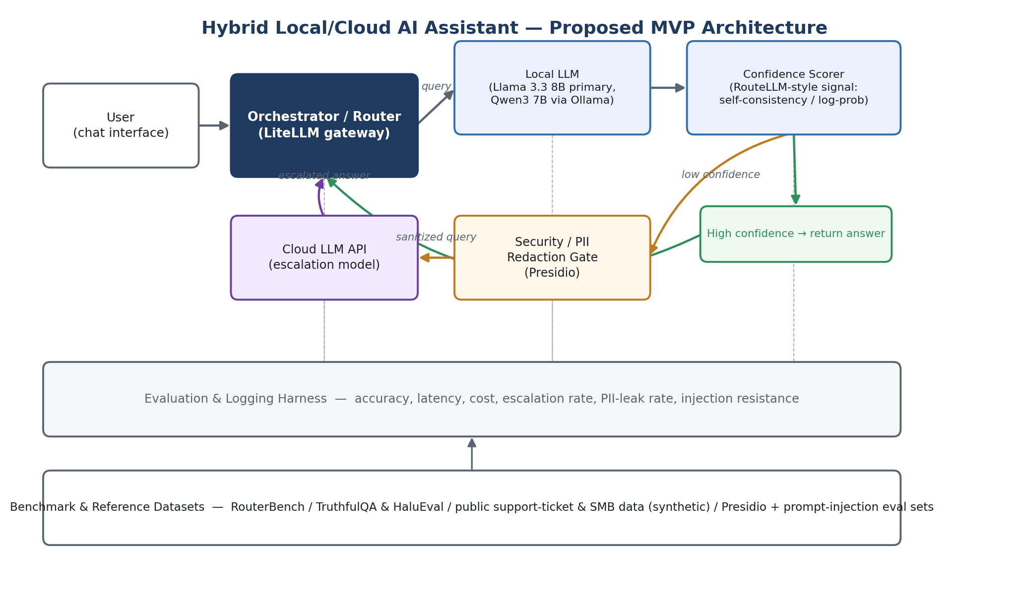

3.1 MVP components (semester commitment)
- Orchestrator / router — built on LiteLLM (open-source, MIT-licensed self-hosted LLM gateway with ~55k GitHub stars — the de facto standard in 2026 for unifying local and cloud model calls behind one interface) rather than a bespoke service. The team writes the routing policy; LiteLLM handles provider translation and credentials.
- Local inference — Llama 3.3 8B as the primary model — currently the strongest all-around open-weight model in the 7–8B class (~73 MMLU, runs in ~6GB RAM) — with Qwen3 7B as a secondary option for code- and multilingual-heavy queries (highest HumanEval score in its size class). Both served locally via Ollama on team hardware.
- Confidence scoring — a cheap, well-understood signal — self-consistency (sample k responses, measure agreement) or token log-probability/entropy — adapted from RouteLLM's open-source learned-router methodology (Apache-2.0) rather than designing a routing approach from scratch.
- Security / PII redaction gate — Microsoft Presidio (open-source, pre-built recognizers) sits between the router and any cloud call, directly implementing Virtual Gold's "keep sensitive data local whenever possible" principle.
- Cloud escalation — one mainstream enterprise-grade API (default: OpenAI or Anthropic — both publish enterprise data-retention/handling commitments) called only on low-confidence queries. Swapping or adding a provider is a one-line config change under LiteLLM, so cost and "international model" exposure stay minimized and measurable.
- Evaluation & logging harness — captures accuracy, latency, cost per query, % of queries escalated, PII-leak rate, and prompt-injection resistance across three configurations: local-only, hybrid, and cloud-only.

3.2 Stretch goals (only if the MVP lands early)
- Task-aware routing (route by query type/complexity, not confidence alone), evaluated against the RouterBench methodology.
- A second local model for A/B comparison, or a small trained router instead of a threshold rule.
- Deeper red-teaming across more prompt-injection/jailbreak categories.
- A short executive-education style summary deck translating findings into governance recommendations.

4. Proposed Datasets & Benchmarks
Because Virtual Gold's data will be public examples used to seed synthetic data, we propose relying on established, well-documented public datasets for each evaluation dimension below rather than building labeled datasets from scratch — this keeps data sourcing inside a few weeks of the timeline. All items are public, license-permitting, and contain no PII.
Purpose | Dataset / Tool | Source | Why it fits
General capability  (local vs. cloud gap) | MMLU (subset) | Hugging Face — cais/mmlu | Standard, widely-cited benchmark for measuring the quality gap between a small local model and a frontier cloud model across knowledge domains.
 | GSM8K | Hugging Face — openai/gsm8k | Grade-school math reasoning; a common case where local models under-perform and should trigger escalation — good for validating the router's decisions.
Enterprise/SMB context  (synthetic, no PII) | Customer-support ticket datasets | Hugging Face: Tobi-Bueck/customer-support-tickets, Kaludi/Customer-Support-Responses; Kaggle: multilingual & CRM ticket sets | Public, pre-existing ticket/response data used only as a style and structure reference; the team will generate its own synthetic enterprise queries (tickets, emails, short memos) via LLM prompting, seeded by these patterns — no real Virtual Gold or third-party data at any point.
 | B2B SaaS / HubSpot sample data | Kaggle — sarahdaily/b2b-saas-hubspot | Illustrates the shape of typical SMB/enterprise CRM-style records, useful as a seed template for synthetic business-context prompts.
Routing / hybrid-  architecture benchmark | RouterBench | arXiv:2403.12031; withmartian.com/post/introducing-routerbench | A benchmark and dataset purpose-built for evaluating multi-LLM routing on cost/quality/latency tradeoffs — lets the team reuse an existing evaluation harness instead of designing one from zero.
Confidence calibration /  hallucination detection | TruthfulQA & HaluEval | Hugging Face (Hallucination Leaderboard); GitHub — EdinburghNLP/awesome-hallucination-detection | Standard public benchmarks for testing whether a model's confidence score actually tracks factual correctness — core to the "confidence scoring" objective in the brief.
Security — PII redaction | Presidio evaluation framework | GitHub/Microsoft — microsoft/presidio (evaluation module) | Open-source, actively maintained detector plus a built-in evaluation methodology — avoids building a labeled PII test corpus from scratch.
Security — prompt injection | Prompt Injection & Benign Prompt Dataset | Kaggle — cyberprince/prompt-injection-and-benign-prompt-dataset | Small labeled set of injection vs. benign prompts for red-teaming the security gate; supplemented by published methodology (e.g., recent LLM security benchmark literature) if time allows.

5. Proposed Defaults for Items Not Specified in the Brief
The original brief leaves several implementation choices open. Rather than pausing on these, we're proposing a specific default for each — grounded in what's currently standard practice — that the team will proceed on unless Virtual Gold redirects us before implementation begins in Week 3.

5.1 Cloud escalation provider
Default: one mainstream enterprise-grade API — OpenAI or Anthropic — for the MVP, both of which publish enterprise-grade data-retention and handling commitments suited to the brief's privacy focus. Because the orchestrator is built on LiteLLM (Section 3.1), swapping or A/B-testing a second provider is a configuration change, not a re-architecture — so a multi-provider comparison is a natural stretch goal (Section 3.2) rather than a blocker for the MVP.

5.2 AI governance / security framework
Default: the NIST AI Risk Management Framework (Govern, Map, Measure, Manage) as the structuring framework for the security assessment and governance recommendations. Compared with ISO/IEC 42001 — the certifiable AI management-system standard — NIST AI RMF is free, self-attestation-based, and designed for exactly this kind of practical, non-certified risk assessment, which fits a one-semester timeline. We'll note where ISO 42001's controls would extend the work, since organizations increasingly pursue both together, but won't attempt a certification-grade audit.

5.3 Enterprise / SMB seed data
Default: the team relies entirely on the public datasets and LLM-generated synthetic data described in Section 4, with no real Virtual Gold or third-party data used at any point this semester. If Virtual Gold has specific example documents or formats in mind for the "enterprise and small business data" mentioned in the original brief, we're glad to incorporate them as an additional seed — but we won't block progress waiting on it.

5.4 MVP scope
Default: the MVP defined in Section 3.1 is the team's committed deliverable; the stretch goals in Section 3.2 are pursued only if the team is ahead of schedule. If Virtual Gold has a narrower priority question (e.g., cost savings vs. quality loss specifically, or security risk specifically), flagging it early lets us weight the evaluation and final report toward that question without changing the underlying architecture.

6. Proposed Timeline (15-week semester)
Weeks | Milestone
1–2 | Confirm this proposal with Virtual Gold; set up local environments (Ollama, models) on team laptops.
3–5 | Build orchestrator, local inference path, and baseline confidence scorer; stand up the evaluation-harness skeleton.
6–8 | Integrate the PII redaction gate and cloud escalation path; assemble/generate the datasets in Section 4.
9–11 | Run benchmarks across local-only / hybrid / cloud-only configurations; security red-teaming (PII leakage, prompt injection).
12–13 | Analyze results; draft cost/latency/quality tradeoff and governance/risk recommendations.
14–15 | Final report, prototype demo, and deliverable handoff to Virtual Gold.

7. Next Steps
- Virtual Gold reviews Sections 4 and 5 and flags any changes to the proposed defaults before Week 3.
- Team finalizes the MVP scope in Section 3 based on that feedback (or proceeds as proposed if none is raised).
- Kickoff of implementation per the timeline in Section 6.

8. References
Sources used to ground the framework and tooling defaults above (current as of September 2026):
- RouterBench: A Benchmark for Multi-LLM Routing System (arXiv:2403.12031)
- LiteLLM — open-source LLM gateway
- RouteLLM — open-source learned LLM router
- Microsoft Presidio — PII detection & evaluation
- NIST AI RMF vs. ISO 42001 — framework comparison (Vanta)
- Best Local LLM Models 2026 — model benchmark comparison (SitePoint)
- 9 Best LLM Routers and Model Routing Tools in 2026 (Entelligence)
- Prompt Injection & Benign Prompt Dataset (Kaggle)

