Welcome to the Neighbourhood Pub Quiz

29th November 2021

|  |  |
| --- | --- |
| Team Name: |  |

|  |  |  |
| --- | --- | --- |
| Round 1 – General Knowledge | | |
| 1 |  |  |
| 2 |  |  |
| 3 |  |  |
| 4 |  |  |
| 5 |  |  |
| 6 |  |  |
| 7 |  |  |
| 8 |  |  |
| 9 |  |  |
| 10 |  |  |
| Total: | |  |

|  |  |  |
| --- | --- | --- |
| Round 2 – News and Current Affairs | | |
| 1 |  |  |
| 2 |  |  |
| 3 |  |  |
| 4 |  |  |
| 5 |  |  |
| 6 |  |  |
| 7 |  |  |
| 8 |  |  |
| 9 |  |  |
| 10 |  |  |
| Total: | |  |

|  |  |  |
| --- | --- | --- |
| Round 3 – Confectionary | | |
| 1 |  |  |
| 2 |  |  |
| 3 |  |  |
| 4 |  |  |
| 5 |  |  |
| 6 |  |  |
| 7 |  |  |
| 8 |  |  |
| 9 |  |  |
| 10 |  |  |
| Total: | |  |

|  |  |  |
| --- | --- | --- |
| Round 4 – Picture Round | | |
| 1 |  |  |
| 2 |  |  |
| 3 |  |  |
| 4 |  |  |
| 5 |  |  |
| 6 |  |  |
| 7 |  |  |
| 8 |  |  |
| 9 |  |  |
| Total: | |  |

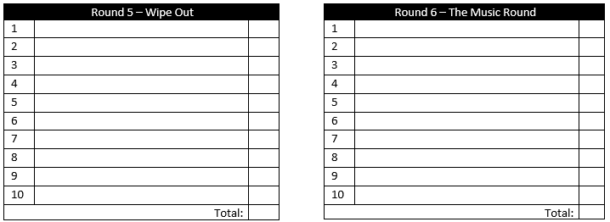

*Please come back and see us again!*