Table of Contents
Table of Contents 1
Sample Engineering Report 1
Executive Summary 1
Introduction 1
Design Criteria 3
Loading Conditions 3
Material Properties 3
Analysis Results 4
Member Design 5
Beam Design 5
Column Design 5
Safety Verification 5
Recommendations 6
Conclusion 6

Sample Engineering Report
Author: John Smith
Company: ABC Engineering
Project: Bridge Analysis Project
Date: June 10, 2025

Executive Summary
This report presents the structural analysis and design recommendations for the proposed bridge structure. The analysis includes load calculations, member sizing, and safety factor verification.

Introduction
The purpose of this analysis is to evaluate the structural integrity of the proposed bridge design under various loading conditions including dead loads, live loads, and environmental factors.
[[INSERT: appendices/Sketch1.pdf]]

Design Criteria

Loading Conditions
- Dead Load: Self-weight of structure
- Live Load: Traffic and pedestrian loads
- Wind Load: Per ASCE 7 standards
- Seismic Load: Site-specific seismic analysis

Material Properties
- Concrete: f'c = 4000 psi
- Steel: Fy = 50 ksi
- Safety Factor: 2.0 minimum

Analysis Results
The structural analysis was performed using advanced finite element software. The key parameters include:
Maximum Moment: $M_{max}=\frac{wL^{2}}{8}=\frac{1.5×{50}^{2}}{8}=468.75\text{ kN-m}$
Deflection Check: $δ = \frac{5wL^{4}}{384EI} ≤ \frac{L}{250}$
Where:
- $w$ = distributed load (kN/m)
- $L$ = span length (m)
- $E$ = modulus of elasticity (GPa)
- $I$ = moment of inertia ($m^{4}$)
The detailed calculations and computer output are provided in the appendix.
[[INSERT: appendices/structural analysis.pdf]]
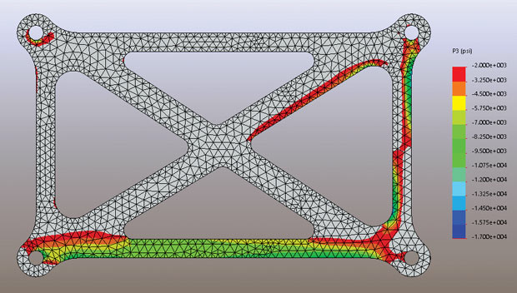
Figure 1: Stress distribution diagram from finite element analysis

Member Design

Beam Design
The main girders were designed for the maximum moment and shear forces determined from the analysis.
Design Equation: $f_{b}=\frac{M}{S}≤F_{b}$
Where the section modulus is: $S=\frac{I}{c}$

Column Design
Columns were designed for axial load plus bending moment combinations.
Interaction Formula: $\frac{P}{P_{n}}+\frac{M}{M_{n}}≤1.0$

Safety Verification
All structural members have been verified to meet or exceed the required safety factors:
- Beam capacity utilization: 85% maximum
- Column capacity utilization: 78% maximum
- Connection capacity utilization: 92% maximum

Recommendations
Based on the analysis results, the following recommendations are made:
- Proceed with construction using the proposed design
- Implement regular inspection schedule post-construction
- Monitor deflections during initial loading phases

Conclusion
The proposed bridge design meets all applicable codes and standards. The structure provides adequate safety margins for the intended loading conditions.
This report was compiled using the Automated PDF Report Compiler system.

