Part 1
Model the World on Paper 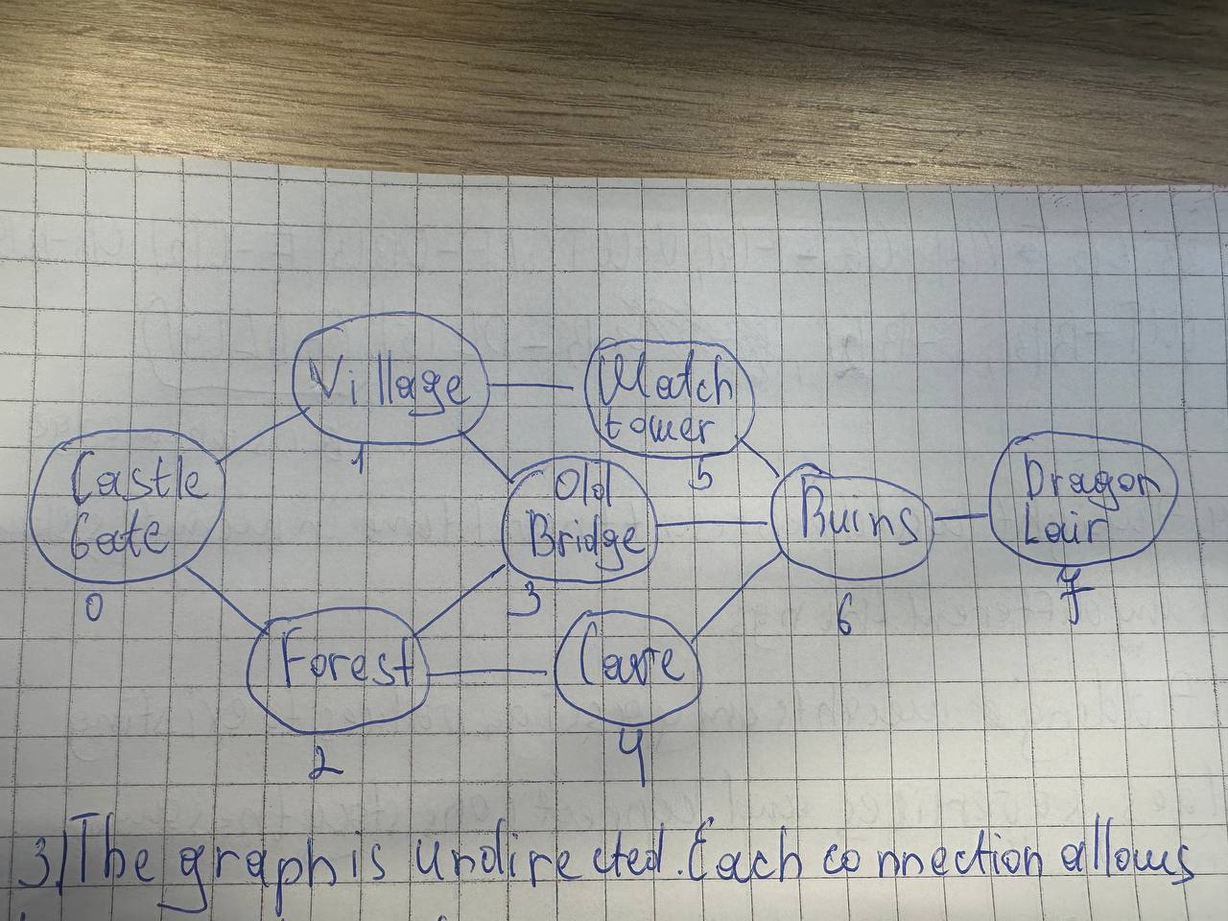Answer the questions 3-8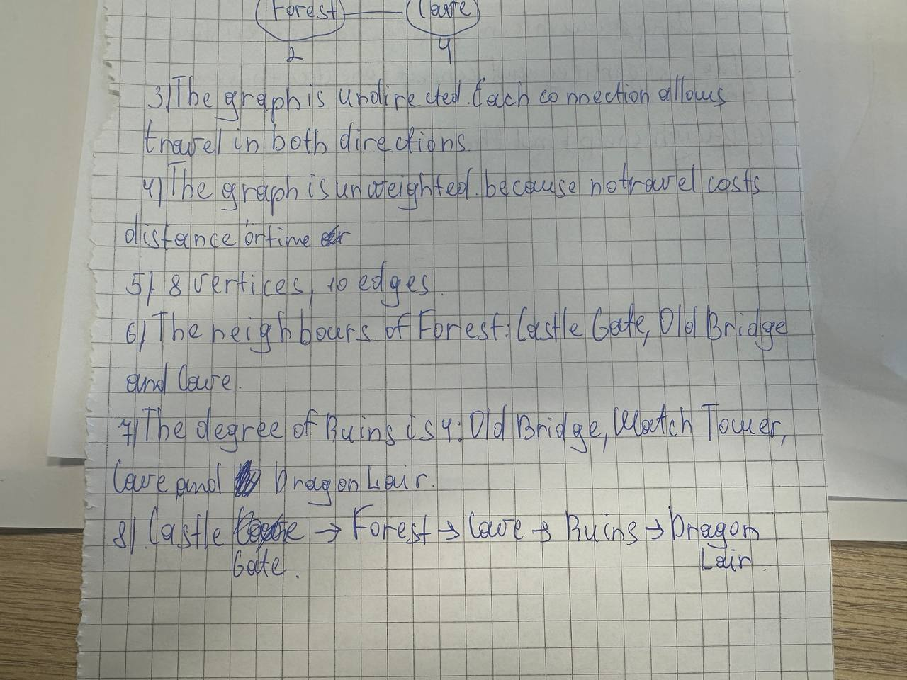
Part 2
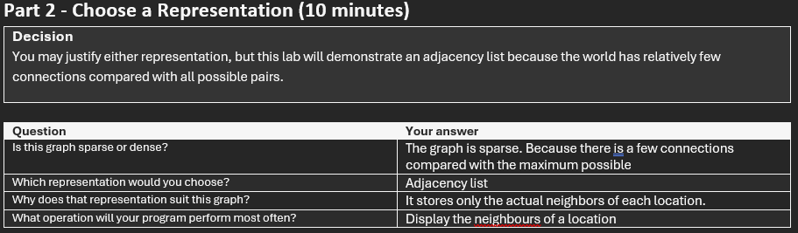

Part 6
Answer the questions 23-26


