Cost of Living Adjustment (COLA)

Table of Contents

[COLA 1](#_Toc499713951)

[What This Manual Covers — and What It Doesn't 1](#_Toc499713952)

[Credits 3](#_Toc499713953)

[Intro to COLA 4](#_Toc499713954)

[What is a COLA? 4](#_Toc499713955)

[If the CP is on TA 4](#_Toc499713956)

[If the CP is NOT on TA 5](#_Toc499713957)

[If the NCP is on TA 5](#_Toc499713958)

[TA Accounts versus Non-TA Accounts: Different COLA Processes 7](#_Toc499713959)

[How Is a COLA Calculated? 11](#_Toc499713960)

[Adding up CPI-U percentages to determine COLA eligibility 12](#_Toc499713961)

[The same example, in dollars and cents: 13](#_Toc499713962)

[Negative CPI-U Years 13](#_Toc499713963)

[Ledgers Affected 14](#_Toc499713964)

[Eligibility 15](#_Toc499713965)

[Orders Subject to COLA 15](#_Toc499713966)

[General Eligibility Criteria for a COLA 16](#_Toc499713967)

[Decision Tree: Is This Order Eligible for a COLA? 17](#_Toc499713968)

[Eligible Ledgers 18](#_Toc499713969)

[Ineligible Ledgers 19](#_Toc499713970)

[Ledgers Codes: Meaning and Syntax 20](#_Toc499713971)

[Multiple Ledgers, Different Payment Frequencies 22](#_Toc499713972)

[Normalizing Ledgers with Different Payment Frequencies 22](#_Toc499713973)

[Ineligibility 23](#_Toc499713974)

[Ineligible Orders or Accounts 23](#_Toc499713975)

[If the worker populates the CEJ State field when the COLA Notice or COLA Order has already been sent out 24](#_Toc499713976)

[TA Process 26](#_Toc499713977)

[Roadmap: TA Process — COLA 26](#_Toc499713978)

[Eligible cases appear on "Cost of Living Adjustment Eligible Cases" screen 29](#_Toc499713979)

[Worker reviews Eligible Cases screen, resolves any cases with Error codes 31](#_Toc499713980)

[ASSETS runs its COLA monthly process (on the third full weekend of each month) 33](#_Toc499713981)

[Proc Ctr mails "Adjusted Order of Support" to all parties 34](#_Toc499713982)

[Non-TA Process 36](#_Toc499713983)

[Roadmap: Non-TA Process — COLA 36](#_Toc499713984)

[Eligible cases appear on "Cost of Living Adjustment Eligible Cases" screen 39](#_Toc499713985)

[Worker reviews Eligible Cases screen, resolves any cases with Error codes 41](#_Toc499713986)

[ASSETS runs its COLA monthly process (on the third full weekend of each month): 43](#_Toc499713987)

[Processing Center prints and mails "Notice of Your Right to Request..." to CP & NCP: 44](#_Toc499713988)

[No COLA requested? No further action required. 45](#_Toc499713989)

[CP or NCP mails request to Processing Center 45](#_Toc499713990)

[Processing Center captures request for COLA 46](#_Toc499713991)

[ASSETS runs its COLA monthly process (on the next third full weekend of the month) 48](#_Toc499713992)

[Processing Center mails "Adjusted Order of Support" to all parties 49](#_Toc499713993)

[CP and NCP decide: Object to COLA, or not? 51](#_Toc499713994)

[No objection to COLA? 51](#_Toc499713995)

[CP or NCP Mails Objection to Court 51](#_Toc499713996)

[Intro to Objections in COLA 52](#_Toc499713997)

[Introduction to Objections in COLA Process 52](#_Toc499713998)

[What is a de novo hearing? 52](#_Toc499713999)

[When Should the CSEU File an Objection to a COLA? 53](#_Toc499714000)

[Objection Process 54](#_Toc499714001)

[Roadmap: Objection Process — COLA 54](#_Toc499714002)

[Court receives objection and notifies the SCU 58](#_Toc499714003)

[Worker enters Adjusted Order Objection Date into ASSETS 58](#_Toc499714004)

[ASSETS locks ledgers so that no COLA goes into effect pending de novo hearing 59](#_Toc499714005)

[Worker prepares for court and conducts financial investigation 59](#_Toc499714006)

[Worker rescinds "Adjusted Order of Support" 60](#_Toc499714007)

[Troubleshooting 62](#_Toc499714008)

[Glossary 66](#_Toc499714009)

[Index 107](#_Toc499714010)

# COLA

## What This Manual Covers — and What It Doesn't

What you are looking at is a "first release" of the first chapter of the Child Support Program Manual.

**Producing a Program Manual serves a number of purposes**, including:

* + Capturing institutional knowledge that might otherwise be lost as seasoned personnel reach retirement age
  + Explaining processes that are otherwise invisible to the caseworker, capturing cause and effect within processes, giving insight into actions performed by the various actors in a process, and giving the end-user an appreciation of the big picture and his or her particular role in it
  + Standardizing terminology
  + Standardizing procedures (That said, it is recognized that there are 58 local districts in New York State, each with their own way of doing things.)

**The intention here is to publish a “first release”** of the COLA chapter of the manual. The first release is meant to be limited in scope to that which is:

* + Clear and definitive in present-day terms and everyday circumstances
  + Universally true or applicable across all 58 local/county social service districts
  + Pragmatic information involving “typical” or “sunny day” scenarios encountered in everyday circumstances

Then, content will be expanded upon incrementally and iteratively through subsequent releases.

The first release of this chapter is not meant to be comprehensive. It is not meant to answer every question or cover every "what-if" scenario, error code, or contingency that may be encountered in the COLA process. Those have been saved for a later release/update of the chapter.

**The interface of the online Child Support Program Manual has been designed to**:

1. Give end-users various ways to navigate the site and various ways to find information quickly
2. Provide users with the information they request, when they request it, without inundating them with information that they did not request.
3. Enable end-users to obtain further details or information about an issue, without having to leave the page that they are on. (Many of these features -- like pop-up screenshots, "Learn More" buttons, etc. -- are designed to provide more information to the end-user with a single click of the mouse.)

# Credits

Child Support Program Manual

The Child Support Program Manual in its various forms

-- online resource/website, PDF document, print document, etc. --

and accompanying materials such as video demonstrations or tutorials pertaining to the manual,

are provided under a contractual agreement between the

New York State Office of Temporary and Disability Assistance

Administrative Services

Training and Staff Development

AND

Professional Development Program

Rockefeller College, University at Albany

State University of New York

through

The Research Foundation for the State University of New York

# Intro to COLA

## What is a COLA?

A "COLA" – or *Cost of Living Adjustment* – is a modification of the obligation amount of a child support order in response to an increase over time in the cost of living in the United States (as measured by the U.S. Bureau of Labor Statistics).

Child Support Services has the authority to apply COLAs to child support orders administratively (i.e., without having to go to court) provided that:

* 1. All eligibility criteria are met

**AND**

* 1. Neither the CP nor the NCP (nor the SCU itself) objects to the increase.

The matter would go to court only if the CP, NCP, or SCU *objects* to the proposed COLA.

The ASSETS system automatically identifies ledgers eligible for a COLA, and then:

### If the CP is on TA

* ASSETS generates a notice to the CP and NCP that a COLA ***will automatically be applied*** to their order unless one of them objects.
* If either party objects to the proposed COLA, a court hearing is held to determine the correct guidelines order.

### If the CP is *NOT* on TA

* ASSETS generates a notice to the CP and NCP that they **have the *right to request*** a COLA.
* If neither party requests a COLA, no action is taken.
* If a request is made by either party, either party (even the one who made the request) has the right to object to the COLA.
* If the CP, NCP, or the SCU objects, a court hearing is held to determine the correct guidelines order.

### If the NCP is on TA

* The case is not eligible for a COLA.

**Note:**

TA status of the NCP is indicated by the NCP's CAN and CIN numbers on ASSETS.

ASSETS will know whether the NCP is on TA in the state of New York only if his/her CAN and CIN numbers are ***both*** in ASSETS.

If the NCP's CAN and CIN numbers are not in ASSETS, the NCP may be on TA i*n a state other than New York --* butASSETS would not know that ***unless the*** Delinquency Switchis a 19 – which the caseworker would have had to set manually.

If ASSETS is unaware that the NCP is on TA, a COLA notice will be sent to both parties.

If an NCP who is on TA receives a Notice of Your Right to Request, s/he should contact the help desk or his/her local CSEU.

 If an NCP who is on TA receives an Adjusted ***Order of Support***, it would be up to the NCP to object to the COLA based upon the fact that s/he is on TA.

## TA Accounts versus Non-TA Accounts: Different COLA Processes

COLA eligibility criteria for TA and Non-TA accounts are the same, but processes are different.

|  |  |
| --- | --- |
| **TA Cases** | **Non-TA Cases** |
| Unless either party *objects* to a proposed COLA, the entire process is automatic.  Neither the CP nor the NCP has to submit a request for a COLA – ASSETS (i.e. the SCU) does this for them.   * ASSETS automatically recognizes when an order becomes eligible for a COLA. * ASSETS automatically requests a COLA on behalf of the CP * ASSETS sends an [Adjusted Order of Support](http://otda.state.nyenet/assets/pages/PDFs/COLA/Adjusted_Order_of_Support.pdf) to both parties, with a notice telling them that their support order is eligible for a COLA. * Unless the CP, NCP, or the SCU files an objection to the proposed COLA, the COLA will automatically take effect 60 days from the mailing of the [Adjusted Order of Support](http://otda.state.nyenet/assets/pages/PDFs/COLA/Adjusted_Order_of_Support.pdf). | ASSETS informs the CP and NCP by mail when their order is eligible for a COLA, and provides them with a request form.  CP or NCP *must request* a COLA for the process to move forward.   * ASSETS automatically recognizes when an order becomes  eligible for a COLA. * The COLA Notice informs the CP and NCP that they have the right to request a COLA. * Either party can request a COLA by mailing in the request form. * If neither the CP nor NCP mails in a request for a COLA, no further action is taken, and no COLA is processed. * If a request for a COLA is received by the Processing Center, when ASSETS next runs its COLA monthly process, an [Adjusted Order of Support](http://otda.state.nyenet/assets/pages/PDFs/COLA/Adjusted_Order_of_Support.pdf) will be sent to all parties. (The worker does not need to take any action. *Learn more button - green 25 percent.png*   + When a CP or NCP mails a COLA Request Form to the Processing Center, workers at the Processing Center enter the appropriate request code into the COLA Request Indicator field. (Code "2" if the CP has made the request, or Code "3" if the NCP has made the request.). ***In this instance, the Caseworker does not need to take any action.***   + When ASSETS next runs its COLA monthly process (on the third full weekend of each month), it picks up that request code and causes the Processing Center to send an Adjusted ***Order of Support*** to all parties -- the CP, NCP, and the Court. * Upon receipt of the [Adjusted Order of Support,](http://otda.state.nyenet/assets/pages/PDFs/COLA/Adjusted_Order_of_Support.pdf) both parties have 35 days from the date of mailing  to file an objection with the court. * If neither party (nor the SCU) files an objection, the COLA will automatically take effect 60 days from the mailing of the [Adjusted Order of Support](http://otda.state.nyenet/assets/pages/PDFs/COLA/Adjusted_Order_of_Support.pdf). * If the CP, NCP, or the SCU files an objection to the COLA, the matter goes to court to determine the correct guidelines order. |

In both TA and Non-TA cases, the ASSETS system automatically identifies orders eligible for COLAs.

TA and Non-TA accounts are processed on the same schedule -- on the third full weekend of each month.

Monthly COLA notices are mailed out in the month of the year corresponding to the month in which the order was first issued or most recently modified or adjusted.

*Learn more button - green 25 percent.png*

**Exceptions:**

All COLA-eligible accounts with January and February order dates are processed during the third full weekend in February.

(No orders are processed in the month of January each year, as the CPI-U average annual percentage change is not available until the very end of January.)

Thereafter, COLA eligible accounts with March order dates are processed the third full weekend of March, cases with April order dates are processed the third full weekend in April...and so forth throughout the rest of the year.

(Note that cases will first appear on the Cost of Living Adjustment Eligible Cases screen two months *prior* to notices being mailed out to CPs and NCPs. This is in order to inform workers in advance of cases becoming eligible for a COLA, ***and to allow them to resolve any error codes*** ***that might prevent the COLA notices from going out on time***. Workers also review this report for TA cases against which the DSS should file an objection because the NCP is earning more wages, and therefore an upward modification might result in a larger increase in the support order amount than the COLA would.

## How Is a COLA Calculated?

In child support, a COLA is determined based upon the sum of the percentage changes in CPI-Us for the years:

* + since 1994,

***OR***

* + since the original support order,

***OR***

* + since the last year in which the order amount was adjusted or modified

-- *whichever is latest* –

if that sum is equal to or greater than 10%.

The support obligation is multiplied by such percentage. The product is the COLA.

For a full description, see New York SSL lll-n (l) (c)

### Adding up CPI-U percentages to determine COLA eligibility

Below is an example of how CPI-U percentages add up to a sum equal to or greater than 10%, making an account eligible for a COLA.

In the example, the support order was originally established in 2010.

In 2016, the order obligation amount was still the same as it was in 2010 – but the cost of living had risen 10.1% since then. (That is, *the sum of* the CPI-Us of each year from 2010 through 2015 *adds up to* 10.1%.)

Therefore, in 2016, this support order was eligible for a COLA increase (of 10.1%).

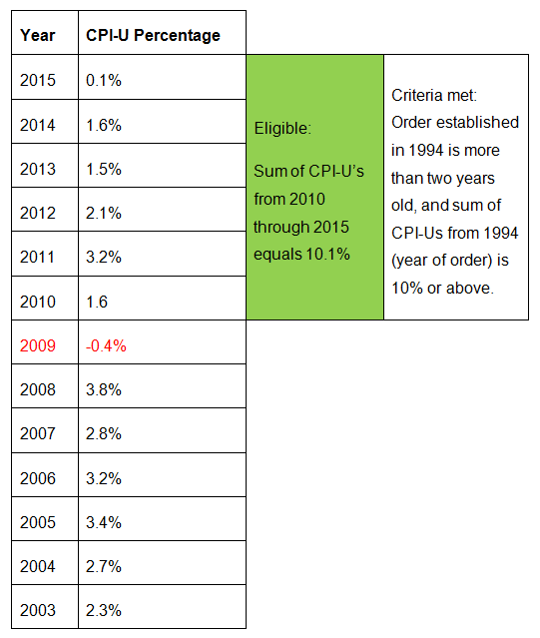

### The same example, in dollars and cents:

A child support order for **$100** per month was established in 2010.

Sum of CPI-U's from 2010 (year of order) through 2015 = **10.1%**

**10.1% X 100** = $10.10 (This is the amount of the COLA increase.)

$10.10 + 100.00 = $110 per month (This is the amount of the new, COLA-adjusted support order.)

Therefore, the new support order, including the COLA increase, would be $110 per month.

*Note:  The adjusted order amount is rounded to the nearest dollar, as required by law.*

### Negative CPI-U Years

In the table above, you can see that in 2009, there actually was a *negative* CPI-U. (i.e. According to the Bureau of Labor Statistics, the cost of living in 2009 was actually 0.4% *lower* than in 2008.) That is an unusual situation.

When adding up the CPI-Us for a range of years to determine whether their sum reaches the equal-to-or-greater-than-10% threshold required for a COLA, any *negative* CPI-Us must be *subtracted* from the sum.

For example, although CPI-Us from 2010 through 2015 add up to 10.1%, CPI-Us from 2009 through 2015 would add up to only 9.7%.

Factoring in of years with negative CPI-Us may affect the year in which an account becomes eligible for a COLA.

### Ledgers Affected

Not all ledgers in an account will be affected by a COLA. See sections on:

* [Eligible Ledgers](#cola_eligibility_eligible_ledger_1952)
* Ineligible Ledgers

# Eligibility

## Orders Subject to COLA

Except as otherwise noted, the COLA is applicable to all orders enforced pursuant to Title 6-A of the Social Services Law on behalf of persons in receipt of temporary assistance (TA), and which include family assistance and safety net assistance and which meet the eligibility criteria. (See “[Eligibility](#cola_eligibility_general_eligibi_6278)” section of this document.)

The COLA is applicable to all other orders receiving services under Title 6-A, including orders for Title IV-E Foster Care and Medicaid-only cases. Orders enforced on behalf of persons not in receipt of public assistance (Non-TA) are subject to COLA under Section 111-g of the Social Services Law, upon request of the CP or NCP.

In [Title IV-E Foster Care](https://www.ssa.gov/OP_Home/ssact/title04/0470.htm) cases where there is an assignment of support rights, the SSD shall be deemed to have requested the COLA review.

# 

## General Eligibility Criteria for a COLA

The child support program can increase the amount of a child support order administratively (i.e. without court involvement) by applying a COLA if:

1)    It has been at least two years since the support order was established, **or** since the obligation amount has been adjusted or modified,

***AND***

2)    the sum of the percentage changes in the CPI-U for the years since 1994, **or** since the original support order, **or** since the last year in which the order amount was adjusted or modified — ***whichever is latest****—* is equal to or greater than 10%.

When these two criteria are met, the case will appear on the Cost of Living Adjustment Eligible Cases screen in Worker Alerts.

You can use the Child Support Standards Act (CSSA) Data and Consumer Price Index (CPI-U) in ASSETS Utilities to view Child Support Standards Act data and Consumer Price Index information.

This information helps the worker determine whether or not a case is eligible for a COLA.

Other criteria for determining eligibility for a COLA are detailed later in this manual. (See sections on Eligibility and [Ineligibility](#cola_ineligibility_ineligibility_7828))

# 

## Decision Tree: Is This Order Eligible for a COLA?

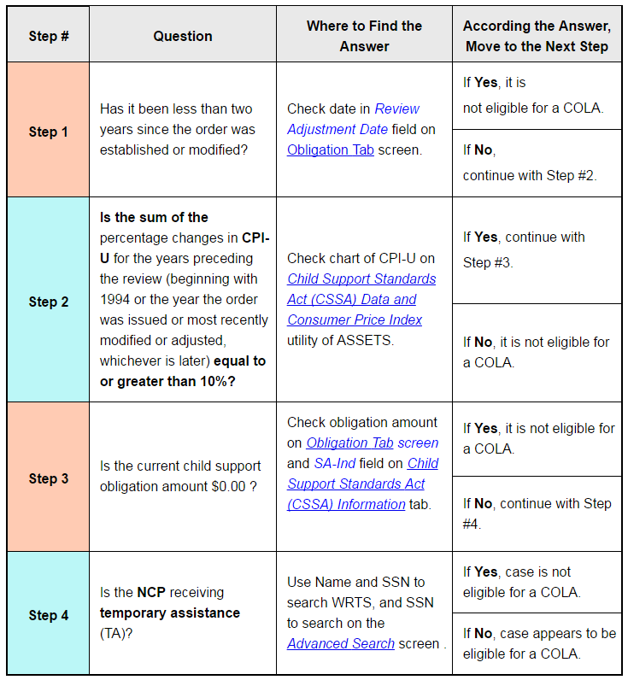

\* WRTS = Welfare Reporting and Tracking System

## Eligible Ledgers

Any given account may contain some ledgers that are subject to COLA increases and some ledgers that are not.

ASSETS displays on the Cost of Living Adjustment Eligible Cases screen all accounts that contain COLA-eligible ledgers, even if an account contains a mix of eligible and ineligible ledgers.

There are a total of 11 types of ledgers that are eligible for COLA increases. They are:

|  |  |
| --- | --- |
| **Ledger** | **Eligibility** |
| 11B\_ | Except for 11BM |
| 21A\_ | Eligibile if there is another eligible ledger which is not 1\_CB |
| 21BC | Eligible if it has a status of 01 |
| 21BE | Eligible if it has a status of 01 |
| 21BF | Eligible if it has a status of 01 |
| 21BK | Eligible if it has a status of 01 |
| 21BP | Eligible if it has a status of 01 |
| 21BR | Eligible if it has a status of 01 |
| 21BT | Eligible if it has a status of 01 |
| 24CZ | 24CZ is eligible only if there is also an eligible 11B\_ ledger |

## Ineligible Ledgers

When an account contains some eligible and some ineligible ledgers, the ineligible ledgers do not render the entirety of the account ineligible for a COLA increase. However, only the eligible ledgers will be factored in to the calculations of the COLA.

## Ledgers Codes: Meaning and Syntax

|  |  |
| --- | --- |
| **Ledger Types** | |
| **1st Position = Beneficiary** | **Description** |
| 1 | Custodial Parent |
| 2 | DSS |
| 3 | 3rd Party |
| 4 | 4th Party |
| **2nd Position = Type of Obligation** | **Description** |
| 1 | Court-Ordered Current |
| 2 | Court-Ordered Arrears |
| 3 | Voluntary Agreement - Current |
| 4 | Voluntary Agreement - Arrears |
| **3rd Position = Type of Collection** | **Description** |
| A | IV-D TANF |
| B | IV-D Non-TANF |
| C | Non-IV-D |
| **4th Position = Type of Collection** | **Description** |
| A | Alimony |
| B | Child Care expenses |
| C | Foster Care |
| D | Administrative expense (i.e. genetic test) |
| E | Title IV-D foster care |
| F | Emergency Assistance to Families (EAF) Foster Care |
| G | Refugees |
| H | Hospitals |
| I | American Indian |
| J | Judgment |
| **4th Position = Type of Collection** | **Description** |
| K | Correctional Schools |
| L | Mental hygiene release |
| M | Medical assistance |
| N | Nursing homes |
| O | Educational expenses |
| P | Pre-determination grant for Family Assistance |
| Q | Cuban-Haitian entrants |
| R | TA Safety Net (formerly Home Relief) |
| S | Supplemental Security Income |
| T | Training schools |
| U | Future reasonable medical expenses |
| V | Child Support out-of-wedlock |
| W | Child Support in wedlock |
| X | Administrative collection of arrears amount |
| Y | State charges |
| Z | Fee for service |
| **5th Position = Interest or Judgment** | **Description** |
| I | Interest |
| J | Judgment |
| **6th Position = Judgment number** | **Description** |
| 1-9 | Same number as the ledger type |

## Multiple Ledgers, Different Payment Frequencies

### Normalizing Ledgers with Different Payment Frequencies

Various eligible ledgers under any given account may have both different payment amounts and different payment frequencies. Some ledgers are weekly, some are every two weeks, some are twice a month, some are monthly, and so on.

For the purposes of calculating a COLA, the payment frequencies of all eligible ledgers are normalized to the frequency of the ledger with the shortest cycle.

For example, if an account has some ledgers that are annual, some that are monthly, and some that are weekly, all ledgers will be normalized to weekly rates for all eligible ledgers involved. The rates are then figured into a total [weekly] sum eligible for a COLA increase.

The total weekly sum is multiplied by the COLA percentage to arrive at a dollar amount for the COLA increase per week.

Then, all ledgers are recalculated back to their actual frequencies, and the COLA increase percentage is applied to each eligible ledger proportionately.

# Ineligibility

## Ineligible Orders or Accounts

**The following types of orders are not eligible for a COLA:**

* $0 obligation amount orders.
* Two-state orders in which New York does not have continuing exclusive jurisdiction ([CEJ](file://c:\01_SOURCE_CSS_MANUAL\00_UNIFIED%20MANUAL\COLA\Ineligibility\javascript:TextPopup(this))).
* Orders with a Status 02, 03, 04, or 05.

**Also ineligible are accounts in which:**

* The [NCP](file://c:\01_SOURCE_CSS_MANUAL\00_UNIFIED%20MANUAL\COLA\Ineligibility\javascript:TextPopup(this)) is active on [TA](file://c:\01_SOURCE_CSS_MANUAL\00_UNIFIED%20MANUAL\COLA\Ineligibility\javascript:TextPopup(this)) at the time of case selection for the year's [COLA](file://c:\01_SOURCE_CSS_MANUAL\00_UNIFIED%20MANUAL\COLA\Ineligibility\javascript:TextPopup(this)) review.
* Neither party has a valid New York State address in the [ASSETS](file://c:\01_SOURCE_CSS_MANUAL\00_UNIFIED%20MANUAL\COLA\Ineligibility\javascript:TextPopup(this)) system.
* The support order predates the [CSSA](file://c:\01_SOURCE_CSS_MANUAL\00_UNIFIED%20MANUAL\COLA\Ineligibility\javascript:TextPopup(this)) (9-15-1989) and the child is in receipt of TA and the Worker determines that a COLA is not in the best interests of the child or the [CP](file://c:\01_SOURCE_CSS_MANUAL\00_UNIFIED%20MANUAL\COLA\Ineligibility\javascript:TextPopup(this)).
* Orders issued by another state and registered in NYS only for enforcement.

**Note:**

In instances where the order was issued by another state and registered in NYS only for enforcement, the worker must enter the value for the state with continuing, exclusive jurisdiction in the CEJ State field.

If there is ***anything*** entered in the CEJ State field on the Cost of Living Adjustment (COLA) Information Edit screen, the order will not be selected by ASSETS for the COLA process.

If a COLA Notice or COLA Order has already been mailed out by the Processing Center at the time that the worker enters data in the CEJ State field, ASSETS will systematically take action to withdraw the notice of eligibility or rescind the COLA order.

If an objection to a COLA has already been filed with the court and the CSEU becomes aware that a state other than New York has continuing exclusive jurisdiction over the case, the worker will not be able to enter the code for the state holding continuing exclusive jurisdiction into the *CEJ* State field until the COLA order is withdrawn.

The worker can withdraw the COLA order by entering a code “W” in the COLA Request Indicator field on the Cost of Living Adjustment (COLA) Information Edit screen). See section “[CEJ State field Is locked](#cola_troubleshooting_-_cola_cann_4055)."

(See the graphic below for details.)

### If the worker populates the CEJ State field when the COLA Notice or COLA Order has already been sent out

If a different state (not NY) has continuing exclusive jurisdiction (CEJ) over an order, the case is not eligible for a COLA.

Entering a state code in the CEJ State field will properly prevent ASSETS from selecting it for the COLA Process.

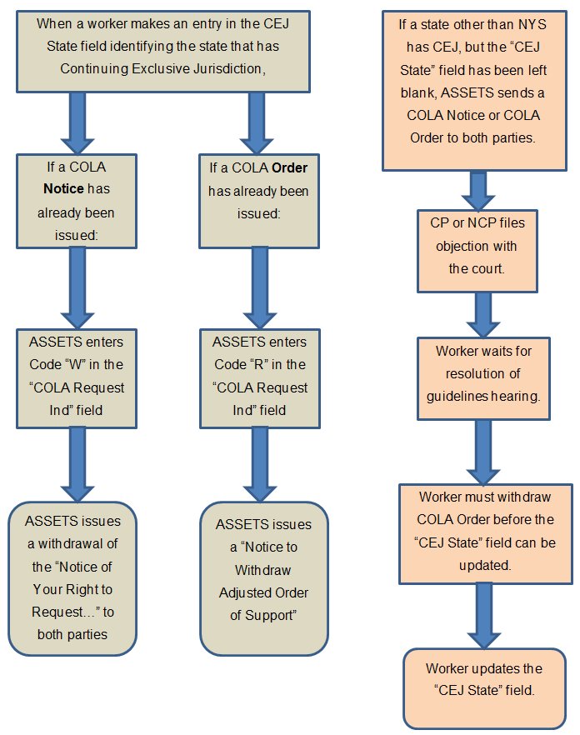

# TA Process

## Roadmap: TA Process — COLA

Nodes in this process diagram that have a plus sign inside a green circle image30.gif on them are linked to drill-down content. Click on those nodes to get more details about that step.

To download the diagram below, simply right click on the diagram, and select "Save image as..."

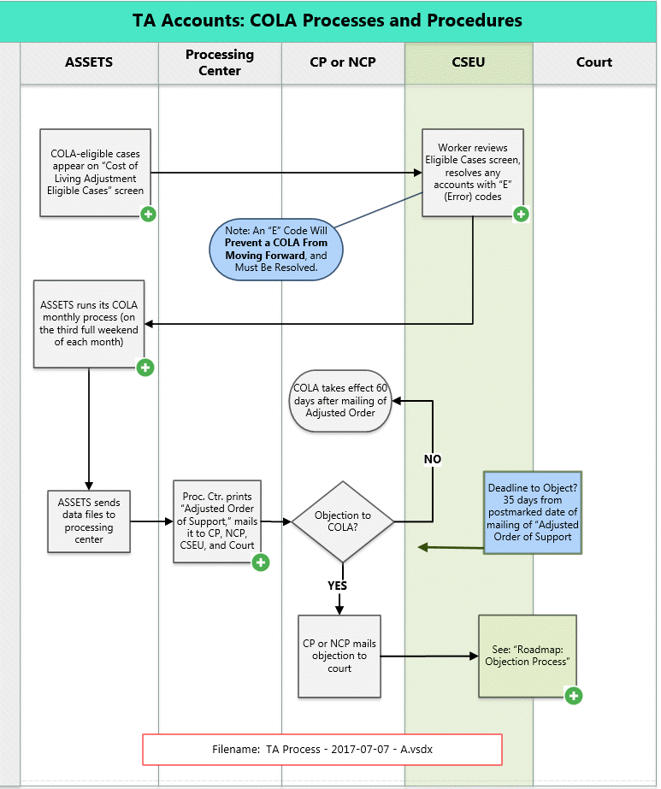

When you click a link in the map and are brought to drill-down content, how can you return to the map?

Three ways:

1)  Click "Non-TA Process" in the table of contents

2)  Click "Non-TA Process" in the breadcrumbs

3)  Click the "back" button on your browser

 Also, if you scroll down to the bottom of the map and want to return to the top of the page, you can:

1)  Scroll back up to the top of the page, or

2)  Click the "Return to Top" button (it looks like an arrow, pointing up) in the bottom right of your screen.

## Eligible cases appear on "Cost of Living Adjustment Eligible Cases" screen

On the last weekend of each month, the Cost of Living Adjustment Eligible Cases screen is refreshed.

The screen is a report under Worker Alerts. It lists TA and Non-TA cases for which notices should go out two months later.

**For example:**

On the last weekend in August, cases appear for which COLA notices should be generated on the third full weekend in October.

That means that in October:

* CPs and NCPs in TA cases should be sent an [Adjusted Order of Support](http://otda.state.nyenet/assets/pages/PDFs/COLA/Adjusted_Order_of_Support.pdf)
* CPs and NCPs in Non-TA cases should be sent a [Notice of Your Right to Request](http://otda.state.nyenet/assets/pages/PDFs/COLA/Notice_of_Your_Right_to_Request_a_Cost_of_Living_Adjustment.pdf)

Workers wishing to see the eligible cases report for the previous month can access it by selecting “Previous Month” in the dropdown menu pictured below:

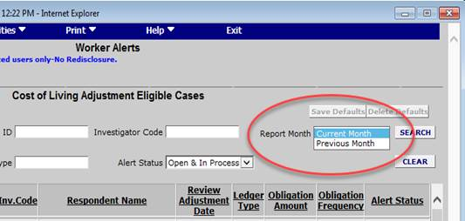

Why do cases appear on the Cost of Living Adjustment Eligible Cases screen two months in advance?

Because it gives the worker advanced notice regarding any cases that have generated error codes, allowing them time to resolve those error codes so that COLA notices can go out as they should, and on time.

**Potential Problem:**

If any cases appearing on the Cost of Living Adjustment Eligible Cases screen have an “E” (Error) Code in the Review Adjustment Ind field, the notice that ***should*** be sent out ***will not*** be sent out.

**Solution:**

The worker must resolve those cases containing an “E” code, so that the COLA process can move forward.

## Worker reviews Eligible Cases screen, resolves any cases with Error codes

The worker reviews the Cost of Living Adjustment Eligible Cases screen.

**If the Review Adjustment Indicator field contains Code "E" (Error):**

A **Code “E”** (Error) in the Review Adjustment Ind field will prevent the COLA process from moving forward.

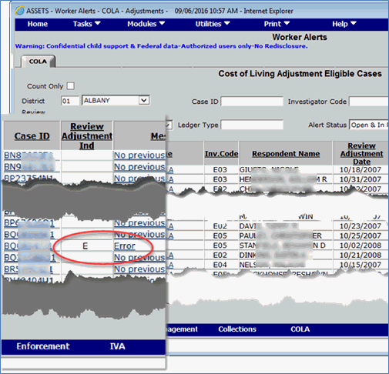

The “E” code indicates that two or more COLA-eligible ledgers on this account have conflicting dates in the Court Order Date fields (on the Obligation Tab screen).

The court order dates on all COLA-eligible ledgers must be identical, ***and*** they must match the date shown in the Review & Adjustment Date field.

## ASSETS runs its COLA monthly process (on the third full weekend of each month)

On the third full weekend of each month, ASSETS runs its COLA monthly process.

**During this process, ASSETS:**

1. Identifies all cases for which CPs and NCPs will be sent monthly COLA-related notices this month. Specifically, the ASSETS system:
   * Identifies TA cases that will be sent an [Adjusted Order of Support](http://otda.state.nyenet/assets/pages/PDFs/COLA/Adjusted_Order_of_Support.pdf) this month
   * Identifies Non-TA cases that will be sent a [Notice of Your Right to Request](http://otda.state.nyenet/assets/pages/PDFs/COLA/Notice_of_Your_Right_to_Request_a_Cost_of_Living_Adjustment.pdf) this month
   * Identifies Non-TA cases for which the CP or NCP has requested a COLA, and which therefore will be sent an [Adjusted Order of Support](http://otda.state.nyenet/assets/pages/PDFs/COLA/Adjusted_Order_of_Support.pdf) this month.

**For each of those cases, ASSETS:**

1. Identifies and normalizes all COLA-eligible ledgers
2. Calculates COLA percentage, dollar amount, and adjusted support order amount
3. Generates data files regarding those cases. (These data files will be sent to the Processing Center for further action.)

## Proc Ctr mails "Adjusted Order of Support" to all parties

The [Adjusted Order of Support](http://otda.state.nyenet/assets/pages/PDFs/COLA/Adjusted_Order_of_Support.pdf) is mailed out within five days of the data files being received by the Processing Center (from ASSETS).

(Note: The cover letter that goes out with the notice bears the date the letter was generated by ASSETS -- not the date that it was printed at or mailed from the Processing Center.)

When an [Adjusted Order of Support](http://otda.state.nyenet/assets/pages/PDFs/COLA/Adjusted_Order_of_Support.pdf) is issued to the CP and NCP, the Processing Center also sends the order by regular mail to the CSEU and to the family court address indicated on the **Court Address** screen on ASSETS. (**Go to Home > Utilities > District Addresses > View > Court [tab]**)

**Family Court cases**

For Family Court cases, notice is sent to the family court address indicated on the **Court Address** screen.

**Supreme Court cases**

For Supreme Court orders, the district should enter Code S in the Supreme Court Indicator field on the **Cost of Living Adjustment (*COLA) Information Edit*** screen. Then the order will be sent to the supreme court address indicated on the **Court Address** screen in ASSETS.

**NY order, but other than local court:**

If the New York order, either Family or Supreme Court, is from other than a local court (i.e. the account was created based on a change of payee), the district should:

a)    Enter Code S in the Supreme Court Indicator field (for Supreme Court)

***OR***

b)    Enter Code F (for Family Court)

***AND***

c)    Enter the court county number for the county that is the origin of the order in the Court County Number  field on the **Obligation Tab** screen.

This will ensure that the appropriate court gets the order.

# Non-TA Process

## Roadmap: Non-TA Process — COLA

Nodes in this process diagram that have a plus sign inside a green circle image39.gif on them are linked to drill-down content. Click on those nodes to get more details about that step.

To download the diagram below, simply right click on the diagram, and select "Save image as..."

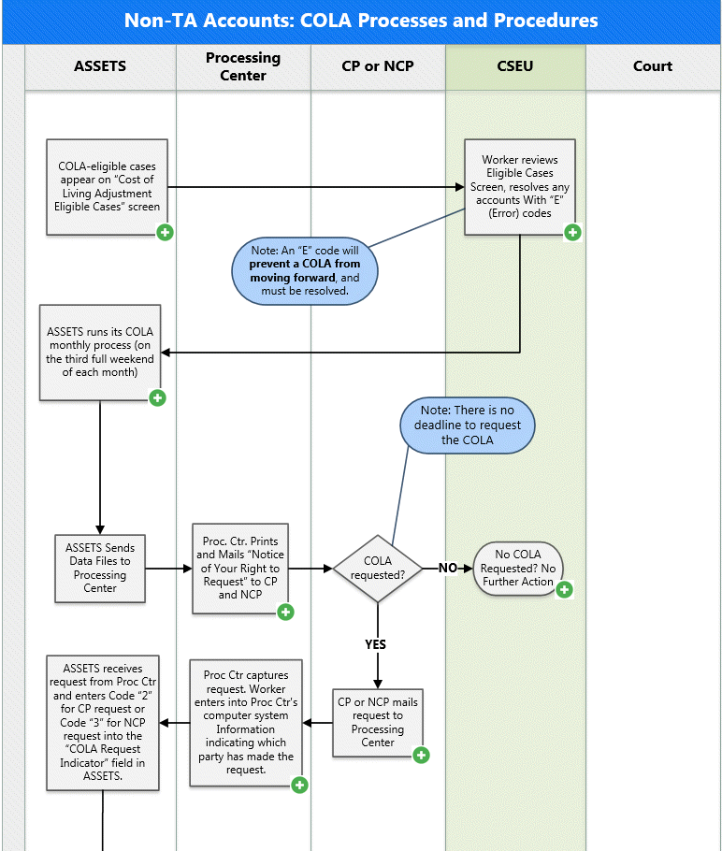

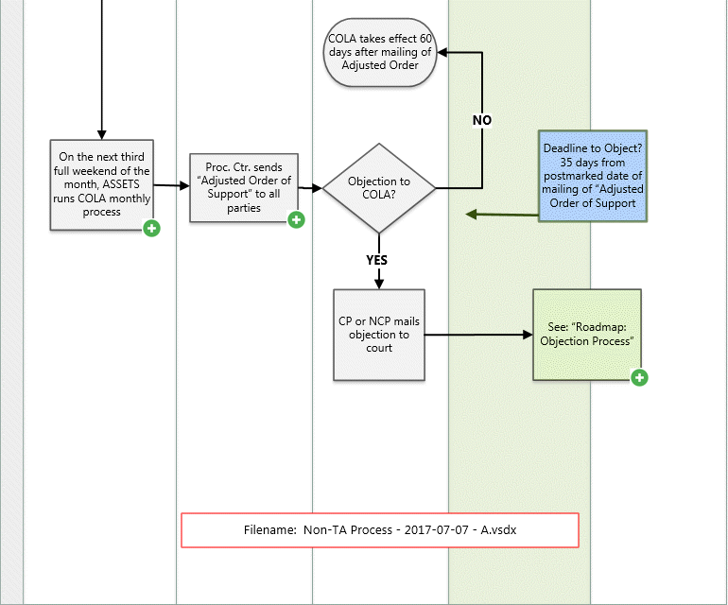

## Eligible cases appear on "Cost of Living Adjustment Eligible Cases" screen

On the last weekend of each month, the Cost of Living Adjustment Eligible Cases screen is refreshed.

The screen is a report under Worker Alerts. It lists TA and Non-TA cases for which notices should go out two months later.

**For example:**

On the last weekend in August, cases appear for which COLA notices should be generated on the third full weekend in October.

That means that in October:

* CPs and NCPs in TA cases should be sent an [Adjusted Order of Support](http://otda.state.nyenet/assets/pages/PDFs/COLA/Adjusted_Order_of_Support.pdf)
* CPs and NCPs in Non-TA cases should be sent a [Notice of Your Right to Request](http://otda.state.nyenet/assets/pages/PDFs/COLA/Notice_of_Your_Right_to_Request_a_Cost_of_Living_Adjustment.pdf)

Workers wishing to see the eligible cases report for the previous month can access it by selecting “Previous Month” in the dropdown menu pictured below:



Why do cases appear on the Cost of Living Adjustment Eligible Cases screen two months in advance?

Because it gives the worker advanced notice regarding any cases that have generated error codes, allowing them time to resolve those error codes so that COLA notices can go out as they should, and on time.

**Potential Problem:**

If any cases appearing on the Cost of Living Adjustment Eligible Cases screen have an “E” (Error) Code in the Review Adjustment Ind field, the notice that ***should*** be sent out ***will not*** be sent out.

**Solution:**

The worker must resolve those cases containing an “E” code, so that the COLA process can move forward.

## Worker reviews Eligible Cases screen, resolves any cases with Error codes

The worker reviews the Cost of Living Adjustment Eligible Cases screen.

**If the Review Adjustment Indicator field contains Code "E" (Error):**

A **Code “E”** (Error) in the Review Adjustment Ind field will prevent the COLA process from moving forward.



The “E” code indicates that two or more COLA-eligible ledgers on this account have conflicting dates in the Court Order Date fields (on the Obligation Tab screen).

The court order dates on all COLA-eligible ledgers must be identical, ***and*** they must match the date shown in the Review & Adjustment Date field.

## 

## ASSETS runs its COLA monthly process (on the third full weekend of each month):

On the third full weekend of each month, ASSETS runs its COLA monthly process.

During this process, ASSETS:

1. Identifies all cases for which CPs and NCPs will be sent monthly COLA-related notices this month. Specifically, the ASSETS system:
   * Identifies TA cases that will be sent an [Adjusted Order of Support](http://otda.state.nyenet/assets/pages/PDFs/COLA/Adjusted_Order_of_Support.pdf) this month
   * Identifies Non-TA cases that will be sent a [Notice of Your Right to Request](http://otda.state.nyenet/assets/pages/PDFs/COLA/Notice_of_Your_Right_to_Request_a_Cost_of_Living_Adjustment.pdf) this month
   * Identifies Non-TA cases for which the CP or NCP has requested a COLA, and which therefore will be sent an [Adjusted Order of Support](http://otda.state.nyenet/assets/pages/PDFs/COLA/Adjusted_Order_of_Support.pdf) this month.

For each of those cases, ASSETS:

1. Identifies and normalizes all COLA-eligible ledgers
2. Calculates COLA percentage, dollar amount, and adjusted support order amount
3. Generates data files regarding those cases. (These data files will be sent to the Processing Center for further action.)

## 

## Processing Center prints and mails "Notice of Your Right to Request..." to CP & NCP:

**The Processing Center mails to the CP and NCP (via USPS) the:**

|  |  |
| --- | --- |
| Paper Clip - Small.PNG | **"**[**Notice  of Your Right To Request a Cost of Living  Adjustment to Your Child  Support Order**](http://otda.state.nyenet/assets/pages/PDFs/COLA/Notice_of_Your_Right_to_Request_a_Cost_of_Living_Adjustment.pdf)**"** |
| Paper Clip - Small.PNG | **"**[**Request for a Cost of Living Adjustment (COLA)**](http://otda.state.nyenet/assets/pages/PDFs/COLA/Request_for_a_Cost_of_Living_Adjustment.pdf)**"**    **(**Note: There is no deadline to submit a request for a COLA. |
| Paper Clip - Small.PNG | A pre- addressed (to the Processing Center), postage-paid envelope |

The notices and orders of adjustment are system-generated and sent by first class mail from the Processing Center to the party’s last known address on ASSETS.

**If there is no address on ASSETS for the Respondent**, a location status will be opened on ASSETS.

**If there is no address on ASSETS for either party**, no Notice of Your Right to Request or [Adjusted Order of Support](http://otda.state.nyenet/assets/pages/PDFs/COLA/Adjusted_Order_of_Support.pdf) will be issued.

## 

## No COLA requested? No further action required.

In a Non-TA case, if neither the CP nor the NCP requests a COLA, the COLA Request Ind (Indicator) field will remain blank, and no further action will be taken.

Two years later, if the case is still eligible for a COLA, both parties will again be sent notice that it is eligible.

The COLA will be recalculated by ASSETS at that time, and the notice sent to the CP and NCP will have updated figures regarding the percentage and dollar amount of the proposed COLA.

## CP or NCP mails request to Processing Center

Either party can request a COLA by filling out the [Request for a Cost of Living Adjustment (COLA)](http://otda.state.nyenet/assets/pages/PDFs/COLA/Request_for_a_Cost_of_Living_Adjustment.pdf) form and mailing it back to the Processing Center. (The CP and NCP are provided a self-addressed, postpaid envelope for this purpose.)

There is no deadline for mailing in the form.

## Processing Center captures request for COLA

When the Processing Center receives a [Request for a Cost of Living Adjustment (COLA)](http://otda.state.nyenet/assets/pages/PDFs/COLA/Request_for_a_Cost_of_Living_Adjustment.pdf) form from the CP or NCP, the Request Form is scanned and the following data is captured and entered into the Processing Center's computer system:

* + Whether or not the Request Form is signed
  + Which party (CP or NCP) has made the request

*Learn more button - green 25 percent.png*

If the form isn't signed, the request is not entered into the system.

Unsigned COLA Request Forms are scanned by the Processing Center and sent to the local district through ECS.

The SCU must reach out to the party who submitted the unsigned request form and have them sign it.

See topic:  "[Processing Center Receives an Unsigned COLA Request Form.](#cola_troubleshooting_-_cola_proc_7583)"

 In the next data exchange between the Processing Center and ASSETS, the data entered by the Processing Center causes ASSETS to change the value in the COLA Request Indicator field from a [blank field], (which is  the system default value), to one of the following values:

* + Code 2 = If the CP has requested a COLA.
  + Code 3 = If the NCP has requested a COLA.

If both the CP *and* the NCP mail in a request, the request code will be set according to whichever request (CP or NCP) was received first.

Then, the next time(no action will be taken on the request until the next time that ASSETS runs its COLA monthly process -- on the third full weekend of the month)  that ASSETS runs its COLA monthly process, ASSETS will recognize this request for a COLA, and will generate an Adjusted Order of Support for this case.

At that time, the Code 2 or Code 3 in the COLA Request Indicator field will cause ASSETS to send by first class mail (via the Processing Center) an [Adjusted Order of Support](http://otda.state.nyenet/assets/pages/PDFs/COLA/Adjusted_Order_of_Support.pdf) to both parties, the CSEU, and the court.

## ASSETS runs its COLA monthly process (on the next third full weekend of the month)

On the next third full weekend of the month, ASSETS runs its COLA monthly process.

ASSETS identifies the orders for which the CP or NCP has requested a COLA (i.e., those cases which now have a Code 2 or Code 3 in the COLA Request Indicator field on the Obligation Tab screen).

For each of those orders, the CP, NCP, SCU, and the court will be sent an Adjusted ***Order of Support*** this month.

For each of those orders, ASSETS generates data files and sends them to the Processing Center, along with all other files involved in the COLA monthly process.

*Learn_More_button.gif*

Note: When ASSETS generates a notice, it doesn’t generate the entire letter. Rather, it generates data elements corresponding to data fields that will be used by the Processing Center to assemble and print the notices. Those data elements contain information like processing date, name, address, COLA percentage, adjusted order of support amount that would result from proposed COLA, etc.

ASSETS sends the data files to the Processing Center during the next batch processing exchange.

The cover letter that goes out with the notice will bear the date the notice is generated by ASSETS -- not the date that it is printed at or mailed from the Processing Center.

## 

## Processing Center mails "Adjusted Order of Support" to all parties

The [Adjusted Order of Support](http://otda.state.nyenet/assets/pages/PDFs/COLA/Adjusted_Order_of_Support.pdf) is mailed out within five days of the data files being received by the Processing Center (from ASSETS).

(Note: The cover letter that goes out with the notice bears the date the letter was generated by ASSETS -- not the date that it was printed at or mailed from the Processing Center.)

When an [Adjusted Order of Support](http://otda.state.nyenet/assets/pages/PDFs/COLA/Adjusted_Order_of_Support.pdf) is issued to the CP and NCP, the Processing Center also sends the order by regular mail to the CSEU and to the family court address indicated on the **Court Address** screen on ASSETS. (**Go to Home > Utilities > District Addresses > View > Court [tab]**)

**Family Court cases**

For Family Court cases, the notice is sent to the family court address indicated on the **Court Address** screen.

**Supreme Court cases**

For Supreme Court orders, the district should enter Code S in the Supreme Court Indicator field on the **Cost of Living Adjustment (*COLA) Information Edit*** screen. Then the order will be sent to the supreme court address indicated on the **Court Address** screen in ASSETS.

**NY order, but other than local court:**

If the New York order, either Family or Supreme court, is from other than a local court (i.e. the account was created based on a change of payee), the district should:

a)    Enter Code S in the Supreme Court Indicator field (for Supreme Court)

***OR***

b)    Enter Code F (for Family Court)

***AND***

c)    Enter the court county number for the county that is the origin of the order in the Court County Number  field on the **Obligation Tab** screen.

This will ensure that the appropriate court gets the order.

## CP and NCP decide: Object to COLA, or not?

Upon receiving an Adjusted Order of Support, the CP and NCP have 35 days from the date of the mailing of the Adjusted Order of Support to file an objection to it.

Either party (even the one who requested the COLA) can file an objection to a COLA.

An objection must be filed directly with the court.

## No objection to COLA?

If neither the CP nor the NCP nor the SCU objects to the COLA, the COLA automatically takes effect 60 days after the mailing of the Adjusted Order of Support.

## CP or NCP Mails Objection to Court

CP or NCP mails objection directly to court, and mails a copy to the other party (CP or NCP).

# Intro to Objections in COLA

## 

## Introduction to Objections in COLA Process

As noted in the "***Adjusted Order of Support***", either party or the SCU has thirty-five (35) days from the date of mailing of the adjusted order to file a written objection with the court and to serve a copy upon the other party and the SCU.

If either party objects to a COLA, the COLA will not take effect.

Instead, a court hearing will be held -- specifically, a ***de novo* hearing** – to determine a right-sized support obligation amount. There is no requirement for proof or showing of a change in circumstances as there would otherwise be with a standard modification petition.

### What is a de novo hearing?

*A de novo* hearing, in child support terms, is equivalent to an original support establishment hearing.

At a *de novo* hearing, a right-sized order will be arrived at through 1) reviewing financial resources and information pertaining to both parties and then 2) applying the CSSA standards to the case. The amount of the resulting child support order could be higher, lower, or the same as it was before the *de novo* hearing.

In preparation for a *de novo* hearing, the caseworker should conduct a financial investigation just as if it were a new case.

## When Should the CSEU File an Objection to a COLA?

When districts receive the [Adjusted Order of Support](http://otda.state.nyenet/assets/pages/PDFs/COLA/Adjusted_Order_of_Support.pdf)in TA and Title IV-E foster care cases for which support rights have been assigned, districts should review ASSETS and other documentation to determine whether or not the COLA order would bring the current support amount to a CSSA level.

If it does not, the district should complete and file an objection and affidavit of service. This document must be generated using ASSETS Document Generation.

A sample of the Objection petition can be viewed at: <http://www.courts.state.ny.us/forms/familycourt/pdfs/4-19.pdf>

# Objection Process

## Roadmap: Objection Process — COLA

Nodes in this process diagram that have a plus sign inside a green circle image39.gif on them are linked to drill-down content. Click on those nodes to get more details about that step. To download the diagram below, simply right click on the diagram, and select "Save image as..."

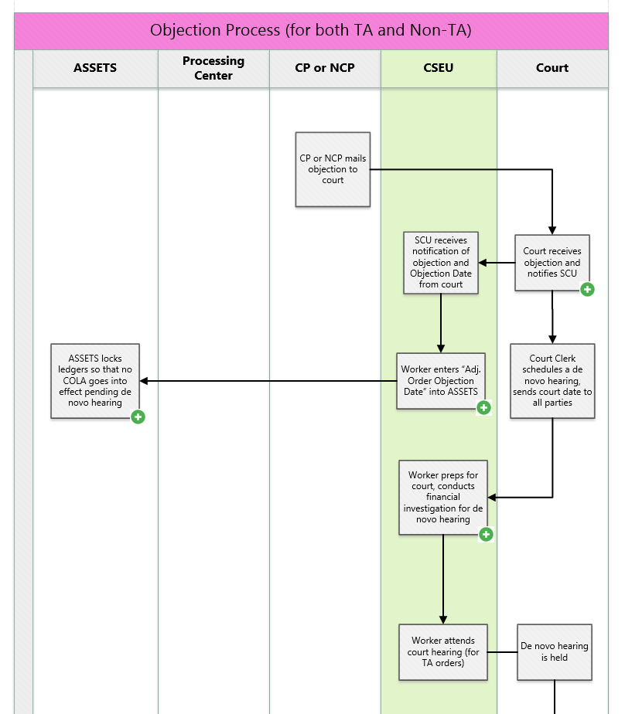

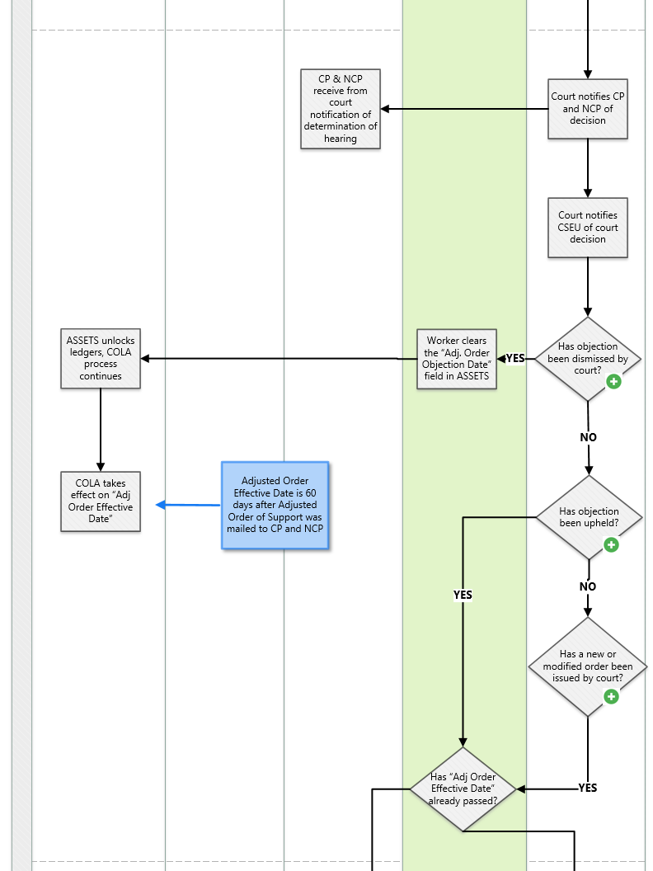

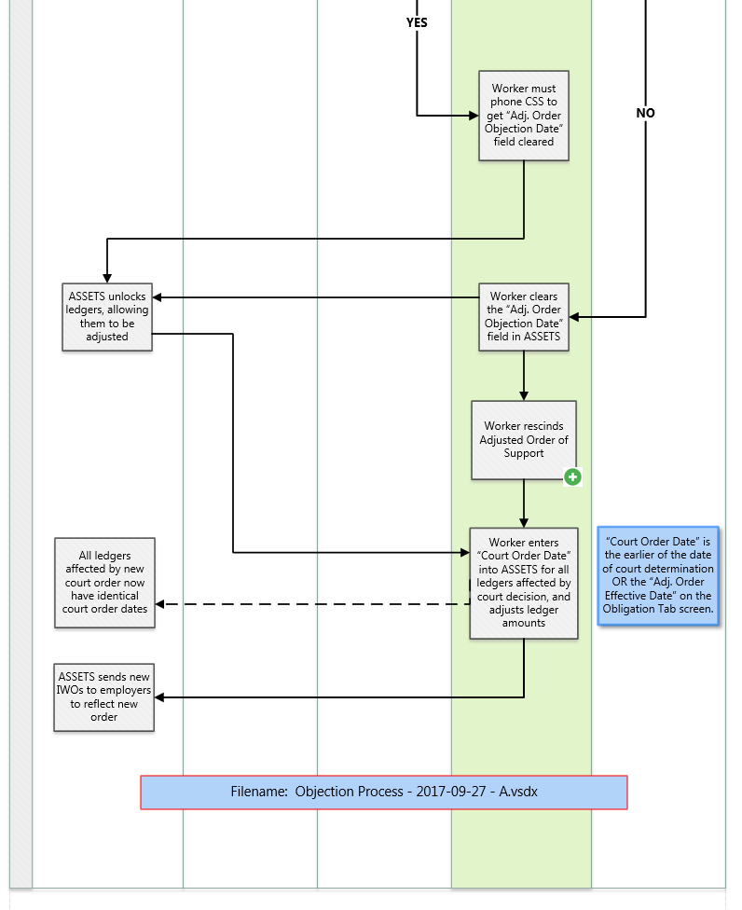

## Court receives objection and notifies the SCU

The court receives the objection from the CP or NCP.

The Court Clerk sends notification of the objection to the SCU.

The notification will include the official Objection Date.

## Worker enters Adjusted Order Objection Date into ASSETS

The worker enters the objection date provided by the court into the Adj Order Objection Date field on the Cost of Living (COLA Information Edit screen.

(This is critical.  It locks the COLA-affected ledgers so that they cannot be adjusted and a COLA cannot be applied).

Entering any value into the Adj. Order Objection Date field has the following effects:

* + Ledgers are locked so that they cannot be adjusted and COLA cannot be applied to them
  + *CEJ* State field is locked so that it cannot be edited

(**Note:** Following determination of this matter in court, the Caseworker must *clear* the Adj Order Objection Date field (or, if necessary, contact CSS to request that it be unlocked), or else the ledgers and the CEJ State fields will remain locked.

## ASSETS locks ledgers so that no COLA goes into effect pending de novo hearing

ASSETS locks the ledgers so that no COLA can go into effect pending a decision at a hearing.

The ledgers will remain locked until the worker clears the Adj. Order Objection Date field is cleared.

## Worker prepares for court and conducts financial investigation

The worker conducts a financial investigation as would otherwise be undertaken in a case to establish an original support order, and provides the court with such financial information as is available on ASSETS.

## Worker rescinds "Adjusted Order of Support"

The worker rescinds the "[Adjusted Order of Support](http://otda.state.nyenet/assets/pages/PDFs/COLA/Adjusted_Order_of_Support.pdf)" by entering Code "R" (Rescind) in the *COLA* Request Indicator field on the Cost of Living Adjustment (COLA) Information Edit screen.

* 1. Go to the Obligation Tab screen (See screenshot below)
  2. Click on the "**Update COLA**" button in the bottom right of the screen
  3. The Cost of Living Adjustment (COLA) Information Edit screen appears (See screenshot below)
  4. Enter Code R (Rescind) in the COLA Request Indicator field

In ASSETS, go to:  Home > Module > Inquiry > [enter search criteria] > Name Search Results screen > [double click on: name of client/case > Parties to Action tab > [click on:] Obligation Tab > "Update COLA" button > Cost of Living Adjustment (COLA) Information Edit screen

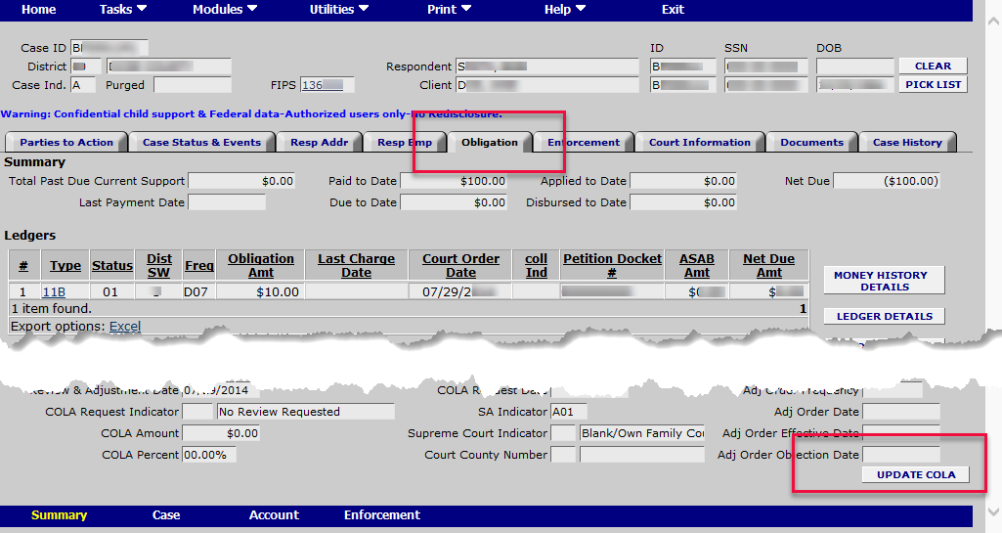

Clicking on the Update COLA button in the screen above brings you to the screen below. Use the dropdown menu under Updatable COLA Data Elements to select COLA Request Indicator, then select the desired code to enter into the COLA Request Indicator field.

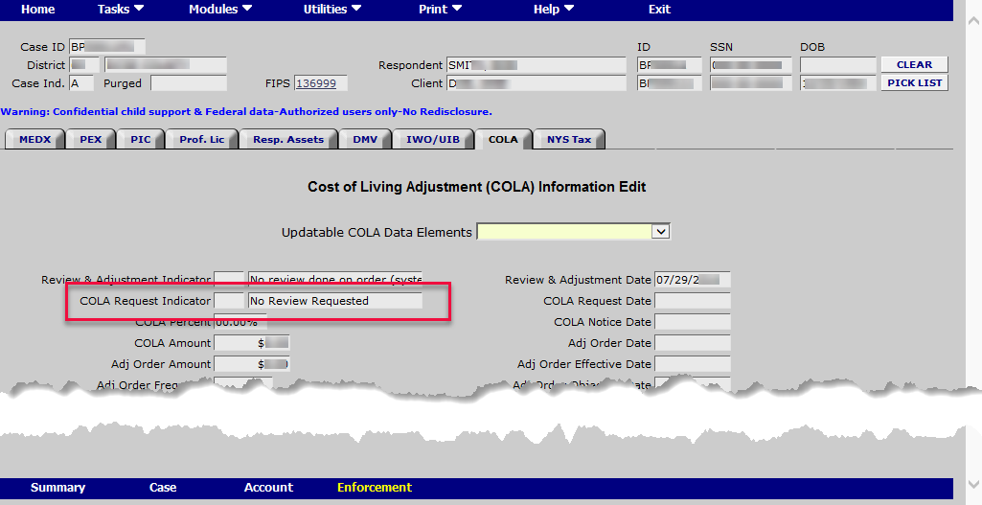

# Troubleshooting

Objection Date field is locked

If Adj. Order Effective Date passes while the Objection Date field is populated, the Worker will be unable to clear the Objection Date field – meaning they cannot edit the *CEJ* State field, and cannot adjust ledgers.

The worker will need to contact New York State Child Support Services to have the Objection Date field cleared and, consequently, the ledgers and CEJ State field unlocked.

CEJ State Field is Locked

The CEJ State field is locked if either one of these is true:

* + Objection Date field is populated, or
  + *COLA* Request Indicator field contains Code R

When the Objection Date field is populated:

* + ASSETS locks the affected ledgers so that they cannot be adjusted, and
  + ASSETS locks the CEJ State field.

 If the Adjusted Order Effective Date passes while the Objection Date field is populated, the Worker will be unable to clear the Objection Date field – meaning they cannot edit the CEJ State field, and cannot adjust ledgers. The worker will need to contact NYS Child Support Services to get the Objection Date field cleared and, consequently, ledgers and CEJ State field unlocked.

**Note:**  If an objection to a COLA has been filed with the court and the CSEU becomes aware that a state other than New York has continuing exclusive jurisdiction over the case, the worker will not be able to enter the code for the state holding continuing exclusive jurisdiction into the *CEJ* State field until the COLA order is withdrawn.

The worker can withdraw the COLA order by entering a code “W” in the COLA Request Indicator field on the Cost of Living Adjustment Information Edit screen). See section “[CEJ State field Is locked](#cola_troubleshooting_-_cola_cann_4055)."

Code "E" (Error) Appears in Review Adjustment Ind field

A Code E (Error) in the Review Adjustment Ind field will prevent the COLA process from moving forward.



The Code E indicates that two or more COLA-eligible ledgers on this account have conflicting dates in the Court Order Date fields (on the Obligation Tab screen).

The court order dates on all COLA-eligible ledgers must be identical, ***and*** they must match the date shown in the Review & Adjustment Date field.

Processing Center Receives an Unsigned Request for a COLA

For a request for a COLA to be entered into the system by the Processing Center, the [COLA Request Form](http://otda.state.nyenet/assets/pages/PDFs/COLA/Request_for_a_Cost_of_Living_Adjustment.pdf) must be signed by the requesting party.

If the COLA Request Form isn't signed, no request is entered into the system.

Instead, the Processing Center scans the unsigned COLA Request Form and sends a copy via ECS to the local SCU.

The SCU will reach out to the party in question in order to obtain the necessary signature.

# Glossary

0

03 ADM 05: Notice Regarding Child Support Requirements for Victims of Domestic Violence.

1

10-ADM-02: ADM entitled "Legal Services and Cost Recovery for Recipients of Child Support Services." The ADM was issued on March 23, 2010,

17 ADM 05: ADM with subject line "Background Investigations of Employees with Access to Federal Tax Information," dated September 26, 2017.

4

4-3b: Family Court Form 4-3b , Addendum to Support Petition -- Request for Child Support (IV-D) Services. This form was described in a DCL dated March 7, 2016 -- though it was actually released by the OCA on 12-10-2015. The form is for courtroom use only.

43B: Form 43B is a court form. (?MT-- NEED CLARIFICATION. FORM MAY BE A PETITION OR AN ADDENDUM. NEED A COPY??

9

98 ADM-14: Administrative Directive 98-ADM-14. This directive outlined procedures for COLA.

A

ACA: Affordable Care Act.

ACF: Administration for Children and Families

Acknowledgement of Paternity: This is a written instrument authorized by the social services Law and Public Health Law wherreby a person admits that he is the biological father of a particular child born out of wedlock.

ACS: Account Creation Summary. The ACS is an ASSETS-generated Family Court report. It can provide info including the parties' and children's names, addresses, SSNs, DOBs, employment statuses, name of NCP's employer, custodian data, TA status, medical insurance, and support orders payable through the CSEU. The ACS can be retrieved via the UCMS (Universal Case Management System), or through ASSETS Summary mode, Court Information tab.

Acuerdo Sobre Derechos de Recuperacion de Pagos por Servicios Legales: LDSS-4920SP. Spanish-language version of Right to Recovery Agreement for Legal Services"

addendum: An addendum is a court document. It reflects changes to an order made on-the-fly during a hearing. A request for child support services may be contained in an addendum, a petition, or a motion, but must be signed by the requesting party.

Addendum to Support Petition: Form 4-3b. This signed addendum serves as an official request for child support services.

additional amount: A system-calculated administrative amount added to the current obligation amount in an Income Withholding Order (IWO) to reduce past-due support.

Address Confidentiality Affidavit: Family Court General Form 21 (GF-21). http://www.nycourts.gov/forms/familycourt/pdfs/gf-21.pdf

Address Information Request form: Formerly known as a "Postal Clearance Letter." See a sample at: http://otda.state.nyenet/assets/pages/PDFs/Location/Address\_Information\_Request.pdf

adjusted annual income: An individual's annual gross income minus specific deductions.

administrative enforcement: Methods to enforce a support order without a court's involvement. Administrative enforcement methods include driver's license suspension, tax refund intercept, passport denial, and others.

affidavit: A written statement, usually notarized, that is signed under oath or by affirmation.

Affidavit of Service: A sworn statement that certifies the delivery of a summons, notice, or order to a person by stating the time and manner in which the papework was given to the party.

AOP: Acknowledgement of Paternity. A legal process through which paternity -- or legal fatherhood -- can be established. A paternity acknowledgment involves the legal establishment of fatherhood for a child through a voluntary acknowledgment signed by both parents as part of an in-hospital or other acknowledgement service.

AP: Absent Parent. This term is used in some districts to denote the NCP.

appeal: A formal legal process requesting that a higher court review a lower court's decision.

APRRS: Absent Parent Resource Reporting System

ASCU: Automated Support Collection Unit.

ASSETS: Automated State Support Enforcement and Tracking System (ASSETS).

Assignment of Support Rights: The legal procedure by which a person receiving public assistance agrees to turn over to the state or tribe any right to child support, including arrearages, paid by the noncustodial parent in exchange for receipt of a cash assistance grant and other benefits. States and tribes can then use a portion of said child support to defray or recoup the public assistance expenditure.

Atestiguación de Falta de Información.: Form LDSS-4281S -- Spanish-language version of "Attestation to Lack of Information"

Attestation to Lack of Information: LDSS-4281. A form used to affirm that a Temporary Assistance applicant or recipient has tried to find out but does not know the putative father’s name, address, Social Security number, telephone number, date of birth, employer’s name and location, or other information that might help locate the putative father. The Spanish-language version of it is LDSS-4281S. They are both available on ERS.

B

batch: A list of financial transactions to be entered or processed. Transactions may move money from one ledger to another within a single account or from one account to another account. All financial transactions are identified and recorded through batch type.

batch type: A two-digit system code (e.g., 54, 61, 75) used in ASSETS to identify and record financial transactions.

BEDS: Back End Detection System.

BICS:

Birth Certificate: Having the father's name on the birth certificate does not constitute proof of paternity and is not a legal indicator of paternity for a child born out of wedlock. It is a legal indicator of paternity for a child born during a marriage.

C

CAN: A CAN number is a CASE NUMBER pertaining to a specific child support CASE. An individual person may have multiple CAN numbers. This is different from a CIN number, which identifies an individual person and can span serveral services under the umbrella of social services. (See glossary entry for CIN number.)

CANs Without CINs Report:

CCPA: Consumer Credit Protection Act. Federal law that limits the amount that may be withheld from earnings to satisfy child support obligations and other garnishments. In New York, the maximum ranges from 50% to 65%, depending on whether the obligor is single and owes arrears for more than 12 weeks.

CEJ: Continuing Exclusive Jurisdiction.

CEJ State: CEJ = Continuing Exclusive Jurisdiction. The CEJ State is the state that has continuing exclusive jurisdiction over this case. If this field in ASSETS is populated, it means that this is an out-of-state case. In other words, it is in our ASSETS system -- and the New York State system -- only for purposes of enforcement.

change in circumstances: A change, usually substantial, in the emotional, financial, or physical condition of one or both parents justifying a modification of a child custody or child support order. http://www.nycourts.gov/courts/7jd/courts/family/Definitions.pdf

Child Support Recovery Act: (CSRA) This Act makes it a federal crime to willfully fail to pay a past-due child support obligation for a child living in another state. The past-due obligation must be either greater than $5,000 or must have remained unpaid for more than one year.

Child Support Standards Act: (CSSA) Family Court Act 413 and Domestic Relations Law 240 Section 1-b, the law that governs child support in New York. Known as the CSSA or simply "the guidelines," it defines a basic child support obligation by percentages of income, i.e., 17% of combined parental income for one child, 25% for two children, 29% for three children, 31% for four children, and no less than 35% for five or more children The law that determines the amount of child support to be paid.

CHIP: Children's Health Insurance Program.

CIN number: Client Identification Number. A CIN number identifies an individual person and spans various services under the umbrella of social services. For example, if a person is receiving TA (temporary assistance), SNAP (food assistance), and Child Support, all of these fall under a single CIN number identifying the person receiving these services. \* An individual CIN (person) may have multiple CAN numbers pertaining to individual services.

CJS:

Client-in-Court letter:

CMU: Case Management Unit.

COLA: Cost-of-Living Adjustment, sometimes called a Cost-of-Living Allowance.

COLA Notice: A notice informing CP and NCP that their support order is eligible to request a COLA and that if they wish to pursue a COLA, they must request one. A request form is enclosed with the COLA Notice.

COLD: Computer Output to Laser Disc.

collection on arrears: Collections on Arrears. This is one of five important performance measures (or KPIs -- Key Performance Indicators). The five are: 1) PEP (Paternity Establishment Percentage); 2) SEP (Support Establishment Percentage); 3) Collections on Current; 4) Collections on Arrears; and 5) Cost Effectiveness.

collections on current: Collections on Current. This is one of five important performance measures (or KPIs -- Key Performance Indicators). The five are: 1) PEP (Paternity Establishment Percentage); 2) SEP (Support Establishment Percentage); 3) Collections on Current; 4) Collections on Arrears; and 5) Cost Effectiveness.

combined parental income amount:

Conduent:

Consumer Credit Protection Act: (CCPA) Federal law that limits the amount that may be withheld from earnings to satisfy child support obligations and other garnishments. In New York, the maximum ranges from 50% to 65%, depending on whether the obligor is single and owes arrears for more than 12 weeks.

Consumer Credit Protection Act (CCPA): Federal law that limits the amount that may be withheld from earnings to satisfy child support obligations and other garnishments. State or tribal law may further limit the amount that can be withheld from a person's paycheck.

Continuation of Services letter: In a TA case, when the client is no longer active on TA, the CSEU (Processing Center?) sends a letter to the CP (and NCP?) indicating that child support services will continue unabated unless the CP requests otherwise.

controlling order: The one order that must be used by all states and tribes for enforcement and modification actions going forward. In cases involving multiple orders issued prior to the enactment of UIFSA, UIFSA provides rules for determining the controlling order, the one order to be prospectively enforced. UIFSA does not apply to tribes.

cooperation: The custodial parent’s willingness to provide information sufficient to identify and locate the absent parent or putative father. May also include willingness to appear in court or at other hearings….Willingness is different from, and should not be confused with, lack of information or fear of harm, violence, or retaliation from the noncustodial parent.

cost effectiveness: Cost Effectiveness of the SCU. This is one of five important performance measures (or KPIs -- Key Performance Indicators). The five are: 1) PEP (Paternity Establishment Percentage); 2) SEP (Support Establishment Percentage); 3) Collections on Current; 4) Collections on Arrears; and 5) Cost Effectiveness.

court-based enforcement: Methods to enforce a support order that require a court’s involvement. Professional and recreational license suspension require a court hearing.

CP: Custodial Parent or Custodial Party. This is the parent with whom the child is living. However, the "Custodial Parent" could be a guardian such as a grandparent, foster home, or other person or entity with whom the child is living, and who is taking care of the child.

CPI-U: The Consumer Price Index for All Urban Consumers (CPI-U) is a measure of the average change over time in the prices paid by urban consumers for a market basket of consumer goods and services. The figure is released by the U.S. Bureau of Labor Statistics.

CPPA:

CPS: Child Protective Services. http://ocfs.ny.gov/main/cps/

credit reporting agency process: The process of reporting to credit agencies the name of the parent who owes past-due child support, and the amount of the delinquency.

CSE: Child Support Enforcement

CSENET: Child Support Enforcement Network. CSENET is a data exchange among states for purposes of location and case establishment.

CSEU: Child Support Enforcement Unit

CSH: Customer Service HelpLine

CSMS: Child Support Management System (CSMS). An automated case management system. The CSMS system is accessed through the interface known as ASSETS.

CSR: Customer Service Representative.

CSRA: Child Support Recovery Act (1992). This Act makes it a federal crime to willfully fail to pay a past-due child support obligation for a child living in another state. The past-due obligation must be either greater than $5,000 or must have remained unpaid for more than one year.

CSS: Child Support Services.

CSSA: Child Support Standards Act, enacted 15 September 1989. Family Court Act 413 and Domestic Relations Law 240 Section 1-b, the law that governs child support in New York. Known as the CSSA, or simply "the guidelines," it defines a basic child support obligation by percentages of income, i.e., 17% of combined parental income for one child, 25% for two children, 29% for three children, 31% for four children, and no less than 35% for five or more children The law that determines the amount of child support to be paid.

Current Assistance IV-D Case: A case where the children are: (1) recipients of Temporary Assistance for Needy Families (TANF) under Title IV-A of the Social Security Act or (2) entitled to Foster Care maintenance payments under Title IV-E of the Social Security Act. In addition, the children’s support rights have been assigned by a caretaker relative to a state or tribe, and a referral to the state or tribal child support agency has been made.

custody: A court's determination of which parent or other appropriate party should have physical and/or legal control and responsibility for a minor child.

D

DCL: Dear Collegue Letter. A letter sent ou to those in the child support community and interested partners that conveys information on child support program activities.

DCSE:

de novo: "de novo" is a Latin expression meaning "afresh", "anew", "beginning again," hence the literal meaning "new hearing," as if the matter had not been previously heard or decided. A de novo hearing is functionally equivalent to an original support establishment hearing. "De novo" is used to refer to a hearing or trial which starts over, which wipes the slate clean and begins all over again, as if any previous partial or complete hearing had not occurred.

Deadbeat Parents Punishment Act of 1998: DPPA. A federal law that imposes criminal penalties on parents who repeatedly fail to support children living in another state or who flee across state lines to avoid supporting them; the Deadbeat Parents Punishment Act established felony violations for the willful failure to pay legal child support obligations in interstate cases.

Delinquecy Switch 09: Delinquency Switch "09" indicates that an IWO has been sent out to an employer for a case, but no payments have been received from that employer in the past 45 days.

Delinquency Switch 11: This code signifies that the CSEU has received only partial payments as of the previous month.

delinquency switch codes: Delinquency switch codes track IWOs and the status of the payments attached to them. Delinquency switch codes are two-digit codes.

distribution: The allocation of child support collected to the various types of debt (e.g., monthly support obligations, arrears, ordered arrears) within a child support case as specified in 45 CFR 302.51 (45 CFR 309.115 for procedures governing tribal child support programs); the process of how the total child support payment amount is divided between all those owed under the support orders, including reimbursement for public assistance.

DNA: DNA or deoxyribonucleic acid.

DOB: Date of Birth.

DOD: Department of Defense.

Domestic Violence Liaison: (DVL) An employee specially trained in assessing client claims of domestic violence, granting waivers from Temporary Assistance requirements, and referring clients to needed services.

DPPA: Deadbeat Parents Punishment Act of 1998. A federal law that imposes criminal penalties on parents who repeatedly fail to support children living in another state or who flee across state lines to avoid supporting them; the Deadbeat Parents Punishment Act established felony violations for the willful failure to pay legal child support obligations in interstate cases.

driver's privilege suspension: The enforcement process by which an NCP who fails to pay child support as ordered may have his or her driver's license suspended.

DRL: Domestic Relations Law (DRL). New York State laws used for divorce and other marriage-related actions and proceedings.

DSS: Department of Social Services

DSS-2860: Form DSS-2860 is obsolete. It was replaced by the LDSS-4882 form.

DSS-2860 (form): Child Support Enforcement Referral

DSS-3570 (form): WMS Certification Guide

DSS-Net: NEED DEFINITION

DUCC: Dynamic User-Centric Content

due process: The principle of fairness in legal proceedings so that a person has a right to know what action is being taken and has an opportunity to be heard.

DV: Domestic Violence.

DVL: Domestic Violence Liaison.

E

E-IWO: Electronic Income Withholding Order.

ECS: Electronic Communications System, used for communications between the Processing Center and local SCUs.

EDE: Electronic Document Exchange. Documents from other states come through the EDE. As of Aug 2017, only about 20 states use this system.

EDI: Electronic Data Interchange

EFT: Electronic Funds Transfer.

ERD: Earliest Release Date (from incarceration).

ERS: Electronic Resource System (ERS). ERS is an intranet website maintained by NYS Child Support Services specifically for the use of local and state staff of NY’s child support program. The site provides access to online policy and program information to assist staff with their responsibilities.

ex-parte communication: A motion, application, requrest, submission, etc., made by one party without including notice to the other party. (http://www.nycourts.gov/courts/7jd/courts/family/Definitions.pdf)

exclusive jurisdiction: The provision, made in the U.S. Constitution, in legislation, or in a contract, that a particular court is the only forum in which a certain type of case may be brought.

F

FA: Family Assistance

family court: Family Court hears cases involving adoption, child abuse and neglect, foster care approval and review, guardianship, PINS (Persons in Need of Supervision), juvenile delinquency, child support, custody, visitation, spousal support and family offenses (Orders of Protection). Divorce actions are heard in Supreme Court.

Family Court Interface: When reported by the Family Court, information about the parties in a Family Court case can be accessed through the Family Court Interface, an ASSETS module that displays information from the Office of Court Administration’s Universal Case Management System (UCMS).

FAOP: Federal Administrative Offset Program. A program that intercepts cetain federal payments in order to collect past-due child support.

FBI: Federal Bureau of Investigations.

FC: Foster Care

FCA: Family Court Act (FCA).

FCI: Family Court Interface.

FCR: Federal Case Registry [of Child Support]. A national database of information on all people with IV-D cases and people with Non-IV-D orders that were entered or changed on or after October 1, 1998. The FCR receives this case information on a daily basis from the State Case REgistry located in each state, and proactively matches it with previous submissions to the FCR and with employment information contained in the National Directory of New Hires (NDNH). Any successful matches are returned to the appropriate state(s) for processing. The FCR and the NDNH are both part of the Federal Parent Locator Service maintained by OCSE.

Federal Admnistrative Offset Program: (FOAP) A program that intercepts cetain federal payments in order to collect past-due child support.

Federal Case Registry: Federal Case Registry [of Child Support]. A national database of information on all people with IV-D cases and people with Non-IV-D orders that were entered or changed on or after October 1, 1998. The FCR receives this case information on a daily basis from the State Case Registry located in each state, and proactively matches it with previous submissions to the FCR and with employment information contained in the National Directory of New Hires (NDNH). Any successful matches are returned to the appropriate state(s) for processing. The FCR and the NDNH are both part of the Federal Parent Locator Service maintained by OCSE.

Federal Financial Participation: FFP. The portion of a state's child support expenditures that are paid by a federal government match. Most child support costs are matched two to one. In other words, the federal share of most child support costs is 66 percent.

Federal Offset Program: FOP. The program that provides several enforcement tools to collect past-due chld suport from NCPs, including federal income tax refund and administrative offset, Passport Denial Program, MSFIDM, and Debt Check.

Federal Parent Locator Service: FPLS. A computerized, national location network operated by OCSE. The FPLS obtains address, employer information, and data on child support cases in every state, then compares the data and returns matches to the appropriate states. This helps state and local child support agencies locate NCPs and PFs for the purposes of establishing custody and visitation rights, establishing and enforcing child support obligations, investigating parental kidnapping, and processing adoption or foster care cases. The expanded FPLS includes the Federal Case Registry (FCR) and the National Directory of New Hires (NDNH).

Federal Tax Refund Offset Program: This program/process collects past-due child support amounts from NCPs through interception of their federal income tax refunds.

FEIN: Federal Employer Identification Number. This is a nine-digit number given to all employers by the Internal Revenue Service (IRS). It is used for collecting child support from a parent's paycheck.

FFCCSOA: Full Faith and Credit for Child Support Act.

FFP: Federal Financial Participation. The portion of a state's child support expenditures that are paid by a federal government match. Most child support costs are matched two to one. In other words, the federal share of most child support costs is 66 percent.

FIDM: Financial Institution Data Match.

file run: File Run, also known as a "job run."

FIPS code: Federal Information Processing Standard (FIPS) code. It uniquely identifies counties and county equivalents in the United States, certain U.S. territories or possessions, and certain freely associated states. In the ASSETS system, the code contains six digits. The first digit is either a "1" (meaning that funds collected are retained within the county is which they are collected) or a "2" (meaning that funds collected are disbursed in a county other than the one in which they are collected). The second and third digits denote the state, U.S. territory or possession. The last three digits denote the county within the state, U.S. territory, or possession. A FIPS code tells you who is enforcing the order. (The case may be from another state, for example.) The FIPS code also routes payments for intergovernmental cases and is used to determine eligibility for enforcement.

FOP: Federal Offset Program. This program provides several enforcement tools to collect past-due chld support from NCPs -- including federal income tax refund and administrative offset, Passport Denial Program, MSFIDM, and Debt Check.

Form OCSE-34: Child Support Enforcement Program Quarterly Collection Report.

Former Assistance IV-D Case: A case where the children formerly received Title IV-A (AFDC or TANF) or Title IV-E foster care.

FPLS: Federal Parent Locator Service (database). A computerized, national location network operated by OCSE. The FPLS obtains address, employer information, and data on child support cases in every state, then compares the data and returns matches to the appropriate states. This helps state and local child support agencies locate NCPs and PFs for the purposes of establishing custody and visitation rights, establishing and enforcing child support obligations, investigating parental kidnapping, and processing adoption or foster care cases. The expanded FPLS includes the Federal Case Registry (FCR) and the National Directory of New Hires (NDNH).

FRC: Foreign Reciprocating Country.

FSA: Family Support Act.

full waiver: If a DVL grants a TA applicant/recipient a "full waiver" of the requirement to cooperate with the child support program, all case and enforcement activity in child support must stop. A full waiver can be granted only by a Domestic Violence Liaison. The DVL will notify the CSEU of this status. (Compare to: "partial waiver.")

FVI: Family Violence Indicator. The FVI is a designation in the Federal Case Registry. It is placed on a participant in a case or order, and indicates that the participant is at risk of child abuse or domestic violence. The FVI is used to prevent disclosure of the location of a party or a child believed by the state or tribe to be at risk of family violence. The Federal Case Registry (FCR) uses this term to identify a person involved in a family violence case or order in another state.

FVO: Family Violence Option.

G

genetic testing: Analysis of inherited factors of the mother, child, and alleged father, which can help to prove or disprove that a particular man fathered a particular child.

GF-21 (form): Family Court form GF-21 is the Address Confidentiality Affidavit. http://www.nycourts.gov/forms/familycourt/pdfs/gf-21.pdf

GF-21a (form): Address Confidentiality Order. This is a NYS Family Court document.

good cause: A legal reason for which a Temporary Assistance for Needy Families (TANF) recipient is excused from cooperating with the child support enforcement process, such as past physical harm by the child’s noncustodial parent. It also includes situations where rape or incest resulted in the conception of the child and situations where the mother is considering placing the child for adoption.

gross income: The amount of money earned before taxes or other required deductions.

GSA: General Services Administration.

guardian: A person who is legally responsible for the c are and management of the person or property of a minor or incompetent person. (http://www.nycourts.gov/courts/7jd/courts/family/Definitions.pdf)

guardianship: Being appointed by a court to manage the affairs of a person incapable of acting for himself, as a minor or person of unsound mind.

Guidelines - Child Support: A standard method for setting child support obligations, using a mathematical formula and based on the income of one or both parent(s) and other factors determined by state or tribal law. The Family Support Act of 1988 requires states to use guidelines to determine the amount of support for each family, unless they are rebutted by a written finding that applying the guidelines would be inappropriate to the case.

H

Hearing Examiner: An attorney employed by the local Family Court who can hear and make decisions in child support cases.

HHS: Dept. of Health and Human Services.

HRA: Human Resources Administration.

I

I/EDR: Imaging Electronic Document Retrieval system? Imaging Enterprise Document Repository?

ICR: Interstate Case Registry.

iDHS: NEED DEFINITION

IEX: Income Execution Order. Also known as an Incoming Withholding Order (IWO).

IM: Informational Memorandum. A document that provides state and tribal child support enforcement agencies with information on program practices that can be useful to program improvement.

imputed income: Income that may be attributed to an individual who refuses to obtain employment, chooses not to work for personal reasons, or chooses to earn less than is typical for someone with the individual’s training, education and skill. An individual cannot be forced to work, but the court or decision-maker can attribute certain income levels to a person based on the person’s education or training, skill, and work history. Some states consider assets, for example, if the obligor is self-employed or owns real estate. This also may be the amount of income the court or administrator determines that an obligor is capable of earning if he or she does not appear at a hearing after proper service. Some will also attribute income to a custodial parent who chooses to remain unemployed.

income withholding: A process by which part of a person’s wages or assets are allocated for payment of a child support obligation.

Informational Memorandum: (IM) A document that provides state and tribal child support enforcement agencies with information on program practices that can be useful to program improvement.

initiating jurisdiction: The state, tribal or county court, or administrative agency that sends a request for action to another court or agency that can exercise legal authority against a party to an action. In cases where a state is trying to establish an initial child support order on behalf of a resident custodial parent and does not have Long-Arm Jurisdiction (cannot legally claim personal jurisdiction over a person who is not a resident), it must file a Two-State Action under the Uniform Interstate Family Support Act (UIFSA) guidelines. (Tribes are not subject to UIFSA.)

IRS: Internal Revenue Service.

ITIN: Individual Taxpayer Identification Number. The ITIN is a tax processing number issued by the Internal Revenue Service (IRS) that must begin with the number 9. For more information on the ITIN, refer to the "Dear Colleague" letter dated April 12, 2005 regarding the entering of ITINs

IV-A: Title IV-A of the Social Security Act pertains to Temporary Assistance for Needy Families (TANF); Temporary Assistance (TA), and Safety Net Assistance (SNA).

IV-A case: A case in which the state provides public assistance under the state’s IV-A program (which is funded under Title IV-A of the Social Security Act) where the child(ren) have been determined to be eligible for Temporary Assistance for Needy Families (TANF). The children’s support rights have been assigned to the state or tribe, and a referral to the child support agency has been made.

IV-D case: A case in which a state provides child support servcies as directed by the state or tribal child support program.

IV-D TANF: (Foster Care and Adoption Assistance) A case in which a state currently oprovides benefits or servicers for foster care maintenance to children entitled to foster care maintenance under the state's IV-E Program authorized under Title IV-E of the Social Security Act. These cases are also eligible for IV-D services.

IV-E Unit:

IWO: Income Withholding Order. Also known as "income execution" (IEX). A notice issued to an employer or income payor directing that child support be deducted from a noncustodial parent’s wages or other income and sent to the Support Collection Unit (SCU) to satisfy the noncustodial parent’s support obligation.

J

judgement:

judgment: A determination of the rights of the parties in an action or special proceeding. A judgment shall refer to and state the result of a verdict or decision, or recite the circumstances upon which it is based.

K

KPIs: Key Performance Indicators, also called "Performance Measures." There are five key KPIs in Child Support. They are are: 1) PEP (Paternity Establishment Percentage); 2) SEP (Support Establishment Percentage); 3) Collections on Current; 4) Collections on Arrears; and 5) Cost Effectiveness.

L

L Group:

LCM: Local Commissioners Memorandum. This is a type of policy document issued by the OTDA.

LD: Local district.

LDMIP:

LDSS-2521: This form no longer exists. It was replaced by form LDSS-4882 on May 1, 2012. This was announced in 12-ADM-03. (The LDSS-2521 was the "Application for Child Support Services.")

LDSS-2521S: This form no longer exists. It was replaced by form LDSS-4882 on May 1, 2012. This was announced in 12-ADM-03. (The LDSS-2521 was the Spanish language version of the "Application for Child Support Services.")

LDSS-2859: Information Transmittal Form. This form is used by child support, temporary assistance (TA), foster care (FC) and other programs to transmit case information. It is also used by Medicaid (MA) to receive child support information.

LDSS-2860: This form no longer exists. It was replaced by form LDSS-4882 on May 1, 2012. This was announced in 12-ADM-03. (The LDSS-2860 was a "Child Support Referral" form.)

LDSS-2921: "New York State Application for Certain Benefits and Services." This is the application form used by the TA Unit when people apply for TA services. You can view this form at: https://otda.ny.gov/programs/applications/2921.pdf

LDSS-3908: This form no longer exists. It was replaced by form LDSS-4882 on May 1, 2012. This was announced in 12-ADM-03. (The LDSS-3908 was the "Important Notice Regarding Child Support to Persons Applying for or Receiving Temporary Assistance or Foster Care Maintenance Payments under Title IV-E.")

LDSS-3908 SP: This form no longer exists. It was replaced by form LDSS-4882 on May 1, 2012. This was announced in 12-ADM-03. (The LDSS-3908 was the Spanish language version of the "Important Notice Regarding Child Support to Persons Applying for or Receiving Temporary Assistance or Foster Care Maintenance Payments under Title IV-E.")

LDSS-4281: Attestation to Lack of Information. This form is available on ERS.

LDSS-4281S: Atestiguación de Falta de Información. This is the Spanish version of the Attestation to Lack of Information. This form is available on ERS.

LDSS-4418: Acknowledgement of Paternity (form) For a Child born to an Unmarried Woman. https://otda.ny.gov/policy/directives/2014/INF/14-INF-01-Attachment-1.pdf

LDSS-4873: Domestic Violence Reassessment Checklist. http://otda.state.nyenet/ldss\_eforms/eforms/4873.pdf

LDSS-4882: "Information about Child Support Services and "Application/Referral for Child Support Services" intake form. (Form LDSS-4882)

LDSS-4882A: "Information About Child Support Services" intake form.

LDSS-4882B: "Information for an Additional Noncustodial Parent (NCP)/Putative Father (PF)" intake form

LDSS-4882C: "Information for an Additional Child" intake form.

LDSS-4920: Form LDSS-4920 is the "Right to Recovery Agreement for Legal Services." This must be completed by Non-TA applicants who are requesting legal assistance services. The form is available in Spanish, as well, as Form LDSS-4920SP.

LDSS-4920SP: Form LDSS-4920SP is the Spanish language version of form LDSS-4920, the "Right to Recovery Agreement for Legal Services." This must be completed by Non-TA applicants who are requesting legal assistance services. The form is available in English as form LDSS-4920.

LDSS-5088: IV-D Payment (Pass-Through) Mass Reauthorization (MRB/A) form.

LDSS-5108: Form: "Request to Change Name Pursuant to 18 NYCRR § 347.3" -- This form was introduced in 17-ADM-07 on September 13, 2017.

ledger: An ASSETS subaccount that identifies a support obligation, including the payee (client, DSS, or other party) and the type of support obligation (e.g., current child support, past-due support, confinement costs, child-care expenses). May also refer to the alphanumeric code that identifies the ledger, e.g., 11BV.

legal father: A man who is recognized by law as the male parent of a child.

LEP: Limited English Proficiency.

Long-Arm Jurisdiction: Legal provision that permits one state or tribe to claim personal jurisdiction over someone who lives in another state or tribe. There must be some meaningful connection between the person and the state, tribe or district that is asserting jurisdiction in order for a court or agency to reach beyond its normal jurisdictional border. Also called Extended Personal Jurisdiction.

lottery prize intercept: The process through which an NCP's lottery prize winnings (if over $600) are applied to satisfy past-due child support obligations.

low income obligation: When the NCP's income is determined by the court to be at or below the federal poverty level for a single person, the presumptive support amount is $25 per month. When income is at or below the self-support reserve (135% of the federal poverty level), but above the federal poverty level, the presumptive support amount is $50 per month.

M

MAMI: Multicultural Association of Medical Interpreters. (area code??) 214-5003

MAO: Medical Assistance Only.

MDO: Modified Downward Order.

medical support: Any medical, dental, optical, prescription drug, health care services, or other health care benefits made available to a child. Medical coverage provided for a child or children pursuant to an order. This includes: (1) private health insurance, (2) publicly-funded health coverage if a parent is ordered by a court or administrative process to provide cash medical support payments to help pay the cost of Medicaid or Children’s Health Insurance Program (CHIP), (3) cash medical support, including payment of health insurance premiums, and (4) payment of medical bills (including dental or eye care). Medical support may be provided by the custodial parent, noncustodial parent or another person, such as a stepparent.

modification: A formal written application to a court requesting a change in an existing child support order. For a court to grant a modification in the amount of a child support order, the petitioner for the modification must prove a significant and unforeseen change in circumstances (e.g. laid off from job, child has developed an unforeseen medical condition, etc)

motion: A formal request made to a judge for an order or judgment. Motions are made in court all the time for many purposes: to continue (postpone) a trial to a later date, to get a modification of an order, for temporary child support, for a judgment, for dismissal of the opposing party's case, for a rehearing, for sanctions (payment of the moving party's costs or attorney's fees), or for dozens of other purposes. Most motions require a written petition, a written brief of legal reasons for granting the motion (often called "points and authorities"), written notice to the attorney for the opposing party and a hearing before a judge. However, during a trial or a hearing, an oral motion may be permitted. (http://www.nycourts.gov/courts/7jd/courts/family/Definitions.pdf)

MSFI: Multi-State Financial Institution. A financial institution that conducsts business in more than one state.

MSFIDM: Multi-State Financial Institution Data Match. A program that allows child support agencies a means of locating financial assets of individuals owing child support.

MSO: Monthly Support Obligation.

multistate employer: An employer that conducts business in two or more states. As with single-state employers, multistate employers are required by law to report all new hires to the State Directory of New Hires (SDNH) operated by their state government. However, unlike single-state employers, a multistate employer may report all of their new hires to the SDNH of only one state in which they do business rather than to each of them.

N

NACHA: National Automated Clearing House Association. The association that establishes the standards, rules, and procedures that enable financial institutions to exchange payments on a national basis. The Electronic Funds Transfer and the child support Electronic Data Interchange formats are established by NACHA.

National Directory of New Hires: (NDNH) A national database containing new hire and quarterly wage data from every State Directory of New Hires and federal agency, and Unemployment Insurance data from State Workforce Agencies. OCSE maintains the NDNH as part of the expanded Federal Parent Locator Service. (Tribes can choose to obtain access to the NDNH by agreements with a state.) The NDHH was established by the Personal Responsibility and Work Opportunity Reconciliation Act of 1996 (PRWORA).

NCP: Non-Custodial Parent. Sometimes called the "absent parent."

NCSL: National Conference of State Legislatures.

NDNH: National Directory of New Hires. A national database containing new hire and quarterly wage data from every State Directory of New Hires and federal agency, and Unemployment Insurance data from State Workforce Agencies. OCSE maintains the NDNH as part of the expanded Federal Parent Locator Service. (Tribes can choose to obtain access to the NDNH by agreements with a state.)

never assistance case: A case in which the customer has never been a receipient of temporary assistance.

Never Assistance IV-D Case: A case where the children are receiving services under the Title IV-D program, but are not currently determined to be eligible for and have not previously received assistance under Titles IV-A or IV-E of the Social Security Act. This classification includes cases where the family is receiving child support services as a result of a written application for IV-D services, including cases where the children are receiving state (not Title IV-E) foster care services, or a case in which they are Medicaid recipients not receiving additional assistance. Tribal and international cases are considered never assistance cases if the case status is unknown.

new hire reporting: Program under which employers submit data on a new employee within 20 days of hire to the State Directory of New Hires in the state where they do business. Minimum data required includes the employee’s name, address, and Social Security number, and the employer’s name, address, and Federal Employer Identification Number. Some states request additional data. A multistate employer has the option of reporting all new hires to a single state in which they do business. The data is then submitted to the National Directory of New Hires (NDNH) and compared against child support order information contained in the Federal Case Registry for possible enforcement of child support obligations by wage garnishment. New hire data may also be used at the state level by other agencies to detect fraud; for example, to find new hires that have been receiving unemployment insurance or other public benefits for which they may no longer be eligible. Federal agencies report new hire data directly to the NDNH. (Tribal programs can have access to NDNH data by agreement with a state.)

New York Civil Practice Law and Rules: The bound book containing the "New York Civil Practice Law and Rules" is often referred to simply as "the red book" or "the Redbook" (the cover is red).

New York Family Law Statutes: The bound book of "New York Family Law Statutes" is often referred to as "the yellow book" (the cover is yellow).

New York State Application for Certain Benefits and Services: LDSS-2921. This is the application form for TA services. The form is used by the TA Unit.

New York State Unified Court System: Family Court forms pertaining to child support are available at http://www.nycourts.gov/forms/familycourt/childsupport.shtml

NHR: New Hire Reporting (database), used for locating an NCP.

NMSN: National Medical Support Notice.

Non-IV-D case: A case where the order is entered into privately and the CSEU is not providing location, enforcement, or collection services. These cases are often entered into during divorce proceedings. Non-IV-D cases are for payment processing only. A Non-IV-D Order is one in which the state is not currently providing services under the state's Title IV-A, Title IV-D, Title IV-E, or Title XIX program.

Non-IV-E Foster Care: In IV-E Foster Care cases are reimbursed by federal funding by up to 60%. Conversely, Non-IV-E Foster Care cases receive no federal funding, and are funded at the local level.

Non-TA: Non-Temporary Assistance

normalized: Normalizing ledgers of different frequencies means breaking the various payment frequency cycles into their lowest common denominator to arrive at a common payment frequency. This is for purposes of applying percentage increases and making other calculations across disparate ledgers. It is a mechanism for "comparing apples to apples" when talking about disparate frequencies of payment.

Notice of Motion: A documentat telling the court and the opposing party when a motion will be heard. It will detail what is being asked for, and why.

Notice of Petition: This is a document telling the opposition party when and where the court will hear a case. It is served along with the petition.

Notification of Order of Filiation:

NPA: Non-Public Assistance.

NPRC: National Personnel Records Center.

NPRM: Notice of Proposed Rule-Making.

NQW:

NYS: New York State.

O

objection: A written request that a Judge review a decision of a Support Magistrate.

obligation frequency: How often the child support is to be paid: usually weekly, bi-weekly, semimonthly, or monthly.

Obligee: The person, state, tribal agency or other entity to which child support is owed.

obligor: The person obligated to pay chid support (also referred to as the NCP).

OBO: "on behalf of" - For example, in a Non-TA case, the petitioner may be the CP, or it may be the CSEU on behalf of the customer.

OCA: Office of Court Administration (OCA).

OCFS: Office of Children and Family Services.

OCSE: [Federal] Office of Child Support Enforcement

ongoing order: A TA client can file for an "ongoing order" -- which means that they still want to pursue a child support order even if or when they are no longer receiving TA or MA (and therefore are no longer required to cooperate with the child support program).

OOF: Order of Filiation.

OOS: Out of State.

OPDV: (NYS) Office for the Prevention of Domestic Violence. http://www.opdv.ny.gov/index.html

OPM: Office of Personnel Management.

oral/written notice: New York State law requires that you provide both parties with oral and written notice regarding the rights, responsibilities, consequences, and alternatives to signing the New York State Acknowledgment of Paternity form (LDSS-4418). Oral notice can be provided through an audio or video presentation (including the CSS Signing the Acknowledgment of Paternity Form video); the AOP document itself can satisfy the written notice requirement.

Order of Filiation: An Order of Filiation. An order establishing the paternity of a child or unborn child born out of wedlock issued by a court. This order establishes the child’s legal right to support and inheritance from the biological father, as well as the father’s right to seek custody and visitation. (http://www.nycourts.gov/courts/7jd/courts/family/Definitions.pdf)

Order of Support: An order directing payments of child support, spousal (husband or wife) support, or both.

OSC: FCR

OTDA: Office of Temporary and Disability Assistance.

overage status tab: A tab found in ASSETS Worker Alerts Management mode that lists all status and reason codes that have exceeded their “aging parameter” (or timeframe for the activity, in months). This tab can be used to review and take action on cases with open statuses that have reached or are about to reach the end of their aging parameter. This information appears on the COLD Weekly Aging Report. ASSETS updates this tab weekly.

P

PA: Public Assistance. This is an old term for what is now called "Temporary Assistance."

padre sin custodia: NCP. Absent Parent.

Parent Locator Service: (PLS)

partial waiver: If a DVL grants a TA applicant/recipient a "partial waiver" of the requirement to cooperate with the child support program, the CSEU may proceed with a child support case, but with certain precautions (such as suppressing the CP's address on petitions). A partial waiver can be granted only by a Domestic Violence Liaison. The DVL will notify the CSEU of this status. (Compare to: "partial waiver.")

pass-through payment: In TA or MA cases, the first UP TO $100 (for one child) or UP TO $200 (for two children) colllected each month is sent directly to the CP. This is called a "pass-through" payment.

PCL: Postal Clearance Letter. The Postal Clearance is now called the "Address Information Request" form. Sample: http://otda.state.nyenet/assets/pages/PDFs/Location/Address\_Information\_Request.pdf

PCL file: Processing Center File -- a file sent from the Processing Center to ASSETS.

PDCL:

PEP: Paternity Establishment Percentage. Calculated by number of paternities established divided by the number of children born out-of-wedlock. This is one of five important performance measures (or KPIs -- Key Performance Indicators). The five performance measures are: 1) PEP (Paternity Establishment Percentage); 2) SEP (Support Establishment Percentage); 3) Collections on Current; 4) Collections on Arrears; and 5) Cost Effectiveness.

Personal Information Letter: Is this the same as the Personal Information Form? (NYS Family Court tab, in the Document Generation utility.

personal values: Concepts or beliefs about what is correct, fair, important, or admirable. Honesty, compassion, friendliness, and privacy may all be personal values. “A person’s principles or standards of behavior” Oxford Dictionaries: https://en.oxforddictionaries.com/definition/value

petition: A petition is a court document reflecting a request made prior to a hearing. A petition may be attached to a court order.

Petition for Paternity Establishment:

petitioner: The person or agency that initiates a case by filing a petition. Known as the "plaintiff" in courts other than Family Court.

PEX: Property Execution, i.e. the seizure of property.

PF: Putative Father. This is a person who is presumed to be the father of a child, though there may not yet be hard evidence to support that presumption.

PFR: Putative Father Registry. It contains Orders of Filiation and Acknowledgements of Paternity.

physical residence: The place where a person lives.

PINS: Persons In Need of Supervision.

PIQ: Policy Interpretation Question. An official reply from the federal Office of Child Support Enforcement to an inquiry submitted by a state or tribal child support agency concerning application of policy.

plaintiff: The person, state, or tribal agency initiating a petition or motion.

PLS: Parent Locator Service.

POFR:

Postal Clearance Letter: The Postal Clearance Letter is now called the "Address Information Request" form. See a sample: http://otda.state.nyenet/assets/pages/PDFs/Location/Address\_Information\_Request.pdf

PPD: Passport Denial Program. A program that works with the Secretary of State in denying passports to any person certified as owing a child support debt greater than $2,500.

private case: Among child support workers, a "private case" is understood to mean a Non-TA case. In a private case, the customer is not mandated or required to cooperate with the child support program, but rather is applying for services of their own accord.

pro se: When a party represents himself in a legal matter, rather than being represented by a lawyer.

Proc. Ctr.: Processing Center

process server: A process server is a person authorized by law or by a court to formally deliver process such as summonses, complaints, subpoenas, writs and other court to a defendant or respondent.

Processing Center: Centralized location where payment processing, notice generation, the Child Support Helpline (call center) and other important functions of the child support program are completed.

professional behaviors: Actions or practices appropriate for or expected in the workplace.

property execution: (PEX) Procedure through which a noncustodial parent’s financial assets may be frozen and seized in order to satisfy child support arrears.

PRWORA: The Personal Responsibility and Work Opportunity and Reconciliation Act of 1996, also known as "welfare reform." It had many important implications for child support services. See section in manual regarding "1996: The Personal Responsibility and Work Opportunity and Reconciliation Act of 1996 (PRWORA)"

putative father: The person alleged to be the father of the child, but who has not yet been medically or legally declared to be the father.

Putative Father Registry: PFR. It contains Orders of Filiation and Acknowledgements of Paternity.

Q

quarterly wage data: (QW Data) Data on all employees that must be submitted by employers on a quarterly basis to the State Workforce Agency in the state in which they operate. The data is then submitted to the National Directory of New Hires (NDNH). Minimum information must include the employee’s name, address, Social Security number, wage amount, and the reporting period, and the employer’s name, address, and Federal Employer Identification Number (FEIN). The data is then compared against child support order information contained in the Federal Case Registry (FCR) for possible enforcement of child support obligations by wage garnishment. Federal agencies report the data directly to the NDNH.

QUICK: QUery Interstate Cases for Kids (QUICK) is a tool that can provide information on many of the child support cases in the country.

QW: Quarterly Wage.

QW data: Quarterly Wage (QW) Data. Data on all employees that must be submitted by employers on a quarterly basis to the State Workforce Agency in the state in which they operate. The data is then submitted to the National Directory of New Hires (NDNH). Minimum information must include the employee’s name, address, Social Security number, wage amount, and the reporting period, and the employer’s name, address, and Federal Employer Identification Number (FEIN). The data are then compared against child support order information contained in the Federal Case Registry (FCR) for possible enforcement of child support obligations by wage garnishment. Federal agencies report the data directly to the NDNH.

R

Reason Code: Reason Codes are distict-specific, and set by supervisors within each district. Reason Codes are attached to Ticklers, and provide a reason for the tickler itself. When the reason for the tickler is not or cannot be stated sufficiently by a Reason Code, the worker should instead (or supplementally) enter remarks to state the reason for the tickler.

Reciprocity: The process by which one jurisdiction grants certain privileges to another jurisdiction on the condition that it receives the same privileges.

Redbook: Often referred to simply as "the red book," this is the bound book of "New York Civil Practice Law and Rules."

referral: A request sent to a CSEU from another jurisdiction or a non-IV-D agent or agency asking that a child support order be established.

referral clients: The following types of cases are commonly called "referrals": TA, MA, IV-E Foster Care, Non-IV-E Foster Care

referred collection: A collection applied to an account built for a custodial parent’s new county (or state) of residence. When a custodial parent moves from the New York county where the order was first established, a referred account is built.

rescind: Revoke, cancel, or repeal (a law, order, or agreement).

residence: A place in which a person lives with or without an intention to make it a permanent home.

Respondent: The person or agency against whom a petition if filed, and who responds to the petition. (The respondent is known as the “defendant” in other types of courts.) (http://www.nycourts.gov/courts/7jd/courts/family/Definitions.pdf)

retained collection: A collection applied to an account in the county where the child support order was originally issued.

ROS: Recipient of Services. This may be a CP receiving child support services, or it may be an NCP receiving paternity establishment services or other services. In some cases, both CP and NCP may be receiving services.

S

Safety Net Assistance: In a TA referral case, if a customer does not meet the requirement to cooperate with the CSEU, the TA may issue the TA benefits, but with sanctions -- meaning, with a 25% reduction in TA benefits.

sanctions (imposed on TA assistance):

SCR: State Case Registry (of Child Support Orders). A database maintained by each state that contains information on individuals in child support cases. Information submitted to the SCR is transmitted to the Federal Case Registry (FCR), where it is compared to cases submitted to the FCR by other states, as well as to employment data in the National Directory of New Hires (NDNH). Matches found are returned to the appropriate states for processing.

SCU: Support Collection Unit.

SDNH: State Directory of New Hires. The SDHR (State Directory of New Hires) provides the name and employer of all recently hired workers in New York State. Each state has a SDNH. Information from the SDNH is then transmitted to the NDNH (National Directory of New Hires), which is then compared against child support order information in the Federal Case Registry (FCR).

SDU: State Disbursement Unit, i.e. the "Processing Center." The facility in each state where all child support payments are sent for processing.

Section 111-b (17) of the Social Services Law:

self-support reserve: In New York State, the self-support reserve is defined as 135% of the federal poverty guideline for a single person, as reported by the federal department of health and human services.

SEP: Support Establishment Percentage. Calculated by: Number of IV-D cases with support orders divided by total number of IV-D cases. This is one of five important performance measures. The five are: 1) PEP (Paternity Establishment Percentage); 2) SEP (Support Establishment Percentage); 3) Collections on Current; 4) Collections on Arrears; and 5) Cost Effectiveness.

service of process: The actual delivery of legal paperwork that requires a person to respond or appear to that person or his/her agent.

Siebel: Seibel is a computer program produced by Oracle and used by workers at the Processing Center. Data fields in Seibel are mapped to data fields in ASSETS. Data captured at the Processing Center and entered into Siebel is communicated to ASSETS in routine data exchanges, and vice versa.

SNA: Safety Net Assistance (SNA) falls under the umbrella of "Temporary Assistance).

SNAP: Supplemental Nutrition Assistance Program (SNAP).

SPLS: State Parent Locator Service (database), used for locating an NCP. This information is accessible to tribes through agreements made with states.

spousal support: Court-ordered support of a spouse or ex-spouse; also referred to as maintenance or alimony.

SSA: Social Security Administration.

SSD: Social Service District

SSDI: Social Security Disablity Income (SSDI, also referred to as "SSD." SSDI pays monthly benefits to workers who are no longer able to work due to a significant illness or impairment that is expected to last at least a year or to result in death within a year. Benefits are based on the disabled worker's past earnings and are paid to the disabled worker and to his or her dependent family members. To be eligible, a disabled worker must have worked in jobs covered by Social Security.

SSI: Supplemental Security Income. Supplemental Security Income is a program that is strictly need-based, according to income and assets. SSI disability benefits are available to low-income individuals who have either never worked or who haven't earned enough work credits to qualify for SSD.

SSL: Social Services Law

SSL § 111-g:

SSN: Social Security Number.

State Case Registry: (SCR) A database maintained by each state that contains information on individuals in child support cases. Information submitted to the SCR is transmitted to the Federal Case Registry (FCR), where it is compared to cases submitted to the FCR by other states, as well as to employment data in the National Directory of New Hires (NDNH). Matches found are returned to the appropriate states for processing.

State Parent Locator Service: (SPLS) This database is used for locating an NCP. This information is also accessible to tribes through agreements made with states.

State Workforce Agencies: (SWA) Agencies in each state that process unemployment insurance claims and maintain databases of employment information and quarterly wage data submitted by employers. Formerly called State Employment Security Agencies (SESAs).

subpoena: A process issued by a cort compelling a witness to appear at a judicial proceeding. Sometimes the process will also direct the witness to bring documentary evidence to the court.

summons: A notice to a defendant or respondent that an action against him or her has been commenced in court and that a judgment will be issued against him or her if the complaint is not answered within a certain time.

Support Magistrate: A Family Court Judge who has the authority to decide legal matters in court and to issue arrest warrants.

support order: A court order that decides the how much money should be paid for the support of a child or spouse (husband or wife). A support order can include money; health care; payment of debts; or repayment of court costs and attorney fees, interest, and penalties; and other kinds of support.

support order date: This is the date the order was signed.

support petition: A formal written application to a court requesting judicial action on a matter of child support. A request to the court to say who is legally responsible for the support of a child, a spouse or a relative, and how much support should be paid.

Supporting Affidavit:

SVES: State Verification Enumeration Service.

SWA: State Workforce Agency. Agencies in each state process unemployment insurance claims and maintain databases of employment information and quarterly wager data submitted by employers. Formerly called State Employment Security Agencies (SESAs).

T

TA: Temporary Assistance. "Temporary Assistance" includes Family Assistance (FA) and Safety Net Assistance (SNA).

TA Account: Temporary Assistance Account. In the past, this was known as a "Public Assistance" account. It pertains to a client who is receiving temporary monetary assistance from the State of New York.

TA Application Form: The application form for TA services is LDSS-2921. https://otda.ny.gov/programs/applications/2921.pdf

TA Cases: The term "TA cases" is used as an umbrella term to describe clients receiving any of the following types of temporary assistance: SNA; SNAP; MA; Family Assistance; and Safety Net.

TAMA: Training and Management Analysis.

TANF: Temporary Assistance to Needy Families. Time-limited public assistance payments made to financially-challenged families, based on Title IV-A of the Social Security Act. TANF replaced Aid to Families with Dependent Children when the Personal Responsibility and Work Opportunity Reconciliation Act (PRWORA) was signed into law in 1996. The program provides parents with job preparation, work, and support services to help them become self-sufficient. Applicants for TANF benefits are automatically referred to their state or tribal child support agency in order to establish paternity and child support for their children from the noncustodial parent. This allows the state or tribe to recoup or defray some of its public assistance expenditures with funds from the noncustodial parent.

tax and finance referral: Referral of a case to the New York State Department of Taxation and Finance for “collection action.” A collection action may include filing a lien against real or personal property and then seizure and sale of the property. The collecting officer may levy upon any personal property in the county belonging to or in the possession of such person and, unless the taxes are paid prior thereto, cause the same to be sold at public auction for the purpose of paying the taxes due and the expense of levy and sale. (http://codes.findlaw.com/ny/real-property-tax-law/rpt-sect-926.html)

tax refund offset: The process by which a respondent’s federal or state income tax refund is directed to NYS CSS to satisfy past-due child support obligations.

TCSE: Tribal Child Support Enforcement.

Temporary Assistance to Needy Families: (TANF) Time-limited public assistance payments made to financially-challenged families, based on Title IV-A of the Social Security Act. TANF replaced Aid to Families with Dependent Children when the Personal Responsibility and Work Opportunity Reconciliation Act (PRWORA) was signed into law in 1996. The program provides parents with job preparation, work, and support services to help them become self-sufficient. Applicants for TANF benefits are automatically referred to their state or tribal child support agency in order to establish paternity and child support for their children from the noncustodial parent. This allows the state or tribe to recoup or defray some of its public assistance expenditures with funds from the noncustodial parent.

testimony: Evidence that a competent witness gives under oath at trial or in an affidavit or deposition.

Title 6A of Social Services Law:

Title IV-E:

TPHI: CSMS gives health insurance information to TPHI systems.

TROP: Tax Refund Offset Process.

U

UCMS: Universal Court Management System. This system pertains to Family Court only. Through the UCMS, workers can retrieve an ACS (Account Creation Summary) containing names, SSNs, DOBs, and much more.

UDC: Undistributed Collections (as opposed to undisbursed collections).

UIB: Unemployment Insurance Benefits.

UIFSA: Uniform Interstate Family Support Act (UIFSA). Law enacted by all states that provides mechanisms for establishing and enforcing child support obligations in interstate cases (when a noncustodial parent lives in a different state from the child and the custodial party). Among the law’s provisions is ability of state child support agencies to send withholding orders to employers across state lines. (UIFSA does not apply to tribes.) See also: Long Arm Jurisdiction, CEJ,

Universal Case Management System: UCMS.

UPA: Uniform Parentage Act.

URA: Unreimbursed Public Assistance.

URESA: Uniform Reciprocal Enforcement of Support Act.

USPS: United States Postal Service.

V

VineLink: VINELink can be used to locate Respondents in states other than New York. VineLink is an online portal to VINE, a victim notification network that provides information regarding incarceration status changes and criminal case information. https://vinelink.com/#/home

violation: Failure to comply with a Family Court order.

violation petition: A formal written application to a court requesting judicial action on the matter of nonpayment of court-ordered child support.

W

Wage and Health Benefits Report: A form sent to an employer to confirm a noncustodial parent’s employment, compensation and benefits, especially health insurance benefits.

Wedlock Indicator: A single-character, alphanumeric code used in ASSETS to show whether paternity has been established, where paternity was established, and how paternity was established.

WHBR: Wage and Health Benefits Report. This is sent to employers to obtain information about an NCP. http://otda.state.nyenet/assets/pages/PDFs/Support\_Establishment/WHBR.pdf

WMS: Welfare Management System. The WMS system used by the TA units supplies referrals and other information to the ASSETS system used by Child Support units.. The relationship is one-way only: WMS can update some information in the ASSETS system (CP residential addresses, for example), but the ASSETS system cannot update any datafields in the WMS system.

WRATS: Waiting Room Appointment Tracking System (WRATS). This is a system to track clients applying for various social services within a county.

WRS: [State] Wage Reporting System. The WRS contains wage data and employer indentification for all persons for whom New York State income tax is withheld by their employer.

WRTS: Welfare Reporting and Tracking System. This is accessed through the Summary Tab.

Y

Yellowbook: Often referred to as "the yellow book" (the cover is yellow), this is the bound book of "New York Family Law Statutes."

# Index

$

$0 Amount Obligation 19

$0 obligation amount orders 24

A

Adj Order Objection Date field 64

Adjusted Order of Support 52, 54

Affidavit of Service 58

C

CEJ State field is locked 24, 70

Code 24, 27, 32, 35, 37, 42, 48, 50, 52, 67, 70, 71

COLA Order 24

COLA Request Form 8, 47, 72

COLA Request Indicator 48

conflicting dates 32, 71

Cost of Living Adjustment Eligible Cases screen 30, 40

court address 52

CPI-U 12

D

de novo hearing 57, 59, 65

deadline 8

decision tree 19

Delinquency Switch 19 5

E

eligibility 18

eligible ledgers (for COLA) 20

error code 32, 42, 71

ERS 4

F

financial investigation 66

forms 4

I

ineligibility 24

ineligibility (for COLA) 24

L

ledger codes 20, 21

ledgers 23

ledgers are locked 64, 65, 70

location status 46

M

multiple ledgers 23

N

no address 46

normalization 20

normalize 23, 43

O

Objection Date 63

Objection Date field is locked 69

objections 54, 56, 57, 58, 59, 64

P

payment frequencies 20, 23

policy directives 4

potential problem 30

process diagram 59

Q

quick reference guide 19

R

rescinding an order 67

Review Adjustment Ind 71

Roadmap 27, 37, 59

S

Status 02 24

Status 05 24

T

training 4

troubleshooting 69, 70, 71, 72

U

unsigned form 48, 72

W

worker alerts 30