Intake: Policies, Processes, and Procedures

Table of Contents

Intake 1

Placeholder Page 1

Introduction to Intake 2

Introduction to Intake 2

Definition of Intake 2

Why is the Intake process important? 2

Why are performance measures important? 3

Case Processing Timelines — a Quick Reference Guide 4

Applications versus Referrals 7

Applications 8

Referrals 9

Do ALL customers need to fill out an LDSS-4882? 11

Linking Cases — Should You Do It? 12

When should you link cases? 12

Potential adverse effects of linking cases 12

Retention of Records 14

General Safety Concerns: The Safety of the Applicant 15

Who is the Customer? Who is the Petitioner? 16

Who is the Customer? 16

Who is the Petitioner? 16

Eligibility for Child Support Services 18

Eligibility for Child Support Services 18

TA Cases 18

Non-TA Cases 18

Title IV-E (Foster Care) Cases 19

Non-IV-E Foster Care Cases 19

Home Relief Cases in Which the Applicant/Recipient is Under 21 Years of Age 19

Equal Access to Services 20

The Application Form 21

The Application/Referral Form — LDSS-4882 21

Who Should NOT Receive an LDSS-4882? 21

Sections of Form LDSS-4882A — "Information About Child Support Services" 22

Minimum Information Needed to Build a Case 22

Section C:  Checking Box 1 or Box 2 25

Box 1 25

Box 2 25

Following Local Protocols 25

Cooperation Requirements 28

Define "Cooperation" with the Child Support Program 28

Customer attests to lack of information about Respondent 30

Results of Non-Cooperation with the Child Support Program 31

Results of Non-Cooperation 31

What does "sanction" mean? 31

Safety Concerns -- Domestic Violence and Good Cause 32

Suppression of Address and Employment Information 32

To the Customer in TA Cases Involving Domestic Violence: 33

"Good Cause" versus Domestic Violence Waivers 34

Good Cause 34

Domestic Violence 35

Referral Procedure for Domestic Violence Screening 35

Referral to Domestic Violence Liaison 38

Domestic Violence Liaison: What They Do 39

After a Determination by a Domestic Violence Liaison:  Required Actions 41

If a Full Waiver is granted, the worker must: 42

If a Partial Waiver is granted, the worker must: 42

Family Violence Indicator (FVI) Codes 42

IMPORTANT INFORMATION About Setting Family Violence Indicator Codes 44

TA Cases (Intake) - Introduction 45

Cooperation Requirements for TA Cases 45

If the TA Unit Denies a Temporary Assistance Application 46

The IVA-IVD Interface Report 47

Best Practices for Using the IVA-IVD Interface Report: 47

What Triggers a Case Appearing on the IVA-IVD Interface Report? 47

TA Process (Intake) 49

Roadmap: TA Cases — Intake Process 49

CP applies for temporary assistance at TA Unit 52

TA Worker provides LDSS-4882 to customer 55

CP fills out an LDSS-4882 57

When There Is More Than One NCP or PF — LDSS-4882B 57

When There Is More Than One Child — LDSS-4882C 58

Supporting Documentation Also Is Required 59

Worker records receipt of the LDSS-4882, and reviews it for completeness 60

Worker reviews LDSS-4882 form for completeness 60

Minimum Required Information 61

When Incomplete or Insufficient Information is Provided 62

Worker must provide notice of cooperation or non-cooperation to the TA Unit 62

Does customer claim personal safety concerns? 63

Worker sends customer to Domestic Violence Liaison 64

Worker examines supporting documentation 65

CP signs Attestation to Lack of Information form 67

Worker interviews the customer (Optional) 68

Worker begins building the case 70

Non-TA Cases (Intake) - Introduction 72

$25 Annual Service Fee — More Information 72

What is the $25 Annual Service Fee? 72

Who Must Pay the Fee? 72

How to Identify Whether the Fee Has Been Paid 72

To Prevent the $25 Fee From Being Withheld 73

Refunding the $25 Annual Service Fee 73

Non-TA Process (Intake) 74

Roadmap:  Non-TA Process — Intake 74

Worker has initial contact with customer 77

Basic (Non-Optional) Services, provided for all cases: 77

Optional Services 77

Services Not Available Through the CSEU 78

Worker provides LDSS-4882 to customer 79

CP or NCP completes & returns LDSS-4882 80

When There Is More Than One NCP or PF — LDSS-4882B 80

When There Is More Than One Child — LDSS-4882C 81

Supporting Documentation Also Is Required 82

Worker records receipt of the LDSS-4882, and reviews it for completeness 84

Worker reviews LDSS-4882 form for completeness 84

Minimum Required Information 85

When Incomplete or Insufficient Information is Provided 86

Worker must provide notice of cooperation or non-cooperation to the TA Unit 86

Worker begins building the case 87

Worker examines supporting documentation 89

Worker interviews the customer (Optional) 91

CP or NCP requests legal services 93

Worker provides customer with legal rates 95

Worker begins building the case 97

Foster Care Cases 99

Foster Care Cases 99

IV-E Foster Care 99

Non-IV-E Foster Care 100

Safety Net Cases 101

Safety Net Cases 101

Case-Building 103

Case-Building — Overview 103

TA Referral appears on IVA-IVD Interface Report 103

If the Paper LDSS-4882 Has Not Arrived at the CSEU 103

Using Referral Search to Build the Case 103

TA Referral Walk-Ins (TA referral customer walks in with a paper LDSS-4882) 104

Non-TA customer submits an LDSS-4882 (in person or by mail) 107

Referral Search — Building a Case from a Referral Search 108

Troubleshooting - Intake 111

How and when does WMS change a CP or NCP address in ASSETS? 111

Required actions if TA customer or referral form never arrives at CSEU: 112

Possible reasons for "no-show" of TA referral : 112

# Intake

## Placeholder Page

Download a PDF

of the Intake chapter

## Introduction to Intake

### Introduction to Intake

Cases must be built within **20 calendar days** of the CSEU receiving a signed application or referral.

#### Definition of Intake

"Intake" refers to a group of activities associated with the opening of a child support case.  At a minimum, these activities include:

* 1. Processing applications and referrals;
  2. Establishing a case record on ASSETS as soon as possible, and within **20 calendar days** of receiving an application or referral;
  3. Initiating system searches; and
  4. Routing the case for the next appropriate case action.

#### Why is the Intake process important?

The Intake process is an opportunity to gather as much information as possible and to enter it into the case record. The more information that can be gathered during the intake process, the easier it will be to build the case, locate the Respondent, and establish paternity.

Also, the intake interview, whether conducted face-to-face or by telephone, may be the only time that the worker has any personal interaction with the applicant.

A clean and complete dataset will enable ASSETS to carry out many functions ***automatically*** -- that is, to recognize when action is needed, and then to either take action on its own or notify the worker of a need to take action.

But automated processes carried out by the ASSETS system depend upon specific pieces of data or information being found in specific datafields within the case record. If information is missing from the case or account record, or is inaccurate, automated processes may not proceed as they should — or at all. This would cause adverse effects for the customer; adverse effects on performance measures for New York State as a whole and for the individual district in question, and additional work for CSEU workers downstream in the process.

Therefore, it is important for a customer to fill out the [LDSS-4882](http://otda.state.nyenet/assets/pages/PDFs/Child_Support_Application/LDSS-4882W.pdf?rhtocid=_10_1_6#bc-1) as completely and accurately as possible, and for the worker to provide ASSETS with as much information as possible when initially building the case. ***Doing so will help with all other aspects of managing that case, for the duration of the case.***

Crucial to accuracy of the performance measures reported to the federal government (including Congress) is proper classification of case types:

* + TA
  + IV-E Foster Care
  + Non-IV-E Foster Care
  + Safety Net
  + Child Support Services Application (Non-TANF)

#### Why are performance measures important?

The day-to-day actions of child support workers throughout the state have a direct, positive human impact on a multitude of children and parents, and therefore on society as a whole.

Performance measures provide state and local offices with metrics regarding how well they are serving families and how cost effective their operations are. This information helps state and local offices to maintain quality assurance and pursue quality improvement.

Also, at the federal level, states with better performance measures receive a bigger portion of federal funding.

### Case Processing Timelines — a Quick Reference Guide

|  |  |  |
| --- | --- | --- |
| **CRITERION** | **SECTION** | **CASE PROCESSING TIMEFRAMES** |
| **Establishment of Cases** | 45 Code of Federal Regulations (CFR) §303.2(a)(2)    Title 18 New York Codes, Rules, and Regulations (NYCRR) §346.2 | * Provide an application to the individual **on the day** the person makes a request in person * Send an application to the requester **within five (5) business days** of a written or telephone request |
|  | 45 CFR §303.2(b)     18 NYCRR §347.18 | **Within 20 calendar days** of receipt of a referral or an application:   * Open a case by establishing a case record * Solicit additional relevant information from the CP * Initiate verification of employment, if appropriate * Refer the case for further location attempts, if needed. |
| **Location of NCP's address, employer, or financial resources** | 45 CFR §303.3(b)(3)    18 NYCRR §347.7(b)(4) | **Within 75 calendar days** of determining that location is necessary, access all appropriate location sources and ensure that location information is sufficient to take next appropriate action. |
|  | 45 CFR §303.3(b)(5)    18 NYCRR §347.7(b)(6) | * **Either quarterly or upon receipt of new information,** whichever occurs first, repeat location attempts (if previous location attempts have failed and adequate identifying and other information exists). Quarterly locates may be limited to automated sources, but must include State employment security files. * If new information is received that may aid location, **within 75 calendar days,** the worker must access all appropriate location sources pursuant to §303.3(b)(3). |
| **Establishment of support (and paternity, if needed)** | 45 CFR §303.4(d)    18 NYCRR §347.7(b)(7) | **Within 90 calendar days** of locating the NCP or alleged father, establish an order for support (and paternity if needed) or complete service of process necessary to commence proceedings to establish support and paternity, if necessary  (or document unsuccessful attempts to serve process, in accordance with State's guidelines defining diligent efforts under §303.3(c). |
| **Collection** | 45 CFR §303.6(c)(1)    18 NYCRR §347.9 | Initiate Income Withholding |
| **Enforcement** | 45 CFR §303.6(c)(2)    18 NYCRR §347.9(d) | Enforce the support obligation by:   * Taking any appropriate enforcement action (except income withholding, and Federal and State income tax refund offset) unless service of process is necessary, **within no more than 30 days** of identifying a delinquency or other support-related noncompliance with the order or the location of NCP, whichever is later; * If service of process is necessary prior to taking a enforcement action, service must be completed (or unsuccessful attempts documented) and enforcement action taken **within no later than 60 calendar days** of identifying a delinquency, or location of the NCP, whichever occurs later. |
|  | 45 CFR §303.6(c)(3)    18 NYCRR §346.9 | Submit **once a year** all cases that meet the certification requirements for State and Federal Income tax refund offset. |
| **Review and Adjustment** | 45 CFR §303.8(b)(1)    Social Services Law §111-n | **No earlier than 24 months** (per NYS SSL) after establishing an order or the most recent review of the order for cases under assignment, or upon the request of either parent, the State must:   * Review and, if appropriate, adjust the order in accordance with State's guidelines if the amount of the child support order differs from the amount that would be awarded per the guidelines; * Apply a COLA to the order based on the State's formula; (Note that the CPI-U must be 10% or greater) * Use automated methods to identify orders eligible for review, conduct the review, identify orders eligible for adjustment, and apply the adjustment. |
| **Expedited Processes** | 45 CFR §303.101(b)(2)(i)    Family Court Act 439-a | Support orders must be established from date of service of process to the time of disposition within:   * **Six (6) months for 75% of the cases**; and * **12 months for 90% of the cases.** |

### Applications versus Referrals

Broadly speaking, the types of cases that workers build or manage can be put into one of two categories. They are:

* + Those in which the customer is ***required*** **to cooperate** with the CSEU because they are receiving or applying to receive some form of temporary assistance from the state of New York.

For these cases **("Referrals")**, an intake interview may be necessary.

* + Those in which the customer is ***not* *required*** to cooperate with the CSEU ***as a condition of receiving temporary assistance or other social services***, but rather is seeking child support services of his or her own volition.  Note that this could include not only CPs, but, NCPs applying for services such as establishment of paternity.

For these cases **("Applications")**, an intake interview is not mandatory, but may be beneficial for purposes of location, paternity establishment, or case-building.

In all cases, lack of cooperation on the part of the customer can result in closure of the case, or in inability to locate the NCP, establish paternity, or establish a support order.

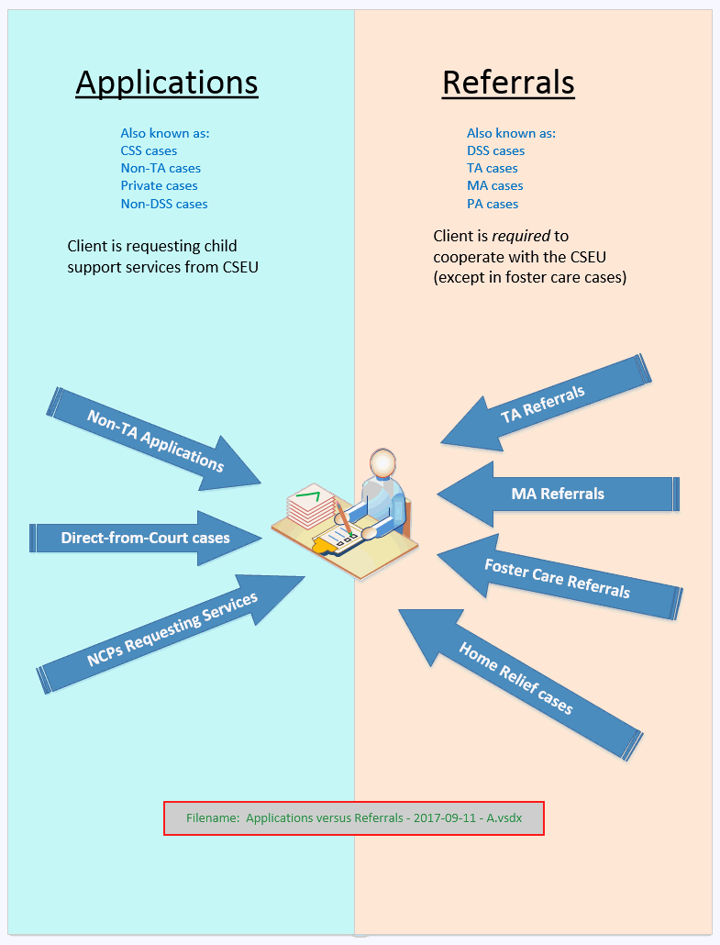

#### Applications

You may sometimes hear applications referred to (by various workers, or in various policy directives) as:

* + Applications (as opposed to Referrals)
  + Private cases
  + Non-TA cases
  + Non-PA cases
  + Non-TANF cases
  + Non-Public Assistance cases
  + Non-SNA cases
  + Non-Cash cases

#### Referrals

These cases are commonly called "referrals" or "TA cases."

Customers are required to cooperate with the CSEU if they are receiving or applying to receive temporary financial or medical assistance from the state.

You may sometimes hear referrals referred to (by various workers, or in various policy directives) as:

* + Referrals (as opposed to Applications)
  + TA Cases
  + DSS cases
  + PA cases
  + TANF cases
  + Public Assistance cases
  + Safety Net cases
  + Cash cases

### Do ALL customers need to fill out an LDSS-4882?

No. Customers in the following types of cases do not need to fill out an [LDSS-4882](http://otda.state.nyenet/assets/pages/PDFs/Child_Support_Application/LDSS-4882W.pdf?rhtocid=_10_1_6#bc-1):

* + Direct-from-court cases in which a [Support Order](https://www.nycourts.gov/forms/familycourt/pdfs/4-7.pdf) is sent from court to the CSEU and is accompanied by a petition, application, or motion for child support services signed by the applicant.
  + Direct-from-court cases in which the customer has already applied for child support services in another SSD or state.

In some districts, applications are filled out on ASSETS by the worker during the intake interview. In those instances, the required signature can be captured using an electronic signature pad, or the worker can print out the completed application and have the applicant sign it.

Regardless of how the signature is captured, the page bearing the signed request for services must be kept on file, and must be readily available at any time in the event of an audit.

### Linking Cases — Should You Do It?

#### When should you link cases?

Please exercise caution when considering whether to link cases.

**Once linked, cases can never be unlinked.**

**Cases should be linked when — and *ONLY* when — all parties in both cases are the same and the worker is building a sub-account.**

**Example:**

A single account can contain a maximum of 18 ledgers. When an account has reached the maximum number of ledgers, but *more ledgers need to be added* to the account, the CSEU worker must build a whole new case to contain the new ledgers.

In this instance, all parties in the new case will be the same as on the older case, and the two cases can be linked.  Implications? When information (like address of CP, for example) is updated in one case, the information will be automatically updated in any and all cases to which it is linked.

#### Potential adverse effects of linking cases

When cases are linked, any case remarks entered in the Case Remarks or Respondent Remarks tab in one case record will appear in the case records of ***all*** cases linked to it.  NCPs can be linked up to nine times; CPs can be linked almost infinitely.

This can make it difficult for a CSEU worker viewing these remarks to know which case (or party) the remarks are referring to.

**Example #1:**

If there are cases regarding multiple NCPs linked to a single CP, remarks referring to "the NCP" will be confusing, since the worker would not know which NCP the remarks are referring to.

**Example #2:**

A CP has two different cases with two different NCPs.

One NCP has violence issues, and ***the other doesn't.***

If a worker client-links these cases, the FVI code will appear in the case records of ***BOTH*** NCPs. This will make locating these NCPs difficult or impossible.

For more information, see the section of the Intake chapter entitled:  "IMPORTANT:  Setting FVI Codes."

### Retention of Records

The following intake-related documents must be retained as a part of the case records:

* + 1. [LDSS-4882](http://otda.state.nyenet/assets/pages/PDFs/Child_Support_Application/LDSS-4882W.pdf?rhtocid=_10_1_6#bc-1) (Information About Child Support Services and Application/Referral for Child Support Services) or any petition, application or motion made to the court requesting child support services
    2. [LDSS-4882B](http://otda.state.nyenet/assets/pages/PDFs/Child_Support_Application/LDSS-4882BW_ncp.pdf) (Information for an Additional NCP/PF)
    3. [LDSS-4882C](http://otda.state.nyenet/assets/pages/PDFs/Child_Support_Application/LDSS-4882CW_child.pdf)  (Information for an Additional Child)
    4. Any appropriate additional supporting documentation

Documents may be retained as paper files or by electronic means, according to SSD protocol.

Regardless of the means used to retain records, the [LDSS-4882](http://otda.state.nyenet/assets/pages/PDFs/Child_Support_Application/LDSS-4882W.pdf?rhtocid=_10_1_6#bc-1) or the signed petition, application, or motion requesting child support services received from the court must be readily available to be retrieved, if needed, by OTDA for audit purposes.

For detailed information regarding record retention policy, see the "Summary of Federal and State Requirements Regarding the Maintenance, Imaging, and Disposal of Records" on ERS at:  <http://otda.state.nyenet/assets/pages/PDFs/Program_Information/Records_Maintenance_-_Summary.pdf>

### General Safety Concerns: The Safety of the Applicant

Upon receipt of an [LDSS-4882](http://otda.state.nyenet/assets/pages/PDFs/Child_Support_Application/LDSS-4882W.pdf?rhtocid=_10_1_6#bc-1), the CSEU should review the form to determine if there is any indication of a safety concern on the part of the customer (refer to Section A – Applicant/Recipient Information, Safety Concerns).

The question regarding safety is at the very top of the application form; it is the second question in the entire application.

If there is no indication of a safety concern, the CSEU should continue to process the [LDSS-4882](http://otda.state.nyenet/assets/pages/PDFs/Child_Support_Application/LDSS-4882W.pdf?rhtocid=_10_1_6#bc-1).

**If the applicant checked “Yes” to indicate the existence of a safety concern:**

The CSEU must discuss the safety concern with the customer and determine whether the individual is applying for child support services pursuant to SSL § 111-g (refer to Section C – Application/Affirmation for Child Support Services of the [LDSS-4882](http://otda.state.nyenet/assets/pages/PDFs/Child_Support_Application/LDSS-4882W.pdf?rhtocid=_10_1_6#bc-1)).

If the individual is not applying for child support services pursuant to SSL § 111-g, the next actions of the CSEU will depend on what services need to be provided and whether the applicant is being referred from TA, MA, or FC.  The underlying presumption is that the safety concern has developed since the initiation of the referral to the CSEU.

Specifics regarding safety concerns for individual types of clients (e.g. TA, MA, or FC) can be found in the sections of this Intake chapter devoted to the type of client in question.

### Who is the Customer? Who is the Petitioner?

#### Who is the Customer?

|  |  |
| --- | --- |
| **Type of Case** | **Customer** |
| **TA** | CP or NCP |
| **Non-TA** | CP or NCP |
| **IV-E Foster Care** | Commissioner OBO the child |
| **Non-IV-E Foster Care** | Commissioner OBO the child |
| **SNA Referrals** | CP or NCP |

#### Who is the Petitioner?

|  |  |
| --- | --- |
| **Type of Case** | **Petitioner** |
| **TA** | Commissioner or Designee of the SSD |
| **Non-TA** | CP, or the CSEU OBO the CP |
| **IV-E Foster Care** | Commissioner or Designee of the SSD or the Commissioner or Designee of the Office of Children and Family Services (OCFS) |
| **Non-IV-E Foster Care** | Commissioner or Designee of the SSD or the Commissioner or Designee of the Office of Children and Family Services (OCFS). |
| **SNA Referrals** | Commissioner or Designee of the SSD |

## 

## Eligibility for Child Support Services

### Eligibility for Child Support Services

Services are available to people who need help to establish paternity or secure support from another person who is legally responsible for that support.  Cases entering the child support program are classified into these categories:

* + TA (or "TANF") cases
  + Non-TA cases
  + Title IV-E Foster Care cases
  + Non-Title IV-E Foster Care cases
  + Home Relief cases in which the applicant or receipient is under 21 years of age

#### TA Cases

The following types of cases, where appropriate, must be referred to the child support program:  [18NYCRR 347.3]

* + Cases in which the CP has applied for or is in receipt of TA or SNA;
  + Cases in which the paternity of an FA applicant/receipient’s dependent child has not been legally established.

#### Non-TA Cases

The full range of child support services are available to any person making an application for such services, where the intended recipient of services has not yet attained the age of twenty-one (21).

An applicant may be a custodial parent, non-custodial parent (for paternity establishment, for example), caretaker relative, legal guardian, a child under the age of twenty-one (21), or a representative of a private or public charitable institution.

#### Title IV-E (Foster Care) Cases

Appropriate Title IV-E (Foster Care) cases must be referred to the CSEU. [18NYCRR 426.8] They are processed like TA cases.

The New York State Title IV-E Home Page can be found at:  <http://ocfs.ny.gov/main/fostercare/titleiv-e/>

#### Non-IV-E Foster Care Cases

Certain Foster Care cases that are not eligible for Title IV-E Foster Care payments (e.g. child welfare cases) are referred to the CSEU.  [18NYCRR 422.2]  They are processed like TA cases.

#### Home Relief Cases in Which the Applicant/Recipient is Under 21 Years of Age

When a person applying for or receiving Home Relief payments is under 21 years of age, that person may be referred by the Home Relief unit to the CSEU so that child support from legally responsible relatives can be sought.  [18NYCRR 370.2 (3)] These cases are processed as referrals (i.e. the same process as for TA cases).

### Equal Access to Services

Non-TA cases are entitled to receive, on an equal basis, all child support services that are available for TA cases.

**Non-TA applicants are to be advised of:**

* 1.  All services available to them (location, paternity establishment, support establishment, collection, and enforcement).
  2.  The distribution policy.
  3.  The mandatory $25 annual federal CP fee (this applies to "never assistance cases" only).
  4.  Costs associated with any legal representation provided in Non-TA cases [18NYCRR 347.17].

## The Application Form

### The Application/Referral Form — LDSS-4882

The multi-purpose [LDSS-4882](http://otda.state.nyenet/assets/pages/PDFs/Child_Support_Application/LDSS-4882W.pdf?rhtocid=_10_1_6#bc-1) form — [Information about Child Support Services and Application/Referral for Child Support Services](http://otda.state.nyenet/assets/pages/PDFs/Child_Support_Application/LDSS-4882W.pdf?rhtocid=_10_1_6#bc-1) — is the primary information collection tool for all child support case types.

It mirrors online Application Form in ASSETS.

#### Who Should NOT Receive an LDSS-4882?

The [LDSS-4882](http://otda.state.nyenet/assets/pages/PDFs/Child_Support_Application/LDSS-4882W.pdf?rhtocid=_10_1_6#bc-1) ***should not be provided*** to the applicant or TA referral if:

* + It has been determined that there is good cause for a refusal to cooperate based upon potential physical harm ([refer to 99 ADM-05](http://otda.ny.gov/policy/directives/1999/ADM/99_ADM-05.pdf))

***OR***

* + a full child support waiver has been granted by the Domestic Violence Liaison

How or Where Can a Customer Obtain an Application Form?

* + Download the application from the New York State Child Support Services website at: [childsupport.ny.gov](https://www.childsupport.ny.gov/dcse/home.html).
  + Phone the NYS Child Support Customer Service HelpLine (CSH). A CSR will have an application mailed to the requestor.
  + Phone the local CSEU and request an application.
  + The LDSS-4882 may be provided to individuals attending court proceedings concerning the establishment of paternity and the establishment, modification, and/or enforcement of an order of support.
  + The LDSS-4882 may also be made available to Head Start; Women, Infants, and Children; fatherhood programs and community-based organizations providing services to families.

An LDSS-4882 form must be sent to any individual within five (5) business days of receiving a written or telephone request for services.

#### Sections of Form LDSS-4882A — "Information About Child Support Services"

|  |  |
| --- | --- |
| **Section** | **Contents** |
| **Section 1** | Eligibility, assignment of support rights and cooperation, and the basic child support obligation, and  provides a summary of child support services. |
| **Section 2** | Rights and consequences resulting from paternity establishment and the right to notice of legal proceedings. |
| **Section 3** | Provides the State's child support policies |
| **Section 4** | Legal services and cost recovery |
| **Section 5** | Annual service fee |
| **Section 6** | Payment and contact information |

#### Minimum Information Needed to Build a Case

|  |  |  |
| --- | --- | --- |
|  | **Information Needed** | **Where You Can Find It**  **(Apart from form LDSS-4882)** |
| **1** | **Worker Code**  Worker Codes are determined locally at the district level. (Technologically speaking, ASSETS will accept any four (4) alpha-numeric characters.) | (Determined by local districts) |
| **2** | **CP Name** | 1. Worker Alerts > IVA Mode > -IVA; or 2. Electronic referral from WMS/WRTS 3. Court Interface |
| **3** | **CP mailing address** | Electronic referral from WMS/WRTS |
| **4** | **NCP name** | 1. Worker Alerts > IVA Mode > -IVA; or 2. Electronic referral from WMS/WRTS 3. Court Interface |
| **5** | **NCP mailing address** | 1. Worker Alerts > IVA Mode > -IVA; or 2. Electronic referral from WMS/WRTS 3. Court Interface |
| **6** | **NCP gender** | 1. Worker Alerts > IVA Mode > -IVA; or 2. Electronic referral from WMS/WRTS 3. Court Interface |
| **7** | **Child name** | 1. Electronic referral from WMS/WRTS 2. Court Interface |
| **10** | **CSS Application for Services Indicator** | This is a checkbox located in Section C of the [LDSS-4882](http://otda.state.nyenet/assets/pages/PDFs/Child_Support_Application/LDSS-4882W.pdf?rhtocid=_10_1_6#bc-1). |

### Section C:  Checking Box 1 or Box 2

Note: For an application or request (including petition, motion, etc.) for child support services to be actionable by the CSEU, it must be ***signed*** by the individual (CP or NCP) requesting services. Cases should not be built until such a signed document is received and **on file** at the CSEU.

#### Box 1

Box 1 should be checked and signed by Non-TA applicants who are not *required* to cooperate with the Child Support Program to meet the requirements of an application for Temporary Assistance services, but rather are applying of their own accord.

#### Box 2

Box 2 should be checked and signed by applicants for temporary assistance (TA or MA). They are required to cooperate with the child support program as a prerequisite for receiving (unsanctioned) TA or MA benefits.

#### Following Local Protocols

Local protocols for completing **Section C** (page **A-8**) may vary.

* In some districts, signatures are captured electronically, using an electronic signature pad.  Note:  the signature document must be readily available in event of an audit.
* In some districts, in order to expedite case-building and support establishment for customers who initially are TA referrals, but for whom TA is denied:
  + 1. The CSEU has TA referral customers check Box 2 (for TA applicants/recipients) on page A-8 of the [LDSS-4882](http://otda.state.nyenet/assets/pages/PDFs/Child_Support_Application/LDSS-4882W.pdf?rhtocid=_10_1_6#bc-1)

***AND***

* + 1. The CSEU also has them check and sign off on Box 1 on a separate form (or on a photocopy of page **A-8**), so that the CSEU can proceed with case-building and subsequent activities regardless of TA status of the customer — since, if the customer is denied temporary assistance, the CSEU will have on hand a signed request authorizing them to build a (Non-TA) case.

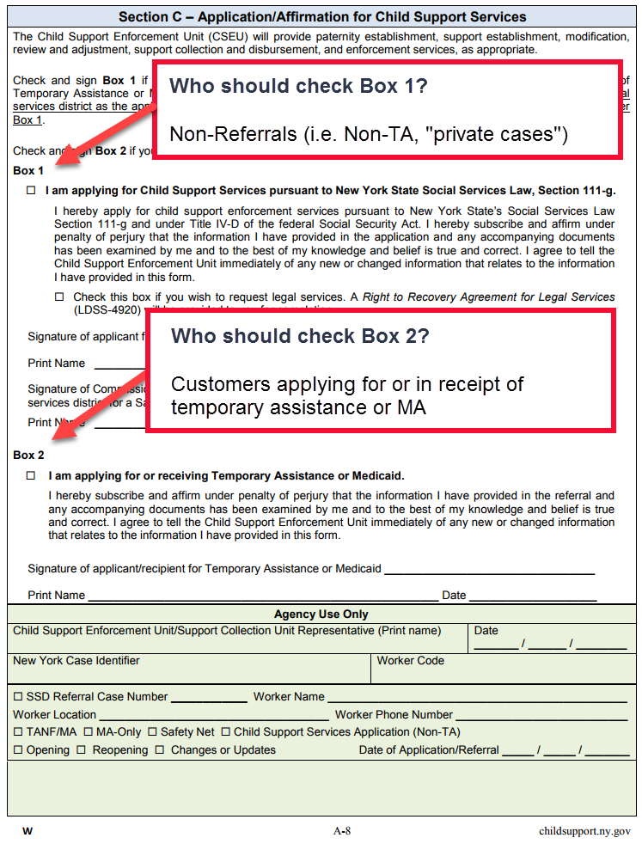

## Cooperation Requirements

### Define "Cooperation" with the Child Support Program

The worker needs to evaluate the customer's ***willingness*** to provide information necessary for location of the NCP, paternity establishment, and support establishment.

***Unwillingness to cooperate*** ***is different from*** -- *and should not be confused with* -- ***lack of information*** on the part of the customer, ***or fear of harm***, violence, or retaliation from the NCP.

"Cooperation" means providing the following information about the customer, the child, and the NCP:

 Name

 SSN

 DOB

 Address

 Employer's name and address (for NCP)

In addition, the customer must:

 Attend scheduled appointments with the child support program.

 Appear in court when necessary.

 Allow for genetic testing to establish paternity, when appropriate.

 Relinquish to the LDSS any payments that are received from the NCP (i.e. "assignment of rights").

 Provide additional information as requested.

### Customer attests to lack of information about Respondent

Every customer has the right to attest that he or she is unable to provide information required about the NCP.

A genuine lack of information should not be confused with willful non-cooperation.

When a customer claims to have lack of information, he or she must complete and sign form [LDSS-4281](http://otda.state.nyenet/ldss_eforms/eforms/4281.pdf) -- or its Spanish equivalent, form [LDSS-4281S](http://otda.state.nyenet/ldss_eforms/eforms/4281-SP.pdf).

### Results of Non-Cooperation with the Child Support Program

When an applicant in a TA case does not meet requirements of cooperating with the CSEU, the CSEU notifies the TA Unit of this via form [LDSS-2859](http://otda.ny.gov/policy/directives/2013/LCM/13-LCM-09-Attachment-1.pdf?rhtocid=_10_1_1#bc-1).

The TA Unit may then sanction the Customer.

#### Results of Non-Cooperation

TA customers and Medicaid customers are required to cooperate with the CSEU. Non-cooperation can result in:

* + 1. Sanctions to TA benefits.
    2. Loss of pass-through payment.
    3. Loss of Medicaid for the parent.
    4. Loss of ability to establish paternity.

Note that if the parent loses Medicaid due to non-cooperation with the child support program, **the child will continue to receive Medicaid** benefits.

#### What does "sanction" mean?

It means that the TA benefits may be reduced by 25% until such time as CSEU notifies the TA Unit that the customer is now in compliance with the requirement to cooperate with the CSEU.

## Safety Concerns -- Domestic Violence and Good Cause

### Suppression of Address and Employment Information

The CSEU must ensure that the customer's address and employment information do not appear on any documents, notices, summons, etc. that are created by the CSEU as part of providing a CSEU service. SSDs should follow local protocols with regard to listing a substitute address for the customer on ASSETS.

If the customer chooses to request address confidentiality from the Family Court, the CSEU should generate the [Address Confidentiality Affidavit](http://www.nycourts.gov/forms/familycourt/pdfs/gf-21.pdf), which is available on ASSETS as a template in the State Folder of the Local Correspondence tab in the Document Generation module.

Alternatively, the customer may complete Family Court General Form 21 (GF-21), [Address Confidentiality Affidavit](http://www.nycourts.gov/forms/familycourt/pdfs/gf-21.pdf), which is available at [www.nycourts.gov](http://www.nycourts.gov).

The [Address Confidentiality Affidavit](http://www.nycourts.gov/forms/familycourt/pdfs/gf-21.pdf) must be filed with the Family Court.

If the request for confidentiality is accepted, the Family Court will issue Family Court General Form 21a (GF-21a), an [Address Confidentiality Order](http://www.nycourts.gov/forms/familycourt/pdfs/gf-21a.pdf).   The order will contain information regarding the person designated as the agent for service of process and all papers in the case.

### To the Customer in TA Cases Involving Domestic Violence:

[03-ADM-05](http://otda.ny.gov/policy/directives/2006/INF/03-ADM-05-attach.pdf) provides an attachment addressed directly to the customer in TA cases who is considering requesting a domestic violence waiver.

It is located at: <http://otda.ny.gov/policy/directives/2006/INF/03-ADM-05-attach.pdf>, and can be printed out and given to the customer.

The document begins:

**"NOTICE REGARDING CHILD SUPPORT REQUIREMENTS FOR**

**VICTIMS OF DOMESTIC VIOLENCE**

If you are a Temporary Assistance (TA) client and a victim of domestic violence (DV), please carefully read the following information about Child Support Enforcement (CSE) services **before** you request a waiver from the child support requirement..."

### "Good Cause" versus Domestic Violence Waivers

"Good Cause" and Domestic Violence Waivers pertain to TA cases only, and concern the requirement for customers referred from the TA Unit to cooperate with the child support program.

"Good Cause" [for non-cooperation with the Child Support Program] requires documentation to prove the situation, whereas a domestic violence waiver is granted by a Domestic Violence Liaison (DVL) after a comprehensive assessment interview with a customer who answered "yes" to being a victim of domestic violence.

A domestic violence waiver does not require strict verification documentation, and is different from Good Cause.

#### Good Cause

Good Cause is determined by the TA Unit. The following are circumstances that are acceptable as good cause for non-cooperation.  They are the ***only*** circumstances that are acceptable as good cause for non-cooperation.

1. "Good Cause" is valid if:
   * 1. Cooperation in establishing paternity or securing support is reasonably anticipated to result in any of the following:
        + Physical harm to the child in the case.
        + Emotional harm to the child in the case.
        + Physical harm to the parent or caretaker relative with whom the child is living, of such nature or degree that it reduces that person's ability to care for the child.

**OR**

* + 1. The child was conceived as the result of a rape.

**OR**

* + 1. Legal proceedings for the adoption of the child are pending before a court.

**OR**

* + 1. The customer is being counseled on whether to give the child up for adoption, and the counseling has not gone on for more than three (3) months.

#### Domestic Violence

Under the Family Violence Option in New York State, procedures are in place to screen TA applicants or recipients for domestic violence when applying for TA benefits.

This option can provide service referrals to the CP, and/or temporary waivers from the requirement to cooperate with the Child Support Program. This is determined by a specially trained Domestic Violence Liaison, and must be honored by the Child Support Program.

#### Referral Procedure for Domestic Violence Screening

Sometimes, a customer may not make a disclosure of domestic violence when initially screened during a TA eligibility interview, but later discloses domestic violence during a child support interview, when compliance with the TA program requirements are discussed in more detail.

If this happens, the CSEU worker must stop the interview and refer the customer to the DVL, following local protocols.

Child support workers cannot conduct a domestic violence screening.

**Local district procedures and protocols** **for referring clients to be screened must be followed.** (Some districts may refer the customer back to the TA Unit, which will do the screening and make a referral to the DVL. Other districts may refer the client directly to the DVL.)

Therefore, it is important to know and follow the procedures in your own particular local district.

|  |  |  |
| --- | --- | --- |
|  | **Good Cause** | **Domestic Violence Waivers** |
| **Who determines status?** | Granted by TA Unit.  Consultation with CSEU may be necessary in some complex cases. | Granted by the DVL |
| **Are CSEU activities on the case suspended?** | All activities are suspended during period of determination by TA Unit. | All activities are suspended when the referral to a DVL is made. |
| **Deadline to prove status or determine status?** | Customer has 20 days to prove claim; determination must be made within 30 days of Customer signing notice to claim good cause. | Determination is made by the DVL as soon as practicable. |
| **CSEU worker actions?** | CSEU can continue certain activities — such as location, paternity establishment, or financial investigations — without the recipient's consent even after a good cause determination is approved. | DVL informs CSEU whether there is no waiver, a full waiver, or a partial waiver granted, and the timeframe for waivers. |
| **Granted under what conditions?** | Granted under four conditions stated above, two of which pertain to issues of family violence. | Granted when compliance with CSEU requirements would make it more difficult for the victim and/or the victim's children to escape from DV or subject them to further risk. |
| **What evidence if required?** | Requires evidence provided by the Customer and further investigation by staff, if necessary. | Requires minimal documentation (e.g. sworn statement), according to the judgement of the DVL. |
| **How long does this status remain valid? Does it expire?** | Timeframe indefinite, but must be reviewed at recertification where circumstances are subject to change. | Granted on a temporary basis for at least four (4) months, and reassessed at least every six (6) months. |

### Referral to Domestic Violence Liaison

If a customer indicates a safety concern on the [LDSS-4882](http://otda.state.nyenet/assets/pages/PDFs/Child_Support_Application/LDSS-4882W.pdf?rhtocid=_10_1_6#bc-1), the worker must stop the intake interview and refer the customer — following local protocols  — to a Domestic Violence Liaison for screening and assessment.

In TA cases, the CSEU must notify the TA Unit of this action via the [LDSS-2859](http://otda.ny.gov/policy/directives/2013/LCM/13-LCM-09-Attachment-1.pdf?rhtocid=_10_1_1#bc-1).

All CSEU activities must be suspended during the domestic violence screening and assessment process, and until a waiver decision is made by the Domestic Violence Liaison.

### Domestic Violence Liaison: What They Do

NYS Law and Regulations require local districts to retain or employ trained Domestic Violence Liaisons who are primarily responsible for completing the following job tasks:

* 1. Assess the credibility of the assertion of domestic violence;
  2. Assess the safety of the victim and the victim's dependents and their need for services and other supports;
  3. Provide information about domestic violence and the options for protection, services and other supports;
  4. Inform victims about their rights and responsibilities with respect to waivers of public assistance program requirements;
  5. Gather facts regarding the extent to which domestic violence is a barrier to meeting public assistance requirements, including employment requirements and the need for waivers of such requirements;
  6. Determine the need for waivers when compliance with public assistance requirements would place the victim and/or the victim's children at greater risk of harm or make it more difficult to escape from the abuse, and make recommendations for granting waivers or grant waivers;
  7. Periodically reassess the individual's domestic violence circumstances and modify, terminate or extend the waiver(s);
  8. Establish and maintain a list of, at a minimum, available domestic violence services and a relationship with the providers of the services;
  9. Coordinate activities with other case managers and examiners within the local SSD;
  10. Facilitate emergency safety planning with victims in a crisis situation, as necessary;
  11. Collect and maintain data/record keeping.

For more information, see: **Office for the Prevention of Domestic Violence**, at <http://www.opdv.ny.gov/index.html>.

New York State Domestic and Sexual Violence Hotline:  1-800-942-6906

### After a Determination by a Domestic Violence Liaison:  Required Actions

**IMPORTANT:  See section of this manual entitled "****Setting FVI Codes****."**

#### If a Full Waiver is granted, the worker must:

* 1. Set the Family Violence Indicator (FVI) to value Code 1.
  2. Cease ***all*** case and enforcement activity.

#### If a Partial Waiver is granted, the worker must:

* 1. Set the FVI  to Code 2.
  2. Proceed with case-building, but with certain precautions.

Setting these indicator codes also serves to provide notification of family violence on the Federal Case Registry (FCR).

The CSEU, to the extent required by such waiver, must forego any enforcement actions or activities on the case with respect to the children of the NCP/PF while the waiver is in effect.

#### Family Violence Indicator (FVI) Codes

|  |  |
| --- | --- |
| **Code** | **Meaning** |
| **1** | Request notification of family violence to the Federal Case Registry (FCR); full family violence waiver granted. |
| **2** | Request notification of family violence to the **FCR**; partial family violence waiver granted. |
| **F** | Family violence indicator sent to the **FCR**; full waiver. |
| **P** | Family violence indicator sent to the **FCR**; partial waiver. |
| **V** | Family violence indicator sent to the **FCR**.  (System set when prior value is Code Y.  Manually set when prior value is Code X.) |
| **X** | Request removal o FVI set on case at the **FCR**.  (Manually set only when prior value is Code V.) |
| **Y** | Request notification of family violence to the **FCR**.  (Manually set only when prior value is blank.) |
| **[blank]** | No family violence indicator set at the Federal Case Registry.  (This is set automatically by the system when the prior value is Code X.  Manually set when prior value is Code Y.) |

For more information, refer to the Dear Colleague letter dated August 10, 2007 regarding Family Violence Waiver indicator values.

### IMPORTANT INFORMATION About Setting Family Violence Indicator Codes

* Family Violence Indicator codes must be set on *individuals* — ***NOT*** on an entire case.
* An FVI  must ***NOT*** be set on the *perpetrator* of family violence.
* An FVI must be set on the people who need protection from family violence. In most cases, mothers and children are the people who need protection.
* An FVI attached to an individual stops the flow of ***all*** information about that individual from the FPLS to ***all*** states — even the state that set the FVI.

The purpose of attaching an FVI to an individual is to protect that individual by making him/her difficult (for a perpetrator) to find. Setting the FVI code means that no information about that person will be shared from the FPLS to any state.

Setting an FVI on an entire case would assign that code to every individual involved in the case — including the perpetrator of family violence.

Setting an FVI on the perpetrator of family violence would make it very difficult, or impossible, to locate the perpetrator or his/her assets for the purpose of pursuing a child support order.

## TA Cases (Intake) - Introduction

### Cooperation Requirements for TA Cases

TA applicants/recipients must cooperate with the CSEU to locate the NCP, establish paternity, and establish, modify, and enforce orders of support.

To satisfy this requirement, all TA applicants/recipients must complete the [LDSS-4882](http://otda.state.nyenet/assets/pages/PDFs/Child_Support_Application/LDSS-4882W.pdf?rhtocid=_10_1_6#bc-1) and provide any needed supporting documentation to the CSEU.

If deemed necessary by the CSEU, the customer must appear at the CSEU for an interview. Failure to do so will result in the CSEU notifying the TA Unit of non-cooperation ( via an [LDSS-2859](http://otda.ny.gov/policy/directives/2013/LCM/13-LCM-09-Attachment-1.pdf?rhtocid=_10_1_1#bc-1)) unless there is a claim of domestic violence, a determination of good cause, or a completed and signed [LDSS-4281, Attestation to Lack of Information](http://otda.state.nyenet/ldss_eforms/eforms/4281.pdf?rhtocid=_10_1_3#bc-1).  For additional information on the cooperation standard, refer to [99 ADM 05](http://otda.ny.gov/policy/directives/1999/ADM/99_ADM-05.pdf).

### If the TA Unit Denies a Temporary Assistance Application

If temporary assistance has been denied by the TA Unit ***less than*** 30 days prior and the customer wishes to apply for services as a private case, they do not need to fill out a new [LDSS-4882](http://otda.state.nyenet/assets/pages/PDFs/Child_Support_Application/LDSS-4882W.pdf?rhtocid=_10_1_6#bc-1). Instead, they may revise the previously submitted [LDSS-4882](http://otda.state.nyenet/assets/pages/PDFs/Child_Support_Application/LDSS-4882W.pdf?rhtocid=_10_1_6#bc-1).

To do this, the applicant must:

* + 1. Check Box 1 in ***Section C – Application/Affirmation for Child Support Services.***
    2. Complete the associated signature area.
    3. Initial the changes to mark the [LDSS-4882](http://otda.state.nyenet/assets/pages/PDFs/Child_Support_Application/LDSS-4882W.pdf?rhtocid=_10_1_6#bc-1) as having been amended.

If temporary assistance has been denied by the TA Unit ***more than*** 30 days prior, the customer must complete a new [LDSS-4882](http://otda.state.nyenet/assets/pages/PDFs/Child_Support_Application/LDSS-4882W.pdf?rhtocid=_10_1_6#bc-1) — this time applying as a private case.

### The IVA-IVD Interface Report

Referrals from the TA Unit appear on the Worker Alerts > IVA > IVA-IVD tab. The Report is refreshed every day and should be reviewed every day.

It can be found on the ASSETS system by going to: Home > Tasks > Worker Alerts > IVA > IVA - IVD tab

#### Best Practices for Using the IVA-IVD Interface Report:

* 1. Check the Worker Alerts > IVA > IVA-IVD tab every day for new TA, MA, or FC cases.
  2. Build new cases promptly.
  3. If you cannot locate the hard copy referral ([LDSS-4882](http://otda.state.nyenet/assets/pages/PDFs/Child_Support_Application/LDSS-4882W.pdf?rhtocid=_10_1_6#bc-1)) form, check to see whether the TA or MA Unit has cancelled the case/referral.
  4. For cases that do not require child support services, reject the case.
  5. For cases that do NOT require child support services, contact the TA or MA unit to have them change the IV-D Indicator so that you don't continue getting messages regarding this case.

#### What Triggers a Case Appearing on the IVA-IVD Interface Report?

A case will appear on the Worker Alerts > IVA > IVA-IVD tab if the IV-D Ind field of the WMS case record has been set with a code of Code D, Code X, or Code Y.

Code D = Medicaid case requiring only paternity establishment.

Code X = Eligible for child support services, and pass-through payment will not be automatically issued for this case.

Code Y = Case is eligible for child support services.

It is important that the TA enters the correct IV-D Indicator into the WMS case record, since that's how the Child Support Program becomes aware of those cases.

A case with a Code D, Code X, or Code Y in the IV-D Ind field in the WMS case record will appear on the Worker Alerts > IVA > IVA-IVD tab in ASSETS (see screenshot below).

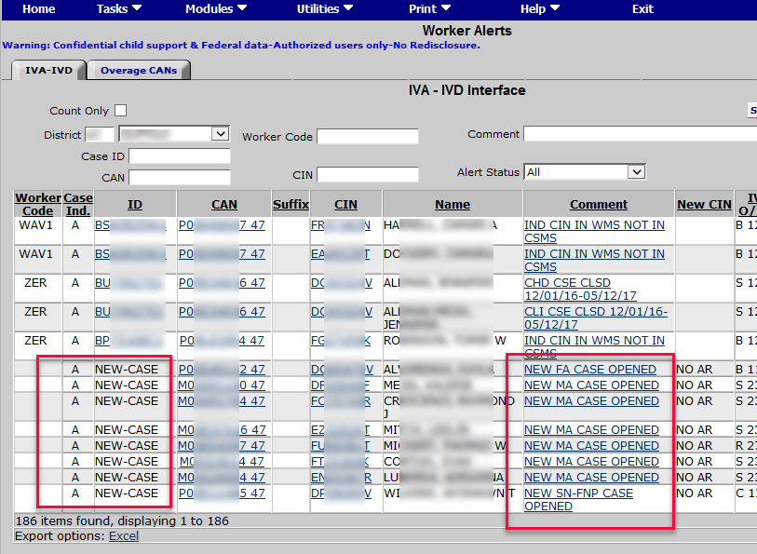

When new cases appear on the Worker Alerts > IVA > IVA-IVD tab, child support workers should expect a hard copy of an [LDSS-4882](http://otda.state.nyenet/assets/pages/PDFs/Child_Support_Application/LDSS-4882W.pdf?rhtocid=_10_1_6#bc-1) to arrive soon.

## TA Process (Intake)

### Roadmap: TA Cases — Intake Process

Nodes in this process diagram that have a plus sign inside a green circle image30.gif on them are linked to drill-down content. Click on those nodes to get more details about that step.

To download the diagram below, simply right click on the diagram, and select "Save image as..."

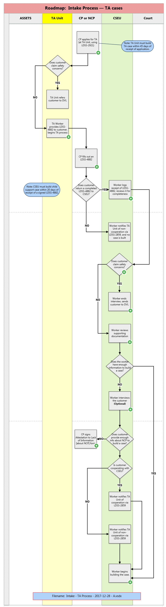

### CP applies for temporary assistance at TA Unit

The CP applies for temporary assistance at the TA Unit.

(The application form for this is: [LDSS-2921, "New York State Application for Certain Benefits and Services](https://otda.ny.gov/programs/applications/2921.pdf).")

During the course of this, the TA worker asks the customer whether he or she has any safety concerns.

**If there are no safety concerns,** the TA Worker gives the customer an [LDSS-4882](http://otda.state.nyenet/assets/pages/PDFs/Child_Support_Application/LDSS-4882W.pdf?rhtocid=_10_1_6#bc-1).

The TA worker, before handing the [LDSS-4882](http://otda.state.nyenet/assets/pages/PDFs/Child_Support_Application/LDSS-4882W.pdf?rhtocid=_10_1_6#bc-1) to the customer, should:

* 1. Put a check mark in Box 2 in Section C of the [LDSS-4882](http://otda.state.nyenet/assets/pages/PDFs/Child_Support_Application/LDSS-4882W.pdf?rhtocid=_10_1_6#bc-1).
  2. Fill out relevant parts of the "Agency Use Only" box at the bottom of Section C of the [LDSS-4882](http://otda.state.nyenet/assets/pages/PDFs/Child_Support_Application/LDSS-4882W.pdf?rhtocid=_10_1_6#bc-1) -- in particular, the Date of Application field.

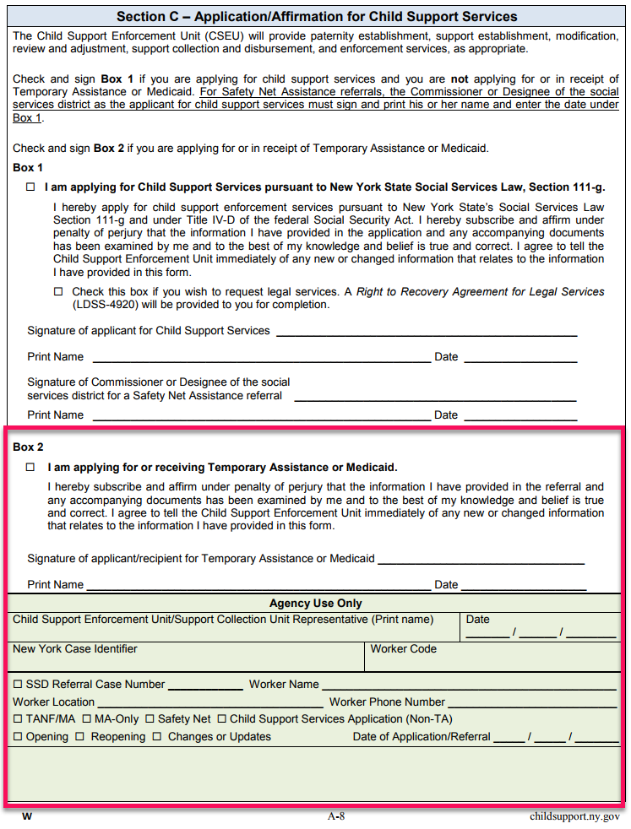

**If there are safety concerns,** the TA Unit should not give the customer a [LDSS-4882](http://otda.state.nyenet/assets/pages/PDFs/Child_Support_Application/LDSS-4882W.pdf?rhtocid=_10_1_6#bc-1).

Instead, they must send the customer to a Domestic Violence Liaison.

When a customer is referred to a DVL, there are several possible outcomes:

* + Full Waiver
  + Partial Waiver
  + No Waiver

After the DVL makes a decision about granting the customer a full waiver, a partial waiver, or no waiver, the TA Unit must notify the CSEU of that decision. This is because even though the case may never actually get built at the CSEU (because a DV waiver negates the cooperation requirement), the referral may still show up on the Worker Alerts > IVA > IVA-IVD tab.

**If this is a case of Good Cause,** the TA Unit notifies the CSEU via an [LDSS-2859](http://otda.ny.gov/policy/directives/2013/LCM/13-LCM-09-Attachment-1.pdf?rhtocid=_10_1_1#bc-1), the [Information Transmittal form](http://otda.ny.gov/policy/directives/2013/LCM/13-LCM-09-Attachment-1.pdf?rhtocid=_10_1_1#bc-1).

### TA Worker provides LDSS-4882 to customer

Prior to providing the [LDSS-4882](http://otda.state.nyenet/assets/pages/PDFs/Child_Support_Application/LDSS-4882W.pdf?rhtocid=_10_1_6#bc-1) to the customer, the TA worker must perform the following actions:

**On page A-5**, enter the CIN and WMS Line Number of the child named in the referral.

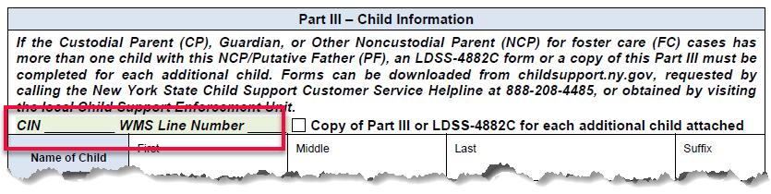

If the customer must complete form [LDSS-4882C](http://otda.state.nyenet/assets/pages/PDFs/Child_Support_Application/LDSS-4882CW_child.pdf?rhtocid=_10_1_9#bc-1), the worker must enter the CIN and WMS Line Number for each additional child on the [LDSS-4882C](http://otda.state.nyenet/assets/pages/PDFs/Child_Support_Application/LDSS-4882CW_child.pdf?rhtocid=_10_1_9#bc-1).

**On page A-8,** under ***Agency Use Only*,** the TA worker should:

1. Check the SSD Referral box and enter the TA case number.
2. Enter the TA worker name, location, and phone number.
3. Check the appropriate box to identify the TA case type and to indicate whether the case is opening or re-opening, and whether changes or updates are being provided.
4. Provide the date of the application/referral.

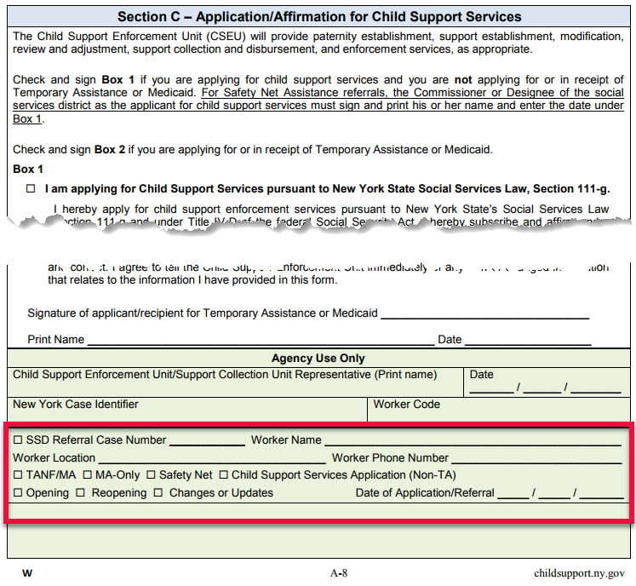

### CP fills out an LDSS-4882

All customers requesting child support services must complete and sign an [LDSS-4882](http://otda.state.nyenet/assets/pages/PDFs/Child_Support_Application/LDSS-4882W.pdf?rhtocid=_10_1_6#bc-1).

**\* The exception to this** is direct-from-court cases in which a court order for child support is accompanied by a request for child support services in the form of a petition, motion, or other court document signed by the customer/petitioner.

The Child Support Application/Referral form ([LDSS-4882](http://otda.state.nyenet/assets/pages/PDFs/Child_Support_Application/LDSS-4882W.pdf?rhtocid=_10_1_6#bc-1)) has space for only one NCP/PF and one child.

#### When There Is More Than One NCP or PF — LDSS-4882B

If support for the child is sought from more than one NCP, or the customer provides several possible PFs for the child:

* For each additional NCP/PF, the customer must complete one form [LDSS-4882B](http://otda.state.nyenet/assets/pages/PDFs/Child_Support_Application/LDSS-4882BW_ncp.pdf?rhtocid=_10_1_8#bc-1), [Information for an Additional Noncustodial Parent (NCP) / Putative Father (PF)](http://otda.state.nyenet/assets/pages/PDFs/Child_Support_Application/LDSS-4882BW_ncp.pdf?rhtocid=_10_1_8#bc-1).
* Alternatively:  Copies of a blank **Part II – Noncustodial Parent (NCP) / Putative Father (PF) Information** (page A-3 and page A-4 of the [LDSS-4882](http://otda.state.nyenet/assets/pages/PDFs/Child_Support_Application/LDSS-4882W.pdf?rhtocid=_10_1_6#bc-1)) may be made, completed, and kept on file in lieu of the [LDSS-4882B](http://otda.state.nyenet/assets/pages/PDFs/Child_Support_Application/LDSS-4882BW_ncp.pdf?rhtocid=_10_1_8#bc-1).

The [LDSS-4882B](http://otda.state.nyenet/assets/pages/PDFs/Child_Support_Application/LDSS-4882BW_ncp.pdf?rhtocid=_10_1_8#bc-1) is available on ERS and on the New York State child support website at [childsupport.ny.gov](http://childsupport.ny.gov).

If an [LDSS-4882B](http://otda.state.nyenet/assets/pages/PDFs/Child_Support_Application/LDSS-4882BW_ncp.pdf?rhtocid=_10_1_8#bc-1) or a completed copy of **Part II – Noncustodial Parent (NCP) / Putative Father (PF) Information** is attached to the [LDSS-4882](http://otda.state.nyenet/assets/pages/PDFs/Child_Support_Application/LDSS-4882W.pdf?rhtocid=_10_1_6#bc-1), the customer must check the box under **Part II – Noncustodial Parent (NCP) / Putative Father (PF) Information** at the top of page A-3 of the [LDSS-4882](http://otda.state.nyenet/assets/pages/PDFs/Child_Support_Application/LDSS-4882W.pdf?rhtocid=_10_1_6#bc-1) to indicate that information about additional NCP(s)/PF(s) is being attached to the [LDSS-4882](http://otda.state.nyenet/assets/pages/PDFs/Child_Support_Application/LDSS-4882W.pdf?rhtocid=_10_1_6#bc-1).

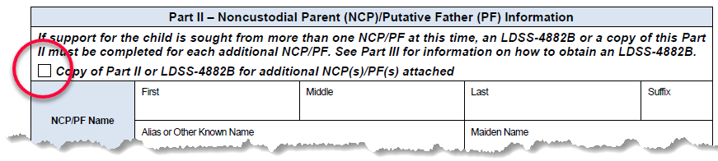

If the [LDSS-4882B](http://otda.state.nyenet/assets/pages/PDFs/Child_Support_Application/LDSS-4882BW_ncp.pdf?rhtocid=_10_1_8#bc-1) is used, the customer must indicate the number of [LDSS-4882B](http://otda.state.nyenet/assets/pages/PDFs/Child_Support_Application/LDSS-4882BW_ncp.pdf?rhtocid=_10_1_8#bc-1) forms attached to the [LDSS-4882](http://otda.state.nyenet/assets/pages/PDFs/Child_Support_Application/LDSS-4882W.pdf?rhtocid=_10_1_6#bc-1) by entering the page information at the top of page 1 of each [LDSS-4882B](http://otda.state.nyenet/assets/pages/PDFs/Child_Support_Application/LDSS-4882BW_ncp.pdf?rhtocid=_10_1_8#bc-1).

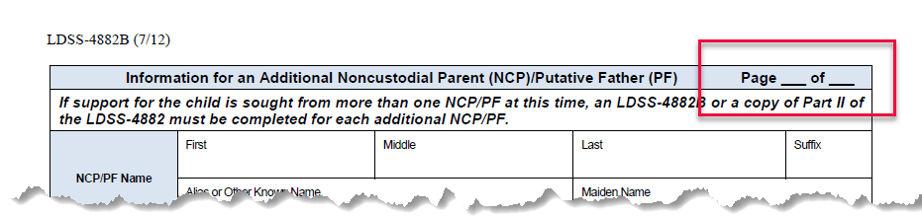

#### When There Is More Than One Child — LDSS-4882C

The [LDSS-4882](http://otda.state.nyenet/assets/pages/PDFs/Child_Support_Application/LDSS-4882W.pdf?rhtocid=_10_1_6#bc-1) has space to accommodate information for only one child.  If the application is for a case involving more than one child, the applicant must provide information about each additional child.

* + The customer must complete and sign an [LDSS-4882C, Information for an Additional Child](http://otda.state.nyenet/assets/pages/PDFs/Child_Support_Application/LDSS-4882CW_child.pdf?rhtocid=_10_1_9#bc-1) form for each additional child.
  + Alternatively, a copy of a blank **Part III - Child Information** (page A-5 of the [LDSS-4882](http://otda.state.nyenet/assets/pages/PDFs/Child_Support_Application/LDSS-4882W.pdf?rhtocid=_10_1_6#bc-1)) may be used.

The [LDSS-4882C](http://otda.state.nyenet/assets/pages/PDFs/Child_Support_Application/LDSS-4882CW_child.pdf) is available on [ERS](http://otda.state.nyenet/assets/) and on the New York State child support website at [childsupport.ny.gov](https://childsupport.ny.gov).

If an [LDSS-4882C](http://otda.state.nyenet/assets/pages/PDFs/Child_Support_Application/LDSS-4882CW_child.pdf) or a completed copy of **Part III – Child Information** is attached to the [LDSS-4882](http://otda.state.nyenet/assets/pages/PDFs/Child_Support_Application/LDSS-4882W.pdf?rhtocid=_10_1_6#bc-1), the customer must check the box under **Part III – Child Information** at the top of page A-5 of the [LDSS-4882](http://otda.state.nyenet/assets/pages/PDFs/Child_Support_Application/LDSS-4882W.pdf?rhtocid=_10_1_6#bc-1) to indicate that information for additional children is being provided.

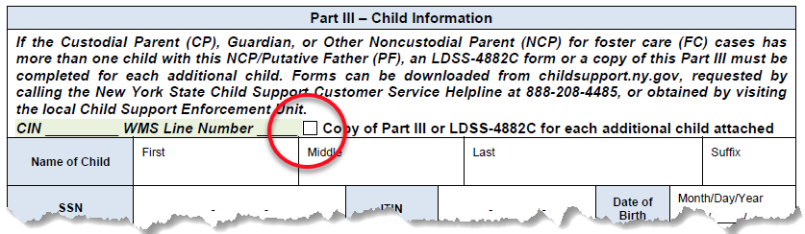

If the [LDSS-4882C](http://otda.state.nyenet/assets/pages/PDFs/Child_Support_Application/LDSS-4882CW_child.pdf) is used, the applicant must indicate the number of [LDSS-4882C](http://otda.state.nyenet/assets/pages/PDFs/Child_Support_Application/LDSS-4882CW_child.pdf) forms attached to the [LDSS-4882](http://otda.state.nyenet/assets/pages/PDFs/Child_Support_Application/LDSS-4882W.pdf?rhtocid=_10_1_6#bc-1) by entering the page information at the top of page 1 of each [LDSS-4882C](http://otda.state.nyenet/assets/pages/PDFs/Child_Support_Application/LDSS-4882CW_child.pdf).

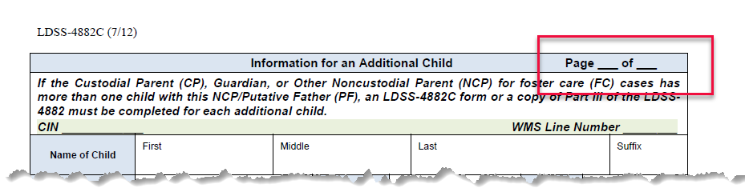

#### Supporting Documentation Also Is Required

In addition, documentation must be provided to verify information on the [LDSS-4882](http://otda.state.nyenet/assets/pages/PDFs/Child_Support_Application/LDSS-4882W.pdf?rhtocid=_10_1_6#bc-1) and to support the CSEU’s efforts to establish paternity and to establish, modify or enforce an order of support.

The [LDSS-4882](http://otda.state.nyenet/assets/pages/PDFs/Child_Support_Application/LDSS-4882W.pdf?rhtocid=_10_1_6#bc-1) and any available supporting documentation must be returned to the CSEU.

### Worker records receipt of the LDSS-4882, and reviews it for completeness

After reviewing the [LDSS-4882](http://otda.state.nyenet/assets/pages/PDFs/Child_Support_Application/LDSS-4882W.pdf?rhtocid=_10_1_6#bc-1) and supporting documentation, the worker completes the Child Support Enforcement Unit/Support Collection Unit Representative and Date areas on page A-8 of the [LDSS-4882](http://otda.state.nyenet/assets/pages/PDFs/Child_Support_Application/LDSS-4882W.pdf?rhtocid=_10_1_6#bc-1), under ***Agency Use Only*,** to record receipt of the [LDSS-4882](http://otda.state.nyenet/assets/pages/PDFs/Child_Support_Application/LDSS-4882W.pdf?rhtocid=_10_1_6#bc-1).

**The date entered in this space by the worker begins the 20-day deadline to build a child support case.**

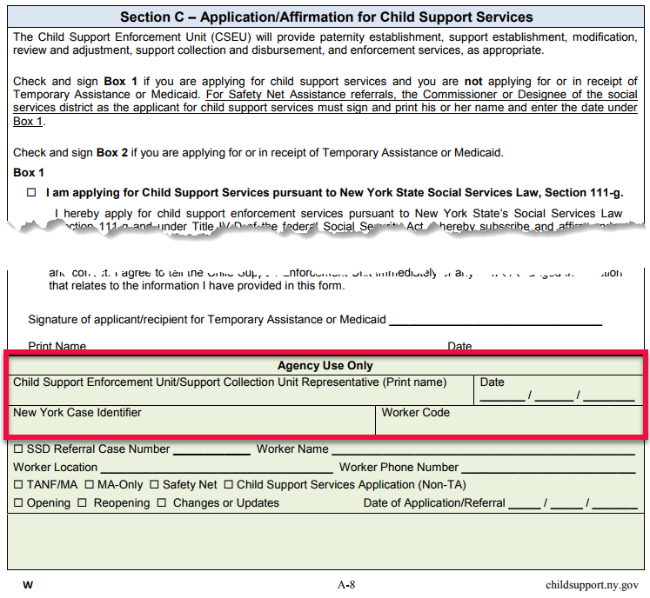

#### Worker reviews LDSS-4882 form for completeness

If still attached upon receipt, detach the **Application/Referral for Child Support Services** and return the **Information about Child Support Services** section of the [LDSS-4882](http://otda.state.nyenet/assets/pages/PDFs/Child_Support_Application/LDSS-4882W.pdf?rhtocid=_10_1_6#bc-1) to the customer.  Review the [LDSS-4882](http://otda.state.nyenet/assets/pages/PDFs/Child_Support_Application/LDSS-4882W.pdf?rhtocid=_10_1_6#bc-1) for completeness and confirm that the customer signed the [LDSS-4882](http://otda.state.nyenet/assets/pages/PDFs/Child_Support_Application/LDSS-4882W.pdf?rhtocid=_10_1_6#bc-1) in the appropriate area.  Determine if the information provided is sufficient to identify and locate the NCP/PF.

#### Minimum Required Information

For TA referrals, the applicant/recipient must provide the following information on the [LDSS-4882](http://otda.state.nyenet/assets/pages/PDFs/Child_Support_Application/LDSS-4882W.pdf?rhtocid=_10_1_6#bc-1) to help the CSEU identify and locate the NCP/PF:

* The full name and SSN of the NCP/PF

**OR**

* The full name of the NCP/PF and at least **two (2)** of the following concerning such parent or father:
  1.  Date of birth

 Residential address (and mailing address, if different)

 Telephone number

 Name and address of employer

**OR**

* The full name of the NCP/PF and any additional information equivalent to above that leads to the establishment of the NCP/PF’s identity and location.

If the customer is unable to provide the required information, the customer must attest, under penalty of perjury, to the lack of information by completing and signing the [LDSS-4281](http://otda.state.nyenet/assets/pages/HTML/Intake.htm)*.*

#### When Incomplete or Insufficient Information is Provided

If the information provided in the [LDSS-4882](http://otda.state.nyenet/assets/pages/PDFs/Child_Support_Application/LDSS-4882W.pdf?rhtocid=_10_1_6#bc-1) and supporting documentation is incomplete or insufficient to identify and locate the NCP/PF, contact the customer to determine if such information can provided.

#### Worker must provide notice of cooperation or non-cooperation to the TA Unit

To meet the cooperation standard for TA and MA cases, the customer must provide the information noted in the section above entitled "Minimum Required Information," or complete and sign the [LDSS-4281](http://otda.state.nyenet/assets/pages/HTML/Intake.htm).  The CSEU must notify the TA Unit of cooperation or non-cooperation via form [LDSS-2859](http://otda.ny.gov/policy/directives/2013/LCM/13-LCM-09-Attachment-1.pdf?rhtocid=_10_1_1#bc-1).

### Does customer claim personal safety concerns?

The question regarding safety is at the very top of the application form; it is the second question in the entire application.

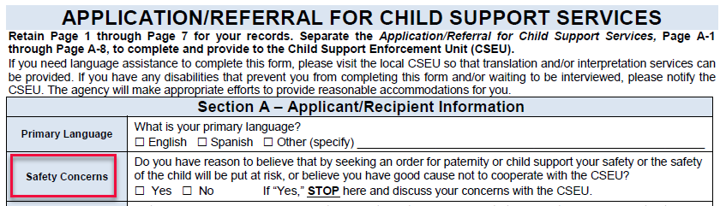

 If there is no indication of a safety concern, the worker should continue to process the [LDSS-4882](http://otda.state.nyenet/assets/pages/PDFs/Child_Support_Application/LDSS-4882W.pdf?rhtocid=_10_1_6#bc-1).

**If the customer has checked "Yes" to indicate safety concerns,** the worker must immediately stop the interview and refer the customer to the DVL, using local protocols.

There is a document concerning domestic violence waivers on [ERS](http://otda.state.nyenet/assets/default.htm) that the worker can print out and give to the customer. It is an attachment to [03-ADM-05](https://otda.ny.gov/policy/directives/2003/ADM/03_ADM-05-attach.pdf), entitled [Notice Regarding Child Support Requirements for Victims of Domestic Violence](http://otda.ny.gov/policy/directives/2006/INF/03-ADM-05-attach.pdf), and can be found at:  <http://otda.ny.gov/policy/directives/2006/INF/03-ADM-05-attach.pdf>

**If the application is received by mail, and the customer has indicated safety concerns,** the worker must contact the customer and explain the process for a referral to the DVL.

### Worker sends customer to Domestic Violence Liaison

When the CSEU refers a customer to a Domestic Violence Liaison for screening and assessment, it must notify the TA Unit of this action via the Information Transmittal form, [LDSS-2859](http://otda.ny.gov/policy/directives/2013/LCM/13-LCM-09-Attachment-1.pdf?rhtocid=_10_1_1#bc-1).

All CSEU activities must be suspended during the domestic violence screening and assessment process, and until a waiver decision is made by the Domestic Violence Liaison.

### Worker examines supporting documentation

1. Examine the supporting documentation:
   * 1. **Compare** information listed on the [LDSS-4882](http://otda.state.nyenet/assets/pages/PDFs/Child_Support_Application/LDSS-4882W.pdf?rhtocid=_10_1_6#bc-1) to information in the supporting documentation.

For example, verify that each party’s name *as listed on the* [*LDSS-4882*](http://otda.state.nyenet/assets/pages/PDFs/Child_Support_Application/LDSS-4882W.pdf?rhtocid=_10_1_6#bc-1) reflects the exact first name, middle name or initial, last name, and any applicable suffix *as recorded on the provided* ***supporting documentation***.

* + 1. **Verify** the listed information regarding each party’s:

 Date of birth.

 Employer information.

 Mailing and residential addresses, including floor number and apartment or suite number.

 Social Security number (SSN) or Individual Taxpayer Identification Number (ITIN), or other identification.

* + 1. **Reconcile** any discrepancies by contacting the applicant to determine the correct information.

1. Identify information to be referenced when building the case.
2. Determine which documents have evidentiary value for court proceedings.

The CSEU should retain documents such as:

 Award letters (TA only)

 Acknowledgement of Paternity forms

Marriage certificates

 Educational and unreimbursed health care expenses

 Most recently filed federal tax returns and all schedules

 Pay stubs

 Proof of child care

 W-2 forms

### CP signs Attestation to Lack of Information form

[Attestation to Lack of Information form LDSS-4281](http://otda.state.nyenet/ldss_eforms/eforms/4281.pdf?rhtocid=_10_1_3#bc-1)

[Attestation to Lack of Information -- Spanish-language version -- form LDSS-4281S](http://otda.state.nyenet/ldss_eforms/eforms/4281-SP.pdf?rhtocid=_10_1_4#bc-1) (Atestiguacion de Falta de Informacion)

### Worker interviews the customer (Optional)

No case should be built without a signed request for services (in the form of a signed [LDSS-4882](http://otda.state.nyenet/assets/pages/PDFs/Child_Support_Application/LDSS-4882W.pdf?rhtocid=_10_1_6#bc-1), a signed petition from court, or other signed document).

If the worker reviews the completed [LDSS-4882](http://otda.state.nyenet/assets/pages/PDFs/Child_Support_Application/LDSS-4882W.pdf?rhtocid=_10_1_6#bc-1) and supporting documentation, but does not yet have enough information to build a case, the worker will interview the customer, either by phone or in person (local protocols vary among districts).

During an interview, the worker should ask the customer to provide specific information needed to locate the NCP and proceed with other actions (e.g. paternity establishment, support establishment, enforcement).

In some districts, CSEU workers fill out the application form on ASSETS during the interview. Some districts also use electronic signature pads to capture the customer's signature.

Note: ***All*** applications and referrals must include a ***SIGNED*** request for child support services from the customer. Regardless of how the customer's signature is captured, the signed (paper or electronic) document must be kept on file with the case record, and must be readily available in case of an audit.

### Worker begins building the case

Use the completed [LDSS-4882](http://otda.state.nyenet/assets/pages/PDFs/Child_Support_Application/LDSS-4882W.pdf?rhtocid=_10_1_6#bc-1) to enter information into the application form on ASSETS **within twenty (20) calendar days** of receiving an Application/Referral for Child Support Services **[18 § NYCRR 347.18[a]]**.

For information on how to access the application form on ASSETS, refer to the [ASSETS User Guide](https://assets.otda.state.nyenet/) on ERS.

If the customer provides an ITIN instead of a SSN, enter the nine-digit number in the ITIN field.

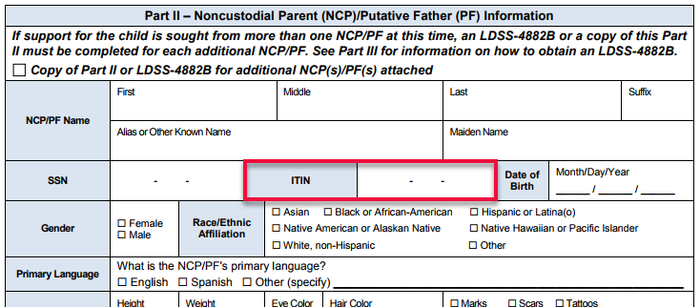

The ITIN is a tax processing number issued by the Internal Revenue Service (IRS). The first digit of that number is nine (9).  For more information on the ITIN, refer to the Dear Colleague letter dated April 12, 2005 regarding the entering of ITINs on CSMS.

When a case has successfully been built, the worker is notified of this by a message at the top of the online application form.

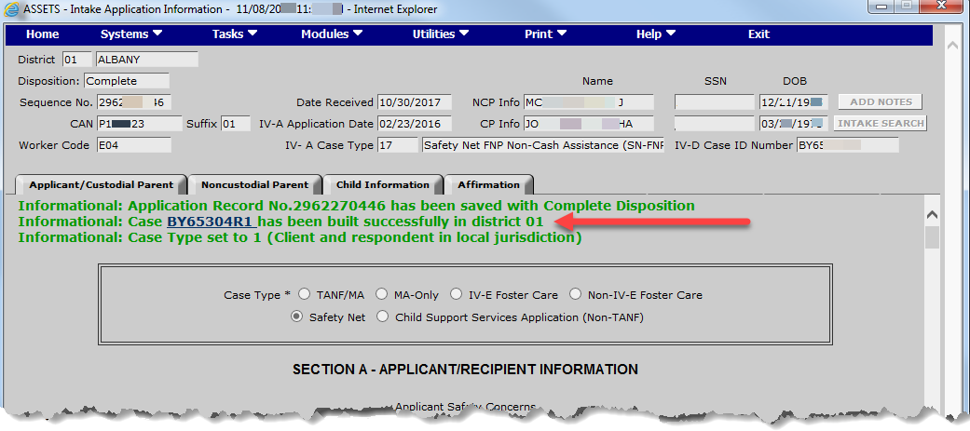

The worker should fill in the *New York Case Identifier* and *Worker Code* on page A-8 of the [LDSS-4882](http://otda.state.nyenet/assets/pages/PDFs/Child_Support_Application/LDSS-4882W.pdf?rhtocid=_10_1_6#bc-1) under ***Agency Use Only***.

The [LDSS-4882](http://otda.state.nyenet/assets/pages/PDFs/Child_Support_Application/LDSS-4882W.pdf?rhtocid=_10_1_6#bc-1) must be kept on file as part of the case record.

## Non-TA Cases (Intake) - Introduction

### $25 Annual Service Fee — More Information

#### What is the $25 Annual Service Fee?

Federal law requires each state to charge an annual fee of $25 for child support services to custodial parents who have never received TANF benefits. This fee is charged by the CSEU to the CP in exchange for receiving child support services.

The customer is informed of the fee in Section 5 of the [Child Support Application/Referral form](http://otda.state.nyenet/assets/pages/PDFs/Child_Support_Application/LDSS-4882W.pdf?rhtocid=_10_1_6#bc-1). Information is also provided on the [DCSE website](https://www.childsupport.ny.gov/dcse/home.html), which includes answers to frequently asked questions concerning the fee.

#### Who Must Pay the Fee?

The fee must be paid by any child support applicant who is not receiving and never has received temporary assistance in any state, and has had $500 or more collected on their behalf during the federal fiscal year (October 1 through September 30).

You can see whether a customer is eligible by looking at the Case Mode > Case tab of ASSETS, in the IV-A Case Status field. The value for this case indicates that the customer has been on assistance in the past, so she would not be required to pay the fee.

#### How to Identify Whether the Fee Has Been Paid

To identify whether the fee has been withheld, look at the Account Mode > Money tab:

* + Trans Code: 80
  + Trans Type:  DISF
  + Batch Number:  7

#### To Prevent the $25 Fee From Being Withheld

If ASSETS indicates that the customer has never been on assistance and then you find out that they have, you need to update the case so that they will not be charged the $25 Annual Service Fee.

To do this

* 1. Verify that the family is or has been on TANF by going to case mode/client tab of ASSETS
  2. Click "Update"
  3. In the Client Fee Indicator field, use the dropdown box to select "Ineligible"
  4. Click "Submit"
  5. The case is now updated, and the fee will not be charged

#### Refunding the $25 Annual Service Fee

If the fee was withheld, and the CSEU subsequently discovers that it should not have been withheld, the CSEU must refund the fee to the customer.

If you verify that the fee needs to be refunded to the customer, you need to do an 80 batch type. To do batches, you need to have the appropriate financial transaction role.

If you do, you will be able to do batches by going to the financial transaction module. Once on the ASSETS Financial Transactions screen, enter the account number, transaction amount and the ledger type.

Then you save and submit, and the next day you can review the Account Mode > Money  tab. That screen will show the fee that was previously withheld being disbursed to the customer.

## Non-TA Process (Intake)

### Roadmap:  Non-TA Process — Intake

Nodes in this process diagram that have a plus sign inside a green circle image30.gif on them are linked to drill-down content. Click on those nodes to get more details about that step.

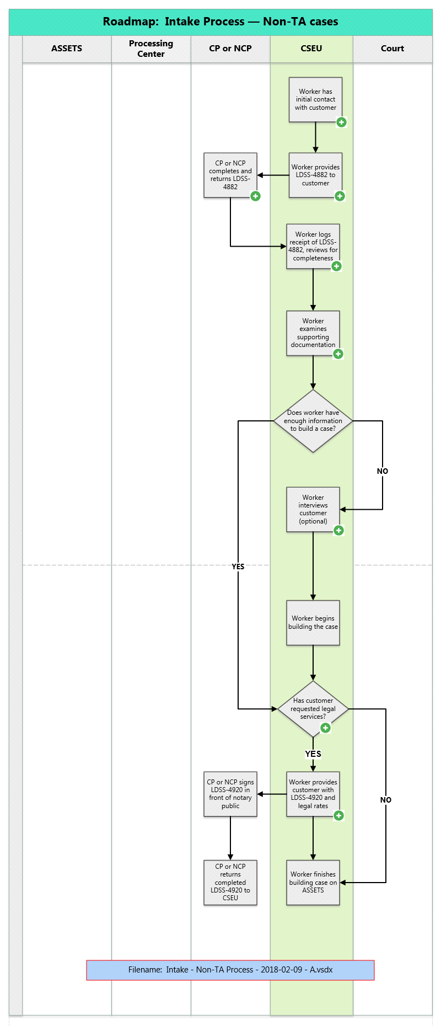

### Worker has initial contact with customer

The worker must explain to the Non-TA customer the full range of child support services, including:

* + Which services are non-optional when a customer applies for child support services.
  + Which services are optional.
  + What services are *not provided* by the CSEU.

#### Basic (Non-Optional) Services, provided for all cases:

The following are services provided to **all** customers applying for child support services:

* + 1. Collection of child support payments through the Support Collection Unit.

(All payments must go through the State Disbursement Unit, i.e. the Processing Center.)

* + 1. Enforcement of support obligations through all available means.

(Customers cannot choose which enforcement actions will be pursued and which won't.)

All of the above services are provided for a single $25 annual fee.

The worker should ask the customer to provide specific information needed to carry out actions necessary for her/his case (e.g. paternity establishment, support establishment, enforcement).

Also, the worker should explain to the customer how collection and distribution work.

#### Optional Services

Legal services are optional for Non-TA customers.

See the section of this manual entitled "Has customer requested legal services?"

#### Services Not Available Through the CSEU

The worker should explain to the customer that the CSEU does not provide assistance in:

* + Seeking custody of children.
  + Seeking visitation rights.
  + Seeking spousal support.

### Worker provides LDSS-4882 to customer

The CSEU must provide the [LDSS-4882](http://otda.state.nyenet/assets/pages/PDFs/Child_Support_Application/LDSS-4882W.pdf?rhtocid=_10_1_6#bc-1) to anyone who requests one.

**If the request is made in person**, the CSEU must provide the [LDSS-4882](http://otda.state.nyenet/assets/pages/PDFs/Child_Support_Application/LDSS-4882W.pdf?rhtocid=_10_1_6#bc-1) to the customer on the day of the request.

**If the request is made by telephone or in writing,** the CSEU must send the [LDSS-4882](http://otda.state.nyenet/assets/pages/PDFs/Child_Support_Application/LDSS-4882W.pdf?rhtocid=_10_1_6#bc-1) to the customer within five (5) business days of the request.

The CSEU should keep a log of dates when [LDSS-4882](http://otda.state.nyenet/assets/pages/PDFs/Child_Support_Application/LDSS-4882W.pdf?rhtocid=_10_1_6#bc-1) forms were provided to customers, and also enter such dates into the case records once the cases are built. This is important, as it relates to federal data reliability audits.

**Note:**  Customer Service Representatives (CSRs) at the New York State Child Support Helpline (CSH) (at the Processing Center) will send the [LDSS-4882](http://otda.state.nyenet/assets/pages/PDFs/Child_Support_Application/LDSS-4882W.pdf?rhtocid=_10_1_6#bc-1) to customers who request one, as well as inform them of the availability of the [LDSS-4882](http://otda.state.nyenet/assets/pages/PDFs/Child_Support_Application/LDSS-4882W.pdf?rhtocid=_10_1_6#bc-1) for print or download on the New York State child support website, at [childsupport.ny.gov](http://childsupport.ny.gov).

### CP or NCP completes & returns LDSS-4882

All customers requesting child support services must complete and sign an [LDSS-4882](http://otda.state.nyenet/assets/pages/PDFs/Child_Support_Application/LDSS-4882W.pdf?rhtocid=_10_1_6#bc-1).

**\* The exception to this** is direct-from-court cases in which a court order for child support is accompanied by a request for child support services in the form of a petition, motion, or other court document signed by the customer/petitioner.

The Child Support Application/Referral form ([LDSS-4882](http://otda.state.nyenet/assets/pages/PDFs/Child_Support_Application/LDSS-4882W.pdf?rhtocid=_10_1_6#bc-1)) has space for only one NCP/PF and one child.

#### When There Is More Than One NCP or PF — LDSS-4882B

If support for the child is sought from more than one NCP, or the customer provides several possible PFs for the child:

* For each additional NCP/PF, the customer must complete one form [LDSS-4882B](http://otda.state.nyenet/assets/pages/PDFs/Child_Support_Application/LDSS-4882BW_ncp.pdf?rhtocid=_10_1_8#bc-1), [Information for an Additional Noncustodial Parent (NCP) / Putative Father (PF)](http://otda.state.nyenet/assets/pages/PDFs/Child_Support_Application/LDSS-4882BW_ncp.pdf?rhtocid=_10_1_8#bc-1).
* Alternatively:  Copies of a blank **Part II – Noncustodial Parent (NCP) / Putative Father (PF) Information** (page A-3 and page A-4 of the [LDSS-4882](http://otda.state.nyenet/assets/pages/PDFs/Child_Support_Application/LDSS-4882W.pdf?rhtocid=_10_1_6#bc-1)) may be made, completed, and kept on file in lieu of the [LDSS-4882B](http://otda.state.nyenet/assets/pages/PDFs/Child_Support_Application/LDSS-4882BW_ncp.pdf?rhtocid=_10_1_8#bc-1).

The [LDSS-4882B](http://otda.state.nyenet/assets/pages/PDFs/Child_Support_Application/LDSS-4882BW_ncp.pdf?rhtocid=_10_1_8#bc-1) is available on ERS and on the New York State child support website at [childsupport.ny.gov](http://childsupport.ny.gov).

If an [LDSS-4882B](http://otda.state.nyenet/assets/pages/PDFs/Child_Support_Application/LDSS-4882BW_ncp.pdf?rhtocid=_10_1_8#bc-1) or a completed copy of **Part II – Noncustodial Parent (NCP) / Putative Father (PF) Information** is attached to the [LDSS-4882](http://otda.state.nyenet/assets/pages/PDFs/Child_Support_Application/LDSS-4882W.pdf?rhtocid=_10_1_6#bc-1), the customer must check the box under **Part II – Noncustodial Parent (NCP) / Putative Father (PF) Information** at the top of page A-3 of the [LDSS-4882](http://otda.state.nyenet/assets/pages/PDFs/Child_Support_Application/LDSS-4882W.pdf?rhtocid=_10_1_6#bc-1) to indicate that information about additional NCP(s)/PF(s) is being attached to the [LDSS-4882](http://otda.state.nyenet/assets/pages/PDFs/Child_Support_Application/LDSS-4882W.pdf?rhtocid=_10_1_6#bc-1).



If the [LDSS-4882B](http://otda.state.nyenet/assets/pages/PDFs/Child_Support_Application/LDSS-4882BW_ncp.pdf?rhtocid=_10_1_8#bc-1) is used, the customer must indicate the number of [LDSS-4882B](http://otda.state.nyenet/assets/pages/PDFs/Child_Support_Application/LDSS-4882BW_ncp.pdf?rhtocid=_10_1_8#bc-1) forms attached to the [LDSS-4882](http://otda.state.nyenet/assets/pages/PDFs/Child_Support_Application/LDSS-4882W.pdf?rhtocid=_10_1_6#bc-1) by entering the page information at the top of page 1 of each [LDSS-4882B](http://otda.state.nyenet/assets/pages/PDFs/Child_Support_Application/LDSS-4882BW_ncp.pdf?rhtocid=_10_1_8#bc-1).



#### When There Is More Than One Child — LDSS-4882C

The [LDSS-4882](http://otda.state.nyenet/assets/pages/PDFs/Child_Support_Application/LDSS-4882W.pdf?rhtocid=_10_1_6#bc-1) has space to accommodate information for only one child.  If the application is for a case involving more than one child, the applicant must provide information about each additional child.

* + The customer must complete and sign an [LDSS-4882C, Information for an Additional Child](http://otda.state.nyenet/assets/pages/PDFs/Child_Support_Application/LDSS-4882CW_child.pdf?rhtocid=_10_1_9#bc-1) form for each additional child.
  + Alternatively, a copy of a blank **Part III - Child Information** (page A-5 of the [LDSS-4882](http://otda.state.nyenet/assets/pages/PDFs/Child_Support_Application/LDSS-4882W.pdf?rhtocid=_10_1_6#bc-1)) may be used.

The [LDSS-4882C](http://otda.state.nyenet/assets/pages/PDFs/Child_Support_Application/LDSS-4882CW_child.pdf) is available on [ERS](http://otda.state.nyenet/assets/) and on the New York State child support website at [childsupport.ny.gov](https://childsupport.ny.gov).

If an [LDSS-4882C](http://otda.state.nyenet/assets/pages/PDFs/Child_Support_Application/LDSS-4882CW_child.pdf) or a completed copy of **Part III – Child Information** is attached to the [LDSS-4882](http://otda.state.nyenet/assets/pages/PDFs/Child_Support_Application/LDSS-4882W.pdf?rhtocid=_10_1_6#bc-1), the customer must check the box under **Part III – Child Information** at the top of page A-5 of the [LDSS-4882](http://otda.state.nyenet/assets/pages/PDFs/Child_Support_Application/LDSS-4882W.pdf?rhtocid=_10_1_6#bc-1) to indicate that information for additional children is being provided.



If the [LDSS-4882C](http://otda.state.nyenet/assets/pages/PDFs/Child_Support_Application/LDSS-4882CW_child.pdf) is used, the applicant must indicate the number of [LDSS-4882C](http://otda.state.nyenet/assets/pages/PDFs/Child_Support_Application/LDSS-4882CW_child.pdf) forms attached to the [LDSS-4882](http://otda.state.nyenet/assets/pages/PDFs/Child_Support_Application/LDSS-4882W.pdf?rhtocid=_10_1_6#bc-1) by entering the page information at the top of page 1 of each [LDSS-4882C](http://otda.state.nyenet/assets/pages/PDFs/Child_Support_Application/LDSS-4882CW_child.pdf).



#### Supporting Documentation Also Is Required

In addition, documentation must be provided to verify information on the [LDSS-4882](http://otda.state.nyenet/assets/pages/PDFs/Child_Support_Application/LDSS-4882W.pdf?rhtocid=_10_1_6#bc-1) and to support the CSEU’s efforts to establish paternity and to establish, modify or enforce an order of support.

The [LDSS-4882](http://otda.state.nyenet/assets/pages/PDFs/Child_Support_Application/LDSS-4882W.pdf?rhtocid=_10_1_6#bc-1) and any available supporting documentation must be returned to the CSEU.

## 

### Worker records receipt of the LDSS-4882, and reviews it for completeness

After reviewing the [LDSS-4882](http://otda.state.nyenet/assets/pages/PDFs/Child_Support_Application/LDSS-4882W.pdf?rhtocid=_10_1_6#bc-1) and supporting documentation, the worker completes the Child Support Enforcement Unit/Support Collection Unit Representative and Date areas on page A-8 of the [LDSS-4882](http://otda.state.nyenet/assets/pages/PDFs/Child_Support_Application/LDSS-4882W.pdf?rhtocid=_10_1_6#bc-1), under ***Agency Use Only*,** to record receipt of the [LDSS-4882](http://otda.state.nyenet/assets/pages/PDFs/Child_Support_Application/LDSS-4882W.pdf?rhtocid=_10_1_6#bc-1).

**The date entered in this space by the worker begins the 20-day deadline to build a child support case.**



#### Worker reviews LDSS-4882 form for completeness

If still attached upon receipt, detach the **Application/Referral for Child Support Services** and return the **Information about Child Support Services** section of the [LDSS-4882](http://otda.state.nyenet/assets/pages/PDFs/Child_Support_Application/LDSS-4882W.pdf?rhtocid=_10_1_6#bc-1) to the customer.  Review the [LDSS-4882](http://otda.state.nyenet/assets/pages/PDFs/Child_Support_Application/LDSS-4882W.pdf?rhtocid=_10_1_6#bc-1) for completeness and confirm that the customer signed the [LDSS-4882](http://otda.state.nyenet/assets/pages/PDFs/Child_Support_Application/LDSS-4882W.pdf?rhtocid=_10_1_6#bc-1) in the appropriate area.  Determine if the information provided is sufficient to identify and locate the NCP/PF.

#### Minimum Required Information

For TA referrals, the applicant/recipient must provide the following information on the [LDSS-4882](http://otda.state.nyenet/assets/pages/PDFs/Child_Support_Application/LDSS-4882W.pdf?rhtocid=_10_1_6#bc-1) to help the CSEU identify and locate the NCP/PF:

* The full name and SSN of the NCP/PF

**OR**

* The full name of the NCP/PF and at least **two (2)** of the following concerning such parent or father:
  1.  Date of birth

 Residential address (and mailing address, if different)

 Telephone number

 Name and address of employer

**OR**

* The full name of the NCP/PF and any additional information equivalent to above that leads to the establishment of the NCP/PF’s identity and location.

If the customer is unable to provide the required information, the customer must attest, under penalty of perjury, to the lack of information by completing and signing the [LDSS-4281](http://otda.state.nyenet/assets/pages/HTML/Intake.htm)*.*

#### When Incomplete or Insufficient Information is Provided

If the information provided in the [LDSS-4882](http://otda.state.nyenet/assets/pages/PDFs/Child_Support_Application/LDSS-4882W.pdf?rhtocid=_10_1_6#bc-1) and supporting documentation is incomplete or insufficient to identify and locate the NCP/PF, contact the customer to determine if such information can provided.

#### Worker must provide notice of cooperation or non-cooperation to the TA Unit

To meet the cooperation standard for TA and MA cases, the customer must provide the information noted in the section above entitled "Minimum Required Information," or complete and sign the [LDSS-4281](http://otda.state.nyenet/assets/pages/HTML/Intake.htm).  The CSEU must notify the TA Unit of cooperation or non-cooperation via form [LDSS-2859](http://otda.ny.gov/policy/directives/2013/LCM/13-LCM-09-Attachment-1.pdf?rhtocid=_10_1_1#bc-1).

### Worker begins building the case

Use the completed [LDSS-4882](http://otda.state.nyenet/assets/pages/PDFs/Child_Support_Application/LDSS-4882W.pdf?rhtocid=_10_1_6#bc-1) to enter information into the application form on ASSETS **within twenty (20) calendar days** of receiving an Application/Referral for Child Support Services **[18 § NYCRR 347.18[a]]**.

For information on how to access the application form on ASSETS, refer to the [ASSETS User Guide](https://assets.otda.state.nyenet/) on ERS.

If the customer provides an ITIN instead of a SSN, enter the nine-digit number in the ITIN field.



The ITIN is a tax processing number issued by the Internal Revenue Service (IRS). The first digit of that number is nine (9).  For more information on the ITIN, refer to the Dear Colleague letter dated April 12, 2005 regarding the entering of ITINs on CSMS.

When a case has successfully been built, the worker is notified of this by a message at the top of the online application form.



The worker should fill in the *New York Case Identifier* and *Worker Code* on page A-8 of the [LDSS-4882](http://otda.state.nyenet/assets/pages/PDFs/Child_Support_Application/LDSS-4882W.pdf?rhtocid=_10_1_6#bc-1) under ***Agency Use Only***.

The [LDSS-4882](http://otda.state.nyenet/assets/pages/PDFs/Child_Support_Application/LDSS-4882W.pdf?rhtocid=_10_1_6#bc-1) must be kept on file as part of the case record.

### Worker examines supporting documentation

1. Examine the supporting documentation:
   * 1. **Compare** information listed on the [LDSS-4882](http://otda.state.nyenet/assets/pages/PDFs/Child_Support_Application/LDSS-4882W.pdf?rhtocid=_10_1_6#bc-1) to information in the supporting documentation.

For example, verify that each party’s name *as listed on the* [*LDSS-4882*](http://otda.state.nyenet/assets/pages/PDFs/Child_Support_Application/LDSS-4882W.pdf?rhtocid=_10_1_6#bc-1) reflects the exact first name, middle name or initial, last name, and any applicable suffix *as recorded on the provided* ***supporting documentation***.

* + 1. **Verify** the listed information regarding each party’s:

 Date of birth.

 Employer information.

 Mailing and residential addresses, including floor number and apartment or suite number.

 Social Security number (SSN) or Individual Taxpayer Identification Number (ITIN), or other identification.

* + 1. **Reconcile** any discrepancies by contacting the applicant to determine the correct information.

1. Identify information to be referenced when building the case.
2. Determine which documents have evidentiary value for court proceedings.

The CSEU should retain documents such as:

 Award letters (TA only)

 Acknowledgement of Paternity forms

Marriage certificates

 Educational and unreimbursed health care expenses

 Most recently filed federal tax returns and all schedules

 Pay stubs

 Proof of child care

 W-2 forms

### Worker interviews the customer (Optional)

No case should be built without a signed request for services (in the form of a signed [LDSS-4882](http://otda.state.nyenet/assets/pages/PDFs/Child_Support_Application/LDSS-4882W.pdf?rhtocid=_10_1_6#bc-1), a signed petition from court, or other signed document).

If the worker reviews the completed [LDSS-4882](http://otda.state.nyenet/assets/pages/PDFs/Child_Support_Application/LDSS-4882W.pdf?rhtocid=_10_1_6#bc-1) and supporting documentation, but does not yet have enough information to build a case, the worker will interview the customer, either by phone or in person (local protocols vary among districts).

During an interview, the worker should ask the customer to provide specific information needed to locate the NCP and proceed with other actions (e.g. paternity establishment, support establishment, enforcement).

In some districts, CSEU workers fill out the application form on ASSETS during the interview. Some districts also use electronic signature pads to capture the customer's signature.

Note: ***All*** applications and referrals must include a ***SIGNED*** request for child support services from the customer. Regardless of how the customer's signature is captured, the signed (paper or electronic) document must be kept on file with the case record, and must be readily available in case of an audit.

### CP or NCP requests legal services

Legal services are optional for Non-TA customers.

If the Non-TA customer is the CP, and wishes to apply for legal services, he or she must indicate this by checking Box 1 in **Section C – Application/Affirmation for Child Support Services** on the [LDSS-4882](http://otda.state.nyenet/assets/pages/PDFs/Child_Support_Application/LDSS-4882W.pdf?rhtocid=_10_1_6#bc-1).

The CP or NCP can request legal services at any time that there is an open child support case.

The CSEU is entitled to recover the costs for legal services provided to Non-TA customers. Therefore, the customer must complete and sign the "[Right to Recovery Agreement for Legal Services](http://otda.state.nyenet/assets/pages/PDFs/Intake/Right_to_Recovery_-_Legal.pdf)" --  form [LDSS-4920](http://otda.state.nyenet/assets/pages/PDFs/Intake/Right_to_Recovery_-_Legal.pdf?rhtocid=_10_1_10#bc-1).

(Note:  Customers in foster care, TA, or Medicaid cases are not given this form, since the DSS does not seek cost recovery for legal services provided to these customers.)

The CSEU worker must explain to the customer that:

* 1. The customer's signature on this document gives the local Department of Social Services the right to recover the money it spends to provide legal services for her/his case.
  2. "Legal representation" means representation that cannot be provided by regular CSEU staff.  There is no attorney-client privilege or confidentiality between the customer and the attorney; the CSEU attorney represents the interests of the CSEU.  Legal representation will be provided only to the extent that the customer’s interests are similar to, and do not conflict with, those of the CSEU.
  3. The CSEU will, as authorized, recover the cost of these services by retaining up to 25% of the current support obligation amount in the case, until the total cost has been recovered.  *Distribution Rules*

Based upon distribution rules, the CP will be paid first, and payments will be applied to the CP's ledger until the net due is satisfied.

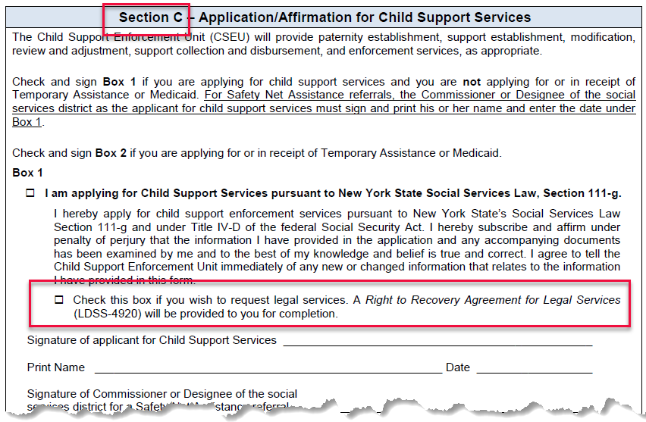

### Worker provides customer with legal rates

The worker provides the customer with form [LDSS-4920](http://otda.state.nyenet/assets/pages/PDFs/Intake/Right_to_Recovery_-_Legal.pdf?rhtocid=_10_1_10#bc-1), the [Right to Recovery Agreement for Legal Services](http://otda.state.nyenet/assets/pages/PDFs/Intake/Right_to_Recovery_-_Legal.pdf?rhtocid=_10_1_10#bc-1).

The [LDSS-4920](http://otda.state.nyenet/assets/pages/PDFs/Intake/Right_to_Recovery_-_Legal.pdf?rhtocid=_10_1_10#bc-1) has a blank field where the legal rate should appear.

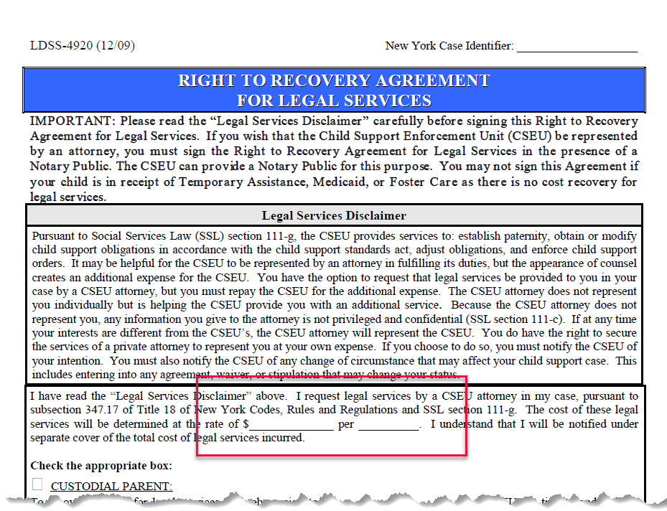

The CSEU worker must:

* 1. Fill in the rate for legal services.
  2. Explain the legal rates to the customer.
  3. Give the form to the customer.

Additionally, the worker must explain to the customer that:

* 1. The attorney is the legal representative of the Commissioner of the Social Services District, and does not represent the customer personally.
  2. There is no attorney-client privilege (i.e. confidentiality) between the customer and the attorney.
  3. Attorney services are limited to establishment of paternity and the establishment, modification, adjustment, and enforcement of support obligations.

Form [LDSS-4920](http://otda.state.nyenet/assets/pages/PDFs/Intake/Right_to_Recovery_-_Legal.pdf?rhtocid=_10_1_10#bc-1) is available in Spanish, as well: [LDSS-4920SP](http://otda.state.nyenet/assets/pages/PDFs/Intake/Right_to_Recovery_-_Legal_-_Spanish.pdf) ([Acuerdo Sobre Derechos de Recuperacion de Pagos por Servicios Legales](http://otda.state.nyenet/assets/pages/PDFs/Intake/Right_to_Recovery_-_Legal_-_Spanish.pdf?rhtocid=_10_1_11#bc-1)).

See also:  [10-ADM-02](http://otda.ny.gov/policy/directives/2010/ADM/10-ADM-02.pdf), issued March 23, 2010, entitled [Legal Services and Cost Recovery for Recipients of Child Support Services](http://otda.ny.gov/policy/directives/2010/ADM/10-ADM-02.pdf).

### Worker begins building the case

Use the completed [LDSS-4882](http://otda.state.nyenet/assets/pages/PDFs/Child_Support_Application/LDSS-4882W.pdf?rhtocid=_10_1_6#bc-1) to enter information into the application form on ASSETS **within twenty (20) calendar days** of receiving an Application/Referral for Child Support Services **[18 § NYCRR 347.18[a]]**.

For information on how to access the application form on ASSETS, refer to the [ASSETS User Guide](https://assets.otda.state.nyenet/) on ERS.

If the customer provides an ITIN instead of a SSN, enter the nine-digit number in the ITIN field.



The ITIN is a tax processing number issued by the Internal Revenue Service (IRS). The first digit of that number is nine (9).  For more information on the ITIN, refer to the Dear Colleague letter dated April 12, 2005 regarding the entering of ITINs on CSMS.

When a case has successfully been built, the worker is notified of this by a message at the top of the online application form.



The worker should fill in the *New York Case Identifier* and *Worker Code* on page A-8 of the [LDSS-4882](http://otda.state.nyenet/assets/pages/PDFs/Child_Support_Application/LDSS-4882W.pdf?rhtocid=_10_1_6#bc-1) under ***Agency Use Only***.

The [LDSS-4882](http://otda.state.nyenet/assets/pages/PDFs/Child_Support_Application/LDSS-4882W.pdf?rhtocid=_10_1_6#bc-1) must be kept on file as part of the case record.

## Foster Care Cases

### Foster Care Cases

What is the difference between Title IV-E Foster Care and Non-Title IV-E Foster Care?

#### IV-E Foster Care

Title IV-E Foster Care expenditures are reimbursable by up to 66% by the federal government.

To build a IV-E Foster Care case, select the IV-E Foster Care radio button at the top of the online application form, then build the case as you would a Non-TA case.

To build a IV-E Foster Care case, the worker must select the IV-E Foster Care radio button.

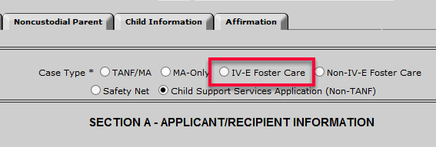

**In order to select that radio button, the following conditions must be met:**

* The Child Services Code must be set to Code E.

**AND**

* Case Type must be "40" for upstate, or "13" for NYC.

ASSETS will open a C Group status, specific to Title IV-E Foster Care cases, to ensure proper federal reporting.

#### Non-IV-E Foster Care

Non-Title IV-E Foster Care cases receive no funding from the federal government. They are funded entirely through non-federal sources, such as state or county funding.

To build a Non-IV-E Foster Care case, select the Non-IV-E Foster Care radio button at the top of the online application form, then build the case as you would a Non-TA case.

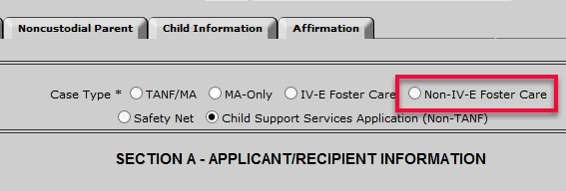

When the worker builds a Non-IV-E Foster Care case, ASSETS opens a Y Group status, ensuring that these cases are not reported as eligible for federal reimbursement.

## Safety Net Cases

### Safety Net Cases

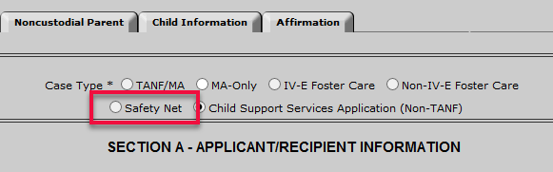

Safety Net is similar to TANF, but is not the same as TANF.

* The Commissioner or Designee of the social services district — as the applicant for child support services — must print his/her name, sign the form, and enter the date under Box 1 of page A-8 of the LDSS-4882 form.
* The TA worker must complete the "*Agency Use Only*" section at the bottom of page A-8.

**Note:**  Date of Referral is the date that the CAN is added to the database.

* When a Safety Net case is built, ASSETS automatically opens a Y Group.

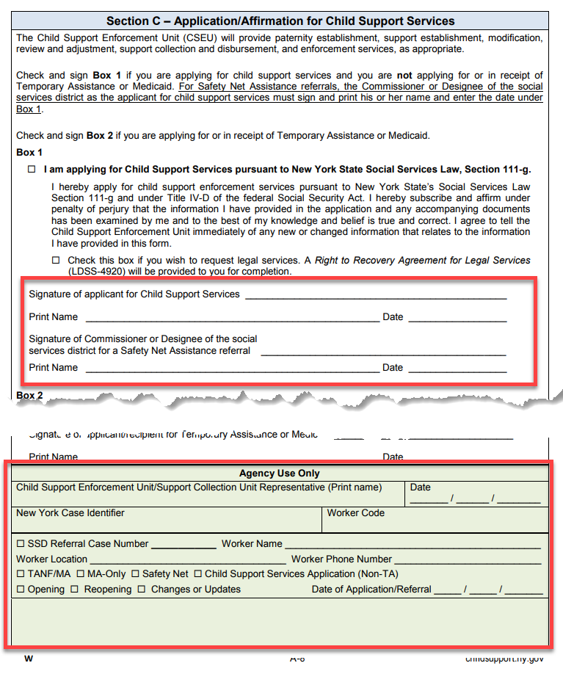

## Case-Building

### Case-Building — Overview

**IMPORTANT:**

**Workers should check the IVA-IVD Interface Report daily.**

**All cases must be built within 20 days of receipt of an application or referral.**

#### TA Referral appears on IVA-IVD Interface Report

**Bottom Line:  Wait until the CSEU receives the paper** [**LDSS-4882**](http://otda.state.nyenet/assets/pages/PDFs/Child_Support_Application/LDSS-4882W.pdf?rhtocid=_10_1_6#bc-1)**, then build the case through Referral Search.**

**See:**[Home](http://uatweb06.otda.state.nyenet/assets/Xexperimental/Program_Manual_Test/homepage.htm)>[Intake](http://uatweb06.otda.state.nyenet/assets/Xexperimental/Program_Manual_Test/INTAKE/Intake_-_Cover_Page.htm)>[Case-Building](http://uatweb06.otda.state.nyenet/assets/Xexperimental/Program_Manual_Test/INTAKE/Case-Building/Case-Building_-_An_Introduction.htm)> Referral Search - Building a Case from a Referral Search

*Learn more button - green 25 percent.png*

##### If the Paper LDSS-4882 Has Not Arrived at the CSEU

* If the CSEU has not yet received a paper [LDSS-4882](http://otda.state.nyenet/assets/pages/PDFs/Child_Support_Application/LDSS-4882W.pdf?rhtocid=_10_1_6#bc-1) when the referral appears on the Worker Alerts > IVA Mode > IVA-IVD tab, the CSEU should notify the TA Unit of this via an [LDSS-2859](http://otda.ny.gov/policy/directives/2013/LCM/13-LCM-09-Attachment-1.pdf?rhtocid=_10_1_1#bc-1).
* If the CSEU still has not received an [LDSS-4882](http://otda.state.nyenet/assets/pages/PDFs/Child_Support_Application/LDSS-4882W.pdf?rhtocid=_10_1_6#bc-1) ten (10) days after the referral appears on the Worker Alerts > IVA Mode > IVA-IVD tab, the worker should:
  + 1. Notify the TA Unit, via an [LDSS-2859](http://otda.ny.gov/policy/directives/2013/LCM/13-LCM-09-Attachment-1.pdf?rhtocid=_10_1_1#bc-1), that the CSEU still has not received an [LDSS-4882](http://otda.state.nyenet/assets/pages/PDFs/Child_Support_Application/LDSS-4882W.pdf?rhtocid=_10_1_6#bc-1).
    2. Reach out to the customer and try to schedule an interview.

##### Using Referral Search to Build the Case

Why should you build the case through Referral Search?

Because in doing that, a link between WMS and ASSETS will be created for the case, and information about the CP and Child(ren) will be automatically imported from WMS into ASSETS.

Importing the data from WMS is better than keying (typing) the information into the Application form in ASSETS for the following reasons:

•         It saves a lot of time.

•         It preserves data integrity and reduces the chance of human error.

When a case is built through Referral Search, the customer must still submit a paper [LDSS-4882](http://otda.state.nyenet/assets/pages/PDFs/Child_Support_Application/LDSS-4882W.pdf?rhtocid=_10_1_6#bc-1), and the CSEU must keep the [LDSS-4882](http://otda.state.nyenet/assets/pages/PDFs/Child_Support_Application/LDSS-4882W.pdf?rhtocid=_10_1_6#bc-1) on file in the case records.

See also:  Cooperation Requirements for TA Cases

See also:  Roadmap: TA Cases — Intake Process

#### TA Referral Walk-Ins (TA referral customer walks in with a paper LDSS-4882)

**Bottom Line:  Build it as a Non-TA case, and convert it to a TA case later (by adding the CAN and CINs to the client record), when the temporary assistance goes active.**

* Note:  When ASSETS opens an X Group (visible on the Status Info screen), you will know that you've successfully converted the case from Non-TA to TA.

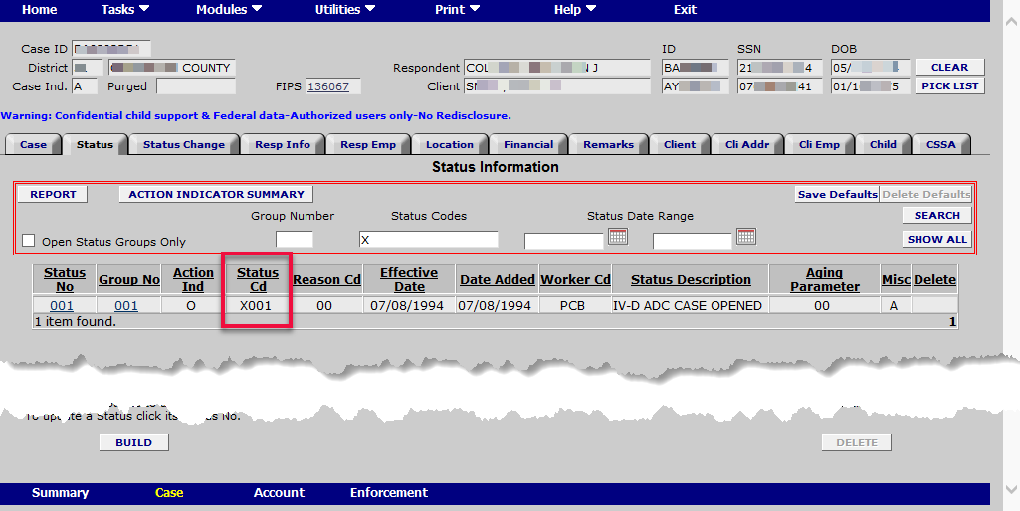

*Learn more button - green 25 percent.png*

If the customer carries the [LDSS-4882](http://otda.state.nyenet/assets/pages/PDFs/Child_Support_Application/LDSS-4882W.pdf?rhtocid=_10_1_6#bc-1) directly from the TA Unit to the CSEU, it is unlikely that the TA Unit has built a temporary assistance case yet – and therefore unlikely that the case will appear on the Worker Alerts > IVA Mode > IVA-IVD tab yet.

However, if the customer applied for temporary assistance at the TA Unit several days prior, and the CSEU only just now receives the [LDSS-4882](http://otda.state.nyenet/assets/pages/PDFs/Child_Support_Application/LDSS-4882W.pdf?rhtocid=_10_1_6#bc-1), the referral may be on theWorker Alerts > IVA Mode > IVA-IVD tab already.

The CSEU worker should check the Worker Alerts > IVA Mode > IVA-IVD tab to see whether a temporary assistance case for this customer is already active. The worker can also check this status by conducting a Referral Search using the CP's SSN.

**If the temporary assistance case is already active**, the worker should build the child support case through a Referral Search.

**If the temporary assistance case is not yet active**, the worker should build the case initially as a Non-TA case, and then convert it to a TA child support referral case when the TA Unit's case goes active.

To do that, follow the following steps:

* + 1. Build the case initially as a Non-TA case (This is in the interest of expediting case-building.)
    2. When the TA Unit’s case goes active, convert the Non-TA child support case to a TA child support referral case by doing the following:
       - 1. Enter the CP's CAN (found on the Worker Alerts > IVA Mode > IVA-IVD tab) into the client record.
         2. Enter the child(ren)'s CIN(s) into the client record.
         3. Enter the NCP's CAN and CIN into the client record, if these are available.  (This will ensure that if the NCP is on any sort of assistance, that will be taken into account when it comes to enforcement mechanisms.)

Entering the CAN into the case record will create a link between ASSETS and WMS for this case.

* + 1. Refresh the screen.

Any demographic information regarding the CP and Child(ren) that is available on WMS will now automatically be imported into the client record.

Also, going forward on this case, when information such as CP address is updated in WMS, the WMS system will subsequently, automatically update the information in ASSETS, as well.

See also:  Home > Intake > Troubleshooting > **ASSETS Changes CP or NCP Address On Its Own**

#### Non-TA customer submits an LDSS-4882 (in person or by mail)

**Bottom Line:  Build the case in the Application Form within the Intake module, using information gathered from the paper** [**LDSS-4882**](http://otda.state.nyenet/assets/pages/PDFs/Child_Support_Application/LDSS-4882W.pdf?rhtocid=_10_1_6#bc-1)**.**

### Referral Search — Building a Case from a Referral Search

Cases appearing on the Worker Alerts > IVA > IVA-IVD tab screen are active TA cases that have been referred to the CSEU. The Worker Alerts > IVA > IVA-IVD tab displays the CAN for each case.

To build a case from a Referral Search:

1. **Go to *Home > Modules > Intake >* Referral Search**

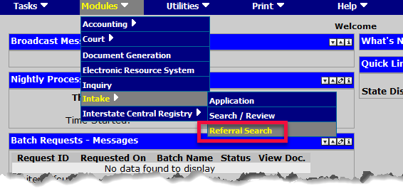

The  Welfare Reporting Tracking System (WRTS) Applicant Search screen appears.

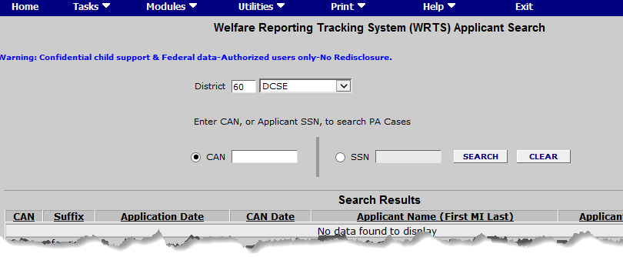

The WRTS is connected to WMS, and accesses the same files.

1. **Enter the CAN or SSN in the appropriate field, and click the Search button.**
   * + You can find the CAN on the Worker Alerts > IVA > IVA-IVD tab.
     + If you search by SSN to determine whether or not an NCP is on TA, this utility will tell you only whether or not NCP is on TA **in *New York State***.

The Select Participants for Child Support Applications screen will display all participants associated with that CAN or SSN.

1. **Select the participants for the case you are building, and assign their roles.**

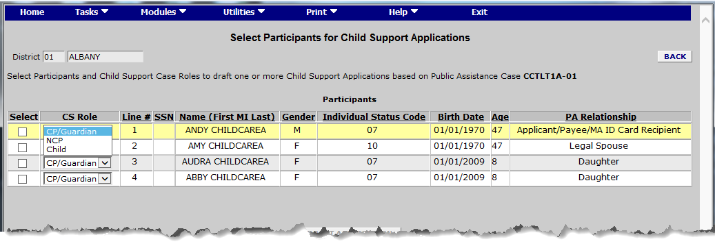

1. **Click on the** Draft Application **button.**

ASSETS drafts an application.

**If the draft application is not accepted**, ASSETS will display an error message telling the worker how to resolve the issue.

(Note: The Build Application button will become active only if ASSETS accepts the draft application first.)

**If the draft application is accepted**, the Build Application button — previously "grayed out" —  becomes actionable.

1. **Click the** Build Application **button.**

The Application form within the Intake module appears.

When ASSETS builds the application, it will import from WMS all available child support-related data about the CP and Child(ren), and use it to pre-populate the Application/Referral Form.

1. **Select the radio button corresponding to the type of case you are building.**



1. **Proceed with building the case.**

-------------------------

## Troubleshooting - Intake

ASSETS Changes CP or NCP Address (Seemingly) On Its Own

Data entered into ASSETS by CSEU workers will not modify any data in the WMS system — but some changes made in the WMS system can modify or update data in the ASSETS system automatically.

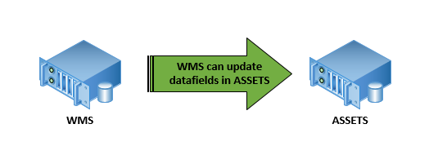

### How and when does WMS change a CP or NCP address in ASSETS?

When ASSETS receives from WMS a file containing a address for a CP or NCP, ASSETS reads the file and compares the address to the address that ASSETS already has.

If the address in ASSETS is more than 60 days old and the address from WMS is different from the one that ASSETS already has, ASSETS updates the address to match the address as reflected in the WMS system.

TA Applicant or Referral Never Arrived from TA or MA

The customer and/or a hard copy of the [LDSS-4882](http://otda.state.nyenet/assets/pages/PDFs/Child_Support_Application/LDSS-4882W.pdf?rhtocid=_10_1_6#bc-1) should arrive at the CSEU **within 2-3 business days** of a referral appearing on the Worker Alerts > IVA Mode > IVA-IVD tab.

If the applicant or application in a TA referral case never arrives, the worker should investigate why.

### Required actions if TA customer or referral form never arrives at CSEU:

If the applicant or application never arrives, the CSEU worker needs to:

* 1. Contact the referring agency.
  2. Find out why the application or applicant never arrived at the CSEU.
  3. Take appropriate actions.

### Possible reasons for "no-show" of TA referral :

* + The TA or MA Unit mistakenly set the IV-D Indicator with Code D, Code X, or Code Y, but child support services are/were not actually necessary.
  + The referral got lost or misplaced (after arriving at the CSEU).
  + The TA or MA Unit referred the case to the CSEU, but never built the case (i.e. after referral to the CSEU, the customer was denied temporary assistance).

In this instance, after confirming such with the referring agency, the CSEU worker must reject the case via the Worker Alerts > IVA Mode > IVA-IVD tab.

Worker cannot select IV-E Foster Care radio button



**In order to select the** **IV-E Foster Care radio button, the following conditions must be met:**

* The Child Service Code must be set to Code E.

**AND**

* Case Type must be "40" for upstate, or "13" for NYC.

Worker is kicked out of online Application Form

If the worker hits the "**Backspace**" key while entering information into the online version of the application/referral form, the ASSETS system will kick the worker out of the application form.

Therefore, workers should:

* + Refrain from hitting the "backspace" key while filling in an online application.
  + Save their work after completing each section of the form.

Note: If a worker is kicked out of the application form, they will arrive at this screen:

