Location: Policies & Procedures
Table of Contents
Location 1
Introduction to Location 1
Acronyms Used in the Location Chapter 1
Introduction to Location 1
A. Location May Be Necessary Any Number of Times Over the Life Cycle of a Case 2
B. Goals of Location Processes and Procedures 3
B. Deadlines for Location 4
C. How are PF/NCP address and PF/NCP employer information verified? 4
Opening an L Group 4
A. A Worker Can Manually Open an L Group At Any Time 4
B. ASSETS Opens an L Group Automatically If the PF/NCP Address is Unknown at Time of Case-Building 4
C. ASSETS Opens an L Group Automatically When Certain Other Conditions Are Met 5
Ways In Which Data Enters Case Records in ASSETS 6
Ways in which data can enter a child support case record: 7
Minimum Information Required to Locate a PF/NCP 8
Essential Screens in the Location Process 9
New Hire Reporting (Fully Automated) 10
Introduction to New Hire Reporting 10
When a "New Hire" is reported 12
What information is included in New Hire Reporting? 12
Roadmap: New Hire Reporting 13
Case appears on Worker Alerts > Management mode > Overage Statuses tab 15
Proc Ctr enters appropriate code into Employer Verification Ind field 15
Automated Location Searches 16
Automated Location Searches — Introduction 16
A. How and when do automated searches begin? 16
B. What agencies or databases are searched? 16
State agency database searches (automated search) 17
Federal agency database searches (automated search) 17
Financial Institution Data Matches 18
C. What does "hits are reported" mean — versus "information is recorded"? 18
D. Where are hits from automated searches reported? 19
E. What does the worker need to do when automated searches return hits? 19
F. Where is information from automated searches recorded? 20
G. How can I verify PF/NCP address and employer information? 20
Manual Location Searches 20
Introduction to Manual Location Searches 21
A. How and when do manual (non-automated) location searches begin? 21
Social Security Number: Sources For Finding It 21
Deceased PF/NCP 23
Automated reporting of confirmed deaths 23
If the customer claims that the PF/NCP is deceased 24
Incarcerated PF/NCPs 24
If the customer indicates that the PF/NCP is or has been in prison, conduct a manual search 24
Military — PF or NCP Is In the Military 25
Military 25
Manually Entering Respondent Address or Employer Into Case Record 26
Manually Enter a 26
New Respondent Address Into the Case Record 26
Manually Enter an Employer into the Case Record 27
Verification of Address or Employment 28
Wage and Health Benefits Report (WHBR) 28
A. What is a WHBR? 28
B. When to use a WHBR 28
C. How to generate a WHBR 29
1. How to manually generate a WHBR 29
2. For new hires with a case-level only child support case, ASSETS automatically generates a WHBR (and the Processing Center prints and mails it) 29
C. When the employer receives a WHBR 30
D. When the completed WHBR arrives back at the Processing Center 31
E. To check the status of WHBRs sent to employers 31
F. Employer Verification Indicator Codes and their meanings 31
Postal Clearance Letter 31
(aka Address Information Request) 31
A. Summary 32
B. What is a PCL? 32
C. When to use a PCL 33
D. How to generate a PCL in ASSETS 33
E. When the Postmaster receives a PCL 33
F. To view the status of PCL queries 34
G. Address Verification Indicator (Ver Ind) codes and their meanings 34

Location

Introduction to Location

Acronyms Used in the Location Chapter

Acronym | Meaning
APRRS | Absent Parent Resource Reporting System
FPLS | Federal Parent Locator Service
IWO | Income Withholding Order (also known as an IEX, or Income Execution)
NCP | Non-Custodial Parent
NDNH | National Directory of New Hires
PCL | Postal Clearance Letter (also known as an Address Information Request)
PF | Putative Father
SDNH | State Directory of New Hires
SPLS | State Parent Locator Service
WHBR | Wage and Health Benefits Report

Introduction to Location
Location searches can be divided into two categories: automated searches and manual searches. 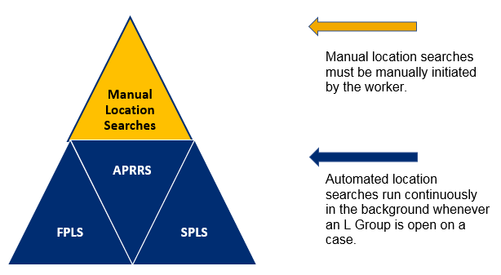

Additionally, automated searches of the following resources run continuously in the background at all times — even when there is no L Group open on a case:
  - Absent Parent Resource Reporting System (APRRS)
  - National Directory of New Hires (NDNH)
  - State Directory of New Hires (SDNH)

Location May Be Necessary Any Number of Times Over the Life Cycle of a Case
Locating a PF/NCP or his/her employer(s) and/or financial resources may be necessary any number of times over the life cycle of a case. This is simply because we live in an increasingly mobile society in which:
    - People relocate to other towns, states, or countries
    - People change jobs or have multiple jobs
    - People do temporary or seasonal work (e.g. supplemental work at Christmas, or seasonal work like snow plowing in the winter)
    - People join the military
    - People change their names
    - People become incarcerated or hospitalized — possibly in a facility (e.g. a residential addiction treatment facility) whose confidentiality rules prohibit disclosure of the identities of patients
Of course, locating the PF/NCP and his/her employer and/or financial resources is necessary in the beginning of a case in order to establish paternity, establish a support order, and begin collecting child support payments.

Goals of Location Processes and Procedures

  - Identify, as soon as possible, cases in which the PF/NCP's location and/or employer is unknown or questionable.
  - Conduct an investigation and generate leads using customer interviews, ASSETS, WRTS, automated searches of federal and state databases, non-automated (online and/or offline) searches, and local resources. (Note that investigators may initially pursue "soft leads" or circumstantial leads.)
  - Verify leads via the PCL and the WHBR forms.
  - Manually input information into the case record in ASSETS (if necessary).
  - Ensure that each PF/NCP whose name has been entered into ASSETS has a corresponding Social Security number.
  - Ensure that case information is communicated to appropriate staff.

Deadlines for Location
Within 75 days of determining that location of the PF/NCP is necessary, the CSEU must access all appropriate location resources and ensure that location information is sufficient to take the next appropriate action (e.g. paternity establishment, support collection, or enforcement).

How are PF/NCP address and PF/NCP employer information verified?
All Respondent addresses can be verified via a PCL.
See: Home > Location > Verification of Address or Employment > How to Generate a PCL

All Respondent employers can be verified via a WHBR or an IWO.
See: Home > Location > Verification of Address or Employment > How to Generate a WHBR.

Opening an L Group
An L Group can be opened (or re-opened) in any of several ways:

A Worker Can Manually Open an L Group At Any Time
A worker can manually open an L Group at any time by opening an L001 (Location Investigation Opened) status on the Case Mode > Status tab.

ASSETS Opens an L Group Automatically If the PF/NCP Address is Unknown at Time of Case-Building
During intake, if the worker checks the [NCP] "Address Unknown" checkbox, ASSETS opens an L Group.
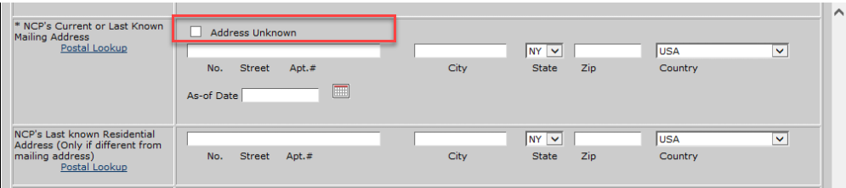

ASSETS Opens an L Group Automatically When Certain Other Conditions Are Met
ASSETS automatically opens an L Group and begins automated location searches when the following conditions are met:
    - PF/NCP's SSN is unknown.
OR

    - There is no verified mailing or residential address for the Respondent.
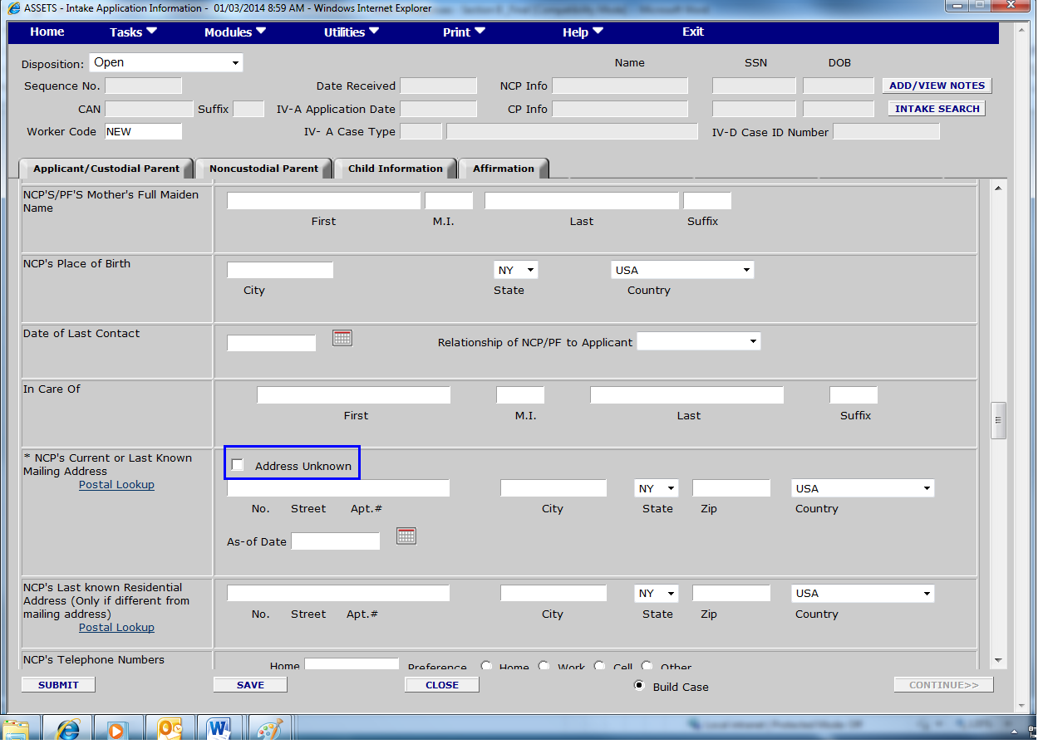
- AND
    - There is no verified employer for the PF/NCP.

Ways In Which Data Enters Case Records in ASSETS

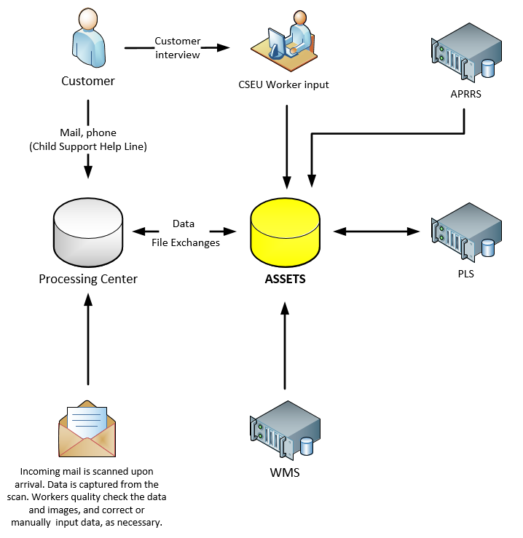

Ways in which data can enter a child support case record:
  - WMS pre-populates some datafields in ASSETS when a CSEU worker builds a case through Referral Search.
  - CSEU workers manually input data into the case record.
  - ASSETS imports data from WMS when a Non-TA case is converted to a TA case.
  - WMS updates ASSETS with PF/NCP information monthly if the PF/NCP is a current or former recipient of TA. (For more information, see How and when does WMS change a CP address in ASSETS?)
  - FPLS, SPLS, and APRRS automatically build and/or update datafields in ASSETS when data is found through automated location searches. PF/NCP addresses obtained through APRRS must be verified.
  - Workers at the Processing Center manually enter data into their computer system, which then updates ASSETS directly or during the next data file exchange.
Also, all mail arriving at the Processing Center is scanned and imaged upon receipt, and data is captured from those scans. Data captured via scanning is fed directly into the computer system at the Processing Center. All scans and data are reviewed and quality-controlled by workers there. The workers manually input any data not successfully captured through automated means.
  - ASSETS receives data regarding an NCP's financial assets through the:
      - Multi-State Financial Institution Data Matches (MSFIDM), which typically concern larger, multi-state financial institutions. The MSFIDM is maintained by the federal government and is included in automated PLS searches.
AND
      - Financial Institution Data Matches (FIDM), which usually pertain to “in-state” reporting from smaller banks and credit unions.

Minimum Information Required to Locate a PF/NCP
To successfully locate a PF/NCP, the CSEU must obtain the following information:
The applicant/recipient must provide the following information on the LDSS-4882 to help the CSEU identify and locate the PF/NCP:
- The full name and SSN of the PF/NCP
OR
- The full name of the PF/NCP and the following concerning such parent or father:
  -  NCP's date of birth
  - CP's SSN
    - OR
- At least three of the following pieces of information:
Mother's maiden name
  - NCP's father's name
NCP's city
NCP's state
OR
- The full name of the PF/NCP and any additional information equivalent to that above that leads to the establishment of the PF/NCP’s identity and location.
If the customer is unable to provide the required information, the customer must attest, under penalty of perjury, to the lack of information by completing and signing the LDSS-4281 (Attestation to Lack of Information) (Spanish: LDSS-4281-S - Atestiguación de Falta de Información).

Essential Screens in the Location Process

Case Mode > Status tab
  - Open an L Group
  - Add a new status to an L Group
  - Update a status
  - Delete a status
  - See a neatly summarized longitudinal history of location requests on the case
Case Mode > Resp Emp tab
  - Add new employer record
  - Update an employer record
  - Delete an employer record
  - Add health insurance information
Summary Mode > Resp Addr tab
  - Add new PF/NCP address
Worker Alerts > Enforcement Mode > PLS tab
  - See notifications of information found through automated location searches
  - Click on notifications to get required actions

New Hire Reporting (Fully Automated)

Introduction to New Hire Reporting
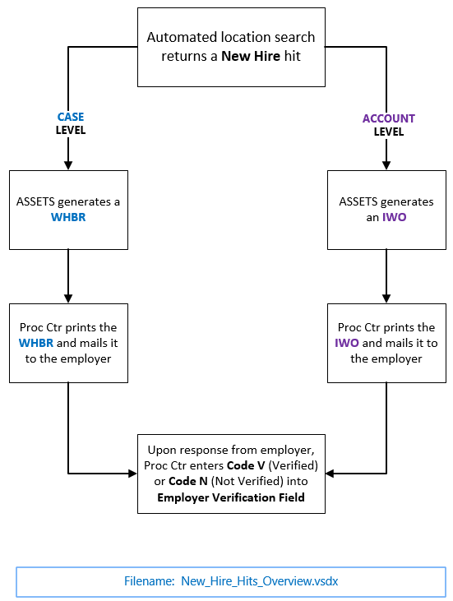

Automated searches of the State Directory of New Hires (SDNH) and the National Directory of New Hires (NDNH) are included in automated PLS searches.
However, unlike other resources under the umbrella of PLS searches, automated searches of the SDNH, NDNH, and APRRS are ongoing at all times — even when the case does not have an L Group open.

When a "New Hire" is reported
When Respondent employer information is found through an automated search of the SDNH or NDNH:
  - ASSETS automatically enters the employer/employment information into the case record.
AND
For case level:
  - ASSETS automatically generates a WHBR to verify the employment information on a case.
  - The Processing Center prints the WHBR and mails it to the employer.
OR
For account level:
  - ASSETS automatically generates an IWO to the employer on an account.
  - The Processing Center prints the IWO and mails it to the employer.

What information is included in New Hire Reporting?
New York State requires the reporting of the following information on all newly hired or rehired employees within 20 calendar days from the hire date:
  - Employee name (first, middle, last)
  - Employee address (street, city, state, and zip code)
  - Employee Social Security number
  - Employee hire date
  - Employer name
  - Employer address (street, city, state, and zip code)
  - Employer Federal Employer Identification Number (FEIN)
  - Whether dependent health insurance benefits (family coverage) are available to the employee, and if so, the date the employee qualifies for the benefits
Employers can submit New Hire information on the web by going to: https://www.nynewhire.com.

Roadmap: New Hire Reporting
Information is received from the NDNH and the SDNH daily.
Search results are reported on the Worker Alerts > Enforcement Mode > PLS tab and information is recorded on the Case Mode > Resp Emp tab and the Summary Mode > Resp Addr tab.
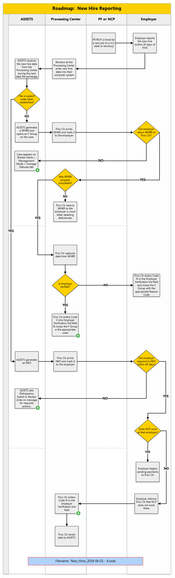

Case appears on Worker Alerts > Management mode > Overage Statuses tab
If a WHBR has been sent to an employer and the employer does not respond within two weeks, the F Group appears on the Worker Alerts > Management Mode > Overage Statuses tab, giving the worker two weeks advance notice that the F Group will age out.
The worker must take manual action, which may include the following:
  - Phone the employer: confirm employment, confirm employer address, and confirm receipt of WHBR.
  - Send a new WHBR to the employer, if necessary.
  - Review the case to see if there are any payments coming from a different employer.
  - Update the Status Code on the case, if appropriate.

Proc Ctr enters appropriate code into Employer Verification Ind field
How an employer is verified via a WHBR:
  - The Processing Center mails a WHBR to the employer needing verification.
  - The employer returns the completed WHBR to the Processing Center.
  - The Processing Center updates the Employer Verification Ind field on the Case Mode > Resp Emp tab with Code V or Code N and makes a notation on the Case Mode > Remarks tab.
  - The Processing Center closes the F Group with the appropriate code.

Automated Location Searches

Automated Location Searches — Introduction
Automated location searches run continuously in the background whenever there is an L Group open on a case.

How and when do automated searches begin?
ASSETS begins automated searches when an L Group is opened on a case. Automated location searches run continuously in the background as long as the L Group remains open. (Note that searches of the APRRS, NDNH, and SDNH continue even when no L Group is open.)
An L Group can be opened manually by a worker or — under certain conditions — automatically by ASSETS.

See also: Location > Introduction to Location > Opening an L Group

What agencies or databases are searched?
Automated location searches include but are not limited to searches of the following three resources:
    - Absent Parent Resource Reporting System (APRRS)
    - Federal Parent Locator Service (FPLS)
    - State Parent Locator Service (SPLS)
In practical terms, the CSEU worker does not need to distinguish between these three resources. Collectively, they are referred to as "PLS Searches," or simply "automated searches."
The PLS searches together search the databases of a number of Federal and State agencies. (Note: Among the databases that the FPLS and SPLS search are those of the National Directory of New Hires (NDNH) and the State Directory of New Hires (SDNH), respectively.)
See also: Roadmap: New Hire Reporting

State agency database searches (automated search)
    - DCJS (NYS Division of Criminal Justice Services)
    - DMV (NYS Department of Motor Vehicles)
    - DTF (NYS Department of Taxation and Finance)
    - UIB (NYS Unemployment Insurance)

Federal agency database searches (automated search)
For detailed information about the Federal Parent Locator Service (FPLS), see: https://www.acf.hhs.gov/css/resource/federal-parent-locator-service-information-for-families
Databases included in the automated FPLS search include:
    - DOD (Department of Defense)
    - FAOP (Federal Administrative Offset Program)
    - FBI (Federal Bureau of Investigation)
    - FCR (Federal Case Registry)
    - FOP (Federal Offset Program)
    - IRS (Internal Revenue Service)
    - MSFIDM (Multistate Financial Institution Data Match)
    - NDNH (National Directory of New Hires)
    - NQW (National Quarterly Wages)
    - NUI (National Unemployment Insurance)
    - OOS (Out of State)
    - PPD (Passport Denial Program)
    - SSA (Information found through SSA must be manually entered into the case record by the worker)
    - VA (Veterans Administration)
    - WRS (Wage Reporting System)
ASSETS automatically relaunches these automated searches every 75 days, for as long as the L Group remains open.

Financial Institution Data Matches
In addition, ASSETS receives monthly information from financial institutions. Data received through the Financial Institution Data Match (FIDM) is automatically entered into the case records.
Information obtained via FIDM appears on the Enforcement Mode > Resp. Assets Information screen

What does "hits are reported" mean — versus "information is recorded"?
Automated location search hits are reported on the Worker Alerts > Enforcement Mode > PLS tab.
"Reported" means that:

      - The worker is notified that information has been found.
      - The notification tells the worker what kind of information was found (e.g. a new/updated PF/NCP address, a new/updated employer address, etc.).
      - The notification contains a message link that the worker can click on to see required actions related to that notification.
      - The report/notification does not contain the actual content or details of the information found — it contains only the notification that information has been found, and what kind of information it is.
"Recorded" means that:
      - The actual information/data found (i.e. the details of the new employer address, updated PF/NCP address, new hire report, etc.) is automatically entered into the case record. The screen where the information is recorded is where a worker can find the details -- the actual content -- of the information found, such as name of employer, street address of the building, city, state, etc.

Where are hits from automated searches reported?
Hits from automated searches are reported on the Worker Alerts > Enforcement Mode > PLS tab. Workers should review that screen daily. All hits reported on this screen contain a clickable message link detailing required actions.

What does the worker need to do when automated searches return hits?
The worker should review the Worker Alerts > Enforcement Mode > PLS tab daily.
All hits reported on this screen contain a clickable message link detailing required actions on the part of the worker.

Where is information from automated searches recorded?
With the exception of address information obtained from the Social Security Administration — which must be manually entered into the case record by the CSEU worker — all address information found through automated searches is automatically entered into the case record.
(Except for NDNH and SDNH employer addresses, PF/NCP address or PF/NCP employer information automatically entered into the case record remains in UNVERIFIED status until it is verified via a PCL, WHBR, or IWO.)

PF/NCP Address information is recorded on the following screen:
Summary Mode > Resp Addr tab
PF/NCP Employer information is recorded on the following screen:
Summary Mode > Resp Emp tab.

How can I verify PF/NCP address and employer information?
PF/NCP addresses must be verified through use of a PCL.
PF/NCP employer information must be verified through use of a WHBR.
Note: In the case of employer/employment information found through automated search of the NDNH or SDNH, ASSETS will automatically generate a WHBR (on case level) or IWO (on account level) to the employer.
  - See: WHBR: Wage and Health Benefits Report
  - See: PCL: Postal Clearance Letter (aka Address Information Request)

Manual Location Searches

Introduction to Manual Location Searches

How and when do manual (non-automated) location searches begin?
Some location activity starts at intake, when the worker gathers as much information as possible from the customer and/or the LDSS-4882 with a view toward locating the PF/NCP, establishing paternity, and pursuing a support order.
Often, the customer has direct knowledge of or can provide valuable leads as to the PF/NCP's location and/or employer.
For example, the customer may know the PF/NCP's current or former employer, or may know the PF/NCP's address or former address. In these instances, the worker should:
  - Build the appropriate address record
  - Generate a WHBR for the PF/NCP's last known employer
AND/OR
  - Generate a PCL for the PF/NCP's last known address.
Even a former employer may be able to provide valuable information, such as:
  - PF/NCP's current employer
  - PF/NCP's SSN
  - PF/NCP's current or last known address
Likewise, even the Postmaster at a PF/NCP's former address may be able to provide a forwarding address or other leads.

Social Security Number: Sources For Finding It
The Social Security number of a PF/NCP is critical in the effort to locate and confirm the identity of that person and his/her resources.
To help find that information, the customer can check these resources:
Where You May Be Able to Find the SSN for a PF/NCP:
Payroll stubs; Forms W-2 or 1099
Statement of Benefits for Workers' Compensation
Tax Returns; particularly any joint returns filed during the past seven years (in cases involving joint returns, PF/NCP's SSN can be traced using the recipient's SSN)
Any of his/her correspondence with the Tax Department
Military documents (Note: The military currently uses the Social Security number as the serial number)
Life insurance policy
Credit applications
Credit agreement for purchases (such as furniture, refrigerator, television)
Old ID cards (health insurance, school ID, alien registration card)
Marriage license
Any personal documents from the Social Security Administration
Documents from the Veterans Administration
College or school records
Medical or dental records or bills
Public assistance/WMS records
Birth Certificate

Deceased PF/NCP
If a customer demonstrates that the PF/NCP is deceased, TA may not refer that customer to CSS. If the customer is referred, an LDSS-4882 must be completed even if the PF/NCP is deceased.
If the PF/NCP dies on an open case, the worker must update the case remarks.
If a customer has been referred from the TA Unit and the PF/NCP dies, the worker must notify the TA Unit of the death via an LDSS-2859 form.

See also: "Death of a Child or a Party to an Order of Support: Questions and Answers," at:
http://otda.state.nyenet/assets/pages/PDFs/Miscellaneous/Death_of_a_Child_or_a_Party_-_Questions_and_Answers.pdf

Automated reporting of confirmed deaths
The Federal Case Registry (FCR) and the Social Security Administration (SSA) report deaths of CPs, NCPs, and children.
Searches of these two resources are included in automated PLS searches.
Automated notifications of deaths from these two sources are reported on the Worker Alerts > Enforcement Mode > FCR tab.
Deaths are recorded on the Case Mode > Status tab. (Specifically, the Q Group will be updated on that screen with code Q400.)

If the customer claims that the PF/NCP is deceased
If a TA referral customer claims to the CSEU that the PF/NCP is deceased, the customer must prove this in order to comply with cooperation requirements.

Incarcerated PF/NCPs
Districts should pursue paternity establishment against incarcerated PF/NCPs.
As for whether or not to pursue support orders against incarcerated PF/NCPs, workers should follow local protocols.
The worker should set a tickler date for the PF/NCP's expected date of release from prison.
Automated PLS searches include a search of the database of the NYS Criminal Justice System (NCJS). Hits resulting from those searches are reported on the Worker Alerts > Enforcement Mode > PLS tab, and data found auto-populates the case record.

If the customer indicates that the PF/NCP is or has been in prison, conduct a manual search
If the customer indicates that the PF/NCP is or has been in prison, the worker should conduct a manual search of correctional facilities. Even if a PF/NCP is no longer incarcerated, a correctional facility may be able to provide valuable information or leads such as a parole officer or probation officer.
The worker may contact the PF/NCP's parole officer or probation officer for information that may lead to locating the PF/NCP.
Below are links to resources that the worker may use to manually locate an incarcerated PF/NCP.
  - Corrections.com (various states)
http://www.corrections.com/links/show?cat=30
Has links to departments of corrections in various states.
  - NYC Corrections Facilities Addresses
http://www1.nyc.gov/site/doc/about/facilities-locations.page
Lists addresses of correctional facilities in New York City
  - NYS County Jail Addresses.
http://www.scoc.ny.gov/jailaddre.htm
  - New York State Dept. of Corrections and Community Supervision (Inmate Population Information Search)
http://nysdoccslookup.doccs.ny.gov/
  - Federal Bureau of Prisons (Federal Prisons)
https://www.bop.gov/inmateloc/
  - VINELink (Victim notification network)
https://vinelink.com/

Military — PF or NCP Is In the Military

Military
A search of the Department of Defense (DOD) database is included in automated PLS searches. Search hits are reported on the Worker Alerts > Enforcement Mode > PLS tab, and data found auto-populates the case record.
Information found is recorded on the Case Mode > Location tab, the Case Mode > Resp Emp tab, and the Summary Mode > Resp Addr tab.
The worker can conduct a manual search of the DOD Entitlement and/or Locate tabs on the child support portal, which is accessible via the ASSETS home screen under Quick Links > FPLS State Services Portal.
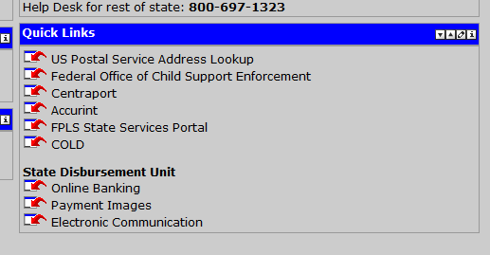
See also: Military Codes
See also: Military Branch Codes

Manually Entering Respondent Address or Employer Into Case Record

Manually Enter a

New Respondent Address Into the Case Record
PF/NCP addresses found through non-automated means or through the Social Security Administration's database must be entered into the case record manually by the worker.
The worker can manually add a new PF/NCP address into the case record by doing the following:
  - Go to Summary Mode > Resp Addr tab.
  - Click on the Add New Record button at the bottom of the screen.
The Summary Mode > Resp Addr Details tab appears.
  - Enter the PF/NCP's address.
  - For Do You Want Postal Clearance Submitted? select the Yes radio button.
  - Click the Submit button.
The new PF/NCP address has now been entered into the case record.
Following the next data file exchange, the Processing Center prints the PCL and mails it to the postmaster for the address needing verification.
The postmaster returns the completed PCL to the Processing Center.
The Processing Center then updates the Address Verification Indicator field with the appropriate Address Verification Code.
During the next routine data exchange, the Processing Center will send a data file to ASSETS to update case records with Address Verification Codes.

Manually Enter an Employer into the Case Record
  - Go to the Case Mode > Resp Emp tab

  - Click the Add New Record button at the bottom of the screen

The Case Mode > Respondent Employer Detail Edit screen appears. Fields highlighted in yellow are editable.

  - Enter the employer information in the appropriate fields, including the Federal Employer Identification Number (FEIN), which can be found on the E-IWO Employers and FEINs link on the Case Mode > Resp Emp tab, or by contacting the employer.

  - Select the Yes radio button next to A Wage Health and Benefits Report will be sent to this Respondent employer

  - Click the Submit button

The new PF/NCP employer has now been entered into the case record in ASSETS.
During the next routine data exchange, ASSETS sends a data file to the Processing Center, and the Processing Center prints a WHBR and mails it to the employer.
When the employer returns the completed WHBR to the Processing Center, the Processing Center updates the Employer Verification Indicator field with the appropriate Employer Verification Indicator code.
Even if the PF/NCP is no longer employed, valuable information can be obtained from the WHBR, such as address, telephone number, SSN, or new employer information.

Verification of Address or Employment

Wage and Health Benefits Report (WHBR)

What is a WHBR?
A Wage and Health Benefits Report (WHBR) is a form used to verify a PF/NCP's employer and gather information about the PF/NCP's wages, medical insurance, and other benefits. (Note that if new hire information is found through automated location searches, the new hire information automatically populates the case record — but does not include information regarding the PF/NCP's wages.)

When to use a WHBR
  - When building a case (the CSEU should send a WHBR to the PF/NCP's last known employer)
  - Whenever the CSEU needs to verify a PF/NCP's employment status and/or gather information about the PF/NCP's wages and benefits (such as medical insurance), a WHBR should be generated and sent to the PF/NCP's employer.

How to generate a WHBR

How to manually generate a WHBR
    - In ASSETS, go to Case Mode > Resp Emp tab.
    - Click the Add New Record button.
The Case Mode > Resp Emp Detail Edit tab appears.
        - Enter a new employer record.
    - Select the Yes radio button for A Wage and Health Benefits Report will be sent to this Respondent employer.
    - Select the Yes radio button for Do you want a copy of the completed document returned to your district? if you want a copy of the WHBR made available on ERS after it is completed by the employer.
    - Click the Submit button at the bottom of the screen.
ASSETS generates a WHBR. During the next data exchange with the Processing Center, the Processing Center receives the WHBR data, prints the WHBR, and mails it to the employer.

For new hires with a case-level only child support case, ASSETS automatically generates a WHBR (and the Processing Center prints and mails it)
If employer information is returned from the National Directory of New Hires (NDNH) or the State Directory of New Hires (SDNH):
          - A Code V is systematically set in the Employer Verification field on the Case Mode > Resp Emp tab.
          - ASSETS automatically generates a WHBR.
          - During the next routine data exchange, ASSETS sends the WHBR data to the Processing Center
          - The Processing Center prints the WHBR and mails it to the employer.

When the employer receives a WHBR
The employer completes the WHBR, providing information including, but not limited to, the following regarding the PF/NCP:

      - Hire date
      - Pay rate (and frequency)
      - Social Security number (or Individual Taxpayer Identification Number)
      - Date of birth
      - Telephone number
      - Residential and/or mailing address
      - Health insurance information
The employer may also provide a Federal Employer Identification Number (FEIN). (Note: Not all employers have a FEIN. Those that do are eligible for receiving an Electronic Income Withholding Order (E-IWO).
The employer mails the completed WHBR to the Processing Center.
See also: E-IWOs (Electronic Income Withholding Orders) and FEINs

When the completed WHBR arrives back at the Processing Center
When the completed WHBR arrives at the Processing Center, it is scanned upon arrival, and data is captured from the scan. The scan and the data are then reviewed by workers at the Processing Center, who input any data not successfully captured through automated means.

To check the status of WHBRs sent to employers
Workers can check the status of WHBRs in the following ways:
      - Check the Summary Mode > Parties to Action tab
      - Check the Employer Verification Ind field on the Case Mode > Resp Emp tab for a Code V (Verified employer or insurance carrier) or Code N (Reviewed; Not a current employer).
      - Check the ECS for a copy of the WHBR (if the worker selected the radio button for Do you want a copy of the completed document returned to your district?

Employer Verification Indicator Codes and their meanings

Postal Clearance Letter

(aka Address Information Request)

Summary
    - The worker needs to verify an address.
    - The worker generates an PCL via ASSETS.
    - ASSETS sends data files to the Processing Center during nightly batch processing.
    - The Processing Center prints the PCL and mails it to the Postmaster who serves the address needing verification.
    - The Postmaster fills out the PCL and mails it back to the Processing Center.
    - Upon arrival at the Processing Center, the PCL is automatically scanned and imaged, and the data in the form is captured.
    - The captured data is fed into the computer system run by the Processing Center.
    - The Processing Center sends data files to ASSETS.
* If the worker checks the box for Do you want a copy of the completed document returned to your district? an image of the actual PCL completed by the Postmaster is made available to the CSEU worker via ECS, accessible from the ASSETS homepage.

What is a PCL?
The PCL is used to ask a Postmaster to confirm or deny that a certain person (i.e. a PF/NCP in a case) receives mail at a certain address, and/or to provide additional information, such as a forwarding address, if applicable.

When to use a PCL
When you have an address for a PF/NCP, but are unsure whether it is current or valid, you need to verify the address via an PCL.
You generate the PCL through ASSETS.

How to generate a PCL in ASSETS
    - In ASSETS, open a case, then go to: Summary Mode > Resp Addr tab.
    - On the Respondent Addresses table, click on UPD in the row containing the address you want to verify.
The Respondent Address Details screen appears. Click the Yes radio button if you want a copy of the PCL returned to your district.
    - Click Submit.
A PCL will be mailed to the Postmaster.
* Note: A PCL can also be initiated by opening a V Group on the Case Mode > Status Information tab.

When the Postmaster receives a PCL
When the Postmaster receives the PCL, he or she will indicate one of the following on the form:
Mail is delivered to the address given
Mail is forwarded to a new address
[PF/NCP is] Not Known at address given
[PF/NCP] Moved, left no forwarding address
No such address
Other (Specify)
The Postmaster will also provide a street address, if available, for a PF/NCP who has a PO Box, and a new address, if the PF/NCP has moved and provided one.

To view the status of PCL queries
You can view the Address Verification Indicator (Ver Ind) code on the Summary Mode > Resp Addr tab. This will tell you the status of the PCL.

Address Verification Indicator (Ver Ind) codes and their meanings

