Appreciation Page

To use Appreciation page correctly user needs following steps:
- User needs to create and login to an account.
- User is directed to Appreciation page where user first selects an Appreciation card of choice. User can filter the images based on the categories too.
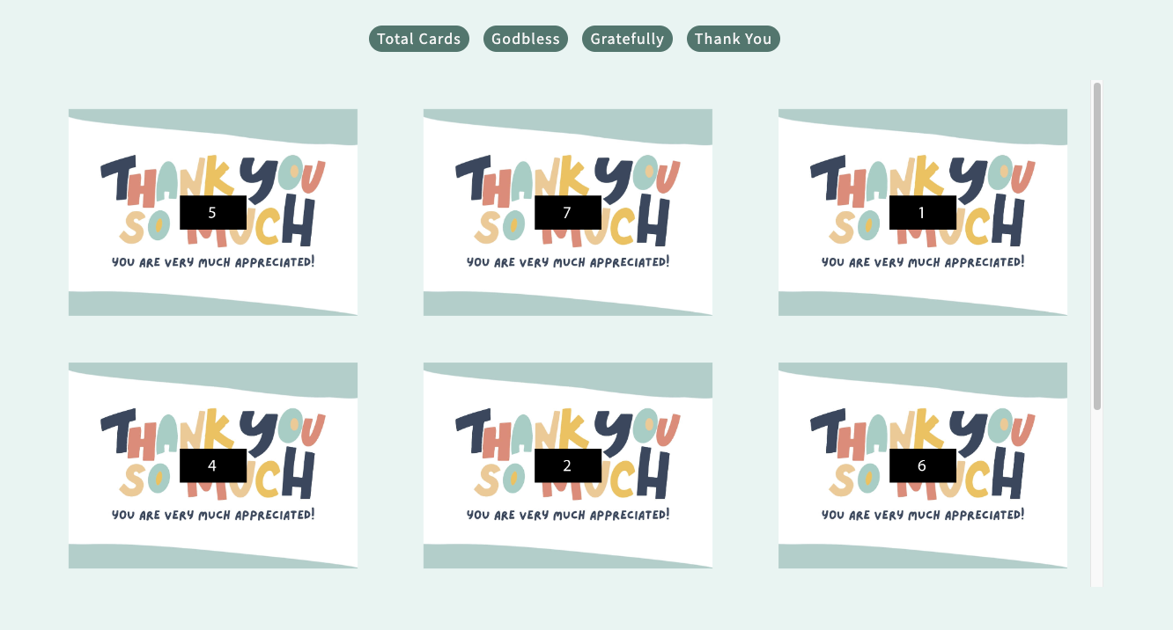
- As soon as user selects the card, the card displays just below Appreciation card display section.
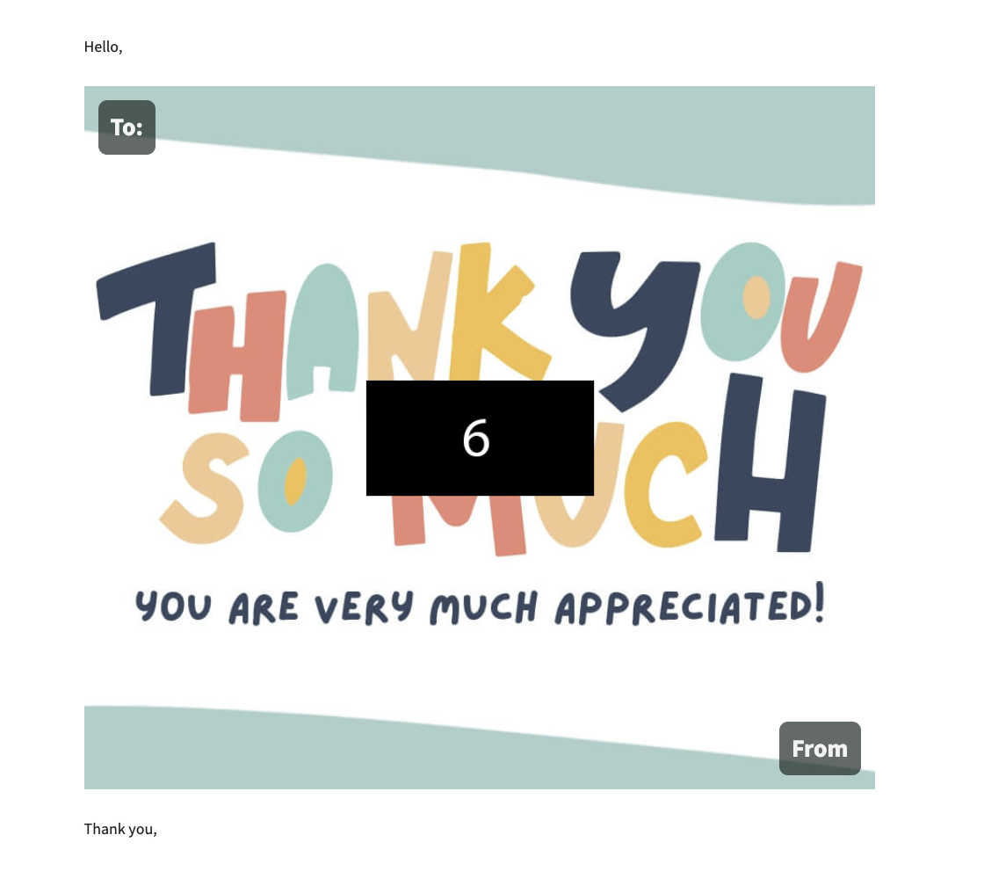
- The information automatically displays as user fills out the form and gives a first look how the card is going to look how the card is going to look in the inbox.
- All the fields in the form are required. If any field is kept empty or incorrectly email filled out, the cursor automatically scrolls up that input-field.
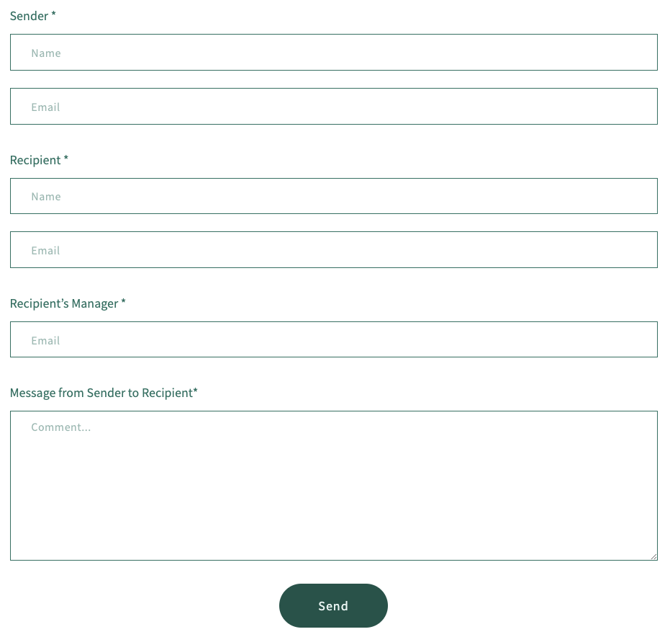
- The email is sent on the click of ‘Send’ button to the recipient and CC to the recipient’s Manager.

Card-Upload Page

Steps to upload a Card.
- User needs to click button to choose the ‘.jpg. file to upload the card.
- If user wish to upload a card in a ‘Thank You’ category, user has to rename the file as in the end use ‘-‘and the category name such as ‘thank you’ else the uploaded card will appear in ‘total card’ category but no other category. For an instance: there is a file name ‘card.jpg’. if user wants to upload the card in ‘thank you’ category, user must rename it as ‘card-thank you.jpg’.
- Initially the button is greyed out means the button is disabled. The button will be active only if the correct format or correct file format is chosen.
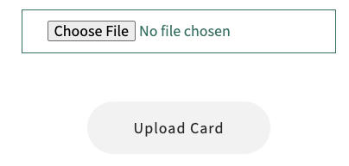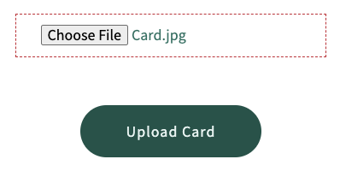

Card-Info Page

Steps to Edit the database using Card-Info.
- User Admin needs to select User Info from Amin Panel.
- When user Info page is loaded click on the Select button to view all the information relation to the customer.
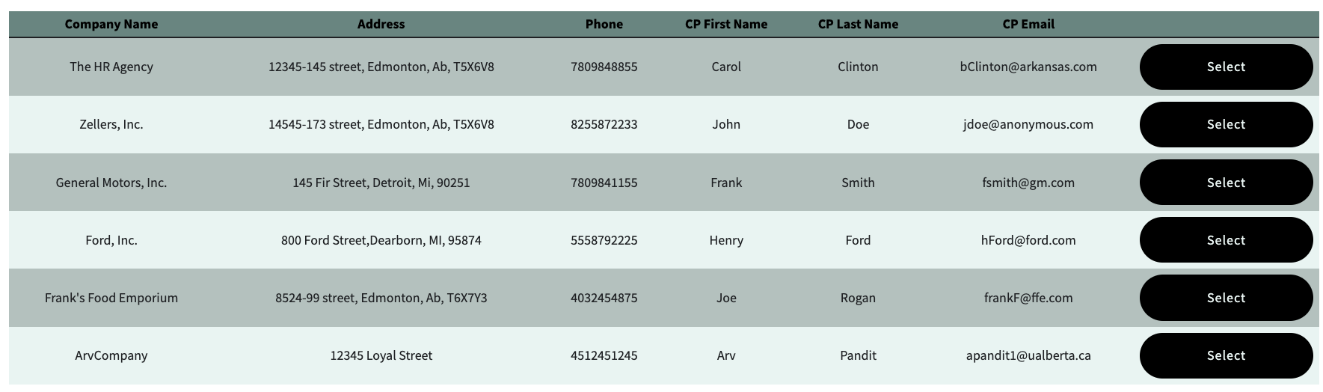
- When User Admin is on User-Detail page, could edit the customer database, ‘Activate/Deactivate the subscription status or even delete the customer from the database.
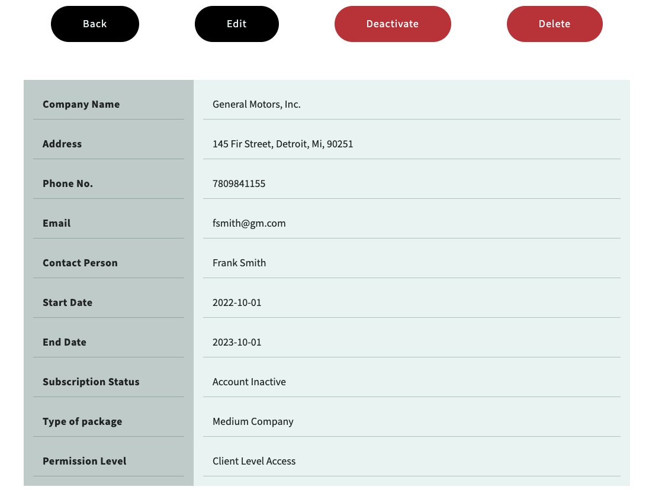
- The Deactivate button will deactivate the subscription status of the selected customer, and if the subscription status is Inactive, deactivate button will change the subscription status into Active.
- The Edit button navigates user Admin to a form where all the information of Client can edit.
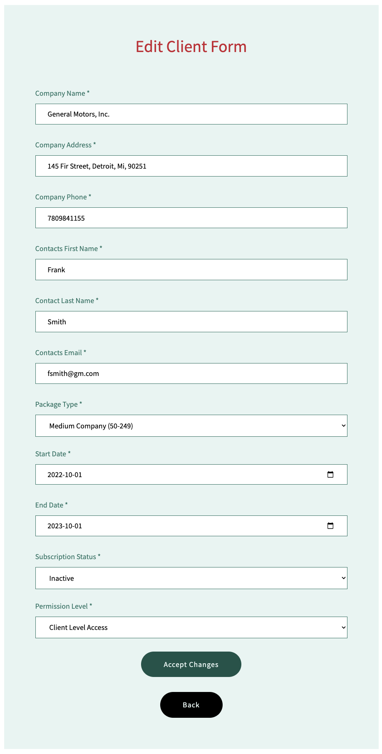
- All the input fields must be filled out before saving the changes.
- “Accept Changes” button saves the input data and redirects to the Client-Info page.
Add New Client Page

Add new client form is for to add new client into the database.
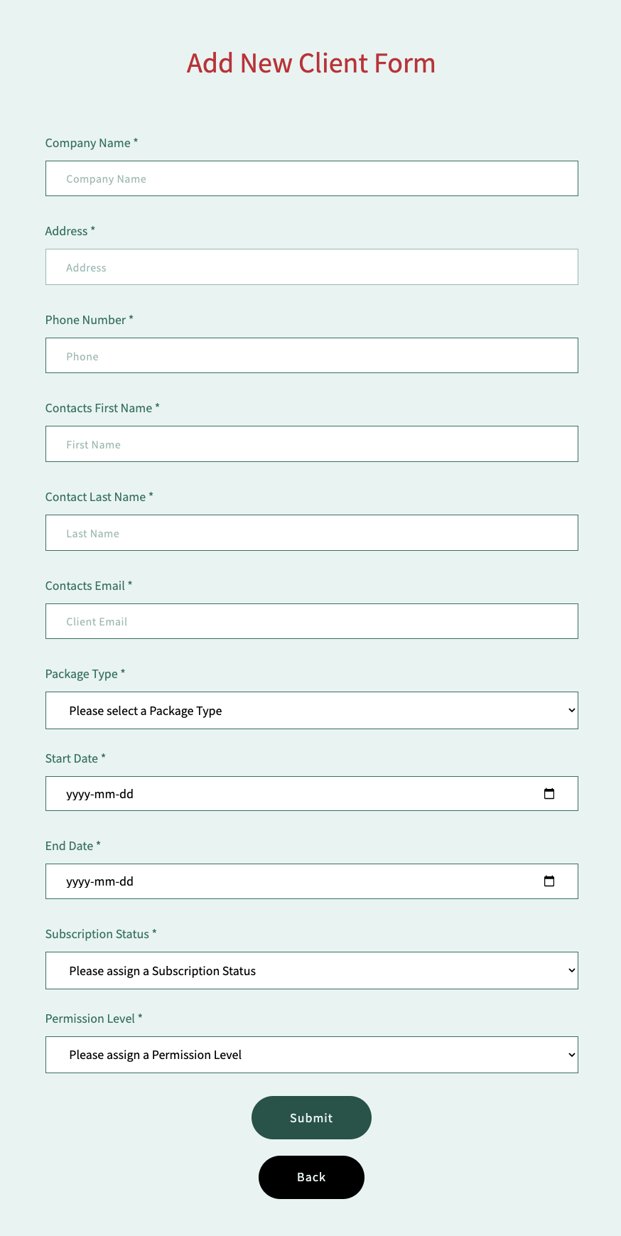
- All the input fields should be filled out.
- Start date can only accept present day date or future date but not past date.
- End date should be after start date.

