COVID-19 Data Analysis and Forecasting

Mark

2025-04-15

## Install and Load Required Packages

# install.packages("plotly")  
library(tidyverse)  
library(dplyr)  
library(lubridate)  
library(forecast)  
library(ggplot2)  
library(scales)  
library(tseries)

## Load the Dataset

covid_data <- read.table('https://catalog.ourworldindata.org/garden/covid/latest/compact/compact.csv', sep=',', head=TRUE)

## Explore the Dataset

head(covid_data, 5)

## country date total_cases new_cases new_cases_smoothed  
## 1 Afghanistan 2020-01-01 NA NA NA  
## 2 Afghanistan 2020-01-02 NA NA NA  
## 3 Afghanistan 2020-01-03 NA NA NA  
## 4 Afghanistan 2020-01-04 0 0 NA  
## 5 Afghanistan 2020-01-05 0 0 NA  
## total_cases_per_million new_cases_per_million new_cases_smoothed_per_million  
## 1 NA NA NA  
## 2 NA NA NA  
## 3 NA NA NA  
## 4 0 0 NA  
## 5 0 0 NA  
## total_deaths new_deaths new_deaths_smoothed total_deaths_per_million  
## 1 NA NA NA NA  
## 2 NA NA NA NA  
## 3 NA NA NA NA  
## 4 0 0 NA 0  
## 5 0 0 NA 0  
## new_deaths_per_million new_deaths_smoothed_per_million excess_mortality  
## 1 NA NA NA  
## 2 NA NA NA  
## 3 NA NA NA  
## 4 0 NA NA  
## 5 0 NA NA  
## excess_mortality_cumulative excess_mortality_cumulative_absolute  
## 1 NA NA  
## 2 NA NA  
## 3 NA NA  
## 4 NA NA  
## 5 NA NA  
## excess_mortality_cumulative_per_million hosp_patients  
## 1 NA NA  
## 2 NA NA  
## 3 NA NA  
## 4 NA NA  
## 5 NA NA  
## hosp_patients_per_million weekly_hosp_admissions  
## 1 NA NA  
## 2 NA NA  
## 3 NA NA  
## 4 NA NA  
## 5 NA NA  
## weekly_hosp_admissions_per_million icu_patients icu_patients_per_million  
## 1 NA NA NA  
## 2 NA NA NA  
## 3 NA NA NA  
## 4 NA NA NA  
## 5 NA NA NA  
## weekly_icu_admissions weekly_icu_admissions_per_million stringency_index  
## 1 NA NA 0  
## 2 NA NA 0  
## 3 NA NA 0  
## 4 NA NA 0  
## 5 NA NA 0  
## reproduction_rate total_tests new_tests total_tests_per_thousand  
## 1 NA NA NA NA  
## 2 NA NA NA NA  
## 3 NA NA NA NA  
## 4 NA NA NA NA  
## 5 NA NA NA NA  
## new_tests_per_thousand new_tests_smoothed new_tests_smoothed_per_thousand  
## 1 NA NA NA  
## 2 NA NA NA  
## 3 NA NA NA  
## 4 NA NA NA  
## 5 NA NA NA  
## positive_rate tests_per_case total_vaccinations people_vaccinated  
## 1 NA NA NA NA  
## 2 NA NA NA NA  
## 3 NA NA NA NA  
## 4 NA NA NA NA  
## 5 NA NA NA NA  
## people_fully_vaccinated total_boosters new_vaccinations  
## 1 NA NA NA  
## 2 NA NA NA  
## 3 NA NA NA  
## 4 NA NA NA  
## 5 NA NA NA  
## new_vaccinations_smoothed total_vaccinations_per_hundred  
## 1 NA NA  
## 2 NA NA  
## 3 NA NA  
## 4 NA NA  
## 5 NA NA  
## people_vaccinated_per_hundred people_fully_vaccinated_per_hundred  
## 1 NA NA  
## 2 NA NA  
## 3 NA NA  
## 4 NA NA  
## 5 NA NA  
## total_boosters_per_hundred new_vaccinations_smoothed_per_million  
## 1 NA NA  
## 2 NA NA  
## 3 NA NA  
## 4 NA NA  
## 5 NA NA  
## new_people_vaccinated_smoothed new_people_vaccinated_smoothed_per_hundred  
## 1 NA NA  
## 2 NA NA  
## 3 NA NA  
## 4 NA NA  
## 5 NA NA  
## code continent population population_density median_age life_expectancy  
## 1 AFG Asia 40578801 62.21548 16.752 NA  
## 2 AFG Asia 40578801 62.21548 16.752 NA  
## 3 AFG Asia 40578801 62.21548 16.752 NA  
## 4 AFG Asia 40578801 62.21548 16.752 NA  
## 5 AFG Asia 40578801 62.21548 16.752 NA  
## gdp_per_capita extreme_poverty diabetes_prevalence handwashing_facilities  
## 1 1516.273 NA 10.9 48.21469  
## 2 1516.273 NA 10.9 48.21469  
## 3 1516.273 NA 10.9 48.21469  
## 4 1516.273 NA 10.9 48.21469  
## 5 1516.273 NA 10.9 48.21469  
## hospital_beds_per_thousand human_development_index  
## 1 0.39 0.462  
## 2 0.39 0.462  
## 3 0.39 0.462  
## 4 0.39 0.462  
## 5 0.39 0.462

tail(covid_data, 10)

## country date total_cases new_cases new_cases_smoothed  
## 491236 Zimbabwe 2025-03-21 266410 0 0  
## 491237 Zimbabwe 2025-03-22 266410 0 0  
## 491238 Zimbabwe 2025-03-23 266410 0 0  
## 491239 Zimbabwe 2025-03-24 266410 0 0  
## 491240 Zimbabwe 2025-03-25 266410 0 0  
## 491241 Zimbabwe 2025-03-26 266410 0 0  
## 491242 Zimbabwe 2025-03-27 266410 0 0  
## 491243 Zimbabwe 2025-03-28 266410 0 0  
## 491244 Zimbabwe 2025-03-29 266410 0 0  
## 491245 Zimbabwe 2025-03-30 266410 0 0  
## total_cases_per_million new_cases_per_million  
## 491236 16579.12 0  
## 491237 16579.12 0  
## 491238 16579.12 0  
## 491239 16579.12 0  
## 491240 16579.12 0  
## 491241 16579.12 0  
## 491242 16579.12 0  
## 491243 16579.12 0  
## 491244 16579.12 0  
## 491245 16579.12 0  
## new_cases_smoothed_per_million total_deaths new_deaths  
## 491236 0 5740 0  
## 491237 0 5740 0  
## 491238 0 5740 0  
## 491239 0 5740 0  
## 491240 0 5740 0  
## 491241 0 5740 0  
## 491242 0 5740 0  
## 491243 0 5740 0  
## 491244 0 5740 0  
## 491245 0 5740 0  
## new_deaths_smoothed total_deaths_per_million new_deaths_per_million  
## 491236 0 357.2093 0  
## 491237 0 357.2093 0  
## 491238 0 357.2093 0  
## 491239 0 357.2093 0  
## 491240 0 357.2093 0  
## 491241 0 357.2093 0  
## 491242 0 357.2093 0  
## 491243 0 357.2093 0  
## 491244 0 357.2093 0  
## 491245 0 357.2093 0  
## new_deaths_smoothed_per_million excess_mortality  
## 491236 0 NA  
## 491237 0 NA  
## 491238 0 NA  
## 491239 0 NA  
## 491240 0 NA  
## 491241 0 NA  
## 491242 0 NA  
## 491243 0 NA  
## 491244 0 NA  
## 491245 0 NA  
## excess_mortality_cumulative excess_mortality_cumulative_absolute  
## 491236 NA NA  
## 491237 NA NA  
## 491238 NA NA  
## 491239 NA NA  
## 491240 NA NA  
## 491241 NA NA  
## 491242 NA NA  
## 491243 NA NA  
## 491244 NA NA  
## 491245 NA NA  
## excess_mortality_cumulative_per_million hosp_patients  
## 491236 NA NA  
## 491237 NA NA  
## 491238 NA NA  
## 491239 NA NA  
## 491240 NA NA  
## 491241 NA NA  
## 491242 NA NA  
## 491243 NA NA  
## 491244 NA NA  
## 491245 NA NA  
## hosp_patients_per_million weekly_hosp_admissions  
## 491236 NA NA  
## 491237 NA NA  
## 491238 NA NA  
## 491239 NA NA  
## 491240 NA NA  
## 491241 NA NA  
## 491242 NA NA  
## 491243 NA NA  
## 491244 NA NA  
## 491245 NA NA  
## weekly_hosp_admissions_per_million icu_patients icu_patients_per_million  
## 491236 NA NA NA  
## 491237 NA NA NA  
## 491238 NA NA NA  
## 491239 NA NA NA  
## 491240 NA NA NA  
## 491241 NA NA NA  
## 491242 NA NA NA  
## 491243 NA NA NA  
## 491244 NA NA NA  
## 491245 NA NA NA  
## weekly_icu_admissions weekly_icu_admissions_per_million stringency_index  
## 491236 NA NA NA  
## 491237 NA NA NA  
## 491238 NA NA NA  
## 491239 NA NA NA  
## 491240 NA NA NA  
## 491241 NA NA NA  
## 491242 NA NA NA  
## 491243 NA NA NA  
## 491244 NA NA NA  
## 491245 NA NA NA  
## reproduction_rate total_tests new_tests total_tests_per_thousand  
## 491236 NA NA NA NA  
## 491237 NA NA NA NA  
## 491238 NA NA NA NA  
## 491239 NA NA NA NA  
## 491240 NA NA NA NA  
## 491241 NA NA NA NA  
## 491242 NA NA NA NA  
## 491243 NA NA NA NA  
## 491244 NA NA NA NA  
## 491245 NA NA NA NA  
## new_tests_per_thousand new_tests_smoothed  
## 491236 NA NA  
## 491237 NA NA  
## 491238 NA NA  
## 491239 NA NA  
## 491240 NA NA  
## 491241 NA NA  
## 491242 NA NA  
## 491243 NA NA  
## 491244 NA NA  
## 491245 NA NA  
## new_tests_smoothed_per_thousand positive_rate tests_per_case  
## 491236 NA NA NA  
## 491237 NA NA NA  
## 491238 NA NA NA  
## 491239 NA NA NA  
## 491240 NA NA NA  
## 491241 NA NA NA  
## 491242 NA NA NA  
## 491243 NA NA NA  
## 491244 NA NA NA  
## 491245 NA NA NA  
## total_vaccinations people_vaccinated people_fully_vaccinated  
## 491236 NA NA NA  
## 491237 NA NA NA  
## 491238 NA NA NA  
## 491239 NA NA NA  
## 491240 NA NA NA  
## 491241 NA NA NA  
## 491242 NA NA NA  
## 491243 NA NA NA  
## 491244 NA NA NA  
## 491245 NA NA NA  
## total_boosters new_vaccinations new_vaccinations_smoothed  
## 491236 NA NA NA  
## 491237 NA NA NA  
## 491238 NA NA NA  
## 491239 NA NA NA  
## 491240 NA NA NA  
## 491241 NA NA NA  
## 491242 NA NA NA  
## 491243 NA NA NA  
## 491244 NA NA NA  
## 491245 NA NA NA  
## total_vaccinations_per_hundred people_vaccinated_per_hundred  
## 491236 NA NA  
## 491237 NA NA  
## 491238 NA NA  
## 491239 NA NA  
## 491240 NA NA  
## 491241 NA NA  
## 491242 NA NA  
## 491243 NA NA  
## 491244 NA NA  
## 491245 NA NA  
## people_fully_vaccinated_per_hundred total_boosters_per_hundred  
## 491236 NA NA  
## 491237 NA NA  
## 491238 NA NA  
## 491239 NA NA  
## 491240 NA NA  
## 491241 NA NA  
## 491242 NA NA  
## 491243 NA NA  
## 491244 NA NA  
## 491245 NA NA  
## new_vaccinations_smoothed_per_million new_people_vaccinated_smoothed  
## 491236 NA NA  
## 491237 NA NA  
## 491238 NA NA  
## 491239 NA NA  
## 491240 NA NA  
## 491241 NA NA  
## 491242 NA NA  
## 491243 NA NA  
## 491244 NA NA  
## 491245 NA NA  
## new_people_vaccinated_smoothed_per_hundred code continent population  
## 491236 NA ZWE Africa 16069010  
## 491237 NA ZWE Africa 16069010  
## 491238 NA ZWE Africa 16069010  
## 491239 NA ZWE Africa 16069010  
## 491240 NA ZWE Africa 16069010  
## 491241 NA ZWE Africa 16069010  
## 491242 NA ZWE Africa 16069010  
## 491243 NA ZWE Africa 16069010  
## 491244 NA ZWE Africa 16069010  
## 491245 NA ZWE Africa 16069010  
## population_density median_age life_expectancy gdp_per_capita  
## 491236 41.53809 17.683 NA 2207.957  
## 491237 41.53809 17.683 NA 2207.957  
## 491238 41.53809 17.683 NA 2207.957  
## 491239 41.53809 17.683 NA 2207.957  
## 491240 41.53809 17.683 NA 2207.957  
## 491241 41.53809 17.683 NA 2207.957  
## 491242 41.53809 17.683 NA 2207.957  
## 491243 41.53809 17.683 NA 2207.957  
## 491244 41.53809 17.683 NA 2207.957  
## 491245 41.53809 17.683 NA 2207.957  
## extreme_poverty diabetes_prevalence handwashing_facilities  
## 491236 39.75453 2.1 42.45609  
## 491237 39.75453 2.1 42.45609  
## 491238 39.75453 2.1 42.45609  
## 491239 39.75453 2.1 42.45609  
## 491240 39.75453 2.1 42.45609  
## 491241 39.75453 2.1 42.45609  
## 491242 39.75453 2.1 42.45609  
## 491243 39.75453 2.1 42.45609  
## 491244 39.75453 2.1 42.45609  
## 491245 39.75453 2.1 42.45609  
## hospital_beds_per_thousand human_development_index  
## 491236 1.7 0.55  
## 491237 1.7 0.55  
## 491238 1.7 0.55  
## 491239 1.7 0.55  
## 491240 1.7 0.55  
## 491241 1.7 0.55  
## 491242 1.7 0.55  
## 491243 1.7 0.55  
## 491244 1.7 0.55  
## 491245 1.7 0.55

#sample(covid_data)  
dim(covid_data)

## [1] 491245 61

names(covid_data)

## [1] "country"   
## [2] "date"   
## [3] "total_cases"   
## [4] "new_cases"   
## [5] "new_cases_smoothed"   
## [6] "total_cases_per_million"   
## [7] "new_cases_per_million"   
## [8] "new_cases_smoothed_per_million"   
## [9] "total_deaths"   
## [10] "new_deaths"   
## [11] "new_deaths_smoothed"   
## [12] "total_deaths_per_million"   
## [13] "new_deaths_per_million"   
## [14] "new_deaths_smoothed_per_million"   
## [15] "excess_mortality"   
## [16] "excess_mortality_cumulative"   
## [17] "excess_mortality_cumulative_absolute"   
## [18] "excess_mortality_cumulative_per_million"   
## [19] "hosp_patients"   
## [20] "hosp_patients_per_million"   
## [21] "weekly_hosp_admissions"   
## [22] "weekly_hosp_admissions_per_million"   
## [23] "icu_patients"   
## [24] "icu_patients_per_million"   
## [25] "weekly_icu_admissions"   
## [26] "weekly_icu_admissions_per_million"   
## [27] "stringency_index"   
## [28] "reproduction_rate"   
## [29] "total_tests"   
## [30] "new_tests"   
## [31] "total_tests_per_thousand"   
## [32] "new_tests_per_thousand"   
## [33] "new_tests_smoothed"   
## [34] "new_tests_smoothed_per_thousand"   
## [35] "positive_rate"   
## [36] "tests_per_case"   
## [37] "total_vaccinations"   
## [38] "people_vaccinated"   
## [39] "people_fully_vaccinated"   
## [40] "total_boosters"   
## [41] "new_vaccinations"   
## [42] "new_vaccinations_smoothed"   
## [43] "total_vaccinations_per_hundred"   
## [44] "people_vaccinated_per_hundred"   
## [45] "people_fully_vaccinated_per_hundred"   
## [46] "total_boosters_per_hundred"   
## [47] "new_vaccinations_smoothed_per_million"   
## [48] "new_people_vaccinated_smoothed"   
## [49] "new_people_vaccinated_smoothed_per_hundred"  
## [50] "code"   
## [51] "continent"   
## [52] "population"   
## [53] "population_density"   
## [54] "median_age"   
## [55] "life_expectancy"   
## [56] "gdp_per_capita"   
## [57] "extreme_poverty"   
## [58] "diabetes_prevalence"   
## [59] "handwashing_facilities"   
## [60] "hospital_beds_per_thousand"   
## [61] "human_development_index"

glimpse(covid_data)

## Rows: 491,245  
## Columns: 61  
## $ country <chr> "Afghanistan", "Afghanistan…  
## $ date <chr> "2020-01-01", "2020-01-02",…  
## $ total_cases <int> NA, NA, NA, 0, 0, 0, 0, 0, …  
## $ new_cases <int> NA, NA, NA, 0, 0, 0, 0, 0, …  
## $ new_cases_smoothed <dbl> NA, NA, NA, NA, NA, NA, NA,…  
## $ total_cases_per_million <dbl> NA, NA, NA, 0, 0, 0, 0, 0, …  
## $ new_cases_per_million <dbl> NA, NA, NA, 0, 0, 0, 0, 0, …  
## $ new_cases_smoothed_per_million <dbl> NA, NA, NA, NA, NA, NA, NA,…  
## $ total_deaths <int> NA, NA, NA, 0, 0, 0, 0, 0, …  
## $ new_deaths <int> NA, NA, NA, 0, 0, 0, 0, 0, …  
## $ new_deaths_smoothed <dbl> NA, NA, NA, NA, NA, NA, NA,…  
## $ total_deaths_per_million <dbl> NA, NA, NA, 0, 0, 0, 0, 0, …  
## $ new_deaths_per_million <dbl> NA, NA, NA, 0, 0, 0, 0, 0, …  
## $ new_deaths_smoothed_per_million <dbl> NA, NA, NA, NA, NA, NA, NA,…  
## $ excess_mortality <dbl> NA, NA, NA, NA, NA, NA, NA,…  
## $ excess_mortality_cumulative <dbl> NA, NA, NA, NA, NA, NA, NA,…  
## $ excess_mortality_cumulative_absolute <dbl> NA, NA, NA, NA, NA, NA, NA,…  
## $ excess_mortality_cumulative_per_million <dbl> NA, NA, NA, NA, NA, NA, NA,…  
## $ hosp_patients <int> NA, NA, NA, NA, NA, NA, NA,…  
## $ hosp_patients_per_million <dbl> NA, NA, NA, NA, NA, NA, NA,…  
## $ weekly_hosp_admissions <int> NA, NA, NA, NA, NA, NA, NA,…  
## $ weekly_hosp_admissions_per_million <dbl> NA, NA, NA, NA, NA, NA, NA,…  
## $ icu_patients <int> NA, NA, NA, NA, NA, NA, NA,…  
## $ icu_patients_per_million <dbl> NA, NA, NA, NA, NA, NA, NA,…  
## $ weekly_icu_admissions <int> NA, NA, NA, NA, NA, NA, NA,…  
## $ weekly_icu_admissions_per_million <dbl> NA, NA, NA, NA, NA, NA, NA,…  
## $ stringency_index <dbl> 0, 0, 0, 0, 0, 0, 0, 0, 0, …  
## $ reproduction_rate <dbl> NA, NA, NA, NA, NA, NA, NA,…  
## $ total_tests <dbl> NA, NA, NA, NA, NA, NA, NA,…  
## $ new_tests <int> NA, NA, NA, NA, NA, NA, NA,…  
## $ total_tests_per_thousand <dbl> NA, NA, NA, NA, NA, NA, NA,…  
## $ new_tests_per_thousand <dbl> NA, NA, NA, NA, NA, NA, NA,…  
## $ new_tests_smoothed <int> NA, NA, NA, NA, NA, NA, NA,…  
## $ new_tests_smoothed_per_thousand <dbl> NA, NA, NA, NA, NA, NA, NA,…  
## $ positive_rate <dbl> NA, NA, NA, NA, NA, NA, NA,…  
## $ tests_per_case <dbl> NA, NA, NA, NA, NA, NA, NA,…  
## $ total_vaccinations <dbl> NA, NA, NA, NA, NA, NA, NA,…  
## $ people_vaccinated <dbl> NA, NA, NA, NA, NA, NA, NA,…  
## $ people_fully_vaccinated <dbl> NA, NA, NA, NA, NA, NA, NA,…  
## $ total_boosters <dbl> NA, NA, NA, NA, NA, NA, NA,…  
## $ new_vaccinations <dbl> NA, NA, NA, NA, NA, NA, NA,…  
## $ new_vaccinations_smoothed <dbl> NA, NA, NA, NA, NA, NA, NA,…  
## $ total_vaccinations_per_hundred <dbl> NA, NA, NA, NA, NA, NA, NA,…  
## $ people_vaccinated_per_hundred <dbl> NA, NA, NA, NA, NA, NA, NA,…  
## $ people_fully_vaccinated_per_hundred <dbl> NA, NA, NA, NA, NA, NA, NA,…  
## $ total_boosters_per_hundred <dbl> NA, NA, NA, NA, NA, NA, NA,…  
## $ new_vaccinations_smoothed_per_million <dbl> NA, NA, NA, NA, NA, NA, NA,…  
## $ new_people_vaccinated_smoothed <dbl> NA, NA, NA, NA, NA, NA, NA,…  
## $ new_people_vaccinated_smoothed_per_hundred <dbl> NA, NA, NA, NA, NA, NA, NA,…  
## $ code <chr> "AFG", "AFG", "AFG", "AFG",…  
## $ continent <chr> "Asia", "Asia", "Asia", "As…  
## $ population <dbl> 40578801, 40578801, 4057880…  
## $ population_density <dbl> 62.21548, 62.21548, 62.2154…  
## $ median_age <dbl> 16.752, 16.752, 16.752, 16.…  
## $ life_expectancy <lgl> NA, NA, NA, NA, NA, NA, NA,…  
## $ gdp_per_capita <dbl> 1516.273, 1516.273, 1516.27…  
## $ extreme_poverty <dbl> NA, NA, NA, NA, NA, NA, NA,…  
## $ diabetes_prevalence <dbl> 10.9, 10.9, 10.9, 10.9, 10.…  
## $ handwashing_facilities <dbl> 48.21469, 48.21469, 48.2146…  
## $ hospital_beds_per_thousand <dbl> 0.39, 0.39, 0.39, 0.39, 0.3…  
## $ human_development_index <dbl> 0.462, 0.462, 0.462, 0.462,…

## Clean the Data

covid_data$date <- as.Date(covid_data$date, format = "%Y-%m-%d")  
complete_covid_data <- covid_data[!is.na(covid_data$total_cases), ]

## Deaths in East Africa

complete_covid_data %>%   
 filter(country %in% c('Kenya','Uganda', 'Tanzania', 'Rwanda', 'Burundi')) %>%   
 ggplot(aes(x = reorder(country, -total_deaths), y = total_deaths)) +  
 geom_bar(stat = "identity", fill = "steelblue") +  
 labs(title = "Total COVID Deaths for countries in East Africa", x = "East Africa Countries", y = "Count of deaths") +  
 scale_y_continuous(labels = comma) +  
 theme_minimal()

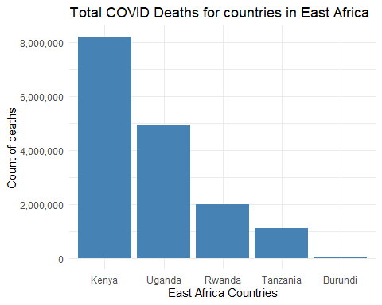

## COVID-19 Cases in Kenya (2020)

complete_covid_data %>%   
 filter(country == "Kenya", date >= "2020-01-01" & date <= "2020-12-31") %>%   
 ggplot(aes(x = date, y = new_cases)) +  
 geom_line(linewidth = 0.5, color = 'red') +  
 labs(title = "Covid cases in Kenya for 2020", x = "", y = "New COVID cases")

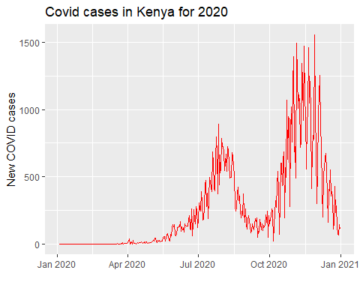

## Age Distribution of Hospital Patients During COVID

complete_covid_data %>%   
 ggplot(aes(x = median_age, y = hosp_patients)) +  
 geom_point(color = 'mediumseagreen') +  
 labs(title = "Age Distribution of Hospital Patients During Covid", x = 'Age', y = 'Number of patients') +  
 theme_minimal()

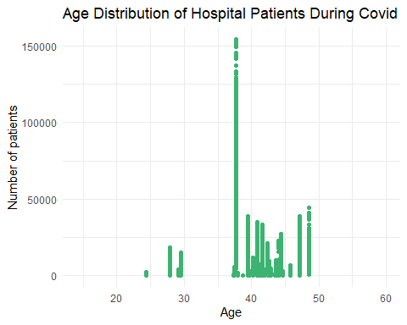

## Vaccinations Across Continents

complete_covid_data %>%   
 filter(continent %in% c("Africa", "Asia", "Europe", "North America", "South America"), !is.na(total_vaccinations_per_hundred)) %>%   
 group_by(continent) %>%  
 summarise(med_vaccinations = median(total_vaccinations_per_hundred, na.rm = TRUE)) %>%   
 ggplot(aes(x = reorder(continent, med_vaccinations), y = med_vaccinations)) +  
 geom_bar(stat = "identity", fill = 'orchid') +  
 labs(title = "Number of vaccinations Across Different Continents", x = "Continents", y = "Total Vaccinations per hundred") +  
 coord_flip() +  
 scale_y_continuous(labels = comma) +  
 theme_classic()

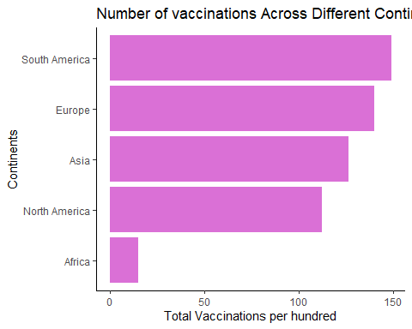

## Reproduction Rate in 2020

complete_covid_data %>%   
 filter(date >= "2020-01-01" & date <= "2020-12-31") %>%   
 filter(!is.na(reproduction_rate)) %>%   
 ggplot(aes(x = date, y = reproduction_rate)) +  
 geom_point(color = "steelblue") +  
 labs(title = "Reproduction Rate in 2020", x = '', y = 'Reproduction Rate') +  
 theme_minimal()

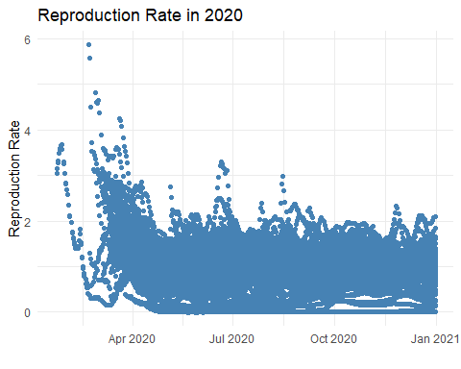

## GDP per Capita by Continent

complete_covid_data %>%   
 filter(continent %in% c("Africa", "Asia", "Europe", "North America", "South America")) %>%  
 group_by(continent) %>%   
 summarise(med_gdp = median(gdp_per_capita, na.rm = TRUE)) %>%  
 ggplot(aes(x = reorder(continent, -med_gdp), y = med_gdp)) +  
 geom_bar(stat = "identity", fill = 'mediumseagreen') +  
 labs(title = "Median GDP per capita per continent in 2020", x = 'Continents', y = 'GDP Per Capita') +  
 scale_y_continuous(labels = comma) +  
 theme_minimal()

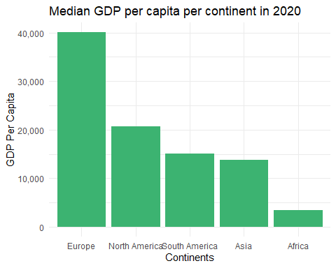

## New COVID Cases vs New Vaccinations

complete_covid_data %>%   
 ggplot(aes(x = new_cases, y = new_vaccinations)) +  
 geom_point(color = 'steelblue') +  
 labs(title = "New Covid Cases vs New Vaccines Issued", x = 'New Cases of Covid', y = 'New Vaccinations Issued') +  
 scale_y_continuous(labels = comma) +  
 scale_x_continuous(labels = comma) +  
 theme_classic()

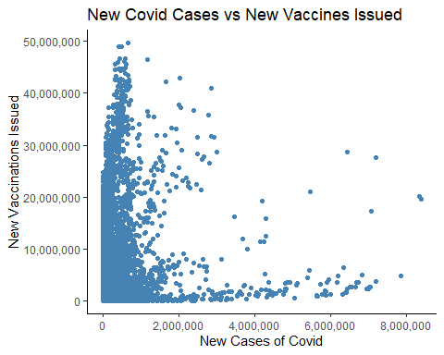

## Forecasting COVID-19 Cases for Kenya (2025)

kenya_cases <- complete_covid_data %>%  
 filter(country == "Kenya") %>%  
 select(date, new_cases) %>%  
 drop_na()  
  
cases_ts <- ts(kenya_cases$new_cases, frequency = 7)  
model <- auto.arima(cases_ts)  
forecast_data <- forecast(model, h = 365)  
  
autoplot(forecast_data) +  
 labs(title = "Forecast of COVID-19 New Cases For 2025", y = "New Cases", x = "Number of days") +  
 theme_minimal(base_size = 14) +  
 theme(axis.text.x = element_text(angle = 45, hjust = 1),  
 panel.grid.major = element_line(color = "gray80"),  
 panel.grid.minor = element_blank())

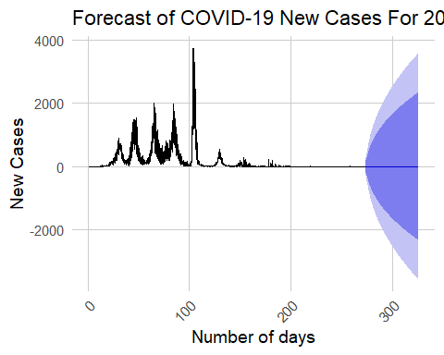

## Export Forecast to CSV

forecast_df <- data.frame(  
 date = seq(from = max(kenya_cases$date) + 1, by = "day", length.out = 365),  
 predicted_cases = as.numeric(forecast_data$mean),  
 lower_80 = forecast_data$lower[, 1],  
 upper_80 = forecast_data$upper[, 1],  
 lower_95 = forecast_data$lower[, 2],  
 upper_95 = forecast_data$upper[, 2]  
)  
  
write.csv(forecast_df, "kenya_covid_forecast_2025.csv", row.names = FALSE)