Complex Network Project Done by Marwen MBARKI

Question 2: Social Network Analysis with the Facebook100 Dataset
We analyzed three networks from the Facebook100 dataset: Caltech, MIT, and Johns Hopkins. These networks represent varying sizes and structures, with Caltech being the smallest (762 nodes in LCC), MIT having 6402 nodes, and Johns Hopkins 5157 nodes in their largest connected components.

(a) Degree Distribution
For each of the three networks, we plotted the degree distribution.
📊 Observations:
- All three networks exhibit right-skewed (heavy-tailed) degree distributions.
- Most users have a low number of connections, while a few hubs have a very high number of friends.
- This is typical of real-world social networks and reflects the preferential attachment process where popular nodes tend to attract more links.
📎 Figures:

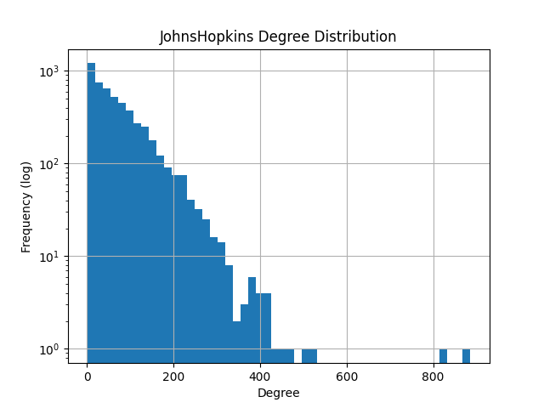
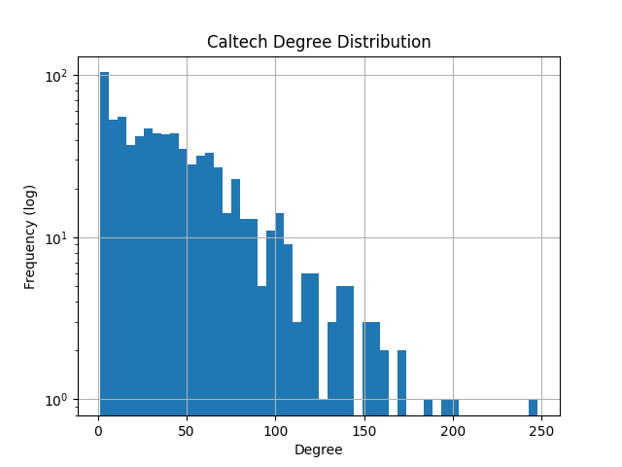
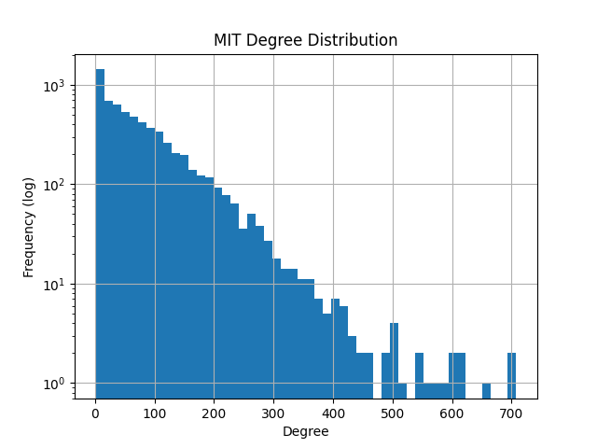

(b) Clustering Coefficients and Edge Density
We computed the global clustering coefficient, mean local clustering coefficient, and edge density for each network:
Network | Global Clustering | Mean Local Clustering | Edge Density
Caltech | 0.2913 | 0.4093 | 0.056404
MIT | 0.1803 | 0.2712 | 0.012118
Johns Hopkins | 0.1932 | 0.2684 | 0.013910

🔍 Observations:
- All three graphs are sparse (density < 0.1), especially MIT and Johns Hopkins.
- Caltech, being a smaller and more tightly-knit institution, shows higher clustering and density.
- The high mean local clustering across all networks indicates the presence of strong community structure and close-knit friendship groups.

(c) Degree vs Local Clustering
We plotted the relationship between node degree and local clustering coefficient.
📊 Observations:
- There is an inverse correlation: nodes with low degree tend to have high local clustering, while high-degree nodes often have lower clustering.
- This suggests that high-degree nodes act as bridges between communities (hubs), while low-degree nodes form tight social circles.
- This pattern is consistent across all three networks, although Caltech shows more consistent high clustering due to its smaller, denser community.
📎 Figures:
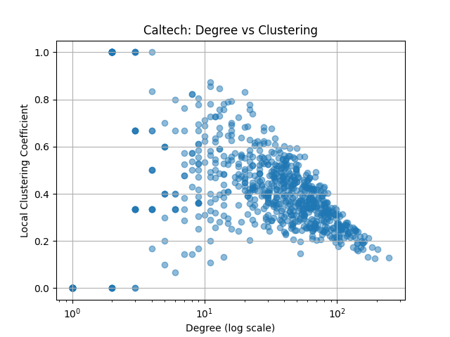
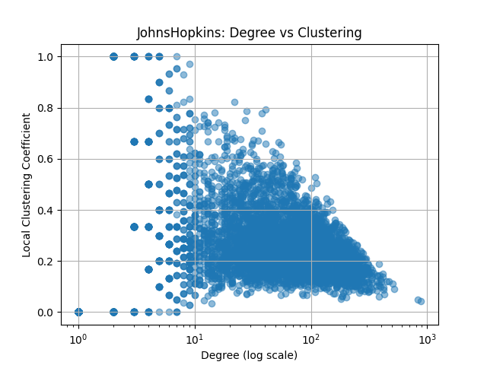
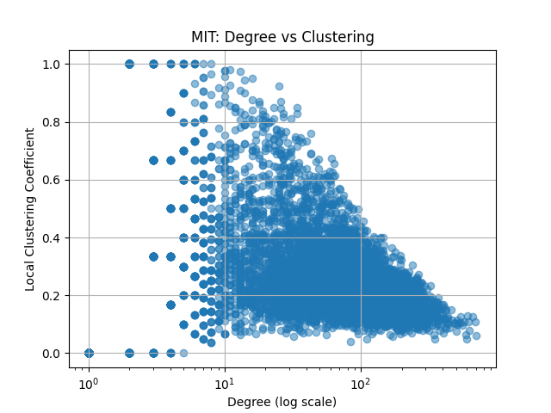

Conclusion:
The three networks follow typical social network patterns with:
- Sparse connectivity,
- Heavy-tailed degree distributions,
- Strong local clustering,
- Hubs with lower clustering bridging tightly-knit groups.
These features confirm that the Facebook100 networks exhibit characteristics of real-world social interactions and community structures.

Question 3 — Assortativity Analysis with the Facebook100 Dataset
We analyzed assortativity in all 100 Facebook100 university networks for five node-level attributes:
- Gender
- Dorm
- Degree
- Major
- Student/faculty status
For each attribute, we computed its assortativity coefficient across networks and plotted:
- A scatter plot of assortativity vs network size (log-linear)
- A histogram of assortativity distribution across all networks

Gender Assortativity
- The scatter plot shows values centered around 0, with most points in the range of -0.05 to +0.10.
- The histogram confirms this trend with a slight skew toward positive values.
- The average assortativity is slightly above 0, suggesting weak homophily by gender (users tend to connect slightly more with others of the same gender).
- Some networks show negative values, indicating weak heterophily (possibly due to gender-balanced friend groups or dating patterns).

Dorm Assortativity
- Dorm shows clear assortative mixing with most values between 0.1 and 0.25, and some going up to 0.4.
- This indicates that students are much more likely to be friends with others in the same dorm.
- The scatter plot shows consistent values regardless of network size.
- This reflects the influence of physical proximity and social life on friendship formation.

Degree Assortativity
- Degree assortativity values mostly fall between 0.0 and 0.15.
- This means that high-degree nodes (hubs) are slightly more likely to connect with other high-degree nodes, and similarly for low-degree nodes.
- It suggests a mild preference for connectivity matching, though much weaker than dorm-based homophily.

Major and Status Assortativity
- The plots for major_index and student_fac show consistent positive assortativity, indicating that students tend to form connections with others who share the same major or role (student/faculty).
- Student/faculty status shows particularly strong assortative mixing (often between 0.2 and 0.5), confirming that students and faculty primarily interact within their own group.
- Major-based assortativity is weaker but still present, with values mostly around 0.04–0.07, suggesting that students in the same academic field are slightly more likely to connect.

General Observations
- Dorm remains the attribute with the strongest assortativity, confirming that physical proximity and shared living spaces are major drivers of connection.
- Student/faculty status follows closely, with clear group-based segregation in the social network.
- Degree assortativity also shows a positive but moderate trend, suggesting that highly connected individuals tend to connect with other highly connected individuals (a “rich club” effect).
- Gender assortativity is low but consistently positive, indicating weak homophily.
- Major shows modest assortative mixing, particularly in smaller or more academically focused campuses.

Figures included: (figures/q3)
- Gender: gender_assortativity_vs_size.png, gender_assortativity_histogram.png
- Dorm: dorm_assortativity_vs_size.png, dorm_assortativity_histogram.png
- Degree: degree_assortativity_vs_size.png, degree_assortativity_histogram.png
- Major : major_index_assortativity_vs_size.png, degree_index_assortativity_histogram.png
- Status : Student_fac_assortativity_vs_size.png, Student_fac_assortativity_histogram.png

Question 4— Link prediction

Q4(c): Evaluation on Caltech
We evaluated three link prediction metrics — Common Neighbors, Jaccard, and Adamic/Adar — on the Caltech network. We randomly removed 10% of the edges and predicted them using each method.
For each metric, we computed Precision@k, Recall@k, and Top@k for k ∈ {50, 100, 200, 400}.
- Adamic/Adar and Common Neighbors achieved the highest precision (~0.58–0.7 at k=50), demonstrating their effectiveness at predicting friend links in clustered networks.
- Jaccard performed significantly worse, especially in precision, likely because it penalizes nodes with large neighborhoods — a common feature in social networks.
- Recall@k increased for all methods as k grew, as expected.
- Precision@k decreased as k increased, since lower-ranked predictions are less likely to be correct.
These trends are clearly visible in our metric-specific plots, with consistent trade-offs between precision and recall.

Q4(d): Comparing metrics ( figure : figures/q4 )
Across all metrics, Adamic/Adar consistently performed best in both precision and recall.
- It assigns higher scores to rare shared neighbors, which helps distinguish strong links in sparse or tightly-knit graphs.
- Common Neighbors also performed well and is a good lightweight baseline.
- Jaccard, on the other hand, struggles in this setting, especially in networks like Caltech where many nodes have high degree and dense connections.
We conclude that Adamic/Adar is the most effective metric for link prediction in this context, followed closely by Common Neighbors.

Question 5: Label Propagation on Facebook100

(a) and (b) – Implementation
We implemented the label propagation algorithm described by Zhu et al. (2002) [arXiv:1101.3291v1], which treats the prediction of missing node attributes as a semi-supervised learning problem on graphs. The algorithm works by iteratively propagating labels from labeled nodes to unlabeled nodes using the majority vote of neighbors. We used the NetworkX library to represent Facebook100 graphs, and implemented label propagation with convergence-based termination.

(c) – Experimental Setup
We selected the MIT8.gml graph from the Facebook100 dataset. We focused on three node attributes:
- dorm
- major_index (replacing "major" in the dataset)
- gender
For each attribute, we randomly removed 10%, 20%, and 30% of the labels and attempted to recover them using label propagation. We evaluated the accuracy and mean absolute error (MAE) on the removed labels.

(d) – Results Table (figures/Question5_Results)
Attribute | Missing Fraction | Accuracy | MAE
dorm | 0.1 | 0.9554 | 7.1944
 | 0.2 | 0.9135 | 15.0739
 | 0.3 | 0.8630 | 23.8249
major_index | 0.1 | 0.9273 | 0.5694
 | 0.2 | 0.8531 | 1.1520
 | 0.3 | 0.7796 | 1.7499
gender | 0.1 | 0.9626 | 0.0433
 | 0.2 | 0.9267 | 0.0867
 | 0.3 | 0.8856 | 0.1326
We observe the expected pattern:
- As the fraction of missing data increases, accuracy decreases and MAE increases.
- Label propagation works best on gender, followed by major_index, and then dorm.

(e) – Conclusion
The label propagation algorithm performs well across all three attributes, with strong robustness even as the percentage of missing data increases.
- Gender is easiest to predict due to its binary nature and strong homophily (e.g., same-gender friendships).
- Major_index shows very good performance, likely due to clusters of students sharing the same academic track.
- Dorm performs slightly worse, probably due to more diversity in dorm assignment and less clear social clustering based on this attribute.
These results confirm that the label propagation algorithm effectively leverages graph structure to infer missing labels, especially when there is a clear local correlation between the node attribute and network connectivity.

Question 6: Community Detection with FB100 Dataset

(a) Research Question & Hypothesis
Research question: Do students from the same dormitory form social communities within university Facebook networks?
Hypothesis: Students who share the same dorm are more likely to be socially connected, and thus community detection algorithms should reveal groups that align closely with dorm labels.

(b) Code & Validation
We selected three universities from the Facebook100 dataset:
- Caltech36
- MIT8
- Harvard1
We used the Louvain algorithm (modularity-based) to detect communities and evaluated alignment with actual dorm labels using Normalized Mutual Information (NMI), where:
- 1.0 = perfect match
- 0.0 = no correlation
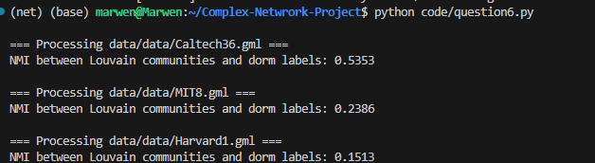

(c) Interpretation & Conclusion
The results show that Caltech36 exhibits a moderately strong correlation (NMI ≈ 0.54) between detected communities and dorm labels, supporting the hypothesis that dorm affiliation influences group formation.
In contrast, MIT8 and Harvard1 display weaker correlations (NMI ≈ 0.24 and 0.15), suggesting that other factors (e.g. shared major, year, or clubs) may be more important drivers of community structure in larger institutions.

Conclusion:
Our hypothesis is partially confirmed:
- In small, tightly-knit campuses (e.g., Caltech), dorms play a central role in community formation.
- In larger universities, social structure is likely shaped by a more complex mix of attributes, making dorms less predictive.

