Flash Controller Verification and Performance Report
Legacy SPI Shadowing, Pure XIP, and Dual-Mode QSPI
Prepared for: FYP technical documentation and result review
Prepared on: May 27, 2026
Result folder: C:\Users\wnmin\OneDrive\Attachments\FYP_results
Source folder: C:\Users\wnmin\OneDrive\Attachments\FYP_source\source
Simulator context: Synopsys VCS with Verdi waveform review
Report purpose
This document consolidates the architecture, memory map, common dataset, test flow, waveform evidence, and measured timing results for the three flash-access implementations. It is intended to be readable by a project examiner or engineer who did not open the Verdi sessions directly.

Executive Summary
All three implementations completed the common 16-byte proof workload and produced the expected completion marker 0xAABBCCDD. The legacy SPI implementation is functionally correct, but most of its time is consumed by the shadow-copy phase. Pure XIP and dual-mode QSPI remove that copy phase for read workloads and therefore complete the common read benchmark in about one third of the legacy time.
Implementation | Measured pass condition | Primary timing | Interpretation
Legacy SPI shadowing | Magic word 0xAABBCCDD written to 0x20008000 after SRAM execution | Total boot-done: 7.705 us | Correct but slow because flash data is copied through SPI into SRAM before execution.
Pure XIP | Four direct flash reads match the common dataset, then marker write passes | Total read time: 2.445 us | Fastest common read result; controller stays in XIP read path.
Dual-mode QSPI | Four direct flash reads match the same dataset, then marker write passes | 4-word read time: 2.545 us | Read performance is close to pure XIP while also supporting program and erase operations.
Important interpretation
The repeated legacy SRAM fetch at 0x20000004 after the AABBCCDD marker is normal. The SRAM payload contains a store instruction followed by an infinite branch in the same aligned word, so the Cortex-M3 keeps fetching that word after success. It is not counted as extra copy or benchmark time.

Scope and Evidence Reviewed
The report is based on the RTL, firmware, testbench monitors, timing text files, and Verdi screenshots under the provided FYP source and result folders.
Evidence category | Files or folders reviewed | Use in report
Legacy SPI results | FYP_results\legacy spi\time taken.txt and shadowing screenshots | Functional pass, copy timing, SRAM execution timing, SPI waveform evidence
Pure XIP results | FYP_results\Pure xip verdi\time taken.txt and xip screenshots | Direct-read pass, first-read/read-time timing, QSPI XIP waveform evidence
Dual-mode results | FYP_results\Dual mode verdi\time taken.txt plus read/write/erase screenshots | Common read benchmark, write/erase capability evidence, XIP-state behavior
RTL and firmware | FYP_source\source\1_legacy_spi, 2_pure_xip, 3_dual_mode, 0_shared_ip | Memory map, commands, common dataset, monitor definitions, and pass criteria

System Specification
The simulated SoC uses an ARM Cortex-M3 integration model with Harvard I-Code, D-Code, and System AHB-style interfaces. The testbenches generate a 50 MHz HCLK using a 20 ns period. Reset is held low for 20 base-clock cycles, then released near a negative edge with a small delay to avoid race-prone same-edge behavior.
Item | Specification
Processor | ARM Cortex-M3 integration model
Simulator | Synopsys VCS with Verdi waveform dumping and inspection
Clock | HCLK base period: 20 ns, equivalent to 50 MHz
Reset | Held for 20 HCLK_base rising edges, then released after a negative-edge delay
AHB transfer qualification | HTRANS NONSEQ or SEQ with HREADY asserted; decoded by high address nibble
Completion marker | 0xAABBCCDD written to 0x20008000
Common dataset size | 4 words / 16 bytes

Address Map
Address range or address | Owner | Use
0x00000000 | Boot ROM image | Reset vector and boot firmware entry point loaded from firmware.hex
0x20000000 - 0x2007FFFF | SRAM, 512 KB | Legacy shadow-copy destination and stack region
0x20000000, 0x20000004, 0x20000008, 0x2000000C | SRAM payload words | Legacy copied payload words verified by the testbench
0x20008000 | SRAM done marker | All tests write 0xAABBCCDD here to signal success
0x40000000 - 0x4000000F | Flash data window | Common 16-byte flash dataset for pure XIP and dual-mode read benchmark
0x40000000, 0x40000004, 0x40000008, 0x4000000C | Legacy SPI MMIO | Control, command, flash address, and data registers in the legacy SPI controller
0x40001000 | Dual-mode test flash address | Program and erase target used by the dual-mode feature workload

Common 16-Byte Dataset
Offset | Word | Role
0x00 | 0x49024801 | Thumb instruction word used by SRAM payload and XIP read checks
0x04 | 0xE7FE6001 | Contains STR marker instruction and infinite branch instruction
0x08 | 0x20008000 | Literal address for done marker
0x0C | 0xAABBCCDD | Magic value used as proof of correct final execution/read

Controller Architectures

Legacy SPI Shadowing Path
The legacy path exposes a memory-mapped SPI controller at 0x40000000. Boot firmware writes the command register with standard read command 0x03, writes the flash address, starts the SPI controller, polls the busy bit, reads back one 32-bit word, and writes it to SRAM. After four words are copied to 0x20000000, the firmware jumps to 0x20000001 so the Cortex-M3 executes the copied Thumb payload from SRAM.
Register | Address | Purpose
SPI_CTRL_REG | 0x40000000 | Bit 0 starts transfer; status includes busy flag
SPI_CMD_REG | 0x40000004 | SPI command, 0x03 for standard read in the bootloader
SPI_ADDR_REG | 0x40000008 | Flash byte address for the current 32-bit word
SPI_DATA_REG | 0x4000000C | Read data returned from external flash model

Pure XIP QSPI Path
The pure XIP path maps flash reads directly into the Cortex-M3 System bus at 0x40000000. The QSPI FSM issues command 0xEC for quad I/O read, transmits a 32-bit address, sends the A5 continuous-read mode byte, waits through dummy cycles, and samples 32-bit data over the 4-bit QSPI input. After the first read, the FSM remains in XIP mode, so subsequent reads skip the explicit command phase and continue with the address/mode/dummy/data sequence.

Dual-Mode QSPI Path
The dual-mode controller keeps the XIP read path but adds flash program and erase behavior. Read transactions use command 0xEC. Write transactions first issue WREN command 0x06, then choose page program command 0x34 for normal data or sector erase command 0x21 when the write data is 0xFFFFFFFF. Any CPU write forces the controller and flash model out of XIP lock, then reads may re-enter XIP through the A5 mode byte.
Operation | Command sequence | Observed proof
Read | 0xEC, 32-bit address, A5 mode, dummy cycles, 32-bit data | Common dataset readback matches all four expected words
Program | 0x06 WREN followed by 0x34 page program | 0x12345678 written and read back at 0x40001000
Erase | 0x06 WREN followed by 0x21 sector erase | 0xFFFFFFFF observed after erase check

Verification and Test Flow

Common pass criteria
- The CPU must leave reset and execute boot firmware from boot ROM.
- The data path under test must return the common dataset without mismatch.
- The firmware must write 0xAABBCCDD to 0x20008000.
- The testbench monitor must observe the marker and terminate the simulation with a success message.

Flow by implementation
Implementation | Flow | Main monitored events
Legacy SPI | Boot ROM firmware reads four flash words through SPI MMIO, shadows them to SRAM, then jumps to 0x20000001. | Writes to 0x20000000 through 0x2000000C; final write of 0xAABBCCDD to 0x20008000.
Pure XIP | Firmware reads four volatile 32-bit words directly from 0x40000000 and checks the final word and checksum. | Read count 1 through 4; expected values at 0x40000000, 0x40000004, 0x40000008, 0x4000000C.
Dual-mode read benchmark | Same firmware behavior as pure XIP, but using the dual-mode controller and shared flash model. | Read count 1 through 4; expected values match common dataset; done marker observed.
Dual-mode feature workload | Separate firmware proves read, program, program-readback, erase, erase-readback, and final read. | 0x12345678 program at 0x40001000; 0xFFFFFFFF erase check; final 0xAABBCCDD marker.

Timing Definitions
Metric | Definition | Applies to
Copy time | Time from reset release until the fourth payload word is written into SRAM at 0x2000000C. | Legacy SPI
Execution time | Time from completion of SRAM shadow copy until the SRAM payload writes 0xAABBCCDD to 0x20008000. | Legacy SPI
Total boot-done | Time from reset release until completion marker write. | Legacy SPI
Init time / first read latency | Time from reset release until first successful flash word is observed. | Pure XIP and dual-mode read benchmark
Operation / 4-word read time | Time from reset release until all four common dataset words have been read. | Pure XIP and dual-mode read benchmark
Marker latency / post-read latency | Time from last flash read until the CPU writes the completion marker. | Pure XIP and dual-mode read benchmark

Measured Results
Implementation | Metric | Time (ps) | Time (us) | Approx HCLK cycles
Legacy SPI | Copy time | 7,425,000 | 7.425 | 371.25
Legacy SPI | Execution time | 280,000 | 0.280 | 14.00
Legacy SPI | Total boot-done | 7,705,000 | 7.705 | 385.25
Pure XIP | First read / init | 945,000 | 0.945 | 47.25
Pure XIP | 4-word read time | 2,445,000 | 2.445 | 122.25
Pure XIP | Marker latency | 360,000 | 0.360 | 18.00
Pure XIP | Boot-to-marker | 2,805,000 | 2.805 | 140.25
Dual-mode QSPI | First read latency | 1,045,000 | 1.045 | 52.25
Dual-mode QSPI | 4-word read time | 2,545,000 | 2.545 | 127.25
Dual-mode QSPI | Post-read latency | 360,000 | 0.360 | 18.00
Dual-mode QSPI | Total boot-to-done | 2,905,000 | 2.905 | 145.25
Cycle counts are approximate because the recorded timestamps are measured from reset release and include the testbench release offset. The conversion uses the 20 ns HCLK period configured in the testbenches.

Comparison
Comparison | Result | Meaning
Pure XIP 4-word read vs. legacy total | 7.705 us / 2.445 us = 3.15x | Direct XIP read benchmark completes about 3.15 times faster than legacy boot-to-done shadowing.
Dual-mode 4-word read vs. legacy total | 7.705 us / 2.545 us = 3.03x | Dual-mode read benchmark keeps almost the same read advantage while supporting write and erase.
Dual-mode read vs. pure XIP read | 2.545 us / 2.445 us = 1.04x | Dual-mode read is about 4.1 percent slower for this 4-word benchmark.
Legacy copy share | 7.425 us / 7.705 us = 96.4 percent | Almost all legacy boot-to-done time is spent in the SPI shadow-copy phase.

Waveform Evidence
The following figures are included from the supplied Verdi screenshots. They are not decorative; each one anchors a specific verification claim used in the result analysis.
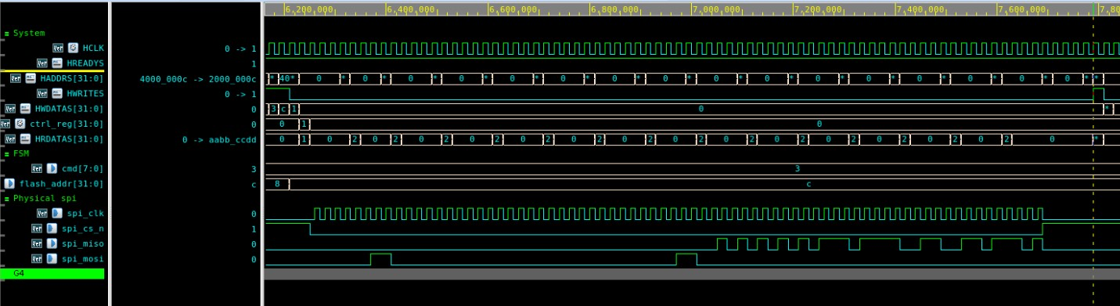
Figure 1. Legacy SPI shadow transfer completes the fourth word, returning 0xAABBCCDD and writing it to SRAM.
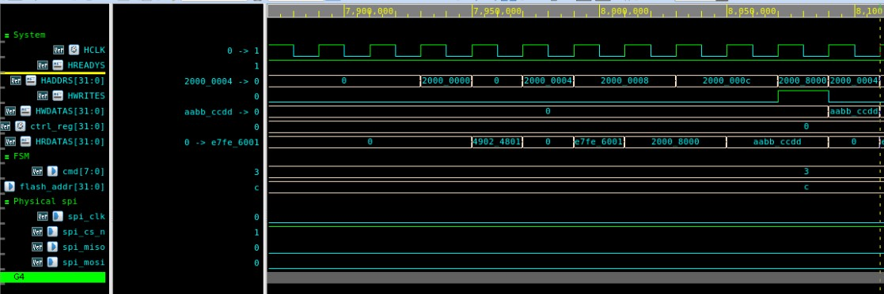
Figure 2. Legacy SRAM execution reaches the done marker path; repeated 0x20000004 fetches are the infinite branch after success.
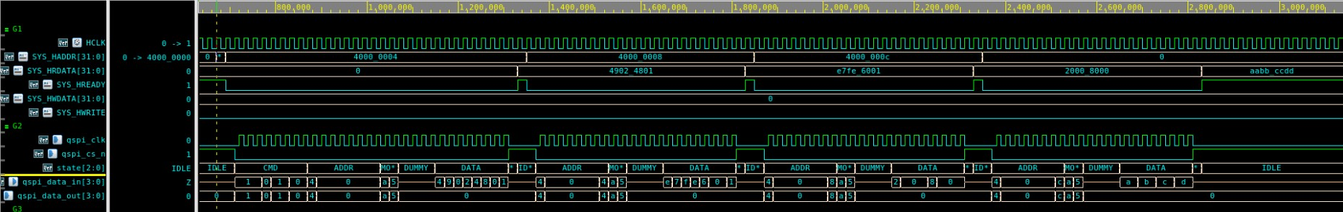
Figure 3. Pure XIP performs four direct flash reads from 0x40000000 through 0x4000000C.
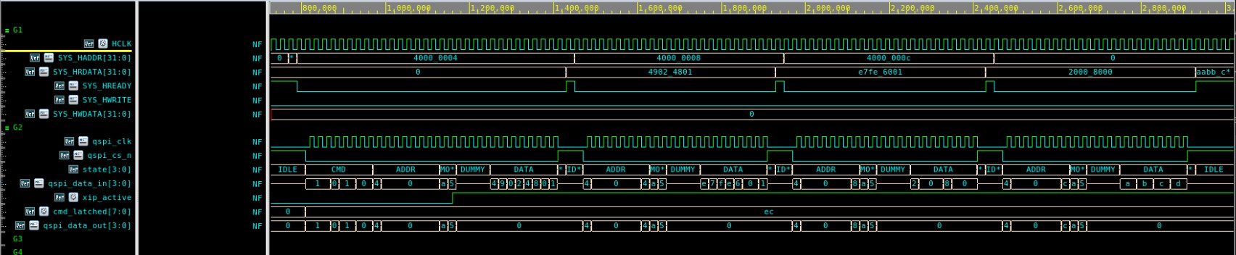
Figure 4. Dual-mode read benchmark performs the same four common dataset reads through the QSPI controller.
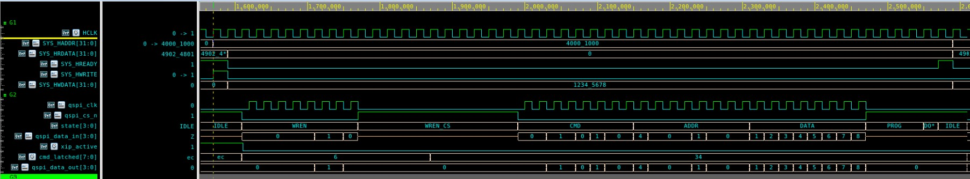
Figure 5. Dual-mode program operation uses WREN followed by command 0x34 and data 0x12345678.
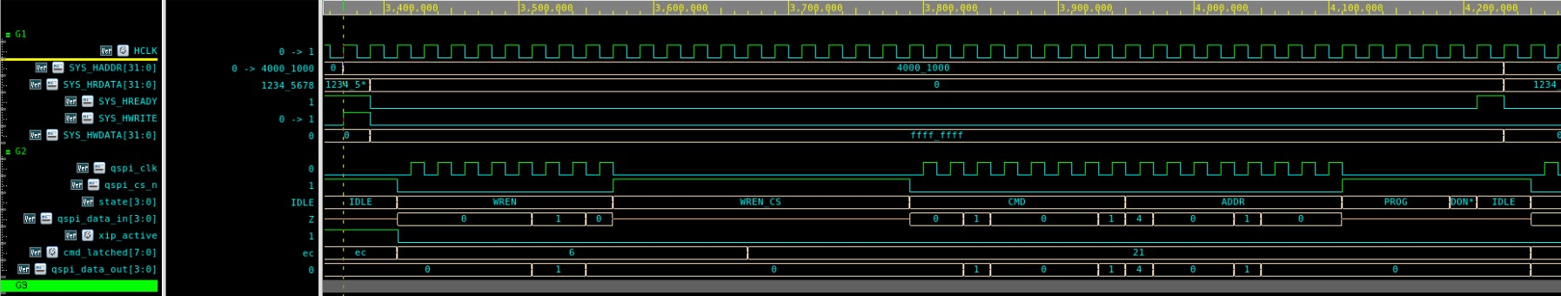
Figure 6. Dual-mode erase operation uses WREN followed by command 0x21 and data 0xFFFFFFFF.

Technical Analysis

Legacy SPI behavior
The legacy implementation proves a traditional boot-shadow design. It is correct because the payload is first copied into SRAM and then executed from SRAM, producing the magic word. Its performance is dominated by serial command/address/data phases and firmware polling. The measured 7.425 us copy time is 96.4 percent of the 7.705 us total boot-to-done time, so optimizing post-copy SRAM execution would not materially change the total result unless the copy path is also improved.

Pure XIP behavior
The pure XIP path avoids SRAM shadowing for the common read workload. The first read includes the setup needed to enter continuous read mode; later reads use the controller's XIP-active path. The 2.445 us 4-word read time is the best measured read result in the supplied data.

Dual-mode behavior
The dual-mode controller intentionally carries more behavior than pure XIP. It can read in XIP style, break XIP on CPU writes, issue WREN, program a word with 0x34, and erase with 0x21. The read benchmark is only 0.100 us slower than pure XIP for four words, while the separate waveforms show the write and erase capability. That makes dual-mode a stronger overall controller candidate when the design requirement includes in-field flash update operations.

Why 0x20000004 appears after legacy success
After the legacy payload writes 0xAABBCCDD to 0x20008000, the CPU continues executing the next instruction. The payload word at 0x20000004 contains both the STR instruction and the E7FE infinite branch. Because instruction fetches are word-aligned, the waveform repeatedly shows 0x20000004. This is normal post-success fetch behavior and should not be interpreted as another SRAM validation read or extra benchmark work.

Limitations and Recommendations

Limitations
- The reported timing is simulation timing from testbench monitors, not silicon timing after synthesis, place-and-route, or real flash memory timing closure.
- The common dataset is intentionally small at 16 bytes. It is good for architectural comparison, but larger payload sizes would better show scaling behavior.
- The Verdi screenshots prove representative transactions. The text timing files are the authoritative numerical source for this report.
- The dual-mode program and erase feature workload is separate from the read-speed benchmark, which is correct for fair read comparison.

Recommended next steps
- Repeat the same comparison with larger payload sizes such as 64 bytes, 256 bytes, and 1 KB to show throughput scaling.
- Report both first-word latency and steady-state words-per-microsecond for XIP paths.
- Keep the dual-mode read benchmark separate from the write/erase feature test in the final evaluation chapter.
- Add a post-synthesis timing or gate-level simulation section if the final project scope requires implementation realism.
- For the legacy path, keep copy time, SRAM execution time, and total boot-to-done time as separate report metrics.

Appendix A: Source Signals and Monitor Points
Signal or variable | Meaning
reset_release_time | Timestamp captured when reset is released and the CPU can begin boot execution.
init_done_time | Legacy: timestamp when the fourth payload word is written to SRAM at 0x2000000C.
op_done_time | Legacy: timestamp when the SRAM payload writes the magic completion marker.
first_read_done_time | Dual read benchmark: first successful read of the common dataset.
all_reads_done_time | Dual read benchmark: fourth successful read of the common dataset.
done_marker_time | Dual read benchmark: timestamp of the CPU's completion marker write.
read_count | Pure XIP and dual read monitors count the four expected flash read completions.

Appendix B: Result Text Extracts

Legacy SPI
*******************************************************
[8110000] PPA BENCH SUCCESS: LEGACY SPI SHADOWING COMMON DATASET PASSED
Copy time : 7425000 ps
Execution time : 280000 ps
Total boot-done : 7705000 ps
The Cortex-M3 successfully woke up from ROM, used the
Legacy SPI Controller to shadow 16 bytes of machine code
from Flash into SRAM, jumped to 0x20000001, and executed
the payload natively from SRAM!
Caught Magic Word 0xaabbccdd at Address 0x20008000
*******************************************************

Pure XIP
*******************************************************
[3210000] PPA BENCH SUCCESS: PURE XIP DIRECT READ PASSED
Init time : 945000 ps
Operation time : 1500000 ps
Total read time : 2445000 ps
Marker latency : 360000 ps
*******************************************************

Dual-mode read benchmark
*******************************************************
[3310000] DUAL MODE READ BENCH SUCCESS: COMMON 16-BYTE DATASET PASSED
First read latency : 1045000 ps
4-word read time : 2545000 ps
Post-read latency : 360000 ps
Total boot-to-done : 2905000 ps
*******************************************************

